Incidence of Tomato aspermy virus infecting field-grown tomato in Northern Nigeria
OCCURRENCE AND DISTRIBUTION OF Tomato aspermy virus (CUCUMOVIRUS) INFECTING IRRIGATED TOMATO (Solanum lycopersicum L.) IN SUDAN SAVANNA, NIGERIA
Peter Abraham^{1,*}, Olalekan Oyeleke Banwo², Boniface David Kashina², Mathew Dada Alegbejo² and Maryam Peter Abraham¹
¹Department of Horticulture, Federal College of Horticulture, Dadin Kowa, Gombe, Nigeria.
²Department of Crop Protection, Institute for Agricultural Research, Ahmadu Bello University Zaria, Nigeria.
* Corresponding author’s contact: +2347039566818; email- peterabraham06@yahoo.com

Novelty Statement
The northern part of Nigeria supplies up to 80% of the total tomato produced in the country by mostly resource-poor peasant farmers as their sole means of income. Virus diseases constitute a menace in vegetable production in Nigeria. The findings of our study report for the first time the occurrence and spread of Tomato aspermy virus (TAV) as a major biotic factor hampering the gainful cultivation of tomato in three major tomato producing states (Gombe, Jigawa and Kano) in northern Nigeria. Prior to this study, farmers had mistaken the symptom expression of TAV infection for nutrient deficiency hence, the findings of the present study will create more awareness and guide the farmers in taking the appropriate management measures against the virus.

Abstract
Tomato aspermy virus (TAV) is one of the important plant viruses limiting the gainful production of fruits and vegetables globally. This present study documents the incidence and spread of TAV infecting tomato plants in the Sudan savanna region (Jigawa, Gombe, and Kano) of Nigeria. Three farms each from 3 leading tomato cultivating Local Government Areas (LGAs) of each State were surveyed during two dry seasons. Forty symptomatic and asymptomatic tomato leaf samples from each farm (n=2160) were collected in five quadrants measuring 4m x 4m and tested against TAV using a double-antibody sandwich enzyme-linked immunosorbent serological assay (DAS-ELISA). The results obtained indicated that TAV was detected in all the States surveyed but with significant (P ≤ 0.05) variation in distribution. TAV incidence was found to be significantly higher (P ≤ 0.05) in Akko (16%) and Kaltungo LGAs (15.9%) in Gombe State. In Jigawa State, Kazaure LGA had the highest virus incidence (55.2%). The highest virus incidence of 33.6% was recorded at Kura LGA in Kano State. This is the first time to report TAV on tomato crops in the surveyed States with Jigawa State recording the highest (P ≤ 0.05) incidence (42.2%) followed by Kano (18.3%) while Gombe had the least virus incidence (15%). This finding suggests further studies on the molecular characterization of TAV to determine its strains and association with other isolates reported elsewhere. It is recommended that awareness and effective management practices of the virus be initiated for tomato farmers in the region to ensure profitable production.
Keywords: Bromoviridae, detection, prevalence, plant virus, spread, Nigeria
Introduction
Tomato aspermy virus (TAV; family Bromoviridae, genus Cucumovirus) is a tripartite positive-sense single-stranded genomic RNA virus (Inoue et al., 2018), which occurs globally with a wide host range infecting vegetable and ornamental crops of high economic value causing a significant reduction in quantity and quality of produce (Maddahian et al., 2017). It is one of the important viruses constraining the profitable production of tomato crops (Masunmi et al., 2009; Abraham et al., 2019a). Under severe infection by TAV, tomato plants express characteristic symptoms such as mottling, necrosis, deformation of leaves, stunted growth, and several axillary buds proliferations making the foliage have a bushy appearance with significant fruit set reduction and production of malformed, small-sized, and seedless fruits (ICTVdB Management, 2006; Blancard, 2012). In nature, TAV is principally transmitted by over 22 species of aphids in a nonpersistent manner (Palukaitis and García-Arenal, 2003; Blancard, 2012) but transmission by dodder, infected plant sap (Brunt et al., 1996), and through seeds of Phaseolus vulgaris and Stellaria media (Sastry, 2013) have also been reported. Bello, (2017) has earlier reported TAV incidence of 27% and 28% in Sokoto and Zamfara States respectively on irrigated tomato plants in northwestern Nigeria. Considering the resource-poor farmers who dominate tomato cultivation as their sole means of livelihood in Nigeria, the paucity of information on the current status of TAV in other major and leading commercial tomato producing states in the country, and the significant yield losses incurred in tomato production due to Tomato aspermy virus disease (Nava et al., 1997; ICTVdB Management, 2006; Hajiabad et al., 2012), this study was initiated, to detect the incidence and spread of TAV in three States (Gombe, Jigawa and, Kano States) in Sudan savanna ecological zone of Nigeria.
Materials and Methods
2.1. Field survey and sample collection
A field survey and sampling of farmers' fields were conducted to ascertain the incidence and spread of TAV infecting irrigated tomato plants in three States (Gombe, Jigawa, and Kano) in the Sudan savanna region of Nigeria during the 2017 and 2018 dry seasons. In each State, three leading tomato producing Local Government Areas (Gombe: Kaltungo, Akko, and Yamaltu-Deba LGAs; Kano: Kura, Garun Mallam, and Bagwai LGAs while in Jigawa: Kirikasama, Kazaure, Hadejia, and LGAs) were selected from which three farms each were surveyed. Forty symptomatic and asymptomatic tomato leaf samples from each farm (n=2160) were collected in five quadrants (with each at the four corners and centre of the farm) measuring 4m x 4m as described by Kashina et al. (2002). Some important Information on each farm surveyed was recorded (Tables 1, 2, 3). Each sample collected was packaged in polythene bags, labeled and kept at 4 °C prior to diagnosis.

Table 1. Some cropping information and symptoms of virus diseases of the surveyed locations in Gombe State during the 2017 and 2018 dry seasons.
LGA | Location | Coordinates | Farm size (Ha) | Variety of tomato | Duration of cultivation | †Source of seed | ‡Symptoms observed | *Sanitary condition | ^{ᶴ} Surrounding  Crops | ^{ѱ} Crop  growth  Stage | ҂ Cropping  Pattern
Akko | Gadawo | N10⁰02.919, E011⁰16.876 | 0.526 | UTC/Syria | 20 years | PS | C, LC, M, S, Mo | W | P, T, Ok | V | MC with O and P
 | Kembu-Gingin Gada | N10⁰02.916, E011⁰17.169 | 1.420 | Syria | 25 years | MV | C, S, LC, N, M, | W | Ok, T | F | MC with O
 | Kembu | N10⁰02.353, E011⁰17.763 | 0.427 | Syria/ Tandino | >60 years | PS | C, S, LC, M, | WD | T, P, W | V | SC: rotated with W and P
Kaltungo | Gujuba | N09⁰58.008, E011⁰18.352 | 0.103 | Syria | 4 years | MV | N, C, LC, M, Mo | W | P, M, C | F | SC: rotated with P and M
 | Awak | N09⁰55.666, E011⁰26.922 | 1.23 | Roma VF | 8 years | PS | C, LC, M, S, N | WD | T, S | V | MC with C
 | Dogon ruwa | N09⁰57.870, E011⁰28.399 | 1.51 | Tandino | 7 years | PS | N, C, LC, M, T | W | T, Ok, O, M | V | MC with O and P
Yamaltu-Deba | Dadin kowa | N10⁰17.802, E011⁰30.606 | 0.442 | Syria | 5years | PS | C,T, S, LC, M, | W | SM, M | V | MC with M and S
 | FCHTRF | N10⁰18.159, E011⁰31.148 | 0.340 | Syria | 15years | PS | C, LC, M, S, T | W | Ok, P | F | MC with O
 | Kwadon | N10⁰16.147, E011⁰31.181 | 1.12 | Syria | 30 years | PS | C, LC, M, S, T, N | WD | T, O, M | F | MC with M
† PS= Previous season; MV= Market vendors. ‡ C= chlorosis; LC= Leaf curl; M= Mosaic; N= Necrosis; S= Stunting; T= Twisting; Mo = Mottling. * W= Weedy; WD= Weeded. ^{ᶴ} P= Pepper; T= Tomato; OK= Okra; W= Water melon; M= Maize; C=Chocories; S= Sugarcane; SM= Sweet melon; O= Onion. ^{ѱ} V= Vegetative; F= Flowering. ҂ MC= Mixed cropping; SC= Sole cropping; O= Okra; P= Pepper; W= Water melon; C= Cucumber; S= Sweet melon; M= Maize.
Source: Field Survey, (2017 and 2018).
Table 2. Some cropping information and symptoms of virus diseases of the surveyed locations in Jigawa State during the 2017 and 2018 dry seasons.
LGA | Location | Coordinates | Farm size (Ha) | Variety of tomato | Duration of cultivation | †Source of seed | ‡Symptoms observed | *Sanitary condition | ^{ᶴ}Surrounding  Crops | ^{ѱ} Crop  growth  Stage | ҂ Cropping  Pattern
Hadejia | Mai Alkama | N12⁰26.120, E 10⁰35. 200 | 1.1024 | Tandino | 25 years | PS | C, N, LC, S, | W | T, O | V | MC with P
 | Hadejia | N12⁰26.379, E 10⁰01. 173 | 0.620 | UTC | 6 years | PS | LC, M, N, Mo | W | P, T | V | SC: rotated with P and O
 | Yayari | N12⁰26.133, E10⁰02.387 | 3.510 | UTC | 30 years | PS | C, Mo, LC, M, | WD | P, T | F | MC with OK and P
Kazaure | Dabaza | N12⁰37.924, E008⁰33.248 | 1.376 | UTC | 8 years | SC | S, C, Mo, N, M, | W | T, C, P | F | SC: rotated with P
 | Dan Dutsi- Sadua | N12⁰36.400, E008⁰33.966 | 1.571 | UTC (Graptor) | 25years | SC | C, Mo, S, LC, M, N | W | T, P | F | MC with C, OK, M
 | Kurfi | N12⁰36.670, E008⁰35.076 | 0.610 | Roma VF | 10 years | PS | C, LC, Mo, M, N | W | M, T | F | SC: rotated with P
Kirikasama | Tarabu | N12⁰30.646, E010⁰10.584 | 1.735 | UTC | 25years | PS | N, C, LC, Mo, S, T | WD | T, P | F | SC: rotated with P
 | Tarabu- Kumoyo | N12⁰30.566, E010⁰09.693 | 0.834 | UTC | 30years | PS | C, S, M, T, LC, N | W | M | Fw | MC with R and M
 | Marma- Giryo | N12⁰39.730, E010⁰21.530 | 0.231 | Roma VF | >30 years | PS | C, Mo, LC, M, S, N | W | R, T, M | F | MC with M
† PS= Previous season; SC= Seed company. ‡C= chlorosis; LC= Leaf curl; M= Mosaic; N= Necrosis; S= Stunting; T= Twisting; Mo = Mottling. * W= Weedy; WD= Weeded. ^{ᶴ} P= Pepper; T= Tomato; C= Cassava; M= Maize; R=Rice; O= Onion. ^{ѱ} V= Vegetative; F= Fruiting; Fw = Flowering. ҂ MC= Mixed cropping; SC= Sole cropping; O= Onions; P= Pepper; C= Cucumber; OK= Okra; M= Maize; R=Rice. Source: Field Survey, (2017 and 2018).
Table 3. Some cropping information and symptoms of virus diseases of the surveyed locations in Kano State during the 2017 and 2018 dry seasons.
LGA | Location | Coordinates | Farm size (Ha) | Variety of tomato | Duration of cultivation |  | †Source of seed | ‡Symptoms observed | *Sanitary condition | ^{ᶴ} Surrounding  Crops | ^{ѱ} Crop  growth  Stage | ҂ Cropping  Pattern
Bagwai | Dabino Center 5 | N12⁰07.394, E008⁰13.611 | 0.1024 | Roma VF |  | 15 years | SC | C, S, N, LC, M, | WD | T, O, M | F | MC with O, GP and G
 | Dabino Center 4 | N12⁰07.481, E008⁰12.699 | 1.720 | UTC |  | 17 years | SC | C, LC, M, N, LC | W | M, T, G | V | MC with GP and M
 | Dabino Center 3 | N12⁰07.544, E008⁰12.729 | 1.050 | Dan Jos |  | 7 years | SC | S, LC, T, M, N | WD | Co, M, T | V | MC with GP and G
Garun Mallam | Chiromawa | N11⁰35.894, E008⁰24.742 | 2.103 | Roma VF |  | 15 years | MV | C, N, LC, M, | W | M, T | V | MC with GP
 | Yantomo | N11⁰37.594, E008⁰24.987 | 0.824 | UTC |  | >15years | PS | C, M, LC, S, | WD | GP, M, Cu, T | Fw | MC with RD, Pk, Cu
 | Kadawa | N11⁰38.299, E008⁰24.903 | 2.120 | Roma VF |  | 7 years | MV | M, Mo, LC, N, | W | W, T, M, GP | V | MC with M and GP
Kura | Butalawa fadama 1 | N11⁰47.309, E008⁰25.529 | 1.420 | UTC (Inster) |  | 27years | PS | C, LC, Mo, N, S, M | W | R, T, M | F | MC with M, P and Cb
 | Butalawa fadama 2 | N11⁰47.341, E008⁰25.507 | 0.540 | UTC (Inster) |  | 10years | MV | Mo, N, C, LC, T, M | W | P, T | F | MC with M, and P
 | Butalawa fadama 3 | N11⁰47.390, E008⁰25.333 | 0.791 | UTC (Inster) |  | 15 years | PS | S, N, LC, M, C, Mo | W | M, C, T | V | MC with M and C
† PS= Previous season; SC= Seed company. ‡ C= chlorosis; LC= Leaf curl; M= Mosaic; N= Necrosis; S= Stunting; T= Twisting; Mo = Mottling. * W= Weedy; WD= Weeded. ^{ᶴ} P= Pepper; T= Tomato; Co= Cowpea; C= Cassava; G= Groundnut; M= Maize; Cu= Cucumber; GP= Green peas; W= Water melon; R=Rice; O= Onion. ^{ѱ} V= Vegetative; F= Fruiting; Fw = Flowering. ҂ MC= Mixed cropping; O= Onions; G= Groundnut; P= Pepper; Cu= Cucumber; GP= Green peas; C= Cassava; R= Radish; M= Maize; Cb=Cabbage; Pk =Pumpkin. Source: Field Survey, (2017 and 2018)

2.2. Serological assay
DAS-ELISA kits specified for TAV detection were obtained from the Leibniz-Institut DSMZ – Deutsche Sammlung von Mikroorganismen und Zellkulturen Gmbh (Braunschweig, Germany) used to index tomato leaf samples against TAV incidence. The procedure described by Clark and Adams, (1977) for determining the antigen-antibody reactions in ELISA was followed in this study. The Uniequip ELISA plate reader (Martinseed, Germany) set at 405 nm wavelength was used to measure the optical density of wells of the microtiter plates after 1 hour. The values of the test samples were rated positively when measured to be two times the value of the negative control (check) as described by Kumar, (2009). Mean virus incidence (%) for the two years was computed as the number of positive samples detected expressed as a percentage of the total number of samples examined per farm.
2.3. Data analysis
The variation in the data collected on the incidence of TAV was analyzed and the differences in their means were declared significant at a 5 % level of probability using the standard error of means as described by Gomez and Gomez, (1984).
Results
The results obtained indicated that TAV was detected in all the States surveyed but with significant (P ≤ 0.05) variation in distribution. TAV incidence was found to be significantly higher (P ≤ 0.05) in Akko (16%) and Kaltungo LGAs (15.9%) than was recorded in Yamaltu- Deba (13.1%) in Gombe State (Figure 1). In Jigawa State, Kazaure LGA had the highest virus incidence (55.2%) followed by Kirikasama (38.9%) while the least incidence (32.6%) was recorded at Hadejia (Figure 1). The highest virus incidence of 33.6 % was recorded at Kura LGA followed by Bagwai (18.1%) while Garun Mallam had the least incidence of 13.2% in Kano State (Figure 1). Of all the States surveyed for TAV, Jigawa recorded the highest (P ≤ 0.05) mean incidence (42.2%) followed by Kano (18.3%) while the least virus incidence (15%) was recorded in Gombe (Figure 2).

Figure 1. Incidence of Tomato aspermy virus in Gombe, Jigawa and Kano States during the 2017 and 2018 dry seasons. Bars indicate standard error of means at 5% probability level.

Figure 2. Mean incidence of Tomato aspermy virus in Gombe, Jigawa and Kano States during the 2017 and 2018 dry seasons. Bars indicate standard error of means at 5% probability level.

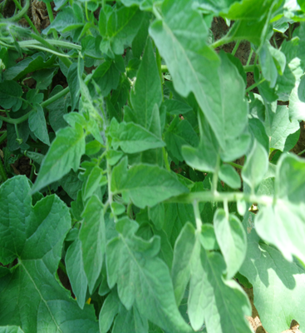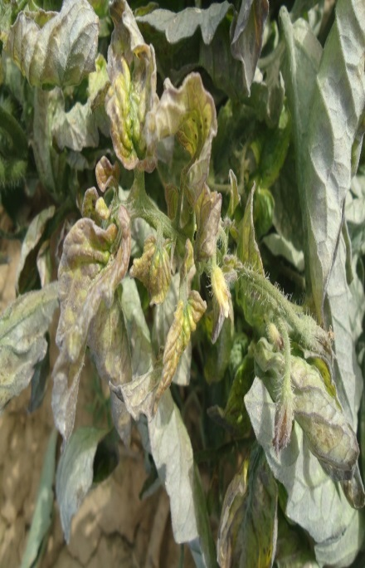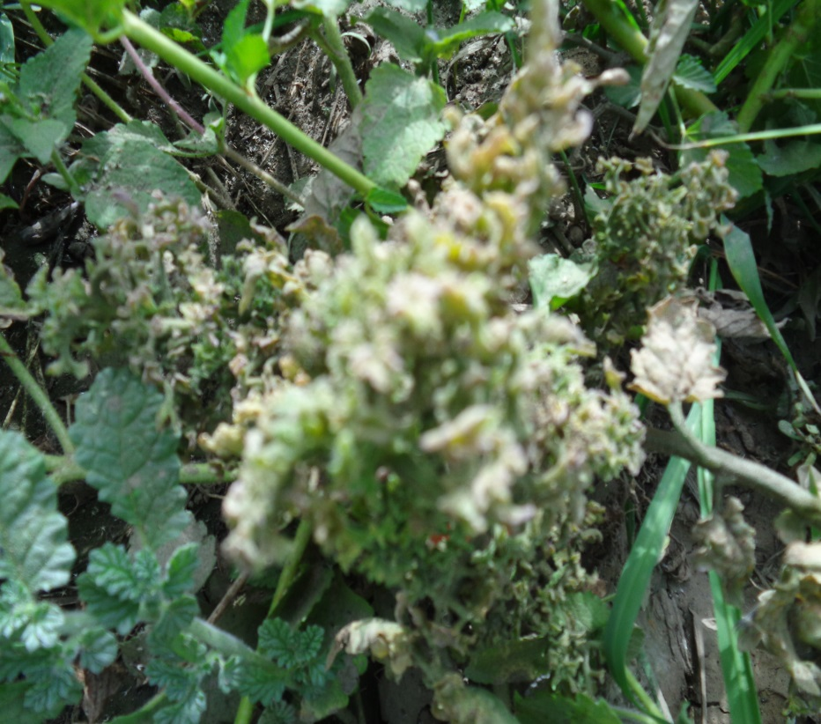
(C)
(B)
(A)
Figure 3. Disease symptoms expression on tomato plants infected by TAV: (A) healthy tomato plant; (B) Showing chlorosis, mottling, necrosis, and deformation of leaves; (C) severely infected tomato plants showing reduced leaf and stem, chlorosis, necrosis, and stunted growth with a bushy appearance.

Discussion
The present study examined the incidence and spread of TAV on irrigated tomato crops in the Sudan savannah region (Gombe, Jigawa, and Kano States) of Nigeria. TAV was detected for the first time on field-grown tomato crops in all the States surveyed. The detection of TAV naturally infecting tomato (Ahmad, 1986; Megan et al., 1996; Nava et al., 1997; Jafari et al., 2010; Bello, 2017), chrysanthemum and gladiolus (Raj et al., 2007, 2011; Maddahian et al., 2017) have previously been reported from several parts of the world. This has further supported the report on the phytopathogenic and global occurrence of TAV (Kafi and Ghahsareh, 2009). Common symptoms noted on tomato crops were leaf curl, mosaic, stunting, mottling, twisting, necrosis, and chlorosis which have earlier been reported to be associated with viral diseases (Gallitelli, 2000). The observed disease symptoms (Figure 3) incited by TAV as similarly reported by Bello, (2017) was further affirmed by the two seasons serological detection of the virus in all the tomato fields surveyed. Senso lato, the incidence of TAV in the region could be attributed to several factors: From our interaction with the farmers in the course of the study revealed that the majority of the farmers are unaware of viral diseases and their effective management measures. Poor weed management is another important factor which influences virus disease spread. Most of the farms surveyed were found to be weedy (Tables 1, 2, 3) which may serve as an inoculum source for the transmission of viruses to tomato plants by vectors. A total of nineteen weed species have been detected to be infected with TAV in tomato fields in northern Nigeria (Bello, 2017; Abraham et al., 2019b). Similarly, 19 and 14 weed species were detected to be naturally infected with Tomato yellow leaf curl virus (TYLCV) and Tomato ringspot virus (ToRSV) in northern Nigeria respectively (Abraham et al., 2021a, 2021b). All-year-round production of tomato in the study area is another significant factor which could avail an uninterrupted TAV disease circle. It was also observed from the farmer’s fields that tomato plants are been inter-cropped with other alternative hosts of TAV vector and the proximity of tomato fields to other surrounding vegetable fields (Tables 1, 2, 3) which could support vectors of viruses that may infest tomato and transmit viruses (Mzyad et al., 1994). In addition, an adaptation of or favourable conditions for the vector of TAV in the study area could also ensure the prevalence of the virus in region. Furthermore, the relatively higher incidence of TAV in Jigawa State (Figures 1 & 2) could be influenced by the predominant cultivation of UTC tomato variety in the State (Table 2) which may be susceptible to the TAV compared to Syria variety been mainly cultivated in Gombe (Table 1) that had the lowest incidence of the virus (Figures 1 & 2).
CONCLUSION
Conclusively, the incidence and spread of TAV naturally infecting tomato crops in the Sudan savannah region (Gombe, Jigawa, and Kano States) of Nigeria were established in the study. This is the first time to detect TAV on tomato crops in the surveyed States with Jigawa State recording the highest incidence. Farmers' unawareness of the virus and its management measures influenced the prevalence of the TAV in the study area. This finding suggests further studies on the molecular characterization of TAV to determine its strains and association with other isolates reported elsewhere. It is recommended that awareness and effective management practices of the virus be initiated for tomato farmers in the region to ensure profitable production.
Acknowledgements
The technical help received from staff technologists (Mr Z. Abdulmalik and Mr J.O.A. Sedi) of the Department of Crop Protection, Ahmadu Bello University Zaria, Nigeria was gratefully recognized by the authors.
Author Contributions
PA, OOB, BDK and MDA planned and designed the research. PA and MPA performed the experiments. MPA analyzed the data, and PA, OOB, BDK and MDA wrote the manuscript. OOB, BDK and MDA contributed equally. All authors reviewed and approved the manuscript.
Conflicts of Interest

All the authors wish to confirm that we have no conflict of interest.

Data Availability

Data supporting the findings of this study are available in this article.

Ethics Approval

This article does not contain any studies with human participants or animals. The collection materials of the plants, complies with the relevant institutional, national, and international guidelines and legislation.

Funding Source

This study received no funding from any organization

References
Abraham, P., Banwo, O. O., David Kashina, B., & Alegbejo, M. D. 2021a. Detection of weed species infected by Tomato ringspot virus in field-grown tomato in Sudan savanna, Nigeria. Nigerian Journal of Plant Protection, 35(2),1-15
Abraham, P., Banwo, O. O., David Kashina, B., & Alegbejo, M. D. 2021b. Identification of Weed Hosts of Tomato yellow leaf curl virus in Field-Grown Tomato in Sudan Savanna, Nigeria. International Journal of Horticultural Science and Technology, 8(3), 235-246.
Abraham, P., O.O. Banwo, B.D. Kashina, and M.D. Alegbejo 2019a. Status of tomato viruses in Nigeria. FUDMA J. Sci. 3(3): 482-494.
Abraham, P., O.O. Banwo, B.D. Kashina, and M.D. Alegbejo 2019b. Detection of alternative hosts of some tomato viruses in Sudan Savanna, Nigeria. A paper presented at the Maiden National Conference of Nigerian Society for Plant Virology held at the Conference centre International Institute of Tropical Agriculture, Ibadan, Oyo State, Nigeria, 28th – 31st October 2019.
Ahmad, I.B. 1986. First Report of Tomato Aspermy Virus in Arkansas. Disease note. Plant Dis. 70:1074. doi: 10.1094/PD-70-1074c.
Bello, I. 2017. Occurrence, distribution and alternative hosts of viruses of irrigated tomato (Solanum lycopersicon L.) Fields in Sokoto and Zamfara States, Nigeria. MSc, Ahmadu Bello Univerisity Zaria, Nigeria.
Blancard, D. 2012. Tomato Diseases- Identification, biology and control 2nd (ed.). Acad. Press. doi.org/10.1016/C2010-0-66813-1.
Brunt, A.A., K. Crabtree, M.J. Dallwitz, A.J. Gibbs L. Watson and E.J. Zurcher (eds.) 1996. `Plant Viruses Online: Descriptions and Lists from the VIDE Database. Version: 20th August 1996.' URL http://biology.anu.edu.au/Groups/MES/vide/ Accessed 20/6/2020.
Clark, M.F. and A.N. Adams 1977. Characteristics of the microplate method of enzyme-linked immunosorbent assay for the detection of plant viruses. J. Gen. Virol. 34: 475-483.
Gallitelli, D. 2000. The ecology of Cucumber mosaic virus and sustainable agriculture. Virus Res. 71: 9 – 21.
Gomez, K.A., and A.A. Gomez 1984. Statistical Procedure for Agricultural Research. 2nd (ed.) Wiley, 680pp.
Hajiabadi, A.M., F. Asaei, B.A. Mandoulakani, and M. Rastgou 2012. Natural incidence of tomato viruses in the North of Iran. Phytopathol. Med. 51(2): 390−396.
ICTVdB Management 2006. 00.010.0.04.003. Tomato aspermy virus. In: ICTVdB - The Universal Virus Database, version 4. Büchen-Osmond, C. (Ed), Columbia University, New York, USA.
Inoue, S., M. Tamura, M. Ugaki, M. Suzuki 2018. Complete genome sequences of three Tomato aspermy virus isolates in Japan. Genome Announc. 6:e00474-18. doi:10.1128/genomeA.00474-18.
Jafari, M. M. Valizadeh, J. Valizadeh, F. Ertiaei, M. Beigami 2010. Detection of important viruses infecting cucurbit and tomato in fields and greenhouses of Baluchestan. In: Proceeding of 19th Iranian Plant Protection Congress, 31 July‒3 August, 2010, Tehran, Iran.
Kafi, M. and M. Ghahsareh 2009. Floriculture, Vol. 1, 4th edn. Jahad Press, Tehran.
Kashina, B.D., R.B. Mabagala, A.A. Mpunami 2002. Reservoir weed hosts of Tomato yellow leaf curl begomovirus from Tanzania. Arch. Phytopathol. Plant Prot. 35 (4): 269–278.
Kumar, V. (Ed.) 2009. Methods for the Diagnosis of Plant Virus Diseases: A Laboratory Manual” Training course on Diagnosis of Plant Virus Diseases held from 28th April – 10th May 2009 at IITA, Ibadan, Nigeria. 90pp.
Maddahian, M., H. Massumi, J. Heydarnejad, P.A. Hosseini, A, Varsani A. 2017. Characterization of Iranian Tomato aspermy virus isolates with a variant 2b gene sequence. Trop. Plant Pathol. 42(6):475–484. doi 10.1007/s40858-017-0173-1.
Massumi, H., M. Shaabanian, P.A., Hosseini, J. Heydarnejad, H. Rahimian 2009. Incidence of viruses infecting tomato and their natural hosts in the southeast and central regions of Iran. Plant Dis. 93:67-72.
Mazyad, H.M., D. Peters, D. Maxwell 1994. Tomato yellow leaf curl virus in Egypt: epidemiological and management aspects. 1st International Symposium on Geminiviruses, Almeria, Spain.
Megan, F.H., J.G. Rowena, R.M. Jane, H. Graham 1996. The incidence of chrysanthemum B. carlavirus, Tomato aspermy cucumovirus, tomato spotted wilt tospovirus in Australian chrysanthemum crops Australia. Plant Pathol. 25 (5): 174-178.
Nava, A., G. Trujillo, D. Chirinos, G. Rivero 1997. Detection of viruses from tomato (Lycopersicon esculentum Mill.) production zones in Venezuela. II. Andean States (Mérida, Táchiraand TrujilIo). Rev. Fac. Agron. (LUZ) 14: 611-624.
Palukaitis, P. and F. García-Arenal 2003. Cucumoviruses. Adv Virus Res. 62:241–323.
Raj, S.K., S. Kumar, S. Choudhary 2007. Identification of Tomato aspermy virus as a cause of yellow mosaic and flower deformation in chrysanthemums. Aust. Plant Dis. Notes 2: 1–2.
Raj, S.K., S. Kumar, D.K. Verma, S.K. Snehi 2011. First report on molecular detection and identification of Tomato aspermy virus naturally occurring on gladiolus in India. Phytoparasit. 39:303–307.
Sastry, K.S. 2013. Seed-borne plant virus diseases, Springer, India. doi: 10.1007/978-81-322-0813-6.

