Effects of Using Agricultural Drainage water on Chemical, Biological and Physical Properties of Soil and Yield of Tomato in Moghan Plain, Iran

Abstract

This study was designed to assess the use of drainage water in agriculture by mixing irrigation water and agricultural drainage water to examine the effects on soil properties and the yield of tomato in Moghan Plain, Iran. The experimental design was completely random, conducted with three irrigation treatments and four replications for two years. The treatments were the control treatment (irrigation water only) (T0), 50% drainage water +50% irrigation water (T1), and agricultural drainage water only treatment (T2). The results showed that the treatments had significant differences (p≤0.05) in terms of the microbial population, basal respiration, and substrate-induced respiration. There were also significant differences among the treatments in terms of soil pH and EC (p≤0.01). While, the soil organic matter, yield, bulk density, and chlorophyll content of tomato showed no significant differences among the treatments. The treatments did not differ significantly in terms of the saturated hydraulic conductivity (K_{s}) in the first year, whereas the K_{s} for the drainage water treatment differed significantly (p≤0.05) in the second year. No significant differences were observed in the parameters of van Genuchten (θ_{s}, θ_{r}, and α) among the treatments. Whereas the statistical results showed that there was a significant difference (p≤0.01) in the parameters of van Genuchten (n) between T0 with T1 and T2 treatments while there was no significant difference between T1 and T2 treatments. It can be concluded that the use of drainage water negatively affected soil pH, salinity, and biological properties; but it did not decrease the plant yield.

Keywords: Drainage Water, Soil properties, Microbial Population, Soil Biological Indices, Substrate-induced respiration, Water re-use
- Introduction
Iran is among the countries affected by the water shortage problem. One of the strategies that could moderate the issue of water shortage is the re-use of agricultural drainages. In recent years, the conditions of water resources in Iran has urged the national policies toward increasing the productivity of water resources. Therefore, optimized use of current water resources, such as drainages, is among the fundamental tasks to be fulfilled by the custodians and consumers.
The agricultural drainage water in the Moghan Plain of Iran is one of the largest water drainage systems in the country. The agricultural drainage water can be returned to the agricultural lands for irrigation by proper management, thereby diminishing severe water shortage. Re-use of drainage water should be evaluated in terms of the long-term and short-term effects on soil properties. The direct use of drainage water on the farmlands is usually conducted without mixing with fresh water. The leading cause of the adverse effect of drainage water is the high concentration of ions, which is referred to as salinity. One of the ways for decreasing water salinity is the mixing of saline water with freshwater or less saline water so that its quality is improved for the irrigation of crops.
Although there are some studies about the feasibility of drainage water re-use in agriculture (Rasoulzadehand and Nasiri, 2013; Beltran, 1999; Omar and Hasan, 1994; Sharma and Rao, 1998; Suyama et al., 2006; Barnes, 2014; Reinhart et al., 2019; El-Zawily et al. 2019). The quantitative data is scarce about the applicability of the drainage water in the Moghan Plain and its impact on the soil properties and the growth of crops. In this regard, Rasoulzadehand and Nasiri (2013) investigated the effects of re-using drainage on soil properties in the Moghan Plain. According to their findings, the use of drainage water mixed with a ratio of 50%, and 70% with irrigation water had no significant impact on the soil-water retention curve (SWRC) after one year. In this regard, Nasiri and Rasoulzadeh (2011) assessed the effects of re-using drainage water on the chemical soil properties. According to their results, sodium concentration had a significant difference in the treatments, and the levels of SAR and ESP were significantly different in the treatments. Omar and Hasan (1994) examined the biological, chemical, and physical quality of drainage water and reported that due to high salinity, this water resource is not appropriate for irrigation.
In another study, Beltran (1999) declared that low-quality water resources (e.g., drainage water, salt water, and wastewater) could be used for irrigation due to the water shortage in arid and semi-arid areas. Using these water resources requires soil salinity to be controlled by the leaching or draining of the extra saltwater.
Cetin and Kirda (2003) assessed temporal and spatial changes of soil salinity in cotton farms under low-quality irrigation water. According to their results, the risk of increased soil salinity was near zero for two years. In this regard, Sharma and Minhas (2005) evaluated the necessary measures for the management of saline/alkaline waters for efficient production in the agriculture section of southern Asia. Salinity, toxicity, sodicity, and water resources not only reduce the production but also restrict the selection of the crops. Choudhary et al. (2006) investigated the effect of irrigation with sodic and non-sodic water on the properties of soil and yield of the sunflower plant. Since the sunflower has an average tolerance against salinity, its response to sodic water remains unclear. Their results indicated that the continuous use of sodic water increased soil ESP and pH while reducing the relative permeability and the yield of sunflower. Therefore, it was concluded that sodic water could be used for irrigation only if it was mixed with non-sodic water in a specific proportion.
In another study, Sharma and Rao (1998) assessed the possibility of the long-term use of drainage saltwater for agricultural irrigation in arid and semi-arid regions that the drainage outlets usually are saline. They used drainage saltwater with salinity levels of 6, 9, 18, 8, and 19 dS.m⁻¹ for the irrigation of wheat for seven years. The high salinity and sodicity of the drainage water increase the salinity and sodicity of the soil. They indicated that the use of low-quality drainage water for the irrigation of winter wheat showed no significant decline in plant yield and soil degradation.
Reinhart et al. (2019) declared that quantifying nutrient load reductions and irrigation potential showed that drainage water recycling is a promising practice for the tile-drained landscape of the U.S. Midwest.
Karimi et al. (2019) declared that the application of treated urban wastewater had a significant effect on the increase of the corn and tomato yields because these water resources containing rich nutrient elements (nitrogen, phosphorus, and other macro and micronutrients).
Aghajani Shahrivar et al. (2020) assessed the effect of irrigation using recycled waters on soil pH and EC under Kikuyu grass production, and the result showed that compared to the initial EC of the soil, an increase recorded for EC of top soils irrigated with treated wastewaters. They indicated that Soil pH increased about 1 unit under irrigation with treated wastewater.
In another study, Smaoui et al. (2020) assessed the effects of raw and treated landfill leachate on the chemical properties of Tunisian soil, and the result showed that the electrical conductivity of the soil increased significantly, also, decrease in pH due to the oxidation of organic compounds.
Compared to irrigation water, the use of wastewater increases the electrical conductivity (EC) of the soil due to the containing of more ions (Tsigoida and Argyrokastritis, 2020).
Although the long-term effects of saltwater use on the chemical and physical soil properties were investigated, limited research was conducted on soil biological properties in the Moghan Plain. The aim of this study was the assessment of the effects of using drainage water on chemical, biological, and physical properties of soil and yield of tomato in Moghan Plain, Iran. The present study could yield valuable data regarding the potential of using drainage outlet saltwater in irrigation, as well as its impact on the chemical and biological soil properties. In case the drainage outlet is usable, a vast area of the agricultural lands could be irrigated with these water resources, which prevents substantial loss of freshwater. Hence, the present study aimed to evaluate the effects of using drainage water in the Moghan Plain on the chemical and biological properties of soil and yield of the tomato plant.
- Materials and Methods
To evaluate the possibility of the use of agricultural drainage water in agriculture, we incorporated normal water and saltwater. This study was carried out conducted for two years (2015-2016) on a farm at Moghan Faculty of Agriculture, University of Mohaghegh Ardabili (UMA) in Pars Abad town. It is located in the north of Ardabil province (Iran), in 39º 20΄ to 39º 42΄ east longitude and 47º 30΄ to 48º 10΄ north latitude (Figure 1).
The mean rainfall in the studied area was 275 mm per year, with a maximum rainfall of 386 and a minimum of 111 mm per year. Maximum rainfall per month and day in the Moghan Plain was estimated at 124 and 94 mm, respectively. Also, the minimum and maximum temperature in the area was -15 and 41 Celsius, respectively. The average altitude of the area was 45 meters above the sea level, with a humid and warm climate. Irrigation and drainage network of Moghan plain was constructed to irrigate 70,000 hectares of agricultural lands. Its main canal is uncoated, with a capacity of 80 cubic meters per second. Its drainage network is subsurface drainage and discharges an average of about 220 million cubic meters of drainage from the network annually. Some quality characteristics of irrigation water, drainage water, and soil of the region are shown in Table (1).
Treatments in this study were T0 (irrigation with water from the canal of Mil- o- Moghan dam), T1 (irrigation with 50% agricultural drainage water+50% water from irrigation the canal), and T2 (irrigation with agricultural drainage water only) at four replications in a completely random design. The plot (3m×16m) was prepared to perform the treatments. For each replication, a plot was created (a total of 12 plots). For tomato irrigation, a furrow system was used. Three furrows were made inside each plot that the width of each furrow was 0.75m. A sampling of soil and plant were made from the middle furrow.
Irrigation was performed based on the irrigation frequencies of the region every ten days. In the planting stage, the salinity was not applied until the plants were well established in the ground in order to increase the seedling resistance against salinity. Therefore, the basins were irrigated with irrigation water only in this stage.
To apply treatments, the drainage water was first pumped into a tanker. Afterward, with an appropriate proportion, the irrigation water was added to the drainage water. In addition, a composite soil sample from different treatments was prepared, and some soil tests including the soil pH, electrical conductivity (EC) of the soil solution (Gupta, 2009), soil texture (Dane and Topp, 2002), organic matter (Jones, 2001), basal respiration, and substrate-induced respiration (Schinner, 2012) were carried out. Soil particle-size distribution was determined using a hydrometric method by four readings (Dane and Topp, 2002). Then, the soil texture was determined using the soil texture triangle. Moreover, basal and substrate-induced respiration was measured using the CO₂ emission method (Schinner, 2012).
Measurement of the soil EC and pH of the soil solution (water to soil ratio of 2:1) was performed using a pH meter and EC meter (Gupta, 2009). Additionally, the absolute of osmotic potential (OP), which directly shows the effects of salinity on plant growth (Mojalali 1987), was obtained using equation (1):
OP = EC × (0.36) (1)
The undisturbed samples of soil were taken using 100 cm³ stainless steel cylinders for measuring the bulk density. Soil samples were oven-dried at 105 ºC, and bulk density was obtained from cylinder volume and oven-dry soil mass. To obtain the Soil Water Retention Curve (SWRC), undisturbed (using 100 cm³ stainless steel cylinders) and disturbed soil samples were used to measure less than one bar suction (1000 cm-water) and more than 1 bar to 15 bar (1000 to 15000 cm-water), respectively. The undisturbed soil samples were saturated from below and after 24 hr.; they were dried down to different suction. For less than 100 and more than 100 to 1500 cm-water suction, the hanging column apparatus and ceramic pressure plate extractors were used. The falling head method was used to measure the saturated hydraulic conductivity (Dane and Topp, 2002).
The SWRC was fitted to the van Genuchten (1980) equation using WATREC software (Rasoulzadeh, 2010) in order to obtain the parameters of the Van Genuchten equation.
In this study, to assess the impact of drainage water on soil hydraulic properties (SWRC), van Genuchten (1980) function was used as follows:
$θ\left(h\right)=θ_{r}+(θ_{s}-θ_{r}){(1+{\left|αh\right|}^{n})}^{-m}$ (2)
Where h is the pressure head (cm-water) and $θ\left(h\right)$ is the soil moisture at h pressure head, $θ_{s}$ and $θ_{r}$ denote saturated and residual soil water content (cm³ cm⁻³), respectively. The symbols α, n, and m=1-1/n are the shape parameters.
ANOVA was conducted using SPSS 16.0 software, and the mean comparison was performed by Duncan’s multiple range test at the appropriate probability level.

- Results and discussion
The results showed that the percentage of the soil particles (sand, silt, and clay) and soil texture were the same in all the treatments. The sand, silt, and clay constituted were 24.6%, 32.4%, and 43% of the soil, respectively, and the soil texture was obtained clay.
Since the quality of the water in irrigation water and drainage outlets might differ at various irrigation times, the sampling from the drainage and irrigation water was carried out per each irrigation event, and each sample was analyzed in the laboratory for water quality (pH and EC) (Table 2).
According to the results, the pH of drainage water and irrigation water was less than 7 in most irrigation events. The maximum and minimum EC of the drainage water was 2.531 and 0.98 dS.m⁻¹, respectively, which belonged to the ninth and fifth irrigations (during the first year of the study). It is also noteworthy that the leading cause of low EC in the drainage water of the fifth irrigation was possible because of the rainfall and mixing of the surface runoff with the drainage water.
In the classification of water resources, EC of most drainage waters was within the range of 2-10 dS.m⁻¹, which is considered to be a medium salinity (Hasheminia et al. 1997). As observed in the results of the drainage water analysis in the Moghan Plain, EC of these water resources also falls within the same range, classifying them as the water resources with a medium salinity. These water resources are found abundantly in Moghan plain and have a high potential for agricultural uses. Nevertheless, these water resources are not used for such purposes.
According to Table 2, the quality of the irrigation water had a slight difference during two years, with a similar trend. Evaluation of EC and pH in different months showed no changes. Therefore, it could be concluded that irrigation water had the same quality during the year in terms of these parameters. Due to salt leaching from the topsoil, drainage water has a higher ionic concentration and EC, compared to irrigation waters. In the present study, only a slight difference was observed in terms of pH in irrigation and drainage water.

  - Effects of Various Treatments on the Chemical Properties of Soil
After applying the treatments, chemical analysis of the soil was conducted in the laboratory. Results of ANOVA and the mean comparison using Duncan’s multiple range tests are presented in Tables 3 and 4, respectively.
According to the results, the replications had no significant differences. Therefore, it could be concluded that the soil properties of all the four replications in each treatment were the same in both years of the study. Furthermore, results of variance analysis indicated that at the probability level of 1%, the treatments had a significant effect on the EC and OP of the soil in both years of the study.
In treatment T2, pH showed a significant difference compared to theT1 and T0 treatments in the first year of the research (2015). However, soil pH showed no significant differences in various treatments during the second year of the research (2016) (Table 3). Although the acidity of irrigation water affects the pH of the soil, after changing the effect of acidity of irrigation water, the soil pH returns to its stable state immediately (Tsigoida and Argyrokastritis, 2020; Smaoui et al, 2020), so according to the acidity of irrigation water (T0) and drainage water (T2) used in this study (Table 1), which is slightly different from soil pH, no change in soil pH was expected. Measurement of EC in the current study indicated with the higher concentration of drainage in the water resources of all the irrigation treatments, EC of the saturated soil mud significantly increase (p≤0.01). It could be attributed to the increased concentrations of calcium, magnesium, sodium, chlorine, and sulfate ions in the T2 treatment compared to the other treatments. (Smaoui et al, 2020; Aghajani Shahrivar, 2020) explained that the increase in EC due to the high mineral loads, Singh et al (2017) stated due to the high levels of dissolved salts, and according to Tsigoida and Argyrokastritis (2020), using wastewater for irrigation increases soil EC.
According to the findings, the T2 treatment caused a significant increase in the EC and OP of the soil solution compared to the T1 and T0 treatments (p≤0.01) in both years (Table 4). On the other hand, the average value of EC and OP of the soil solution had no significant difference in the T0 and T1 treatments during the first year of the research (2015). While the difference was considered significant between these treatments in the second year (2016), therefore it could be concluded that the diluted drainage water did not increase EC and OP of the soil solution in the first year of the study. It could increase these parameters compared to the T0 treatment after two years. It could be attributed to the quality of the irrigation water. Irrigation was performed with a higher proportion of the drainage water in the T1 and T2 treatment, which causes the cations and anions to enter the soil. Consequently, it leads to a significant increase in the EC of these treatments compared to the T0 treatment.
The boundary line between saline and non-saline soils is considered to be at the EC of 4 dS.m⁻¹ for the saturated soil extract (Mojalali, 1987). Nevertheless, the risk of salinity is low in the treatments, which is expected only to affect highly sensitive plants. In this regard, many researchers have reported similar results. For instance, Choudhary et al. (2006) investigated the effects of alternative irrigation with sodic and non-sodic water on the properties of soil and yield of the sunflower plant and obtained similar results. Accordingly, constant use of sodic water increased soil EC, while decreasing the relative permeability and yield of the sunflower. Also, Suyama et al. (2006) evaluated the yield of the forage irrigated by sodic-saline drainage in the greenhouse, concluding that irrigation with sodic-saline water would significantly increase soil EC.
Soil pH reaction is a prominent measurement method for the chemical properties of the soil (Mclean 1982). Soil pH not only determines the acidic or alkaline condition of the soil, but it also determines the availability of essential nutrients and toxicity of the other elements to plants (Thomas1996). Soil pH declines typically by increasing the soil to water ratio or the presence of salts. Soil pH was measured in the saturated soil mud in the irrigation treatments with various proportions of saline drainage water. There was a significant difference (p≤0.01) among the treatments in terms of soil pH, with the mean value estimated at 7.6, which is a healthy pH for most plants. Although there were minor changes in soil pH. The decrease in soil pH as an effect of the drainage water addition could be due to the higher concentration of soluble cations, which slightly releases exchangeable acidity (H⁺) (Neishabouri and Reyhani Tabar 2010).
Findings of current research demonstrated that the application of T2 treatment significantly decreased soil pH compared to the T0 and T1 treatments in the first year. However, no significant difference was observed between the T0 and T1 treatments. Moreover, soil organic matter (OM) showed no significant difference among the treatments in the first year. While the OM in the T2 treatment was significantly (p≤0.01) more than the T0 treatment in the second year (Table 3). A certain amount of OM likely enters the T2 treatment during the leaching process. As a result, the T2 treatment obtains some organic materials, which will enhance the organic content of soil irrigated with the T2 in the long-term.
According to the results, irrigation with the T2 decreased OP in the soil, such that the absolute of OP showed a significant increase in the T2 treatment compared to the other two treatments. It could be attributed to the higher concentrations of ions in the soil as well as the increased EC after irrigation with the T2. This increase might influence plants by impacting the water-soil potential (Mojalali 1987).
  - Effects of Various Treatments on the Biological Properties of the Soil
After the irrigation with T0 and T2 at the end of each year, some biological indices (basal and substrate-induced respiration, and the microbial population) were measured in the soil and statistical results presented in Tables 5 and 6. The results showed that there was a significant difference (p≤0.05) in the basal respiration between T2 with T0 treatments while there was no significant difference between T0 and T1 treatments as well as T1 and T2 at the end of the first year. Also, a significant difference (p≤0.05) was observed between all treatments in the basal respiration at the end of the second year (Table 6).
According to the results, the mean comparison of soil substrate-induced respiration indicated no significant difference between the T0 and T1 treatments at the end of the first year. However, a significant difference was observed between these two treatments and the T2. The same trend was observed in terms of the bacterial population at the end of the first year. The results showed a significant difference (p≤0.01) between all treatments in the bacterial population at the end of the second year. There was a significant difference (p≤0.05) in the soil substrate-induced respiration between T0 with T1 and T2 treatments while there was no significant difference between T1 and T2 treatments at the end of the second year (Table 6).
  - Effects of Irrigation with different Treatment Water resources on soil physical properties
Variations of soil bulk density (BD) and saturated hydraulic conductivity (K_{s}) were shown in Figure 2. The treatments did not differ significantly in terms of the BD in 2015 and 2016 as well as the K_{s} in 2015, whereas the K_{s} for the T2 treatment differed significantly (p≤0.05) in 2016 (Figure 2). It is noticeable that with increasing EC of irrigation water, the amount of Na ions increases. The higher concentration of Na can disperse soil aggregate and consequently decreasing K_{s}. This result is in line with the results of Bagarello et al. (2006) who found that with increasing SAR in irrigation water, K_{s} decreases significantly in clay and sandy loam soils.
The variation of Van Genuchten function parameters is illustrated in Figure 3. No significant differences were observed in the parameters of van Genuchten (θ_{s}, θ_{r}, and α) in all of the treatments. This finding can be due to the low salinity of the drainage water and the existence of the drainage system in the study area. Kiremit and Arslan (2016) reported that if appropriate leaching and drainage systems are applied, slightly saline water can be used for irrigation with little or no soil damage. There was a significant difference (p≤0.01) in the n (the parameters of van Genuchten which is indicated the slope of the SWRC) between T0 with T1 and T2 treatments. While there was no significant difference between T1 and T2 treatments in the n.

  - Effects of Irrigation with different Treatment Water resources on Plant Growth Properties
Tomato growth parameters, including the yield and chlorophyll content, after the first and the second year of irrigation with T0, T1, and T2 treatments were recorded, and the results are shown in Tables 7 and 8.
According to the results of variance analysis (Table 7), there were no significant differences among the treatments in terms of yield and chlorophyll content. Furthermore, a comparison of the means of the yield and chlorophyll content in different treatments showed no significant differences in this regard (Table 8). Gatta et al (2015), reported that irrigation with wastewater no effect on yield. But some studies have had different results (Karimi et al, 2019; Fereidooni et al, 2013) because irrigation with wastewater is effective if it contains so enough nutrients such as nitrate and phosphate. Irrigation with T2 compared to T0 treatment led to a 4% and 3% increase in yield of tomato in the first and second years of the study, respectively. However, the increase was not considered statistically significant. Generally, the T2 treatment is high in nutrients because of fertilizer leaching from the soil column. Thus, the slight increase of tomato yield in irrigation with the T2 might be due to the possible nutrients in the T2 treatment, which enhanced the yield of the crops.
- Conclusion
It is essential the use unconventional water resources such as drainage water in the agricultural sector due to population growth as well as a freshwater shortage problem in the semi-arid regions. This study focuses on the effect of the re-using of drainage water in agriculture on soil chemical, biological and physical properties and the yield of tomato. The results showed that re-use of drainage water decreases pH and increases EC, OP, and OM of the soil solution. It is noticeable that the increase of OM in the effect of irrigation with drainage water probably is due to the leaching process. It is expected that due to the salinity of drainage water, irrigation with this water causes to decrease the yield of tomato whereas it causes to increase yield. It can be justified by increasing OM.
Results suggested that the use of the drainage water decreased soil microbial population, basal respiration, and substrate-induced respiration. The application of the drainage water for two years significantly affected the soil biological properties in all of the treatments. In other words, in comparison with the irrigation water, long-term use of the drainage water has more evident adverse effects on the biological properties of soil. The basal and substrate-induced respiration are expected to reduce due to the use of the drainage water so that the soil respiration would decrease because of the reduction in soil microbial population. Re-use of the drainage water increased soil salinity and OP, which adversely affected the microbial population, microbial activities, and soil respiration. Soil respiration and substrate-substrate-induced respiration are the sensitive indices for determination of the effects of non-biological stress, such as salinity, on the microbial activities in the soil.
Based on the results, re-use of the drainage water causes a decrease in saturated hydraulic conductivity and water content as well as an increase in bulk density. The reason for the lack of significant effect of the drainage water on the physical parameters is the presence of organic matter as well as the medium salinity of the drainage water. It can be concluded that re-use of the drainage water has no significant effect on the mentioned soil physical parameters.
The effect of re-use of drainage water on the shape parameters of van Genuchten function (α and n) showed that only the n parameter significantly (p≤0.01) affected by the re-use of drainage water in the second year of the experiment. It can be concluded that the organic matter in the drainage water is affecting α greater than n.
Funding
The authors would like to appreciate the University of Mohaghegh Ardabili for financial support (Grant No. 3357) of the study.
References

Aghajani Shahrivar, A., Hagare, D., Maheshwari, B. and Muhitur Rahman, M., 2020. The effect of irrigation using recycled waters obtained from MBR and IDAL wastewater treatment systems on soil pH and EC under kikuyu grass (Pennisetum clandestinum) production. Water Supply.
Anderson TH, and Domsch KH. 1993. The metabolic quotient for CO2 (qCO2) as a specific activity parameter to assess the effects of environmental conditions, such as pH, on the microbial biomass of forest soils. Soil Biology and Biochemistry 25: 393–398.
Bagarello V, Iovino M, Palazzolo E, Panno M, Reynolds WD. 2006. Field and Laboratory Approaches for Determining Sodicity Effects on Saturated Soil Hydraulic Conductivity. Geoderma 130: 1-13.
Barnes J. 2014. Mixing waters: The reuse of agricultural drainage water in Egypt. Geoforum 57:181-191.
Beltran JM.1999. Irrigation with saline water: benefits and environmental impact. Agricultural Water Management 40: 183-194.
Cetin M, Kirda C. 2003. Spatial and temporal changes of soil salinity in cotton field irrigated with low-quality water. Journal of Hydrology 272: 238-249.
Choudhary OP, Ghuman BS, Josan AS, Bajwa MS. 2006. Effect of alternating irrigation with sodic and non-sodic waters on soil properties and sunflower yield. Agricultural Water Management 85: 151-156.
Dane JH, Topp GC. 2002. Methods of Soil Analysis, Part 4, Physical Method. Soil Science Society of America Journal, Inc. Madison, Wisconsin.
El-Zawily AE, Meleha M, El-Sawy M, El-Attar E, Bayoumi Y, Alshaal T. 2019. Application of magnetic field improves growth, yield and fruit quality of tomato irrigated alternatively by fresh and agricultural drainage water. Ecotoxicology and Environmental Safety 181: 248-254
Fereidooni MJ, Farajee H and Owliaei HR, 2013. Effect of treated urban sewage and nitrogen on yield and grain quality of sweet corn and some soil characteristics in yasouj region. Water and Soil Science- University of Tabriz 23(3): 43-56.
Gatta G, Libutti A, Gagliardi A, Beneduce L, Brusetti A, Borruso L, Disciglio G and Tarantino M, 2015. Treated agro-industrial wastewater irrigation of tomato crop: Effects on qualitative/quantitative characteristics of production and microbiological properties of the soil. Agricultural Water Management 149: 33–43.
Gupta PK. 2009. Soil, Plant, Water and Fertilizer Analysis. Agrobios, India.
Hasheminia M, Koochaki A, Ghahreman N. 1997. Use of Saline Water in Sustainable Agriculture. Mashhad ACECR Publications (In Persian).
Jones JB. 2001. Laboratory Guide for Conducting Soil Tests and Plant Analysis. CRC Press, New York.
Karimi, B., Abdi, C., Fathi Tileko, Z. (2019). 'Effects of Irrigation with Treated Urban Wastewater on Yield and Some Growth Characteristics of Tomato and Corn in Greenhouse Condition', Water and Soil Science, 28(4), pp. 19-29.
Kiremit MS, Arslan H. 2016. Effects of irrigation water salinity on drainage water salinity, evapotranspiration and other leek (Allium porrum L.) plant parameters. Scientia Horticulturae 201: 211-217.
Liang Y, Nikolic M, Peng Y, Chen W, Jiang Y. 2005. Organic manure stimulates biological activity and barley growth in soil subject to secondary salinization. Soil Biology and Biochemistry 37: 185–1195.
Mclean EO. 1982. Soil pH and lime requirement. P. 199-224. In A.L Page, R.H. Miller, and D.R. Keeney (eds.) Methods of Soil Analysis. Part 2. Chemical and Microbiological Properties. 2nd ed. Agron. Monogr. 9. ASA and SSSA, Madison, Wisconsin.
Mojalali H. 1987. Chemistry of the Soil. Tehran University Publishing (In Persian).
Nasiri N, Rasoulzadeh A. 2011. Evaluating the Effects of Reusing Drainage on the Chemical Properties of Soil (A Case Study: Moghan Plain). The First National Congress of Novel Agricultural Sciences and Technologies; Zanjan University; September 10-12 (In Persian).
Neishabouri M, Reyhani Tabar A. 2010. Interpretation of the Soil Test Results. Tabriz University Publications (In Persian).
Norton-Brandão D, Scherrenberg SM, van Lier JB. 2013. Reclamation of used urban waters for irrigation purposes-a review of treatment technologies. Journal of Environmental Management 122: 85–98.
Omar SA, Hasan ZS. 1994. Drainage water reuse or disposal, Jeddah, Saudi Arabia. Desalination 98: 173-183.
Rasoulzadeh A, Nasiri N. 2013. Investigation of Saline Drainage Water Reuse Effect on Soil HydraulicProperties Using Inverse Method (Case Study: Moghan Plain). Journal of Civil and Environmental Engineering 43(3):29-40 (In Persian).
Rasoulzadeh A, Yaghoubi A. 2014. Inverse modeling approach for determining soil hydraulic properties as affected by application of cattle manure. International Journal of Agricultural and Biological Engineering 7(2): 27-35.
Rasoulzadeh A. 2010. Evaluation of water retention functions by developing a code for quantifying the hydraulic functions of unsaturated soils. Journal of Food, Agriculture and Environment 8: 1180-1184.
Reinhart BD, Frankenberger JR, Hay CH, Helmers MJ. 2019. Simulated water quality and irrigation benefits from drainage water recycling at two tile-drained sites in the U.S. Midwest. Agricultural Water Management 223: doi.org/10.1016/j.agwat.2019.105699.
Schinner F, Öhlinger R, Kandeler E, Margesin R. 2012. Methods in Soil Biology. Springer Berlin Heidelberg.
Sharma BR, Minhas PS. 2005. Strategies for managing saline/alkali waters for sustainable agricultural production in South Asia. Agricultural Water Management 78: 136-151.
Sharma DP, Rao KVGK. 1998. Strategy for long term use of saline drainage water for irrigation in semi-arid reigns. Soil & Tillage Research 48: 287-295.
Singh S, Janardhana Raju N, RamaKrishna Ch (2017) Assessment of the effect of landfill leachate irrigation of different doses on wheat plant growth and harvest index: a laboratory simulation study. Environ Nanotechnology Monit Manag 8:150–156
Smaoui, Y., Chaari, L., Fersi, M., Gargouri, K. and Bouzid, J., 2020. Effects of raw and treated landfill leachate on the chemical properties of a Tunisian soil. Euro-Mediterranean Journal for Environmental Integration, 5(3), pp.1-10.
Suyama H, Benes SE, Robinson PH, Grattan SR, Greive CM, Getachew G. 2006. Forage yield and quality under irrigation with saline-sodic drainage water: Greenhouse evaluation. Agricultural Water Management 88: 159-172.
Thomas GW. 1996. Soil pH and soil acidity. P. 475-495. In: D.L. Sparks (ed.) Methods of Soil Analysis. Part 3. Chemical Methods. No. 5. ASA and SSSA, Madison, Wisconsin.
Tsigoida, A. and Argyrokastritis, I., 2020. Electrical conductivity, pH and other soil chemical parameters after sub-irrigation with untreated and treated municipal wastewater in two different soils. GLOBAL NEST JOURNAL, 22(1), pp.55-66.
van Genuchten MTh. 1980. A closed-form equation for predicting the hydraulic conductivity of unsaturated soils. Soil Science Society of America Journal 44: 892-898.

Table 1. Results of Chemical Analysis for irrigation water, drainage water and soil in study area
Sources | Date | Concentration (meq/lit) |  |  |  |  |  |  | ds/m | - | - | -
 |  | Ca⁺² | Mg⁺² | Na⁺¹ | K⁺¹ | HCO3⁻ | Cl⁻ | SO4⁻² | EC | pH | SAR | ESP
Water drainage | Oct 2015 | 4.95 | 3.15 | 20.50 | 0.24 | 4.00 | 7.60 | 17.24 | 2.89 | 7.69 | 10.2 | 12.11
 | Jan 2016 | 2.75 | 3.30 | 16.18 | 0.27 | 4.20 | 6.30 | 11.99 | 2.26 | 7.65 | 9.3 | 11.08
 | Apr 2016 | 2.45 | 1.95 | 12.40 | 0.25 | 3.90 | 4.70 | 8.45 | 1.71 | 7.62 | 8.36 | 9.97
Water irrigation | Oct 2015 | 1.35 | 1.65 | 5.10 | 0.24 | 3.80 | 2.80 | 1.75 | 0.84 | 7.79 | 4.16 | 4.65
 | Jan 2016 | 1.5 | 1.65 | 4.02 | 0.24 | 3.80 | 2.90 | 1.72 | 0.75 | 7.75 | 3.20 | 3.34
 | Apr 2016 | 1.6 | 1.65 | 4.83 | 0.24 | 3.80 | 3.00 | 1.43 | 0.84 | 7.72 | 3.79 | 4.15
Soil | - | 3.6 | 1.53 | 14.38 | 4.50 | 3.86 | - | - | 1.77 | 7.77 | 5.71 | 6.68

Table 2. Results of Chemical Analysis for pH and EC (dS/m⁻¹) of T0 (Irrigation water only), T1 (50% drainage water +50% irrigation water) and T2 (drainage water only) treatments in the each irrigation event in the first (2015) and the second year (2016)
EC |  |  | pH |  |  | Irrigation event
T2 | T1 | T0 | T2 | T1 | T0
Year-2015
2.19 | 1.62 | 0.80 | 6.72 | 6.58 | 6.83 | 1
2.45 | 1.95 | 0.84 | 7.03 | 6.70 | 6.52 | 2
2.25 | 1.47 | 1.30 | 6.84 | 6.75 | 6.84 | 3
2.36 | 1.83 | 0.84 | 7.20 | 6.60 | 6.54 | 4
0.98 | 0.90 | 0.74 | 6.60 | 6.53 | 6.60 | 5
2.25 | 1.50 | 0.84 | 6.58 | 6.78 | 6.71 | 6
1.77 | 1.29 | 0.84 | 6.85 | 6.66 | 6.45 | 7
2.48 | 1.64 | 0.83 | 7.03 | 6.67 | 7.02 | 8
2.53 | 1.71 | 0.83 | 6.87 | 6.71 | 6.82 | 9
2.14 | 1.66 | 0.87 | 6.85 | 6.66 | 6.70 | 10
Year-2016
2.35 | 1.58 | 0.70 | 6.58 | 6.66 | 6.80 | 1
1.87 | 1.85 | 0.85 | 7.10 | 6.69 | 6.82 | 2
2.45 | 1.92 | 0.97 | 6.84 | 6.59 | 6.84 | 3
2.36 | 2.24 | 0.88 | 7.23 | 6.70 | 6.52 | 4
1.98 | 1.65 | 0.75 | 6.51 | 6.78 | 6.59 | 5
2.01 | 1.32 | 0.78 | 6.58 | 6.53 | 6.70 | 6
1.95 | 0.90 | 0.87 | 6.72 | 6.66 | 6.56 | 7
1.68 | 1.49 | 0.89 | 7.12 | 6.69 | 6.71 | 8
1.97 | 1.89 | 0.88 | 6.70 | 6.71 | 6.62 | 9

Table 3. Variance Analysis of Treatment Effects on pH, EC, organic matter (OM) and osmatic pressure (OP) of Soil in in the first (2015) and the second year (2016)
Mean squares (Year-2015) |  |  |  | df | Source of variation
OP | OM | EC | pH
0.005^{ns} | 0.096^{ns} | 0.039^{ns} | 0.004^{ns} | 3 | Replication
0.042** | 0.091^{ns} | 0.322** | 0.049** | 2 | Treatment
0.001 | 0.068 | 0.009 | 0.003 | 6 | Error
Mean squares (Year-2016)
0.006^{ns} | 0.017^{ns} | 0.045^{ns} | 0.000^{ns} | 3 | Replication
0.113** | 0.027^{ns} | 0.874** | 0.004^{ns} | 2 | Treatment
0.001 | 0.008 | 0.007 | 0.014 | 6 | Error
ns and ** show the non-significant and significant at P≤0.01, respectively.

Table 4.Means Comparison of the Effects of Using Drainage Water on pH, EC Organic matter and OP of Soil Solution in the first (2015) and the second year (2016)
(Year-2015) |  |  |  | Treatment
OP (bar) | OM (%) | EC (ds.m⁻¹) | pH
0.46ª (±0.019) | 1.55ª (±0.130) | 1.28ª (±0.053) | 7.81ª (±0.033) | T0
0.52ª  (±0.021) | 1.67ª  (±0.113) | 1.43ª  (±0.059) | 7.83ª  (±0.023) | T1
0.66^{b}  (±0.032) | 1.85ª  (±0.169) | 1.83^{b}  (±0.089) | 7.63^{b}  (±0.032) | T2
(Year-2016)
0.22ª  (±0.014) | 2.05ª  (±0.040) | 0.62ª  (±0.040) | 7.71ª  (±0.058) | T0
0.45^{b}  (±0.021) | 2.14^{ab}  (±0.046) | 1.24^{b}  (±0.074) | 7.76ª  (±0.035) | T1
0.55^{c}  (±0.042) | 2.23^{b}  (±0.066) | 1.54^{c}  (±0.086) | 7.70ª  (±0.046) | T2
Different letters in the same column denote significant difference (P ≤ 0.01).

Table 5. Variance Analysis of Treatment Effects on Basal respiration, Substrate-induced respiration and Microbial Population of Soil in the first (2015) and the second year (2016)
Mean squares (Year-2015) |  |  | df | Source of variation
Bacterial population | Substrate- induced respiration | Basal respiration
5.3E+12^{ns} | 0.000^{ns} | 0.001^{ns} | 3 | Replication
5.6E+12** | 0.000* | 0.002* | 2 | Treatment
3.5E+12 | 9.9E-05 | 0.000 | 6 | Error
Mean squares (Year-2016)
5.3E+11^{ns} | 0.000^{ns} | 0.000^{ns} | 3 | Replication
9.3E+12** | 0.001* | 0.005** | 2 | Treatment
10.1E+13 | 0.000 | 0.000 | 6 | Error
ns,*and ** show the non-significant, significant at P≤0.05and P≤0.01, respectively.

Table 6.Mean Comparison of Different Treatments in Terms of Basal respiration, Substrate-induced respiration and Microbial Population of Soil in the first (2015) and the second year (2016)
(Year-2015) |  |  | Treatment
Bacterial population  (Number. g-¹ dry Soil) | Substrate- induced respiration  (mg CO₂ g⁻¹) | Basal respiration  (mg CO₂ g⁻¹)
5.4E+06^{a**}  (±5.2E+05) | 0.0965^{a*}  (±0.0111) | 0.2439^{a*}  (±0.0293) | T0
4.8E+6^{a**}  (±1.3E+05) | 0.0935^{a*}  (±0.0040) | 0.2137^{ab*}  (±0.0149) | T1
3.1E+6^{b**}  (±1.0E+05) | 0.0761^{b*}  (±0.0030) | 0.1987^{b*}  (±0.0128) | T2
(Year-2016)
5.3E+06^{a**}  (±1.5E+05) | 0.0790^{a*}  (±0.0076) | 0.2475^{a*}  (±0.0031) | T0
3.9E+06^{b**}  (±1.6E+05) | 0.0599^{b*}  (±0.0029) | 0.2122^{b*}  (±0.0240) | T1
2.2E+06^{c**}  (±8.9E+05) | 0.0528^{b*}  (±0.0058) | 0.1782^{c*}  (±0.0110) | T2
Different letters in the same column along with asterisks denote significant difference at P ≤ 0.05(*) and P ≤ 0.01 (**).

Table 7.Variance Analysis of Treatment Effects on Tomato yield and Chlorophyll in the first (2015) and the second year (2016)
Mean squares(Year-2015) |  | df | Source of variation
Chlorophyll | Yield
16.819^{ns} | 1.551^{ns} | 3 | Replication
0.528^{ns} | 0.288^{ns} | 2 | Treatment
7.461 | 0.784 | 6 | Error
Mean squares (Year-2016)
1.551^{ns} | 9.700^{ns} | 3 | Replication
0.288^{ns} | 0.048^{ns} | 2 | Treatment
0.784 | 1.745 | 6 | Error
ns shows the non-significant.

Table 8.Mean Comparison of Different Treatments in Terms of Tomato yield and Chlorophyll in the first (2015) and the second year (2016)
(Year-2015) |  |  | Treatment
Chlorophyll | Yield  (ton ha⁻¹)
49.97ª  (±1.69) | 13.61ª  (±0.43) |  | T0
50.53ª  (±0.64) | 13.86ª  (±0.73) |  | T1
50.65ª  (±0.55) | 14.14ª  (±0.26) |  | T2
(Year-2016)
50.74ª  (±1.57) |  | 16.91ª  (±0.75) | T0
50.86ª  (±0.71) |  | 17.10ª  (±0.82) | T1
50.95ª  (±0.57) |  | 17.44ª  (±0.47) | T2
Different letters in the same column along with asterisks denote significant difference at P ≤ 0.05.

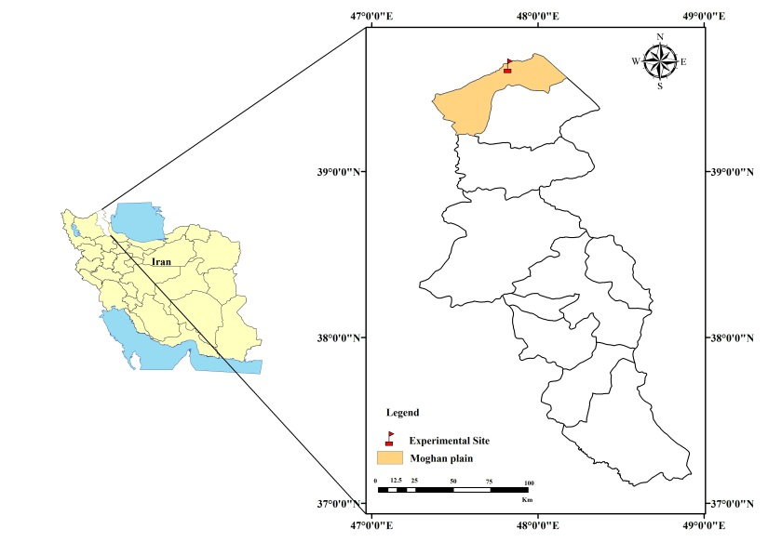
Fig. 1 Map of Iran showing location of experimental site

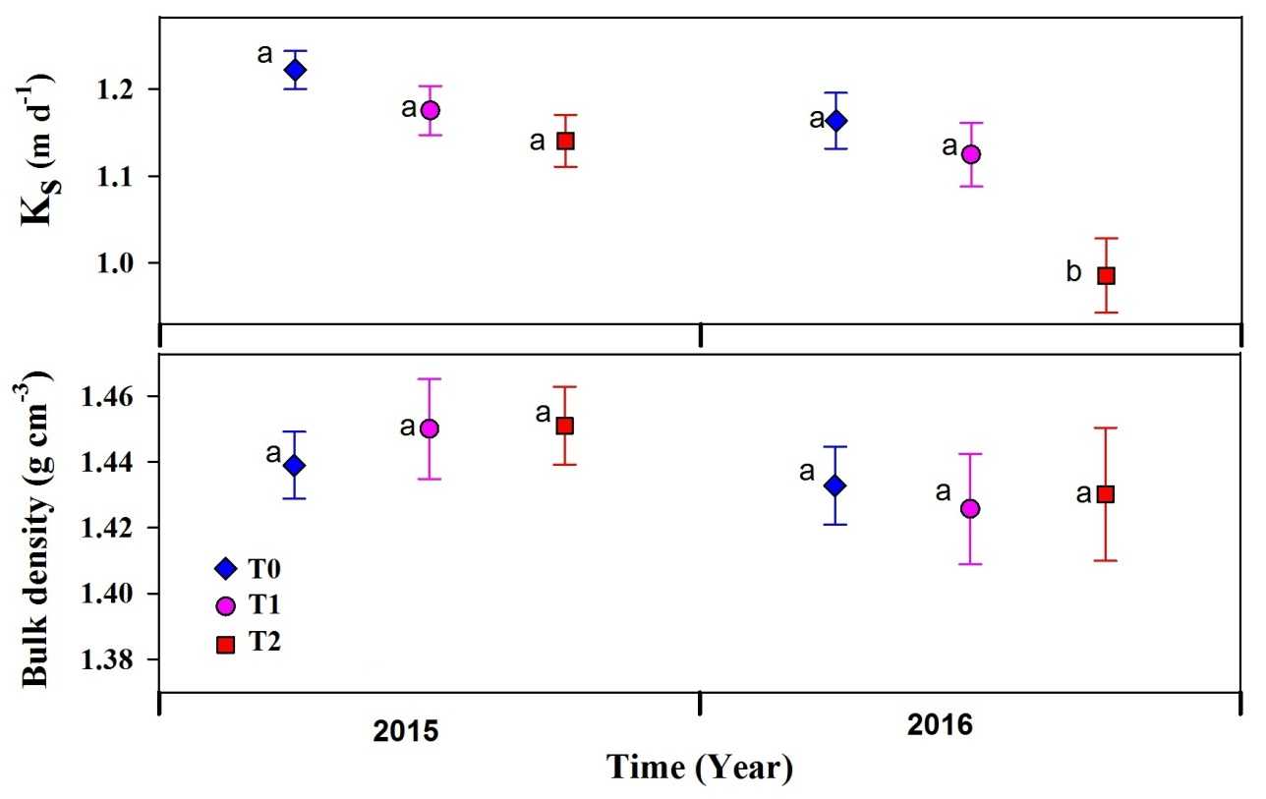
Fig. 2 Variation of bulk density and saturated hydraulic conductivity (K_{s}) (mean and ±SE values) for two years (same letter indicates no significant difference (p≤0.05)(T0 (Irrigation water only), T1 (50% drainage water +50% irrigation water) and T2 (drainage water only) treatments)
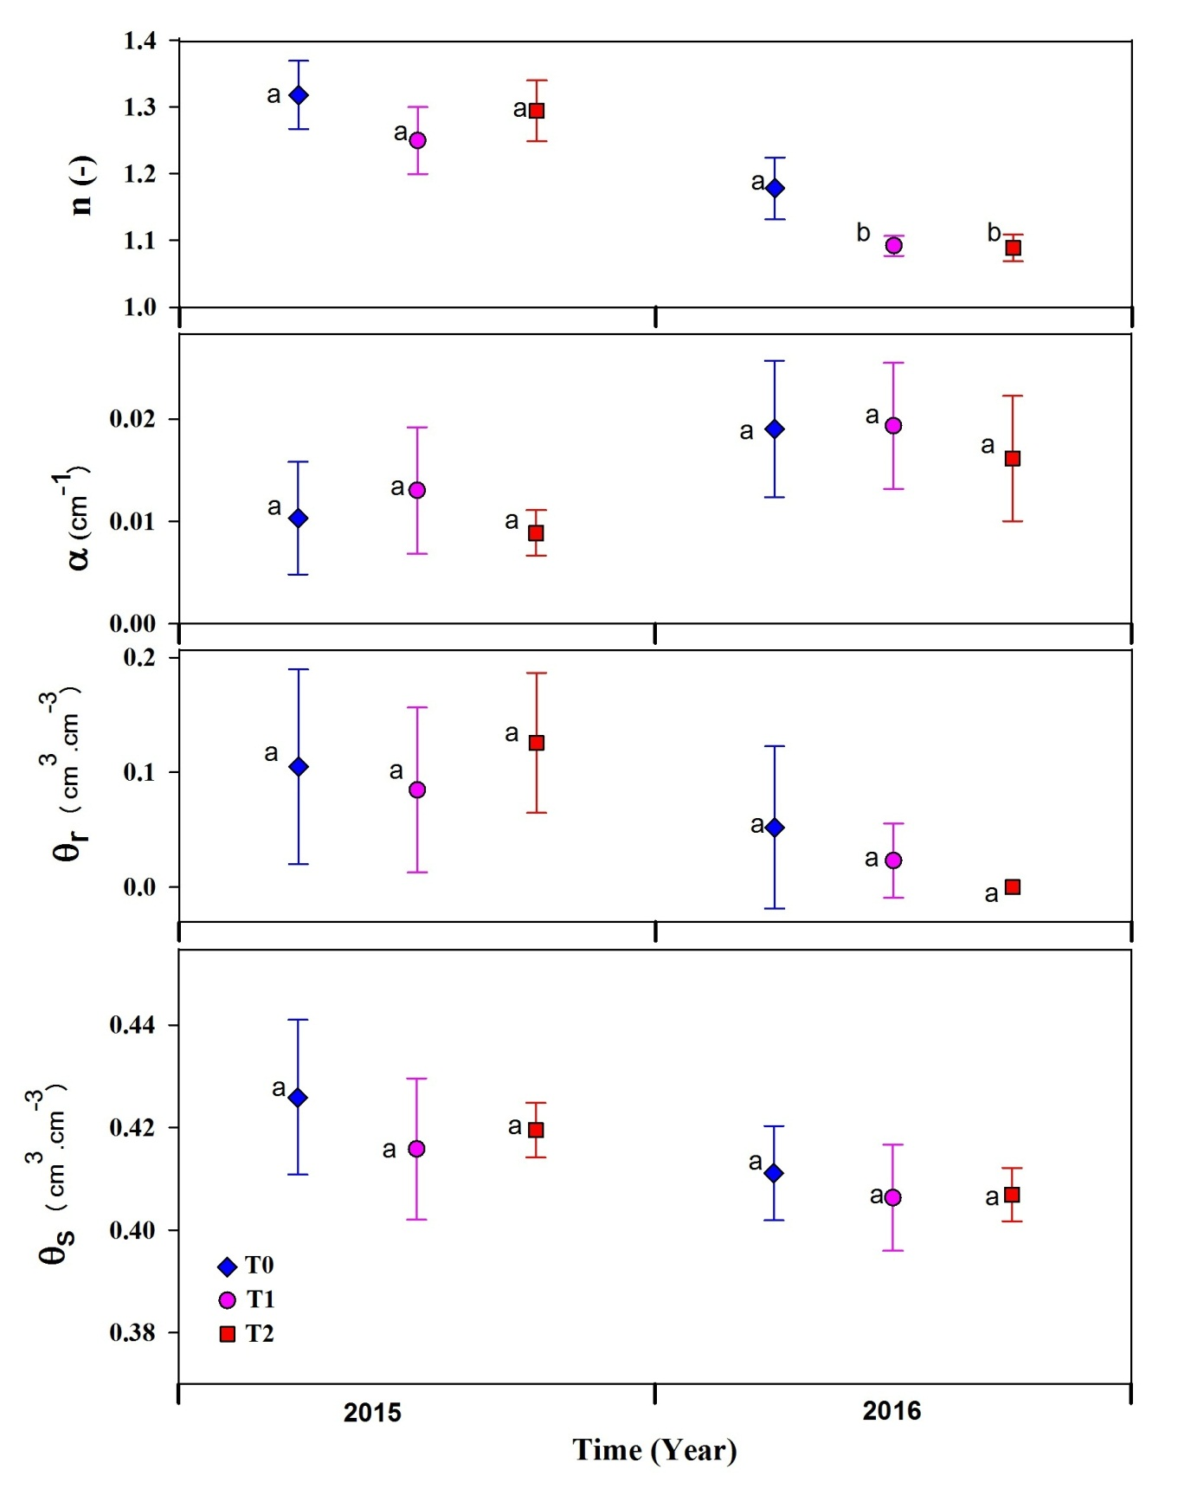
Fig. 3 Variation of van Genuchten’s retention function parameters (mean and ±SE values) for two years (same letter indicates no significant difference (p≤0.01) (T0 (Irrigation water only), T1 (50% drainage water +50% irrigation water) and T2 (drainage water only) treatments)

