Manuscript type: Original Research
Title: The effects of fertigation-applied sulfuric acid on phosphorus availability and some
microelements for greenhouse cucumbers
Running Title: Elements availability improved
Author: Hemn Othman Salih
Plant production Department, Khabat Technical Institute, Erbil Polytechnic University,
Erbil, Kurdistan Region, Iraq
Corresponding Author: hemn.salih@epu.edu.iq.
Novelty Statement:
- Low concentrations of sulfuric acid improve the elements availability?
- Adding low concentrations of sulfuric acid can decrease pH value then the elements are available.
- Availability of phosphorus and micronutrients (Fe, Zn, Cu, B and Mn) was improved by C4 (5 ml L-1).
- The concentration of the elements in plant tissues and yield increased.
- The work is related to soil chemistry and plant nutrition which is a scope of the journal.
ABSTRACT. Essential nutrient elements such as P, Fe, Zn, Cu, B and Mn are mostly affected by soil pH. In calcareous soils, it is often difficult to obtain a pH of 6-6.5 - the optimum soil pH value of phosphorus and micronutrients. In order to study the addition of different amounts of sulfuric acid through irrigation to minimize soil pH value, and to improve the availability of the elements on cucumbers, experiments were carried out on two types of soil textures: Silty Clay Loam SiCL (S1) and Silty Clay SiC (S2). The sulfuric acid was applied with different concentrations (0, 0.5, 1, 3, and 5 ml L⁻¹). The elements’ concentration was studied at three soil depths (D1=0-10, D2=10-20 and D3=20-30) cm. The availability of P and micronutrients primarily increased in C4D3 in S2 soil. The P in this work was a positive correlation with Zn in both soils, while it showed a negative correlation with other micronutrients (Fe, Cu, B and Mn). Element concentration in plant tissue was studied in the plant residues after harvesting. The C3 was highly effective in increasing the elements (P, Fe, Zn, Cu, B, and Mn) in plant tissues in both soils, and had a significant effect on the increase in cucumber yield.
Keywords: Fertigation; Sulfuric acid; phosphorus; Microelements availability; cucumber

Introduction
Cucumber (Cucumis sativus L.) is considered to be one of the most important vegetables and is a popular member of the Cucurbitaceae family (Renner et al., 2007). Most nutrients are recommended to be necessary to improve cucumber yield and product quality (Maboko et al., 2017). Among these nutrients, phosphorus (P) is deemed the most important macro element to the plant, as it is vitally connected to a number of functions in the plant including photosynthesis, energy transfer, respiration, and cell division (Esmail et al., 2019). Also, micronutrients contribute to numerous physiological processes. For example, iron (Fe) is a component of several enzymes involved in various biological processes including respiration and photosynthesis; zinc (Zn) is an important component of many enzymes, and a structural stabilizer of proteins and plant membranes; manganese (Mn) is an active component of the water-splitting system of photosystem II that supplies the electrons necessary for photosynthesis; copper (Cu) is a redox transition element with an important function in photosynthesis, respiration, and the metabolism of carbon (C) and nitrogen (N). Cu also induces protection against oxidative stress, and boron (B) participates in cell division, water relations, ion adsorption, the metabolism of carbohydrates, and the translocations of sugar and fruit (Ramírez-Pérez et al., 2017). Furthermore, the availability of these nutrients is mainly affected by soil type, in particular, calcareous soils due to a high pH value. Iraqi soils are categorized in this class of soil (Rate and Sheikh-Abdullah, 2017; Mam-Rasul, 2019).
Sheikh-Abdullah (2019) confirmed that active CaCO₃ negatively influences the availability of micronutrients such as Fe, Zn and Mn. Khorsandi (1994) stated that better P solubility occurs at a pH ranging between 6-6.5. Several methods have been reported to benefit a reduction in pH value and then increase nutrient availability; for example, adding sulfur to the soils then oxidation into H₂SO₄ results in increasing the availability of nutrients by reducing soil pH (Soaud et al., 2011). However, the direct use of sulfuric acid into the soil to minimize the pH value might be helpful to increase soil nutrient availability (Khorsandi, 1994). In Iraqi calcareous soils, the factor of adding sulfuric acid to improve nutrient availability has not been carried out; thus, this study aimed to add sulfuric acid at different concentrations to lower soil pH under plastic house conditions, and illustrate its impact on the growth and yield of cucumbers, as well as the availability of P, Fe, Zn, Cu, B and Mn.

Material and Methods
The experiments were conducted at the Agricultural Research Station in Grdarasha (412 m, 36⁰07'10.44" N – 44⁰00' 50.52" E), about 4 km south of Erbil centre, and at Khabat Agricultural Technical Institute (246 m, 36⁰15'53.18" N – 43⁰39'21.28" E), 30 km west of Erbil centre, under plastic house conditions during the summer season of 2016 (Figure 1). The experiments were carried out to evaluate the impact of applying different concentrations of sulfuric acid directly to soils on P and certain micronutrients including Fe, Zn, Cu, B and Mn, and its effect on the growth and yield of the Rainbow variety of cucumber.
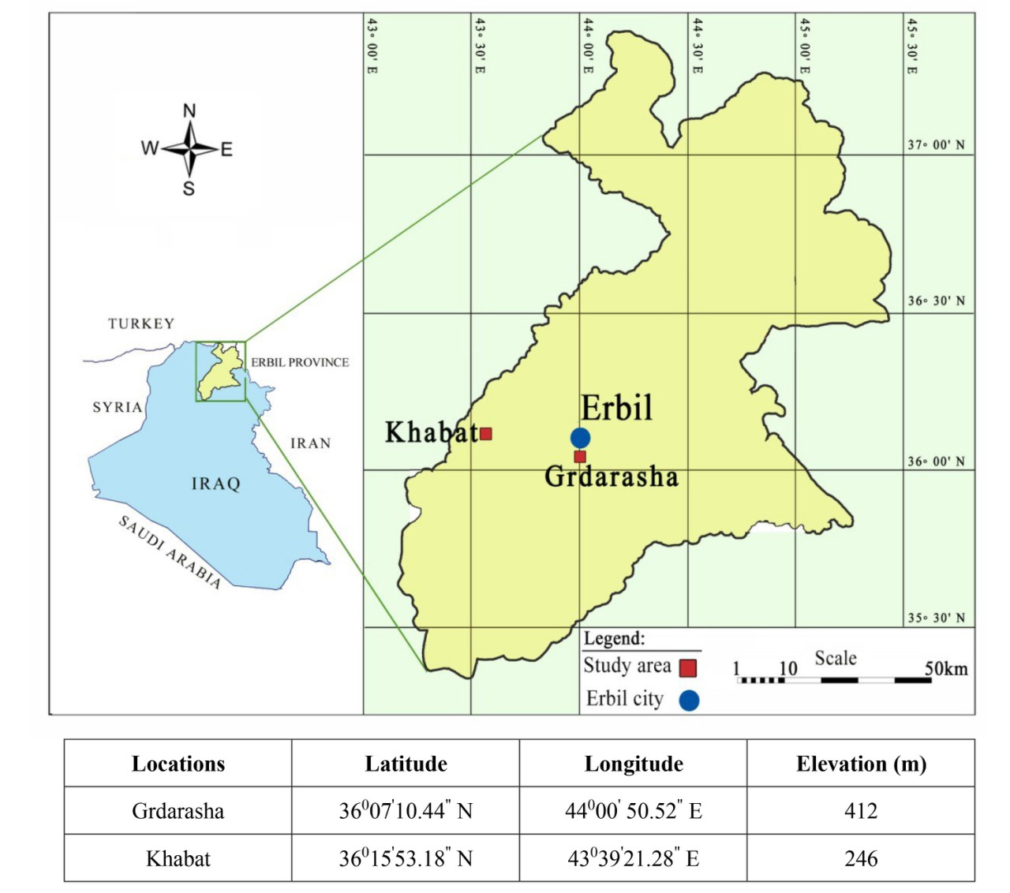
Figure1. The experiments location map.
At the site of the plastic houses, the land was prepared through ploughing, harrowing and levelling, and two samples from the site were taken (0-30 cm) to determine some of the chemical and physical properties of the soils under study (Table 1). Next, the experimental sites were shaped into mounds. Every experimental unit included a mound of 4m in length, and ten plants were cultivated in every mound with a spacing of 40cm between plants. Also, 75 cm was left between every experimental unit. Five concentrations of sulfuric acid (0, 0.5, 1, 3, and 5 ml L⁻¹) were applied into the soil surface for two types of soils. This was determined according to the USDA soil textural classification (Groenendyk et al., 2015), including Silty Clay Loam SiCL (S1) and Silty Clay SiC (S2), to the Grdarasha and Khabat soils, respectively. During the experiment, the crop was irrigated every two weeks; the total watering was eight times to avoid acid accumulation in the soil. The study took a chemical analysis of the soil at both locations (pH, P, Fe, Zn, Cu, B and Mn). The soils were sampled by end harvesting with an auger drill at three depths (0-10, 10-20, 20-30) cm. Also, the concentration of P, Fe, Zn, Cu, B and Mn in the plant was analysed by sampling the above-ground plant-parts at the end of harvest, in addition to the cucumber yield. Available Fe, Mn, Zn, and Cu contents of the soil samples were extracted with 0.005 M diethylenetriamine pentaacetic acid + 0.01 M CaCl₂ + 0.1 M triethanol amine, and the extractable elements were determined on an atomic absorption spectrophotometer as described by Lindsay and Norvell (1978). Furthermore, the plant samples were digested and prepared for total element determination by inductively coupled plasma–atomic emission spectrometry (Anderson and Henderson, 1986). In addition, the experiments were designed according to Factorial Randomized Completely Block Design (RCBD). In all cases, Tukey’s H.S.D multiple range tests were applied at (P ≤ 0.05) for comparison between the means of treatments using SPSS 25.0.

Table 1. Some physical and chemical properties of two soils before experiment
Parameter of  average soil | pH | EC dS m⁻¹ | Organic Matter gm kg⁻¹ | Total CaCO₃  gm kg⁻¹ | CEC cmol kg⁻¹ | Bulk Density  Mg m⁻³ | Texture name | PSD% |  |  | Fe | Zn | Cu | B | Mn
 |  |  |  |  |  |  |  | Clay | Silt | Sand
 |  |  |  |  |  |  |  |  |  |  | mg kg⁻¹
S1 | 8.10 | 0.60 | 8.70 | 340 | 22.20 | 1.20 | SiCL | 30.20 | 57.60 | 12.20 | 7.50 | 2.50 | 1.20 | 4.54 | 2.58
S2 | 7.9 | 1.60 | 9.20 | 280 | 24.10 | 1.40 | SiC | 44.30 | 49.30 | 6.40 | 8.40 | 3.20 | 1.10 | 4.85 | 2.30
Parameter of  average soil | Concentration mmol_{c} L⁻¹ |  |  |  |  |  |  | P mg kg⁻¹ | N % | Mg²⁺/Ca²⁺ | Na⁺/Ca²⁺ | RSC | SAR
 | Ca²⁺ | Mg²⁺ | Na⁺ | K⁺ | Cl⁻ | HCO₃⁻ | SO₄²⁻
S1 | 2.75 | 1.92 | 1.39 | 0.12 | 1.20 | 2.08 | 2.85 | 4.15 | 0.16 | 0.69 | 0.50 | -3.59 | 0.91
S2 | 6.28 | 3.80 | 4.08 | 0.14 | 1.28 | 4.23 | 8.10 | 7.80 | 0.20 | 0.60 | 0.65 | -5.85 | 1.82
EC (Electrical conductivity), CEC (Cation Exchange Capacity) S1 (Silty Clay Loam), S2 (Silty Clay), RSC (Residual sodium carbonates), SAR (Sodium adsorption ratio).

Results
Soil Properties
The results showed the significant effects of sulfuric acid levels at the end of the growing season for both soils at different soil depths in reducing pH in the soil solution. The fourth concentration of sulfuric acid and a 0-10 cm soil depth had a greater decrease of soil pH value compared to other the treatments. As a result, the availability of phosphorus was primarily increased, in particular, by a 5ml treatment of sulfuric acid and 20-30 cm depths for both soils (Figure 2).
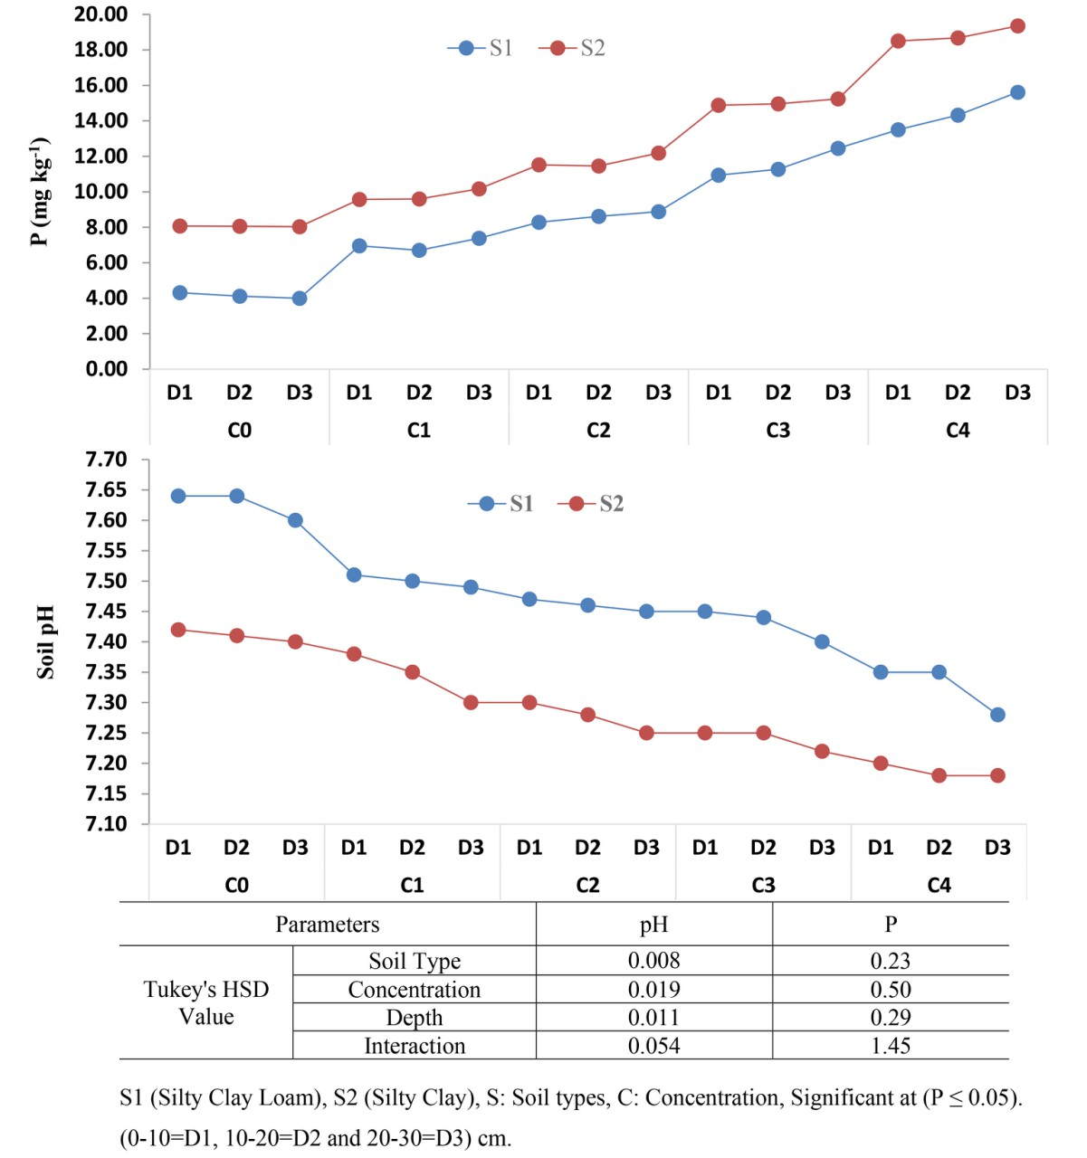
Figure 2. Effect of sulfuric acid concentrations on pH and phosphorus availability in two different soils and three depths.
Furthermore, the maximum concentration of micronutrients (Fe, Zn, Cu, B and Mn) was obtained by the fourth concentration of sulfuric acid and the third depth of soil in both experiments compared to other treatments. On the other hand, better results for the concentration of micronutrients was obtained in Khabat soils due to the high content of clay particles, particularly in the fourth concentration of the sulfuric acid and the third depth of the soil (Figure 3).
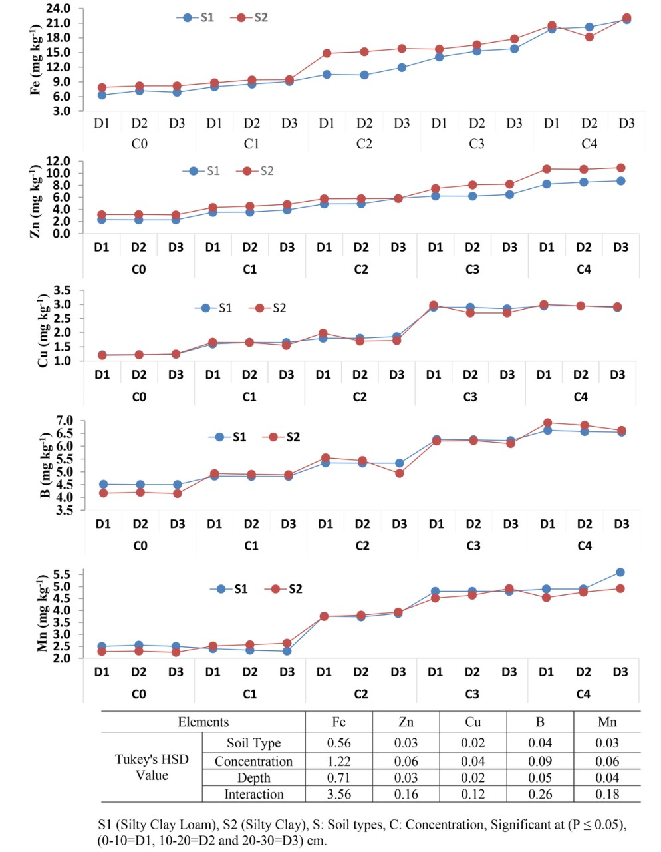
Figure 3. Effect of different sulfuric concentrations on micronutrient availability in two soils.

Element concentration in plant tissue and cucumber yield
The best result for phosphorus, Fe, Zn, Mn, Cu and B in the cucumber stem after harvesting was obtained by the fourth concentration (3 ml L⁻¹), as this concentration showed statistically significant (P ≤ 0.05) effects in increasing the number of elements in the plant stem tissues. The amount of Cu, Fe, B, Mn and Zn in the leaves increased (Figure 4) with a decrease in pH in treatments, particularly the fourth factor as well as P concentration (Figure 5).
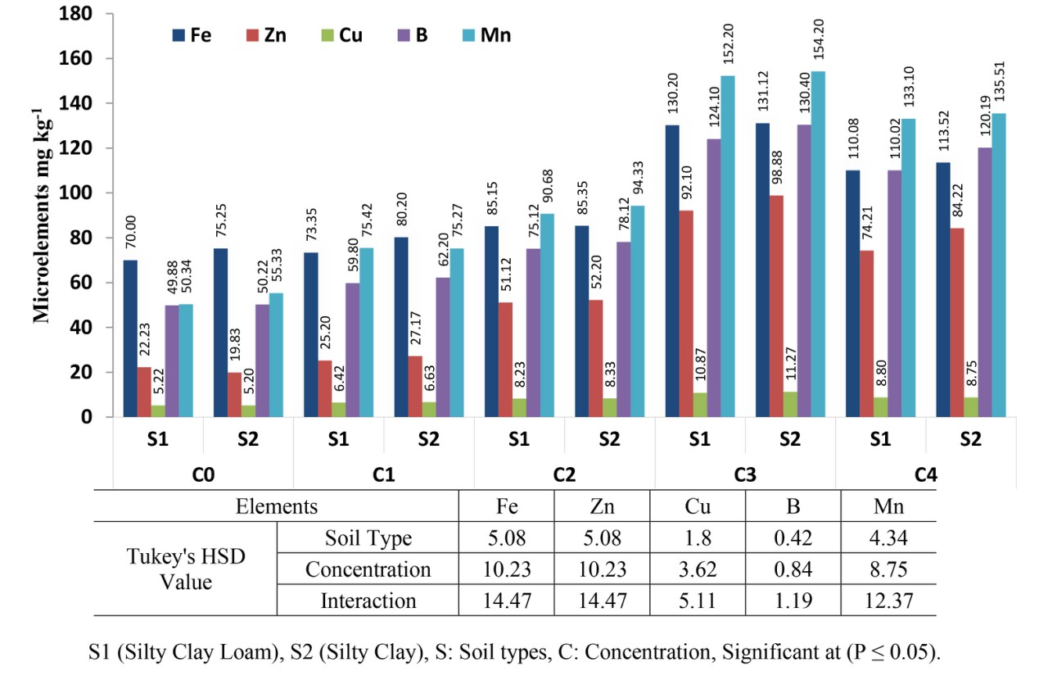
Figure 4. Response of micronutrients in plant tissues by different concentrations of sulfuric acid in two soils.
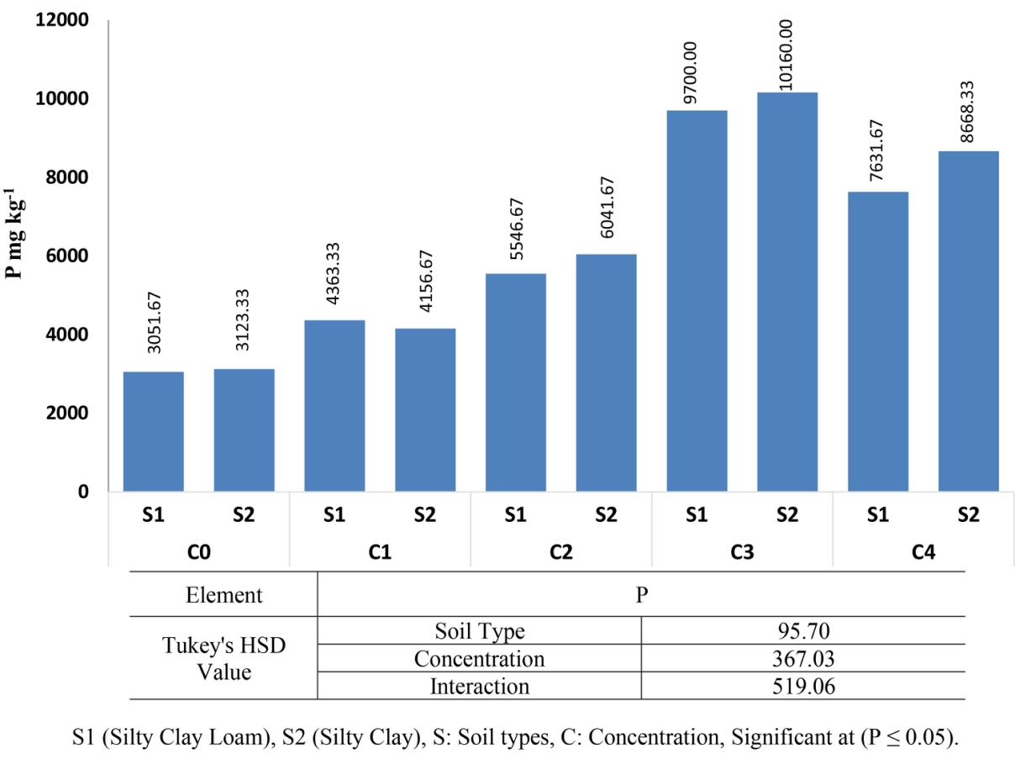
Figure 5. Response phosphorus in plant tissues by different concentrations of sulfuric acid in two soils.

In addition, the fourth concentration of sulfuric acid (P ≤ 0.05) had a statistically significant impact on the yield (158.22 t ha⁻¹) of the cucumber plant (Figure 6).
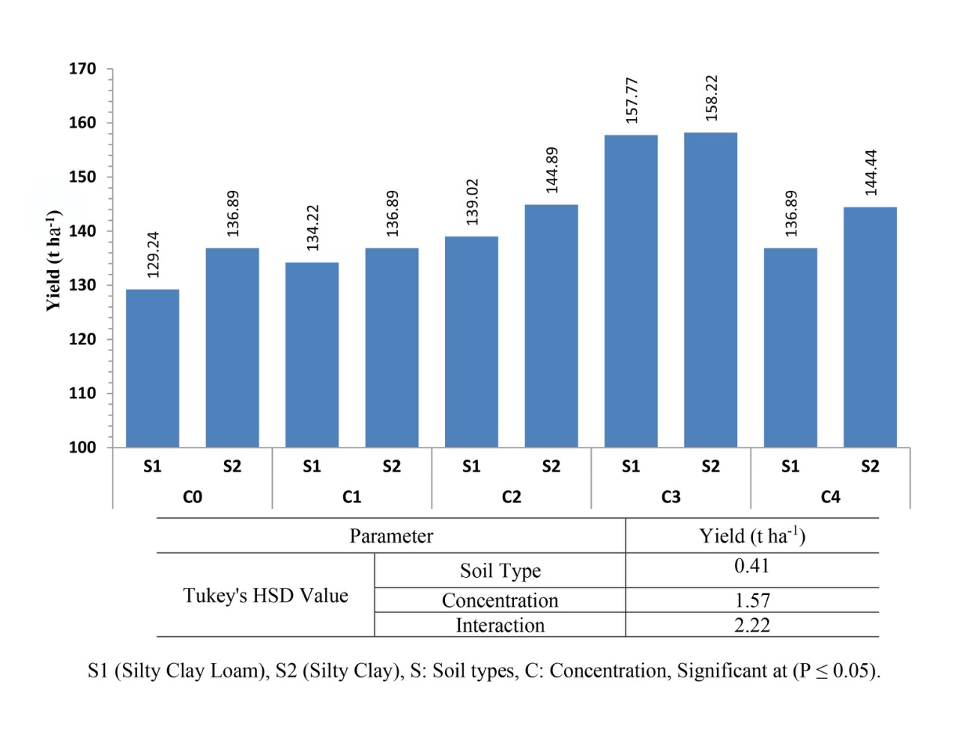
Figure 6. Effect of different concentrations of sulfuric acid on cucumber yield in the two soils.
Discussion
Soil Properties
The calcite amount in the soil was diminished, possibly due to the dissolution of the lime by acid. This emphasized that the application of acid to calcareous soils dramatically decreases the pH value of the soil as a result of neutralizing soil CaCO₃. A very low soil pH is obtained as the sulfuric acid results in a low pH in the soil solution. As a result, some of the phosphate compounds are dissolved, then the available phosphorus is released (Singh and Reddy, 2011). In addition, Sumner and Yamada (2002) found that soil acidification results in increasing the concentration of some nutrient elements in the soil solution, particularly phosphorus.
It is commonly known that there is a direct relationship between soil pH and CaCO₃ in soil. When a high concentration of sulfuric acid was added to the soils, the pH tended to an extremely low value, then the activity of CaCO₃ was diminished. After the active carbonate calcium was restricted, most of the micronutrients are available. Sheikh-Abdullah (2019) found a negative correlation between the availability of Fe, Zn and Mn, and CaCO₃ activity. Then, the rate of micronutrients markedly increased. In soil with a low pH, most micronutrients are at their peak availability; this is probably due to the strong attraction of H⁺ ions to the negative site on the surface of the soil particles, which is then sufficiently replaced by other cations. Consequently, these cations are released to the soil solution obtaining better availability (Maruf and Mam Rasul, 2019). In addition, Ghehsareh and Samadi (2012) found that acidification of soil can result in the dissolution of soil minerals, particularly microelement minerals.
In addition, the correlations between P and micronutrients were varied (Figure 7). The P in this work was a positive correlation with Zn in both soils, while it showed a negative correlation with other micronutrients (Fe, Cu, B and Mn). In contrast, the work of (Ali et al., 2014) showed different results, as Zn, Cu and B decrease with an increase in P concentration in the soil, whereas Fe and Mn showed a positive correlation.
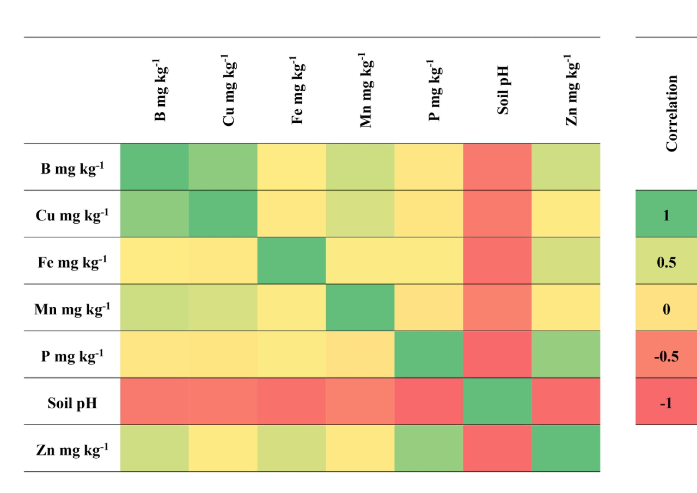Figure 7. Heat map of Pearson correlation coefficients between available forms of micronutrients and phosphorus of the studied soil at 0-10, 10-20 and 20-30 cm.
Besides soil pH as a factor that affects micronutrient availability, soil texture is also deemed an important feature that influences the nutrient elements (Bajgiran, 2013). However, finer-textured clay soils often display more concentrations of micronutrients and can endure higher pH compared to sandier soils (Shuman, 1986). Silva et al. (2019) explained that soils with a sand texture contain the lowest Fe, Mn, Zn, and Cu, and the researchers stated that the average content of micronutrients in these soils was 4-10 times lower than those of clay loam and loam texture soils at 0.00-0.20 m layer. In addition, Najafi-Ghiri et al. (2013) in their work on the availability of micronutrients in calcareous soil found that a better content of clay in the soil showed preferable concentrations of micronutrients. These cations exist in the soil solution and can bind to negative charges of clay minerals by external sphere (ion exchange) or internal sphere (specific adsorption) bonds (Silva et al., 2019).
In calcareous soils at both locations, a high level of active lime can result in the release of calcium carbonate to the soil solution, which causes an increase in soil pH. As a result, the iron element is precipitated, as iron hydroxide is formed in the soil and is unavailable to be absorbed by the plants. In addition, increasing soil pH can reduce available Cu concentration due to the precipitation of the element as Cu(OH)₂. However, the available form of Mn mainly depends on dissolving manganese compounds in soil, which occurs under low soil pH. Also, soil microorganisms, which influence the availability of manganese reduction, rely markedly on soil pH, and the optimum value of pH for soil microorganism activity is around 7. Furthermore, the sharp decrease in Zn concentration above pH 7 appears to be the result of the decreased concentration of Zn²⁺ species and the increase in hydrolysed forms of Zn(OH)⁺ and Zn(0H)₂ (Metwally et al., 1993).
Soil Textures
Micronutrient concentration was higher at soil type S2, which contains a higher clay content. It was observed that soils with a high clay content have greater adsorptive capacities and higher bonding energies for micronutrients (Chukwuma et al., 2010). In addition, Rengel (2015) confirms that micronutrients (Fe, Zn, Cu and Mn) have better availability with a relatively higher proportion of clay. Furthermore, the availability of B is greater with higher clay content in the soil, and the mechanism of the B adsorption step is considered to be ligand exchange with surface hydroxyl groups on the clay’s particle edges. Therefore, additions of B could be made without it becoming toxic to plants because of a high adsorption capacity (Steiner and Lana, 2013).

Element concentration in plant tissue and cucumber yield

The acidification of soil might cause an increase in the dissolution of minerals containing microelements. Also, the absorbance of B by plants in H₃BO₃ form, and an increase in soil pH, can result in the dissociation of H₃BO₃ and transformation into H₂BO₃ form (Barber, 1995); finally, the availability of boron to the plants would be decreased. As a result, the B uptake is decreased by increasing the pH of the soil solution. However, in this work, the concentration of micronutrients in cucumber leaves was similar to the study of Kreij et al. (1992). Therefore, it seems that soil acidification to a pH range of about 5.5 improved the provision of micronutrients for cucumber plants. (Fageria, 2012) also explained that a decrease in pH of irrigation water caused an increase in micronutrient uptake. Ghehsareh and Samadi (2012) in their work on corn found that an increase of phosphorus uptake by the crop was obtained by acidifying irrigation water in the corn plantation.
As the availability of microelements and their uptake to the plant are improved by reducing the pH value, the yield is noticeably enhanced. The improvement of this parameter is probably due to an increase in the amount of chlorophyll in the leaves, which results from a decrease in alkalinity. Moreover, the highest amount of chlorophyll in leaves can be obtained from plant leaves in an acidic media, as the amount of chlorophyll in leaves can be an important index in determining the rate of photosynthesis (Duchovskis et al., 2006). Also, gains in high yields and good quality of cucumber depend on a convenient supply of macro- and microelements into the plant. Nutrient deficiency, particularly microelements, in plants can cause a deterioration in plant resistance to detrimental environmental factors: declining yields and quality can occur (Rutkowska et al., 2014). However, the most important nutrients for cucurbits, especially cucumber, which are mainly affected by soil pH are P and micronutrients in the soil (Mousavi et al., 2011). As a result, the pH for cucumber production is managed at 5.5–6.5, levels ordinarily used for plant production, and it has been observed that a target pH of 7.0 resulted in a 9.5% increase in the growth rate compared to the 5.0 treatment when the soil was acidified with an acid to manage the pH value (Blanchard et al., 2020).
Conclusion
Soil pH values noticeably were decreased by the addition of a low concentration of sulfuric acid. The values of soil pH were regularly decreased by increasing sulfuric acid (ml L⁻¹). The lowest soil pH was obtained by C4 (5 ml L⁻¹). The availability of phosphorus and micronutrients (Fe, Zn, Cu, B and Mn) was markedly improved by C4 (5 ml L⁻¹), and their concentration in plants were also improved particularly in (S2). As the acid reduces the soil pH temporarily, it would be useful for the elements to be adsorbed by the plant. Consequently, cucumber yield is enhanced, particularly in calcareous soils that have a higher soil pH that restricts the availability of most elements, especially phosphorus.

Acknowledgements
This research did not receive any specific funding.

References
Ali, F., A. Sadiq, I. Ali, M. Amin and M. Amir, 2014. Effect of applied phosphorus on the availability of micronutrients in alkaline-calcareous soil. Environ. Earth Sci. 4: 143-147.
Anderson, D.L. and L.J. Henderson, 1986. Sealed chamber digestion for plant nutrient analysis. Agronomy J. 78: 937-939.
Bajgiran, A.R. 2013. Influence of Soil Amendments and Soil Properties on Macro–and Micronutrient Availability to Microorganisms and Plants. Swedish University of Agricultural Sciences, Uppsala.
Barber, S.A., 1995. Soil Nutrient Bioavailability. 2 ed. John Wiley and Sons, New York, USA.
Blanchard, C., D.E. Wells, J.M. Pickens and D.M. Blersch, 2020. Effect of pH on cucumber growth and nutrient availability in a decoupled aquaponic system with minimal solids removal. Horticulturae 6.
Chukwuma, M.C., E.T. Eshett, E.U. Onweremadu and M.A. Okon, 2010. Zinc availability in relation to selected soil properties in a crude oil polluted eutric tropofluvent. Int. J. Environ. Sci.Technol. 7: 261-270.
Duchovskis, P., A. Brazaitytė, R. Juknys, I. Januškaitienė, A. Sliesaravičius, A. Ramaškevičienė, N. Burbulis, J. B. Šikšnianienė, K. Baranauskis, L. Duchovskienė, V. Stanys and C. Bobinas. 2006. Changes of physiological and genetic indices of Lycopersicon esculentum mill. by cadmium under different acidicity and nutrition. Pol. J. Environ. Stud. 15: 235-242.
Esmail, A.O., S.M. Sheikh-Abdullah and M.T. Maruf, 2019. Phosphorus availability in entisols, inceptisols, and mollisols of Iraqi Kurdistan. Soil Sci. 184: 95-100.
Fageria, N.K., 2012. Role of soil organic matter in maintaining sustainability of cropping systems. Commun. Soil Sci. Plan. 43: 2063-2113.
Ghehsareh, A.M. and N. Samadi, 2012. Effect of soil acidification on growth indices and microelements uptake by greenhouse cucumber. Afr. J. Agric. Res. 7: 1659-1665.
Groenendyk, D.G., T.P. Ferre, K.R. Thorp and A.K. Rice, 2015. Hydrologic-Process-Based soil texture classifications for improved visualization of landscape function. PLoS One 10.
Khorsandi, F., 1994. Sulfuric acid effects on iron and phosphorus availability in two calcareous soils. J. Plan. Nutr. 17: 1611-1623.
Kreij, D.C., C. Sonneveld, M.N. Warmenhoven and N. Straver. 1992. Guide Values for Nutrient Element Contents of Vegetables and Flowers Under Glass. 3 ed., Naaldwijk, Aalsmeer, Netherlands
Lindsay, W.L. and W.A. Norvell, 1978. Development of DTPA micronutrient soil test for zinc, iron, manganese and copper. Soil Sci. Soc. Am. Proc. 42: 421-428.
Maboko, M.M., C.P. Du Plooy and S. Chiloane, 2017. Yield and mineral content of hydroponically grown mini-cucumber (Cucumis sativus L.) as affected by reduced nutrient concentration and foliar fertilizer application. HortScience 52: 1728-1733.
Mam-Rasul, G.A., 2019. Zinc sorption in calcareous soils of the Kurdistan Region of Iraq. Soil Sci. 184: 60-68.
Maruf, M.T. and G.A. Mam Rasul, 2019. Effect of humic acid and sulfur fertilizer levels on some physiological traits of maize (Zea mays L.) on calcareous soil. Appl. Ecol. Environ. Res. 17: 13199-13217.
Metwally, A.I., A.S. Mashhady, A.M. Falatah and M. Reda, 1993. Effect of pH on zinc adsorption and solubility in suspensions of different clays and soils. Zeitschrift für Pflanzenernährung und Bodenkunde 156: 131-135.
Mousavi, S.R., M. Shahsavari and M. Rezaei. 2011. A General overview on manganese (Mn) importance for crops production. Aust. J. Basic Appl. Sci. 5: 1799-1803.
Najafi-Ghiri, M., R. Ghasemi-Fasaei and E. Farrokhnejad, 2013. Factors affecting micronutrient availability in calcareous soils of southern Iran. Arid Land Res Manag. 27: 203-215.
Ramírez-Pérez, L., A. Morales-Díaz, K. de Alba-Romenus, S. González-Morales, A. Benavides-Mendoza and A. Juárez-Maldonado, 2017. Determination of micronutrient accumulation in greenhouse cucumber crop using a modeling approach. Agronomy 7.
Rate, A.W. and S.M. Sheikh-Abdullah, 2017. The geochemistry of calcareous forest soils in Sulaimani Governorate, Kurdistan Region, Iraq. Geoderma 289: 54-65.
Rengel, Z., 2015. Availability of Mn, Zn and Fe in the rhizosphere. J. Soil Sci. Plant Nutr. 15: 397-409.
Renner, S.S., H. Schaefer and A. Kocyan, 2007. Phylogenetics of Cucumis (Cucurbitaceae): cucumber (C. sativus) belongs in an Asian/Australian clade far from melon (C. melo). BMC Evol. Biol. 7: 58.
Rutkowska, B., W. Szulc, T. Sosulski and W. Stępień, 2014. Soil micronutrient availability to crops affected by long-term inorganic and organic fertilizer applications. Plan. Soil Environ. 60: 198-203.
Sheikh-Abdullah, S.M., 2019. Availability of Fe, Zn, Cu, and Mn in soils of Sulaimani Governorate, Kurdistan Region, Iraq. Soil Sci. 184: 87-94.
Shuman, L.M., 1986. Effect of liming on the distribution of manganese, copper, iron, and zinc among soil fractions. Soil Sci. Soc. Am. J. 50: 1236-1240.
Silva, R.d.C.F.d., F.B.V.d. Silva, C.M. Biondi, C.W.A.d. Nascimento and E.C.A.d. Oliveira, 2019. Assessing the content of micronutrients in soils and sugarcane in different pedogeological contexts of northeastern Brazil. Rev. Bras. Ciênc. Solo 43.
Singh, H. and M.S. Reddy, 2011. Effect of inoculation with phosphate solubilizing fungus on growth and nutrient uptake of wheat and maize plants fertilized with rock phosphate in alkaline soils. Eur. J. Soil Biol. 47: 30-34.
Soaud, A.A., F.H. Al Darwish, M.E. Saleh, K.A. El-Tarabily, M. Sofian-Azirun and M.M. Rahman, 2011. Effects of elemental sulfur, phosphorus, micronutrients and Paracoccus versutus on nutrient availability of calcareous soils. Aust. J. Crop Sci. 5: 554-561.
Steiner, F. and M.d.C. Lana, 2013. Effect of pH on boron adsorption in some soils of Paraná, Brazil. Chil. J. Agric. Res. 73: 28-29.
Sumner, M.E. and T. Yamada, 2002. Farming with acidity. Commun. Soil Sci. Plan. 33: 2467-2496.

