Bioactive Content and Anticancer Bioactivity of MCF-7 Cell on Smadan root Extract From Bitung City Forest North Sulawesi

Amanda Gratia Karundeng^{1,*}, Revolson Mege², Mokosuli Yeremia Semuel²
¹Magister Biology Program, Faculty of Mathematics, Natural and Earth Sciences, Manado State University, Tondano, Indonesia
²Department of Biology, Faculty of Mathematics, Natural and Earth Sciences, Manado State University. Tondano, Indonesia.
*Corresponding Author: amandakarundeng3@gmail.com
Received _______________; Accepted _______________; Published _______________

Novelty statement
Smadan roots from North Sulawesi have their own morphology which can be differentiated from Bajakah roots from Kalimantan. The bioactive content and anticancer activity of Smadan roots have never been studied. This research is the first to be carried out and the results are that Smadan roots contain strong bioactive and cytotoxic activity to prevent and kill breast cancer cells (MCF-7).

Abstract
Cancer is a disease with the second largest death rate in the world. Cancer Prevalence has continued to increase in the last decades. The aim of this research was to determine the bioactive content and anticancer bioactivity of michigan cancer foundation-7 (MCF-7) in Smadan root (Spatholobus Littoralis Hassk) extract from the Bitung city forest, North Sulawesi. The bioactive content was analyzed using the high performance liquid chromatography (HPLC) method, total flavonoids were determined using ultraviolet and visible light spectrophotometry, while the anticancer activity was tested in vitro on MCF-7 cell cancer (breast cancer cells). The results of the high performance liquid chromatography analysis research showed that 26 compounds were at a wavelength of 254 nanometer, while 37 compounds were at a wavelength of 310 nanometer. The total flavonoid content of dry Smadan root extract was 62.66 mgQE/gram while the wet extract was 14 mgQE/gram and the cytotoxic activity of Smadan root extract had IC₅₀ = 50.12 µg/mL. These results indicate that Smadan root extract has strong cytotoxic. Thus, the ethanol extract of smadan roots has the potential to be developed as a source bioactives and drug of anticancer that can help the people of the world in curing cancer.

Keywords: Anticancer; Bioactive content; MCF-7; Smadan root.

Introduction
Indonesia is a megabiodiversity country. There are various endemic species of flora and fauna. Indonesia is also known as a country that has an ethnomedical and ethnobotanical culture (Kaunang and Mokosuli, 2017; Rahmawaty et al., 2019). The use of plants and animals as bioactive sources for the treatment of various types of diseases is carried out by many tribes in Indonesia and is passed down from generation to generation (Mokosuli et al., 2019). Indonesia has an abundance of medicinal plants (Ansori and Solikhah, 2021). Medicinal plants originating from forests currently have a very important role for society and globally (Kaunang and Mokosuli, 2017; Rahmawaty et al., 2019). The medicinal plants used can lead to the discovery of new drugs that have the potential to treat diseases that are considered difficult to cure (Ansori and Solikhah, 2021; Roy et al., 2022). Cancer is a chronic disease with the second highest prevalence of death in the world (Rakhmanovna, 2022).
The World Health Organization (WHO) states that cancer is one of the main causes of death throughout the world. Around 8.2 million people die from cancer (Joya et al., 2020). Based on the number of cases and deaths due to cancer until 2018, 18.1 million cases and 9.6 million deaths in 2018 are data from the Global Burden of Cancer released by WHO (Pangribowo, 2019). Breast cancer is the most common cancer in women (Rabiee et al., 2023). The incidence rate is still increasing in Asia (Choi et al., 2023). Breast cancer is a serious disease faced by the world and Indonesia (Jumaryatno et al., 2022; Shaluhiyah and Surjoputro, 2023). Breast cancer is one of the types of cancer that has the highest prevalence in the world (Coelho et al., 2023; Kurniawati, 2023; Hasnita and Meiriza, 2023). Based on data from the World Health Organization in 2020, 2.1 million women were diagnosed with breast cancer and this cancer cannot be underestimated (Qodria and Nur, 2020).
Cancer treatment also currently has major obstacles because side effects have a big impact on cancer sufferers, so that treatment based on ethnomedical culture is one of the treatments used by cancer sufferers, namely medicinal plants that have the potential to be anticancer or cytotoxic to cancer cells. In developing countries, plants from nature are used as natural sources to maintain public health. Traditional medicine is now used as alternative medicine because it is considered safer and has fewer side effects (Wahid and Raudah, 2022). The bioactive content in plants has antioxidant properties that can prevent cancer. Bioactive compounds can prevent cells from mutating into cancer cells (Nurtiana and Budijanto, 2017). Available therapies for cancer treatment have major hurdles (Jagdale et al., 2023). Currently the treatment that cancer patients can undergo is chemotherapy, radiology, immunotherapy and in general surgery, however, this treatment can have side effects that have a very big impact on cancer patients, namely hair loss, neurological disorders, bone marrow suppression and so on (Zein and Hazar, 2022), so there is a need for more treatment strategies and drugs for the survival and quality of life of cancer patients (Malacrida et al., 2023; Li et al., 2023). For this reason, the use of natural ingredients will be better (Roy et al., 2022), namely plants that have the potential to kill cancer cells.
The city of Bitung has medicinal plants that are used by the community as traditional medicine to cure cancer cells, namely what is known as Smadan root. When the Smadan root is cut first, it will produce clear water. It is used by the community of Bitung City as a substitute for drinking water and is believed to have the property of increasing the body's immune system. Stew Smadan roots, the water is dark red. Local wisdom: Local people generally consume water boiled from Smadan roots to keep the body healthy and to cure various diseases. Smadan roots originating from the city of Bitung are empirically believed to have anticancer and antitumor activity, but have never been studied scientifically.
The roots of Smadan have many similarities with Bajakah in the Kalimantan area or in Latin Spatholobus Littoralis Hassk (Sianipar et al., 2023). Bajakah plants originate from remote areas in Kalimantan Province which have not spread to other areas (Iskandar, 2020). However, in the city of Bitung there is a bajakah plant or Smadan root which has long been known by the public not as bajakah but Smadan root. This plant is found very widely in the forests of Bitung city, and also in several places in the North Sulawesi region. However, with the acceleration of development and population growth, many forest areas that are the home of Smadan's roots have changed their function to plantations and/or housing areas, so their sustainability needs to be maintained. In previous research, bajakah roots in the Kalimantan area have been studied by researchers and it has been proven that they contain anticancer properties (Zein and Hazar, 2022; Syarifah et al., 2019; Iskandar et al., 2022), which contain secondary metabolite compounds, namely alkaloids, flavonoids, terpenoids and phenolics (Zein and Hazar, 2022). However, the north Sulawesi area is different from the Kalimantan area. The content of chemical compounds in plants also depends on the environment in which the plant grows (Fitriani et al., 2020).
Smadan roots from North Sulawesi also have their own morphology which can be differentiated from Bajakah roots from Kalimantan. To prove the similarities and differences, they need to be tested scientifically. The aim of this study was to examine the bioactive content and anticancer activity of MCF-7 in Smadan root extract from Bitung city forest, North Sulawesi.
Methods
Sample
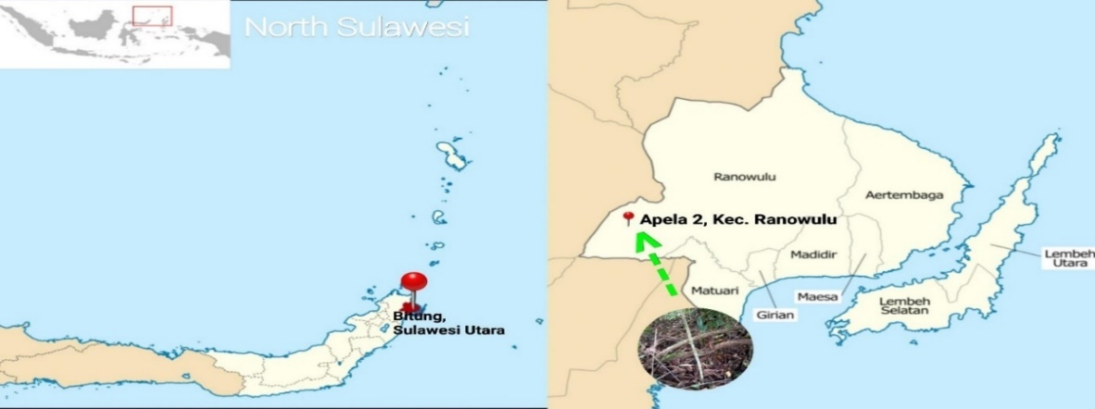
Smadan root samples were taken in the forest of Apela Dua urban village, Ranowulu sub-district, Bitung city, North Sulawesi.
Fig 1: Smadan root sampling location in Apela Dua urban village, Ranowulu district, Bitung city, North Sulawesi.
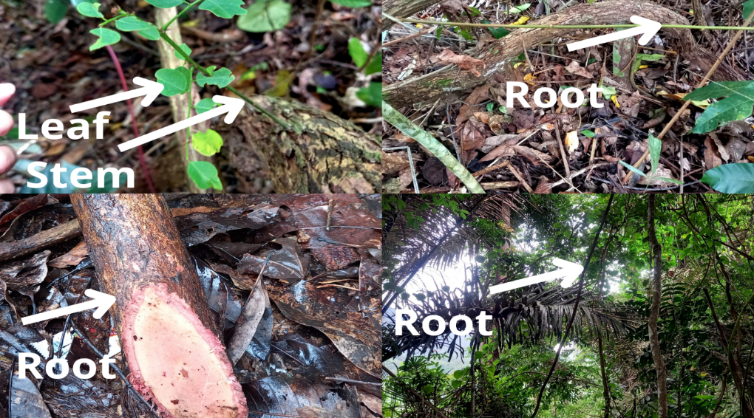
Fig 2: Roots, stem and leaves of Smadan from Apela dua sub-district, Ranowulu sub-district, Bitung city, North Sulawesi (Personal Documentation).

Research procedure
This research was carried out in several stages: Making simplicia and extraction, testing the bioactive content using the HPLC method, testing the total flavonoid content using UV-Vis Spectrophotometry and testing the anticancer cytotoxic activity of MCF-7. Extraction and testing of total flavonoid content of Smadan root was carried out at the Biology Laboratory, Manado State University and the cytotoxic test on MCF-7 cancer cells as well as the bioactive content test using the HPLC method was carried out at the Central Laboratory of Padjadjaran University in 2023.
Making Simplicia and Extraction
The Smadan root samples that have been taken are cleaned first, then finely cut into dry samples and wet samples. The dry samples are oven-treated for 60 minutes. The wet samples are not oven. Both samples were blended separately until smooth. When the samples were smooth, the two samples were weighed at 100 gr each and put into different jars to enter the maceration stage and 400 ml of 95% ethanol was added to both. Ratio 1:4 to macerate for 3 days. Samples that had been macerated for 3 days were filtered using filter paper. After that, it goes to the evaporation stage (changing the solvent into steam) to get a thick extract from Smadan root extract.
Bioactive Content Testing HPLC Method
The use of the HPLC (High Performance Liquid Chromatography) method on Smadan root extract (dry samples) which was tested at the Central Laboratory of Padjadjaran University to analyze its bioactive content.The working principle of HPLC is to separate analyte components based on their cappolarity and any mixture that comes out will be detected with an existing detector and recorded in the form of a chromatogram. The steps involved weighing 100 mg of the Smadan root ethanol extract sample to be used, then dissolving it with 2 ml of air and 8 ml of methanol, then sonicating it for 10 minutes. After that, filtered with a 0.45 Ul millipore and put 1 ml into an HPLC vial. Solution ready injected.
Flavonoid Content Testing Using UV-Vis Spectrophotometry
a). Determination of the maximum wavelength of quarcetin
To determine the maximum wavelength of kearcetin, the quercetin solution was analyzed in the wavelength range of 400-500 nm. The analysis results show that the maximum wavelength of the quercetin standard is 435 nm, which is used to measure the absorbance of the ethanol extract sample.
b). Making of a quercetin standard curve
In making the standard curve, 25 milligrams of standard quercetin was used and dissolved in 25 milliliters of ethanol. The stock solution was pipetted at 1 milliliter and then added up to 10 milliliters of ethanol to reach a concentration of 100 ppm. Using a standard 100 ppm quercetin solution, several concentrations of quercetin were prepared: 6 ppm, 8 ppm, 10 ppm, 12 ppm, and 14 ppm. To each of these concentrations, 1 mL of 2% AICI3 was added and 1 mL of potassium acetate at 120 mM. Samples were incubated for 60 minutes at room temperature. The UV-Vis spectrophotometry method with a maximum wavelength of 435 nm was used to measure absorbance.
c). Measurement of total flavonoid levels
At the stage of measuring total flavonoid levels, 15 mg of Smadan root extract was dissolved in 10 mL of ethanol to reach a concentration of 1500 ppm. Pipette 1 mL of solution then add 1 mL of 2% AICI3 solution and 120 mM potassium acetate. Samples were incubated for 60 minutes at room temperature. The UV-Vis spectrophotometry method with a maximum wavelength of 435 nm was used to measure absorbance.
Cytotoxic (Anticancer) Testing
Smadan root samples that had been evaporated were tested for cytotoxic activity (dry samples) on MCF-7 cancer cells. The equipment used in cytotoxic testing: Biosafety cabinet (BSC) (Thermo scientific 1300 series a2), CO2 incubator (Thermo scientific 8000DH series), Centrifuge (Thermo scientific micro CL17), Multimode reader (Tecan Infinite M200 PRO), Microscope (Thermo scientific EVOS XL Core). Prepare anti-proliferation assay working solution. The working solution to be used is Presto Blue™ cell viability reagent.
a). Cell preparation
The cells to be used are at least 70 % confluent, then discard the media on a dish, then rinse the cells twice with 1 mL of PBS, add 1 mL of Trypsin-EDTA solution then incubate for 5 minutes so is dispersed (under an inverted microscope the cells will appear to float) transferred the cells into a tube containing media, centrifuged the cells at a speed of 3000 rpm for 5 minutes and discarded the supernatant, then the pellet was dissolved into a tube containing the media.
b). Seeding cells into 96 well plate
Determining the number and viability of cells by trypan blue exclusion and resuspend cells with a final cell density of 170,000 cells/ml in media (17,000 cells/well) where 10 µL of trypan blue was prepared in a sterile microtube, 10 µL of cell suspension was added to the trypan blue solution and then homogenized and clean the hemacytometer. Cover the slip using 70 % ethanol then dry, slowly insert 10 μL of trypan blue cell solution into one side of the chamber using a pipette, count the number of healthy cells and determine the number of (viable) cells per mL. Seeding/culture of cells into 96 well plates is then incubated for 24 hours or until the cells are at least 70% confluent at a temperature of 37° C and 5 % CO2 gas.
c). Treatment of cells with sample/positive control/negative control
Prepare 8 microtubes 1.5 mL and each microtube is labeled with the appropriate dilution concentration, then the stock sample is diluted into 8 concentration variants using media solvent, 96 well plates containing cells are removed from the incubator. Labeled on the plate along the left margin are which rows will be treated by the standard and which rows will be sample. Then remove the media from each well. Using a micropipette, transfer 100 μL of each sample and positive control from the microtube into each appropriate well on a 96 well plate containing cells, then incubate again for 48 hours.
d). Administration of Presto Blue reagent and measurement of absorbance
At this stage, discard the media in each well, then prepare 9 mL of media in a tube to which 1 mL of "Presto Blue™ cell viability reagent" is added (10 µL of reagent for 90 µL of media). Put 100 µL of the solution mixture into each well of the microplate and then incubate for 1-2 hours until a color change is visible (When entering living cells, the presto blue reagent will be reduced from the blue compound resazurin with no intrinsic fluorescent value, to the red and highly colored resorufin compound fluorescent). The conversion value is proportional to the number of metabolically active cells and therefore can be measured quantitatively (to measure absorbance, the absorbance spectrum for resazurin and resorufin is used), then the absorbance is measured at a wavelength of 570 nm (reference: 600 nm) using a multimode reader.
Results
Extraction sample
Extraction is a method used to extract or withdraw certain compounds from plants using certain solvents (Senewe et al., 2023). Extraction aims to be able to extract chemical components or secondary metabolites contained in the sample. Factors that influence the extraction process include the extraction method, type of solvent, particle size, and length of extraction time (Putri et al., 2021).
The extraction method used in this research is the maceration method. The maceration method is a simple method of extraction. The processing process is carried out by soaking simplicia powder in a solvent. The maceration method was chosen because the maceration method can avoid damage to thermolabile compounds. The active substance will be distributed or dissolved in the filter or solvent solution (Asworo and Widwiastuti, 2023). The extraction process, the sample that had been macerated for 3 days was dark red in color and had a fragrant smell like wood mixed with the smell of ethanol.
The type of solvent used during maceration, namely 95% ethanol and a solvent volume of 400 ml, the weight of the sample used is 100 g. The final extract weight obtained from solvent evaporation was 4.75 g for the dry Smadan root sample and the wet Smadan root sample was 4.61 g. The soaking yield of Smadan root extract for dry samples was 4.75% and for wet samples 4.61% (Table 1). Using the formula % Soaking = Extract weight / sample weight x 100%.
Table 1: Results of soaking Smadan root extract

Sample Type of Solvent Weight Weight % Rendemen
Solvent Volume Sample Extract
Dry extract Etanol 95 % 400 ml 100 g 4,75 g 4,75 %
Wet extract Etanol 95 % 400 ml 100 g 4,61 g 4,61 %

Testing Bioactive Content HPLC Method
Testing bioactive content using the HPLC method which was recorded in the form of a chromatogram at a wavelength of 310 nm detected 26 active compounds Smadan root extract in the time of 30 minutes and where there was 1 active compound with a very high percentage, namely 13.118 which has a retention time of 2.853 minutes (Fig. 3). Based on (Table 2) below, it can be seen that the RT is a retention time of 30 minutes, there are 26 bioactive compounds detected. It can be seen in the area and % area and or how high (large) the bioactive content is from the test results of Smadan root extract at a wavelength of 310 nm.
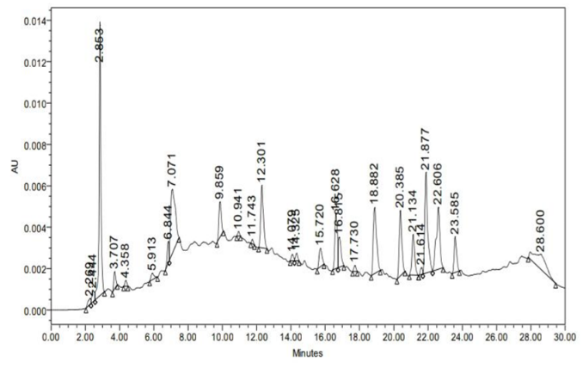
Fig 3: Retention time of 310 nm wavelength extract

Table 2: HPLC results of Smadan root extract, at a wavelength 310 nm
No RT Area %Area Height
1. 2.269 3582 0.65 283
2. 2.444 5907 1.07 555
3. 2.853 95261 17.29 13118
4. 3.707 6585 1.20 836
5. 4.358 2163 0.39 267
6. 5.913 3749 0.68 3.05
7. 6.844 8354 1.54 1048
8. 7.071 58261 10.57 3112
9. 9.859 16457 2.99 1712
10. 10.941 1560 0.28 210
11. 11.743 1478 0.27 201
12. 12.301 32753 5.94 3091
13. 14.079 2726 0.49 300
14. 14.325 3222 0.58 361
No RT Area %Area Height
15. 15.720 10282 1.87 891
16. 16.628 27039 4.91 2689
17. 16.815 16028 2.91 1460
18. 17.730 2565 0.47 296
19. 18.882 41883 7.60 3196
20. 20.385 33082 6.00 3150
21. 21.134 21494 3.90 1959
22. 21.614 2845 0.52 323
23. 21.877 57213 10.38 4881
24. 22.606 43974 7.98 3000
25. 23.585 17240 3.13 1734
26. 38.600 35253 6.40 7.19

The bioactive content test recorded in the form of a chromatogram at a wavelength of 254 nm detected that there were 37 active compounds in the Smadan root extract over a period of 30 minutes and there was 1 active compound with a very high percentage, namely 20. 1531 which has a retention time of 2.861 minutes (Fig. 4). Based on (Table 3) below, it can be seen that the RT is the retention time for 30 minutes. The 30 bioactive compounds detected can be seen in the area and % area and height or how high (large) the bioactive content is from the test results of Smadan root extract at a wavelength of 254 nm.
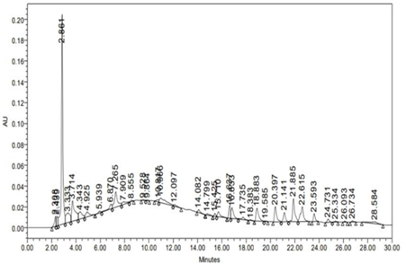
Fig 4: Retention time of 254 nm wavelength extract

Table 3: HPLC results of Smadan root extract, wavelength 254 nm
No. RT Area % Area Height  1. 2.308 82636 1.67 9460  2. 2.439 81741 1.66 9161  3. 2.861 1543462 31.26 201531  4. 3.333 223011 4.52 9162  5. 3.714 366637 7.43 19452  6. 4.343 143739 2.91 6832  7. 4.925 97735 1.98 4509  8. 5.939 20625 0.42 1616  9. 6.870 73304 1.48 4515  10. 7.265 259136 5.25 14674  11. 7.909 56673 1.15 2382  12. 8.555 14900 0.30 1320  13. 9.528 6394 0.13 521  14. 9.864 4605 0.09 490  15. 10.817 28561 0.58 2378  16. 10.966 182283 3.69 4328  17. 12.097 29041 0.59 1533  18. 14.082 36996 0.75 2672  19. 14.799 24404 0.49 1349  20. 15.425 26713 0.54 2682 | No. RT Area % Area Height  21. 15.710 75659 1.53 4816  22. 16.637 110266 2.23 11789  23. 16.833 148260 3.00 10205  24. 17.735 44089 0.89 2418  25. 18.383 9220 0.19 579  26. 18.883 188503 3.82 12225  27. 19.585 5339 0.11 527  28. 20.397 180532 3.66 14381  29. 21.141 106416 2.16 8891  30. 21.885 283545 5.74 21908  31. 22.615 243384 4.93 14031  32. 23.593 73411 1.49 7427  33. 24.731 38394 0.78 3065  34. 25.334 9897 0.20 737  35. 26.093 8339 0.17 836  36. 26.734 13301 0.27 1081  37. 28.584 95633 1.94 1788

Analysis of Total Flavonoid Compound Content of Smadan Root Extract
The quercetin standards with concentrations of 6, 8, 10, 12 and 14 ppm with the Absorbance values obtained for each concentration (ppm). This value shows that the higher the concentration of the solution used, the higher the absorbance value obtained (Table 4). The quercetin standard results obtained are plotted between the levels and absorbance to obtain a linear regression equation, namely y = 0.014x + 0.498 with a value of R² = 0.924. The quercetin calibration curve equation can be used as a comparison to determine the concentration of flavonoid compounds in the total extract of Smadan root samples (Fig. 5). The calculation results show that dry Smadan root extract (dry extract) has a total flavonoid content of 62.66 mgQE/g extract and the total flavonoid content of wet Smadan root extract (wet extract) is 14 mgQE/g extract (Table 5).

Table 4: Quercetin absorbance
Concentration (ppm) Absorbance (y)
6 0,580
8 0,608
10 0,663
12 0,682
14 0,689

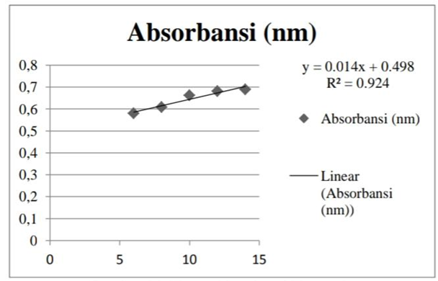
Fig 5: Quercetin absorbance curve
Table 5: Total flavonoid content of Smadan root extract
Sample Absorbance(y) Total Flavonoid
Content (mgQE/g)
Dry extract 1,895 62,66 mgQE/g Extract
Wet extract 0,882 14 mgQE/g Extract

MCF-7 Anticancer Cytotoxic Activity Assay
The curve of test results for Smadan root extract on MCF-7 cells, namely the obteined IC₅₀ value = 50.12 µg/mL, which means that Smadan root extract has strong cytotoxic properties to kill MCF-7 cancer cells or breast cancer cells (Fig. 6). A very strong cytotoxicity test has an IC₅₀ of less than 10 µg/mL, a strong cytotoxicity has an IC₅₀ value between 10-100 µg/mL and a moderate cytotoxicity IC₅₀ between 100-500 µg/mL (Tunjung and Sayekti, 2019). The average live cancer cells, namely = 104.45% and the average MCF-7 cancer cells lived after being given Smadan Root extract. At sample concentrations of 7.81 µg/mL = 104.73 %, 15.63 µg/mL= 99.80 %, 31.25 µg/mL= 61.06 %, 62.50 µg/mL= 33.17%, 125.00 µg/mL = 31.24%, 250.00 µg/mL = 29.33%, 500.00 µg/mL = 5.43%, 1000.00 µg/mL = 0.66% average % live cells. Based on these results, after being given Smadan root extract with the addition of a higher concentration, it can kill cancer cells in greater numbers or has a stronger cytotoxic effect on cancer cells. A concentration of 1000.00 µg/mL has the strongest cytotoxic activity (Table 6). (Note: The cisplatin concentration used in the test was 53 μM).
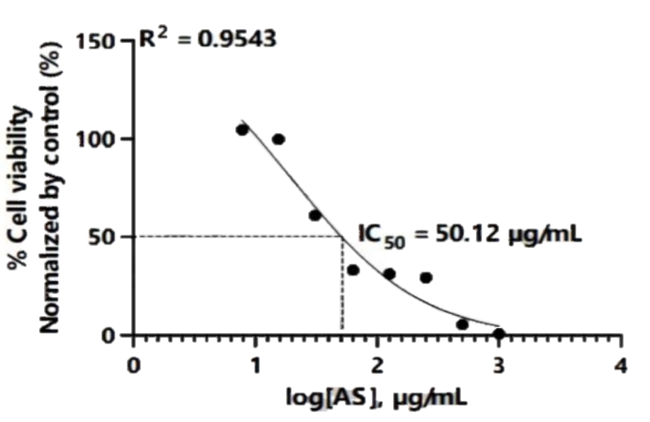
Fig 6: Smadan test results curve for MCF-7 cells
Table 6: Absorbance of extract Smadan root results on MCF-7 cells
Media Media Ciplatin Solvent  + Cell |  |  | Sample concentration (µg/mL)
 |  |  | 7,81 15,63 31,25 62,50 125,00 250,00 500,00 1000,00
Absorbance 570 nm | 0,4786 0,7932 0,5217 0,7813 0,8204 0,7947 0,6685 0,6136 0,6015 0,6004 0,5138 0,5209
 | 0,4889 0,8024 0,5303 0,7827 0,8090 0,8027 0,7135 0,6117 0,6045 0,5973 0,5330 0,5338
Absorbance 600 nm | 0,6127 0,2080 0,5923 0,2228 0,2226 0,2403 0,4199 0,5130 0,5214 0,5427 0,6147 0,6518
 | 0,6261 0,2087 0,6035 0,2241 0,2240 0,2428 0,3856 0,5231 0,5222 0,5191 0,6280 0,6650
Difference absorbance | -0,1341 0,5852 -0,0706 0,5585 0,5978 0,5544 0,2486 0,1006 0,0801 0,0577 -0,1009 -0,1309
 | -0,1372 0,5937 -0,0732 0,5586 0,5850 0,5599 0,3279 0,0886 0,0823 0,0782 -0,0950 -0,1312
% living cells |  | 103,84 9,37 99,99 105,65 99,40 55,35 34,03 31,40 27,85 5,01 0,68
 |  | 105,06 9,00 100,01 103,81 100,19 66,77 32,30 31,40 30,81 5,86 0,64
Average living cell 104,45 9,18 100,00 104,75 99,80 61,06 33,17 31,24 29,33 5,43 0,66
SEM 0,61 0,19 0,01 0,92 0,40 5,71 0,86 0,16 1,48 0,42 0,02
Data Normalization
% Living Cells 104,45 9,18 100,00 104,73 99,80 61,06 33,17 31,24 29,33 5,43 0,66

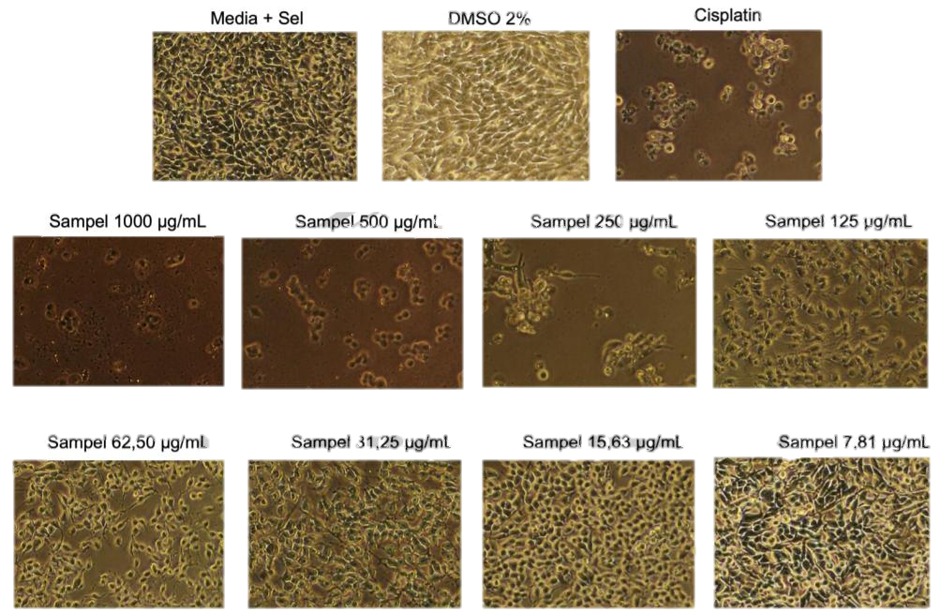
The morphology of MCF-7 cells using Smadan root extract which can be seen in the documentation image above, media and cells and testing with the addition of 2% DMSO (Dimethyl sulfoxide is a solvent that can dissolve almost all polar and non-polar compounds). polar), as well as Cisplatin (which is a cancer chemotherapy drug) along with testing Smadan Root extract with different concentrations on MCF-7 cancer cells where after adding higher concentrations it kills MCF-7 cancer cells or breast cancer cells (Fig. 7).

Fig 7: Documentation of MCF-7 cell morphology from extract Smadan root test results
Discussion
The bioactive content and anticancer activity test of MCF-7 Smadan root extract from Bitung city forest, North Sulawesi was carried out step by step, namely: Making simplicia and extracting Smadan root samples, testing the bioactive content using the HPLC method, testing the total flavonoid content using UV-Vis Spectrophotometry and MCF-7 anticancer cytotoxic activity assay.
The extraction stage aims to extract chemical components or secondary metabolites contained in the Smadan root samples. The extraction process has 2 stages, namely sample maceration and solvent evaporation. The maceration process is carried out by soaking the crushed Smadan root powder into a jar and then adding 95% ethanol. Ethanol solvent is used as an extraction solvent because ethanol has selective properties and is able to extract the compounds contained in the sample (Chen et al., 2020). The ratio in the maceration process is 1: 4 Smadan root simplicia 100 gr and ethanol 95% 400 ml. Smadan roots are soaked in a jar for 3 days at room temperature. The maceration process is carried out at room temperature to protect the which cannot stand heat bioactive content from being damaged (Nur et al., 2020).
The maceration method was chosen because it can avoid the destruction of thermolabile compounds, which may have very important antioxidants (Setyawardhani & Saputri, 2020). Apart from that, the advantage of the maceration method is that the procedure and equipment are simple and affordable. After maceration, the sample is filtered using filter paper to enter the solvent evaporation process. Evaporation of the solvent uses a rotary evaporator to convert the solvent into steam and the active compound content of the Smadan root extract (thick extract) remains. The thick extract resulting from evaporation of the solvent shows the distinctive aroma of the Smadan root plant, namely the smell of wood mixed with the smell of ethanol. Then the thick extract of Smadan roots (dry sample) was tested for bioactive content.
Bioactive content testing using the HPLC method recorded in the form of a chromatogram at a wavelength of 310 nm detected 26 active compounds in the Smadan root extract at a time span of 30 minutes and where there was 1 active compound with a very high percentage, namely 13,118 at a retention time of 2,853 minutes while at a wavelength of 254 nm, 37 active compounds were detected in the Smadan root extract at a retention time of 30 minutes and there was 1 active compound with the highest percentage, namely 20.1531 at a retention time of 2.861 minutes.
In the total flavonoid content test using UV-VIS spectrophotometry from the results of measuring the absorbance of a standard quercetin solution with a maximum wavelength of 435 mm. The standard results of quercetin obtained from the linear regression equation are y = 0.014x + 0.498 with an R² value = 0.924. The total flavonoid content based on calculations found that dry Smadan root extract had a flavonoid content of 62.66 mgQE/g extract and wet Smadan root extract 14 mgQE/g extract. Flavonoids are natural phenolic compounds found in almost all plants in the flowers, roots, skin, leaves and even seeds. Flavonoids play an important role as medicine because they have antioxidant, antibacterial, antiviral and anticancer activities (Fahira, 2023).
In the cytotoxic test, the effectiveness of Smadan root extract was tested against MCF-7 breast cancer cells. Based on the results of the cytotoxic test of Smadan root extract with an IC₅₀ value = 50.12 µg/mL, which means that Smadan root extract has strong cytotoxic properties to prevent MCF-7 cancer or breast cancer. A very strong cytotoxicity test has an IC₅₀ of less than 10 µg/mL, a strong cytotoxicity has an IC₅₀ value between 10-100 µg/mL and a moderate cytotoxicity IC₅₀ between 100-500 µg/mL (Tunjung and Sayekti, 2019).
In previous tests on the Kalimantan Bajakah plant which was tested for anticancer in vitro on the breast cancer cell line 4T1, it turned out to have potential as a strong anticancer and antioxidant (Iskandar et al., 2022). However, its anticancer activity is weak against breast cancer (MCF-7) and is not toxic to normal cells (Yuniarti et al., 2021). Meanwhile, the results of this study showed that cytotoxic test on Smadan roots were proven to be strong in killing MCF-7 breast cancer cells.
Conclusion
Based on the results of research conducted by researchers, it was concluded that in testing the bioactive content using the HPLC method which was recorded in the form of a chromatogram at a wavelength of 310 nm, 26 active compounds were detected and at a wavelength of 254 nm, 37 active compounds were detected in the Smadan Root extract over a period of time 30 minutes and The total flavonoid content of Smadan Root using UV-VIS spectrophotometry on dry Smadan root extract had a total flavonoid content of 62.66 mgQE/g extract and wet Smadan root extract 14 mgQE/g extract. In the cytotoxic test of Smadan root extract, the IC₅₀ value = 50.12 µg/mL, which means that Smadan root extract has strong cytotoxic activity to prevent and kill MCF-7 or breast cancer.
Acknowledgement
The author would like to express his thanks to the Biology Laboratory, Faculty of Mathematics, Natural and Earth Sciences, Manado State University and the Central Laboratory of Padjadjaran University which helped carry out this research.
Authors’ Contributions
AGK and MYS were involved planning the research and AGK performed the data acquisition/collection. AGK, RM and MYS aided in interpreting the results. AGK performed data analysis. MYS, RM revised the manuscript. All authours were involved in this research.
Conflict of Interest
All authors declare no conflict of interest

References
Ansori, A. N. M., Kharisma, V. D., & Solikhah, T. I. Medicinal properties of Muntingia calabura L: A Review. Research Journal of Pharmacy and Technology. 2021; 14(8): 4509-4512. doi: 10.52711/0974-360X.2021.00784
Asworo, R. Y., & Widwiastuti, H. Pengaruh Ukuran Serbuk Simplisia dan Waktu Maserasi terhadap Aktivitas Antioksidan Ekstrak Kulit Sirsak. Indonesian Journal of Pharmaceutical Education. 2023; 3(2): 256-263. doi: 10.37311/ijpe.v3i2.19906.
Chen H., Xiao H., & Pang, J. Parameter Optimization and Potential Bioactivity Evaluation of a Betulin Extract from White Birch Bark, Plants. 2020; 9(3): 392. doi: 10.3390/plants9030392.
Choi, Y. J., Choi, Y. K., Ko, S. G., Cheon, C., & Kim, T. Y. Investigation of Molecular Mechanisms Involved in Sensitivity to the Anti-Cancer Activity of Costunolide in Breast Cancer Cells. International Journal of Molecular Sciences. 2023; 24(4): 4009. doi: 10.3390/ijms24044009.
Coelho, A., Kendir, C., Barrenho, E., Klazinga, N., Paiva, C., Abreu de Sousa, J., & Gaspar, T. Patient-reported outcomes and experiences assessment in women with breast cancer: Portuguese case study. International Journal of Environmental Research and Public Health. 2023; 20(4): 2931. doi: 10.3390/ijerph20042931.
Fahira, J. Flavonoid pada ekstrak daun pacar (Lawsonia inermis L), (Doctoral dissertation). Universitas Tadulako; 2023.
Fitriani, F., Sampepana, E., & Saputra, S. H. Karakterisasi Tumbuhan Akar Bajakah (Spatholobus littoralis Hassk) Dari LOA KULU Kabupaten Kutai Kartanegara. Indonesian Journal of Industrial Research. 2020; 12(2): 365- 376. doi: 10.26578/jrti.v14i2.6590.
Hasnita, Y., & Meiriza, W. Pengaruh pengetahuan wanita usia subur terhadap perilaku dalam melakukan pemeriksaan payudara sendiri (sadari). Saintekes: Jurnal Sains, Teknologi Dan Kesehatan. 2023; 2(4): 500-505. doi: 0.55681/saintekes.v2i4.176.
Iskandar, D. Qualitative Phytochemical Screening and Antioxidant Activity of Ethanol Root Extract of Spatholobus littoralis Hassk. The Journal of Food and Medicinal Plants. 2020; 1(1): 13-15. doi: 10.25077/jfmp.1.1.
Iskandar, D., Widodo, N., Warsito, M., & Rollando, YPPA. Phanolic content, antioxidant, cytotoxic of fractions of Spatholobus littoralis Hassk from Kalimantan, Indonesia. Journal of Hunan University Natural Sciences. 2022; 49(3): 14-23. doi: 10.55463/issn.1674-2974.49.3.2.
Jagdale, S., Narwade, M., Sheikh, A., Md, S., Salve, R., Gajbhiye, V., & Gajbhiye, KR. GLUT1 transporter- facilitated solid lipid nanoparticles loaded with anti-cancer therapeutics for ovarian cancer targeting. Internasional journal pharmaceutics. 2023; 637: 122894. doi: 10.1016/j.ijpharm.
Joya, M., Stanikzai, Z., Akbarzadeh, I., Babaloui, S., Bradley, D. A., & Jafari, S. M. Prevalence of cancers diagnosed in Jamhuriyat Hospital, Kabul, Afghanistan, Heliyon. 2020; 6(3). doi: 10.1016/j.heliyon.2020.e03603.
Jumaryatno, P., Fawwazi, M. H. A. F., & Ramadani, A. P. Studi Aktivitas Sitotoksik Ekstrak dan Fraksi Daun Patindis (Urophyllum arboretum (Reinw. Ex Blume) Korth) terhadap Sel Kanker Payudara MCF-7 dengan Metode Prestoblue Assay. 2022; 130-142.
Kaunang, ENS & Mokosuli, YS. Botanical and phytochemical constituents of several medicinal plants from mount Klabat North Minahasa. Journal of medicinal plants studies. 2017; 5(2): 29-35.
Kurniawati, H. Deteksi dini kanker payudara dengan sadari dan sadarnis. Baktimu: Jurnal Pengabdian Kepada Masyarakat. 2023; 3(2): 55-64. doi: 10.37874/bm.v3i2.821.
Li, J., Wang, YF, Shen, ZC, Zou, Q., Lin, XF, & Wang, XY. Recent development on natural polysaccharides as potential anti-gastric cancer substance: Structural feature and bioactivity. Internasional Journal of Biological Macromoleculer. 2023; 232: 123390. doi: 10.1016/j.ijbiomac.
Malacrida, A., Deschamps-Wright, M., Rigolio, R., Cavaletti, G., & Milo, M. Another Brick to Confirm the Efficacy of Rigosertib as Anticancer Agent. International Journal of Molecular Sciences. 2023; 24(2): 1721. doi: 10.3390/ijms24021721.
Mokosuli, Yeremia, Mege, RA, Versya, G., & Rompas, C. Aktivitas antihiperlipidemia ekstrak sarang Apis dorsata Binghami pada tikus hiperlipidemia akibat diet aterogenik. Jurnal Internasional Studi Botani. 2019; 4(4): 174-178.
Nur, Y., Cahyotomo, A., Nanda, N., & Fistoro, N. Profil GC-MS Senyawa Metabolit Sekunder dari Jahe Merah (Zingiber officinale) dengan Metode Ekstraksi Etil Asetat, Etanol dan Destilasi. Jurnal Sains dan Kesehatan. 2020; 2(3): 198-204. doi: 10.25026/jsk.v2i3.115.
Nurtiana, W., & Budijanto, S. Bekatul Beras sebagai Pencegah Kanker Kolon. Jurnal Pangan. 2017; 26(3). doi: 10.33964/jp.v26i3.368.
Pangribowo, S. Beban Kanker di Indonesia. Pusat Data Informasi Kesehatan Kementrian Kesehatan RI. 2019; 1-16.
Putri, N. M., Wiraningtyas, A., & Mutmainah, P. A. Perbandingan metode ekstraksi senyawa aktif daun kelor (moringa oleifera): metode maserasi dan microwave-assisted extraction (MAE). Dalton, Jurnal Pendidikan Kimia Dan Ilmu Kimia. 2021; 4(2): 25-33. doi: 10.31602/dl.v4i2.5931.
Qodria L, Nur Rachma MY. Pemilihan Sel yang Tepat Untuk Penelitian Kanker Payudara, Biotrends. 2020; 11(2): 17-28.
Rabiee, F., Eghbalifard, N., Fathi, M., Rajabi, H., & Riazi, S. S. Evaluation of the potential of the MicroRNAs to predict chemotherapy resistance in breast cancer patients: a systemic review with meta-analysis. International Journal of Scientific Research in Dental and Medical Sciences. 2023; 5(3): 135-140. doi: 10.30485/IJSRDMS.2023.409070.1520.
Rahmawaty, R.,Samosir, J.B., Batubara, R., & Rauf, A. Diversity and distribution of medicinal plants in the Universitas Sumatera Utara arboretum of deli serdang, North Sumatra, Indonesia. Biodiversitas Journal of Biological Diversity. 2019; 20(5): 1457-1465. doi: 10.13057/biodiv/d200539.
Rakhmanovna, P.O. Nutrition and diet in breast cancer. Texas journal of medical science. 2022; 7: 27-30.
Roy, A., Khan, A., Ahmad, I., Alghamdi, S., Rajab, BS, Babalghith, A. O & Islam, M. Flavonoids a bioactive compound from medicinal plants and its therapeutic applications. Hindawi, BioMed Research Internasional. 2022; 1-9. doi: 10.1155/2022/544529.
Senewe, R. E., Permatasari, S., Utami, S., & Pesireron, M. Preferensi Serangga Herbivora Henosepilachna sparsa (Coleoptera: Coccinellidae) Terhadap Beberapa Jenis Tanaman Budidaya. Journal of top agriculture (top journal). 2023; 1(1): 24-30.
Setyawardhani, D. A., & Saputri, C. M. Pembuatan dan Uji Organoleptik Hand Sanitizer dari Daun Mangga (Mangifera indica) dengan Metode Maserasi. Equilibrium Journal of Chemical Engineering. 2020; 4(1): 1–7. doi: 10.20961/equilibrium.v4i1.42852.
Shaluhiyah, Z., & Surjoputro, A. Studi Fenomenologi Pasien Kanker Payudara dalam Upaya Meningkatkan Kualitas Hidup: Literature Review. Media Publikasi Promosi Kesehatan Indonesia (MPPKI). 2023; 6(8): 1495-1500. doi:.10.56338/mppki.v6i8.3513.
Sianipar, R. N., Suryanegara, L., Fatriasari,W., Arung, E. T., Kusuma, I. W., Achmadi, S. S., & Hamid, Z. A. A. The Role of Selected Flavonoid from Bajakah Tampala (Spatholobus littoralis Hassk) Stem on Cosmetic Properties: A Review. Saudi Pharmaceutical Journal. 2023; 31(3): 382-400. doi: 10.1016/j.jsps.
Syarifah, S., Widyawati, T., Anggraini, D. R., Wahyuni, A. S., & Sari, M. I. Anticancer activity of uncaria gambir roxb on T47D breast cancer cells. Journal of Physics: Conference Series. 2019; 1317(1): 1-5. doi: 10.1088/1742-6596/1317/1/012106.
Tunjung, W., & Sayekti, P.R. Apoptosis induction on human breast cancer T47D cell line by extracts of Ancorina sp. F1000 Research. 2019; 8(168). doi: 10.12688/f1000research.17584.2.
Wahid, R. S. A., & Raudah, S. Uji Senyawa Komponen Bioaktif dan Kadar Total Flavonoid Ekstrak Daun Kelor (Moringa oleifera). Jurnal Teknologi Laboratorium Medik Borneo. 2022; 1(1): 1-10. doi: 10.35728.
Yuniarti, L., Kharisma, Y., Respati, T., & Tejasari, M. Halal Critical Point Analysis of Bajakah Wood (Spatholobus littoralis Hassk) Nano Particle as Anticancer Agent. Global Medical and Health Communication (GMHC). 2021; 9(2): 81-87. doi: 10.29313/gmhc.v9i2.6997.
Zein, M. F. F., & Hazar, S. Uji Sitotoksik Fraksi dan Ekstrak Batang Kayu Bajakah (Uncaria. sp) Menggunakan Metode Brine Shrimp Lethality Test (BSLT). In Bandung Conference Series: Pharmacy. 2022; 2(2): 830-840. doi: 10.29313/bcsp.v2i2.4567.

