Running title: alternatives for soil acidity correction

Egg and crab shells, alternatives for soil acidity correction

Jessivaldo Rodrigues Galvão ^{1*†}, Pedro Paulo da Costa Alves Filho ^{2†}, Leonardo Braga Neves ² João Roberto Rosa e Silva ², Odete Kariny Souza Santos ², Mário Davi Coutinho Santos ², Alessandra Marie Ohashi ²
¹Universidade Federal Rural University of Amazonia - Institute of Agricultural Sciences
²Federal Rural University of Amazonia
*For correspondence: jessigalvao50@gmail.com
†Contributed equally to this work and are co-first authors
Received ; Accepted ; Published

Abstract

The experiment was developed in vegetation house the Soil Sciences department of the Federal Rural University of Amazonia (Belém campus) with the objective of evaluating the effects of use and doses (1.5, 2.5, 3.5 and 4,5 t ha⁻¹) of crab shell and eggshell as a remedy for Oxisol soil acidity. pH values were evaluated every 15 days over a 60-day period, with a fertility analysis conducted at the end of the experiment. We used a completely randomized design in a 4x2 factorial scheme, with four replications. The experimental unit was represented by plastic pots of 1 kg capacity containing the soil under study. Significant effects from the remedy materials were observed on the soil pH starting after 45 days of incubation. No effects were observed from doses only addressing K concentration. Interactions of remedy and dosage were significant for all variables with the exception of the concentrations of K and Al interchangeably. The crab shell yielded the best results for the variables studied here. The materials tested as correctives significantly reduced the concentrations of exchangeable aluminum in the soil after incubation, with crab shells proving to be the greatest reducer of exchangeable aluminum concentrations in the soil.

Keywords: Nutrients; pH; Fertility; correctives

Introduction

Currently, the problem of waste is becoming increasingly important, with the aim of increasing productivity in areas in order to reduce deforestation to open up new areas for production. In this context, the use of techniques that make it possible to optimize plant production systems requires the use of appropriate agricultural practices, so as to intensify the use of cultivated areas and reduce pressure on the forest (BRASIL & CRAVO, 2009).
In general, the soils of the Amazon region have low fertility, high acidity and a high degree of aluminum saturation, naturally providing low yields (ROCHA et al., 2020). Therefore, soil acidity is one of the main limiting factors for crop development, requiring the adoption of pH correction practices with improvements in the supply of nutrients to plants (PANTOJA et al., 2019).
Liming is an efficient method for correcting soil acidity, since in addition to reducing high levels of aluminum and hydrogen, it also provides the soil with calcium and magnesium. In this sense, the use of alternative sources for soil correction in agroecological systems is a way of reusing waste that would mostly be disposed of inappropriately and would lead to serious soil and water pollution problems, as well as providing satisfactory levels of crop productivity and promoting the conservation of natural resources (MARTINS, 2018).
Examples of natural sources of calcium ions include hen's eggshells, crabs, shells, corals, among others, indicating the potential use of this waste as soil acidity correctors (GOMES et al., 2012; NÚÑEZ et al., 2018; AGUILAR et al., 2019; HORTA et al.., 2019; RAMOS & RIBEIRO, 2019) The exoskeleton of crustaceans contains calcium carbonate (CaCO3), which, depending on the species and function (greater rigidity or flexibility), comes in different forms, such as aragonite, calcite and magnesium-calcite (Boßelmann et al., 2007). Lira (2018) points out that the search for new compounds from waste materials such as eggshells has proved essential to promote the valorization of the waste produced, making it possible to minimize environmental impacts, however, little reference is found in the literature regarding the use of these materials to correct soil acidity.
Considering the lack of studies on the association and use of eggshell and crab residues to correct soil acidity and fertility, as well as the need to combine agronomic and environmental interests, this study aims to evaluate the effects of using eggshell and crab residues to correct soil acidity.

Materials and Methods

Experimental details and treatments

Experimental material: The experiment was carried out over a period of four months, in a greenhouse, in the soil science area of the Institute of Agrarian Sciences of the Federal Rural University of Amazonia - UFRA, located in the municipality of Belém (PA), with geographical coordinates of 48º 26'28" Greenwich West Longitude and 01º27'9" South Latitude, at an altitude of 13 meters.
To carry out the chemical analysis, soil samples were collected from a depth of 0.0 to 0.20m. They were then dried and sieved through a 2 mm sieve. The soil used in the experiment was dystrophic yellow latosol, classified according to the Brazilian Soil Classification System (EMBRAPA, 2006). The results obtained after chemical analysis of the soil were pH(H2O)= 4.5; MO= 12.51%; P= 4.02 mg.dm-3; K= 0.03 mmolc dm-3; Ca= 0.29 mmolc dm-3; Mg= 0.29 mmolc dm-3; H+Al= 8.3 mmolc dm-3; Al= 1.8 mmolc dm-3; SB= 0.61%.
Treatments: The experiment was set up in a completely randomized experimental design, with the treatments distributed in a 2x4 factorial scheme, the factors being eggshell and crab shell, applied to the soil in the following four dosages: 1.5; 2.5; 3.5 and 4.5 t ha-1.
The soil samples, according to the treatments, were incubated for a total period of 60 days, with the pH in water being assessed every 15 days of incubation, i.e. 15, 30, 45 and 60 days. Initially, the amount of water added to the soil was done with the aim of keeping it close to 60% of field capacity, and daily weighings were made to replenish the water according to needs. At the end of the experiment, a complete soil fertility analysis was carried out in accordance with EMBRAPA, 2006.

Material collection

The crab shells used as a corrective were obtained by collecting the waste from extracting the meat, mainly the shells, in the municipalities of Capanema, Bragança and Belém. Eggshells were obtained from commercial houses in Belém. To be used in the experiment, the materials were washed with 0.2% NaClO for about 1 hour, followed by running water. After drying in a forced air circulation oven at 60º C for 75 hours, the material was crushed and ground into powder (particles <2 mm).

Chemical composition

The chemical composition of the crab shell was 2.71% N, 0.946 mg.kg-1 P, 131.19 mg.kg-1 K, 5.6 cmolc.dm-3 Ca and 1.1 cmolc. dm-3 of Mg, while the composition of the eggshell was 2.1% N, 0.331 mg.kg-1 of P, 17.83 mg.kg-1 of K, 4 cmolc.dm-3 of Ca and 0.5 cmolc.dm-3 of Mg.
For the chemical analysis of N, P and K, the methodology recommended by Tedesco et al. (1995) was used. For the determination of Ca and Mg, the complexometry methodology of Embrapa (1997) was used.

Statistical analysis

In our study, we used the Sivar program for non-descriptive statistical analysis, such as the mean and standard deviation, to interpret the results. The data from the treatment means were compared using the Tukey test at a 5% probability level. We used the parametric test to compare quantitative variables with a significance threshold of 5%.

Results

Change in soil pH

Corrective doses: There were significant effects of the alternative materials used as correctives on soil pH at 45 and 60 days of incubation. The doses of the correctives used significantly influenced the concentration of nutrients in the soil, except for K. The interactions between doses and correctives also had significant effects on nutrient concentrations, with the exception of K and Al (Table 1).
The significant effects of the alternative materials used as a corrective on pH, observed only after 45 days of incubation, may be related to the need for a longer reaction time of these materials in the soil, since they had larger granulometries than the limestone used commercially, given the use of 2 mm sieves, corresponding to ABNT n 10, to obtain them.
The soil pH data, after 15 days of incubation of the correctives in the soil, showed that this variable was significantly affected by the interaction between the doses and the correctives, with a quadratic response. The highest pH value (5.13) due to the corrective action of crab shells was observed with the estimated dose of 3.67 t ha-1. For the eggshell corrective, the maximum pH value (5.11) was reached with the estimated dose of 4 t ha-1 (Figure 1A).
The maximum pH values reached after 15 days of incubation did not reach the range considered ideal for most agricultural crops (5.5 to 6.5). It is possible that this time was not enough for the material to react in the soil, thus preventing pH values closer to the ideal for neutralizing acidity.
Changes in P: The P concentrations in the soil fitted an increasing linear regression model for crab shells and a quadratic one for egg shells, at the doses applied, indicating changes in the P concentrations in the soil, promoting different responses between the corrective materials used (Figure 2).
The increasing linear effect for crab shells led to changes in P concentration, which increased according to the doses applied. These values ranged from 47.56 to 59.06 mg.dm-3, considered a high level in the soil (SILVA, 2003).
The P concentration data, with the doses of eggshell fertilizer, fitted a quadratic regression model, where the maximum concentration of the nutrient (46.18 mg dm-3) was reached with an estimated dose of 2.88 t ha-1 of the fertilizer.
It is possible to see a reduction in P concentration from 2.88 t ha-1 of eggshell, a fact that may be related to the high presence of Calcium (Ca), since, with an increase in pH, there is also an increase in Ca ions in the solution and these, when in excess, react with phosphate, resulting in a compound called hydroxyapatite, this process is characterized as chemical precipitation of phosphorus (MARONEZE, 2014).
Araújo (2011), testing different fertilizer arrangements on corn plants, obtained 17.5 mg.dm-3 of P after 90 days of incorporating dolomitic limestone. However, the results obtained in this study are much higher, despite the shorter incubation time. These results may be linked to the high concentration of P found in eggshells.
Changes in K: Irino (2007), testing increasing doses of lime, found a P concentration of 51 mg dm-3 at a dose of 4.0 t ha-1, which was higher than that obtained in this study. The concentration of K in the soil (Figure 3), obtained by the isolated action of crab shells (0.0381 mmolc/dm-3) was significantly higher than that provided by egg shells (0.0312 mmolc/dm-3), although these values are similar to the natural concentration of this nutrient in the soil before the experiment. According to Silva; Vale (2003), the exchangeable K values obtained are considered high.
Changes in Ca: The results obtained for the concentration of Ca in the soil fit the increasing linear regression model, indicating that the doses of the correctives used, for both correctives, were not sufficient to obtain the maximum concentration of the nutrient (Figure 4 A).
The initial Ca concentration in the soil of 0.29 cmolc/dm-3 was increased to 6.56 and 4.51 cmolc/dm-3 with the application of 4.5 t ha-1 of crab shells and eggshells, respectively. For both correctives, the application of 2.5 t ha-1 would be sufficient to obtain high values of exchangeable calcium in the soil. At all dosages, the soil exchangeable Ca values obtained with crab shells were higher than those obtained with eggshells.
Changes in Mg: The data on exchangeable Mg in the soil showed a quadratic trend with the doses of eggshell and crab correctives applied, indicating that there was a positive response as the doses in the soil increased (Figure 4 B).
The quantities applied covered the points needed to estimate the maximum concentration of this nutrient. For crab shells, the maximum Mg concentration observed (0.89 cmolc/dm-3) was obtained with an estimated dose of 3.05 t ha-1, while for eggshell fertilizer this estimated dose was 2.77 t ha-1 for an Mg concentration equivalent to 0.4 cmolc/dm-3. The maximum Mg concentrations found are considered medium level, according to the classification of Silva; Vale (2003).
Changes in Al: The materials tested as correctives significantly reduced the concentrations of exchangeable aluminum in the soil after incubation, with crab shells proving to be the greatest reducer of exchangeable aluminum concentrations in the soil (Figure 5).
The values of exchangeable Al in the soil obtained at the different doses of soil improver did not differ between the two applied soil improvers (Figure 6).
However, the reduction in the natural concentration of the element (1.8 cmolc/dm-3) to the values obtained with the maximum dose of 4.5 t ha-1 of the corrective (0.15 and 0.325 cmolc/dm-3), for crab shells and eggshells, respectively, is highly significant. It can be seen that the application of just 1.5 t ha-1 of any of the correctives used would be enough to significantly reduce the concentration of exchangeable Al to non-toxic levels, according to the classification of Figueiredo et al. (2013).

Discussion

The effectiveness of these materials in correcting soil pH is slightly linked to the presence of high concentrations of Ca and Mg, which is responsible for decreasing the amount of exchangeable aluminum, in order to reduce toxicity levels and promote better crop development (VARGAS & MARQUES, 2017).
Neto et al, (2015) studying boron recovery in the presence and absence of liming, observed an increase in pH from 4.2 to 5.5 after 15 days of incubating the soil with limestone. At 30 days of soil incubation, there was a significant effect of the doses interacting with the correctives used, with the data fitting the quadratic regression model (Figure 1B).
The maximum pH values (5.5 and 5.43), according to the equation, were obtained with the estimated doses of 3.41 and 3.37 t ha-1 of crab shells and eggshells, respectively. The maximum pH values obtained with the doses of both corrective materials used in the experiment, observed by adjusting the quadratic equation in the pH variable, are close to the range considered ideal for the development of most crops (5.5 to 6.5), and are more satisfactory than those obtained with 15 days of soil incubation.
According to tests carried out by Sebastião et al. (2019), with the aim of testing different doses of lime (2, 4, 6, 8, and 10 t/ha) at a PRNT of 58.56% in soil pH correction, they observed that at 30 days, the value of 10t/ha was the one that promoted the greatest increase in soil pH value. The efficiency of the materials tested in this study as soil acidity correctors is therefore clear. It is worth noting that Teixeira et al (2010), testing the use of serpentine rock in yellow latosol, obtained a maximum pH of 6.5 after 35 days of incubation.
At 45 days into the experiment, the effects of the doses of the materials tested fitted the increasing linear regression model, indicating an increase in pH values up to the highest doses applied. However, the pH values reached at doses of 2.5, 3.5 and 4.5 t ha-1 are within the range considered ideal for plant development, for these doses the crab shell had higher pH values than the eggshell.
Souza et al. (2013), studying increasing doses of CaCO3 in a red Argissolo, observed an increase in the pH value from 5.61 to 6.82 with the application of 4 t ha-1 at 30 days of incubation, a value higher than that found at 45 days in this study. This difference in relation to the results obtained may be due to the characteristics of Latosols, given their frequent acidity and low fertility.
At 60 days of incubation, the pH data fitted the linear regression model, showing an increasing behavior of this variable for both correctives, up to the highest dose used, which was 4.5 t ha-1 (Figure 1 D).
Considering the ideal pH values of the soil, ranging from 5.5 to 6.5, applying a dose of 2.5 t ha-1 of crab shells would be enough to raise the pH to 5.73. This value would be suitable for the full development of most vegetable crops of economic interest. With eggshell, a pH value of 5.66 was achieved with the highest dose of the corrective (4.5 t ha-1), which would be enough to adjust the soil's acidity levels to satisfactory agricultural production. In this sense, the use of alternative residues shows great potential for correcting pH. For example, Raymundo et al. (2013) when testing marble sawdust residues in comparison to commercial limestone, concluded that diamond and steel blades are effective for correcting the acidity of the latosol studied.
Better results were obtained by Bambolim et al. (2015) testing the efficiency of types and doses of limestone, with pH varying between 6.0 and 6.5 at 70 days of incubation in the soil using 2.5 t ha of commercial limestone. These results, although superior to those of the experiment, were obtained in longer incubation periods than the experiment, which were obtained in 60 days.
Irino (2007) found that after 60 days of incubation, the doses of limestone applied had a significant effect on soil pH. Liming raised the pH values from 4.6 to 6.52 at a dose of 5 t ha-1. These results are similar to those of the experiment, showing the effectiveness of the correctives used in the study, which raised the pH from 4.5 to 6.25 and 5.66 with doses of 4.5 t ha-1 of crab shells and eggshells, respectively.
Caires et al. (2013), studying the action of soil acidity correctives and evaluating corn growth, observed K concentrations of 0.8 cmolc/dm-3 for a dose of 4 t ha-1 of dolomitic limestone (PRNT of 84%) in a red latosol, higher than those found in the yellow latosol in the experiment.
The exchangeable calcium values obtained were higher than those observed by Irino (2007), who tested increasing doses of commercial dolomitic limestone with a PRNT of 75% and found a value of 3.02 cmolc/dm-3 of Ca for a dose of 4 t ha-1.
Teixeira et al. (2010), testing serpentine rock as an acidity corrector, obtained a concentration of 4.0 cmolc/dm-3 of Ca with an application of 13.8 t ha-1, which was lower than that obtained in the experiment.
The decrease in magnesium concentrations in the soil as a result of the increase in doses of the products used as correctives may be linked to the antagonistic reaction with calcium, since the correctives applied to the soil had low levels of Mg and high concentrations of Ca. In this way, the materials used may have caused nutritional imbalances. It can also be seen that for eggshell there were no significant differences between the Ca concentrations obtained between the lowest (1.5 t ha-1) and highest (4.5 t ha-1) doses applied, which can be attributed to the low concentration of magnesium in this soil improver.
As observed by Salvador et al. (2011), the Ca/Mg ratio is much discussed because it is related to the similarity in the chemical properties of both elements, such as the degree of valence and mobility, which causes competition for absorption sites in the soil, reducing the absorption of one when the concentration of the other is high.
The Mg values obtained were lower than those observed by Irino (2007), corresponding to 2.42 cmolc/dm-3 and 4.33 cmolc/dm-3, respectively, for a dose of 4.0 t ha-1 of dolomitic limestone.
The concentrations of exchangeable Al obtained were lower than those found by Teixeira et al (2010), who studied the use of 13.8 t ha-1 of serpentine as a soil acidity corrective and observed a concentration of 2.2 cmolc/dm-3 of this element after 30 days of incubation.
This reduction is probably due to the high levels of Ca and Mg contained in the crab and egg shells used as a soil improver, which are adsorbed in the soil's colloids, neutralizing its acidity. As a result, when the amount of fertilizer applied is sufficient to overcome the buffering action of the soil, mainly due to Al+3, the pH in water will be in a range above 5.5 (WUTKE, 1972).

Conclusion

Crab shell and eggshell waste are effective in correcting soil acidity. The concentrations of exchangeable Al were reduced to values considered non-toxic from the dose of 1.5 t ha-1 of the alternative correctives used. Crab shells are superior to eggshells for all the attributes evaluated. The best values for the chemical indicators of soil quality studied, in substrates with similar characteristics, are achieved after 60 days of incubating the soil with crab shells as an acidity corrective, at a dosage of around 2.5 t ha-1.

Acknowledgements

We would like to thank the Federal Rural University of Amazonia for their collaboration in the laboratory evaluation.

Author contributions

Pedro Paulo da Costa Alves Filho elaborated and conducted the experiment, Jessivaldo Rodrigues Galvão and João Roberto Rosa e Silva organized, elaborated and discussed the results; Leonardo Braga Neves carried out experimental conduction; Odete Kariny Souza Santos, Mário Davi Coutinho Santos and Alessandra Marie Ohashi organized and elaborated the data.
References

AGUILAR, M. S. et al. Viabilidade do uso de cascas de ovos na síntese da hidroxiapatita utilizando o método sol-gel. A Aplicação do Conhecimento Científico nas Engenharias. Editora Atena, p. 54-62, 2019. DOI 10.22533/at.ed.4491904046.

BAMBOLIM, A.; CAIONE, G.; SOUZA, N.F.; SEBEN-JUNIOR, G.F.; FERBONINK, G.F. Calcário líquido e calcário convencional na correção da acidez do solo. Revista de Agricultura Neotropical, Cassilândia-MS, v. 2, n. 3, p.34–38, jul./set. 2015. DOI: https://doi.org/10.32404/rean.v2i3.277

BRASIL, E.C.; CRAVO, M.S. Recomendação de Adubação e Calagem para o Estado do Pará: A Importância do Uso Racional de Fertilizantes e Calcário. Revista de Estudos Paraenses, v. 2, p. 55-66, 2009.

BOßELMANN, F. et al. The composition of the exoskeleton of two crustacea: The American lobster Homarus americanus and the edible crab Cancer pagurus. Thermochimica Acta, v. 463, n. 1-2, p. 65-68, 2007.

GOMES, L. C. et al. Síntese e caracterização de fosfatos de cálcio a partir da casca de ovo de galinha. Cerâmica, v. 58, p. 448-452, 2012.

GONÇALVES, J.R.P., MOREIRA, A; BULL, L.T; CRUSCIOL, C.A.C; BOAS R.L.V. Granulometria e doses de calcário em diferentes sistemas de manejo. Acta Scientiarum Agronomy, Maringá, v. 33, n. 2, p. 369-375, 2011. DOI: 10.4025/actasciagron.v33i2.3659.

HORTA, M. K. S. et al. Synthesis and characterization of green nanohydroxyapatite from hen eggshell by precipitation method. Materials Today: Proceedings, v. 14, p. 716-721, 2019.

IRINO, V.H. de F. Produção do feijão-caupi e atributos químicos de um latossolo amarelo, em função da calagem, na região do nordeste paraense. 64 f.: il. Dissertação (Mestrado em Agronomia) - Universidade Federal Rural da Amazônia - UFRA, 2007.

LIRA, A. S. Estudo da cinética e do equilíbrio da adsorção de corante Têxtil sobre a farinha de casca de ovos. 54f. Trabalho de Conclusão de Curso (Graduação em Engenharia Sanitária e Ambiental) - Universidade Estadual da Paraíba, Campina Grande, 2018.

MARONEZE, Mariana Manzoni et al. A tecnologia de remoção de fósforo: Gerenciamento do elemento em resíduos industriais. Revista Ambiente & Água, v. 9, p. 445-458, 2014.

MARTINS, D. D. Casca de sururu como alternativa de correção do pH no solo e fonte de cálcio e magnésio na cultura do rabanete agroecológico. Tese (Mestrado em Agricultura e Ambiente), Programa de pós-graduação em agricultura e ambiente, Universidade Federal de Alagoas. Arapiraca, p.8. 2018.

MONACO, P.A.V.; MATOS, A.T., JÚNIOR, V.E.; RIBEIRO, I.C.A.; TEIXEIRA, D.L. Utilização do farelo de conchas de vôngole na adsorção de fósforo e como corretivo da acidez do solo. Eng. Agríc., Jaboticabal, v.32, n.5, p.866-874, set./out. 2012. DOI: http://dx.doi.org/10.1590/S0100-69162012000500006.

NETO, J.A. dos S; FONTES, R.L.F; ALVAREZ, V.H; NEVES, J.C.L; FONTES, M.P.F; FARIA, A.F. de; SANTO, H.S.N. Taxas de recuperação de Boro por extratores em solos da Bahia e de Minas Gerais, na presença e ausência de calagem. Revista Brasileira de Ciência do Solo, 39. p.1121-1126, 2015. DOI: https://doi.org/10.1590/01000683rbcs20140669.

NÚÑEZ, D.; ELGUETA, E.; VARAPRASAD, K. et al. Hydroxyapatite nanocrystals synthesized from calcium rich bio-wastes. Materials Letters, v. 230, p. 64-68, 2018.

PANTOJA, J. C. M. et al. Multivariate analysis in the evaluation of soil attributes in areas under different uses in the region of Humaitá, AM. Revista Ambiente & Água, v. 14, n. 5, e2342, 2019.

RAMOS, M. O.; RIBEIRO, S. C. A. Compostagem orgânica do resíduo de caranguejo-uçá no cultivo de coentro. Revista Verde de Agroecologia e Desenvolvimento Sustentável, v. 14, n. 2, p. 188-196, 2019.

RAYMUNDO, V. et al. Resíduos de secagem de mármores comocorretivos da acidez do solo. Revista Brasileira de Engenharia Agrícola e Ambiental, v.17, n.1, p.47-53, 2013.

ROCHA, L. P. M. et al. Ocorrência de fungos micorrízicos arbusculares em um plantio de cupuaçu na estrada de Balbina, Amazonas. Revista Ibero-Americana de Ciências Ambientais, v. 11, n. 2, p. 78-84, 2020

SALVADOR, J. T.; CARVALHO, T. C.; LUCCHESI, L. A. C. Relações cálcio e magnésio presentes no solo e teores foliares de macronutrientes. Revista Acadêmica de Ciências Agrárias e Ambiental, Curitiba, v.9, n.1, p.27-32, 2011

SEBASTIÃO, J. V. et al., Aplicações de doses crescentes por incubação nos solos da Chianga-Hiambo, Angola, Revista Cubana de Química, v.32, n.2, p.258-282, 2019.

SOUZA, L.F.R. de A.; MARINHO, R.W.D.; NUNES, F.N; Silva, R.V; NASCIMENTO, I. de O; SILVA, W.A. Determinação do pH de um argissolo vermelho amarelo distrófico incubado com aplicação de doses crescentes de CaCo³ por diferentes métodos. Revista Agroecossistemas, v. 5, n. 2, p. 58-63, 2013. DOI: http://dx.doi.org/10.18542/ragros.v5i2.1800.

SILVA, C.A.; VALE, F.R. Disponibilidade de nitrato em solos Brasileiros sob efeito da calagem e de fontes e doses de nitrogênio. Pesquisa Agropecuária Brasileira, Brasília, v. 35, n. 12, p. 2461-2471, dezembro, 2003. DOI: https://doi.org/10.1590/S0100-204X2000001200017.

TEIXEIRA, A.M.S; SAMPAIO, J.A; GARRIDO, F.M.S; MEDEIROS, M.E. Estudo do uso de serpentinito como corretivo de solos agrícolas. II SIMPÓSIO DE MINERAIS INDUSTRIAIS DO NORDESTE, Campina Grande - PB, 17 a 20 de Novembro de 2010. DOI: 10.13140/2.1.4079.5200.

VARGAS, G. DE .; MARQUES, R.. Crescimento e Nutrição de Angico e Canafístula sob Calagem e Gessagem. Floresta e Ambiente, v. 24, p. e20160102, 2017.

WUTKE, A. M.; Acidez. In: MONIZ, A. C., Elementos de Pedologia. São Paulo. Editora universidade de São Paulo. p. 149–168, 1972.

Table 1 - Summary of analysis of variance for pH at 15, 30, 45 and 60 days (d) and concentrations of macronutrients and exchangeable aluminum for eggshell and crab doses.

Sources of variation | G.L. | pH |  |  |  | P | K | Ca | Mg | Al
 |  | 15 | 30 | 45 | 60
Concealers (CL) | 1 | ns | ns | ** | ** | ** | ** | ** | ** | **
Doses (D) | 3 | ** | ** | ** | ** | ** | ns | ** | ** | **
CT X D | 3 | ** | ** | ** | ** | ** | ns | ** | ** | ns
CV (%) | - | 1,64 | 1,35 | 1,24 | 2,25 | 2,74 | 9,76 | 7,03 | 2,24 | 27,99
* e **- significant at the (P<0,05) and (P<0,01) and not significant (ns).

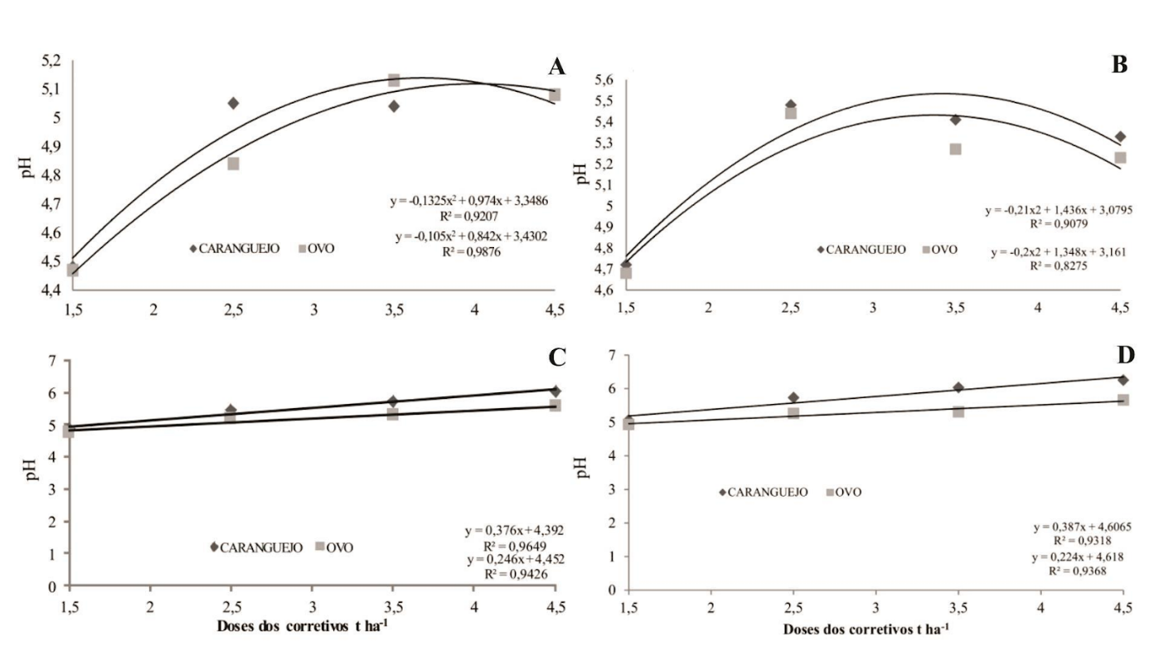
corrective doses t ha ⁻¹
corrective doses t ha ⁻¹
CRAB
EGG
CRAB
EGG
EGG
CRAB
CRAB
EGG
Figure 1 – Behavior of pH at 15 (A), 30 (B), 45 (C) and 60 (D) days of experiment as a function of increasing doses of eggshell and crab.

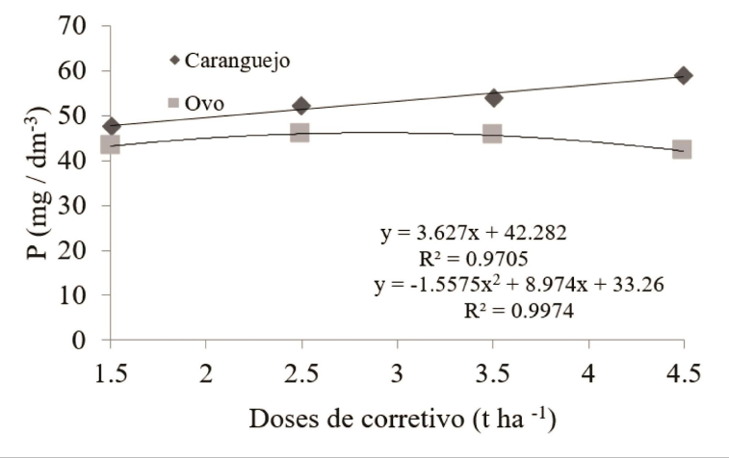
corrective doses (t ha ⁻¹)
CRAB
EGG
Figure 2 - Phosphorus concentration as a function of increasing doses of crab shell and egg, after 60 days of incubation.

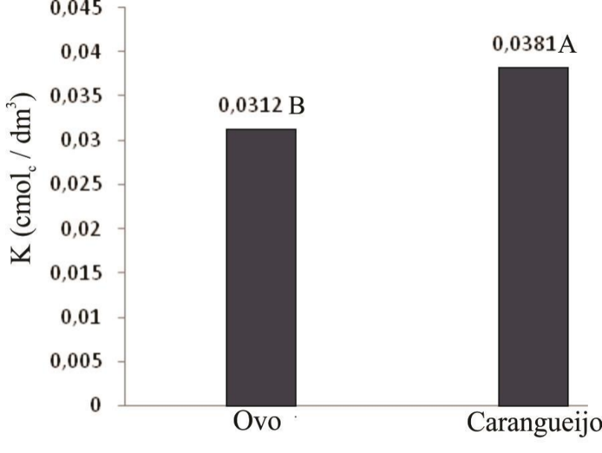
EGG
CRAB
Figure 3 - Average values obtained as a result of incubating eggshell and crab in the soil.

A
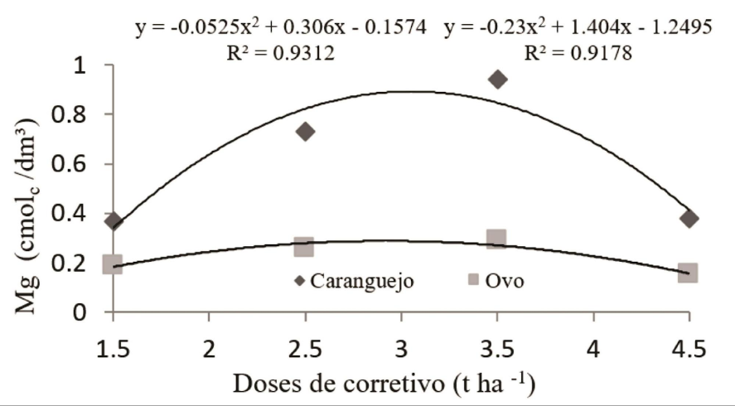
corrective doses (t ha ⁻¹)
EGG
CRAB

B
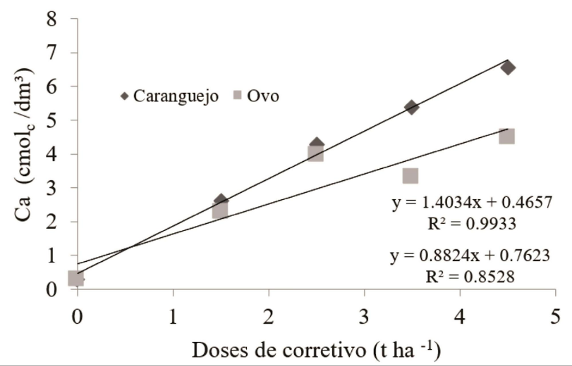
corrective doses (t ha ⁻¹)
EGG
CRAB

Figure 4 - Concentration of calcium (A) and magnesium (B) as a function of increasing doses of crab shell and egg, after 60 days of incubation.

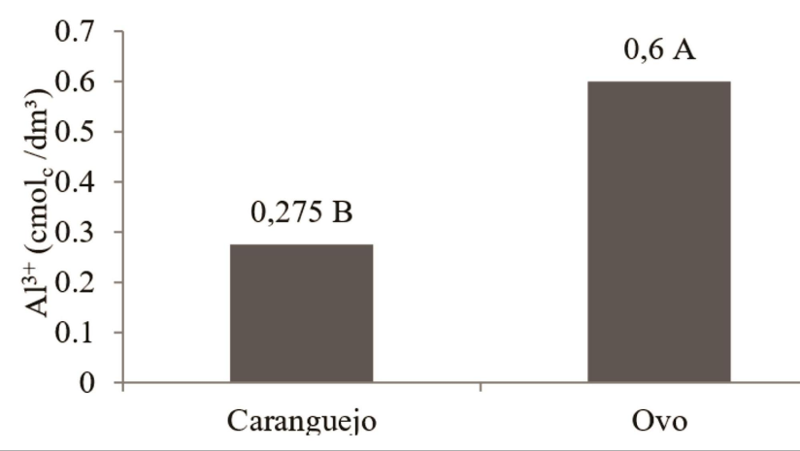
CRAB
EGG
Figure 5 - Average values obtained as a result of incubating eggshell and crab in the soil.

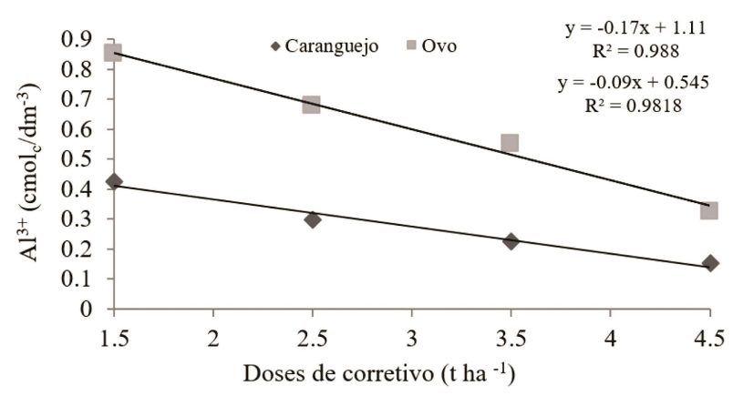
corrective doses (t ha ⁻¹)
CRAB
EGG

Figure 6 - Aluminum content as a function of corrective doses from crab shells and eggshells.

