Original Research Article
Impact of Molasse as Carbon Sources on Mycelium Formation and Fruiting Body Production in Cordyceps militaris
Running title: Cordyceps militaris cultivation using molasse

Duanpen Wongsorn¹
¹ Faculty of Agricultural Innovation and Technology, Rajamangala University of Technology Isan, Nakhon Ratchasima, 30000, Thailand
duanpen.wo@rmuti.ac.th

Phawarin Phoemkhunthod¹
¹ Faculty of Agricultural Innovation and Technology, Rajamangala University of Technology Isan, Nakhon Ratchasima, 30000, Thailand
tmo15822@gmail.com

Surachai Rattanasuk^{2*}
² Major of Biology, Department of Science and Technology, Faculty of Liberal Arts and Science, Roi Et Rajabhat University, Selaphum, Roi Et 4510, Thailand
surachai_med@hotmail.com

*Corresponding author: Surachai Rattanasuk, Major of Biology, Department of Science and Technology, Faculty of Liberal Arts and Science, Roi Et Rajabhat University, Selaphum, Roi Et 4510, Thailand Tel: +6643556111

Conflict of interest: The authors have declared that no conflict of interest exists.
Novelty statement: The most substantial growth of Cordyceps militaris mycelium was achieved using potato agar enriched with molasses, fructose, and lactose. Furthermore, the production of Cordyceps militaris fruiting bodies on rice grains supplemented with molasses resulted in the greatest measurements for fruiting body height, dry weight of the fruiting body, and biological efficiency.

Abstract
The objective of this study was to investigate the impact of various sugar-based carbon sources, such as glucose, fructose, lactose, maltose, sucrose, brown sugar, and molasses, on the formation of mycelium and the production of fruiting bodies in Cordyceps militaris. The study employed a Completely Randomized Design (CRD) experimental approach. The growth of mycelium on a synthetic solid culture medium was facilitated by cultivating the Cordyceps mushroom on potato agar (PA) supplemented with different sugars. The results indicated that the cultivation of PA combined with molasses, fructose, and lactose led to the largest colony diameter (83.33 mm). In terms of mycelium growth in potato broth (PB), PB supplemented with molasses exhibited the highest dry weight of mycelium at 10.3090 g/L. This was not statistically different (p > 0.05) from PB supplemented with brown sugar (10.1643 g/L). For the production of fruiting bodies on a substrate of rice grains, cultivation with rice grains and molasses yielded the highest values for fruiting body height, dry weight of the fruiting body, and biological efficiency, at 6.10 g/bottle, 4.32 g/bottle, and 29.92%, respectively. These values were statistically different (p < 0.05) from those obtained using other substrates. The study concluded that molasses is an effective carbon source for the cultivation of Cordyceps mushrooms.
Keywords: Cordyceps militaris, mycelium formation, Molasses, fruiting body production, carbon source
Introduction
Cordyceps mushrooms, belonging to the phyla Basidiomycota and Ascomycota, encompass over 14,000 identified species within the genus Cordyceps (Fr.) Link (Daba et al., 2020; El-Hagrassi et al., 2020; ALKolaibe et al., 2021). Various bioactive compounds are found in Cordyceps mushrooms, such as cordycepin, a nucleoside known for its ability to enhance blood circulation, combat bacterial infections, and exhibit anti-inflammatory properties. Cordyceps sterols, belonging to the sterol group, aid in reducing inflammation, alleviating pain, regulating stress, promoting body recovery, and combating cancer cells. Adenosine and polysaccharides or β-glucan help stimulate the body's immune system, fight free radicals, inhibit tumor growth, and reduce blood sugar and cholesterol levels (Elkhateeb and Daba, 2022). Consequently, Cordyceps mushrooms are highly sought after in the market and widely used in the form of medicine or health supplements. Therefore, studies have been conducted to increase the yield and bioactive compounds of Cordyceps sinensis and accelerate production in limited spaces. The method used involves cultivating fungal mycelium in a liquid medium, which still provides important bioactive compounds similar to cultivation on solid substrates or grains, but with a shorter cultivation period (Das et al., 2008; Lee et al., 2019).
The yield and quantity of bioactive compounds in Cordyceps mushrooms depend on several factors, including the strain, nutrients (nitrogen, carbon, and various minerals), and environmental conditions (Zhang et al., 2016). Particularly, suitable nutrient sources containing appropriate levels of carbon and nitrogen can promote Cordyceps mushrooms to produce fruiting bodies and bioactive compounds in large quantities. Nitrogen sources are mainly derived from proteins, yeast extract, peptone, and insects, which aid in cell growth and division of Cordyceps, while carbon sources, such as carbohydrates and sugars from various grains, are essential for providing carbon and energy for cultured cells. The effects of different carbon sources on polysaccharide production by Cordyceps militaris have been reported (Park et al., 2001; Kim et al., 2004). Additionally, compounds like adenine, adenosine, glucose, glycine, L-aspartic acid, and L-glutamine contribute to the biosynthesis of bioactive compounds such as cordycepin and adenosine (Mao et al., 2005; Patthanajuck and Bunnag, 2021). Suitable carbon and nitrogen sources for enhancing the production of Cordyceps sinensis mushrooms are considered important and beneficial for further development into various bioproducts, thereby increasing income for farmers, especially those involved in Cordyceps cultivation. Furthermore, this knowledge also serves as a valuable guideline for future commercial trade endeavors. This study concentrated on the influence of carbon sources on enhancing the formation of mycelium and the production of fruiting bodies in C. militaris. The insights acquired are deemed essential and beneficial for refining the cultivation process of C. militaris, thereby facilitating efficient production using an appropriate carbon source.

Materials and methods
The Growth of Mycelium on a Solid Culture Medium
Synthetic Solid culture medium
To prepare the synthetic culture medium (Potato Agar, PA), begin by boiling 200 grams of potato in water for 15-20 minutes. Subsequently, filter the mixture to isolate the liquid, adjusting its volume to 1000 ml. Incorporate 15 grams of agar per liter and an assortment of sugars (glucose, fructose, lactose, maltose, sucrose, brown sugar, and molasses) at a concentration of 15 grams per liter. Following this, sterilize the medium by autoclaving it at a temperature of 121°C and a pressure of 15 psi for 15 minutes. Upon completion of the sterilization process, decant the medium into petri dishes to allow for solidification. Cordyceps mycelium growth
Cordyceps mycelium cultivated on 10-day-old PDA was sampled using a cork borer with a diameter of 0.7 cm at outer edge of the colony. The agar plugs were then transferred to center of PA + Glucose, PA + Fructose, PA + Lactose, PA + Maltose, PA + Sucrose, PA + Brown sugar, and PA + Molasses media, before being incubated in the dark at 18-20 °C. The method was applied according to Wongsorn et al. (2021) with an experimental design using a Completely Randomized Design (CRD) comprising 8 treatments (media), each treatment replicated 10 times. The experiment was compared with the culture using PA, a sugar-free medium.
Data Analysis
After incubating for 7, 14, and 21 days, colony diameters were measured, and the averages were calculated. The differences in the average values of the diameters for each treatment were compared using Duncan's New Multiple Range Test (DMRT). Statistical analysis of variance was conducted using the SAS software.

The Growth of Mycelium on a Liquid Culture Medium
Synthetic liquid culture medium
Formulate a liquid culture of Potato Broth (PB) incorporating ingredients such as Peptone, Yeast extract, Dihydrogen Potassium Phosphate, Magnesium Sulfate, Thiamine, and various sugars (glucose, fructose, lactose, maltose, sucrose, brown sugar, and molasses). The liquid culture medium is then autoclaved at a temperature of 121 °C and a pressure of 15 psi for 15 minutes. Post sterilization, the mycelium of Cordyceps mushrooms, which has been cultivated on PDA for 10 days, is extracted using a cork borer with a diameter of 7 mm. Three samples of the mycelium, each procured from a circular region, are subsequently transferred to the liquid medium. The cultivation process is carried out in darkness at a temperature range of 18-20 °C on an Incubator Shaker (JSSI-300CL, JSR, Korea) operating at 150 rpm/min for 7 days. After 7 days of cultivating the Cordyceps mushrooms in the liquid medium, the mycelium was harvested using a centrifuge machine model (Digicen 21R, Ortoalresa, Spain) at a temperature of 20 °C, 4000 rpm for 10 minutes. The supernatant was discarded, and distilled water was added before centrifugation was repeated twice. Subsequently, the mycelium was filtered through filter paper No.1, and the fungal mycelium was dried at a temperature of 60°C for 24 hours. The dried mycelium was then weighed.
Data Analysis: Analyze the statistical variation and compare the differences in the mean values of each treatment using the Duncan's Multiple Range Test (DMRT) with the SAS statistical analysis program.

Evaluation of the Fruiting Body Formation
Preparation of starter culture
A culture of Cordyceps mushrooms, which has been cultivated on PDA for 10 days, is aseptically punctured using a cork borer of 7 mm diameter at the region exhibiting uniform mycelium growth. This punctured culture is then transferred to a liquid medium of Potato Dextrose Broth (PDB), containing ingredients such as peptone, yeast extract, dihydrogen potassium phosphate, magnesium sulfate, and thiamine. This medium is subsequently autoclaved at a temperature of 121 °C and a pressure of 15 psi for 15 minutes. Following this, three agar pieces with mycelial threads are positioned on the inoculum medium and incubated at a temperature range of 18-20 °C on an Incubator Shaker (JSSI-300CL, JSR, Korea) operating at 150 rpm in darkness for 7 days.
Preparation of supplement
Simmer 200 grams of potato and 50 grams of baby corn in 1,000 milliliters of boiling water for 15-20 minutes. Following this, strain the mixture, preserving only the liquid. Incorporate a variety of ingredients, including peptone, yeast extract, thiamine, magnesium sulfate heptahydrate, and various sugars (glucose, fructose, lactose, maltose, sucrose, brown sugar, and molasses). Blend these components and adjust the total volume to 1,000 milliliters.

Evaluation of the Fruiting Body Formation
Introduce 35 ml of supplement into 16-ounce bottles, each containing 30 grams of rice grains. Subject the bottles to autoclaving at 121°C and 15 psi for 20 minutes. Following this, incorporate the liquid Cordyceps mushroom culture into the bottles, ensuring a volume of 5 ml per bottle. Incubate the bottles in darkness at a temperature range of 20-22 °C until the mycelium permeates the substrate. Thereafter, adjust the temperature to 15-18 °C and provide illumination at an intensity of 600-1,000 lux with a 12/12 light:dark cycle. The experimental design adheres to a CRD with treatments that include Rice grains supplemented with Glucose, Fructose, Lactose, Maltose, Sucrose, Brown sugar, and Molasses. These treatments are benchmarked against the control, which comprises rice grains devoid of added sugar. Each treatment is replicated 5 times, with each replicate consisting of 5 bottles. After cultivating the Cordyceps mushroom in the substrate for 60 days, the number of fruiting body, high of fruiting body, fresh and dry weight of fruiting bodies, as well as the total weight, were recorded in each treatment. The Biological Efficiency (BE) values were calculated using the formula (Lin et al., 2010):
[dry weight of fruit bodies / dry weight of growth substrate] x 100%.

Data Analysis
A comparison of mean values was performed using the DMRT. Statistical analysis of variance was conducted using the pre-built SAS software program.

Results
Mycelium Growth of Cordyceps militaris on a Solid Culture Medium
The growth of Cordyceps mushroom mycelium on PA supplemented with various carbon sources at 7 and 14 days after inoculation showed no statistically significant differences (p>0.05) in colony diameter in all treatments. However, at 21 days, it was observed that PA + Fructose, PA + Lactose, and PA + Molasses had the largest colony size (83.33 mm), which was statistically different (P<0.05) from PA (79.00 mm) as presented in Table 1. The colony characteristics of Cordyceps mushroom in PA (Potato Agar) medium exhibit some distinct features. The mycelial has a thin and smooth appearance, adhering closely to the surface of the nutrient agar. Meanwhile, when grown on a medium consisting of PA + Sugar, the mycelial becomes densely thick and extends along the surface of the culture media. In the case of PA + Molasses, the mycelial grows thickest and most densely among all treatments (Figure 1).

Mycelium growth of Cordyceps militaris on Synthetic liquid culture medium
The Cordyceps mushroom achieved the highest growth in PB + molasses, exhibiting the highest dry weight of mycelium at 10.3090 g/L. Following closely is the combination of PB + brawn sugar at 10.1643 g/L, which is statistically difference (p<0.05) from PB + Fructose, having the lowest dry weight of mycelium at 8.74.03 g/L (Figure 2).

The fruiting body formation of Cordyceps militaris on rice grains medium
The cultivation of Cordyceps mushrooms on rice grains medium with different types of sugar-derived carbon sources showed no statistically significant differences (p<0.05) in the number of fruiting bodies across all treatments. However, concerning the height of the fruiting body, dry weight of fruiting bodies, and biological efficiency, the rice grains + molasses exhibited the highest values. These values were statistically significant (p<0.05) from other treatments, measuring at 6.10 cm, 4.32 g, and 29.92%, respectively. (Figure 3 & Table 2)

Discussion
From this study, it can be observed that molasses is a good source of carbon for promoting the growth of the Cordyceps mushroom. Both cultivation on solid media and promotion of mycelial growth in liquid media are better with molasses compared to other carbon sources. Additionally, it also has positive effects on Cordyceps mushroom fruiting body formation. This result is according to Singpoonga and Yosmethakun (2022) studied the effect of culture medium mixed with molasses and protein sources, which were silkworm pupa and milk powder, on the yield and production of bioactive compounds of Cordyceps militaris. Results showed that formula 10 (30 g of Sao Hai rice mixed with 50 mL of 5% w/v molasses and 5 g of silkworm pupa) exhibited the highest yield and production of bioactive compounds. This finding agrees with Mascarin et al. (2010), who reported that Isaria farinosa (ESALQ1205) cultivated in a mixture of molasses and rice had the highest dry weight of mycelium, followed by a combination of molasses, yeast, and rice. Similar findings were reported by Bansal et al. (1988), who found that using 5% and 10% molasses with N and P as nutrient sources for Paecilomyces lilacinus cultivation resulted in no significant difference in dry weight of mycelium compared to cultivation in PDB medium. Additionally, Afify, Aida et al. (2012) reported that cultivating oyster mushrooms using rice straw treated with 5% molasses had a valuable effect on spawn running, pinhead formation, and fruiting body formation, resulting in the maximum mushroom yield. These results are in agreement with those reported by Erkel (2019) in their study on the yield performance of Lacquered bracket (Ganoderma lucidum (Fr.) Karst) cultivation on substrates containing 1% molasses, which significantly affected the yield and biological efficiency (BE) (p < 0.01) of Lacquered bracket. These findings are consistent with some authors who reported that molasses stimulates the growth of the mycelium of Ganoderma lucidum (Fr.) Karst. When 1% of various sugars were added to PDA medium, the highest mycelial growth was found on the PDA with molasses addition (Hsieh et al., 2005). Furthermore, Gonkhom et al. (2022) tested nine different carbon sources, including dextrose, fructose, glucose, glycine, lactose, maltose, molasses, sucrose, and xylose, on the mycelial growth of the genus Hericium, revealing that growth was higher on the basal medium supplemented with molasses, which is in agreement with Hoa and Wang (2015), recording molasses as a good carbon source for Pleurotus ostreatus and P. cystidiosus. Molasses is suitable as a carbon source for various types of microbial. This may be due to molasses containing a surplus of 57-71% sugars, including sucrose up to 48.8%, and other sugars such as glucose, fructose, raffinose, galactose, and arabinose, which microbial can use as a carbon source. Additionally, molasses contains both protein and non-protein amino acids, as well as fatty acids, which serve as nitrogen sources (Palmonari et al., 2019; Khairul et al., 2022).
Conclusions
The study examined the impact of various sugar sources on the growth of mycelium and the yield of Cordyceps mushrooms. It was observed that the use of molasses led to the most significant growth of mycelium, as well as the highest dry weight of mycelium, height of the fruiting body, dry weight of the fruiting body, and biological efficiency. These differences were statistically significant when compared to other sugars. Consequently, molasses is deemed appropriate for use as a carbon source in future Cordyceps mushroom cultivation efforts.

Author Contributions
Conceptualization validation investigation DW, PP, SR, writing, and editing DW and SR. All authors have read and agreed to the published version of the manuscript.

Conflicts of Interest
The authors declare no conflicts of interest.
Data Availability
Information presented in this study will be available upon request to the corresponding author
Ethics Approval
Not applicable
Funding Source
This research project is supported by the Rajamangala University of Technology Isan. Contract No. NKR 2562 EXT001

References
Aida, H. Afify, M.M.A. El-Sawah, M.S. Ali, N.K. Abd El-Rahman. 2012. Effect of molasses on cultivation of Oyster mushroom (Pleurotus osrteatus) on different agro-industrial wastes. J. Agric. Chem. and Biotechn., Mansoura Univ. 3(3): 103 - 111. DOI: 10.21608/JACB.2012.54723
ALKolaibe, A.G., W.A. Elkhateeb, M.O. Elnahas, M. El-Manawaty, C.Y. Deng ,T.C. Wen, and G.M. Daba. 2021. Wound healing, anti-pancreatic cancer, and α-amylase inhibitory potentials of the edible mushroom, Metacordyceps neogunnii. Research Journal of Pharmacy and Technology. 14(10):5249-5253. doi:10.52711/0974-360X.2021.00914.
Bansal, R.K., R.K. Wallia, and D.S. Bhatti. 1988. Evaluation of some agro-industrial wastes for mass production of the nematode parasitic fungus Paecilomyces lilacinus. Nematol. medit. 16: 135-136.
Daba, G.M., W. Elkhateeb, A.N. ELDien, E. Fadl, A. Elhagrasi, W. Fayad, and T.C. Wen. 2020. Therapeutic potentials of n-hexane extracts of the three medicinal mushrooms regarding their anti-colon cancer, antioxidant, and hypocholesterolemic capabilities. Biodiversitas Journal of Biological Diversity. 21(6): 2437-2445. doi:10.13057/biodiv/d210615.
Das, S.K., M. Masuda, M. Hatashita, A. Sakurai, and M. Sakakibara. 2008. A new approach for improving cordycepin productivity in surface liquid culture of Cordyceps militaris using high‐energy ion beam irradiation. Letters in Applied Microbiology. 47(6): 534 - 538. https://doi.org/10.1111/j.1472-765X.2008.02456.x.
El-Hagrassi, A., G. Daba, W. Elkhateeb, E. Ahmed, A.N. El-Dein, W. Fayad, M. Shaheen, R. Shehata, M. El-Manawaty, and T. Wen. 2020. In vitro bioactive potential and chemical analysis of the n-hexane extract of the medicinal mushroom, Cordyceps militaris. Malays J Microbiol. 16(1):40-48. doi:10.21161/mjm.190346.
Elkhateeb, W.A., and G.M. Daba. 2022. Cordyceps more than edible mushroom-a rich source of diverse bioactive metabolites with huge medicinal benefits. J Biomed Res Environ Sci. 3(5): 566-574. doi: 10.37871/jbres1481
Erkel, E. 2019. Yield performance of Ganoderma lucidum (Fr.) Karst cultivation on substrates containing different protein and carbohydrate sources. African Journal of Agricultural Research. 4(11): 1331 – 1333. http://akademikpersonel.kocaeli.edu.tr/erkel/sci/erkel23.11.2009_12.13.13sci.pdf.
Gonkhom, D., T. Luangharn, K.D. Hyde, M. Stadler, and N. Thongklang. 2022. Optimal conditions for mycelial growth of medicinal mushrooms belonging to the genus Hericium. Mycological Progress. 21: 82. https://doi.org/10.1007/s11557-022-01829-6.
Hoa, H.T., and C.L. Wang. 2015 The effects of temperature and nutritional conditions on mycelium growth of two oyster mushrooms (Pleurotus ostreatus and Pleurotus cystidiosus). Mycobiology 43: 14–23. https://doi.org/10.5941/MYCO.2015.43.1.14.
Hsieh, C., T.H. Hsu, and F.C. Yang. 2005. Production of polysaccharides of Ganoderma lucidum. Process. Biochem. 40(2): 909-916. https://doi.org/10.1016/j.procbio.2004.02.004.
Khairul, S.-A. M., M.N. Ainy, A.Faridah, N.-S. Jamaludin, and N.-K. M. AB Rashid. 2022. The proximate composition and metabolite profiling of sugarcane (Saccharum officinarum) molasses. Malays. Appl. Biol. 51(2): 63-68 https://doi.org/10.55230/mabjournal.v51i2.2259.
Kim, S.W., C.P. Xu, H.J. Hwang, J.W. Choi, C.W. Kim, J.W. Yun. 2003. Production and characterization of exopolysaccharides from an enthomopathogenic fungus Cordyceps militaris NG3. Biotechnol Prog. 19: 428–35. DOI: 10.1021/bp025644k
Lee, S.K., J.H. Lee, H.R. Kim, Y. Chun, J.H.Lee, H.Y. Yoo, C. Park, and S.W. Kim. 2019. Improved cordycepin production by Cordyceps militaris KYL05 using casein hydrolysate in submerged conditions. biomolecules. 9(9):461. doi: 10.3390/biom9090461.
Lilly, V.G., and H.L. Barnett. 1951. Physiology of the fungi. London:Mc Graw–Hill Book Company.
Mao, X.B., T. Eksriwong, S. Chauvatcharin, and J.J. Zhong. 2005. Optimization of carbon source and carbon/nitrogen ratio for cordycepin production by submerged cultivation of medicinal mushroom Cordyceps militaris. Process Biochemistry. .40(5): 1667-1672. Doi 10.1016/j.procbio.2004.06.046
Mascarin, G,M., S.B. Alves, and R.B. Lopes. 2010. Culture media selection for mass production of Isaria fumosorosea and Isaria farinose. Braz. Arch. Biol. Technol. 53(4): 753-761.
Palmonari, A., D. Cavallini, C.J. Sniffen, L. Fernandes, P. Holder, L. Fagioli, I. Fusaro, G. Biagi, A. Formigoni, and L. Mammi. 2019. Short communication: characterization of molasses chemical composition. J. Dairy Sci. 103:6244–6249 https://doi.org/10.3168/jds.2019-17644.
Park, J.P., S.W. Kim, H.J. Hwang, J.W. Yun. 2001. Optimization of submerged culture conditions for the mycelial growth and exo-biopolymer production by Cordyceps militaris. Lett App Microb. 33:76–81. DOI: 10.1046/j.1472-765x.2001.00950.x
Patthanajuck, V., and S. Bunnag.2021. Effects of carbon and nitrogen sources on fruiting body formation and cordycepin production of Cordyceps militaris (L.) Link. Khon Kaen Agriculture Journal. 49(1): 274-283(2021)./doi:10.14456/kaj.2021.23.
Singpoonga, N., and R. Yosmethakun. 2022. Development of culture media for Cordyceps militaris cultivation with molasses. PSRU Journal of Science and Technology 7(1): 14-29. https://ph01.tci-thaijo.org/index.php/Scipsru/article/view/247544 (In Thai)
Wongsorn, D., T. Surasilp, and S. Rattanasuk. 2021. The effects of edible insects as the nitrogen source in potato dextrose agar on the mycelium formation of Cordyceps militaris. Pakistan Journal of Biological Science. 24 (8): 881-887. DOI: 10.3923/pjbs.2021.881.887.
Zhang, Q., Y. Liu, Z. Di, C.C. Han, and Z. Liu. 2016. The strategies for increasing cordycepin production of Cordyceps militaris by liquid fermentation. Fungal Genom Biol. 6:1 (1000134). DOI: 10.4172/2165-8056.1000134.

Table 1. Colony diameter of Cordyceps militaris grown on different carbon sources for 7, 14, and 21 days after inoculation at 18 ºC
Treatments | Colony diameter (mm.±sd)
 | 7 days | 14 days | 21 days
Potato Agar (PA) | 25.17 ± 0.76 | 54.50 ± 0.50 | 79.00 ± 1.32 c
PA + Dextrose (Mo) | 28.67 ± 1.89 | 59.83 ± 3.97 | 79.67 ± 0.76 bc
PA + Fructose (Mo) | 25.67 ± 4.16 | 57.33 ± 5.97 | 83.83 ± 1.61 a
PA + Lactose (Di) | 24.50 ± 0.50 | 56.17 ± 2.08 | 83.83 ± 0.58 a
PA + Maltose (Di) | 24.50 ± 4.27 | 53.50 ± 4.27 | 81.83 ± 1.53 abc
PA + Sucrose (Di) | 27.67 ± 1.15 | 59.67 ± 1.04 | 82.00 ± 1.32 ab
PA + brawn sugar (Di) | 25.17 ± 5.84 | 53.83 ± 0.76 | 79.17 ± 3.06 bc
PA + Molasses | 26.67 ± 0.29 | 62.33 ± 1.53 | 83.33 ± 0.76 a
P-value | 0.5970 | 0.1235 | 0.0021
C.V. (%) | 11.91 | 6.95 | 1.90
Means ± sd in the column followed by the same common letter were not significantly different (P>0.05) according to DMRT; sd= Standard deviation

Table 2. Number, high and yields of Cordyceps militaris grown on different media.
Substrates | Number of Fruiting body per Bottle | High of fruiting body (cm. ± SD) | Yields of Cordyceps Mushroom (g ± sd/Bottle) |  |  |  | Biological efficiency (% ± S.D.)
 |  |  | Fruiting Body |  | Spent Mushroom Substrate
 |  |  | Fresh Weight | Dry Weight | Fresh Weight | Dry Weight
Rice grains (without sugar) | 39.33 ± 3.21 | 5.00 ± 0.10 bc | 17.98 ± 3.22 | 2.77 ± 0.40 b | 46.52 ± 5.19 | 18.71 ± 1.83 | 14.87 ± 2.07 b
Rice grains + Glucose | 40.33 ± 13.80 | 2.97 ± 0.45 d | 19.05 ± 4.06 | 3.07 ± 0.39 b | 48.43 ± 4.47 | 16.73 ± 1.06 | 18.47 ± 3.36 b
Rice grains + Fructose | 30.67 ± 6.66 | 4.30 ± 0.35 c | 17.57 ± 5.23 | 2.75 ± 0.18 b | 49.01 ± 3.38 | 15.83 ± 0.47 | 17.38 ± 1.10 b
Rice grains + Lactose | 32.00 ± 18.03 | 4.77 ± 0.25 bc | 18.61 ± 10.73 | 2.92 ± 0.34 b | 52.23 ± 10.57 | 16.41 ± 1.94 | 18.08 ± 3.92 b
Rice grains + Maltose | 29.33 ± 4.16 | 5.33 ± 0.76 b | 16.54 ± 3.60 | 2.82 ± 0.27 b | 47.11 ± 7.96 | 16.35 ± 1.73 | 17.46 ± 3.43 b
Rice grains + Sucrose | 40.33 ± 7.09 | 3.43 ± 0.59 d | 18.26 ± 3.38 | 3.14 ± 0.14 b | 48.16 ± 5.67 | 16.24 ± 0.62 | 19.37 ± 1.38 b
Rice grains + Brown Sugar | 36.33 ± 12.10 | 4.63 ± 0.32 bc | 18.69 ± 9.10 | 2.91 ± 0.58 b | 48.52 ± 5.32 | 15.47 ± 0.57 | 18.82 ± 3.94 b
Rice grains + Molasses | 34.00 ± 5.00 | 6.10 ± 0.10 a | 27.19 ± 3.13 | 4.32 ± 0.54 a | 42.54 ± 5.55 | 14.48 ± 1.24 | 29.92 ± 4.17 a
P-value | 0.7984 | <0.0001 | 0.3591 | 0.0025 | 0.8295 | 0.0562 | 0.0013
C.V. (%) | 27.67 | 9.28 | 28.18 | 12.47 | 14.12 | 8.03 | 16.26
Means ± sd in the column followed by the same common letter were not significantly different (P>0.05) according to DMRT;
sd= Standard deviation

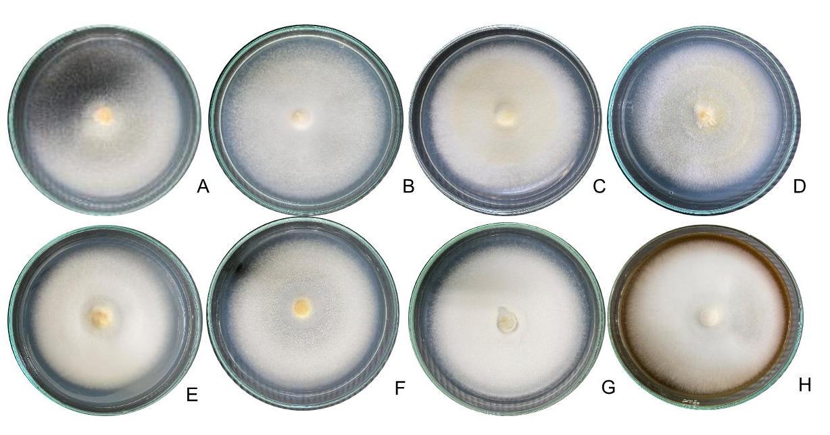

Figure 1. Mycelium growth of Cordyceps militaris grown on different carbon sources for 21 days after inoculation at 18 ºC.; A= Potato agar (PA, Control), B = PA + Glucose, C = PA + Fructose, D = PA + Lactose, E = PA + Maltose, F = PA + Sucrose, G = PA + brown sugar, and H = PA + Molasses

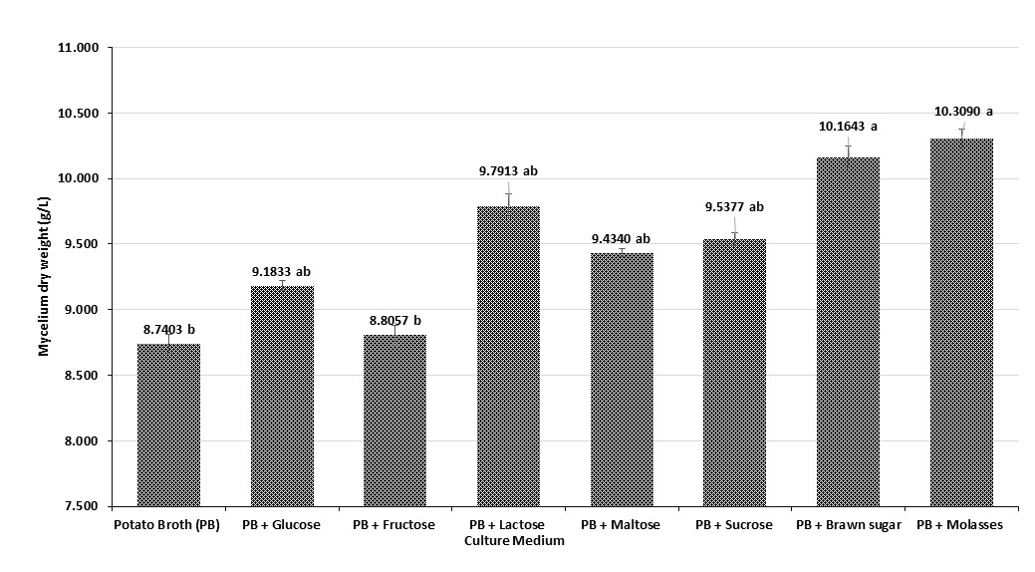
means followed by the same letter are not significantly different (DMRT, P >0.05).

Figure 2. The dry weight of Cordyceps militaris mycelium using different carbon sources under submerged culture conditions

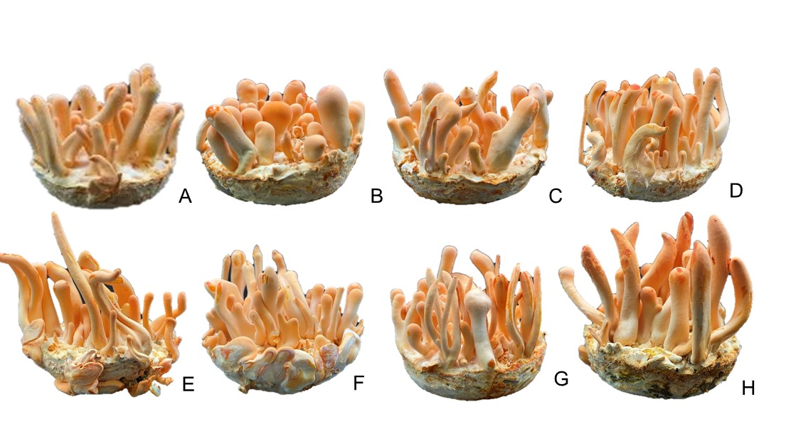

Figure 3. Fruiting body of Cordyceps militaris grown on different media; A= Rice (without sugar, Control), B = Rice + Glucose, C = Rice + Fructose, D = Rice + Lactose, E = Rice + Maltose, F = Rice + Sucrose, G = Rice + brawn sugar, and H = Rice + Molasses

