**Running Tittle:** The Effect of traditional smoking using local vegetable ingredients on

corn quality

**Post-Harvest Handling of Corn by Traditional Timorese Smoking Using Local Vegetable Ingredients and Their Effects on Nutritional Content, Shelf Life and Digestibility**

MM Endah Mulat Satmalawati1, Jefrianus Nino2*, Aloysius Rusae3*

*1,2,3 Department of Agricultural Technology, Universitas Timor Indonesia*

For correspondence: [mulatendah@gmail.com](mailto:mulatendah@gmail.com)

*Contributed equally to this work and are co-first authors

**Novelty statement**

The conventional smoking method has not been well designed so it is possible for quality degradation and damage to occur. Deterioration in quality is caused by improper smoking techniques such as time and duration of smoke and excessive heat. The existence of vegetable materials that have been identified as natural chemical secondary metabolites have potential as materials for smoking processes such as kirinyuh (*Chromolaena odorata*), gringsingan (*Hyptis suaveolens*), gamal (*Gliricidia sepium*) and kusambi (*Schleicera oleosa*) which are abundantly available and have not been widely used, especially for smoking corn and its studies are still very lacking.

**Abstract**

Smoking is one of the conventional corn-storing methods and local wisdom of Timorese people, specifically in the Timor Tengah Utara (TTU) Regency. There is still a possibility to experience a decrease in quality and damage during storage using the conventional smoking method. Nutritional quality is very important to be examined as a measure of corn quality during storage including digestibility. Therefore, shelf life research was carried out to determine the time limit for maintaining corn quality. The design used consisted of factor 1, namely four types of local vegetable ingredients including gamal, gringsingan, kirinyuh, and kusambi, and factor 2, which was two smoking frequencies of 1 and 2 times with observation parameters for macro and micronutrients. Also, shelf life was determined through the accelerated shelf life test (ASLT) method, as well as digestibility. The results showed that the application of local vegetable ingredients combined with smoking frequency had a significant effect on corn storage quality, particularly on macronutrients, proteins, and overall micronutrients. Corn smoked using gringsingan (*Hyptis suaveolens)* with a 2x frequency led to the longest shelf life at 126 days and increased digestibility.

**Keywords**: corn, smoking corn, shelf life, local vegetable ingredients

**Introduction**

Corn (*Zea mays* L) is one type of grain or cereal plant used as a food source for most of the world's population after rice. Corn superiority is due to its protein content which is not found in other types of carbohydrate sources e.g. tubers or cereals such as rice known as the staple food of society in general. Protein is an indispensable macronutrient due to being a building material besides its function as an energy substance once required or under certain conditions (Majid, 2015).

On Timor island, specifically in TTU Regency, corn is used as a staple food and animal feed. Following the concept of food security, each region must seek to optimize local food usage. Considering the importance of corn’s role, there is a need to carry out post-harvest handling efforts, namely good storage aimed to maintain quality. The local food expected to meet regional food security has not yet met the food safety aspect. Nutrient degradation of corn during storage affects the fulfillment of macronutrients, particularly protein which can function to support tissue growth. This is in line with stunting prevalence in the TTU Regency, and stunting is generally a growth failure due to long-term chronic malnutrition, specifically a lack of protein energy (Ihromi & Saputrayadi, 2020). Moreover, the prevalence in 2021 was quite high (25.6%) compared to the case in NTT as a whole (23.3%). The results of the Riset Kesehatan Dasar (Riskesdas) in 2018 showed that nationally stunting prevalence was 30.8% while Nusa Tenggara Timur (NTT) Province had 42.6%. This means the regional prevalence was higher than the national, hence public health problems are still a priority in human resources development food security in the food safety review is one of the sensitive interventions of national and regional policies in seeking to reduce stunting prevalence. In addition to macronutrients, the body requires the intake of micronutrients that function as metabolic regulators. The main minerals needed include Ca, P and Fe and if there is a deficiency of these minerals will cause system disturbances in the body. The availability of food that maintains its nutritional quality is the main target in achieving food security.

Smoking is a method of storing corn in accordance with the Timorese traditional wisdom which has been passed from one generation to another. Smoke is obtained from the process of burning dry wood or corn cobs. A decrease in quality is caused by improper smoking techniques such as the time and duration of providing smoke and excessive heat. Damage to nutrients increases once heating lasts a long time, hence smoking can reduce foodstuffs’ nutritional value due to the chemical reactions produced (Suroso *et al*., 2018).

TTU people usually store smoked corn for a long period (1-1.5 years) to meet food needs before the next planting season. The possibility of a decrease in corn nutrients during storage affects the fulfillment of macro or micronutrients. Each processed product or food ingredient has a certain shelf life (expiration date) to ensure that the nutritional content is maintained. Shelf life analysis describes how long a product can last at the same quality during the storage process. During the product’s shelf life, the nutritional content, physical appearance, taste, and function must be maintained, and it ought to be safe for consumption (Al-Kadamany *et al*., 2003).

The conventional smoking method has not overcome the corn damage experienced during storage specifically due to pest attacks, and the less optimal design facilitates the quality reduction and damage. The application of chemicals as pesticides is not recommended because contamination of the product causes less safety for consumption. One alternative for chemical pesticides is the use of abundantly available plant materials that have the potential as natural pesticides. In the concept of food security, apart from quantity, quality must also be met, which includes food safety. According to Da Lopez *et al*., (2008) ; Eze and Jayeoye (2021) and Panche *et al*., (2016) vegetable extracts used in corn storage have a good effect on controlling corn powder pests (Sitophillus zeamais). It is estimated that some local plants in NTT can be used as botanical insecticides, so they are expected to be able to assist farmers in controlling pests and diseases and handling post-harvest.

In this research, corn smoking was examined using local vegetable ingredients containing identified natural chemicals of secondary metabolites that have fumigant potential and are expected to suppress the quality decline encountered during storage. Vegetable ingredients such as kirinyuh (*Chromolaena odorata*), gringsingan (*Hyptis suaveolens*), gamal (*Gliricidia sepium*), and kusambi (*Schleicera oleosa*) are available in abundance, but not yet used for smoking corn because the conventional method is still carried out according to daily processing activities (Fig.1).

**Materials and Methods**

Local corn samples (*Pen muti*) as well as kirinyuh, kusambi, gamal, and gringsingan were obtained from Taekas Village, Kecamatan Miomafo Timur, TTU Regency. Aquades, K2S2O4, HgO, H2SO4, K2S, 50% NaOH, HCl, HNO3, and HClO4 were used for macro-micro nutrients analysis besides the chemicals for in vitro resistant starch analysis.

**Corn smoking**

In this research, corn was smoked according to existing local wisdom using a completely randomized design (CRD) consisting of two factors. The first was the type of vegetable material (N), namely gamal (N1), gringsingan (N2), kirinyu (N3), and kusambi (N4). The second was the smoking frequency (P) which consisted of 1x (P1) and 2x (P2). From both factors, there were eight treatment combinations, including N1P1, N2P1, N3P1, N4P1, N1P2, N2P2, N3P2, and N2P4, with three replications each to make 24 experimental units. As a control, conventional smoking was carried out in accordance with traditional wisdom (Fig.2).

**Determination of moisture content and macronutrients**

The moisture content of smoked corn was determined by thermogravimetry method used oven at 105 ºC until a constant weight was obtained (AOAC, 1990). The crude protein was measured by converting the nitrogen content determined by Kjeldahl̕s method (6.25 × N), fat content was determined using the soxhlet system, and carbohydrate was measured by "carbohydrates by difference" methods (AOAC, 1990).

**Mineral analyses**

For analyses of mineral content, the samples were digested in HNO3/HClO4. The Ca and Fe elements were measured by atomic absorption spectrophotometry (AAS) using a Varian spectra atomic absorption spectrophotometer model A-400 ContrAA300 JENA (Jamali *et al*., 2021). Phosphorus (P) was also evaluated by a spectrophotometer (Shimadzu UV 1800) after the samples' color development in Barton solution. The results were expressed as absorbance at 430 nm, while the elements in question were determined with standard curves (Lewu, 2009; Uran and Gokoglu, 2014).

**Resistant Starch analyses**

Resistant starch (RS) was determined by in vitro method (Goni *et al*., 1996).

**Determination of the shelf life of smoked corn using the Arrhenius curve**

The ASLT method was employed to analyze shelf life through an environmental condition that can accelerate the food deterioration reaction with a critical moisture content approach applied to dry products using water content parameters or water activity as expiration criteria (Al-Kadamany *et al*., 2003; Bai *et al*., 2017; Herawati, 2008). Smoked corn husks were stored and conditioned at a certain temperature (100C, 250C, 400C, and 550C), then an increase in water content was observed (Fig. 3).

**Statistical analysis**

All results showed variance (ANOVA) at a 0.05 (5%) probability level. Their means were compared through the Duncan test using the Statistical Package of Social Science (SPSS 20.0 version).

**Results**

**Shelf Life**

The initial moisture content of corn smoked using the conventional method was 11.81% during storage and later increased to 19.36%. Meanwhile, the lowest increase in water content (1.02%) was produced from smoking with local vegetable ingredients (Kusambi), namely from 11.54% to 12.58%. The results also showed that smoking corn using kusambi, gringsingan, and gamal led to a more controlled increase in water content than kirinyu which caused a 4.20% increase during storage (Fig. 4).

Based on the moisture content data at various storage conditions, the shelf life of smoked corn can be determined through the mathematical calculation of the Arrhenius curve with the function 1/T (temperature) and Ln k (slope of the equation resulting from the measured moisture content of each storage condition). The normal logarithm equation as a function of shelf life calculation was obtained as demonstrated in Fig. 5a and 5b.

Corn smoking treatment with a 2x frequency using gringsingan vegetable ingredients led to the longest shelf life (126 days or 4.2 months), while the shortest was generated from the kirinyu combination with 1x frequency (60 days). This was still longer than the shelf life obtained from the conventional method, namely 63 days or 1.7 months. The mathematical calculation results of the shelf life of corn smoked both conventionally and using vegetable ingredients can be correlated with the tendency of increasing water content during storage where the previous data showed smoking with a 1x frequency and kirinyu tends to increase water content quite quickly.

Smoking using gringsingan (*Hyptis suaveolens*) and kusambi (*Schleicera oleosa*) with a 2x frequency tends to produce a longer shelf life compared to other treatment combinations. During the storage period, both treatments showed a relatively low increase in water content. Gamal (*Gliricidia sepium*) and kirinyu (*Chromolaena odorata*) with 1x smoking frequency yielded a shelf life equivalent to the conventional method (60-63 days) (Fig. 6).

**Macronutrient (Protein, Carbohydrate and Fat content)**

Protein is one of the macronutrients with a higher presence in corn than in other cereals. The results showed that the use of local vegetable ingredients combined with smoking frequency had a significant effect on corn protein content. Using local greens gringsingan with a 1x frequency produced the greatest increase in protein content among other treatments. The initial protein content of corn after being harvested was 7.9%. This increased to 10.52% (which was the highest) once smoked with gringsingan at 1x, as well as to 10% while using kusambi at the same frequency. Gamal and kirinyu in combination with a 2x smoking frequency elevated the increase protein content. Kirinyu treatment with 2x frequency increased the original content to 10.12%, but at 1x it produced the lowest content of 7.17%, which was lesser than before smoking. Smoking corn using local vegetable ingredients tends to increase protein levels (Fig. 7).

Other macronutrients such as carbohydrates was determined using calculations "by difference", hence it is influenced by several factors, namely water, ash, fat, and protein content. The combination of gringsingan with 1x smoking treatment led to the lowest carbohydrate content (70,31%) where the previous parameter produced the highest protein content. Smoking corn using kirinyu with a frequency of 2x also resulted in a relatively lower carbohydrate content compared to other treatments with a percentage of 70,4% (Fig. 8).

Apart from protein and carbohydrates, other macronutrients are from the fat group. Fat content presence often affects the shelf life of corn. It is one of the macronutrients producing greater energy than carbohydrates and protein, but on the other hand, the fat tends to be more easily damaged through oxidation reactions by water and oxygen. Smoked corn with low-fat content was discovered to have a tendency for longer shelf life. The use of local vegetable ingredients, specifically gringsingan, with a 2x smoking frequency, generated the longest shelf life. Meanwhile, smoked corn with relatively higher fat content tends to have a shorter shelf life as seen in the combination of gamal with 1x and kirinyu with 2x treatment (Fig. 9).

**Micronutrient (Ca, P and Fe Content)**

The combination of gamal with 2x smoking produced the highest Ca content (19.74 mg/kg). Meanwhile, the use of local vegetable ingredients, both with 1x and 2x frequency, increased calcium levels (19.2 mg/kg). Corn after being harvested contains 14.59 mg/kg Ca and the conventional smoking process has no impact on increasing Ca levels. The results showed smoking corn using local vegetable ingredients tended to elevate Ca levels in the range of 14.75 mg/kg to 19.74 mg/kg (Fig.10).

While the analysis of P levels showed the P content in early corn or before smoking of 2714.41 mg/kg decreased by 51.27% to 1322.84 mg/kg due to a combination of kusambi with 2x treatment frequency. Meanwhile, a sharp decline of 35.74% occurred from using conventional methods, making the P content to become 1744.23 mg/kg. The results showed that P levels in corn could be maintained or decreased by a relatively low percentage (4.78%) from the kirinyu treatment with 1x frequency to produce a P content of 2584.7 mg/kg. Overall, smoking using gamal and kirinyu led to a lower decrease in P levels (4.78-8.85%) compared to gringsingan and kusambi with a reduction of 17.45-51.27% (Fig. 11).

In contrast to the results of P analysis, the results showed that smoking both conventionally and using local vegetable ingredients tended to increase Fe levels. Kusambi with 2x treatment frequency increased Fe to 51.87 mg/kg from the original level of 14.01 mg/kg. Smoking corn using local vegetable ingredients can relatively stimulate the presence of iron, especially using kusambi leaves (*Schleicera oleosa* ) combined with 2x smoking frequency which can produce iron-rich smoked corn (Fig. 12).

**Resistant Starch (RS)**

Analysis of macro and micronutrients is complemented by the RS test to determine the level of digestibility of smoked corn both conventionally and using local vegetable ingredients. Conventional smoking produces 23.04 g of RS and tends not to change the initial content in corn, namely 23.25 g. The application of local vegetable ingredients, specifically gringsingan at a 2x frequency is the treatment that generated the longest shelf life. This led to a decreased RS with a 19.47 g value lower than the initial content in corn before smoking and after using the conventional methods (Fig. 13).

**Discission**

Corn smoking is a form of post-harvest handling practice with one of the objectives being to control moisture content during storage. Water content plays a role in determining corn shelf life because it is a medium for the growth of microbes that can cause seed damage. To test the shelf life, data were collected on the increase in corn water content at various storage conditions with different temperatures (100C, 250C, 400C, and 550C). The results of storage at room temperature (250C) showed a faster increase in moisture levels on day 28 in conventional smoking methods compared to using local plant materials.

Smoking with conventional methods is more directed at the transfer of heat generated from the wood-burning process for daily kitchen activities. This is adjusted to the local community's daily activities to ensure not being limited to the number of times the smoking is carried out, which can hasten the water content reduction for the corn to become drier. Materials with drier conditions will more easily absorb water from their environment during storage, hence corn smoked with conventional methods tends to increase in water content which is quite high when stored.

Water content also affects the macronutrient content, the increased protein content is thought to be due to a decrease in the moisture content of corn during smoking. Tenyang *et al*., (2022) explained that the decrease in moisture content in cooked including the smoking process has been described as the change that makes the lipid and protein increased.

Proteins can undergo a denaturation caused by heat, extreme acid or alkaline conditions, and the addition of saturated salts (Novia *et al*., 2011). The results showed a tendency for higher protein content produced from vegetable ingredient treatments compared to conventional smoking which was more directed towards heat transfer due to the burning process of kitchen activities carried out by the community. The decrease in protein content can also be initiated by several factors, for example the change in amino acid structure due to heating which can damage nutritional components, specifically the proteins and carbohydrates. Protein degradation is capable of leading to the formation of short-chain peptides, amino acids, and volatile ammonia (Syarif *et al*., 2017).

According to Fatkurahman and Atmaka (2012), the heating process of foodstuffs can increase carbohydrate availability, as seen in conventional smoking which produces higher levels of carbohydrates compared to local vegetable ingredients, except for kirinyu applied at a 1x frequency. Heating for too long will decrease anti-nutritional compounds and increase the availability of nutrients, including carbohydrates (Sundari and Astuti Lamid, 2015). Smoking treatment with vegetable materials tends to decrease carbohydrate content. This can be caused by the increase in corn water content during storage which can provide opportunities for more complex interactions of the chemical components. The interaction result promotes the formation of new compounds and can lead to a reduction in other components such as carbohydrates.

Conventional smoking of corn involving more heat transfer from the process of burning wood or other materials in daily activities tends to elevate fat content while using fresh vegetable ingredients can lead to fat increase or decrease. This resulting increase is explained by Tenyang *et al*., (2022) where water evaporation occurs because of the smoking process to augment the presence of other components, such as fat.

An analysis of micronutrients that are important for the body such as Ca, P and Fe is also carried out. The body needs calcium in larger amounts than other micronutrients. Corn quality from the smoking process can be observed with the presence of micronutrients that are maintained. The results showed a tendency to increase Ca levels of the corn smoked using local vegetable ingredients. According to Gokoglu *et al*., 2004 and Tenyang *et al*., (2020), smoking tends to increase calcium levels in fish more than boiling. Calcium is needed for the fulfillment of micronutrients in the body, particularly for building bones and teeth, as well as regulating the processes in the blood and tissues. Based on the data and tests carried out, the corn smoking method using gamal, gringsingan, kirinyu, and kusambi can improve corn quality by increasing mineral Ca availability as one of the necessary micronutrients.

In contrast to Ca which increases with the smoking process using local vegetable ingredients, the phosphorus (P) content seems to show a decreasing trend. During the smoking process it is possible to accumulate heat which can cause a decrease in the phosphorus content of corn. According to Lewu (2009) a significant decrease in mineral levels, especially phosphorus, potassium and zinc in Colocasia esculenta (L.) Schott occurred after the heat treatment cooking process was carried out.

According to Natekar *et al*., (2022), iron (Fe) is classified as a micronutrient due to being needed in relatively small amounts in the body. However, the presence is very important because it participates in blood and hemoglobin formation as O2 and CO2 carriers, and a catalyst. Fe also plays a role in the synthesis of purines which are part of DNA/RNA. The importance of the role of iron as one of the micronutrients for the health of the body must be fulfilled from food intake.

Starch can be classified into three, namely fast digestible starch (RDS), slowly digested starch (SDS), and resistant starch (RS) according to glucose release and absorption rate in the gastrointestinal tract (Chung *et al*., 2009). RS cannot be digested by the small intestine but is fermented in the large intestine. Its health benefits have been reported as colon cancer prevention, hypoglycemic effect, a substrate for the growth of probiotic microorganisms, gallstone formation reduction, hypocholesterolemic effect, fat accumulation inhibition, and increased mineral absorption (Sajilata *et al*., 2006). The potential health benefits of SDS are related to stable glucose metabolism, diabetes management, mental performance, and satiety (Lehmann and Robin, 2007). Among granular starches, maize, waxy maize, sorghum, and legume starches have been shown to contain high amounts of SDS due to optimal grain size interactions and interactions with proteins or other ingredients (Lehmann and Robin, 2007; Zhang *et al*., 2006).

The RS decline can be correlated with the reduction in carbohydrate content in the previous parameter where corn smoked with gringsingan at a 2x frequency has a relatively lower carbohydrate content compared to other treatments, while decreased RS levels can indicate increased digestibility.

**CONCLUSION**

The application of local vegetable ingredients combined with smoking frequency had a significant effect on corn storage quality, particularly on macronutrients, proteins, and overall micronutrients. Corn smoked using gringsingan (*Hyptis suaveolens)* with a 2x frequency led to the longest shelf life at 126 days and increased digestibility.

**Acknowledgments**

The first author acknowledges the financial grant from LPPM of Universitas Timor, Nusa Tenggara Timur, Indonesia.

**Author Contributions**

MMEM planned the experiments and interpreted the results, JN and AR made the write up statistically analyzed the data and made illustrations

**Conflict of Interest**

All authors declare no conflict of interest

**Data Availability**

Data presented in this study will be available on a fair request to the corresponding author

**Ethics Approval**

Not applicable to this paper

**References**

Al-Kadamany, E., Khattar, M., Haddad, T., Toufeili, I. (2003). Estimation of shelf-life of concentrated yogurt by monitoring selected microbiological and physicochemical changes during storage. *LWT* *36*(4):407–414.

AOAC. (1990). *AOAC*.

Bai, Y. P., Guo, X. N., Zhu, K. X., Zhou, H. M. (2017). Shelf-life extension of semi-dried buckwheat noodles by the combination of aqueous ozone treatment and modified atmosphere packaging. *Food Chemistry* 237: 553–560.

Chung, H. J., Liu, Q., Hoover, R. (2009). Impact of annealing and heat-moisture treatment on rapidly digestible, slowly digestible and resistant starch levels in native and gelatinized corn, pea and lentil starches. *Carbohydrate Polymers* 75(3):436–447.

Da Lopez, Y. F., Boboy, W. (2008). The effectiveness of extracts of some local vegetable ingredients as vegetable pesticides in controlling corn pests *(Sitophylus zeamays)*. *Jurnal Partner* 15: 231-237.

Eze, F. N., Jayeoye, T. J. (2021). Chromolaena odorata (Siam weed): A natural reservoir of bioactive compounds with potent anti-fibrillogenic, antioxidative, and cytocompatible properties. *Biomedicine and Pharmacotherapy* 141:1-11

Fatkurahman, R., Atmaka, W. (2012). The sensory characteristics and physicochemical property of cookies with black rice bran (Oryza sativa L.) and maize (Zea mays L.) flour Substitution. *Jurnal Teknosains Pangan* 1(1):49-57

Goni, I., Garcia-Diz, L., Ma, E., Saura-Calixto, F. (1996). Analysis of resistant starch: a method for foods and food products. *Food Chemistry* 56 (4): 445-449.

Gokoglu, N., Yerlikaya, P., Cengiz, E. (2004). Effects of cooking methods on the proximate composition and mineral contents of rainbow trout (Oncorhynchus mykiss). *Food Chemistry* 84(1):19–22.

Herawati. (2008). Penentuan Umur Simpan Pada Produk Pangan. *Jurnal Litbang Pertanian* 27 (4):124–130.

Jamali, S., Khoso, M. A., Zaman, M. H., Jamil, Y., Bhutto, W. A., Abbas, A., Mari, R. H., Kalhoro, M. S., Shaikh, N. M. (2021). Elemental analysis of kohl using laser ablation and atomic absorption spectroscopy (AAS) techniques. *Physica B: Condensed Matter* 620: 1-7

Lehmann, U., Robin, F. (2007). Slowly digestible starch - its structure and health implications: a review. *Trends in Food Science and Technology* 18(7): 346–355.

Muinat N. Lewu, P. O. A. A. J. A. (2009). Effect of cooking on the mineral and antinutrient contents of the leaves of seven accessions of Colocasia esculenta (L.) Schott growing in South Africa. *Journal of Food, Agriculture & Environment* 7: 358–361.

Natekar, P., Deshmukh, C., Limaye, D., Ramanathan, V., Pawar, A. (2022). A micro review of a nutritional public health challenge: Iron deficiency anemia in India. In *Clinical Epidemiology and Global Health* 14:1-5

Novia, D., Melia, S., Ayuza, N. Z. (2011). Kajian suhu pengovenan terhadap kadar protein dan nilai organoleptik telur asin. *Jurnal Peternakan* 8 (2): 70-76

Panche, A. N., Diwan, A. D., Chandra, S. R. (2016). Flavonoids: An overview. In *Journal of Nutritional Science*, 5. Cambridge University Press.

Sajilata, M. G., Singhal, R. S., Kulkarni, P. R. (2006). Resistant starch - A review. In *Comprehensive Reviews in Food Science and Food Safety* 5 (1):1–17.

Sundari, D., Astuti Lamid (2015). Pengaruh proses pemasakan terhadap komposisi zat gizi bahan pangan sumber protein. *Media Litbangkes* 25 (4): 235-242.

Suroso, E., Utomo, T. P., Hidayati, S., Nuraini, A. (2018). Pengasapan Ikan Kembung menggunakan Asap Cair dari Kayu Karet Hasil Redestilasi. *Jurnal Pengolahan Hasil Perikanan Indonesia* 21(1): 42-47

Syarif, W., Holinesti, R., Faridah, A., Fridayati, L., Ilmu, J., Keluarga, K. (2017). Analisis kualitas sala udang rebon. *Jurnal Teknologi Pertanian Andalas* 21(1): 45-51

Tenyang, N., Mawamba, L. A., Ponka, R., Mamat, A., Tiencheu, B., Womeni, H. M. (2022). Effect of cooking and smoking methods on proximate composition, lipid oxidation and mineral contents of *Polypterus bichir bichir* fish from far-north region of Cameroon. *Heliyon* 8(10)

Tenyang, N., Ponka, R., Womeni, H. M. (2020). Effect of local hot smoking on proximate composition, lipid oxidation, fatty acid profile and minerals content of Chrysichthys nigrodigitatus from Lake Maga in Cameroon. *International Journal of Biological and Chemical Sciences* 14(4):1124–1127.

Uran, H., Gokoglu, N. (2014). Effects of cooking methods and temperatures on nutritional and quality characteristics of anchovy (Engraulis encrasicholus). *Journal of Food Science and Technology* 51(4): 722–728.

Zhang, G., Venkatachalam, M., Hamaker, B. R. (2006). Structural basis for the slow digestion property of native cereal starches. *Biomacromolecules* 7(11): 3259–3266.

d

a

c

b

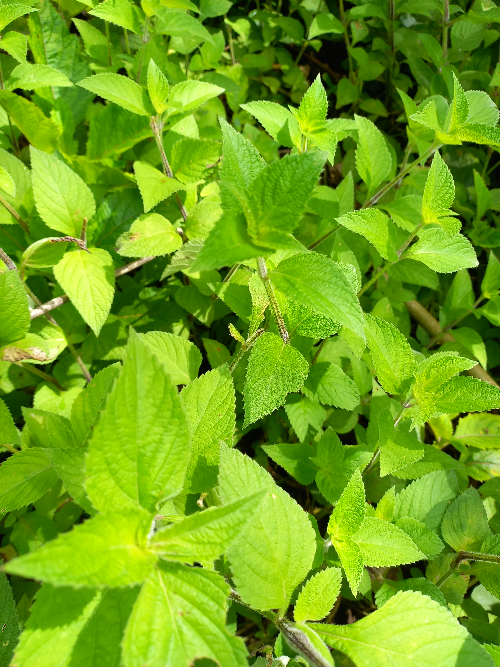

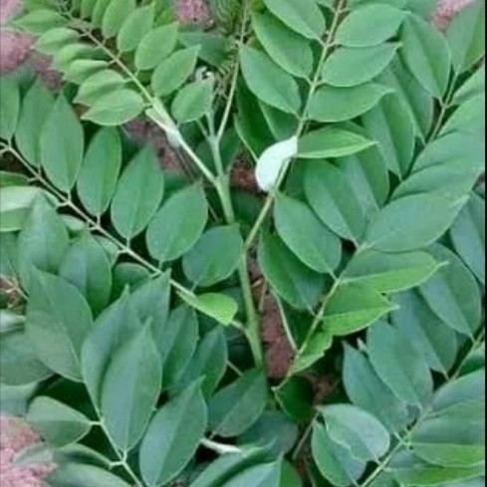

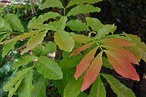

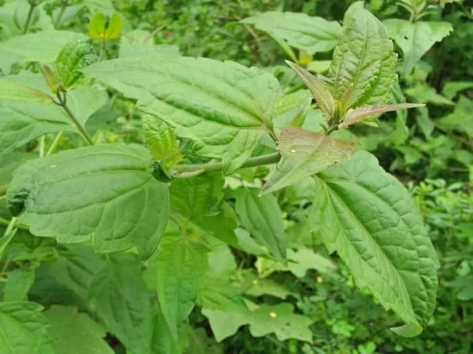

**Fig. 1.** The Local vegetable ingredients : a) kirinyuh (*Chromolaena odorata),* b) kusambi (*Schleicera oleosa*), c) gamal (*Gliricidia sepium*)

d) gringsingan (*Hyptis suaveolens)*

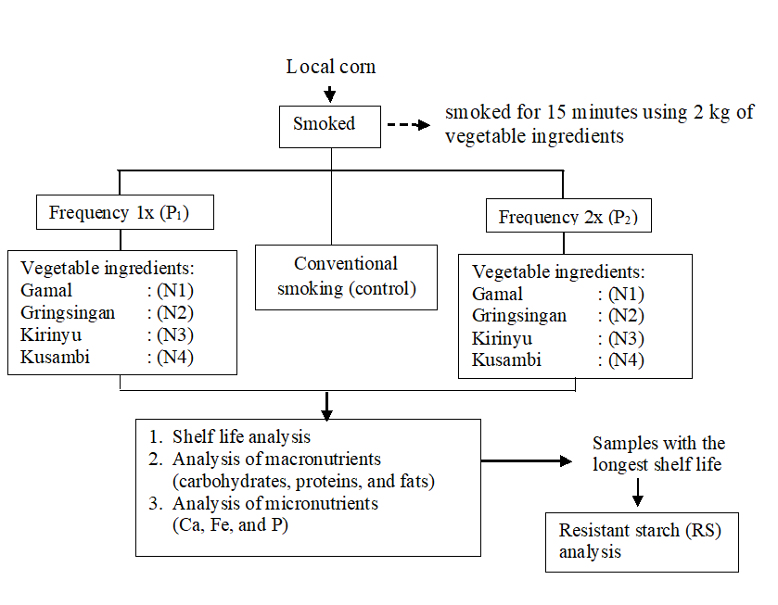

**Fig. 2.** The scheme of corn smoking using local vegetable

ingredients



**Fig. 3.** Flowchart for determination of the shelf life of smoked corn

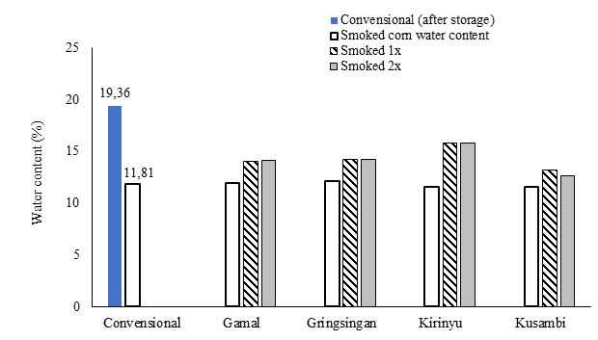

**Fig. 4.** Moisture content of smoked corn for 28 days at room temperature

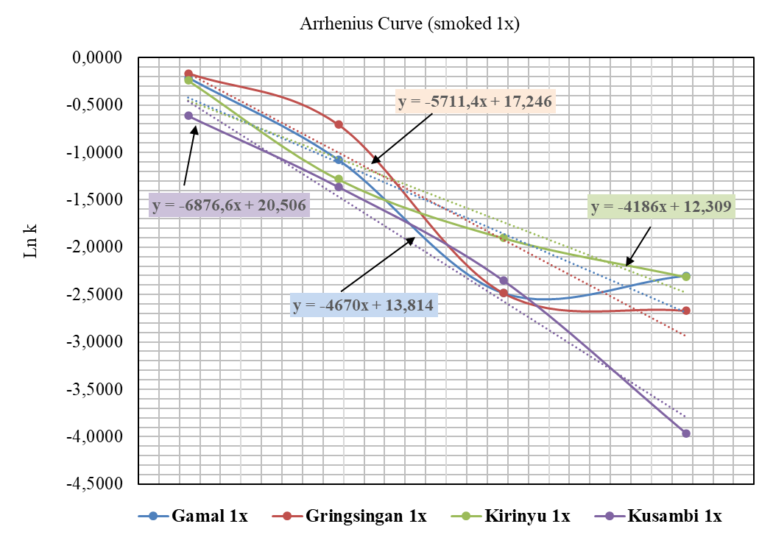

**Fig. 5a.** Arrhenius curve at smoking frequency 1x

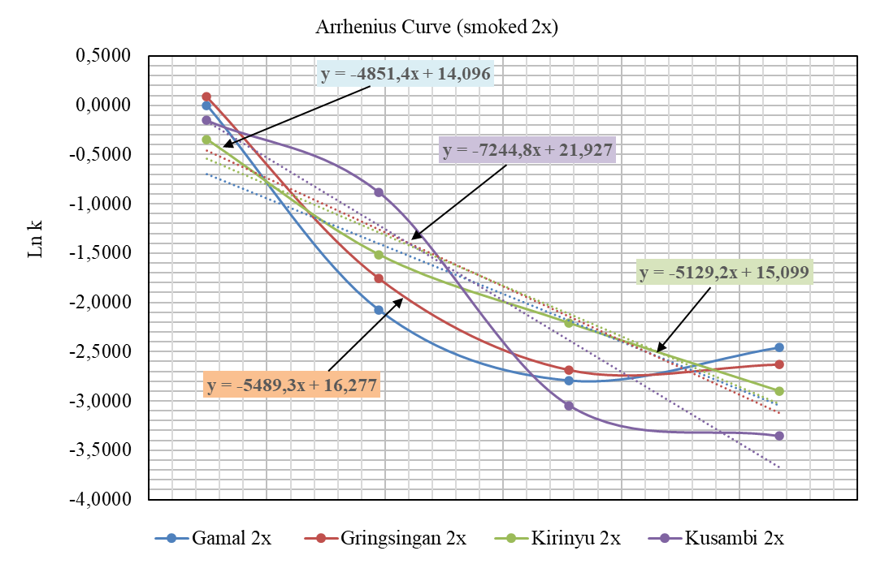

**Fig. 5b.** Arrhenius curve at smoking frequency 2x

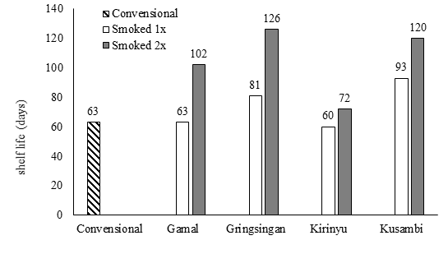

**Fig. 6.** Comparison of shelf life of corn smoked conventionally

and using local vegetable ingredients

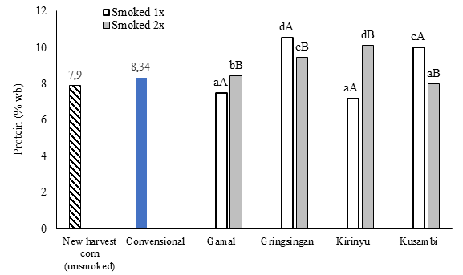

**Fig. 7.** Comparison of protein content of corn smoked

conventionally and using local vegetable ingredients

(The same letter indicates not significant at the 95% confidence level

a,b,c: local vegetable ingredients ; A,B,C: smoking frequency)

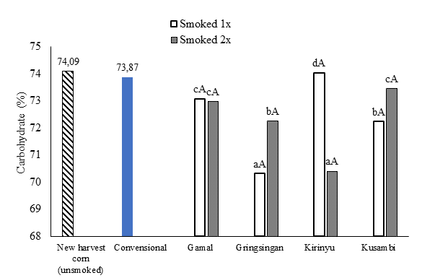

**Fig. 8.** Comparison of carbohydrate content of corn smoked

conventionally and using local vegetable ingredients

(The same letter indicates not significant at the 95% confidence level

a,b,c: local vegetable ingredients; A,B,C: smoking frequency)

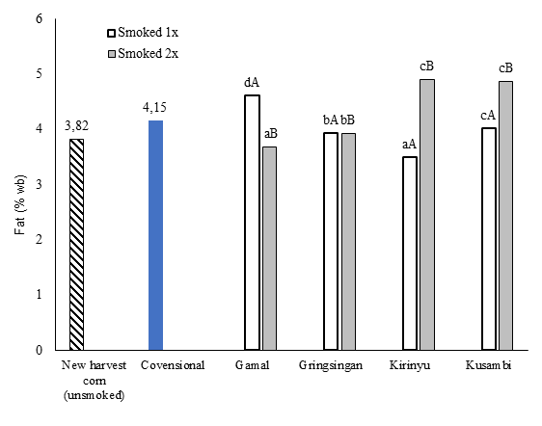

**Fig. 9.** Comparison of fat content of corn smoked conventionally

and using local vegetable ingredients

(The same letter indicates not significant at the 95% confidence level

a,b,c: local vegetable ingredients ; A,B,C: smoking frequency)

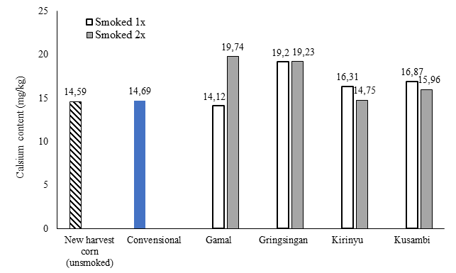

**Fig. 10.** Calcium content of corn smoked conventionally

and using local vegetable ingredients

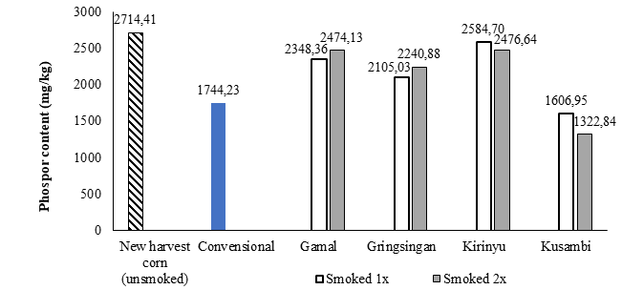

**Fig.11.** Phosporous content of corn smoked conventionally and

using local vegetable ingredients

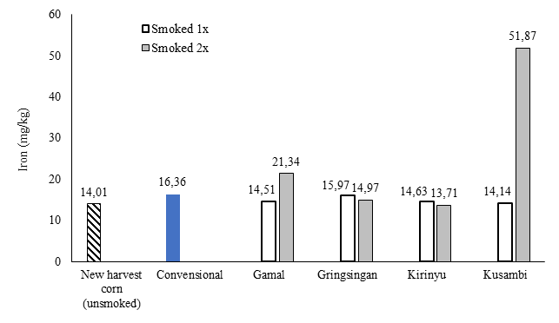

**Fig. 12.** Iron content of corn smoked conventionally and

using local vegetable ingredients

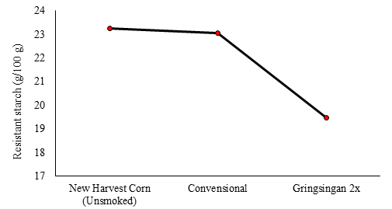

**Fig. 13.** Reducing resistant starch levels in smoked corn using

local vegetable ingredients