**Manuscript type: original article**

**Title** Ets proteins significance in breast cancer progression: a meta-analysis.

**Running Title:** Ets protein in Breast cancer

**Authors:**

Sidra Mumtaz : Writing, software analysis, methodology

Sidra Arshad: literature search, software analysis

Naila Malkani: Conceptualization, study design and supervision

Department of Zoology, GC University, Katchery Road, Lahore, Pakistan.

**Corresponding Author:**

Dr. Naila Malkani

Assistant Professor,

Department of Zoology,

GC University, Lahore, Pakistan.

Email: [nailamalkani@gcu.edu.pk](mailto:nailamalkani@gcu.edu.pk)

Contact: +923331491708

**Novelty statement**: In this study we have done a meta-analysis for the first time demonstrating the association of Ets proteins and development of breast cancer. Our results have explained that Ets factors especially Ets-1 can be associated to the breast cancer. It is important to mention here that expression of these proteins is more significant during the metastasis stage of the disease rather than disease onset.

# Abstract:

# Objectives: Numerous studies have identified members of Ets transcription factors family showing aberrant expression in various stages of tumor formation in breast tissue. However their use as prognostic factor is not very clear. Therefore, a metaanalysis was performed to analyze their involvement in breast tumorigenesis.

# Methods: A thorough literature search was performed and relevant studies were identified. Random effect model was applied and correlation was calculated using odd ratios (OR) at 95% confidence intervals (CI).

# Results: Twenty six studies covering 4553 subjects were included. Combined OR calculated showed a significant relation between Ets factor expression and breast cancer risk (OR=3.185, 95% CI=2.161–4.69, p<0.001). In subgroup analysis Ets-1 over expression was found highly associated (OR=2.149, 95% CI=1.141–4.048, p= 0.018) with breast cancer as compared to other Ets factors. Funnel plots confirmed no publication bias.

# Conclusions: Our study suggested Ets over expression (especially Ets-1) might indicate increased progression rate of breast cancer. However, to make conclusive statement further investigations and clinical trials are needed.

**Keywords:** Meta-analysis; Ets transcription factors; Ets-1; Breast cancer, random analysis model.

# Introduction

Breast cancer is the most common cause of cancer related deaths in women all over the world. It is a multifactorial disease that has many environmental and genetic causes (Autorino et al.,2007). Combination of genetic abnormalities and environmental factors decide about the fate of spreading tumor. Angiogenesis play a critical part in metastasizing a cancer as blood vessels are required for the nutrient supply to the growing tumor for stabilization and maintenance (Anothaisintawee et al., 2013).

An important role in angiogenesis is performed by a family of transcription factors known as ETS family which has significance also in cancer initiation and progression (Folkman et al., 1995). A number of genes from this family have atypical expression during various stages of breast cancer (Hsu et al., 2004). ETS proteins, a family of mitogen activated protein kinase (MAPK), are highly conserved proteins with a unique winged helix turn helix DNA binding domain (Buggy et al., 2006). ETS is divided into 12 subfamilies or sub groups on the basis of ETS binding domain (EBD) sequence homology. These subgroups are ETS, ERG, PEA3, ETV-2, TCF, GABP, SPI, ELF, ERF, TEL, PDEF and ESE (Macleod et al., 1992).

The conversion of ETS factors from normal to oncogene is important in cancer progression. Many studies show that about three ETS proteins can bind to one eukaryotic gene at a time. So an individual ETS factor is not related in progression of cancer but a dynamic regulatory network of multiple factors is involved in disease progression. ETS family members are related to breast carcinoma by their increased or reduced expression. This abnormality in expression leads to migration, invasion, angiogenesis, cell growth and adhesion. They interact with other transcriptional factor like p53, N-MYC, GATA and disturb cell homeostasis. Chromosomal alterations and rearrangements like gene amplification, deletions and translocations in ETS family genes lead to abnormal expressions. Several dysregulations in breast cancer include upregulation of ETS-1, increased level of PEA-3 along with HER-2 overexpression of ESE-1 in invasive ductal carcinoma and reduced expression of PDEF and FLI-1 in invasive breast cancer tissues (Watson et al., 2020).

Diverse results of multiple studies related to a medical question often make clinical decisions difficult. Same is true in this case as there are quite a number of studies with different results which make it difficult to formulate a statement about the role of ETS factors in breast cancer. Therefore, a meta-analysis was performed to collect information from different studies and determine relationship between ETS factors and breast cancer.

**Methods**

## Literature Search Strategy:

Electronic search was performed in databases, PubMed and Google Scholar for identification of the studies related to ETS transcription factor expression in breast cancer. Key words used were “ETS transcription factors; ETS expression; Breast cancer; Breast carcinoma and Breast tumors”. All ETS transcription family factors were also searched individually. Studies published before December 2017 were included while there was no lower date limit. Appropriate references of retrieved studies were also searched for data.

## Selection criteria:

For selection of literature following criteria were followed; (i) Only original and independent studies were included for analysis (ii) Samples used in the study were of human breast tissue or human breast cell line (iii) Patients must be diagnosed originally with breast malignancy (iv) Expression of ETS transcription factor must be checked (v) Number or percentage for positive expression of ETS or odds ratio with 95% Confidence Interval must be mentioned. Studies lacking this information, having samples taken from other than human breast tissue like mice or rabbit etc. and review articles were excluded from analysis.

## Literature retrieval and Data Extraction

Total of 250 articles were selected as a result of preliminary search through databases. Out of these, 177 studies that were irrelevant to our research were excluded from further evaluation. 73 relevant studies were assessed at abstract level. 58 retained studies were assessed for further full text assessment. After full text assessment 26 studies were selected for performing meta-analysis in which complete required information was given.

Data extracted from selected articles included first author name, year of publication, country where study was conducted, name of ETS transcription factor, mean age of patients (if mentioned), number of breast tissue samples and positive expression of ETS transcription factor in both cancer and normal tissue, odds ratio with upper and lower limit with 95% confidence interval (CI), methods of expression analysis like immunohistochemistry, western blotting, qPCR etc., relation or effect of ETS factor on other genes expression like HER2 positive etc., and type of breast cancer. Supplementary data was also retrieved if required information was not mentioned in the article.

Statistical analysis:

The expression of ETS transcription factors was measured by calculating odds ratio and standard error. For analyzing the significance of expression, forest plot for random effect model was used. Weight and residual of each study used in meta-analysis was also calculated. A subgroup analysis was performed on the individual Ets factor family members. Bias in studies was checked by funnel plots followed by Egger’s regression and Begg-Mazumdar test. Heterogeneity within the study was estimated using I-squared (Oikawa et al., 2003) and between the study variation was checked by the Tau2 statistics (Krishnamoorthy et al., 2014). All calculations were done with Comprehensive Meta-Analysis Version 3.0.

**Results**

## Literature retrieval

After thoroughly analyzing 250 studies finally 26 studies were selected for performing meta-analysis in which complete required data was given (Figure 1). Table S1 summarizes the characteristics of the included studies. In 10 studies the expression of ETS factor was analyzed at mRNA level ((Benz, O'Hagan et al. 1997; Ghadersohi and Sood 2001; Kinoshita, Kitamura et al. 2002; Span, Manders et al. 2002; Tognon, Knezevich et al. 2002; Bièche, Tozlu et al. 2004; Chotteau-Lelièvre, Révillion et al. 2004; Katayama, Nakayama et al. 2005; Buchwalter, Hickey et al. 2013; Kar and Gutierrez-Hartmann 2017)), in 14 studies it was at protein level ((Behrens, Rothe et al. 2001; Mitas, Mikhitarian et al. 2002; Fleming 2004; Myers, Hill et al. 2005; Myers, Hill et al. 2006; Xia, Lien et al. 2006; Sood, Saxena et al. 2007; Turcotte, Forget et al. 2007; Sood, Wang et al. 2009; Zhang, Yan et al. 2011; Laliotis, Vrekoussis et al. 2013; Mesquita, Lopes et al. 2013; Puzovic, Brcic et al. 2014; Yuan, Dai et al. 2014)) while in remaining 2 studies expressions was analyzed both at mRNA and protein (Yuan et al., 2014). Studies included in this systematic review illustrate eleven ETS transcription factors having important role in breast cancer. These ETS transcription factors are ETS-1, ETS-2, ELK-1, ERM, ETV-4, PDEF, ELF-3, ETV-6, ETV-3, SPDEF and ELK-4. All studies were about single ETS transcription factor except Myers et al. and Mesquita et al. in which more than one ETS factor was evaluated. Individual study sample size ranged from 13-364 patients. Mean patient age was 48-64 years. In two studies odds ratio was directly calculated (24, 29). In most studies RT-PCR was used to evaluate mRNA expression (8,9,10,11,12,13,14,15,16,32), while for protein analysis immunohistochemistry (17, 18, 31, 19, 4, 21, 22, 26, 27, 28, 29, 30),western blotting (17, 31, 23, 24, 25)ELISA (4, 31)and other methods (8, 20) were used. Most common types of carcinoma in selected studies were ductal and lobular invasive carcinomas. One study was about very rare subtype that is secretory breast cancer (12). Breast cancer subtypes in these studies were Triple negative (30), luminal (16) and HER2 +ve breast cancer. In 7 studies the subtype was not specified (9, 10, 13, 20, 21, 26, 29).

**Ets factors and Breast Cancer:**

In 26 studies for which meta-analysis was performed, the expression of ETS transcription factors was closely related to breast cancer. In 19 studies the expression was greater in breast cancer patients as compared to controls (8, 10, 18, 12, 13, 14, 19, 15, 4, 21, 23, 16, 27, 28, 29, 30, 32). In 9 studies the expression was almost equal in both cases (9,11,31,20,24,25,26) while in 2 studies expressions of ETS factor in breast cancer samples was less than that of normal samples (31, 22). Random effect model was chosen to calculate odds ratio and heterogeneity. OR (Odds Ratio) value of individual studies and forest plot is illustrated in (Figure 2). Combined Odds ratio was OR = 3.185, 95% CI (2.161-4.693) and P < 0.001. This shows a statistically significant relationship between ETS factors over expression and breast cancer risk. The I-square statistics to measure heterogeneity between studies showed I2 = 86% meaning that 86% of observed variance between studies is due to real difference in effect size and only 14% of observed variance should be expected to base on random error. The tau2 value to measure the variance among studies was 0.841. It was observed that this heterogeneity was due to studies of (17, 11, 12, 15, 22, 28), therefore a meta-analysis was performed excluding these studies. The combined OR after excluding these studies is OR = 2.564, 95% CI (1.88-3.48) and P < 0.001. After excluding these studies the I2 and tau2 values reduced to 76% and 0.369 respectively (Figure 3).

Bias in studies is calculated by funnel plot for standard error of random effect model as shown in figure 4a and b. The symmetrical plot indicates that there is no biasness in studies included in meta-analysis. The Egger’s regression test and Begg and Mazumdar test details are shown on funnel plots. Sub-group analysis was performed for the individual Ets- family factors to minimize heterogeneity among the included studies. In each speciﬁc group the effect of individual Ets factor was evaluated on breast cancer. The forest plots for Ets-1 (OR = 2.149, 95% CI = 1.141 – 4.048, P = 0.018), Ets-2 (OR = 3.06, 95% CI = 1.226 – 7.648, P = 0.017) and ETV-4 (OR = 2.885, 95% CI = 0.779 – 10.684, P = 0.113) are shown in figure 5 a, b, c. The funnel plots for publication bias were also determined and shown in figure 6 a, b, c. All reported p values were two-sided and p values < 0.05 were regarded as statistically signiﬁcant.

**Discussion:**

Breast cancer clinical progression is rather unpredictable due to the greater variation and heterogeneity in the underlying causes (Kar et al., 2017). It is therefore, particularly important to identify the biomarkers that can predict the progression of disease. Several molecular targets have been identified which can serve as potential biomarkers for breast cancer and the hunt is still continued (Polyak et al., 2011). ETS family of transcription factors have emerged to play a significant role in the progression of breast malignancy. In the present study a meta-analysis of 26 studies was performed after careful scrutiny to determine the relationship between ETS factors over expression and breast cancer progression. Thorough literature survey could not found any study which have comprehensively analyzed and reviewed the ETS factors and breast cancer occurrence.

Random effect model was selected for the meta-analysis, as this model allowed to examine the true variation in effect size (Odds ratio) among individual studies. Effect size can be slightly higher or lower according to the characteristics or condition of subjects in a study. In combined effect size, random effect model gives the mean effect size for all studies and more precise effect size from studies having large number of samples or patients as compared to small sample size studies can be obtained (Li et al., 2002; Walker et al., 2008). The publications finalized in our meta-analysis had variable Ets factors for breast cancer patients, so random effect model was found to be more appropriate. In contrast, fixed effect model was not selected because it assumes same effect size for all studies.

The meta-analysis results depicted that ETS factors family over expression increases the odds of breast cancer in a significant way (combined OR = 3.262). However, the ETS family factor Ets-1 was found more closely related to breast cancer occurrence (OR = 2.149).

There are multiple evidences that suggested the regulation of breast cancer metastasis by combined action of several ETS factors affecting various pathways. Ets factors are also associated with poor prognosis of breast cancer. The possible mechanism of their action on breast cancer progression is maybe through angiogenesis pathway (Folkman et al., 1995). Among the selected 26 studies the increased expression of Ets transcription factors was observed in all types of breast cancer cases as compared to respective controls. However, there was one study (22) where the ETS factor, PEA3 was down regulated in breast metastasis and was not associated with breast cancer prognosis.

Ets family of transcription factors regulates the expression of numerous signaling molecules and regulators of tumor progression. The pathways of tumor microenvironment and their interactions are also under influence of Ets-factors (Haidich et al., 2010). It is evident from the literature that some Ets- factors have coordinated functions and control tissue homeostasis for tumor microenvironment. Ets proteins altered expression in breast tumorigenesis is determined in several studies. Some Ets proteins are overexpressed while others are down regulated during breast tumorigenesis thus acting as both activators and suppressors of the process (Folkman et al., 1995).

Our literature search and meta-analyis results have demonstrated thatEts-1 is the most investigated factor among all Ets proteins. The subgroup analysis was performed with Ets-1, Ets-2 and ETV-4 only because for other factors number of studies was not enough (3 or less). Among these factors the Ets-1 was most significantly related to breast cancer progression with minimum heterogeneity i.e tau2 was 0.54 as compared to 0.67 and 2.66 for Ets-2 and ETV-4 respectively.

Ets-1 has been found closely related to angiogenic pathways where it is involved in inducing the expression of pro-angiogenic factors. By enhancing the angiogenic mechanism Ets-1 can contribute in invasiveness and progression of breast cancer. Ets-1 in numerous findings is related to aggressive angiogenesis and invasive phenotypes. Ets-1 have a significant correlation with several important molecules like uPA (Urokinase activator) and HER2/neu (a proto-oncogene), therefore, its over-expression can be associated with breast tumor progression. Moreover, there is also a significant correlation between Ets-1 expression and VEGF and PAI-1 (Yuan et al., 2014). Based on these and other investigations Ets-1 can be used as prognostic factor to determine breast cancer progression.

**Conclusions:**

Form these results we conclude that ETS factor family members can serve as the biomarkers for the progression of breast cancer. It is worth mentioning that instead of causative factor Ets proteins are more involved in development of metastasis of cancer. Since ETS proteins appeared at various stages of breast cancer therefore, their expression can predict the disease progression.

**Acknowledgements:**

The authors are thankful to Department of Statistics, GC University, Lahore, Pakistan for their support. No funding of any type was received for this project.

**References**

# Autorino, R., M.G. Lamendola and G. De Luca, 2007. Neuroendocrine immunophenotype as predictor of clinical recurrence in 110 patients with prostate cancer. Int. J. Immunol Pharmacol., 20: 765-70.

# Anothaisintawee, T., C. Wiratkapun and P. Lerdsitthichai, 2013. Risk factors of breast cancer: a systematic review and meta-analysis. Asia. Pac. J. Public. Health., 25: 368-387.

1. Folkman, J., 1995. Angiogenesis in cancer, vascular, rheumatoid and other disease. Nat. Med., 1: 27.
2. Hsu, T., M. Trojanowska and D.K. Watson, 2004. Ets proteins in biological control and cancer. J. Cell Biochem., 91: 896-903.
3. Buggy Y., T.M. Maguire, E. McDermott and Hill, 2006. Ets2 transcription factor in normal and neoplastic human breast tissue. Eur. J. Cancer., 42: 485-491.
4. Macleod, K., D. Leprince and D. Stehelin 1992. The ets gene family. Trends. Biochem. Sci., 17: 251-256.
5. Watson, D.K., D.P. Turner and M.N. Scheiber, 2020. ETS transcription factor expression and conversion during prostate and breast cancer progression. Open. Cancer. J., 3: 24-39.
6. Scheiber, M.N., P.M. Watson and T. Rumboldt, 1997. FLI1 Expression is Correlated with Breast Cancer Cellular Growth, Migration, and Invasion and Altered Gene Expression. Neoplasia., 16: 801-813.
7. Benz, C.C., R.C. O'Hagan and B. Richter, 1997. HER2/Neu and the Ets transcription activator PEA3 are coordinately upregulated in human breast cancer. Oncogene., 15: 1513.
8. Ghadersohi, A. and A.K. Sood, 2001. Prostate epithelium-derived Ets transcription factor mRNA is overexpressed in human breast tumors and is a candidate breast tumor marker and a breast tumor antigen. Clin. Cancer. Res., 7: 2731-2738.
9. Kinoshita, J., K. Kitamura and S. Tanaka, 2002. Clinical significance of PEA3 in human breast cancer. Surgery., 131: 222-225.
10. Span, P.N., P. Manders and J.J. Heuvel, 2002. Expression of the transcription factor Ets-1 is an independent prognostic marker for relapse-free survival in breast cancer. Oncogene., 21:8506.
11. Tognon, C., S.R. Knezevich and D. Huntsman, 2002. Expression of the ETV6-NTRK3 gene fusion as a primary event in human secretory breast carcinoma. Cancer Cell., 2:367-376.
12. Bièche, I., S. Tozlu and I. Girault, 2004. Expression of PEA3/E1AF/ETV4, an Ets-related transcription factor, in breast tumors: positive links to MMP2, NRG1 and CGB expression. Carcinogen., 25: 405-411.
13. Chotteau-Lelièvre, A., F. Révillion and V. Lhotellier. 2004. Prognostic value of ERM gene expression in human primary breast cancers. Clin Cancer Res., 10:7297-7303.
14. Katayama, S., T. Nakayama and M. Ito, 2005. Expression of the ets-1 proto-oncogene in human breast carcinoma: differential expression with histological grading and growth pattern. Histopathol., 20: 119-126.
15. Buchwalter, G., M.M. Hickey and A. Cromer, 2013. PDEF Promotes Luminal Differentiation and Acts as a Survival Factor for ER-Positive Breast Cancer Cells. Cancer Cell., 23: 753-767. doi:10.1016/j.ccr.2013.04.026.
16. Behrens, P., M. Rothe and A. Wellmann, 2001. The Ets-1 transcription factor is up-regulated together with MMP 1 and MMP 9 in the stroma of pre-invasive breast cancer. J. Pathol., 194: 43-50, doi:10.1002/path.844.
17. Mitas, M., K. Mikhitarian and L. Hoover, 2001. Prostate-Specific Ets (PSE) factor: a novel marker for detection of metastatic breast cancer in axillary lymph nodes. Br. J. Cancer., 86: 899.
18. Fleming, F.J., 2004. Expression of SRC-1, AIB1 and PEA3 in HER2 mediated endocrine resistant breast cancer; a predictive role for SRC-1. J. Clin. Pathol., 57: 1069-1074. doi:10.1136/jcp.2004.016733.
19. Myers, E., A.D. Hill and G. Kelly, 2005. Associations and interactions between Ets-1 and Ets-2 and coregulatory proteins, SRC-1, AIB1, and NCoR in breast cancer. Clin. Cancer. Res., 11:2111-2122.
20. Myers, E., A. D. K. Hill, G. Kelly, E. W. McDermott, N. J. O'Higgins and L. S. Young, 2006. A positive role for PEA3 in HER2-mediated breast tumour progression. British. j. of cancer., 10: 1404-1409.
21. Xia, W.Y., H.C. Lien and S.C. Wang, 2006. Expression of PEA3 and Lack of Correlation Between PEA3 and HER-2/neu Expression in Breast Cancer. Breast. Cancer. Res. Treat., 98:295-301. doi:10.1007/s10549-006-9162-7.
22. Sood,` A.K., R. Saxena and J. Groth, 2007. Expression characteristics of prostate-derived Ets factor support a role in breast and prostate cancer progression. Hum. Pathol., 38: 1628-1638.
23. Turcotte S., M.A. Forget and D. Beauseigle, 2007. Prostate-Derived Ets Transcription Factor Overexpression is Associated with Nodal Metastasis, Hormone Receptor Positivity in Invasive Breast Cancer. Neoplasia., 9: 788-796.
24. Sood, A.K, J. Wang and P. Mhawech-Fauceglia, 2009. Sam-Pointed Domain Containing Ets Transcription Factor in Luminal Breast Cancer Pathogenesis. Cancer. Epidemiol. Biomarkers. Prev., 18: 1899-1903.
25. Zhang, Y., L.X. Yan and Q.N. Wu, 2011. miR-125b Is Methylated and Functions as a Tumor Suppressor by Regulating the ETS1 Proto-oncogene in Human Invasive Breast Cancer. Cancer. Res., 71: 3552-3562.
26. Laliotis, A., T. Vrekoussis and M. Kafousi, 2013. Immunohistochemical study of pElk-1 expression in human breast cancer: Association with breast cancer biologic profile and clinicopathologic features. Breast., 22: 89-95.
27. Mesquita, B., P. Lopes and A. Rodrigues, 2013. Frequent copy number gains at 1q21 and 1q32 are associated with overexpression of the ETS transcription factors ETV3 and ELF3 in breast cancer irrespective of molecular subtypes. Breast. Cancer. Res. Treat., 138: 37-45.
28. Puzovic, V., I. Brcic, I. Ranogajec and J. Jakic-Razumovic, 2014. Prognostic values of ETS-1, MMP-2 and MMP-9 expression and co-expression in breast cancer patients. Neoplasma., 61: 439-447.
29. Yuan, Z.Y., T. Dai and S.S. Wang, 2014. Overexpression of ETV4 protein in triple-negative breast cancer is associated with a higher risk of distant metastasis. OncoTargets. Ther., 1733.
30. Buggy, Y., T.M. Maguire and G. McGreal, 2004. Overexpression of the Ets-1 transcription factor in human breast cancer. Br. J. Cancer., 91: 1308-1315.
31. Kar, A., and A. Gutierrez-Hartmann, 2017. ESE-1/ELF3 mRNA expression associates with poor survival outcomes in HER2+ breast cancer patients and is critical for tumorigenesis in HER2+ breast cancer cells. Oncotarget., 8: 69622.
32. Polyak, K., 2017. Heterogeneity in breast cancer. J. Clin. Invest., 121: 3786-3788.
33. Li J., Z. Zhang and J. Rosenzweig, 2002. Proteomics and bioinformatics approaches for identification of serum biomarkers to detect breast cancer. Clin. Chem., 48: 1296-1304.
34. Walker, E., A.V. Hernandez and M.W. Kattan, 2008. Meta-analysis: Its strengths and limitations. Cleve. Clin. J. Med., 75: 431.
35. Haidich, A.B. 2010. Meta-analysis in medical research. Hippokratia., 14: 29.
36. Oikawa, T., and T. Yamada, 2003. Molecular biology of the Ets family of transcription factors. Gene., 303:11-34.
37. Begg, C.B., and M. Mazumdar, 1994. Operating characteristics of a rank correlation test for publication bias. Biometrics., 1088-1101.
38. Krishnamoorthy K., and M. Lee, 2014. Improved tests for the equality of normal coefficients of variation. Comput. Stat., 29: 215-232.

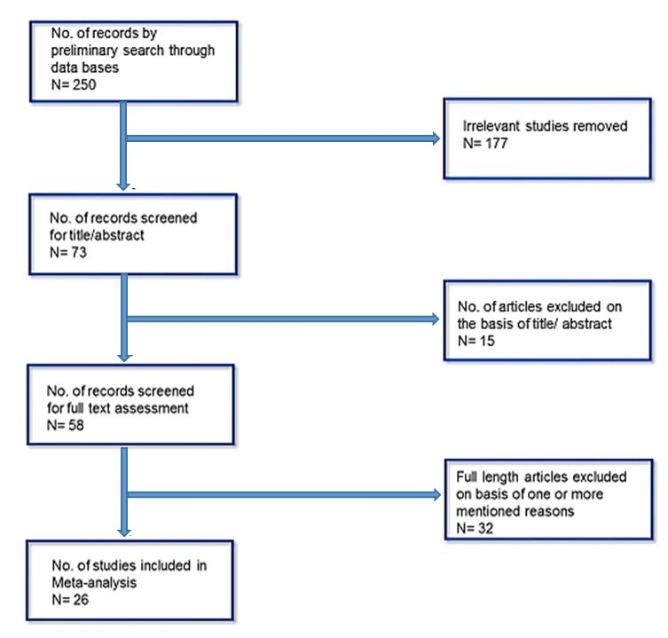

Figure 1: Flowchart representing the steps of literature search and selection



**Figure 2: Forest Plot of odd ratio with a random-effects Model for Prognosis Between Increased Expression of ETS factors and control in Breast Cancer**



**Figure 3: Forest Plot of odd ratio with a random-effects Model for Prognosis Between Increased Expression of ETS factors and control in Breast Cancer after exclusion of some studies.**

**a.**

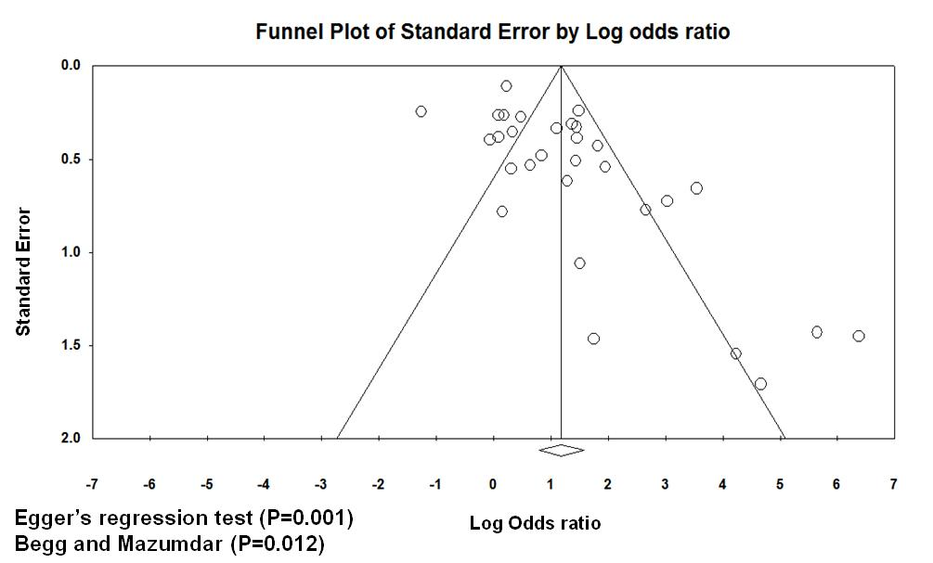

**b.**

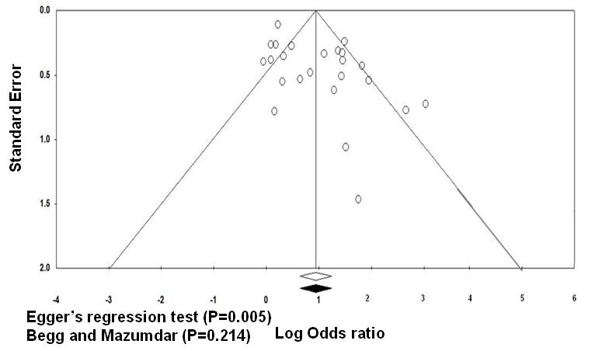

**Figure 4. Funnel Plot of standard error by log odd ratio for Increased Expression of ETS factors in Breast Cancer and control Group; a) for all 26 studies b) for 21 selected studies.**

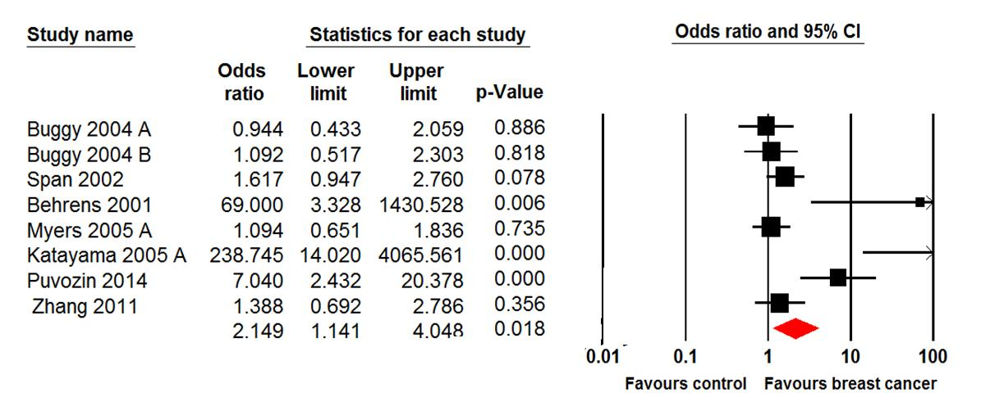

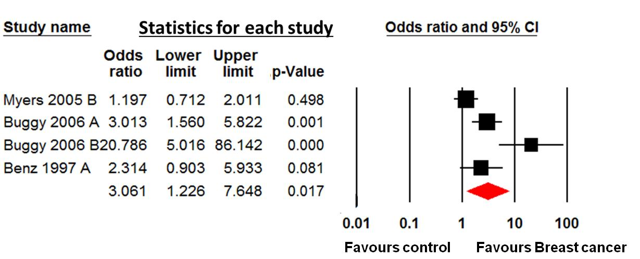

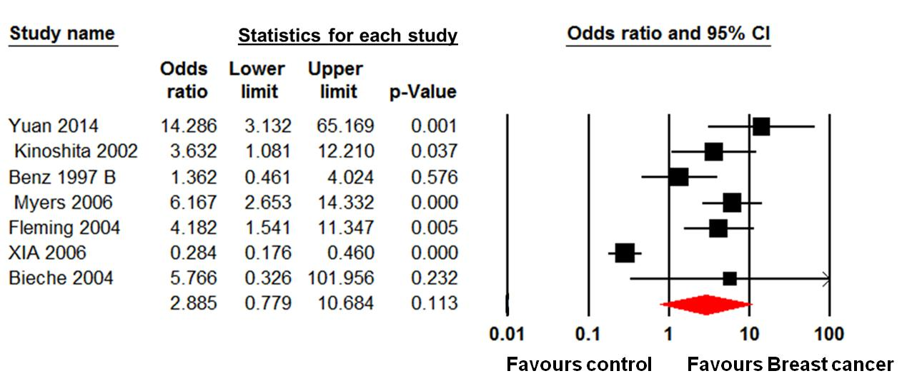

**Figure 5: Forest Plot of odd ratio with a random-effects Model for Prognosis Between Increased Expression of a) Ets-1 b) Ets-2 c) ETV-4 and control in Breast Cancer.**

**a)**

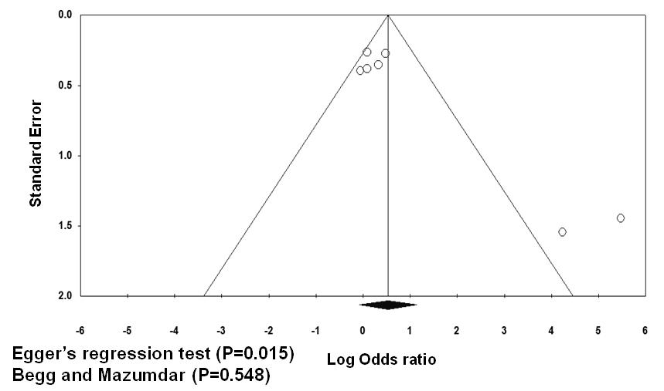

**b)**

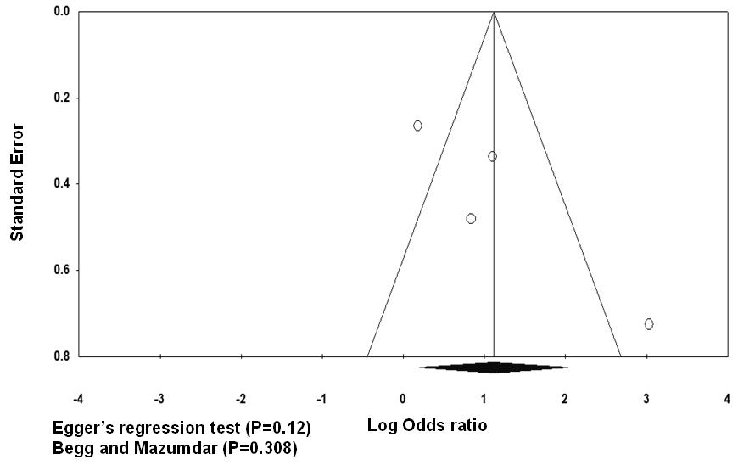

**c)**

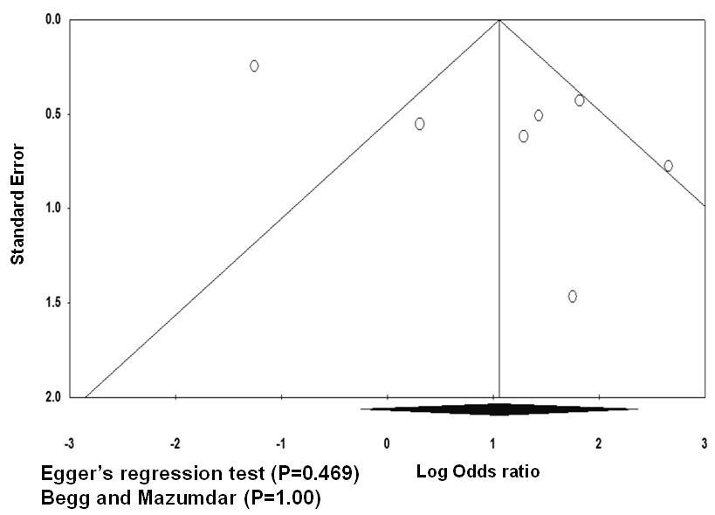

**Figure 6: Funnel Plot of odd ratio with a random-effects Model for Prognosis Between Increased Expression of a) Ets-1 b) Ets-2 c) ETV-4 and control in Breast Cancer.**

Table S1: Characteristics of All Eligible Studies

|  |  |  |  |  |  |  |  |  |  |  |
| --- | --- | --- | --- | --- | --- | --- | --- | --- | --- | --- |
| Sr. # | Name | Est Factor | Exp. Level | Patients | Positive Expression | Control | Postive Expression | Odds Ratio | Method of Evaluation | Site of Evaluation / Subtype |
| 1A | Buggy 2004 A | ETS-1 | Protein | 78 | 42 | 38 | 21 |  | Western Blot, IHC, ELISA | Ductal, Lobular, Others |
| 1B | Buggy 2004 B | ETS-1 | mRNA | 179 | 131 | 42 | 30 |  | PCR | Ductal, Lobular, Others |
| 2 | Span 2002 | ETS-1 | mRNA | 123 | 76 | 100 | 50 |  | RT-PCR | Ductal, Lobular, Others |
| 3 | Behrens 2001 | ETS-1 | Protein | 34 | 34 | 10 | 5 |  | In situ hybridization, IHC, | Intralobular, Ductal Insitu, Invasive |
| 4A | Myers 2005 A | ETS-1 | Protein | 134 | 70 | 100 | 50 |  | Western blot, Coimmunoprecipitation | Not Specified |
| 4B | Myers 2005 B | ETS-2 | Protein | 134 | 73 | 100 | 50 |  | Western blot, Coimmunoprecipitation | Not Specified |
| 5 | Laliotis 2012 | ELK-1 | Protein | 46 | 45 | 120 | 109 |  | IHC,ELISA | Ductal and Lobular |
| 6 | Mesquita 2013 | ETV-3, ELF3, ELK-4 | Protein | 141 | 141 | 100 | 50 |  | IHC, Floroscent Insitu Hybridization | Ductal, Lobular, others |
| 7 | Lelievre 2004 | ERM | mRNA | 364 | 297 | 100 | 50 |  | RT-PCR, ABI SEQ. | Ductal, Lobular, Others |
| 8 | Turcotte 2007 | PDEF | Protien |  |  |  |  | 1.25,( CI 95%, 1.004–1.540) | Western Blot | 80% ductal, others are lobular and mixed |
| 9 | Kar 2017 | ESE/ELF-3 | mRNA | 186 | 112 | 61 | 16 |  | PCR | Luminal B & HER-2+ substype |
| 10 | Katayama 2005 A | ETS-1 | mRNA | 137 | 114 | 24 | 0 |  | RT-PCR | Invasive ductal, lobular,Medullary & Apocrine carcinoma. |
| 11A | Buggy 2006 A | ETS-2 | mRNA | 181 | 125 | 47 | 20 |  | RT-PCR | Ductal and Lobular |
| 11B | Buggy 2006 B | ETS-2 | Protien | 111 | 97 | 12 | 3 |  | IHC, ELISA | Ductal and Lobular |
| 12 | Puvozic 2014 | ETS-1 | Protien |  |  |  |  | 7.04(CI 95% 2.43- 20.36 ) | IHC, | Not Specified |
| 13 | Sood 2007 | PDEF | Protien | 104 | 50 | 62 | 11 |  | IHC, Western blot | Intraductal, Invasive Lobualr and ductal carcinoma |
| 14 | Ghadersohi 2001 | PDEF | mRNA | 20 | 14 | 12 | 8 |  | RT-PCR | Not Specified |
| 15 | Mitas 2002 | PDEF | Protien | 15 | 14 | 5 | 0 |  | RT-PCR | Auxillary lymph nodes |
| 16 | Yuan 2014 | ETV-4 | Protien | 77 | 75 | 58 | 42 |  | IHC, | Triple Negative Breast cancer |
| 17 | Kinoshita 2002 | ETV-4 | mRNA | 42 | 38 | 47 | 34 |  | IHC, | Not Specified |
| 18A | Benz 1997 A | ETS-2 | mRNA | 33 | 18 | 41 | 14 |  | In situ hybridization | Invasive breast cancer |
| 18B | Benz 1997 B | ETV-4 | Protien | 33 | 26 | 41 | 30 |  | In situ hybridization | Invasive breast cancer |
| 19 | Myers 2006 | ETV-4 | Protien | 55 | 37 | 52 | 13 |  | IHC, Western blot | Not Specified |
| 20 | Sood 2009 | SPDEF | Protien | 27 | 20 | 45 | 27 |  | Western blot | Luminal Subtype& epithelial lineage |
| 21 | Zhang 2011 | ETS-1 | Protien | 40 | 24 | 181 | 94 |  | IHC, | Not Specified |
| 22 | Fleming 2004 | ETV-4 | Protien | 35 | 24 | 35 | 12 |  | IHC | Endocrine resistant breast cance |
| 23 | XIA 2006 | ETV-4 | Protien | 289 | 64 | 100 | 50 |  | IHC | Ductal carcinoma |
| 24 | Tognon 2002 | ETV-6 | mRNA | 13 | 12 | 50 | 1 |  | RT-PCR | Secretary Breast Carcinoma |
| 25 | Buchwalter 2013 | PDEF | mRNA | 100 | 77 | 100 | 46 |  | RT-PCR | ER+ Luminal Breast Cancer |
| 26 | Bieche 2004 | ETV-4 | mRNA | 130 | 30 | 9 | 0 |  | PCR | Not Specified |