- Running title: Analysis of fungal resistance of Eucommia ulmoides EuCHIT1

Overexpression of EuCHIT1, A New Chitinase Gene, from Eucommia ulmoides Enhances Resistance to Botrytis cinerea and Fusarium oxysporum in Transgenic Tobacco
Xuan Dong^{1,2,3}†, Zong-You Wei³†, De-Gang Zhao^{1,4} and Yichen Zhao^{3,*}
¹The Key Laboratory of Plant Resources Conservation and Germplasm Innovation in Mountainous Region (Ministry of Education), Institute of Agro-Bioengineering, Guizhou University, Guiyang 550025, Guizhou Province, People’s Republic of China
²The State Key Laboratory Breeding Base of Green Pesticide and Agricultural Biological Engineering,Guiyang 550006, Guizhou Province, People’s Republic of China
³College of Tea Sciences, Guizhou University, Guiyang 550025, Guizhou Province, People’s Republic of China
⁴Guizhou Academy of Agricultural Sciences, Guiyang 550006, Guizhou Province, People’s Republic of China
*For correspondence: yczhao@gzu.edu.cn
† Contributed equally to this work and are co-first authors
Received ; Accepted ; Published ;

Novelty statement
Eucommia ulmoides is a traditional Chinese herbal medicine, which is primarily used to regulate blood pressure. Literature on its anti-fungal property is scarce. In this study, a chitinase gene was cloned and transformed into tobacco. The results showed that the overexpressed gene improved the activity of chitinase and the resistance to Botrytis cinerea in tobacco. The total protein of transgenic tobacco was extracted and its activity against Fusarium oxysporum was studied. The results showed that compared with wild tobacco, the transgenic tobacco significantly inhibited the growth of F. oxysporum.

Abstract

Eucommia ulmoides is a medicinal plant with proven antifungal activity in clinical trials. Moreover, this species produces antifungal chitinases that could be used in other species as a resistance strategy. We studied the transcriptome of E. ulmoides and identified 15 chitinase fragments and a new chitinase gene, EuCHIT1, which was cloned by rapid amplification of cDNA ends (RACE) technology. The DNA and amino acid sequences of EuCHIT1 were found to be 77 to 81% and 70 to 84% similar to those of other plant chitinases. EuCHIT1 consists of conserved catalytic residues and a sugar-binding site. The phylogenetic analysis indicated that its close association with Acacia koa and Ricinus communis. Furthermore, we generated transgenic tobacco lines that exhibited significantly higher chitinase activity and concomitant resistance to Botrytis cinerea and Fusarium oxysporum than the wildtype.

Keywords: chitinase; Botrytis cinerea; Fusarium oxysporum; pathogenesis-related protein

Introduction

Plants produce numerous small molecules (secondary metabolites) following exposure to a variety of biotic and abiotic stimuli during their long-term interaction with the environment. These play essential roles in providing resistance to various types of stress, such as pathogens, pests, cold, and drought (Wink 1999; Dixon 2001). Because of their specific biological characteristics, secondary metabolites are pharmaceutical constituents of traditional Chinese medicines. Eucommia ulmoidies, a traditional Chinese medicinal plant, contains a variety of moieties that regulate blood pressure, prevent miscarriage, and significantly increase the resistance to microbial pathogens (Deyama et al. 2001; Liu and Zhao 2008). Transgenic plant research primarily focuses on developing insect-resistant, anti-viral, and herbicide-resistant compounds. Numerous transgenic plants containing these traits have been generated (James 2013). However, not considerable efforts have been made to generate anti-fungal transgenic plants. Fungal pathogens not only cause substantial losses to crop production but also seriously affect the market value of crops. Currently, chemical fungicides are extensively used in global agricultural production (Inglis and Kawchuk 2002) to control diseases; however, these exert a serious impact on the environment. The use of fungal-resistant transgenic plants could help counter the adverse environmental effects of fungicides (Balode 2009; Conijn 2014).
Numerous antimicrobial components are found in Chinese traditional medicinal plants (Deyama et al. 2001; Chen et al. 2016). Research on anti-microbial functions of E. ulmoides has been reported since 1994 (Liu et al. 1994), and certain antifungal proteins have been extracted and characterized. For example, Huang et al. (2002) extracted EAFP1 and EAFP2 from E. ulmoides. Both these proteins possess broad-spectrum antifungal activity against Phytophthora infestans, Fusarium moniliforme, Colletotrichum gossypii, and Alternaria lycopersici. EAFP1 and EAFP2 are structurally similar to Hevin protein, with these three sharing a high degree of sequence homology (Huang et al. 2002). Our research group focused on the use of E. ulmoides for almost two decades and cloned the following three genes: EuFPS (AY15247), CAD (DQ142643.1), HMGR (AY796343.1). All genes cloned from E. ulmoides were reverse transcribed (Liu et al. 2003; Zhou et al. 2003). We successfully extracted and purified an antifungal peptide, EAFP3, from E. ulmoides bark that significantly inhibited the growth of Candida albicans (Liu et al. 2008b).
Chitinase (EC3.2.1.14) is an important plant pathogenesis-related enzyme and multiple genes have been cloned from several plants (Payne et al. 1990; Davis et al. 1991). Furthermore, a novel germplasm that contained chitinase-related genes showed resistance to fungal diseases (Huang et al. 2013; Kovács et al. 2013). Identifying the genes encoding for the antimicrobial activity and exploring their functions to generate novel fungus-resistance germplasm are crucial for sustained environmental and economical development. In this study, the chitinase gene (EuCHIT1) (gi|616997549, KJ413008.1) from E. ulmoides was cloned for the first time using RACE technology. Furthermore, the conserved region and the phylogenetic relationship between EuCHIT1 and other organisms were compared.

Materials and Methods

Plant materials and microbial strains

Eucommia ulmoides tree, Nicotiana tabacum cv. Xanthi, Escherichia coli strain DH5α, Agrobacterium tumefaciens strain LBA4404 were obtained from the Key Laboratory of Mountain Plant Resources Conservation and Germplasm Innovation, Ministry of Education. Botrytis cinerea (HM2), a tobacco pathogen, was provided by Dr. Hancheng Wang, Guizhou Academy of Tobacco Science. Fusarium oxysporum, another tobacco pathogen, was provided by Dr. Zhong Li, Guizhou University.

RNA isolation

Total RNA was extracted and purified from 100 mg of tender leaves or spear of a mature E. ulmoides tree. For difficult samples, the leaves were grounded in liquid nitrogen to powder using the E.Z.N.A. Plant RNA Kit (Omega Bio-Tek., USA). Wood was removed from the preparation. To remove the excess salt, the extract products were washed twice with ethanol. Next, the extract was dissolved in 40 µL of RNAse-free water.
Total RNA was extracted from tobacco tissue (100 mg) and purified for RT-PCR. The tissue was grounded to powder and stored in liquid nitrogen according to the method described by Dong et al. (2017). All steps were performed strictly in accordance with the instructions provided in the kit. All RNA samples were examined at 260/280 nm absorbance ratio and their quality was checked using a 1.2% agarose gel electrophoresis and GelRed (Biotium, USA) staining.

Rapid amplification of cDNA ends

According to the partial sequence of EuCHIT1 in the E. ulmoides transcriptome, gene-specific primers EuCHIT1-GSP1 and EuCHIT1-GSP2 were designed (Table1) and 5′ and 3′ ends of the gene EuCHIT1 were cloned by RACE. The reagents, methods, and conditions used in the synthesis of first-strand cDNA and PCR were based on those described by Dong et al. (2017). The PCR products corresponding to the DNA band (Fig. S1) were separated and visualized on a 1.0% agarose/GelRed gel. The product was cloned into T-Vector, amplified, and sequenced according to the method described by Han et al. (2014, 2015). Serial Cloner 2.1 was used to align putative 3′ and 5′-RACE cDNAs with overlapping fragments of the transcriptome library to form a cDNA contig. BIOX and SERIAL CLONER 2.1 software were used for sequence analysis to determine the putative domain of 5'-UTR, ORF, and 3'-UTR. A pair of primers EuCHIT1-BamHI-F and EuCHIT1-EcoRI-R was devised to amplify the ORF of EuCHIT1 (Table 1 and Fig. S1). All primers were synthesized by Invitrogen Trading (Shanghai).

Bioinformatics analysis of EuCHIT1

BLASTn was used for nucleotide search of EuCHIT1, and encoded amino acid sequence search was conducted using BLASTp (http://blast.ncbi.nlm.nih. gov/Blast.cgi). The ORF and the deduced amino acid sequences were analyzed by Serial Cloner V2.6.1. Isoelectric point (pI), molecular weight (MW), and instability index of EuCHIT1 were predicted using the ExPASy tool ProtParam (http://web.expasy.org/protparam/). EuCHIT1 with chitinase from Beta vulgaris (gi:1168935), Chenopodium (gi:2570162), Fragaria ananassa (gi:6002766), Picea glauca (gi:7435352), F. ananassa (gi:11528439), Arabidopsis thaliana (gi:15224321), A. thaliana (gi:15228911), P. infestans (23394444), Citrus jambhiri (gi:23496447), and Hordeum vulgare (2BAA) revealed conserved signature domains with CDD tool CD-Search (http://www.ncbi.nlm.nih.gov/Structure/cdd/docs/cdd_search. html). Conserved domains of the amino acid sequence of EuCHIT1 were analyzed using the CDD tool CD-Search. Transmembrane regions and signal peptide were forecasted using a SignalP 4.1 server (http://www.cbs.dtu.dk/services/SignalP/). The amino acid sequences of EuCHIT1 and CHITs from other organisms were analyzed by cluster analysis and phylogenetic trees constructed using MegA 5.22 (5130611) analysis software with 1,000 permutation neighborhood connection method.

Construction of plant overexpression vector

All DNA experiments were performed in accordance with the protocols described in the fourth edition of Molecular Cloning (Green et al. 2012). The composition of the binary plasmid pSH737 (Fig S2A) was consistent with that of Qin et al. (2015b). Plasmid pSH737 was provided by the Institute of Agro-Bioengineering (Guizhou University). The PCR was conducted to amplify the ORF sequence of EuCHIT1 using primers and BamHI and EcoRI as restriction enzymes. The purified PCR products were inserted into the BamHI and EcoRI sites of multiple cloning sites in the pSH-35S binary vector, which were present between the 35S promoter of cauliflower mosaic virus (CaMV) and the terminator of the nopaline synthase (NOS) (Fig. S2B). The overexpressed vector pSH-35S-EuCHIT1 was transformed into A. tumefaciens strain LBA4404 (Bevan 1984) by freeze-thawing (Chen et al. 1994; Liu et al. 2015a).

Genetic transformation and analysis of transgenic tobacco

Transgenic-resistant seedlings of tobacco were grown and transplanted according to the study of Qin et al. (2015a). Only one seedling was planted in each tub, which contained 5 g of active organic fertilizer (soybean cake), and an equivalent amount of organic fertilizer was applied at the 6th to 8th leaf stage of plant development. Gus (β-glucuronidase) histochemical staining was used to identify kanamycin-resistant plants. We used the DNA extraction kit (Tiangen, China) (Zeng et al. 2016) to extract the genomic DNA from Gus-positive plants as per the instructions given in the kit. A pair of primers was designed to validate the amplification using the method described by Dong et al. (2017) and EuCHIT2 replaced with EuCHIT1. The PCR was performed with Premix Taq (Takara, Dalian, China) using 20 ng of DNA as a template to generate a product of 1,387 bp fragment. The PCR was performed under the following conditions: 98℃, 10 s, 55℃, 30 s, 72℃, 1 min, and 30 cycles, 4℃. The transgenic lines overexpressing EuCHIT1 and identified by PCR were preserved for further analysis.

Analysis of chitinase activity

The seedings of T1 generation transgenic tobacco lines identified as positive by Gus staining and PCR were cultured at 25°C on a 16 h light/8 h dark cycle to the 6th to 8th leaf stage. The chitinase activity was determined using the method described by Zeng et al. (2016) with leaf tips of seedlings at similar growth stages. The chitinase activity of tobacco seedlings from wild type and transgenic lines was determined without inoculation and after 6 h, 12 h, 24 h, and 72 h inoculation with B. cineria. Tobacco leaves (100 mg) were homogenized and centrifuged. Next, the supernatant was used to prepare the crude enzyme (Mauch et al. 1984). Colloidal chitin was prepared according to the method described by Shimahara et al. (1988) as a reaction substrate. The release of 1 µg of N-acetylglucosamine (SIGMA-Aldrich, China) in 1 h (measured by the change in absorption at 540 nm) was defined as one unit of chitinase activity.

Analysis of anti-fungal activity of EuCHIT1

We use BL21 (DE3) cells to express the pMCSG-EuCHIT1 fusion expression vector. Next, the cells were induced with 1 mM IPTG (isopropyl β-D-thiogalactoside) and cultured at 16℃ at 120 rpm. The cells were broken by ultrasonic waves on ice, and the fusion protein was purified using a Ni column; 100 mM imidazole was used to wash the fusion protein followed by measuring the antifungal activity.
Potato dextrose agar (PDA, 9 mL) containing streptomycin (Shanghai Bioway Technology Co. Ltd.) to 10 cm diameter in a petri dish. Next, agar mycelium plugs of 6 mm diameter were inoculated in a petri dish until the diameter was approximately 5 cm. Afterward, 6 mm diameter of filter paper saturated with the protein solution, 1% carbendazim as the positive control, and 100 mM imidazole (Yeasen Biotech Co. Ltd.) as the negative control, 26 ℃ inversion darkness, every 24 h observation records.
The root tissue of the 6th to 8th leaf stage was removed to extract the total protein of transgenic tobacco and wild type tobacco to inhibit the experiment. Next, 1 mL of extract protein was added to 9 mL of the PDA medium in the 10 cm petri dish. Subsequently, 6 mm diameter agar mycelium plugs were inoculated in a petri dish at 26℃ in dark in an inverted position. The measurements were recorded every 24 h.

Analysis of disease resistance

Leaf pieces were inoculated with B. cinerea (HM2) to evaluate the resistance of transgenic tobacco to a fungal pathogen. Three lines, EuCHIT1-31, EuCHIT1-37, EuCHIT1-151 of the sterile T₁ transgenic tobacco seedlings (Gus- and PCR-positive), and wild-type tobacco seedlings were cultivated at 25°C with a 16 h light/8 h dark cycle until the 6th to 8th leaf stage. Nine similar leaves 5 to 6 cm long were picked from each row of tobacco. Botrytis cinerea (HM2) was incubated on PDA for 10 days at 25℃. Actively mycelial plugs, 3 mm in diameter, were cut from the colony margins containing actively growing hyphae were used to inoculate the detached tobacco leaves. The leaves were inoculated into 90 mm Petri dishes containing 10 g·L⁻¹ agar medium and a single leaf piece per dish (Miclot et al. 2012). Inoculated leaves were maintained at 25°C with a 16 h light/8 h dark cycle (Doukhanina et al. 2006; Sun et al. 2014). The disease progression was measured by studying symptom formation and was noted each day after inoculation.
To analyze the activities of catalase (CAT), peroxidase (POD), and the content of malondialdehyde (MDA) and the expression of genes PR-1a and COI1, tobacco plants were inoculated with two 6 mm diameter agar mycelium plugs, which were at 6th to 8th leaf stage. Inoculations were performed with agar plugs as controls.

Determination of physicochemical indicators

The activities of CAT and POD and the content of MDA were assayed separately as per the manufacturer’s instructions and using the kit obtained from Suzhou Comin Biotechnology Company and the method described by Pan et al. (2016). The leaves were collected from both transgenic and wild-type tobacco before inoculation and at 6 h, 12 h, 24 h, and 72 h after inoculation with the pathogen. The collected leaves were preserved at –80°C until they were used in subsequent experiments (Qin et al. 2015a).

Analysis of gene expression

Next, the expression of COI1 and PR-1a genes was analyzed. The sequence of tobacco gene COI1 was identified from the National Center of Biotechnology Information (NCBI) and using real-time PCR primers. The real-time PCR primers for β-actin (the internal control) and PR-1a genes were used as mentioned in the literature by Qin et al. (2015b) (Table 1). The total RNA was extracted from transgenic and wild-type plants before and after inoculation with the pathogen at 6 h, 12 h, 24 h, and 72 h. They were subsequently reversed transcribed into the cDNA using the reverse transcription M-MLV (RNase H-) (Takara, China). The reagents, methods, and conditions used in the amplification and RT-PCR were based on the method described by Dong et al. (2017).

Results

Cloning and characterization of EuCHIT1
A partial chitinase sequence of 186 bp was found using the annotation transcriptome database of E. ulmoides. The complete cDNA sequence of this specific gene was obtained with RACE technology and cloned using PCR amplification. The length of this cDNA sequence was 1,402 bp, which was composed of a 969 bp ORF, a 137 bp 5′-UTR, and a 296 bp 3′-UTR. The GC content of the ORF was 51.1%. This cDNA sequence was named EuCHIT1 and deposited in GenBank (Fig. S1). The new chitinase gene, EuCHIT1, encoded a predicted protein of 322 amino acids with molecular weight and PI of 35.21 kDa and 7.10, respectively. It corresponded to a stable, transmembrane protein that belonged to the chitinase glycol hydroxy 19 family. Alignment analysis with the NCBI conserved domain database (CDD) indicated that this polypeptide contained catalytic residues and a putative sugar-binding site. Multiple sequence alignment of EuCHIT1 with chitinase from diverse organisms revealed highly conserved signature domains. Seven residues were well-conserved and consisted of the catalytic residues at 127 (K), 149 (E), 180 (P) positions, and sugar-binding residues at 185 (Y), 186 (N), 262 (Y), and 271 (S) loci (Fig. 1). Furthermore, this sequence was analyzed using the program available at http://www.ebi.ac.uk and http://smart.embl-heidelberg.de. Each program indicated that EuCHIT1 was a typical plant chitinase.

Sequence and phylogenetic analyses

The EuCHIT1 nucleotide sequence was analyzed by BLASTn and indicated 77 to 81% similarity of the chitinase gene sequence with other organisms in the NCBI database. The EuCHIT1-encoded amino acid sequence was analyzed by BLASTp revealing 70 to 84% identity with other plant chitinases. EuCHIT1 had high sequence similarity with other plant chitinases (80%–84%). Phylogenetic analysis of the deduced amino acid sequence of EuCHIT1 and those of other CHITs from diverse organisms, including plants, bacteria, fungi, and insects, indicated that EuCHIT1 belonged to the plant chitinase group and had high homology with Ricinus communis chitinase. All chitinases originated from the same ancestor, and EuCHIT1 shared a common evolutionary origin with other plant chitinases as revealed by the phylogenetic analysis (Fig. 2).

Verification of vectors and transgenic plants

The plant overexpression vector pSH-35S-EuCHIT1 was constructed; it included a reporter gene Gus and a selection gene Kan. A 1,006 bp fragment was amplified from the vector using EuCHIT1-specific primers. The sequencing demonstrated that this fragment contained the complete CDS of EuCHIT1 (Figs. 3A, C, and D). A 1,387 bp fragment (containing 448 bp partial 35S promoter fragment and 939 bp partial fragment of EuCHIT1) was present in the A. tumefaciens vector (Fig. 3B). Transgenic tobacco plants were generated using this EuCHIT1 overexpression vector, and transformation was confirmed by Gus staining and PCR amplification (Fig. 4). In total, 53 transgenic lines were regenerated.

Chitinase activity in transgenic tobacco

The chitinase activity in the wildtype tobacco was 1,270 U·g⁻¹ as compared to 2 to 4 fold less activity in the transgenic lines EuCHIT1-31 (4,011 U·g⁻¹), EuCHIT1-37 (2,703 U·g⁻¹), and EuCHIT1-151 (2,413 U·g⁻¹) (Fig. 5A). Moreover, the chitinase activity in both wild-type and transgenic tobacco plants was measured after they were inoculated with B. cinerea (Fig. 5B). Six h after the inoculation, the chitinase activity was significantly elevated in both wild-type and transgenic plants as compared with controls. At 6 h, the chitinase activity in the transgenic plants was 2,808 U·g⁻¹, which was significantly higher (P < 0.05) than 2,302 U·g⁻¹ measured in the wildtype. However, because transgenic plants had higher chitinase activity before inoculation, the enzymatic increment in transgenic tobacco plants was less than that in the wild-type plants. The enzyme activity in wild-type tobacco increased 1.9 times, whereas that in transgenic lines only increased by 1.2 times (Fig. 5B).

Effect of EuCHIT1 on fungal resistance

The final concentrations of 5 mg·mL⁻¹, 10 mg·mL⁻¹, 15 mg·mL⁻¹, and 20 mg·mL⁻¹ protein extracted from transgenic tobacco and wildtype were used to examine the resistance against F. oxysporum. The results demonstrated that the growth of F. oxysporum was inhibited when the concentration of tobacco protein was increased. The colony diameters of F. oxyporum were 5.77 cm, 4.93 cm, 2.73 cm, and 2.1 cm in transgenic plants at 5 mg·mL⁻¹, 10 mg·mL⁻¹, 15 mg·mL⁻¹, and 20 mg·mL⁻¹, respectively, whereas the colony diameters were 6.57 cm, 5.30 cm, 3.9 cm, and 3.17 cm in the wildtype, respectively (Fig. 6). However, only when protein concentration was 15 mg/mL, the bacteriophage colony of the transgenic plant (2.73 cm) was significantly smaller than that in the wildtype (3.9 cm), suggesting that overexpressing EuCHIT1 in transgenic tobacco increased the resistance against F. oxysporum in the certain range.
The 110 mg·mL⁻¹ concentration exerted a significant difference in inhibiting F. oxysporum growth (Fig. 7) as demonstrated by cotton blue staining. transgenic tobacco extract processing to the heavy commitments of the hyphae has beaded change in the transgenic tobacco extract protein, wild type tobacco also changes a little bead in wild type tobacco extract protein and the hyphae was normal in the negative medium. The mycelial state of F. oxysporum was observed under the inhibition of transgenic tobacco protein. The microscopic image demonstrated that when EuCHIT1 overexpression tobacco protein (total protein concentration at 110 mg·mL⁻¹) was applied, the growth of fungal hyphae was severely inhibited and appeared as a chain bead. This result indicated that under EuCHIT1 inhibition, the cell wall of fungal hyphae was greatly damaged, consistent with the function of chitinases. This finding proved that this novel gene identified from E. ulmoides encoded a chitinase protein.
The antifungal activity of EuCHIT1 on F. oxysporum and B. cinerea was examined in vitro using EuCHIT1-His recombinant protein, which was expressed using the prokaryotic expression system, whereas 1% carbendazim and 100 mM imidazole were used as positive and negative controls, respectively (Fig. 8). The results showed that 1 mg/mL recombinant protein could not directly inhibit fungal growth. In addition, there was a possibility that the activity of the recombinant protein may be affected by the His-tag or lack of modification when expressed in the prokaryotic system. EuCHIT1 indirectly enhanced the antifungal activity in transgenic lines.

Disease resistance assay with B. cinerea

POD, CAT, and MDA are inducible enzymes and participate in plant resistance. To determine whether EuCHIT1 transgenic plants increased plant’s defense against fungal pathogens, the activity of these enzymes and the content MDA was measured (Fig. 9). The CAT activity was 122 U·g⁻¹ in the transgenic lines 72 h after inoculation with B. cinerea, which was significantly higher than that measured in the wildtype (50 U·g⁻¹) simultaneously. The transfer of the EuCHIT1 gene dramatically increased the activity of CAT in tobacco leaves (Fig. 9A). However, the POD activity was 3,050 U·g⁻¹ in transgenic lines 72 h after inoculation, which was significantly lower than that in wild-type leaves (7916.667 U·g⁻¹) (Fig. 9B). In this study, the MDA content was 5.7 mmol·g⁻¹ in transgenic tobacco and significantly (P < 0.05) lower than that in wild-type tobacco (9.4 mmol·g⁻¹) before inoculation. The MDA content was 8.7 mmol·g⁻¹ in transgenic tobacco 72 h after inoculation and was significantly lower than that in wild-type tobacco (10.5 mmol·g⁻¹) (Fig. 9C).
The development of symptoms after inoculation with B. cinerea was observed each day. Small, pinpoint lesions appeared after 2 days on both wild and transgenic tobacco leaves, which enlarged over time. The diameters of the lesion were measured after 4 days and reflected the severity of the disease (Fig. 10). Mean lesion diameters in wild type (2.6 cm) and three transgenic tobacco lines (EuCHIT1-31: 1.2 cm, EuCHIT-37: 1.8 cm, EuCHIT-151: 1.7 cm) were significantly smaller on transgenic plants as compared with wild-type plants (Fig. 10). Overexpressed EuCHIT1 in tobacco increased the resistance to B. cinerea in transgenic plants.

Synergistic effects of EuCHIT1 on B. cinerea resistance-related gene expression

The relative expression of PR-1a and COI1 involved in EuCHIT1-mediated resistance signaling pathways was analyzed (Fig. 11). The relative expression of COI1 in three transgenic lines was approximately twice as high as that in the wild-type lines before inoculation (Fig. 11A). In wild-type tobacco plants, the expression of the COI1 gene increased in the first 12 h and decreased thereafter. The mean expression increased 4.1 times 12 h after inoculation. However, in the transgenic tobacco, the COI1 gene activity was significantly reduced after inoculation, and the relative expression were only 0.5, 0.3, and 0.5, respectively, in the three transgenic lines after 12 h inoculation. Therefore, tobacco transformed with EuCHIT1 induced the expression of COI1 gene before B. cinerea inoculation; however, it inhibited its expression after inoculation with the pathogen. The relative expression of PR-1a averaged about 3.6 times higher in three transgenic lines than in wildtype before inoculation. The PR-1a gene expression was the maximum in the 6 h samples of wild-type tobacco and 72 h transgenic tobacco after inoculation with B. cinerea. The maximum expression of PR-1a gene in transgenic tobacco was 33.8 times higher than that in wild-type tobacco (Fig. 11). EuCHIT1 gene transformed into tobacco induced the resistance to B. cinerea by stimulating the expression of PR-1a.

Discussion

Chitinases produced by higher plants are encoded by a family of genes. Moreover, they share high sequence similarity (Brunner et al. 1998). Chitinases degrade the chitin found in the cell walls of true fungi into N-acetyl-D-glucosamine (Van Loon 1989) and its activity rapidly increases when the plant is attacked by pathogens (Mauch et al. 1984; Legrand et al. 1987; Broekaert and Peumans 1988; Kombrink et al. 1988). Since the past 3 years, chitinase genes have been transferred into the target plants to create new resistant germplasms. In this regard, several plant chitinase genes have been cloned and used to generate antifungal transgenic plants (Kovács et al. 2013). Eucommia ulmoides is a traditional Chinese medicinal plant, recorded in The Classic of Herbal Medicine that has proven antibacterial properties. A study in our laboratory showed that the total protein isolated from E. ulmoides was effective against B. cinerea (Liu et al. 2008a).
In this study, we used RACE technology to successfully clone and characterize the full-length EuCHIT1 gene from E. ulmoides. The deduced amino acid sequence included the conserved catalytic residues and a sugar-binding site, belonging to the chitinase glycol hydroxy 19 family. Multiple sequence alignment of EuCHIT1 with chitinases from various species demonstrated that the position of catalytic residues and the sugar-binding residue was conserved well. In nature, chitinases are widely distributed in animals, plants, bacteria, and fungi. According to our phylogenetic analysis, EuCHIT1 shares the evolutionary origin with other plant chitinases. Therefore, EuCHIT1 is a typical chitinase and is likely to encode an active protein with biological functions.
Chitinase is considered a crucial pathogenesis-related protein in plants. Studies have reported that a transgenic plant with chitinase expression enhanced the resistance to rice blast (Zeng et al. 2016), black leaf streak disease (Kovács et al. 2013), and B. cinerea (de Cáceres González et al. 2015). Botrytis cinerea commonly infects the seedlings of tobacco. In this study, although the first chitinase gene was cloned from E. ulmoides, its protein activity could not be studied in E. ulmoides transgenic plants that are difficult to generate. Therefore, we studied the function of this gene using a rapid and effective method of transformation of tobacco. Compared with the wild-type tobacco, the chitinase activity and resistance to B. cinerea increased in the transgenic tobacco. Chitinase activity was significantly higher in transgenic plants as compared with wild-type tobacco before inoculation. However, the difference in the enzyme activity between transgenic and wild-type tobacco plants decreased significantly, and this difference disappeared after 12 h. Twelve h after infection with B. cinerae, the transgenic tobacco resisted the fungus by not only chitinase. Chitinases are known to function in two ways in response to fungal infection. First, chitinases digest the fungal cell wall, and second, they release pathogen-borne elicitors to induce defense immune responses (Jach et al. 1995; Lorito et al. 1998). Moreover, POD and CAT play crucial roles in the active oxygen scavenging system during the response to biotic and abiotic stressors (Chamnongpol et al. 1998). For instance, compared with wild type tobacco, the CAT activity was significantly higher in transgene tobacco after inoculation. The expression of EuCHIT1 in tobacco increased with CAT expression to mitigate the damage of B. cinerea. Malondialdehyde (MDA) concentration is used to evaluate plant defensive ability. It can be used as a proxy indicator for the extent of oxidative damage caused to the cell membranes (Draper and Hadley 1990; Marnett 2002). The MDA content was lower than that in the wildtype plants before and after inoculation, and confirmed that the CAT expression reduced the damaging effects of B. cinerea.
The overexpression of two chitinases from the mycoparasitic fungus T. harziaum in tobacco significantly increased the expression of PR-1a (de las Mercedes Dana et al. 2006). PR-1a is the key gene involved in the pathway of SA (salicylic acid)-dependent systemic acquired resistance or SARs (Uknes et al. 1993). In our study, PR-1a expression was assayed before plant and pathogen interaction and results similar to those of the study by de las Dana were obtained. However, B. cinerea normally evokes plant resistance signaling through JA (jasmonic acid)-dependent induced systemic resistance (ISR), but not SARs (Thomma et al. 1998). In this study, the expression of the key gene COI1 (Feys et al. 1994; Xie et al. 1998) of ISR was measured. Before inoculation, the expression of COI1 gene was significantly higher in transgenic tobacco than in the wildtype, indicating that the overexpression of EuCHIT1 increased the expression of COI1 gene in pathogen challenged, healthy plants. However, after inoculation with the pathogen, the expression of COI1 was significantly suppressed in transgenic tobacco. Therefore, the overexpression of EuCHIT1 in tobacco plants affected the ISR pathway.
This study presents a new chitinase gene, which was cloned from E. ulmoides. The overexpression of this gene increased the chitinase and CAT activities in tobacco and increased the resistance to B. cinerea. In addition, the overexpression of EuCHIT1 affected the expression of PR-1a and COI1, which are key genes involved in SAR and ISR pathways.

Conclusion
The EuCHIT1 gene was transformed into tobacco, which improved the resistance of tobacco to Botrytis cinerea. Furthermore, the total protein significantly inhibited the mycelial growth of Fusarium oxysporum. The possible mechanism could be that this gene enhanced the chitinase activity and the expression of pathogenesis-related proteins in tobacco. Prokaryotic expression proteins had no inhibitory effect on fungal growth, which may be related to the lack of modification in the prokaryotic system.

Acknowledgments

We would like to thanks Dr. Hancheng Wang, Guizhou Academy Tobacco Science. for kindly providing Botrytis cinerea (HM2). We would like to thanks Robert Trigiano the editors in chief of critical reviews in plant sciences give us many suggestion and Language modification , which contributed to improve the quality of this paper.

Funding
This work was supported by the grants from National Natural Science Foundation of China(31660076, 31360272), National Special Project for the Cultivation of New Genetically Modified Varieties #3] under Grant [number 2016ZX08010003-009, National High Technology Research and Development Program 863 (2013AA102605-05). [Construction Program of Biology First-class Discipline in Guizhou #3] under Grant [number GNYL[2017] 009].

Competing Interests

The authors declare there are no competing interests.

Author contributions

DGZ and YZ conceived and designed the experiments; XD performed the experiments, analyzed the data, wrote the manuscript, and prepared figures and/or tables; and ZYW contributed reagents/materials/analysis tools, conducted historical bleaching research, and performed the experiments
References

Balode A (2009). Breeding for resistance against Botrytis in lily. In: XXIII International Eucarpia Symposium, Section Ornamentals: Colourful Breeding and Genetics 836:143-148
Bevan M (1984). Binary Agrobacterium vectors for plant transformation. Nucleic Acids Res 12:8711-8721
Broekaert WF, WJ Peumans (1988). Pectic polysaccharides elicit chitinase accumulation in tobacco. Physiol Plant 74:740-744
Brunner F, A Stintzi, B Fritig, M Legrand (1998) Substrate specificities of tobacco chitinases. Plant J 14:225-234
Chamnongpol S, H Willekens, W Moeder, C Langebartels, H Sandermann, M Van Montagu, D Inzé, W Van Camp (1998). Defense activation and enhanced pathogen tolerance induced by H₂O₂ in transgenic tobacco. Proc Natl Acad Sci U S A 95:5818-5823
Chen H, RS Nelson, JL Sherwood (1994). Enhanced recovery of transformants of Agrobacterium tumefaciens after freeze-thaw transformation and drug selection. Biotechniques 16:664-668, 670
Chen X, X Mu, J Xu (2016). Screening approach of antimicrobial Chinese traditional medicine and practice. Chin J Vet Drug 50:1-6 (in Chinese)
Conijn CGM (2014). Developments in the control of lily diseases. In: III International Symposium on the Genus Lilium pp. 213-229
Davis JM, HR Clarke, HD Bradshaw, MP Gordon (1991). Populus chitinase genes: structure, organization, and similarity of translated sequences to herbaceous plant chitinases. Plant Mol Biol 17:631-639
de Cáceres González FF, MR Davey, EC Sanchez, ZA Wilson (2015). Conferred resistance to Botrytis cinerea in Lilium by overexpression of the RCH10 chitinase gene. Plant Cell Rep 34:1201-1209
de las Mercedes Dana M, JA Pintor-Toro, B Cubero (2006). Transgenic tobacco plants overexpressing chitinases of fungal origin show enhanced resistance to biotic and abiotic stress agents. Plant Physiol 142:722-730
Deyama T, S Nishibe, Y Nakazawa (2001). Constituents and pharmacological effects of Eucommia and Siberian ginseng. Acta Pharmacol Sin 22:1057-1070
Dixon RA (2001). Natural products and plant disease resistance. Nature 411:843-847
Dong X, Y Zhao, X Ran, L Guo, DG Zhao (2017). Overexpression of a new chitinase gene EuCHIT2 enhances resistance to Erysiphe cichoracearum DC. in tobacco plants. Int J Mol Sci 18: 2361
Doukhanina EV, S Chen, E van der Zalm, A Godzik, J Reed, MB Dickman (2006). Identification and functional characterization of the BAG protein family in Arabidopsis thaliana. J Biol Chem 281:18793-18801
Draper HH, M Hadley (1990). [43] Malondialdehyde determination as index of lipid Peroxidation. In: Methods in Enzymology, Vol. 186, pp:421-431. Packer L, AN Clazer (eds). Academic Press
Feys BJ, CE Benedetti, CN Penfold, JG Turner (1994). Arabidopsis mutants selected for resistance to the phytotoxin coronatine are male sterile, insensitive to methyl jasmonate, and resistant to a bacterial pathogen. Plant Cell 6:751-759
Green MR, J Sambrook, J Sambrook (2012). Molecular Cloning: A Laboratory Manual 4 edition, Cold Spring Harbor Laboratory Press, New York, USA
Han L, Y Liu, A He, D Zhao (2014). 16S rRNA gene phylogeny and tfdA gene analysis of 2, 4-D-degrading bacteria isolated in China. World J Microbiol Biotechnol 30:2567-2576
Han L, Y. Liu, C Li, D Zhao (2015). Cloning, expression, characterization and mutational analysis of the tfdA gene from Cupriavidus campinensis BJ71. World J Microbiol Biotechnol 31:1021-1030
Huang RH, Y Xiang, XZ Liu, Y Zhang, Z Hu, DC Wang (2002). Two novel antifungal peptides distinct with a five-disulfide motif from the bark of Eucommia ulmoides Oliv. FEBS Lett 521:87-90
Huang X, J Wang, Z Du, C Zhang, L Li, Z Xu (2013). Enhanced resistance to stripe rust disease in transgenic wheat expressing the rice chitinase gene RC24. Transgenic Res 22:939-947
Inglis GD, LM Kawchuk (2002). Comparative degradation of oomycete, ascomycete, and basidiomycete cell walls by mycoparasitic and biocontrol fungi. Can J Microbiol 48:60-70
James(2013). ISAAA. Annual Report Executive Summary, Global Status of Commercialized Biotech/GM Crops: 2013 ISAAA Brief 46-2013, Retrieved 6 August 2014.
Jach G, B Görnhardt, J Mundy, J Logemann, E Pinsdorf, R Leah, J Schell, C Maas (1995). Enhanced quantitative resistance against fungal disease by combinatorial expression of different barley antifungal proteins in transgenic tobacco. Plant J 8:97-109
Kombrink E, M Schröder, K Hahlbrock (1988). Several “pathogenesis-related” proteins in potato are 1,3-β-glucanases and chitinases. Proc Natl Acad Sci U S A 85:782-786
Kovács G, L. Sági, G Jacon, G Arinaitwe, JP Busogoro, E Thiry, H Strosse, R Swennen, S Remy (2013). Expression of a rice chitinase gene in transgenic banana (‘Gros Michel’, AAA genome group) confers resistance to black leaf streak disease. Transgenic Res 22:117-130
Legrand M, S. Kauffmann, P Geoffroy, B Fritig (1987). Biological function of pathogenesis-related proteins: Four tobacco pathogenesis-related proteins are chitinases. Proc Natl Acad Sci U S A 84:6750-6754
Liu S, D Zhao (2008). Effect of Eucommia antifungal peptide against Aspergillus flavus. Nat Product Res Dev 20:332-334
Liu S, D Zhao DG, B Song (2008a). Study on inhibition activity of Eucommia ulmoides antifungal protein to Botrytis cinerea. Agrochemicals 11:836-838(in chinese)
Liu S, D Zhao, Y Han (2008b). Isolation of a novel antifungal peptide from the bark of Eucommia ulmoides Oliv. High Technol Lett 14:216-219
Liu W, Y Han, D Zhao (2003). Cloning of cDNA encoding cinnamyl alcohol dehydrogenase from Eucommia ulmoides Oliv. J China Agric Univ 8:27-30(in chinese)
Liu X, Z Hu, Y Li, J Yang, B Li (1994). Isolation and characteritation of an antifungal protein from the bark of Eucommia ulmoides. Acta Bot Yuannica 16:385-391(in chinese)
Liu Y, L Han, L Qin, D Zhao (2015a). Saccharomyces cerevisiae gene TPS1 improves drought tolerance in Zea mays L. by increasing the expression of SDD1 and reducing stomatal density. Plant Cell Tissue Organ Culture (PCTOC) 120:779-789
Lorito M, SL Woo, IG Garcia, G Colucci, GE Harman, JA Pintor-Toro, E Filippone, S Muccifora, CB Lawrence, A Zoina, S Tuzun (1998). Genes from mycoparasitic fungi as a source for improving plant resistance to fungal pathogens. Proc Natl Acad Sci U S A 95:7860-7865
Marnett LJ (2002). Oxy radicals, lipid peroxidation and DNA damage. Toxicology 181:219-222
Mauch F, LA Hadwiger, T Boller (1984). Ethylene: symptom, not signal for the induction of chitinase and β-1, 3-glucanase in pea pods by pathogens and elicitors. Plant Physiol 76:607-611
Miclot AS, S Wiedemann-Merdinoglu, E Duchêne, D Merdinoglu, P Mestre (2012). A standardised method for the quantitative analysis of resistance to grapevine powdery mildew. Eur J Plant Pathol 133:483-495
Pan L, X Zhang, J Wang, X Ma, M Zhou, L Huang, G Nie, P Wang, Z Yang, J Ji (2016). Transcriptional profiles of drought-related genes in modulating metabolic processes and antioxidant defenses in Lolium multiflorum. Front Plant Sci 7:519
Payne G, P Ahl, M Moyer, A Harper, J Beck, F Meins, J Ryals (1990). Isolation of complementary DNA clones encoding pathogenesis-related proteins P and Q, two acidic chitinases from tobacco. Proc Natl Acad Sci U S A 87:98-102
Qin LJ, D Zhao, DG Zhao (2015a). Overexpression of NrCN improved TMV resistance in selection marker-free tobacco generated by Gene-Deletor system. Plant Mol Biol Rep 33:1619-1633
Qin LJ, D Zhao, Y Zhang, DG Zhao (2015b). Selectable marker-free co-expression of Nicotiana rustica CN and Nicotiana tabacum HAK1 genes improves resistance to tobacco mosaic virus in tobacco. Funct Plant Biol 42:802-815
Sun H, X Hu, J Ma, C Hettenhausen, L Wang, G Sun, J Wu, J Wu (2014). Requirement of ABA signalling‐mediated stomatal closure for resistance of wild tobacco to Alternaria alternata. Plant Pathol 63:1070-1077
Shimahara, K(1988). Preparation of crustacean chitin. Methods Enzymol 161: 417-424

Thomma BP, K Eggermont, IA Penninckx, B Mauch-Mani, R Vogelsang, BP Cammue, WF Broekaert (1998). Separate jasmonate-dependent and salicylate-dependent defense-response pathways in Arabidopsis are essential for resistance to distinct microbial pathogens. Proc Natl Acad Sci U S A 95:15107-15111.
Uknes S, S Dincher, L Friedrich, D Negrotto, S Williams, H Thompson-Taylor, S Potter, E Ward, J Ryals (1993). Regulation of pathogenesis-related protein-1a gene expression in tobacco. Plant Cell 5:159-169
Van Loon LC (1989). Stress proteins in infected plants. In: Plant-Microbe Interactions: Molecular and Genetic Perspectives, Vol. 3, pp:189-237. Kosuge T, EW Nester (eds). McGraw-Hill, New York, USA
Wink M (1999). Functions of Plant Secondary Metabolites and Their Exploitation in Biotechnology. Taylor & Francis
Xie DX, BF Feys, S James, M Nieto-Rostro, JG Turner (1998). COI1: An Arabidopsis gene required for jasmonate-regulated defense and fertility. Science 280:1091-1094
Zeng XF, L Li, JR Li, DG Zhao (2016). Constitutive expression of McCHIT1-PAT enhances resistance to rice blast and herbicide, but does not affect grain yield in transgenic glutinous rice. Biotechnol Appl Biochem 63:77-85
Zhou M, Y Xiao, D Zhu, Y Pei, D Zhao (2003). Molecular cloning and sequence analysis of EuFPS involved into rubber biosynthesis in Eucommia ulmoides Olive. Mol Plant Breed 1:66-71(in chinese)

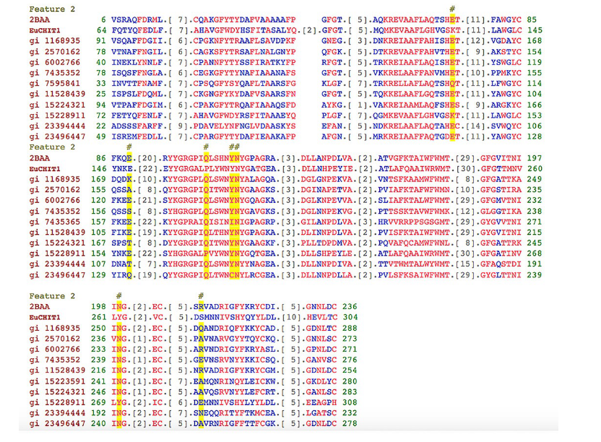
Fig. 1: Alignment of deduced amino acid sequence of EuCHIT1 with others CHITs from diverse organisms. Beta vulgaris (gi:1168935), Chenopodium (gi:2570162), Fragaria ananassa (gi:6002766), Picea glauca(gi:7435352), Fragaria ananassa (gi:11528439), Arabidopsis thaliana (gi:15224321), Arabidopsis thaliana (gi:15228911) Phytophthora infestans (23394444), Citrus jambhiri (gi:234964476), and Hordeum vulgare (2BAA). #Indicates acid residues in the sugar-binding residues and catalytic residues.

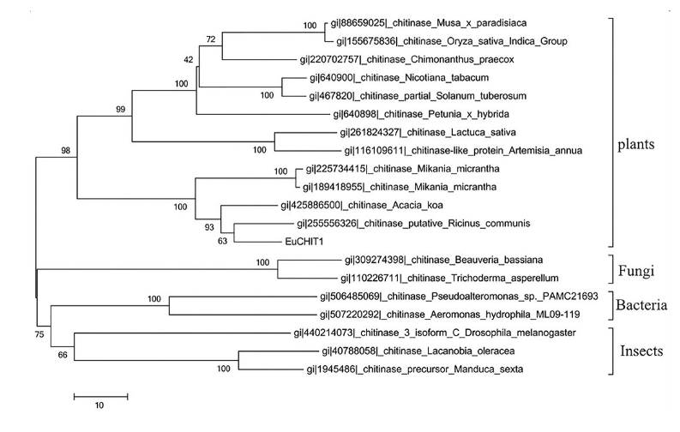
Fig. 2: Phylogenetic analysis of deduced amino acid sequence of EuCHIT1 with others organisms including plants, bacteria, fungi, and insects. Chitinase shares a common evolutionary origin with other plant chitinases, indicating that EuCHIT1 belongs to the plant Chitinase group and has a high homology with the chitinase of Acacia koa and Ricinus communis. Alignments were performed with MEGA5.2.2 software.

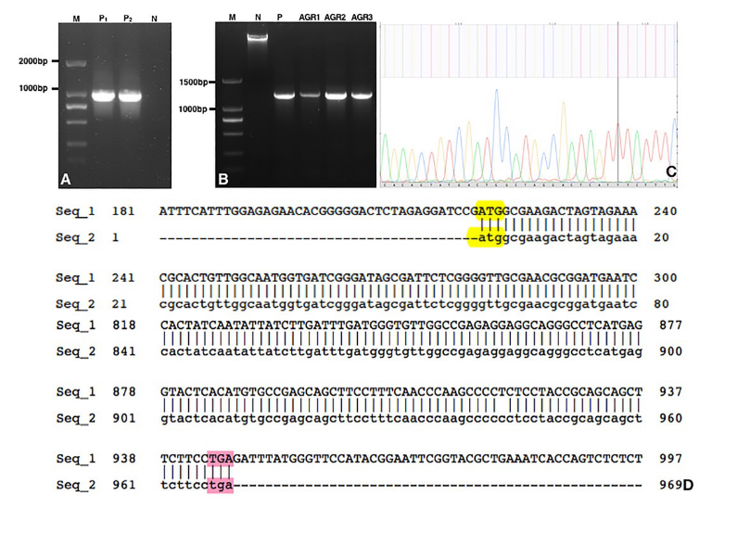
Fig. 3: Identification of vectors and Agrobacterium strains. (A) M, DL2000 DNA marker. PCR amplification of pSH-35S-EuCHIT1 and P1, P2 plasmid vector. N, negative control. (B) M DL2000 DNA maker; N, negative control; P, positive control. AGR1~AGR3 kanamycin-resistance positive strains. (C) and (D) Exact sequence results.

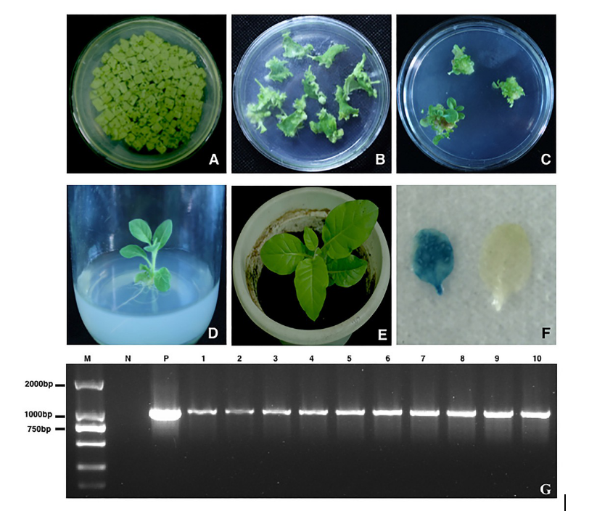
Fig. 4: Transformation of tobacco and identity of transgenic tobacco plants. (A), (B),(C), (D), and (E) The transformation process of tobacco leaves. (F) Histochemical staining by Gus for transgenic tobacco (blue, positive staining; no color or white, wild type tobacco negative staining). (G) M: DL2000 DNA marker, PCR amplification for Gus-positive transgenic tobacco line. N wild type tobacco, p plasmid pSH-35S-EuCHIT1.

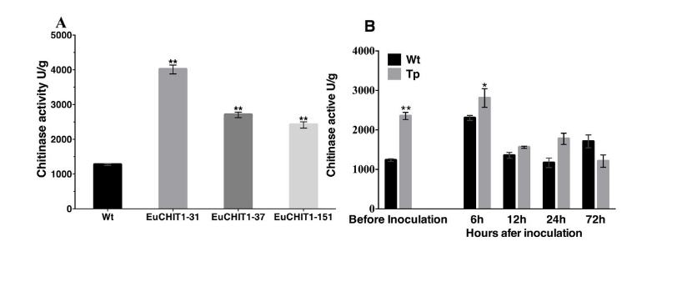
Fig. 5: Chitinase activities of basal condition and infection with B. Cinerea in wildtype and transgenic tobacco plants. (A) Chitinase activities of basal condition tobacco lines (Wt-wildtype and T1 EuCHIT1 transgenic lines EuCHIT1-31, EuCHIT1-37, and EuCHIT1-151).(B) Chitinase activities of wildtype and T1 EuCHIT1 transgenic lines before and 6 h, 12 h, 24 h, and 72 h after inoculation with B. cinerea. Error bars represent standard deviation, *Represents significant differences at P <0.05 and **indicates significant differences at P < 0.01.

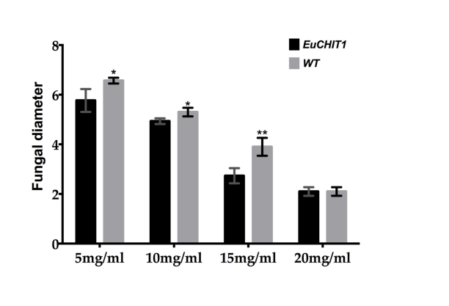
Fig. 6: In vitro antifungal activity of EuCHIT1. The fungal diameter formed after 6 days inoculated with Fusarium oxysporum. Wt-wild type and T1 EuCHIT1 transgenic lines EuCHIT1-31, EuCHIT1-37, and EuCHIT1-151. Error bars represent standard deviation, *indicates significant differences at P < 0.05;**indicates significant differences at P < 0.01.

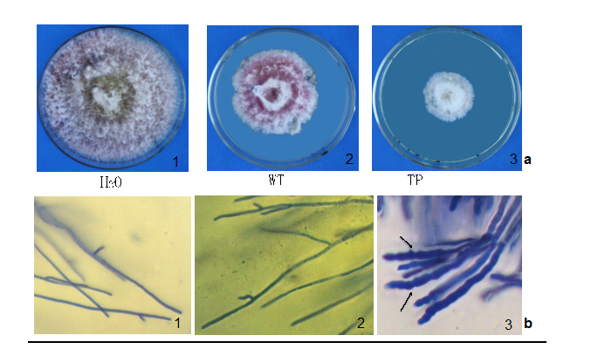
Fig. 7: In vitro antifungal activity of EuCHIT1. A. Crude leaf extracts (110 mg/mL) from EuCHIT1 transgenic tobacco treatment on day 6. B. Crude leaf extracts (110 mg/mL ) from EuCHIT1 transgenic tobacco treatment on day 3 showing the change of mycelium.
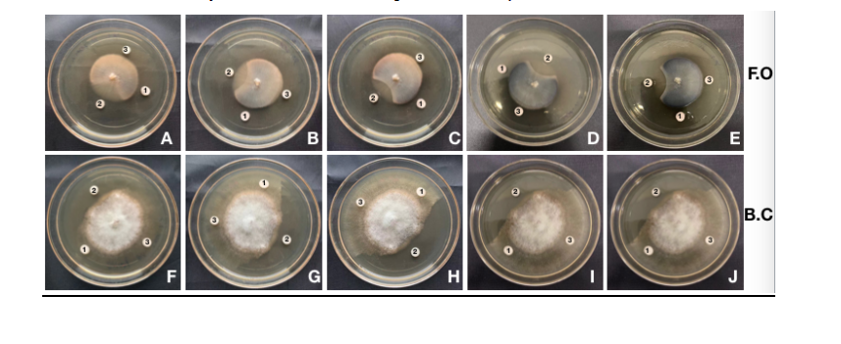
Fig. 8: In vitro antifungal activity of EuCHIT1 of E. coli. (1) Recombinant protein (1 mg/mL) (2) 1% carbendazim (3) 100 mM imidazole. (A–E) The inhibitory effect of recombinant protein to Fusarium oxysporum. (F–J) The inhibitory effect of recombinant protein to Botrytis cinerea.

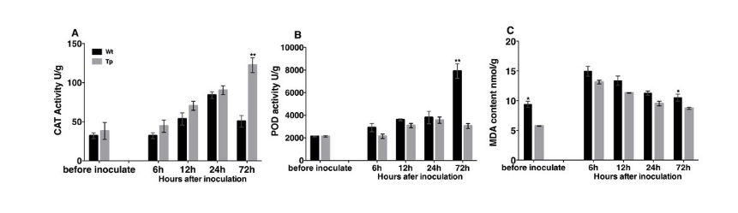
Fig. 9: Measurement of physiological and biochemical characteristics before and after inoculation with B. cinerea in tobacco plants. (A) Measurement of CAT activity. (B) Measurement of POD activity.(C) Measurement of MDA content. Wt-wildtype, Tp-transgenic plant. Error bars represent standard deviations. *Represents significant differences at P < 0.05 and **indicates significant differences at P < 0.01

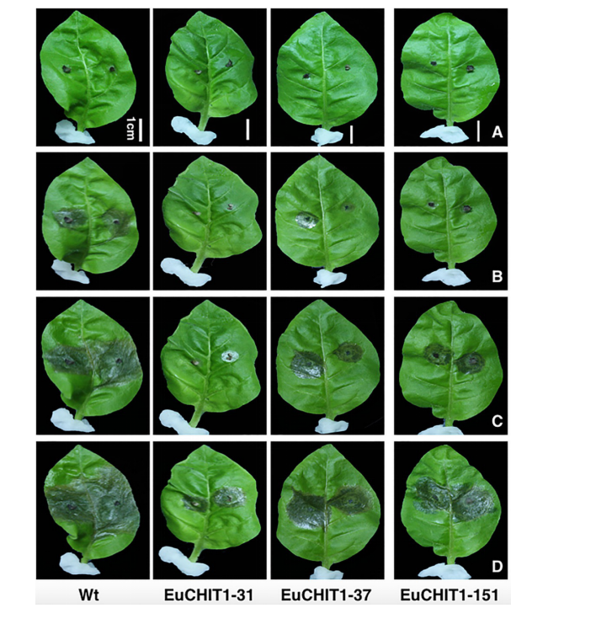
Fig. 10: Disease development on Nicotiana tabacum cv. Xanthin inoculated with B. cinerea. Necrotic lesions on the leaves of wild-type tobacco and T1 EuCHIT1 transgenic lines, EuCHIT1- 31, EuCHIT1-37, and EuCHIT1-151. (A) One day after inoculation. (B) Two days after inoculation. (C) Three days after inoculation. (D) Four days after inoculation, Bar = 1 cm.

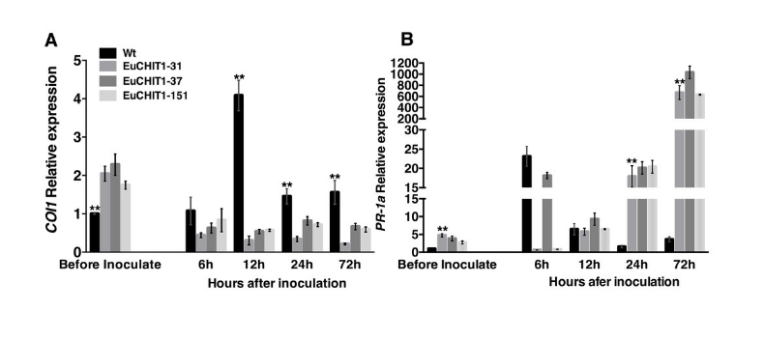
Fig. 11: The relative expression of resistance-related genes in basal condition tobacco plants and Botrytis-inoculated tobacco plants. (A) Relative expression of COI1. (B) Relative expression of PR-1a. Wt-wildtype and T1 EuCHIT1 transgenic lines EuCHIT1-31, EuCHIT1-37, and EuCHIT1-151 were three different transgenic lines. Error bars represent standard deviations. **Indicates significant differences at P < 0.01.

Table 1: Primers used in the full-length cloning of EuCHIT1 and expression analysis

Use in study | Gene | Sequence (5’-3’)
RACE | EuCHIT1-GSP1 | CCTGGATTCGGTACCACTATGAATGTCC
 | EuCHIT1-GSP2 | GCTTGGGTTGAAAGGAAGCTGCTCG
ORF | EuCHIT1-BamHI-F | CGGGATCCCGATGGCGAAGACTAGTAGAAACGCAC
 | EuCHIT1-EcoRI-R | CGGAATTCCGTATGGAACCCATAAATCTCAGGAAG
Verification | pSH-35s-F | TCGTCAACATGGTGGAGCACGAC
 | T-EuCHIT1-R | GCTTGGGTTGAAAGGAAGCTGCTCG
Internal control | Actin | TGGTTAAGGCTGGATTTGCT
 |  | TGCATCCTTTGACCCATAC
Expression analysis | PR-1a | ACAGCTCGTGCAGATGTAGGT
 |  | GCTAGGTTTTCGCCGTATTG
 | COI1 | GTTGTAGCCAGTGAGGGAAATA
 |  | TTGCCCAGCAAGAGAATAGTAG

Supplementary information
Overexpression of EuCHIT1, A New Chitinase Gene, from Eucommia ulmoides Enhances Resistance to Botrytis cinerea and Fusarium oxysporum in Transgenic Tobacco

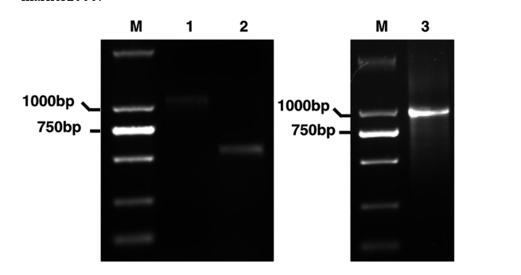
Fig. S1: Electrophoresis of PCR product. 1, EuCHIT1-3’RACE (512 bp) 2, EuCHIT1-5’ RACE (1076 bp) 3, PCR product of ORF EuCHIT1 (1006 bp) M, DNA Marker 2000.

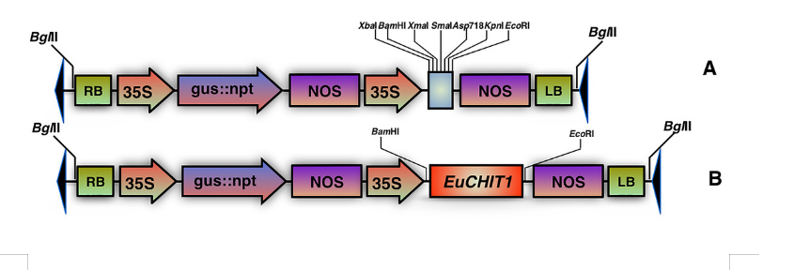
Fig. S2: Linear schematic representation of T-DNA regions of the binary overexpression vector. pSH-35S-EuCHIT1. (A) Structure map of the T-DNA region of vector pSH-35S for plant transformation including 35S::GUS::NPT II cassette and another harbored 35S::MCS.NPT II was a selective maker in E. coli, Agrobacterium, and plants. GUS was a selective maker of transformants. (B) Structural map of the T-DNA region of vector pSH-35S-EuCHIT1, cDNA of EuCHIT1 was inserted between 35S promoter and NOS terminator for overexpression. RB, right border; LB, left border; 35S, cauliflower mosaic virus (CaMV) 35S promoter; NOS, nopaline synthase terminator; Gus, β-glucuronidase; NPT II, neomycin phosphotransferase; MCS, multiple cloning site.

