Gibberellic acid induces early emergence by activating alpha-amylase production and improves yield and quality in potato crop

¹Ali Asad Bahar, ¹Hafiz Nazar Faried*, ¹Sami Ullah, ¹Kashif Razzaq, ²Mohsin Bashir, ³Muhammad Amin, ¹Gulzar Akhtar, ¹Syed Bilal Hussain, ¹Ghulam Mustafa, ⁴Fahad Masoud Wattoo, ⁵Shoaib Munir, ³Muhamad Rashid Shaheen, ⁶Abid Hussain, ⁷Muqarrab Ali
*Corresponding Author: nazar.farid@mnsuam.edu.pk
¹Department of Horticulture, MNS-University of Agriculture, Multan, Pakistan.
²Institute of Horticultural Sciences, University of Agriculture, Faisalabad, Pakistan.
³Department of Horticultural Sciences,The Islamia University of Bahawalpur, Pakistan.
⁴Department of Plant Breeding and Genetics, PMAS-University of Arid Agriculture, Rawalpindi, Pakistan.
⁵MOE Key Laboratory of Horticultural Plant Biology, Huazhong Agricultural University, Wuhan, Hubei, China.
⁶Department of Soil and Environmental Sciences, MNS-University of Agriculture, Multan, Pakistan.
⁷Department of Agronomy, MNS-University of Agriculture, Multan, Pakistan.

ABSTRACT
Potato (Solanum tuberosum L.) is the 3rd and 4th top consumed and cultivated food crop worldwide. Relatively high price of seed potatoes and inability of seed potatoes to emergence constraints a significant yield reduction to potato crop particularly in developing countries (e.g., Pakistan). The aim of this study was to evaluate the influence of gibberellic acid (GA₃) on potato crop in inducing early emergence and in improving the morpho-physio-biochemical and yield attributes. We assessed gibberellic acid potential in a randomized completely block design (RCBD), with different levels of gibberellic acid: T₀ = control (double distilled water), T₁ = GA₃ spray at 50ppm and T₂ = GA₃ spray at 100ppm. It was observed that seed potatoes treated with gibberellic acid showed early emergence and better growth performance as comparison to non-treated. Seed potatoes treated with GA₃ at 100ppm induced early emergence by reducing mean emergence time (22.81%) and improved plant height (1.27 folds) as compared to GA₃ at 50ppm and to non-treated. However, all other attributes including morphological (root length, root and shoot fresh weight), physiological (photosynthesis, transpiration, stomatal and sub-stomatal conductance) and biochemical (chlorophyll, carotenoids, total phenolic contents and antioxidant scavenging activity) were found maximum under 50ppm GA₃ application. Conclusively, seed potatoes treated with gibberellic acid at (50ppm) responded appropriately in improving plants physiology, morphology, bio-chemical and yield related traits. Hence, seed potatoes treated with GA₃ (50 ppm) may be recommended for breaking dormancy and inducing early emergence with higher plant growth and yield to benefit from autumn crop season in Punjab, Pakistan.

Key Words: Solanum tuberosum; Emergence; GA₃; Quality; Yield

INTRODUCTION
Potato (Solanum tuberosum L. family Solanaceae) the “King of vegetables” is an important tuber crop. Globally, it is the 3rd top consumed food crop after wheat and rice (Anwar et al., 2015) It is among the valuable human kind’s food crops. In fact, potatoes have a more favorable overall nutrient-to-price ratio than many other vegetables and are an important staple (Drewnowski, 2013) Worldwide, more than 5000 potato varieties have been cultivated in different parts of the world (Zaheer and Akhtar, 2016). Potato contains an efficient source of carbohydrates, proteins, resistant starch, vitamins and minerals which are essential dietary constituents (Camire et al., 2009).It also contains anti-oxidative properties that helps in preventing human body against degeneration and age-related diseases (Burgos et al., 2009).
Potato crop has also gained popularity in Pakistan due to its short duration. Potato crop is one of the main cash crops for the farmers in Pakistan and thus plays a trait role in Gross Domestic Product (GDP) of Pakistan (Abbas et al., 2013). The demand for potato crop has been increasing but its productivity is either stagnant or becoming low due to various factors such as inadequate accessibility of quality seed potatoes and due to poor sprouting of seed tubers due to prolong dormancy period (Chindi and Tsegaw, 2019). In Pakistan, potato crop has three growing season during a year. Autumn (October-February) crop is the main potato crop the production share of about seventy five (75%), followed by spring (10%) and summer (15%), respectively. Relatively expensive seed potatoes are imported during November followed by planting as spring crops leads to delay in emergence partially due to seed potato dormancy and predominantly low winter temperature resulted in slow growth, thereby higher vegetative growth during spring accompanied with less tuber development due to increase in day (˃ 25 °C) and night (˃ 12 °C) temperature. Further, aphid attack may transmit viruses which leads to seed potato deterioration and yield potential reduction (Majeed and Muhammad, 2018).
Inability of potato buds to sprout due to dormancy of the tuber constitutes a serious problem when the tuber is to be used as seed within 2–3 months of harvest. Different chemicals are being used in breaking seed dormancy like bromoethane (Akoumianakis et al., 2000) and rindite but they are not eco-friendly and causing hazardous impacts to human health (Rehman et al., 2001). Therefore, an economical and safer approach for breaking seed dormancy and triggering sprouting by the utilization of plant growth regulators like gibberellic acid (GA₃). GA₃ may help early emergence, appropriate haulm growth, thereby disease free seed potato production. Gibberellic acid (GA₃) has proven more effective in emancipating the dormant period especially in sprouting of seed potato:(Carrera et al., 2000; Nadjafi et al., 2006) and maintaining the health and vigor of seed potatoes (Demo, 2002).GA₃ is known for its specific involvement in cell enlargement and for the mechanisms of improving both the flowering and fruit growth (Taiz and Zeiger, 2002). GA₃ application to plant parts, then tubers broke their dormancy faster as compared to the control (untreated) plants (Alexopoulos et al., 2006). Therefore, by keeping in view the functions of gibberellic acid, we examined the impact of gibberellic acid on early growth, quality and productivity of potato plants under South Punjab environment, Multan, Pakistan.

MATERIAL AND METHODS
Plant material and GA₃ concentration
A pot experiment was conducted at university research farms, MNS-University of Agriculture, Multan (MNS-UAM), Pakistan (latitude 30° 8'26.93"N and longitude 71°26'35.43"E) during November 2019- March 2020. Seed potatoes viz. FD 81-1 was collected from local farmer. Initially, these seeds were treated with recommended dose of Emesto 24 FS (fungicide) for disinfection. Pots were filled with sandy loam soil that was collected randomly from university research farm. Before filling the pots, the soil was collected randomly for determining the physicochemical analysis as delineated by (Jackson, 2005) (Table 1).GA₃ stock solution was prepared as described by (Chindi and Tsegaw, 2019) for which three gram of GA3 was added in 10 ml of ethanol (96%), then double distilled water (DDW) was used to make the final volume up to 1000 ml. The treatment plan was consist of T₀= control (DDW), T₁= GA₃ spray at 50ppm and T₂=GA₃ spray at 100ppm with 3 replication and 10 plants in each replication. The experiment was repeated thrice. Five plants from each replication was tagged for data collection.

Table 1: Physicochemical features of soil used for the pot experiment
Physical |  | Chemical
Texture | Saturation (%) | Organic matter (%) | Nitrogen (mg kg⁻¹) | Phosphorus (mg kg⁻¹) | Potassium (mg kg⁻¹)
Sandy Loam | 7.8 | 0.78 | 101 | 6.50 | 112

Emergence parameter: Mean emergence time (days) was checked on daily bases to collect tuber emergence data. It was calculated by using following formula as described by (Orchard, 1977).

$MET=∑(Dn)/∑n$
Here:
n=Number of tubers emerged on day
D=Days in numbers noted from the onset of tubers emergence.
Physical parameters: Shoot length (SL) and root length (RL) were measured with the help of measuring tape and expressed in centimeter (cm). While shoot fresh weight (SFW) and root fresh weight (RFW) were noted via using digital weight balance (OHASU Corporation, USA).
Gaseous Exchange parameters: Gaseous exchange traits comprises of photosynthetic rate (Pn), stomatal conductance (gs), sub-stomatal CO₂ (Ci) and transpiration rate (E). They were estimated by CIRAS-3 portable open flow gas exchange system (PP Systems, Amesbury, USA). 3rd top leaf was used for the assessment of these attributes. CIRAS-3 was adjusted at 200 mL min⁻¹ mL airflow rate, 1100 μmol∙m⁻²∙s⁻¹ concentration of photosynthetic photon flux, 90± 5 kPa atmospheric pressure rate and 390 ± 5 μmol∙mol⁻¹ CO₂ concentration rate.
Biochemical parameters: Leaf samples were used for biochemical analysis. Total phenolic contents (mg GAE/100 g) and antioxidant scavenging activity (% Inhibition) were assessed by Folin-Ciocalteu and 1, 1-diphenyl-2-picrylhydrazyl (DPPH), as outlined by (Razzaq et al., 2013) via using spectrophotometer (CE-7400S, Germany) at 765nm and 517 nm. Additionally, chlorophyll a and b absorbance was recorded at 662nm and 645nm while total carotenoids were recorded at 470 nm via spectrophotometer (CE-7400S, Germany) by adopting the procedure described by (Lichtenthaler, 1987).

Yield parameters: Average tuber length and width were recorded with the help of vernier caliper (Mitutoyo Corporation, Japan) while average tuber plant yield (gram/plant) was estimated by digital weight balance (OHASU Corporation, USA) having readability of 0.01 gram.

RESULTS
Mean emergence time (Days): Supplementation of GA₃ significantly (P < 0.05) influenced the mean emergence time (days). Overall, mean emergence time was reduced by GA₃ application (Figure 1). Seed potatoes treated with GA₃ at higher doses (100ppm) and at lower doses (50ppm) reduced the emergence time about 53.44% and 39.67% respectively as compared to control.
Morphological Traits: Physical attributes such as shoot length (SL), shoot fresh weight (SFW), root length (RL), and root fresh weight (RFW) were significantly (P < 0.05) influenced with GA₃ implication. SL was significantly improved with GA₃ at 100ppm (2.2 folds) as compared to control. Irrespective to this, RL, RFW and SFW was considerably improved at lower dose of GA3 (50ppm) in comparison to GA₃ at higher doses and control (Figure 2). A significant increase in RL (1.59 folds), RFW (1.91 folds) and SFW (2.36 folds) was observed when seed potatoes were treated with GA₃ (50ppm) as comparison to untreated plants.

Physiological Attributes: Gaseous exchange attributes were significantly (P < 0.05) improved by GA₃ supplementation. A noticeable increase in Pn (1.92 folds), E (1.77 folds), g_{s} (1.51) and C_{i} (1.28 folds) was recorded when plants were treated with GA₃ at lower doses (50ppm) as comparison to control. Overall, GA₃ at 50ppm performs well in comparison to GA₃ at higher doses (100ppm) and control (Figure 3).

Biochemical Analysis: Biochemical attributes (chlorophyll (a) and (b), carotenoids, total phenolic contents and antioxidant scavenging activities) were significantly affected by GA₃ supplementation. Supplementation of GA₃ at (50 ppm) caused a significant improvement in chlorophyll (a) (2.26 folds) and (b) (1.57 folds) carotenoids (1.48 folds), total phenolic contents (1.21 folds) and antioxidant scavenging activities (1.55 folds) over control. Conclusively, biochemical traits performed well where GA₃ was supplemented @ 50ppm as compared to control and GA₃ with 100ppm (Figure 4).

Yield related Attributes: Foliar spray of GA₃ significantly (P < 0.05) influenced yield attributes (tuber length, width and tuber yield). Seed potatoes treated with GA₃ at 50ppm caused a significant improvement towards yield and its components. A considerable increasing trend of tuber length (1.25 folds), width (1.14 folds) and yield (1.85 folds) was noticed as comparison to control. Conclusively, gibberellic acid at lower doses (50ppm) exhibited better performance as compared to control and GA₃ with higher dose (100ppm) (Figure 5).

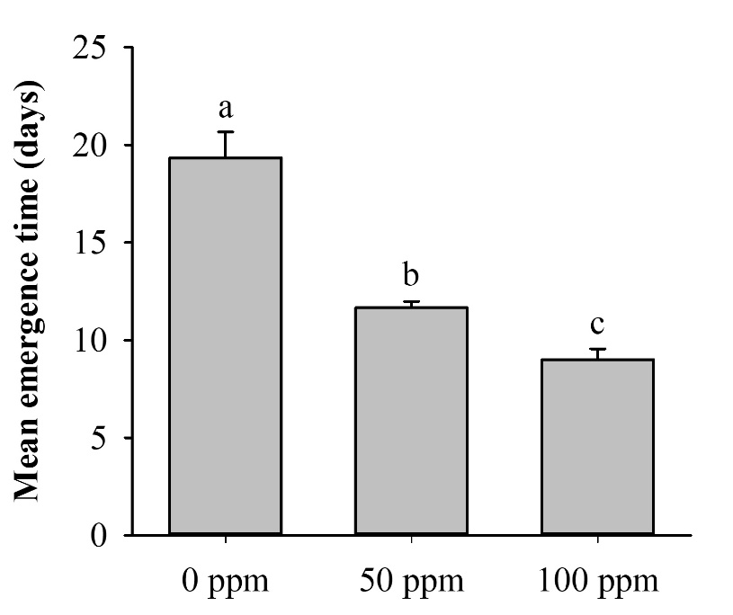

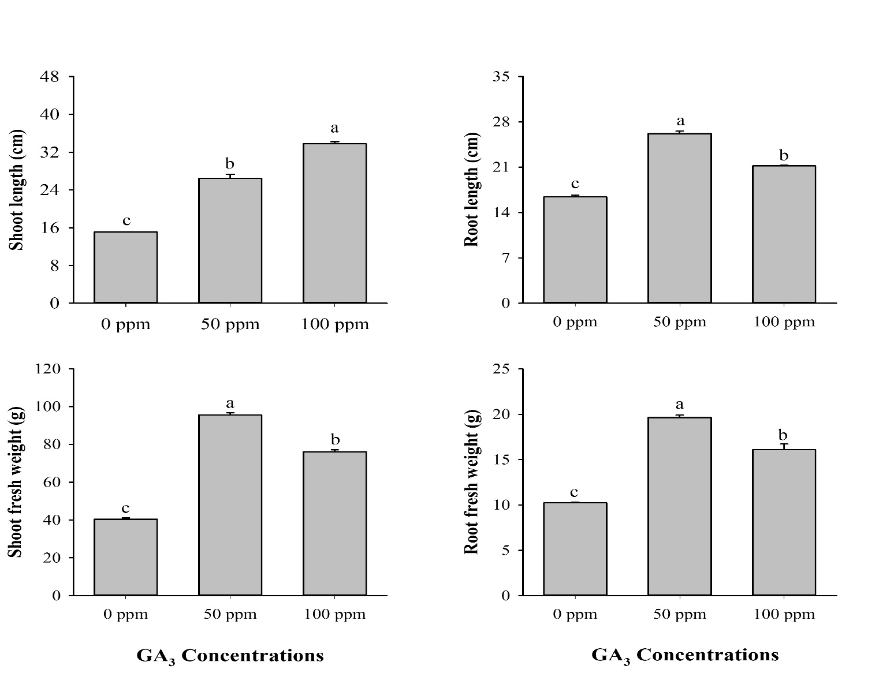
FIGURE 1 Influence of GA3 on mean emergence time (Days). Graph bars sharing different letters are significant at P ≤ 0.05.
FIGURE 2 Impact of GA3 on physical parameters of potato crop. Graph bars with different letters are significant at P ≤ 0.05
A.
B.
D.
C.
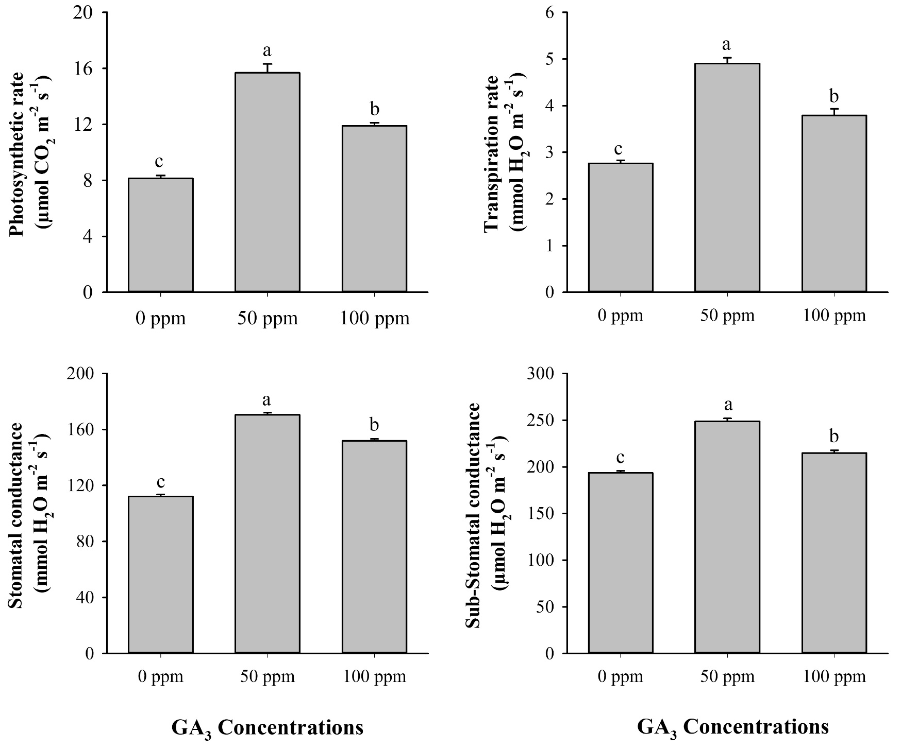
D.
C.
B.
A.
FIGURE 3 Physiological attributes influenced by GA3 supplementation. Graph bars with unalike letters are significant at P ≤ 0.05.

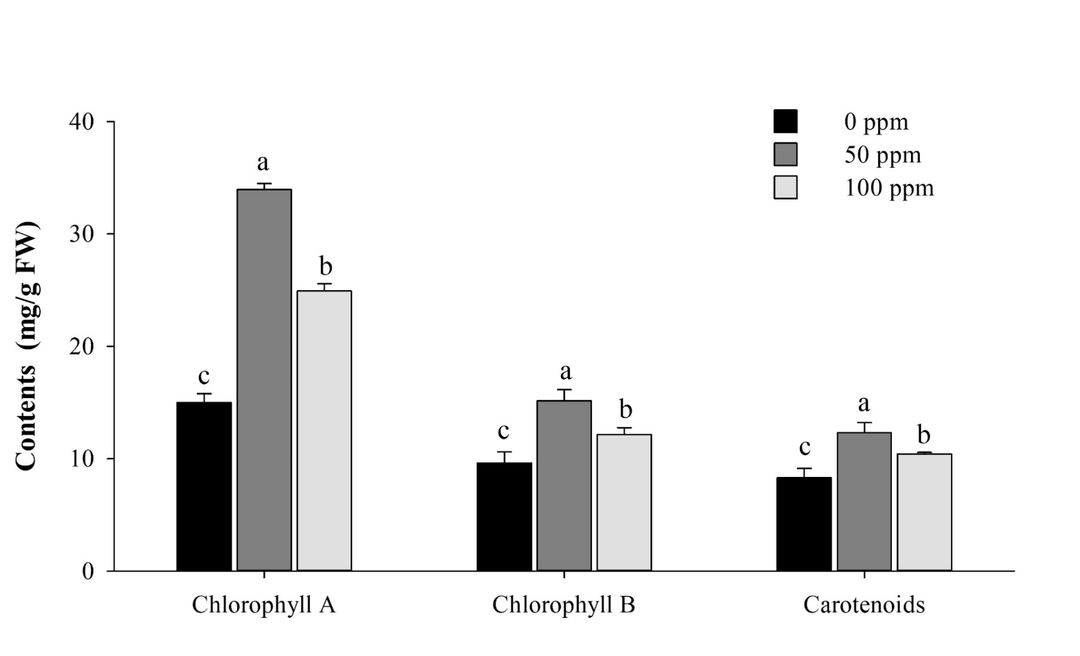
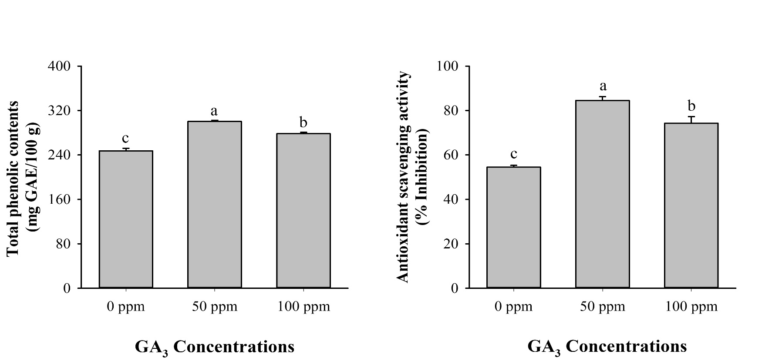
C.ws.….....
B.
A.
FIGURE 4 Biochemical attributes influenced by various GA3 supplementation. Graph bars sharing different letters are significant at P ≤ 0.05.

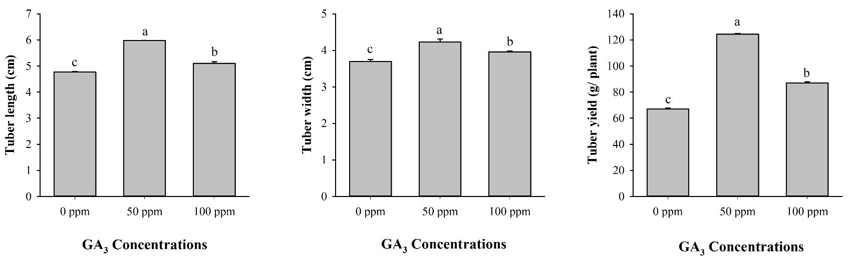
B.
C.
A.
FIGURE 5 Yield traits as influenced by different GA3 supplementation. Graph bars having non-similar letters are significant at P ≤ 0.05.

DISCUSSION
Plant’s morphological and physiological attributes are affected by the interference of PGRs particularly GA₃ (Papadopoulos et al., 2006). Previous reports has illustrated that GA₃ supplementation improves the vegetative phase of plants in various crops such as in okra (Ayyub et al., 2013), tomato (Kumar et al., 2014) and cucumber (Pal et al., 2016). Similarly, in present study, significant variation was observed in emergence and physical parameters with foliar application of GA₃ as compared to control (Figure 1 and 2).The decreasing trend in days to emergence were possibly due to the impact of starch hydrolysis with the production of sugar contents that aids in releasing seed dormancy. This phenomenon leads to tuber sprouting and hence helps in early emergence (Barani et al., 2013). In this study, the improvement in vegetative parts may attributed as a product of protein, DNA and RNA synthesis (Taiz and Zeiger, 2002). This may also be a result of early cell division and cell elongation as stimulated by gibberellins (Taiz and Zeiger, 2010).
GA₃ plays an integral role in the stimulation of plants physiology (Varier et al., 2010). Like presented study, physiological attributes including photosynthetic rate (Pn), transpiration rate (E), stomatal conductance (g_{s}) and sub-stomatal CO₂ (C_{i}) were improved in GA₃ treated plants as compared to control. The improvement in these components might be due to enhanced Rubisco activity that regulates the CO₂ intake (Yuan and Xu, 2001). The improvement in nutrient status particularly sulfate anion contents (K⁺) with increasing GA₃ concentration has also been reported by (Pérez-Jiménez et al., 2015) and (Husain et al., 2018). Another possible reason for the increase in physiological traits is the availability of potassium mineral which is directly involved in the activation of enzymes and ATP synthesis (Ul-Allah et al., 2020). However, GA₃ supplementation at higher concentration (100ppm), these traits were reduced as compared to lower GA₃ supplementation (50ppm) but superior to control. The possible statement for this declination may be the plants altered response towards photosynthesis production via increasing the shoot partitioning (Ayad et al., 2018).
Chlorophyll is the most imperative parameter that plays a vital role in photosynthetic capacity (Zheng et al., 2018). Several reports has reported that GA₃ has a promoting impact on chlorophyll and carotenoid contents (Mukhtar, 2008); (Prajapati et al., 2015) and (Azab, 2018). However, decrease in chlorophyll contents by GA₃ supplementation has also been illustrated in many crops such as in eggplant (Magdah, 2016). However, in existing study, GA₃ treated plants exhibited higher chlorophyll (a and b) and carotenoid contents in comparison to control. The possible answer for this enhancement is due to the improvement of ultra-structural morphogenesis of plastids coupled with retention of chlorophyll (Ahmad, 2010). Additionally, the chlorophyll contents were lower when GA₃ was sprayed at higher doses (100ppm) as comparison to lower doses (50ppm) but succeeded in achieving higher chlorophyll contents over control. This improvement of GA₃ at 100ppm over control may be accredited to the inhibition of chlorophyll degradation by down regulation of Mg-dechelation and peroxidase (POD) activities while maintaining the lipoxygenase (LOX) activity (Li et al., 2010). The deleterious impact of gibberellic acid at high concentration (100ppm) might be as a combined effect of stem elongation and thickness that leads to decline in leaf size and resulted to a pale green color (Taiz and Zeiger, 2010).
Estimation of DPPH radical scavenging activity and total phenolic compounds (TPC) are directly linked with antioxidant activities. Higher TPC is directly correlated with antioxidant activity because phenolic compounds act as a good free radical scavengers via donating their hydrogen to free radicals (Ali et al., 2012). During current study, significant improvement in phenolics and antioxidant scavenging activity were observed in GA₃ treated plants at lower concentration (50 ppm) relative to higher GA₃ concentration (100ppm) and control (DDW) (Figure 3a ,4a,) which might be due to the improvement in chlorophyll and photosynthetic rate. This combined impact stimulates the C0₂ flow and Rubisco activity that might mitigates reactive oxygen species (ROS) production. Another reason for the enhancement in antioxidant scavenging activity was the presence of DELLA protein that prevents the plants from oxidative stress (Achard et al., 2008) and (Jusovic et al., 2018). Additionally, the plants treated with higher concentration of GA₃ failed to scavenge free radicals that leads to oxidative damage and ultimately cell death (Fath et al., 2001). The same observation was depicted during current study as reported by (Fath et al., 2001) at higher GA₃ acid concentration.
Yield is an important aspect for any crop. In present study, yield and yield related parameters (tuber length and width) were significantly (P≤0.05) affected by GA₃ foliar application. In past, deleterious effects of GA₃ at higher doses on yield in various crops has been reported i.e. sweet pepper (Pérez-Jiménez et al., 2015). Similarly in present study, yield attributes were maximum where GA₃ was sprayed at lower concentration (50ppm) as comparison to control (DDW) and GA₃ at higher concentration (100ppm) (Figure 5). This can be attributed to the decrease in reserves of the GA₃ treated plants at high dose. This might create competition and thus no more storage reserves available that plants can use to improve their size (Singh and Singh, 2006) and (Qureshi et al., 2013). Decline in yield and in its components at higher GA₃ dose may be accredited to the over expression of genes particularly StCYP707A1 that negatively effects potato tuberization (Liu et al., 2017).
CONCLUSION
In this study, the foliar application of gibberellic acid induces a significant variation as compared to untreated plants. GA₃ at high dose (100ppm) induces early emergence and improves plant height relative to low dose (50ppm) and control. However, gibberellic acid at 100ppm were unsuccessful in improving the morpho-physio-chemical and yield attributes as compared to GA₃ at 50ppm. Conclusively, GA₃ supplementation at lower dose 50ppm improves all above parameters. This improving impact might be attributed to the higher generation of antioxidative properties and total phenolic contents via reducing reactive oxygen species (ROS) and by maintaining rubisco activity that regulates the flow of carbon dioxide (CO₂).

REFERENCES
Abbas, M.F., Aziz-ud-Din, G.A., Qadir, A., and R. Ahmed, 2013. Major potato viruses in potato crop of pakistan: A brief review. Int. J. Biol. Biotech., 10(3): 435-440.
Achard, P., Renou, J.-P., Berthomé, R., Harberd, N.P., and P. Genschik, 2008. Plant DELLAs restrain growth and promote survival of adversity by reducing the levels of reactive oxygen species. Curr Biol., 18: 656-660.
Ahmad, P., 2010. Growth and antioxidant responses in mustard (Brassica juncea L.) plants subjected to combined effect of gibberellic acid and salinity. Arch. Agron. Soil Science., 56(5): 575-588.
Akoumianakis, K., Olympios, C., and H. Passam, 2000. Effect of" rindite" and bromoethane on germination, sprout emergence, number of sprouts and total yield of tubers of potato cv. Spunta. Advc. Hortic Sci.,14, 33-35.
Alexopoulos, A.A., Akoumianakis, K.A., and H.C. Passam, 2006. Effect of plant growth regulators on the tuberisation and physiological age of potato (Solanum tuberosum L.) tubers grown from true potato seed. Can. J. Plant. Sci., 86: 1217-1225.
Ali, Q., Ashraf, M., Anwar, F., and F. Al-Qurainy, 2012. Trehalose-induced changes in seed oil composition and antioxidant potential of maize grown under drought stress. J.Am.Oil. Chem. Soc., 89(8): 1485-1493.
Anwar, D., Shabbir, D., Shahid, M.H., and W. Samreen, 2015. Determinants of potato prices and its forecasting: A case study of Punjab, Pakistan.
Ayad, J.Y., Othman, Y.A., Al-Ajlouni, M.G., and N.G. Alsmairat, 2018. Photosynthesis, gas exchange and yield of two strawberry (Fragaria× ananassa duch.) cultivars in response to gibberellic acid. FRESENIUS ENVIRONMENTAL BULLETIN., 27: 9127-9134.
Ayyub, C., Manan, A., Pervez, M., Ashraf, M., Afzal, M., Ahmed, S., Jahangir, M., Anwar, N., and M. Shaheen, 2013. Foliar feeding with Gibberellic acid (GA3): A strategy for enhanced growth and yield of Okra (Abelmoschus esculentus L. Moench.). Afr. J. Agric. Res., 8(25): 3299-3302.
Azab, E., 2018. Seed Pre-soaking on Gibberellic Acid (GA3) Enhance Growth, Histological and Physiological Traits of Sugar Beet (Beta vulgaris L) under Water Stress. Egypt. J. Agron., 40(2): 119-132.
Barani, M., Akbari, N., Ahmadi, H. (2013). The effect of gibberellic acid (GA3) on seed size and sprouting of potato tubers (Solanum tuberosum L.). Afr. J. Agric. Res., 8(29): 3898-3903.
Burgos, G., Salas, E., Amoros, W., Auqui, M., Munoa, L., Kimura, M., and M. Bonierbale, 2009. Total and individual carotenoid profiles in Solanum phureja of cultivated potatoes: I. Concentrations and relationships as determined by spectrophotometry and HPLC. J. Food Compos. Anal. 22, 503-508.
Camire, M.E., Kubow, S., and D.J. Donnelly, 2009. Potatoes and human health. Crit Rev Food Sci Nutr., 49(10): 823-840.
Carrera, E., Bou, J., García‐Martínez, J.L., and S. Prat, 2000. Changes in GA 20‐oxidase gene expression strongly affect stem length, tuber induction and tuber yield of potato plants. Plant J., 22(3): 247-256.
Chindi, A., and T. Tsegaw, 2019. Effect of gibberellic acid on growth, yield and quality of potato (Solanum tuberosum L.) in central highlands of Ethiopia. J. Hortic. Sci., 1(2): 1-10.
Demo, P., 2002. Strategies for seed potato (Solanum tuberosum L.) production using rooted apical stem cuttings and tubers in Cameroon. (Ph. D Thesis) University of Ibadan.
Drewnowski, A., 2013. New metrics of affordable nutrition: which vegetables provide most nutrients for least cost? J. Acad. Nutr. Diet., 113(9): 1182-1187.
Fath, A., Bethke, P.C., and R.L. Jones, 2001. Enzymes that scavenge reactive oxygen species are down-regulated prior to gibberellic acid-induced programmed cell death in barley aleurone. Plant physiol., 126(1): 156-166.
Husain, A.J., Muhmood, A.G., and A.H. Alwan, 2018. Interactive effect of ga3 and proline on nutrients status and growth parameters of pea (Pisum sativum L.). Indian J. Ecol., 45(1): 201-204.
Jackson, M.L., 2005. Soil chemical analysis: Advanced course. UW-Madison Libraries Parallel Press.
Jusovic, M., Velitchkova, M.Y., Misheva, S.P., Börner, A., Apostolova, E.L., and A.G. Dobrikova, 2018. Photosynthetic responses of a wheat mutant (Rht-B1c) with altered DELLA proteins to salt stress. J. Plant Growth Regul., 37(2): 645-656.
Kumar, A., Biswas, T., Singh, N., and E. Lal., 2014. Effect of gibberellic acid on growth, quality and yield of tomato (Lycopersicon esculentum Mill.). J. Agric. Vet. Sci., 7(7): 28-30.
Li, J., Yu, K., Wei, J., Ma, Q., Wang, B., and D. Yu, 2010. Gibberellin retards chlorophyll degradation during senescence of Paris polyphylla. Biol. plant., 54(2): 395-399.
Lichtenthaler, H.K., (1987). Chlorophylls and carotenoids: pigments of photosynthetic biomembranes. Methods Enzymol., 148: 350-382.
Liu, L., Zhang, R.-J., Zhu, W.-J., Liu, X.-R., Shi, K., Chen, M., and Q. Yang, 2017. Inhibitory effect of StCYP707A1 gene on tuberization in transgenic potato. Plant Biotechnol Rep., 11(4): 219-228.
Magdah, A., 2016. Impact of biostimulant and synthetic hormone gibberellic acid on molecular structure of Solanum melongena L. J. Mol. Biol. Res., 6(1): 100-110.
Majeed, A., and Z. Muhammad, 2018. Potato production in Pakistan: challenges and prospective management strategies–a review. Pak. J. Bot., 50(5): 2077-2084.
Mukhtar, F., 2008. Effect of some plant growth regulators on the growth and nutritional value of Hibiscus sabdariffa L.(Red sorrel). Int. J. Pure Appl. Sci., 2(3): 70-75.
Nadjafi, F., Bannayan, M., Tabrizi, L., and M. Rastgoo, 2006. Seed germination and dormancy breaking techniques for Ferula gummosa and Teucrium polium. J. Arid Environ., 64(3): 542-547.
Orchard, T., 1977. Estimating the parameters of plant seedling emergence. Seed Sci. technol.
Pal, P., Yadav, K., Kumar, K., and N. Singh, 2016. Effect of gibberellic acid and potassium foliar sprays on productivity and physiological and biochemical parameters of parthenocarpic cucumber cv.‘Seven Star F1’. J. Hortic Res., 24(1): 93-100.
Papadopoulos, A., Saha, U., Hao, X., and S. Khosla, 2006. Response of rockwool-grown greenhouse cucumber, tomato, and pepper to kinetin foliar sprays. HortTechnol., 16: 493-501.
Pérez-Jiménez, M., Pazos-Navarro, M., López-Marín, J., Gálvez, A., Varó, P., and F.M. del Amor, 2015. Foliar application of plant growth regulators changes the nutrient composition of sweet pepper (Capsicum annuum L.). Sci. Hortic., 194: 188-193.
Prajapati, S., Jamkar, T., Singh, O., Raypuriya, N., Mandloi, R., and P. Jain, 2015. Plant growth regulators in vegetable production: An overview. Plant Arch., 15(2): 619-626.
Qureshi, K.M., Chughtai, S., Qureshi, U.S., and N.A. Abbasi, 2013. Impact of exogenous application of salt and growth regulators on growth and yield of strawberry. Pak. J. Bot., 45(4): 1179-1185.
Razzaq, K., Khan, A.S., Malik, A.U., and M. Shahid, 2013. Ripening period influences fruit softening and antioxidative system of ‘Samar Bahisht Chaunsa’mango. Sci. Hortic., 160: 108-114.
Rehman, F., Lee, S.K., Kim, H.S., Jeon, J.H., Park, J.Y., and H. Joung, 2001. Dormancy breaking and effects on tuber yield of potato subjected to various chemicals and growth regulators under greenhouse conditions. Online J. Biol. Sci., 1(9): 818-820.
Singh, A., and J. Singh, 2006. Studies on influence of biofertilizers and bioregulators on flowering, yield and fruit quality of strawberry cv. Sweet Charlie. Ann. Agric. Res. 27(3): 261-264.
Taiz, L., and E. Zeiger, 2002. Plant Physiology. Sunderland, MA. Sinauer Associates, Inc., Publishers 3, 484.
Taiz, L., and E. Zeiger, 2010. Responses and adaptations to abiotic stress. Plant Physiology, Fifth Edition. Sunderland, MA: Sinauer Associates, Inc, 755-778.
Ul-Allah, S., Ijaz, M., Nawaz, A., Sattar, A., Sher, A., Naeem, M., Shahzad, U., Farooq, U., Nawaz, F., and K. Mahmood, 2020. Potassium application improves grain yield and alleviates drought susceptibility in diverse maize hybrids. Plants., 9(1): 75.
Varier, A., Vari, A.K., and M. Dadlani, 2010. The subcellular basis of seed priming. Curr. Sci., 450-456.
Yuan, L., and D.Q. Xu, 2001. Stimulation effect of gibberellic acid short-term treatment on leaf photosynthesis related to the increase in Rubisco content in broad bean and soybean. Photosynth. Res., 68(1): 39-47.
Zaheer, K., and M.H. Akhtar, 2016. Potato production, usage, and nutrition—a review. Crit Rev Food Sci Nutr., 56(5): 711-721.
Zheng, T., Liu, N., Wu, L., Li, M., Sun, H., Zhang, Q., and J. Wu, 2018. Estimation of chlorophyll content in potato leaves based on spectral red edge position. IFAC-PapersOnLine., 51(17): 602-606.

