Synthesis and Recommendations for the Effects of NPK
Fertilizer on Paddy Rice Yield and Soil on Irrigated Land in Rwanda
Peace Bamurigire^{1 ID} , Anthony Vodacek^{2 ID} , Emmanuel Ndashimye ^{3 ID}
Said Rutabayiro Ngoga⁴
¹African Center of Excellence in Internet of Things, College of Science and Technology, University of Rwanda
²Chester F. Carlson Center for Imaging Science, Rochester Institute of Technology, Rochester USA
³College of Science and Technology, University of Rwanda
⁴Rwanda Information Society Authority
April 8, 2022

Abstract
Rice is a staple food for more than half of the world population, Africa is also the major food, and Rice in Rwanda is one of the food baskets of rural and urban households where 62the rice purchased is imported from outside countries to reach population demand. Nitrogen (N),phosphorus (P), and potassium (K) deficiency is one of the major yield-limiting constraints in most rice-producing soils around the world. In paddy rice, NPK recovery efficiency is 50% off applied fertilizers in most agroecological, and the NPK efficiency is associated with losses caused by leaching, volatilization, denitrification, and surface runoff. Improving NPK efficiency, and timing is crucial for higher yields and reducing the environmental pollution. This study aimed to identify how much amount of NPK can be applied at the appropriate time to increase rice production and reduce soil pollution. The result indicates that the maximum rate of NPK from 90 to 140 kg/ha varied with rice yield of 6500 to 7000 kg/ha. The application timing also varied from the total required amount applied at flooding to split into three or four applications during the crop growth cycle. This work accounts for the context of rice farming at the Muvumba Valley Rice Plantation located in Nyagatare District, Eastern Province, Rwanda.
Keywords:Rwanda; Fertilizer; NPK; Management; Rice Agriculture

Introduction
Rice is a staple food for more than half of the world population where 90% of the world’s rice is cultivated in Asia, especially in China, India, Indonesia, and Bangladesh, and smaller amounts grown in Japan, Pakistan, and other Southeast Asian nations. Rice is also cultivated in parts of Europe, in North and South America, and in Australia[1]. In Asia, rice is important as a source of income to millions of rice farmers and different workers[2]. Malaysia requires to import over 1,100 thousand tons of rice production per year to attain the 90% self-sustenance level to support the population growth rate[3]. In the Sarawak, 123,250 square kilometers land is planted with wetland and upland rice. The total of rice production in Sarawak is 19 million tons[4]. In Africa consumes 11.6 million tons of milled rice per year[5] of which 3.3 million tons (33.6%) is imported. Rice farmers continue to cultivate rice below their actual yield potential and they can not yield rice production nearly enough comparing cultivated to account for rapid population growth. Furthermore, the quality of the rice harvest cannot compete with that of imported rice from outside Africa[6], Most African countries are far from self-sufficient in meeting their rice consumption, in more than twenty countries the production, the consumption ratio, ranged from 0.16 to 1.18 in 2012. Which indicates that by the year 2025, with population increasing, diet change and yield increase on existing land countries will not become fully self-sufficient in rice. This implies that in the future, a mixture of different technologies to improve rice production and imports will be needed to close the gap[7].
In Rwanda, rice has been identified and promoted as one of the priority food crops and a major commodity in the food baskets of rural and urban households where 76% of the rice purchased is imported from other rice producing countries to meet the demands of consumers[8]. According to the National Rice Program of the Government of Rwanda [9, 10], past predictions for the national demand for rice were underestimated, so one aspect of food security for Rwanda is to bolster domestic rice production. However, based on the National Institute of Statistics of Rwanda[11] indicates that production in 2020 was only about a third of the demand, thus leading to negative economics[12].To increase rice crop production, there is always a need to apply fertilizers to produce enough rice production and income[13]. Potassium, phosphorus, and nitrogen(NPK) is one of the fertilizers that allows rice crops to grow bigger, faster, and to produce more rice yield [14, 15].The soil capacity to produce rice crops is indeed the basis of yield prediction and could be considered as the most useful expression of soil productivity. Rice yield and rice performances are however closely correlated with soil condition. To ensure food security in the Rwanda’s rice-consuming, large amount of NPK fertilizer are applied to meet demands[16, 17] due to rice has become a major commodity in the food baskets of rural and urban households in Rwanda where 62% of the rice was imported from outside country [10], it is imperative to increase rice yields on the remaining agricultural land to meet food demands [18]. One of the obstacles to increasing rice production in Rwanda is the deterioration of soil quality with low utilization rate and high wastage rate of NPK. Excessive NPK fertilizer application of 200 kg/ha aggravates soil degradation and environmental pollution[8] resulting in soil-related problems, such as acidification, loss of organic matter, deterioration of the structure, and reduction in biological activities and fertility . Consequently, rice crop yields in several regions are stagnating or declining[19]. The soil quality in Rwanda indicated that most rice fields in Rwanda are in a condition of soil sickness with an indicator of soil organic content due to the unbalanced use of organic and inorganic fertilizers. Excessive or inappropriate use of inorganic fertilizers is a significant cause of nutrient imbalance in the soil, causing high losses, especially NPK fertilizers [20]. Unbalanced use of NPK fertilizers decreased soil fertility and reduced rice paddy rice yield[21].Therefore, it is crucial to explore the appropriate application amount of NPK fertilizer, which can not only reduce the loss of NPK fertilizer but also reduce the pollution of soil and the environment. NPK is a necessary nutrient element for plants, which is essential for photosynthesis, growth and development, yield, quality and biomass of rice. There have been many studies on the effect of NPK fertilizer on rice showing that rice yield increases with the increase of NPK application within a certain range, but the yield and NPK utilization rates also decrease when the NPK application is too high. The yield difference is mainly caused by the difference in seed setting rate and effective panicle number[22]. The canopy population of leaves, as the main organ of photosynthesis, is affected by NPK, where according to [23],the appropriate NPK application rate could ensure that the rice canopy population reached higher and the formation of rice quality is also closely related to NPK. Li et al. [24] have shown increasing NPK can help improve the nutritional quality and processing quality of rice, but the excessive NPK fertilization can increase rice chalkiness and rice appearance quality and cooking and eating quality becomes worse, with the increase of NPK fertilization rate of paddy rice rate. At present, there is no unified NPK utilization efficiency evaluation system for rice in Rwanda , and there are many factors affecting NPK utilization. For this purpose, [16, 23] took the compact rice variety and the loose rice variety as the test materials to explore the differences in NPK metabolism between the different stages of rice, and the results showed that more NPK application would affect the growth of the plant. In addition, their results showed that the efficiency of NPK use was related to varieties of rice. According to Hu et al. [25], studies showed that rice usually had higher NPK efficiency and Using NPK-sensitive and high-yield varieties[26]. There have been many previous studies on the effect of NPK on rice yield, quality and NPK utilization rate, but few reports on the effect of NPK on paddy rice compared with common rice. The new variety of paddy rice has the characteristics of a tall plant, high biological yield, and requires a large amount of fertilizer, so it is necessary to determine the optimal NPK application amount of paddy rice. This work accounts for the context of rice farming at the Muvumba Valley Rice Plantation located in Nyagatare District, Eastern Province, Rwanda. The main goal of this study is to explore the appropriate application amount of NPK fertilizer in paddy rice at each stage to avoid unnecessary waste of NPK fertilizer and pollution of soil environment caused by excessive application of NPK. Finally, minimum NPK fertilization recommendations are provided to farmers with few resources so they have the opportunity to prevent crop loss in critical conditions.

Growth and Development of Rice
The fertilization helps in rice for growth, development, and increasing of rice yields. The knowledge of how much to apply in each growth stage are critical during plant growth and development that are sensitive to environmental factors, where rice growth is defined as the irreparable change in the size of a plant cell [27].On the other hand, rice development is defined as the sequence of five stages which are genetic events that involving differentiation, leading to change in function and morphology form. these five stages are: seedling, tillering, panicle growth, flowering, and Ripening[28] . Development is most clearly manifested in changes in the form of organisms, as when it changes from seedling to reproductive stage and from reproductive to maturity in rice crop plants ,each stage needs certain amount of NPK fertilizer which is different from previous one. Adequate Phosphorus (P) nutrition of rice is essential because it is needs for energy storage and transfer to the plant body. When P is applied in early maturity, straw strength, and rice crop quality and disease resistance. Phosphorus exists in soil in two basic pools.one in organic and another inorganic, where organic P (Po) is the part of soil organic matter and soil biomass. The change nature of soil organic matter mineralization and immobilization processes dictate that some of Po contributes to plant available P. On the side of inorganic P (Pi) regulates P nutrition for rice plant uptake [29]. Pi in soils has five forms: (i) calcium phosphate (Ca-P), (ii) iron phosphate (FeP), (iii) aluminum phosphate (Al-P), (iv) occluded P (O-P), (iv) soluble orthophosphate (Sl-P). P deficiency indicates bronzed leaves and very similar symptoms appeared when rice grown on zinc deficiency soil. In general, P fertilizer rates of 30, 20, and 10 kg P/ha are recommended for rice when the soil tests are very low and medium in P, respectively[30].On side of Potassium (K),it also plays an important role in ensuring efficient utilization of N[31].Potassium is difficult to assimilate into organic matter as in the case of N and P, but helps in translocation of photosynthetic rice products and metabolites, as result to improved grain quality[32, 33].K also plays a role in many important governing processes in the plant such as the grain quality of rice [5]. Rice require a large amount of K, and continuous Applying K is necessary up to the flowering stage after completion of the reproduction stage[34].Figure1 indicates nitrogen as the essential element in rice crop. Proper application of N fertilizers is vital to improve crop growth and grain yields, especially in demanding agricultural systems. Inadequate fertilizer N management can be harmful to rice crops and the environment. Organic N is converted to ammonium by a biological process called ammonification (N mineralization) when applied in flooded rice fields. The rate of ammonification is slower in paddy rice fields more than upland agricultural fields because O₂ is depleted in paddy fields [35]; however, a low level of O2 also limits nitrification (i.e., oxidation of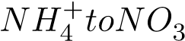) also N immobilization converted into inorganic N to organic N primarily by microbial assimilation of NH4 +[36] ,resulting in the accumulation of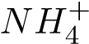 in soil[37]. the days for rice stages where each stage demands and the change of nitrogen within soil.
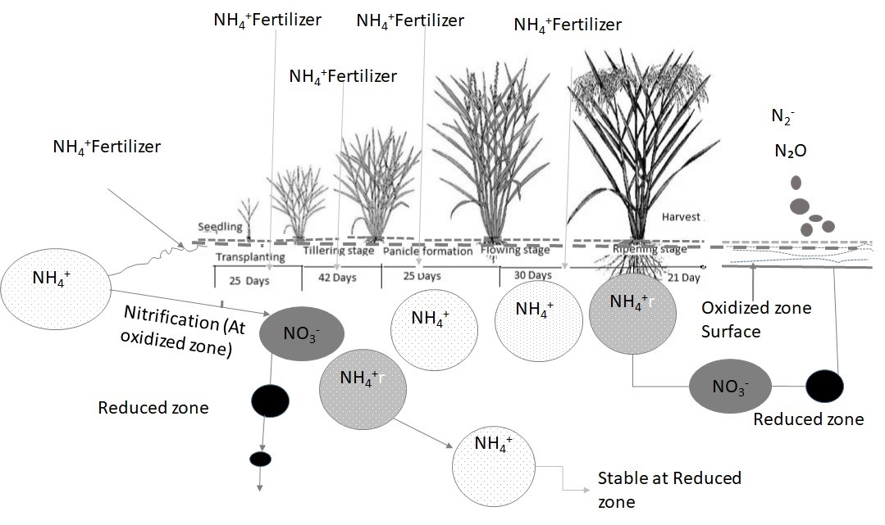
Figure 1: Days for each Stage and Nitrogen chemicals forms in Rice Growth

Nutrient Management Approaches for Rice Growth
Integrated plant nutrient management system is a holistic approach to integrate one of all natural man-made sources of plant nutrients to maintain and sustain soil fertility to enhance rice crop productivity in an efficient, environmentally safe, ecologically compatible, socially acceptable and economically viable way. It uses both organic and in-organic plant nutrients to avoid loss of crop yield and prevent soil degradation. This system can keep a balance between the nutrients removed by the crop and the nutrients added to soil. The smart nutrient management program takes into account the availability of nutrients in all types of soil, crop requirements, and other factors, such as removal of nutrients from the soil by the crop, economics of fertilizer profitability, farmers ability to invest, soil moisture regime, physical and microbiological condition of the soil, available soil nutrient status, nutrient recycling and cropping sequence, limiting loss to the environment [38, 39]. Soil is a complex substance with thousands of soil types existing in the
world having arisen from different materials under various ecological conditions. Some are fertile, tillable, and wonderfully suited for agriculture, and others may need a great deal of husbandry to become useful. Sustainable agriculture or regenerative farming all aim to produce food and fiber on a sustainable basis and to repair the damage caused by destructive procedure[40, 41]. The fertilizer should be applied based on the stages of rice and availability of different parameters as shown in figure2.
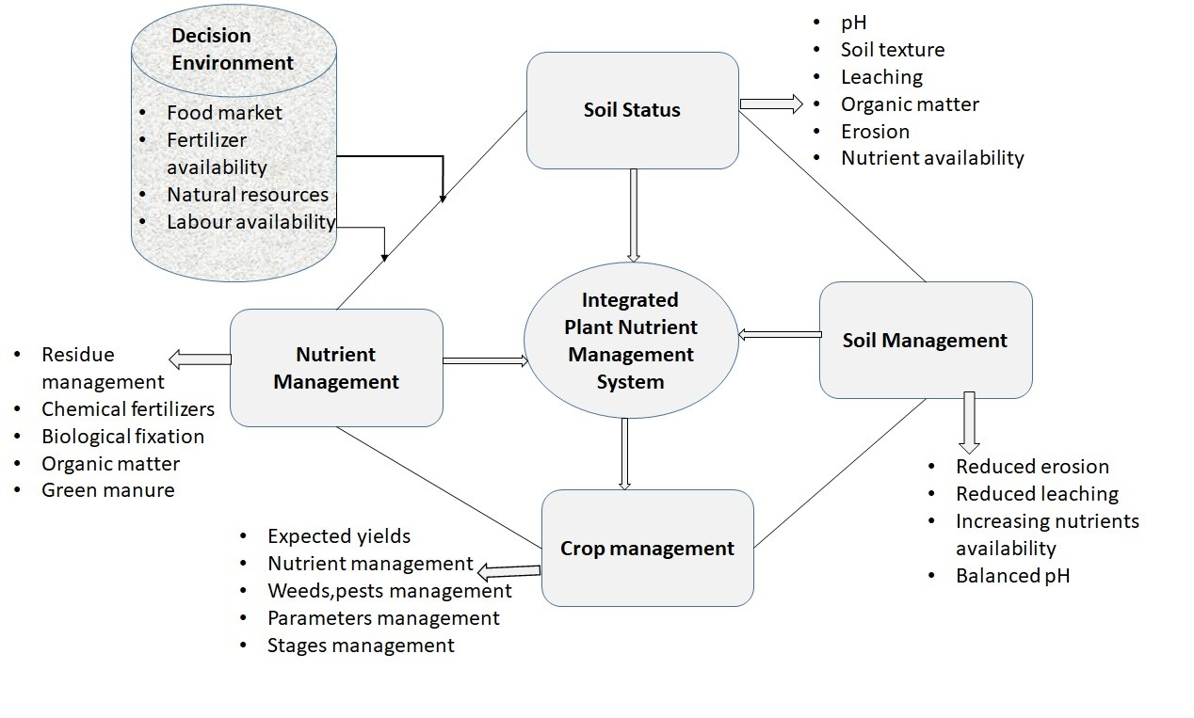
Figure 2: Nutrient management system in agriculture

NPK Concentration and Uptake
Nitrogen, phosphorus, and potassium are essential nutrients that play an essential role in the growth of rice plants. The increasing doses of organic fertilizers and the modification of the grid cropping system had a fairly good effect on increasing levels and uptake of NPK in plant tissues. The increasing uptake of NPK to the rice plant occurs when the water level in the soil is low to reduce leaching and volatilizing and improves the plant growth performance. NPK has an important role in the process of plant metabolism because N is an essential constituent of the amino acids that make up proteins, while potassium plays a role in the movement of water, nutrients, and carbohydrates in plant tissues, and involved in the activation of enzymes in plants that affect the production of protein, starch, and adenosine triphosphate (ATP) where ATP production can determine the rate of photosynthesis. In general, the mobility of NPK is quite high in the soil, especially in the rice fields, as a result of the inundation and drying process. Microbial activity can lead to increased K availability in the soil[42]. However, the K contained in the soil solution in a form that can be absorbed by rice plants, which can be easily washed[43]. In contrast to N and K that only increased 0.02 % N content and 1.6 g/plant N uptake and 0.17 % K content and 7.27 g/plant K uptake, there was a high increase in the P content and uptake in rice, 0.4 % P content and 104.52 g/plant P uptake. The Knowledge of adequate NPK concentration and uptake is an important plant parameter for appropriate NPK management of a crop. The adequate NPK concentration and uptake varied with rice yield level, which is affected by crop management practices. The NPK adequate concentration level in rice shoots varies from 43.4 to 6.5 g/kg depending on plant age[44]. It decreases with the advancement of plant age, reflecting a dilution effect with the advancement of plant age[34]. At physiological maturity, the optimum NPK concentration in the grain is 10.9 g/kg, which is 68% higher compared to the shoot concentration.The higher values of NPK uptake in the shoot after 35 days of growth stage indicate NPK uptake increased in the shoot with the advancement of rice plant stage.This means that NPK uptake determination during this growth stage is more important for knowing the quantity of NPK ,water level,and other soil conditions within the soil[45]. Adopting appropriate NPK management practices to supply the desired NPK rate from seedling to flow stage[27].Table??,indicates the minimum and maximum variable values define the ranges of variables for each growth stage which lead to optimized rice yields. If the variables can be controlled by the farmer, then these are a target range for manipulation. If the variable cannot be controlled, such as temperature, the farmer can assess how conditions might impact their yield. The particular importance are the minimum and maximum total growing season NPK requirements to produce good yields are 91.24 kg ha⁻¹ and 113.7 kg ha⁻¹ , respectively. This optimal range of NPK is considerably less than the standard government allotment of NPK of 200 kg ha⁻¹ that farmers typically apply during a growing season. These results are consistent with reports of fertilization of Rwandan rice plantations in recent years

NPK Efficiency
It is essential to use Nitrogen (N), phosphorus (P),and potassium (K) in rice crop with the knowledge for improving the use of NPK efficiency and consequently management. In the previous work,NPK use efficiency is defined and calculated in several ways[46] and according to[47] suggested five definitions and methods of calculating NPK use efficiency in rice crop plant. These efficiencies are known as agronomic efficiency (ARE), physiological efficiency (PE), agrophysiological efficiency (APE), apparent recovery efficiency (ARE), and utilization efficiency (UE). Definitions of these efficiencies and their methods of calculation [48].These five NPK efficiencies in marshland rice genotypes were distinct in differences among genotypes. Overall, 29% of the NPK applied was recovered,the large amount of NPK which is lost in soil plant system and appropriate management practices are necessary to improve its efficiency.After different studies ,the management of NPK fertilizer is essential especially by knowing how much remaining in the soil,at what amount of NPK should be applied in each stage of rice,and at what time.These results are consistent in improving the yield of rice.

Timing Application for NPK
When NPK is applied in the flooding plot, some are lost through volatilization, leaching, denitrification, or surface runoff[47, 49]. This suggests that there is more NPK lost during the crop growing season. For marshland rice under Rwanda conditions, applying 200kg/ha of NPK in rice for the whole season.To increase both NPK fertilizer use efficiency and NPK uptake by minimizing leaching by applying,NPK should be applied 2 days before irrigation. According[50],agronomic efficiency of NPK in marshland rice was higher when NPK was applied in three split application (one at tillering stage,the second at panicle initiation, and third on flowering stage). Minimum grain yield was obtained when NPK was applied at flooding,where one part at seedling,the second at tillering, third at panicle initiation, and the fourth at flowering and applying NPK in the appropriate time will affect rice yield. Figure3 indicates the different total NPK applied in each year as well as rice yield. This information demonstrates the capability of decision modeling to adequately monitor and invoke fertilization actions incorporating soil conditions. Upon these, the farmers applied 200kg/ha based on their own expert knowledge combined with recommendations.The information demonstrated that due to the poor of applied NPK, the rice yield is very low. The current practice have no promise to increase the yield,that is why it is essential to apply fertilizer where close control of fertilization actions is required to maintain efficient uptake of nutrients over time,which will potentially increase the return on investment by more precise control of fertilization to decrease costs while boosting yield.
Figure4 describes the potential actionable information to improve rice yield while applying NPK.
We demonstrate the ability of decision modeling to adequately monitor and invoke fertilization actions incorporating weather prediction and irrigation status of field. Upon the farmer can receive the information, assess the reliability of the information, and interact with fertilization controls based on their own expert knowledge combined with recommendations. The provided fertilizer usage and potentially increase return on investment by more precise control of fertilization to
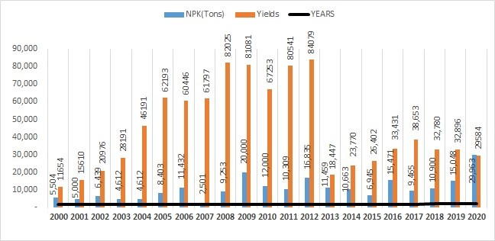
Figure 3: Yield vs NPK
decrease costs while boosting yield by as much as 2000 kg ha1. Furthermore, data collected over time can be used for long-term analysis of conditions at plantations such as Muvumba Valley, and help agronomists respond to long-term trends such as climate change. While this was done for food fertilization, the farmer has the potential to apply NPK in alternate stages of rice where close control of fertilization actions is required to maintain efficient uptake of nutrients over time.
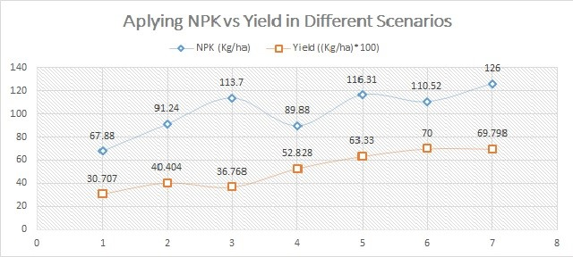
Figure 4: Aplying NPK and Yield in Different Scenarios

Recommendation
Rice is the staple food in the diet of about 65% of Rwanda’s population and produced under marshland ecosystems. However, the marshland ecosystem produces around 80,000 MT per year in two seasons of the Rwanda rice.NPK is usually the most yield-limiting nutrient in marshland rice production in most of the rice producing soils.The NPK recovery by rice is less than 50% because it is lost by leaching, denitrification, volatilization, soil erosion, and plant canopy. On an average, NPK balance in rice plant soil system is 40% uptake, 25% immobilized in soil plant system, and 35% is lost through volatilization, leaching, and denitrification. Soil available NPK is an important source to sustain rice yield even in cases where fertilizer NPK is applied at high rates in most situations. If rice crop producing factors are at a favorable level like water, cultivars, control of diseases, insects,and weeds.On average,NPK source of soil without application of chemical fertilizers can sustain 3 mg/ha rice yield for a long duration under most agroecological conditions. Improving NPK efficiency in rice is important for higher yield and to avoid environmental pollution.NPK as a mobile nutrient in soil plant system,NPK recommendations based on field trials that determine the crop response to various rates of fertilizer application are the most efficient and effective. Plant tissue tests compared with specified benchmark concentrations that separate deficient, sufficient, or toxic levels are an important diagnostic method of plant NPK status. The amount of NPK required for producing the maximum economic yield varied from 90 to 130 kg/ ha of NPK. This NPK rate generally produces 6500 to 7000 kg/ha rice yields. NPK application rate should be applied in split doses. Under controlled conditions, half of the required NPK should be banded at flooding and the remaining half should be applied at active tillering ,the second at panicle initiation,and the third flowering stage. Adopting other management practices such as flooding, high yield potential cultivars, crop rotation, water management, use of appropriate NPK sources, conservation tillage, control of diseases, insects,and weeds can improve NPK use efficiency. The NPK partitioning and use efficiency varied with crop species and cultivar to species. Hence, planting NPK efficient genotypes is a very attractive strategy for improving crop yields and keeping a healthy environment.

References
- N.K Fageria, Nathan Slaton, and V. Baligar. “Nutrient Management for Improving Lowland Rice Productivity and Sustainability”. In: Advances in Agronomy 80 (Dec. 2003), pp. 63–152. doi: 10.1016/S0065-2113(03)80003-2.
- Pallavolu Reddy, Euan James, and Jagdish Ladha. “Chapter 15. Nitrogen Fixation in Rice”. In: Dec. 2002, pp. 421–445. isbn: 9780444509659. doi: 10.1016/B978044450965-9/50015-X.
- Abul Al-Amin et al. “Assessing the Impacts of Climate Change in the Malaysian Agriculture Sector and its Influences in Investment Decision”. In: (June 2011).
- Hasmah Mohidin et al. “Soil and Agricultural Capability of UiTM Sarawak Campus Farm, Malaysia”. In: Journal of Agricultural Science 1 (Nov. 2009). doi: 10.5539/ jas.v1n2p35.
- J.W, Otenga and R. Sant’Annab. Rice production in Africa: current situation and issues. Tech. rep. 3 March 2004. url: https://https://www.fao.org/3/J1242e/ J1242e.htm(accessedon05febuary2022).
- FAO. Determination of the Irrigation Schedule for Paddy Rice. Tech. rep. 2015. url: http://www.fao.org/3/t7202e/t7202e07.htm(accessedon10June2020).
- P.A.J. van Oort et al. “Assessment of rice self-sufficiency in 2025 in eight African countries”. In: Global Food Security 5 (2015). Special Section on ”Selected papers from the 3rd Africa Rice Congress ”, pp. 39–49. issn: 2211-9124. doi: https: //doi.org/10.1016/j.gfs.2015.01.002. url: https://www.sciencedirect.com/science/ article/pii/S2211912415000036.
- NATIONAL RICE DEVELOPMENT STRATEGY (2011-2018). Rwanda rice commodity chain facing globalization. Tech. rep. NATIONAL RICE DEVELOPMENT STRATEGY, August, 2013. url: http:http://www.riceforafrica.net/images/stories/ PDF/rwanda revised aug2013.pdf.
- MINISTRY OF AGRICULTURE and ANIMAL RESOURCES. National Rice Development Strategy (2021 – 2030). Tech. rep. Ministry Of Agriculture and Animal Resource, July,2021. url: https://riceforafrica.net/images/countries/NRDS rev/ rwanda nrds2.pdf.
- Abdellatif Boutouta. Agriculture Mechanization Strategy for Rwanda. Tech. rep. Ministry of Agriculture and Animal Resources, 2013. url: http://amis.minagri.gov. rw/download/file/fid/515.
- NISR. Agricultural Survey 2019 Annual Report. Tech. rep. National Institute of Statistics of Rwanda, 2019. url: http://www.statistics.gov.rw/publication/seasonalagricultural-survey-2019-annual-report.
- Pauw K Ghins L. “Biological water quality assessment in the degraded Mutara rangelands, northeastern Rwanda”. In: In FAO Agricultural Development Economics
Working Paper 18-02; FAO: Rome, Italy, 2018 191 (2018). doi: 978-92-5-130384-9.
- Alphonsine Mukamuhirwa et al. “Quality and Grain Yield Attributes of Rwandan
Rice ( Oryza sativa L.) Cultivars Grown in a Biotron Applying Two NPK Levels”. In: Journal of Food Quality 2018 (June 2018), pp. 1–12. doi: 10.1155/2018/5134569.
- Christopher Sedlacek, Andrew Giguere, and Petra Pjevac. “Is Too Much Fertilizer a Problem?” In: Frontiers for Young Minds 8 (May 2020), p. 63. doi: 10.3389/frym. 2020.00063.
- Stephen Oyedeji et al. “Research Article Effect of NPK and Poultry Manure on Growth, Yield, and Proximate Composition of Three Amaranths”. In: Journal of Botany 2014 (Jan. 2014). doi: 10.1155/2014/828750.
- Yang J C Peng S B. “Current status of the research on high yielding and high
efficiency in resource use and improving rice quality”. In: Chin J Rice Sci,17: 275–280 8 (2003).
- Tyler Steusloffother et al. “Enhanced Efficiency Liquid Nitrogen Fertilizer Management for Corn Production”. In: International Journal of Agronomy 2019 (Aug. 2019), pp. 1–12. doi: 10.1155/2019/9879273.
- Nathaniel Mueller et al. “Closing yield gaps through nutrient and water management”. In: Nature 490 (Aug. 2012), pp. 254–7. doi: 10.1038/nature11420.
- Jagdish Ladha et al. “How extensive are yield declines in long-term rice-wheat experiments in Asia?” In: Field Crops Research 81 (Feb. 2003), pp. 159–180. doi:
10.1016/S0378-4290(02)00219-8.
- Timothy Krupnik et al. “An Assessment of Fertilizer Nitrogen Recovery Efficiency by Grain Crops Across Scales”. In: Jan. 2004, pp. 193–207.
- P. Bharteey. “Organic farming and sustainable agriculture: an overview”. In: Feb. 2020, pp. 172–179. isbn: 978-3-96492-155-0.
- Deyong Ren et al. “Multifloret spikelet improves rice yield”. In: New Phytologist 225.6 (2020), pp. 2301–2306. doi: https://doi.org/10.1111/nph.16303. eprint: https://nph.onlinelibrary.wiley.com/doi/pdf/10.1111/nph.16303. url: https: //nph.onlinelibrary.wiley.com/doi/abs/10.1111/nph.16303.
- Xiaowei Liu et al. “Effect of N Fertilization Pattern on Rice Yield, N Use Efficiency and Fertilizer–N Fate in the Yangtze River Basin, China”. In: PLoS ONE 11 (2016).
- Li ShuXian ; Pu ShiLin ; Deng Fei ; Wang Li ; Hu Hui ; Liao Shuang ; Li Wu ; Ren WanJun. “Influence of optimized nitrogen management on the quality of medium hybrid rice under different ecological conditions”. In: Eco-Agric 27, 1042–1052. (2019).
- B. Hu et al. “Variation in NRT1.1B contributes to nitrate-use divergence between rice subspecies”. In: Nature Genetics 47 (June 2015), pp. 834–838. doi: 10.1038/ng.3337.
- Cheng-Xin JU et al. “Comparison in Nitrogen Metabolism and Photosynthetic
Characteristics between Japonica Rice Varieties Differing in Nitrogen Sensitivity”. In:
Acta Agronomica Sinica 44 (Jan. 2018), p. 405. doi: 10.3724/SP.J.1006.2018.00405.
- N. Fageria. “Nutrient management for improving upland rice productivity and sustainability”. In: Communications in Soil Science and Plant Analysis - COMMUN SOIL SCI PLANT ANAL 32 (Sept. 2001), pp. 2603–2629. doi: 10.1081/CSS-
120000394.
- Jerry L. Hatfield and John H. Prueger. “Temperature extremes: Effect on plant growth and development”. In: Weather and Climate Extremes 10 (2015). USDA Research and Programs on Extreme Events, pp. 4–10. issn: 2212-0947. doi: https:
//doi.org/10.1016/j.wace.2015.08.001. url: https://www.sciencedirect.com/science/ article/pii/S2212094715300116.
- Rai Mukkram Ali Tahir et al. “Smart Nutrition Management of Rice Crop under Climate Change Environment”. In: Protecting Rice Grains in the Post-Genomic Era (2019).
- Sheetal Sharma, Rajeev Padbhushan, and Upendra Kumar. “Integrated Nutrient Management in Rice-Wheat Cropping System: An Evidence on Sustainability in the Indian Subcontinent through Meta-Analysis”. In: Agronomy 9 (Feb. 2019), p. 71.
doi: 10.3390/agronomy9020071.
- Bijay Singh et al. “Potassium Nutrition of the Rice– Wheat Cropping System”. In: Advances in Agronomy 81 (Dec. 2003), pp. 203–259. doi: 10.1016/S00652113(03)81005-2.
- Patrick Armengaud, Rainer Breitling, and Anna Amtmann. “The Potassium-Dependent Transcriptome of Arabidopsis Reveals a Prominent Role of Jasmonic Acid in Nutrient Signaling”. In: Plant physiology 136 (Oct. 2004), pp. 2556–76. doi: 10.1104/pp. 104.046482.
- Patrick Armengaud et al. “Multilevel Analysis of Primary Metabolism Provides New Insights into the Role of Potassium Nutrition for Glycolysis and Nitrogen Assimilation in Arabidopsis Roots”. In: Plant physiology 150 (May 2009), pp. 772–
85. doi: 10.1104/pp.108.133629.
- N. K. Fageria, V. C Baligar, and Charles Allan Jones. Growth and mineral nutrition of field crops / N.K. Fageria, V.C. Baligar, Charles Allan Jones. eng. 2nd ed., rev. and expanded. Books in soils, plants, and the environment v. 57. New York: Marcel Dekker, 1997. isbn: 0824700899.
- Piw Das et al. “Effect of fertilizer application on ammonia emission and concentration levels of ammonium, nitrate, and nitrite ions in a rice field”. In: Environmental
monitoring and assessment 154 (July 2009), pp. 275–82. doi: 10.1007/s10661-0080395-2.
- D Keeney and Kanwar Sahrawat. “2. Nitrogen transformations in flooded rice soils”. In: Fertilizer Research 9 (Feb. 1986), pp. 15–38. doi: 10.1007/BF01048694.
- Y. Uehara Y.; Takai. “Nitrification and denitrification in the surface layer of submerged soil 2. Oxidation-reduction conditions, nitrogen transformation and bacterial flora in the surface and deeper parts of some submerged soils”. In: Journal of the Science of Soil and Manure, Japan 47.12 (1976), pp. 542–548.
- Peter Gruhn, Francesco Goletti, and Montague Yudelman. “Integrated nutrient management, soil fertility,and sustainable agriculture: Current issues and future challenges”. In: Food, Agriculture, and the Environment Discussion Paper (Feb. 2000).
- Anil Mahajan and R. Gupta. Integrated Nutrient Management (INM) in a Sustainable Rice—Wheat Cropping System. Jan. 2009. isbn: 978-1-4020-9874-1. doi:
10.1007/978-1-4020-9875-8.
- Philip White. “Growth and Mineral Nutrition of Field Crops. 3rd edition. By N. K. Fageria, V. C. Baligar and C. A. Jones. Boca Raton, FL, USA: CRC Press (2011), pp. 560, £95.00. ISBN 978-1-4398-1695-0.” In: Experimental Agriculture 47 (July 2011), p. 574. doi: 10.1017/S0014479711000263.
- N. Fageria and Adonis Moreira. “The Role of Mineral Nutrition on Root Growth of Crop Plants”. In: Advances in Agronomy - ADVAN AGRON 110 (Dec. 2011), pp. 251–331. doi: 10.1016/B978-0-12-385531-2.00004-9.
- Si Han et al. “The Effects of Organic Manure and Chemical Fertilizer Application Levels on the Growth and Nutrient Concentrations of Yellow Poplar (Liriodendron tulipifera Lin.) Seedlings”. In: Journal of the Korea Society of Environmental
Restoration Technology 18 (Oct. 2015), pp. 37–48. doi: 10.13087/kosert.2015.18.5.37.
- Sergian Juniarso et al. “The effect of cow manure and neem compost toward NPK uptake, soil respiration, and rice production in organic paddy field in Imogiri Bantul, Indonesia”. In: IOP Conference Series: Earth and Environmental Science 215 (Dec. 2018), p. 012026. doi: 10.1088/1755-1315/215/1/012026.
- N. K. Fageria. “Plant Tissue Test for Determination of Optimum Concentration and Uptake of Nitrogen at Different Growth Stages in Lowland Rice”. In: Communications in Soil Science and Plant Analysis 34.1-2 (2003), pp. 259–270. doi: 10.1081/CSS120017430. eprint: https://doi.org/10.1081/CSS-120017430. url: https://doi.org/
10.1081/CSS-120017430.
- Z. Masni and Mohd Effendi Wasli. “Yield Performance and Nutrient Uptake of Red Rice Variety (MRM 16) at Different NPK Fertilizer Rates”. In: International Journal of Agronomy 2019 (June 2019), pp. 1–6. doi: 10.1155/2019/5134358.
- Peace Bamurigire et al. “A Decision-making Module for fertilization and Irrigation Control System in Rice Farming Using Markov Chain Process and SARSA Algorithms”. In: The 11th International Workshop on Computer Science and Engineering
(WCSE 2021). 2021. doi: 10.18178/wcse.2021.06.052. url: http://www.wcse.org/ index.php?m=content&c=index&a=show&catid=22&id=1012.
- N. K. Fageria and M. P. Barbosa Filho. “Enhancing Nitrogen Use Efficiency in Crop Plants”. In: vol. 88. Advances in Agronomy 9-10. Academic Press, 2005, pp. 97–185. doi: https://doi.org/10.1016/S0065-2113(05)88004-6. eprint: https: //doi.org/10.1080/00103620701328537. url: https://www.sciencedirect.com/ science/article/pii/S0065211305880046.
- N.K. Fageria, V. Baligar, and Richard Zobel. “Yield, Nutrient Uptake, and Soil Chemical Properties as Influenced by Liming and Boron Application in Common
Bean in a No-Tillage System”. In: Communications in Soil Science and Plant Analysis 38 (May 2007). doi: 10.1080/00103620701380413.
- Maren Veatch-Blohm. “Physiology of Crop Production, N.K. Fageria, V.C. Baligar,
R.B. Clark. Food Products Press/Haworth Press Inc., Binghamton, NY, USA
(2006), 345 pp., 49.95softcover,ISBN : 1 − 56022 − 289 − 1; 69.95 hardcover, ISBN: 1-50622-288-3”. In: Industrial Crops and Products 25 (Jan. 2007), p. 108. doi:
10.1016/j.indcrop.2006.09.001.
- N.K. Fageria. “Liming and Fertilization”. In: Vieira NRA, Santos AB, Santana EP (eds), Rice crop in Brazil. Embrapa Arroz e Feijlo, Santo Antonio de Goias 329–353 (1999).

