Running title: Planted Area, Productivity and Sugarcane Production

Planted Area, Productivity and Sugarcane Production in the Eastern Brazilian Amazon

Luiz Antonio Soares Cardoso1*, Paulo Roberto Silva Farias2, João Almiro Corrêa Soares2, Fabio Júnior de Oliveira3

¹ Federal Rural University of the Amazon (UFRA), Belém Campus, Pará, Brazil and Federal Institute of Pará (IFPA), Bragança Campus, Pará, Brazil
² Federal Rural University of the Amazon (UFRA), Belém Campus, Pará, Brazil
³ Federal Rural University of the Amazon (UFRA), Capitão Poço Campus, Pará, Brazil
*For correspondence: luizcardoso.geologo@gmail.com
Received ; Accepted ; Published

Novelty statement
Sugarcane cultivation is still little studied in the Brazilian Eastern Amazon. Through this research, with the use of correlation and regression tests based on the Planted Area, Productivity and Production data referring to the existing plantations in the region, it was possible to perceive the current moment of the culture in the Brazilian states that compose it. As a novelty, the State of Pará stands out, which has positive data regarding the advancement of the crop in question in the Brazilian Eastern Amazon.

Abstract
This work aimed to carry out an analysis to measure the importance of sugarcane culture for the Brazilian Eastern Amazon, which comprises the States of Amapá, Mato Grosso, Pará, Tocantins and part of the State of Maranhão. For this, data on Planted Area, Productivity and Production, provided by the National Supply Company (CONAB), referring to the 2012/2013 to 2021/2022 harvests in the states of the region in question were used. Data were normalized and submitted to correlation and regression analysis between the considered variables (planted area, productivity and production), to better understand how these variables behaved and related to each other in these last 10 sugarcane harvests in the region. As a result, it was noticed that the data had a normal distribution, with some strong and moderate correlations, whether positive or positive, which coincided with the results also obtained in the regression tests. However, the identified correlations and regressions occur differently in each State, with emphasis on the State of Pará, which presented strong positive correlations for all tests carried out (planted area, productivity and production), as well as regressions considered significant. The evaluations carried out demonstrated the quality of the data used and provided greater robustness in the analysis of the variables considered, allowing a better understanding of the importance of sugarcane for the Eastern Amazon.© 2020 Friends Science Publishers
Keywords: Saccharum spp.; Statistical analysis; Data normality; Correlation between variables

Introduction
Sugarcane is a semi-perennial plant species, belonging to the Poaceae family (Pereira et al. 2020), probably having India as its country of origin, arriving in Brazil in the newly colonized period in the 16th century. In Brazilian territory, sugarcane found very favorable factors for its full development, such as: fertile soils, abundant water, warm temperatures, flat reliefs and large amount of labor (Rodrigues and Ross 2020).
It is a grass typically cultivated in tropical and/or subtropical countries, such as Brazil, consisting of a complex hybrid of several species, mainly derived from the Saccharum officinarum species. The propagation of the crop is carried out vegetatively by planting sugarcane logs, allowing new shoots to emerge from the buds in the nodes of the sugarcane itself, thus ensuring uniform tillering. Productivity, in turn, tends to fluctuate according to the variety planted, climatic factors, water availability, cultivation practices and duration of its cycle (Rein 2013).
Some by-products can be produced from the processing of sugarcane, as is the case, mainly, with ethanol, either anhydrous – used in the mixture with gasoline – or hydrated, in addition, of course, to the sugar itself (CONAB 2020). Approximately 70% of the world's sugar is produced from sugarcane (Kumar et al. 2017).
In this context, Brazil has a prominent role in the world scenario of sugarcane production, consolidating itself as the world's largest producer of the crop (Cheavegatti-Gianotto et al. 2018; Dias and Sentelhas 2018). Its production has more than doubled in recent decades (Bordonal et al. 2018), mainly due to growing world demands for reducing dependence on crude oil and for the manufacture of sustainable fuels such as ethanol, which today has even greater appeal, placing Brazil as the second largest fuel producer in the world (Yusuf and Caldarelli 2018; Müller et al. 2019).
According to data from IBGE (2021a), Brazilian Institute of Geography and Statistics, Brazil produced around 715,659,212 tons of sugarcane in 2021, with the State of São Paulo being the largest producer, with approximately 405,000,643 tons in same year, which represented more than half of all production in the country. In turn, the states that make up the Eastern Amazon produced a total of about 25,401,785 tons, representing about 3.54% of national production. Among these States, the one that stands out the most is Mato Grosso, with a production of 19,348,547 tons per year, representing more than 76% of everything produced in the Eastern Amazon.
It should also be noted that the sugarcane agroindustry continues to expand in the national territory, demonstrating great capacity to also add value to sugar and ethanol derivatives, such as vinasse (fertilizer), filter cake (fertilizer), bagasse (raw material for industries, animal feed and electricity generation) and vegetable straw (electricity generation) (Carbonari et al. 2020). In this sense, as a prognosis for the future, it is estimated a total production of 26.7 billion liters of ethanol and 35 million tons of sugar in the 2021/2022 harvest for the country (CONAB 2022).
From everything that has been reported, one can see the size of the representativeness of the sugarcane culture for the Brazilian economy, which justifies the need for constant research on the subject, to better understand the dynamics present in its production system, even more so when it comes to areas and regions considered agricultural frontiers, as is the case of the Brazilian Eastern Amazon.
Given the above, this article aims to carry out an analysis of the Planted Area, Productivity and Production of sugarcane in this region of Brazil, through the study of possible correlations between these variables, in each State, in the last 10 harvests (2012/2013 to 2021/2022). The intention is to allow a better visualization of the current moment of sugarcane production in the Brazilian states that make up the Eastern Amazon, as well as to outline future perspectives in the midst of the challenges of culture in the region.

Sugarcane Phenology
Following the logical sequence of this article, it is important to start by understanding how sugarcane develops in general. Thus, according to EMBRAPA (2022), the Brazilian Agricultural Research Corporation, sugarcane has four phases, illustrated in Figure 1 and explained below.
The first phase is the Establishment phase, which corresponds to the moment when the bud, also known as primary culm, breaks through the leaves and develops towards the soil surface, at the same time that the roots of the stem appear. The emergence of shoots occurs 20 to 30 days after planting, which will depend on factors such as seedling quality, environment, time and planting management. In this phase, the initial rooting and the emergence of the first leaves also occur.
The second phase is called Vegetative, subdivided into two moments. The first is characterized by the process of emission of culms by the same plant, resulting in the growth of buds towards the surface, approximately 20 to 40 days after the emergence of the primary culm. The second moment represents the apex of tillering, constituted by the total coverage of the soil by the foliage of the plants.
The third phase, in turn, is the Grand Growth phase, where the vigorous growth of plant roots occurs and the definition of the final population of stems. Surviving culms continue their development and growth, stimulated by light, moisture and heat. At that time, sugar accumulates at its base and the plant gains height, reaching three meters in height, varying according to the climate and soil.
The fourth and final phase is called Ripening. It starts with the intense growth of the surviving stalks from the tillering phase and the continuous storage of sugar at the base of each stalk. However, when reaching a height equal to or greater than two meters, it is possible to notice the yellowing and drying of the leaves, which indicates the beginning of the deposition of sugar in that region. Finally, in the final part of this phase, there is greater maturation activity, less growth activity and intense storage of sugars, which will culminate in the moment of harvest, which must occur depending on the variety of the plant and planting time, also taking into account the duration of the cycle, maturation management and climatic conditions of the environment.

The Eastern Brazilian Amazon
The Brazilian Eastern Amazon is currently made up of the entire territory of the States of Pará, Amapá, Tocantins and Mato Grosso, as well as part of the State of Maranhão (west of the 44th meridian) (IBGE 2020). There is no specific legislation that establishes the Eastern Amazon as it is known today, but there is a legal framework that leads us, by exclusion, to delimit its total area.
The region is part of the Legal Amazon, initially instituted by Law 1.806/1953, which dealt with the Plan for the Economic Valorization of the Amazon and created the SPVEA (Superintendence of the Plan for the Economic Valorization of the Amazon). Subsequently, Law 1,806/1953 was revoked by Law 5,173/1966, which, in turn, provided for a new Plan for the Economic Valorization of the Amazon, extinguishing the SPVEA and creating the Superintendency for the Development of the Amazon (SUDAM).
Currently, the Legal Amazon corresponds exactly to the area of operation of SUDAM, updated by Complementary Law 124/2007. Altogether, it comprises 772 municipalities, in a total area of 5,015,067.86 km², corresponding to approximately 58.93% of the Brazilian territory. Of the 772 municipalities, 751 are fully located in the Legal Amazon, while 21 are partially integrated, as part of them are located east of the 44th meridian in the State of Maranhão (IBGE 2021b).
Although instituted by the aforementioned laws, the nomenclature “Legal Amazon” only started to be used in more recent legislation, such as Law 11.962/2009 and Law 12.651/2012, not appearing expressly, with this nomenclature, in the laws that defined the Amazon in the legislation from previous decades (IBGE 2017).
In this way, the Legal Amazon is composed of the sum of the territories of the Eastern Amazon, mentioned above, and also of the Western Amazon, which, in turn, has a legal basis, being instituted by Decree-Law 291/1967 and updated through Decree- Law 356/1968 and subsequent legislation. In this sense, the Western Amazon currently covers the states of Amazonas, Acre, Rondônia and Roraima (IBGE 2020).
As the focus of this article is the Eastern Amazon, the states that make up this region will be highlighted here (Fig. 2). Table 1 presents a sequence of the main laws that make up the history of the legal framework that refers to the Eastern Amazon and the states belonging to the region.

Brief Description of the Planted Area, Productivity and Sugarcane Production in the Eastern Amazon States (2012/2013 Crop to 2021/2022 Crop)
The information referring to the planted area, productivity and production of sugarcane in Brazil and, more specifically, in the Eastern Amazon, which will be considered in this topic, was made available free of charge through surveys carried out by the National Supply Company (CONAB), public company linked to the country's federal government, and reflect information on the last 10 harvests in the region, referring to the harvests from 2012/2013 to 2021/2022.
As the focus of this article is the Eastern Amazon, we will highlight the current scenario of production in the states that make up the region: Amapá, Maranhão, Mato Grosso, Pará and Tocantins. It is worth mentioning that the State of Maranhão does not belong entirely to the Eastern Amazon, but the data considered here will take into account the state as a whole.
Among the 26 federative units of Brazil plus the Federal District, the State of Mato Grosso is the largest producer of sugarcane in the Eastern Amazon, occupying the position of 6th largest national producer, followed by Maranhão (13th largest producer in the country), Tocantins (15th largest producer), Pará (18th largest producer) and finally the State of Amapá (26th largest producer). The State of Amapá, by the way, occupies only the penultimate position in the national scenario, producing more sugarcane only than the State of Roraima, which is located in the context of the Western Amazon (IBGE 2021a).

State of Amapá (AP)
Among the states that make up the Eastern Amazon, Amapá is the least relevant in terms of sugarcane cultivation in the country, which also reflects the lack of data in the surveys made available by CONAB in relation to the harvests analyzed in this work (2012/2013 to 2021/2022).
Through the IBGE, an institute of the federal government of Brazil, it was possible to identify that the state produced only about 8,153 tons of sugarcane in 2021, in a harvested area of only 314 hectares, with an average yield of 25,965 kg per hectare. The State has only 16 municipalities, with small sugarcane production in 10 of them, with emphasis on the municipality of Amapá, which had 1,611 thousand reais as production value in 2021, just over 40% of the total production value of the state in 2021 (IBGE 2021a).

State of Maranhão (MA)
The State of Maranhão has 217 municipalities in all, but only 181 of them are part of the Eastern Amazon, located west of the 44th meridian. It should also be noted that of the 181 municipalities in Maranhão that are located in the Eastern Amazon, 21 of them are not entirely in the region in question, as part of their territory is east of the 44th meridian. Of the 217 municipalities in the state as a whole, 76 municipalities are sugarcane producers, with emphasis on the municipality of São Raimundo das Mangabeiras, which generated a production value of 100,398 thousand reais in 2021, which represented practically 35% the value of the state as a whole (IBGE 2021a; IBGE 2021b).
For this analysis, information from the state as a whole, made available by CONAB, will be considered. From the preliminary analysis of the data, it was already possible to notice that the planted area decreased between the 2012/2013 and 2021/2022 harvests, but there was an increase in productivity and sugarcane production in the State (Fig. 3).

State of Mato Grosso (MT)
The State of Mato Grosso is the most outstanding in the Eastern Amazon. In all, it has 141 municipalities, of which 61 are sugarcane producers, with emphasis on the municipality of Barra de Bugres, which generated a production value of 303,119 thousand reais, which represented almost 20% of what was produced in 2021 (IBGE 2021a). During the 2012/2013 to 2021/2022 harvests, there was a decrease in the planted area and in the production of sugarcane, however, even with this decrease, there was an increase in productivity (Fig. 4).

State of Pará (PA)
The State of Pará is made up of 144 municipalities, of which only 34 produce sugarcane, with emphasis on the municipality of Ulianópolis, which reached a production value of 119,440 thousand reais in 2021, practically 95% of everything that was generated in the State (IBGE 2021a). Regarding the planted area, there was an increase during the 2012/2013 to 2021/2022 harvests, which reflected in the increase in productivity and production in the State (Fig. 5).

State of Tocantins (TO)
The State of Tocantins has a total of 139 municipalities, 52 of which are sugarcane producers, with emphasis on the municipality of Pedro Afonso, which obtained a production value of 275,000 thousand reais, equivalent to almost 95% of what was generated in the state (IBGE 2021a). During the 2012/2013 to 2021/2022 harvests, there was an increase in the planted area, productivity and production of sugarcane in the State (Fig. 6).

Analysis of the Normality of Data on Planted Area, Productivity and Production of Sugarcane in the States of the Eastern Amazon (2012/2013 Crop To 2021/2022 Crop)
For analysis of the normality of data on Planted Area, Productivity and Production of the Eastern Amazon States, referring to the 2012/2013 to 2021/2022 harvests, the Kolmogorov-Smirnov (K-S) tests were used with a probability of 95% in the Minitab Software 14. For this, two hypotheses were considered: H₀ (null hypothesis) which considers that the data follow a normal distribution and H_{a} (alternative hypothesis) which considers that the data do not follow a normal distribution.
For decision making between the hypotheses, the P-Value values were considered for each variable, in each of the states, within the evaluated time interval. The values for each state will be presented and discussed below, through the presentation of normality graphs and their respective histograms.

State of Amapá (AP)
As previously mentioned, the State of Amapá does not have a Planted Area relevant to the context of the country and, consequently, does not present a Productivity and Production in a significant amount. Thus, this state was not considered for monitoring by CONAB.

State of Maranhão (MA)
The Planted Area, Productivity and Production data unanimously accepted H₀, showing normal distribution for the data of the variables considered for the 2012/2013 to 2021/2022 harvests in the State. The three variables had the same P-Value of >0.150 (Fig. 7).

State of Mato Grosso (MT)
Data referring to the State of Mato Grosso also showed a normal distribution. The variables Productivity and Production presented a P-Value >0.150, while the Planted Area obtained a P-Value of 0.071 (Fig. 8).

State of Pará (PA)
The state of Pará also presented a normal distribution for the considered data. The three variables had a P-Value >0.150 (Fig. 9).

State of Tocantins (TO)
In the State of Tocantins, the P-Value estimates were identical to those also presented in the States of Maranhão and Pará, that is, >0.150, also presenting a normal distribution for the considered data (Fig. 10).

Correlation and Regression between Planted Area, Productivity and Sugarcane Production Data in the states of the Eastern Amazon (2012/2013 Crop To 2021/2022 Crop)
In this topic, we carried out correlation and regression tests between the variables Planted Area, Productivity and Production, relative to the States that make up the Eastern Amazon, as a way of associating the results obtained. To verify the magnitude of the correlation, two parameters were considered: Cohen (1992) and Rumsey (2016), according to Tables 2 and 3.
During the correlation tests, we also checked the significance values of each of these tests, through the P-Value values. Accepted correlations were those with P-value less than 0.05.
In the case of regression tests, to validate the relationships, the values of the determination coefficients, also known as R², were considered. R² values vary from 0 (0%) to 1 (100%), where, the closer to 0 the tendency is that the model does not significantly explain the variability of the data and, the closer to 1, the tendency is that the model significantly explains the variability of the data (Minitab, 2019). In summary, we consider here that the greater the R², the better the data fit.
In the regression tests, as well as in the correlation tests, the significance values of each one of the tests were also verified, through the P-Value values. Accepted regressions were those that had a P-value less than 0.05.

State of Amapá (AP)
The State of Amapá was not considered in this topic for the same reasons expressed in the previous topics.

State of Maranhão (MA)
In the State of Maranhão, it was possible to perceive that there is a strong negative correlation between the variables Planted Area and Productivity, for both parameters of magnitude of correlation considered, where, throughout the harvests, there was a decrease in Planted Area and consequent increase in Productivity. Regarding the variables Planted Area and Production, it was not possible to observe significance between the correlation of the variables, since the P-Value generated was above 0.05, in addition, the data did not show relevant correlations, according to the magnitude parameters considered (Fig. 11).
The regression tests confirmed what had already been observed in the correlation tests, as the R² was greater in the regression between Planted Area and Productivity (R² = 0.74), with a P-Value of 0.01, while the values for regression between Area and Production was considered insignificant (R² = 0.06), with P-Value of 0.495, that is, a statistically insignificant value.

State of Mato Grosso (MT)
In the State of Mato Grosso it was also possible to verify a strong negative correlation between the variables Productivity and Planted Area, and it was also possible to visualize an inversely proportional behavior between the variables in question. The correlation between Planted Area and Production was not considered significant, according to the resulting P-Value values (Fig. 12).
In the regression tests, values of R² of 0.54 were identified for the regression between Planted Area and Productivity with P-Value of 0.015, as well as R² of 0.19 for the regression between Planted Area and Production with P-Value of 0.205. These values confirm what was observed in Pearson's correlation, as only the regression between Planted Area and Productivity showed statistically significant R² and P-Value.

State of Pará (PA)
The State of Pará was the only one that showed correlation in the two tests performed. In both, it was possible to identify strong positive correlations, with significant P-Values, which demonstrates that the variables considered present a directly proportional relationship in that state (Fig. 13). Regarding the regression tests, an R² of 0.65 was obtained for the regression between Planted Area and Productivity, with P-Value of 0.005, and an R² of 0.87 for the regression between Planted Area and Production, with P -Value of 0.000, which confirmed what was observed during the correlation tests, as statistically significant values were identified for both regressions, as occurred in both correlations previously performed for data from the State in question.

State of Tocantins (TO)
In the State of Tocantins, it was possible to identify a negative correlation between the variables Planted Area and Productivity, with a strong magnitude for Cohen's parameters (1992) and moderate for Rumsey's (2016), with a P-Value of 0.05 of significance. As for the variables Planted Area and Production, the P-Value ended up surpassing 0.05, generating a P-Value of 0.48. In addition, the data presented correlations without adequate significance, according to the considered magnitude parameters (Fig. 14).
The regression tests for the State also confirmed what was observed in the correlation tests. The regression between Planted Area and Productivity obtained an R² of 0.39, staying within the moderate margin, as suggested by the correlation parameters of Rumsey (2016), in addition to a P-Value of 0.05, well on the limit to be considered statistically significant. The regression between Planted Area and Production, presented an R² of 0.06, with a P-Value of 0.482, both considered statistically not significant, as occurred in the previously performed correlation between Planted Area and Production for the State of Tocantins.

Discussions
According to Silva et al. (2021b), Brazil has more than 10 million hectares cultivated with sugarcane. As a result, sugarcane occupies a prominent position in Brazil, representing one of the main crops produced in the national territory and of great relevance for the country's economy. These factors justify the sum of efforts between producers, researchers and the government itself, for improvements in relation to their productivity and consequent production, in order to anticipate and avoid possible problems that may affect crops during the plant's vegetative cycle, as well as in the processing period.
In this sense, one of the main concerns, which may interfere with the productivity and expansion of sugarcane throughout the national territory and also in the Eastern Amazon, is the possibility of the emergence of new pests that may affect the crop, causing damage to the producers and directly compromising the quality of the sugarcane produced, reflecting negatively on the sector's performance (Cezar 2021). To exemplify, Narayan et al. (2020) point out that sugarcane productivity losses range from 10 to 30% due to insect pests that attack the crop.
In recent decades, with the constant expansion of sugarcane fields and the prohibition of burning during harvesting, there has been a significant increase in the population of pests in Brazil (Bezerra et al. 2021), as harvesting sugarcane without burning was adopted in about 84% of the country's sugarcane fields, making the management of pest insects even more complex, due to the presence of residues in the soil, which ends up directly affecting the action of herbicides, increasing the incidence of certain pests (Castro et al. 2019; Carbonari et al. 2020).
In this sense, it is known that the sugarcane crop can be attacked by the most diverse pests, each one varying according to its manifestation and proliferation capacity, associated with the conditions of the sugarcane field and the affected variety (Nocelli et al. 2017). As a way to exemplify these possible pests, Pinto et al. (2016) subdivided the main sugarcane pests into: key pests, important, regional or sporadic pests, secondary pests and nematodes, as shown in Table 4.
Another challenge for Brazilian sugarcane in general is the adverse climatic effects of drought and also low temperatures during the production cycle of national crops, oscillating between high and low temperatures in the regions of the country throughout the year. However, in this negative context, the Eastern Amazon has stood out positively in recent years, obtaining higher yields than past harvests, contrary to what is observed in the rest of the country. This happens, according to CONAB (2022), due to the better climate conditions in the region and also due to the aggregation of better management practices in their crops.
Another challenge, according to CONAB (2022), is the enormous economic pressure that the grain sector has been exerting on producing regions in general, ending the hegemony of sugarcane cultivation in areas that previously only produced this crop. This has also been happening in the Eastern Amazon, with increased production of corn and soybeans in the region, for example, as these grains now have a more advantageous economic return and greater liquidity. Corn has even had a growing share in ethanol production, especially in the state of Mato Grosso, where there have been greater investments in the crop, generating good expectations for the next harvests in the state.
Another limitation of production in the Eastern Amazon was legal issues that prevented the expansion of the crop in recent years. Cardoso et al. (2022) exposed these issues, highlighting the agroecological zoning of sugarcane, imposed by Decree No. 6,961/2009, which limited sugarcane production in the Eastern Amazon, as it is located in the Amazon and Pantanal biomes, as sugarcane production could pose a potential risk to the environment. However, Decree nº 6,961/2009 was revoked by Decree 10,084/2019, which may facilitate the expansion of culture in the region as a whole, even in areas of native and indigenous forests that were previously also limited by the decree of the year 2009.
Obviously, it is important that the sugar and alcohol sector develop its activities within the scope of a sustainable agricultural activity, seeking to increase its profitability through tools that optimize production without causing significant impacts to the environment. CONAB (2022) highlights this good relationship between the sugar-energy sector and the environment, emphasizing that, unlike what happens in other countries, national production operates in a positive and sustainable context, in harmony with current legislation.
But how to increase Productivity and Production without increasing deforestation in the country, thus enabling greater productivity and profitability of national crops? A solution that has emerged in the national context over the last few years and decades is the use of the various tools available in Precision Agriculture (PA), which make it possible to optimize production in crops, seeking to minimize the identified problems and enabling, for example: detection rapid detection of pests, vegetation analysis to measure possible planting failures and water stress, monitoring of growth rates during the plant's vegetative cycle, analysis of possible soil erosion in planting areas, among other possibilities.
Another option is the use of already degraded areas. In the research carried out by Marin et al. (2016), the authors demonstrated, for example, that the country has the possibility of increasing its productivity without expanding the planting areas, but the historical pace of productivity gains must be increased, which would minimize the pressure and future demand for land. AP tools are also important to achieve this goal. Precision Agriculture tools are also important to achieve this goal.
The CNA (2021), Confederation of Agriculture and Livestock of Brazil, also warns of recent problems regarding the high prices of agricultural inputs used in planting, such as imported fertilizers, for example, still reflecting the impacts resulting from the COVID-19 pandemic, which had a direct impact on production costs. This whole scenario points to the need to implement government measures to exploit these fertilizers, in sufficient quantity, in the country itself, to meet the national demand for the crop and other crops produced in Brazil.

Conclusions
Through the analysis of the data during the construction of this article, it was possible to perceive the dimension of the importance of the sugarcane culture for the Eastern Amazon. A fact worth mentioning is that, in general, the States analyzed in that region showed a significant increase in sugarcane productivity in the 2012/2013 to 2021/2022 harvests.
The State of Pará was the one that most expanded its Planted Area in the period, while the States of Maranhão and Mato Grosso had their planting areas reduced. On the other hand, the State of Tocantins increased its Planted Area, when directly comparing the 2012/2013 harvests with the 2021/2022 harvest, but had its apex of Planted Area in the 2016/2017 harvest and since then has been showing a decrease in its Planted Areas.
With regard to Production, there was greater variation between States. Mato Grosso was the only one that presented a drop in production in the comparison between the beginning and the end of the series, reaching the peak of production in the 2019/2020 harvest. The other states had increased production in this same comparison, but with different production peaks. The states of Maranhão and Tocantins had their maximum production in the 2015/2016 harvest, while Pará showed an increase in the last of the evaluated harvests, the 2021/2022 harvest, yet another indicator of the positive growth trend of this state, as it was the only one among the analyzed states showing growth in the three variables considered: Planted Area, Productivity and Production.
It was possible to perceive a positive trend in relation to the growth of sugarcane production in the states that make up the Eastern Amazon, when analyzing the data of Planted Area, Productivity and Production of the last 10 harvests. It remains for the region to overcome the challenges that still exist for this expansion, since, in fact, this territory represents one of the last agricultural frontiers present in Brazil, requiring more research and investments for its broad sustainable development.

Acknowledgements
The authors would like to thank the Graduate Program in Agronomy (PGAGRO) of the Federal Rural University of Amazônia

Author Contributions
LASC participated in all stages of the research, ending with the writing of the article, PRSF guided the stages of the research, JACS carried out the co-supervision of the research and FJO carried out the final revision of the submitted text.

Conflicts of Interest
All authors declare no conflict of interest

Data Availability
Data presented in this study will be available on a fair request to the corresponding author

Ethics Approval
Not applicable in this paper

References

Bezerra JIM, A Molter, M Rafikov, DF Frighetto (2021). Biological control of the chaotic sugarcane borer-parasitoid agroecosystem. Ecological Modelling 450. https://doi.org/10.1016/j.ecolmodel.2021.109564.

Bordonal RO, JLN Carvalho, R Lal, EB Figueiredo, BG Oliveira, NL Scala Júnior (2018). Sustainability of sugarcane production in Brazil. A review. Agronomy for Sustainable Development 38: 13. https://doi.org/10.1007/s13593-018-0490-x.

BRASILa (2009). Decree nº 6961. Available at: https://www.planalto.gov.br/ccivil_03/_ato2007-2010/2009/decreto/d6961.htm (Accessed 03 January, 2023).

BRASILb (2019). Decree nº 10084. Available at: https://www.planalto.gov.br/ccivil_03/_Ato2019-2022/2019/Decreto/D10084.htm (Accessed 03 January, 2023).

Carbonari CA, AKA Matos, IPFS Brito, ED Velini, FE Dayan (2020). Impact of green cane harvesting on pest management in sugarcane. Outlooks on Pest Management 31(2): 64-73. https://doi.org/10.1564/v30_apr_04.

Cardoso LAS, PRS Farias, JAC Soares (2022). Use of Unmanned Aerial Vehicle in sugarcane cultivation in Brazil: a review. Sugar Tech 24(6): 1636-1648. https://doi.org/10.1007/s12355-022-01149-9.

Castro SGQ, LL Dinardo-Miranda, JV Fracasso, RO Bordonal, LMS Menandro, HCJ Franco, JLN Carvalho (2019). Changes in Soil Pest Populations Caused by Sugarcane Straw Removal in Brazil. BioEnergy Research 12: 878-887. https://doi.org/10.1007/s12155-019-10019-4.

Cezar MA (2021). Avanços e perspectivas no manejo de podridões da cana-de-açúcar. In Introdução à tecnologia sucroalcooleira, Publisher UFPB, Brazil.

Cheavegatti-Gianotto A, HMC Abreu, P Arruda, JC Bespalhok Filho, WL Burnquist, S Creste, L Ciero, JA Ferro, AVO Figueira, TS Filgueiras, MF Grossi-de-Sá, EC Guzzo, HP Hoffmann, MGA Landell, N Macedo, S Matsuoka, FC Reinach, E Romano, WJ Silva, MC Silva Filho, EC ULIAN (2011). Sugarcane (Saccharum X officinarum): a reference study for the regulation of genetically modified cultivars in Brazil. Tropical Plant Biology 4: 62-89. https://doi.org/10.1007/s12042-011-9068-3.

Cheavegatti-Gianotto A, A Gentile, DA Oldemburgo, GA Merheb, ML Sereno, RP Lirette, THS Ferreira, WS Oliveira (2018). Lack of detection of Bt sugarcane Cry1Ab and NptII DNA and proteins in sugarcane processing products including raw sugar. Frontiers in Bioengineering and Biotechnology 6: 24. https://doi.org/10.3389/fbioe.2018.00024.

CNA (2021). Safra 2021/2022 de cana-de-açúcar iniciará com expectativas de alta nos custos de produção. Available at: https://cnabrasil.org.br/publicacoes/safra-2021-2022-de-cana-de-acucar-iniciara-com-expectativas-de-alta -nos-custos-de-producao-o (Accessed 10 January, 2023).

Cohen J (1992). Statistical power analysis. Current Directions in Psychological Science 1(3): 98-101. https://doi.org/10.1111/1467-8721.ep10768783.

CONAB (2013). Acompanhamento da safra brasileira de cana-de-açúcar, safra 2012/2013, quarto levantamento, abril/2013. CONAB. Publisher CONAB, Brazil.

CONAB (2014). Acompanhamento da safra brasileira de cana-de-açúcar, safra 2013/2014, quarto levantamento, abril/2014. CONAB 1. Publisher CONAB, Brazil.

CONAB (2015). Acompanhamento da safra brasileira de cana-de-açúcar, safra 2014/2015, quarto levantamento, abril/2015. CONAB 1(4). Publisher CONAB, Brazil.

CONAB (2016). Acompanhamento da safra brasileira de cana-de-açúcar, safra 2015/2016, quarto levantamento, abril/2016. CONAB 2(4). Publisher CONAB, Brazil.

CONAB (2017). Acompanhamento da safra brasileira de cana-de-açúcar, safra 2016/2017, quarto levantamento, abril/2017. CONAB 3(4). Publisher CONAB, Brazil.

CONAB (2018). Acompanhamento da safra brasileira de cana-de-açúcar, safra 2017/2018, quarto levantamento, abril/2018. CONAB 4(4). Publisher CONAB, Brazil.

CONAB (2019). Acompanhamento da safra brasileira de cana-de-açúcar, safra 2018/2019, quarto levantamento, abril/2019. CONAB 5(4). Publisher CONAB, Brazil.

CONAB (2020). Acompanhamento da safra brasileira de cana-de-açúcar, safra 2019/2020, quarto levantamento, abril/2020. CONAB 6(4). Publisher CONAB, Brazil.

CONAB (2021). Acompanhamento da safra brasileira de cana-de-açúcar, safra 2020/2021, quarto levantamento, maio/2021. CONAB 7(4). Publisher CONAB, Brazil.

CONAB (2022). Acompanhamento da safra brasileira de cana-de-açúcar, safra 2021/2022, quarto levantamento, abril/2022. CONAB 8(4). Publisher CONAB, Brazil.

Dias HB, PC Sentelhas (2018). Sugarcane yield gap analysis in Brazil–A multi-model approach fordetermining magnitudes and causes. Science of the Total Environment 637-638: 1127-1136. https://doi.org/10.1016/j.scitotenv.2018.05.017.

IBGE (2021b). Amazônia Legal. Available at: https://www.ibge.gov.br/geociencias/cartas-e-mapas/mapas-region ais/15819-amazonia-legal.html?=&t=o-que-e/ (Accessed 03 January, 2023).

IBGE (2017). Censo Agro 2017. Available at: https://censoagro2017.ibge.gov.br/1992-novo-portal/edicao/16194-amazo nia-legal-amazonialegal-2.html (Accessed 03 January, 2023).

IBGE (2020). IBGE atualiza Mapa da Amazônia Legal. Available at: https://agenciadenoticias.ibge.gov.br/agencia-sala-de-imprensa/2013-agencia-de-noticias/releases/28089-ibge-atualiza-mapa-da-amazonia-legal (Accessed 03 January, 2023).

IBGE (2021a). Produção de Cana-de-açúcar. Available at: https://www.ibge.gov.br/e xplica/producao-agropecuaria/cana-de-acucar/br (Accessed 03 January, 2023).

Kumar P, S Chandra, B Singh, VS Chauhan, S Srivastava (2017). PCR based RGAs strategy for identification of putative disease resistance genes analogues in sugarcane. Trends in Biosciences 10(33): 7029-7034.

Marin FR, GB Martha, KG Cassman, P Grassini (2016). Prospects for increasing sugarcane and bioethanol production on existing crop area in Brazil. BioScience 66(4): 307-316. https://doi.org/10.1093/biosci/biw009.

Minitab (2019). Análise da regressão: como interpretar o R-quadrado e avaliar a qualidade de ajuste. Available at: https://blog.minitab.com/pt/analise-de-regres sao-como-interpretar-o-r-quadrado-e-avaliar-a-qualidade-de-ajuste (Accessed 21 March, 2023).

Müller C, LM Milani, A Giehl, ET Barrilli, L Deoti, AC Lucaroni, V Tadioto, H Treichel (2019). Resíduos de cana-de-açúcar e milho como matéria prima do etanol 2G: atualidades e perspectivas. In Impactos das Tecnologias na Engenharia Química 3, ed. Atena. https://doi.org/10.22533/at.ed.3191901042.

Narayan JA, C Mohan, M Esterling, Y Yau (2020). Development of transgenic sugarcane for insect resistance. In Climate Change, Photosynthesis and Advanced Biofuels, ed. Springer. https://doi.org/10.1007/978-981-15-5228-1_16.

Nocelli RCF, TC Roat, PC Socolowski, O Malaspina (2017). Controle de pragas na cana-de-açúcar e seu impacto sobre organismos voadores não alvos. In Cana-de-açúcar e seus impactos: uma visão acadêmica, Publisher Canal 6, Brazil.

Pereira IA, M Ferreira, BKS Oliveira, FG Menezes, JVM Peixoto, JG Mageste, RMQ Lana, ER Moraes (2020). Diatraea saccharalis, (Fabr.) (Lepidoptera: Crambidae) em cana-de-açúcar de segundo corte fertilizada com organomineral de lodo de esgoto e bioestimulante. Brazilian Journal of Development 6(1): 2265-2271. https://doi.org/10.34117/bjdv6n1-165.

Pinto AS, VL Lopes, AA Lima (2016). Manejo de pragas. In Cana-de-açúcar do plantio a colheita, Publisher UFV, Brazil.

Rein P (2013). Engenharia do açúcar de cana. Publisher Bartens, Germany.

Rodrigues GSSC, JLS Ross (2020). A trajetória da cana-de-açúcar no Brasil: perspectivas geográfica, histórica e ambiental. Publisher EDUFU, Brazil.

Rumsey DJ (2016). Statistics for Dummies. Publisher For Dummies, United States.

Silva MSO, JFM Cardoso, MEP Ferreira, FB Baldo, RSA Silva, JG Chacon-Orozco, DI Shapiro-Ilan, S Hazir, CJ Bueno, LG Leite (2021). An assessment of Steinernema rarum as a biocontrol agent in sugarcane with focus on Sphenophorus levis, host-finding ability, compatibility with vinasse and field efficacy. Agriculture 11(6). https://doi.org/10.3390/agriculture11060500.

SUDAM (2021). Legislação da Amazônia. Available at: https://www.gov.br/sudam/pt-br/acesso-a-informacoes/institucio nal/legislacao-da-amazonia (Accessed 03 January, 2023).

Yusuf KA, CE Caldarelli (2018). Novos desafios para a agroindústria canavieira no Brasil. Revista de Política Agrícola 27(2).

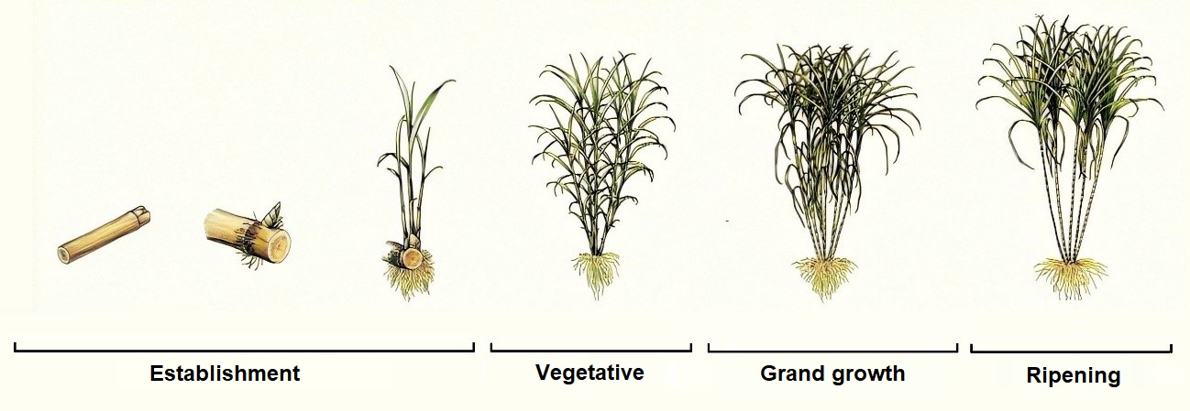
Fig. 1: Stages of sugarcane growth. Source: adapted from Cheavegatti-Gianotto et al. (2011).

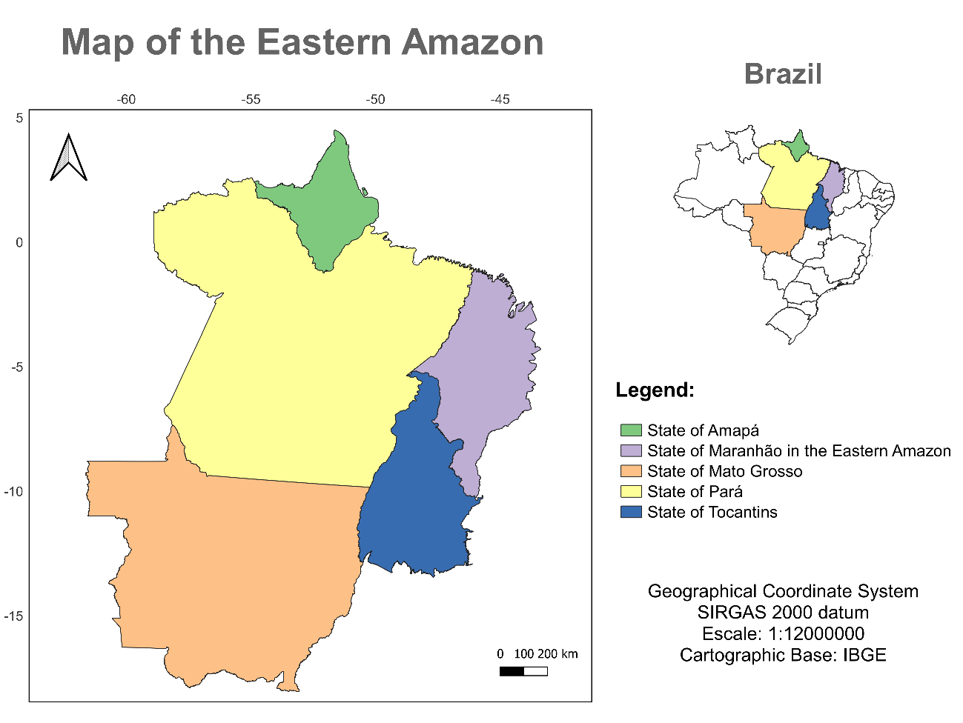
Fig. 2: Map of the Eastern Brazilian Amazon. Source: author.

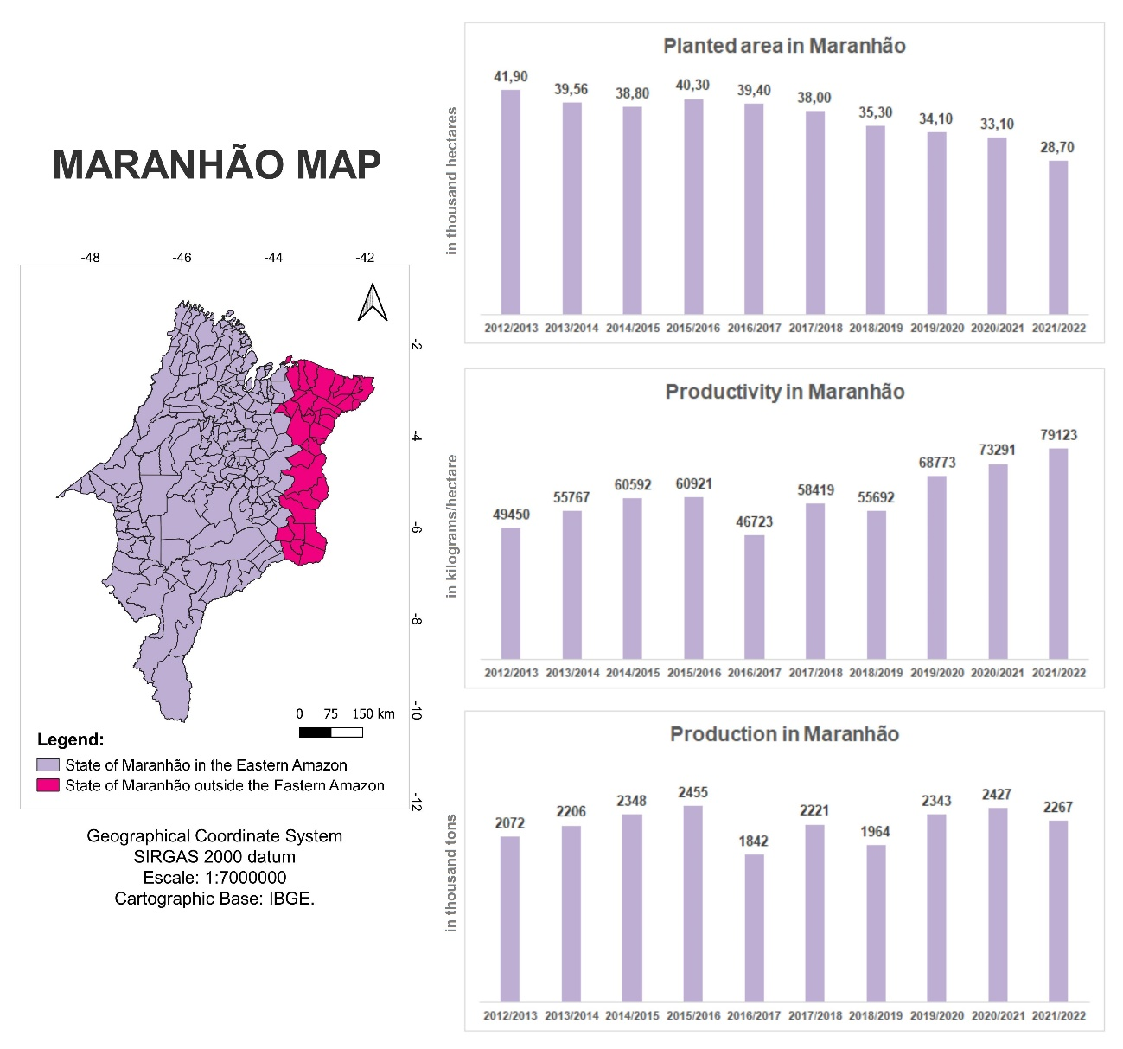
Fig 3: Map of the State of Maranhão with data on Planted Area (in thousand hectares), Productivity (in kilograms/hectare) and Production (in thousand tons) for the years 2012/2013 to 2021/2022. Source: author, based on data from CONAB (2013); CONAB (2014); CONAB (2015); CONAB (2016); CONAB (2017); CONAB (2018); CONAB (2019); CONAB (2020); CONAB (2021); CONAB (2022).

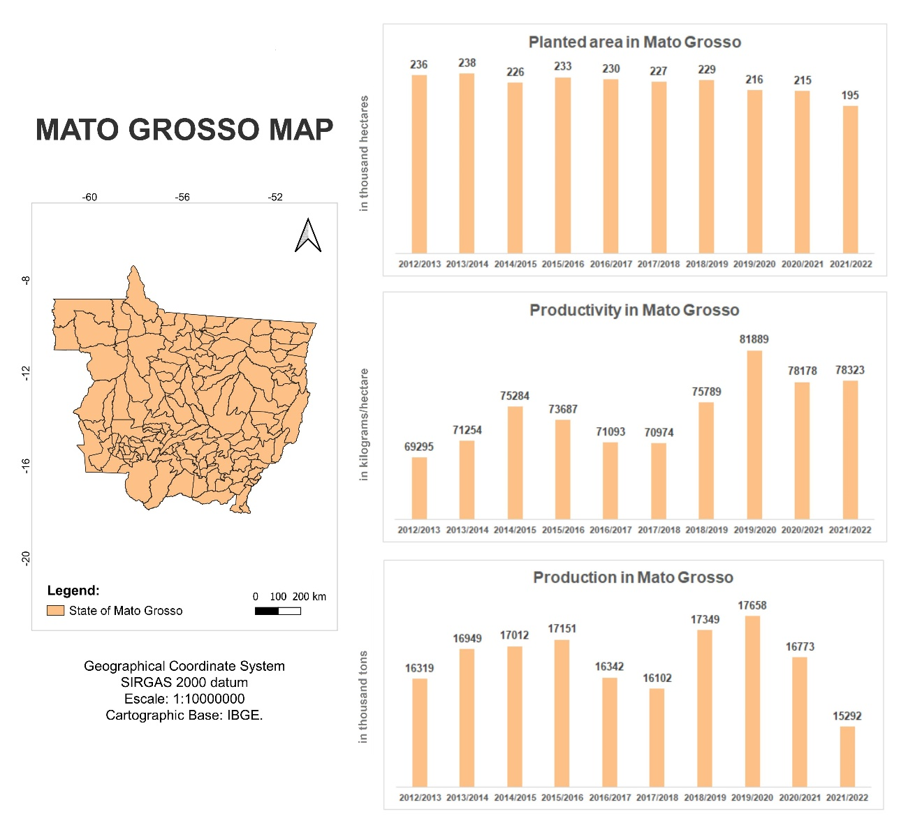
Fig 4: Map of the State of Mato Grosso with data on Planted Area (in thousand hectares), Productivity (in kilograms/hectare) and Production (in thousand tons) for the years 2012/2013 to 2021/2022. Source: author, based on data from CONAB (2013); CONAB (2014); CONAB (2015); CONAB (2016); CONAB (2017); CONAB (2018); CONAB (2019); CONAB (2020); CONAB (2021); CONAB (2022).

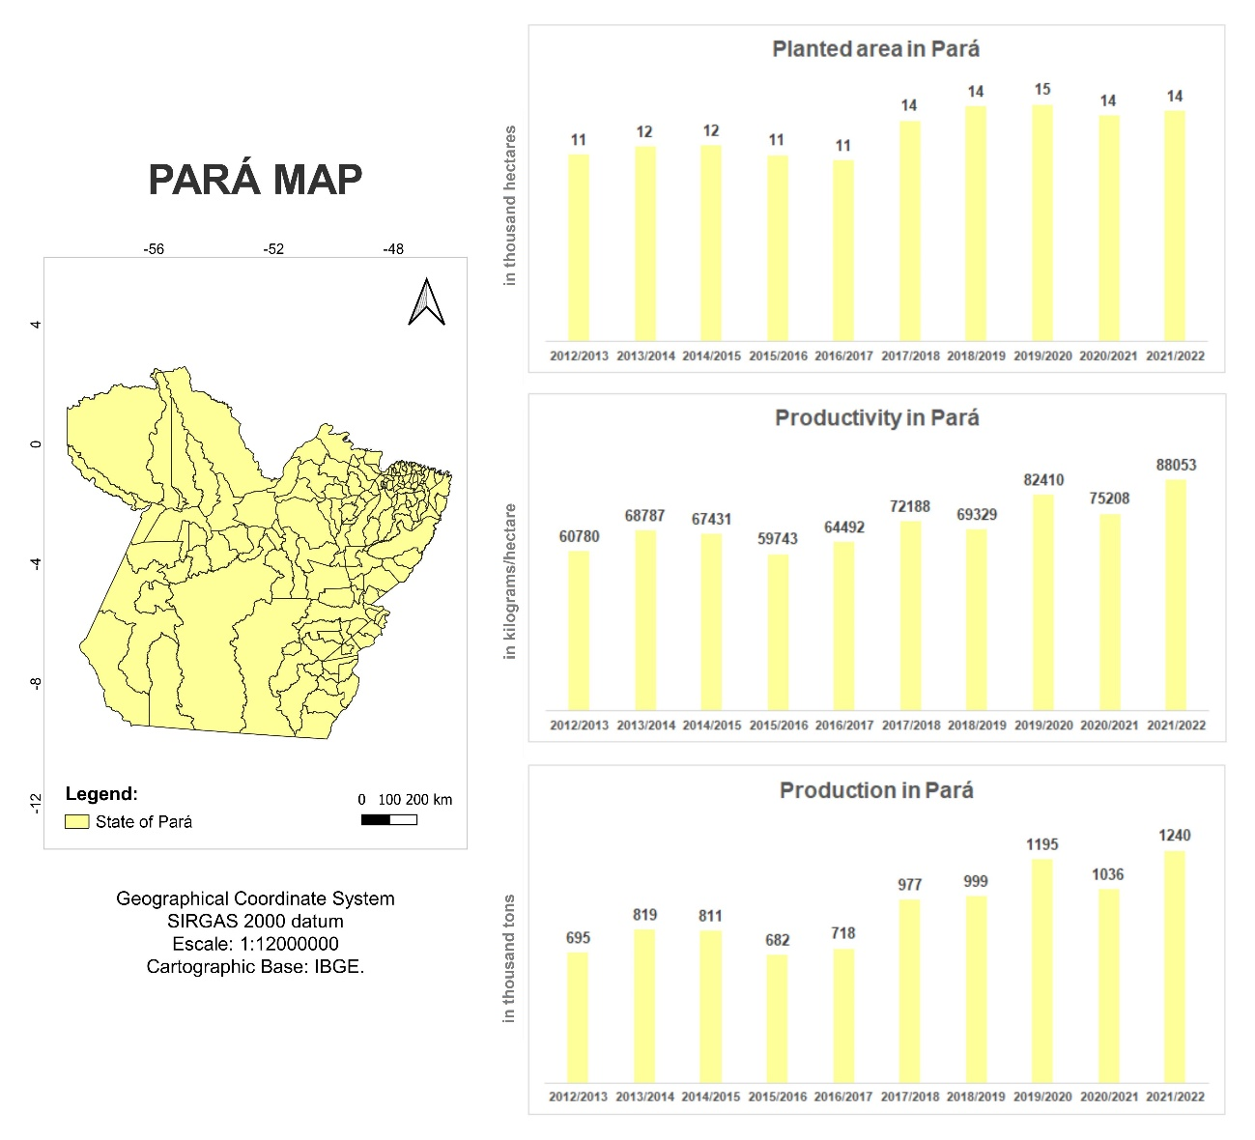
Fig 5: Map of the State of Pará with data on Planted Area (in thousand hectares), Productivity (in kilos/hectare) and Production (in thousand tons) from the years 2012/2013 to 2021/2022. Source: author, based on data from CONAB (2013); CONAB (2014); CONAB (2015); CONAB (2016); CONAB (2017); CONAB (2018); CONAB (2019); CONAB (2020); CONAB (2021); CONAB (2022).

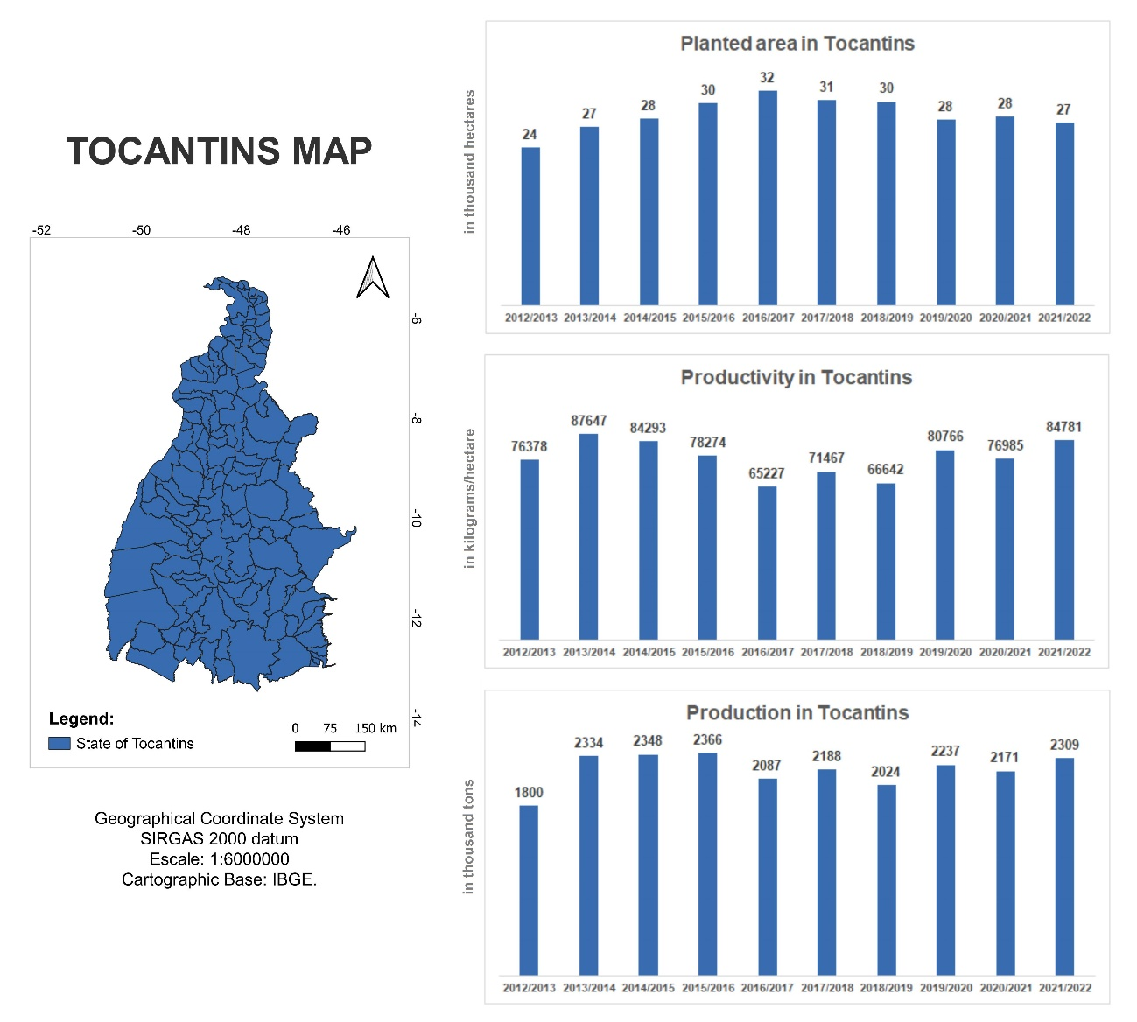
Fig 6: Map of the State of Tocantins with data on Planted Area (in thousand hectares), Productivity (in kilograms/hectare) and Production (in thousand tons) from the years 2012/2013 to 2021/2022. Source: author, based on data from CONAB (2013); CONAB (2014); CONAB (2015); CONAB (2016); CONAB (2017); CONAB (2018); CONAB (2019); CONAB (2020); CONAB (2021); CONAB (2022).

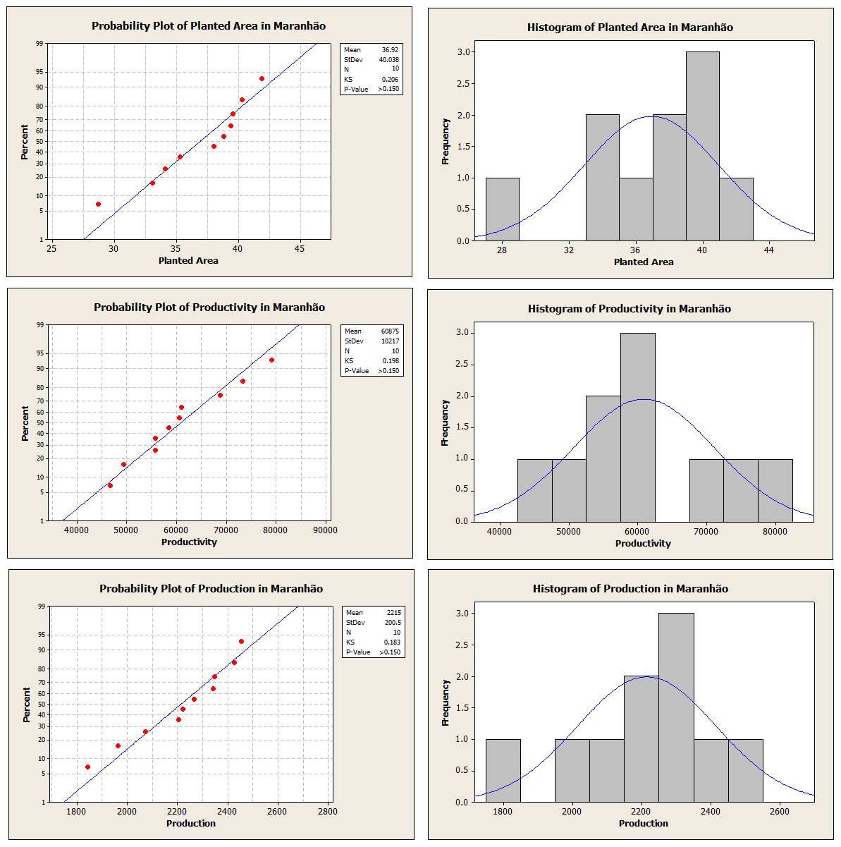
Fig 7: Frequency histograms of the variables Planted Area (in thousand hectares), Productivity (in kilograms/hectare) and Production (in thousand tons) of sugarcane in the State of Maranhão, Brazil, in the years 2012/2013 to 2021/2022. Source: author.

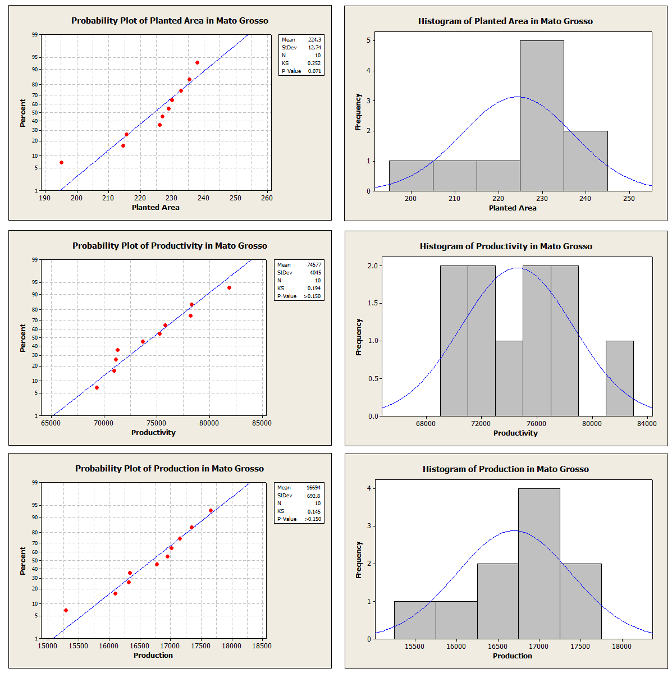
Fig 8: Frequency histograms of the variables Planted Area (in thousand hectares), Productivity (in kilograms/hectare) and Production (in thousand tons) of sugarcane in the State of Mato Grosso, Brazil, in the years 2012/2013 to 2021/2022. Source: author.

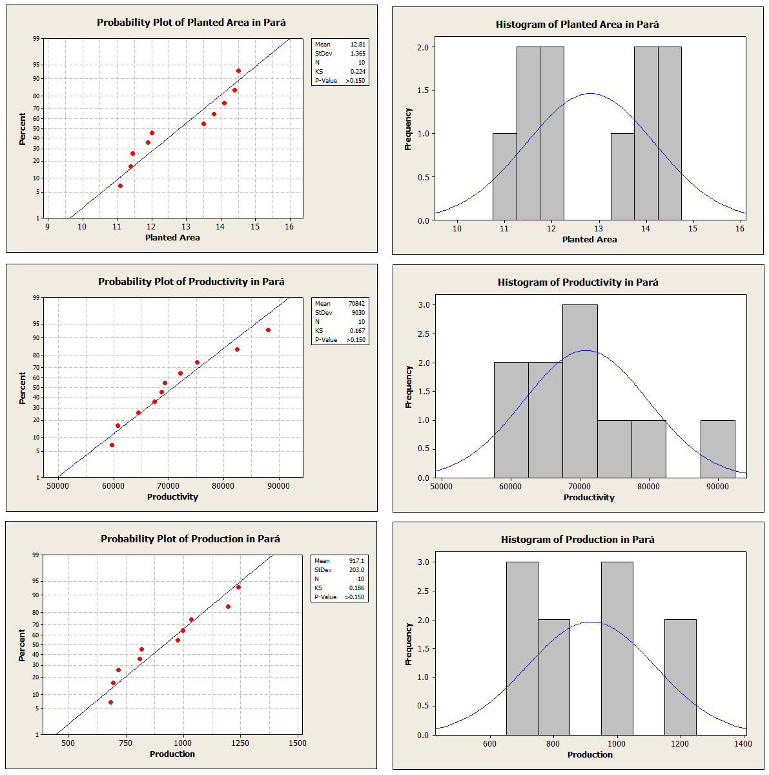
Fig 9: Frequency histograms of the variables Planted Area (in thousand hectares), Productivity (in kilograms/hectare) and Production (in thousand tons) of sugarcane in the State of Pará, Brazil, in the 2012/2012 2013 to 2021/2022. Source: author.

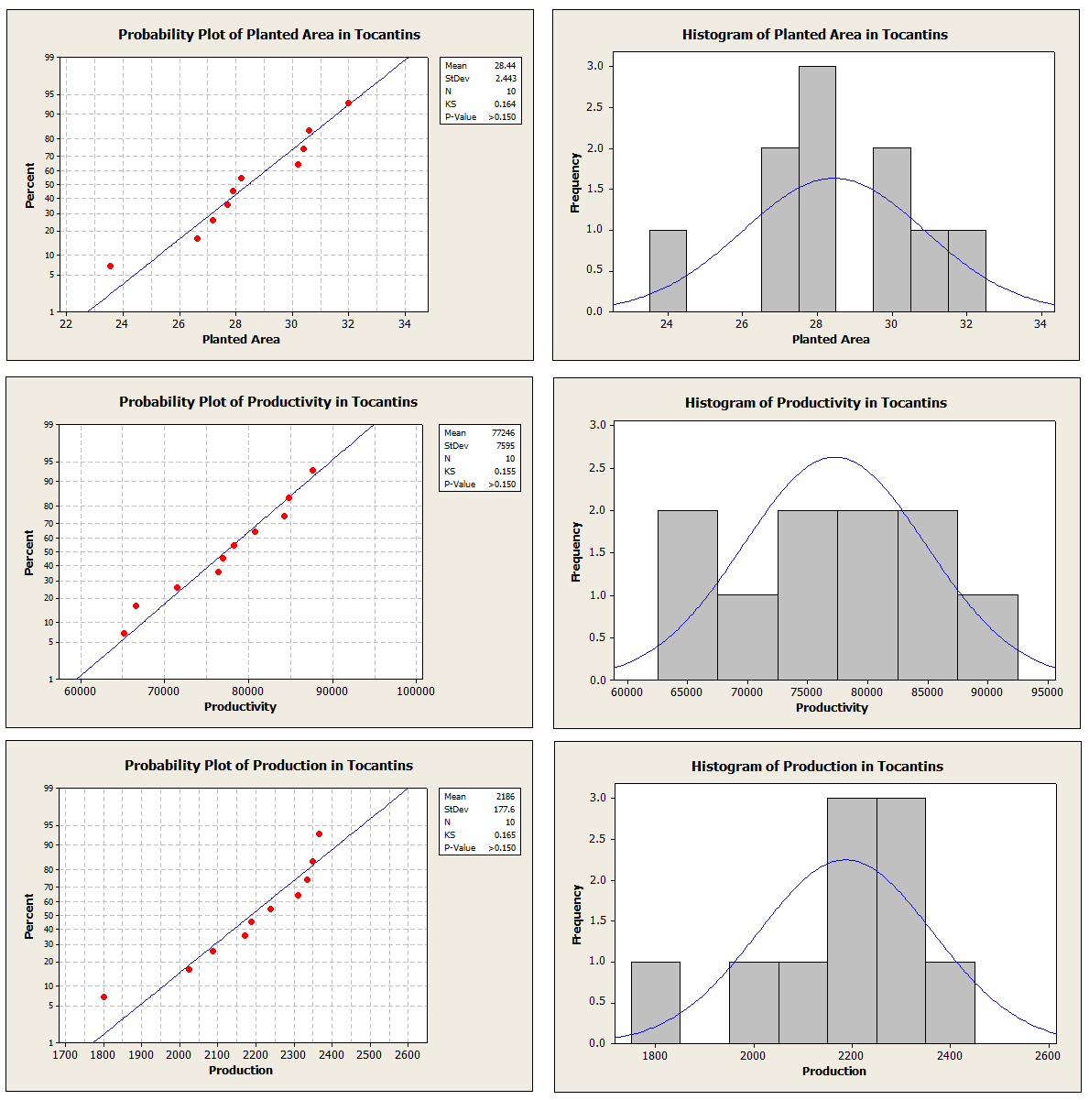
Fig 10: Frequency histograms of the variables Planted Area (in thousand hectares), Productivity (in kilograms/hectare) and Production (in thousand tons) of sugarcane in the State of Tocantins, Brazil, during the years 2012/2013 to 2021/2022. Source: author.

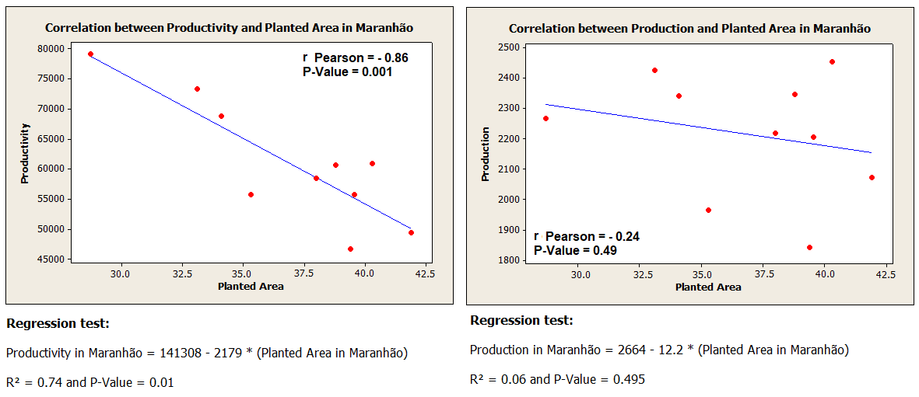
Fig.11: Correlations between Planted Area x Productivity and Planted Area x Production for the State of Maranhão.

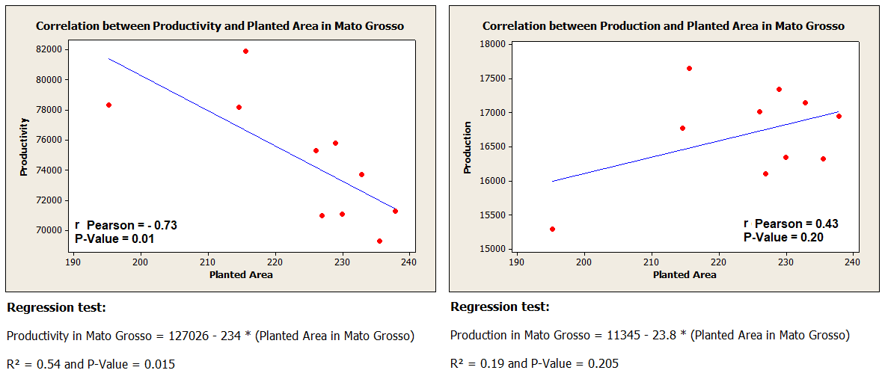
Fig 12: Correlations between Planted Area x Productivity and Planted Area x Production for the State of Mato Grosso.

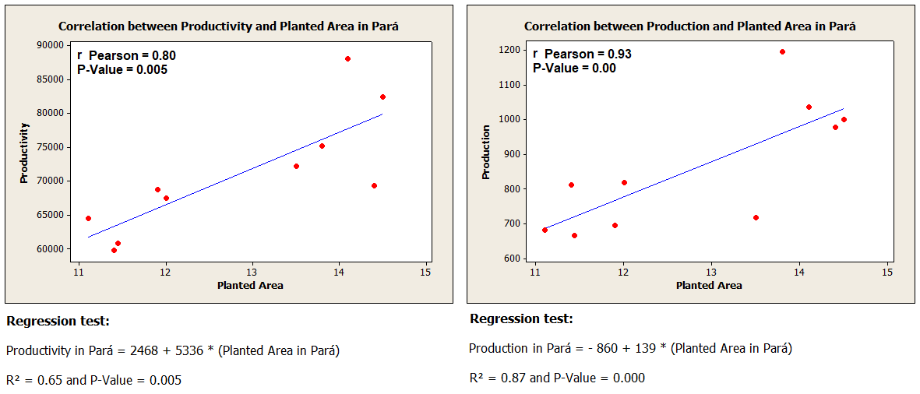
Fig 13: Correlations between Planted Area x Productivity and Planted Area x Production for the State of Pará.

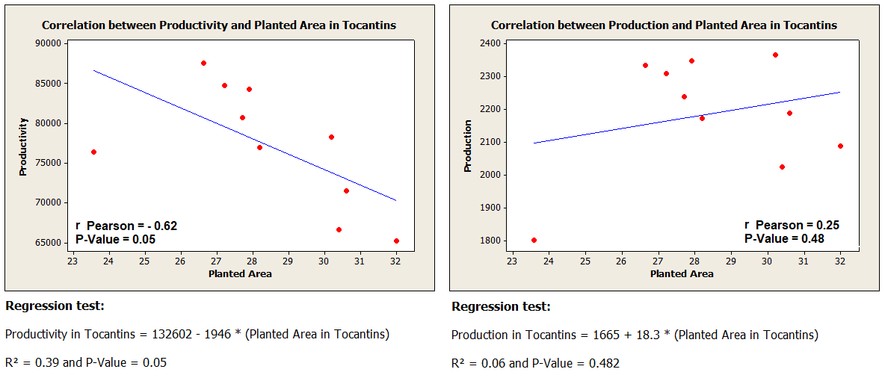
Fig 14: Correlations between Planted Area x Productivity and Planted Area x Production for the State of Tocantins.

Table 1: Legal framework of the Brazilian states belonging to the Eastern Amazon. Source: author, adapted from IBGE (2017), IBGE (2020) and SUDAM (2021).
STATES | LEGAL FRAMEWORK
Pará | It belongs to the Eastern Amazon in its entirety and in the same way since Law 1.806/1953.
Amapá | It belongs to the Eastern Amazon in its entirety since Law 1.806/1953, originally as a Federal Territory of the same name, however, with the advent of the Federal Constitution of 1988, it was elevated to the status of a state by article 14 of the Transitory Constitutional Provisions Act ( ADCT).
Tocantins | It became part of the Eastern Amazon with the advent of the Federal Constitution of 1988, through article 13 of the ADCT, which provided for the creation of the State of Tocantins from the dismemberment of part of the territory of the State of Goiás. More recently, Provisional Measure 2.146-1/2001 confirmed the border between the States of Tocantins and Goiás, as the limit of the Legal Amazon, with Tocantins remaining in the Eastern Amazon and the State of Goiás outside the Legal Amazon as a whole.
Mato Grosso | It belongs to the Eastern Amazon since Law 1.806/1953, but the state's area was modified by Complementary Law 31/1977, which created the State of Mato Grosso do Sul through the dismemberment of part of the original area of the State of Mato Grosso. What remains as territory of the State of Mato Grosso belongs entirely to the Eastern Amazon.
Maranhão | It belongs to the Eastern Amazon in the same way since Law 1.806/1953.

Table 2: Parameters for interpreting the magnitude of the correlation proposed by Cohen (1992). Source: author.
Cohen (1992)
r Pearson | Magnitude of Correlation
0.10 ─ 0.30 | Weak Correlation
0.30 ├─ 0.50 | Moderate Correlation
0.50 ├─ 1.00 | Strong correlation

Table 3: Parameters for interpreting the magnitude of the correlation proposed by Cohen (1992). Source: author.
Rumsey (2016)
r Pearson | Magnitude of Correlation
0.30 ─ 0.50 | Weak Correlation
0.50 ├─ 0.70 | Moderate Correlation
0.70 ├─ 1.00 | Strong correlation

Table 4: Pests present in the Brazilian sugarcane crop. Source: author, based on Pinto et al. (2016).
 | SCIENTIFIC NAME
MAIN PESTS | Diatraea saccharalis  (Lepidoptera: Crambidae)
Mahanarva fimbriolata
(Hemiptera: Cercopidae)
IMPORTANT, REGIONAL OR SPORADIC PESTS | Sphenophorus levis  (Coleoptera: Curculionidae)
Heterotermes tenuis
(Isoptera: Rhinotermitidae)
 | Atta spp.
Acromyrmex spp.
(Hymenoptera: Formicidae)
Migdolus fryanus
(Coleoptera: Cerambycidae)
Telchin licus
(Lepidoptera: Castniidae)
Mahanarva posticata
(Hemiptera: Cercopidae)
SECONDARY PESTS | Metamasius hemipterus  (Coleoptera: Curculionidae)
Besouros de várias espécies
(Coleoptera: Scarabaeidae)
Elasmopalpus lignosellus
(Lepidoptera: Pyralidae)
Hyponeuma taltula
(Lepidoptera: Noctuidae)
Spodoptera frugiperda
(Lepidoptera: Noctuidae)
Mocis latipes
(Lepidoptera: Noctuidae)
NEMATODES | Pratylenchus zeae  (Nematoda: Pratylenchidae)
Meloidogyne incognita
(Nematoda: Heteroderidae)
Meloidogyne javanica
(Nematoda: Heteroderidae)

