Manuscript type: Original Research
Title: Molecular and biological characterization of an Egyptian isolate of Sclerotinia sclerotiorum mitovirus 1
Running Title:Characterization of a novel mitovirus isolate.
Authors: Mahmoud E. Khalifa^{1*}, Eldessoky S. Dessoky^{2,3} and Atef S. Sadik⁴

¹Botany and Microbiology Department, Faculty of Science, Damietta University, Damietta, Egypt.
²Department of Biology, College of Science, Taif University, P.O. Box 11099, Taif 21944, Saudi Arabia.
³Plant Genetic Transformation Department, Agricultural Genetic Engineering Research Institute (AGERI), Agricultural Research Center (ARC), Giza, Egypt.
⁴Department of Agricultural Microbiology, Faculty of Agriculture, Ain Shams University, P.O. Box 68, Hadayek Shobra 11241, Cairo, Egypt.

*For correspondence: mkha201@aucklanduni.ac.nz; mahmoud.khalifa@du.edu.eg

Novelty statement
Because of their potential as biological control agents of fungal pathogens, the interest in mycoviruses has increased in recent years. In the current study, A novel mitovirus isolate, SsMV1-D7, was reported from a hypovirulent strain of Sclerotinia sclerotiorum. The full-length sequence of SsMV1-D7 was determined and deposited in GenBank. Horizontal transmission of SsMV1-D7 was studied and experiments revealed that it is responsible for conferring hypovirulence on S. sclerotiorum.
Abstract
A single double-stranded RNA (dsRNA) segment of 2531 nts was detected and sequenced from an Egyptian isolate (D7) of Sclerotinia sclerotiorum fungus. The dsRNA segment encodes a single open reading frame (ORF) with the characteristic conserved motifs of viral RNA-dependent RNA-polymerases (RdRps). The RdRp encoded by the ORF shares 91.84% identity with that of Sclerotinia sclerotiorum mitovirus 1 (SsMV1- HC025) and consequently it was tentatively named SsMV1-D7. As for previously described mitoviruses, the termini of the (+) strand of SsMV1-D7 RNA could potentially fold into stable secondary structures. SsMV1-D7 is probably responsible for the reduced growth rate and virulence of S. sclerotiorum.
Key Words:
dsRNA; Mycovirus; Mitoviridae; Mitovirus; Sclerotinia sclerotiorum; Hypovirulence

Introduction
Mycoviruses, viruses that infect and replicate in fungi, are widespread in all major taxa of fungi (Pearson et al., 2009). Several mycoviruses with different genome types have been reported from several fungal species including Sclerotinia sclerotiorum. Mycovirus infection may reduce the fitness of the fungal hosts and consequently have potential as biological control agents against fungal pathogens (Ghabrial and Suzuki, 2009, Pearson et al., 2009). Among the simplest known mycoviral families is Mitoviridae which include members that severely debilitate their fungal hosts (Hillman and Cai, 2013, Hillman and Esteban, 2011).
S. sclerotiorum is a devastating phytopathogenic fungus capable of infecting over 400 plant species worldwide, including economically important crops (Boland and Hall, 1994). Due to the drawbacks associated with S. sclerotiorum chemical control (Bolton et al., 2006), researchers paid attention to the potential use of mycoviruses in controlling S. sclerotiorum diseases. Several mycoviruses have been identified from S. sclerotiorum, many of which are associated with hypovirulence (Khalifa and Pearson, 2013, Xie and Ghabrial, 2012, Xu et al., 2015, Yu et al., 2010).
In the present study, a dsRNA segment was isolated from an Egyptian hypovirulent isolate of S. sclerotiorum (isolate D7). The aims of this study were (i) to molecularly characterize the D7-dsRNA segment and (ii) to determine the effect of this dsRNA on S. sclerotiorum pathogenity.

Materials and methods
Fungal isolates

Isolate D7 of S. sclerotiorum was isolated in 2015 from a diseased legume of black-eyed pea (Vigna unguiculata) obtained from a grocery store in Damietta governorate, Egypt. Isolate 13844sh^{hyg} is a hygromycin-labeled, virus-free S. sclerotiorum used in virus transfer experiments (Khalifa and Pearson, 2013). All isolates were cultured and maintained on potato dextrose agar (PDA) media. For liquid cultures, isolate were grown on potato dextrose broth (PDB) media for 4-5 days at 20^{ᴼ}C.
Purification, sequencing and RT-PCR detection of dsRNA
DsRNA was extracted using a CF11 cellulose chromatography method as previously described by Valverde et al. (1990). Purified dsRNA was separated by electrophoresis in 1% (w/v) agarose gel in TAE buffer. Separated dsRNA was visualized, photographed under UV light and dsRNA nature was confirmed as described by Howitt et al. (1995). To determine the nucleotide sequence of dsRNA, it was gel-extracted and used as a template for random cDNA synthesis prior to sequencing using a method based on that of Roossinck et al. (2010) as described by Khalifa and Pearson, (2013). Terminal sequences of dsRNA were confirmed by adapter ligation at the 5' and 3' ends, RT-PCR and sequencing, as described by Khalifa and Pearson, (2013).
Sequence and phylogenetic analyses
Sequence reads were assembled using Geneious R8.1 (Kearse et al., 2012). Open reading frame (ORF) was detected using the ORFfinder tool of NCBI (https://www.ncbi.nlm.nih.gov/orffinder/). Potential stem-loop and panhandle secondary structures were predicted using MFOLD software (Mathews et al., 1999). Conserved motifs of RNA-dependent RNA-polymerase (RdRp) amino acid (aa) sequences were detected using MUSCLE sequence alignment software (https://www.ncbi.nlm.nih.gov/orffinder/). Neighbor joining phylogenetic tree was executed using MEGA 5 software (Tamura et al., 2011).
Virus transmission and biological characteristics
Dual-culture technique was used to transfer dsRNA from isolate D7 to isolate 13844sh^{hyg} for producing isolate 13844sh^{hyg}-D7 as described by Khalifa and Pearson, (2013). All isolates were sub-cultured on PDA prior to RNA extraction and RT-PCR detection of dsRNA associated with isolate D7 (dsRNA-D7). To assess the growth rate of S. sclerotiorum isolates, agar plugs were taken from the growing margins, sub-cultured on PDA plates (three replicates), plates incubated at 20^{ᴼ}C for 4-5 days and growth rate was measured daily. For virulence assessment, agar plugs were used to infect tomato detached leaves (three replicates) placed in tissue culture tubs. Lesion diameters were measured three days post incubation. Growth rate and lesion diameter data were analysed by one-way analysis of variance (ANOVA) and differences with P<0.05 were considered statistically significant.
RT-PCR detection of dsRNA associated with S. sclerotiorum isolate D7
To detect dsRNA-D7 in different isolates of S. sclerotiorum, RNA was extracted and used as a template for RT-PCR using specific primers for dsRNA-D7 (Forward: 5′-CCTGGGATAAAAGTTTTGATCG-3′; Reverse: 5′-AGAGATGAGTAAGGAAAGGCGG-3′) to amplify a 219 nucleotides (nts) long fragment. Primers actin-qF2 (5′-GAGCTGTTTTCCC TTCCATTGTC-3′) and actin-qR4 (5′-GACGACACCGTGCTCGATTGG-3′) were used to amplify a 146 nts long fragment of S. sclerotiorum actin gene as an internal control for RT-PCR (Sexton et al., 2009). RT-PCR products were separated by electrophoresis, visualized and photographed under UV.

Results
DsRNA profile of S. sclerotiorum isolate D7
DsRNA associated with isolate D7 of S. sclerotiorum was purified using CF11 chromatography. The dsRNA nature of purified RNA was confirmed by DNase and RNase treatments at high and low-salt buffer solutions. Gel electrophoresis of purified dsRNA revealed the presence of a single dsRNA band of ~2.5kb (Figure 1). The band was gel-extracted and used as a template for RT-PCR amplification of random cDNAs that were cloned and sequenced. The full sequence of the D7-dsRNA segment was completed by RACE-PCR.
Sequence properties of D7-dsRNA
The full-length sequence of D7-dsRNA is 2531 nts long and codes for a single ORF, using the mitochondrial translation table in which the UGA stop codon encodes tryptophan amino acid. The sequence is high in A+U content (60.4%) and the ORF is flanked by 5' and 3' untranslated regions (UTRs) of 307 and 52 nts, respectively. The ORF starts at an AUG codon (nt positions 308-310), terminates at two adjacent UAG UAA termination codons (nt positions 2477-2479 and 2480-2482) and codes for a 723 aa long protein with estimated molecular weight of 83.85 kDa. BLASTP search of D7-dsRNA-ORF against the non-redundant protein sequences (nr) revealed identities to RdRps of several mitoviruses. The D7-RdRp shared the highest identity with that of Sclerotinia sclerotiorum mitovirus 1-HC025 (SsMV1-HC025) and therefore, it was considered as an isolate of SsMV1 and tentatively named SsMV1-D7. The nt sequence of SsMV1-D7 was deposited in GenBank under accession number MW161169.
Potential secondary structures of SsMV1-D7 5' and 3' UTRs
The 5' and 3' UTRs of SsMV1-D7 (+) RNA have the potential to fold into stem-loop secondary structures with ΔG values of -28.6 and -39.0 kcal/mole, respectively. The inverted complementary sequences of the 5’ and 3’ termini are predicted to form a panhandle structure with ΔG value of -70.7 kcal/mole (Figure 2).
SsMV1-D7 RdRp and its relatedness to other mitoviruses
Multiple aa sequence alignments of SsMV1-D7 RdRp and corresponding sequences of previously described mitoviruses revealed that it contains the aa conserved motifs of RdRp proteins, including the highly conserved GDD region in motif IV (Figure 3). The RdRp aa sequence identities of SsMV1-D7 and other representative mitoviruses are presented in Table 1. SsMV1-D7 RdRp shared the highest identity of 91.84% with SsMV1-HC025. SsMV1-D7 was considered as an isolate of SsMV1 based on the International Committee on Taxonomy of Viruses (ICTV) rules for species demarcation of mitoviruses, as isolates of the same species share RdRp aa identities greater than 90% (Hillman and Esteban, 2011). Phylogenetic analysis based on multiple alignments of full-length RdRp mitoviral proteins divided the sequences into several clades with SsMV1-D7 clustering with other isolates of SsMV1 and other viruses from Ophiostoma novo-ulmi, Botrytis cinerea and Colletotrichum falcatum. Other mitovirus species isolated from S. sclerotiorum were randomly scattered in different clades (Figure 4).
Biological characteristics of SsMV1-D7
To study the effect of SsMV1-D7 on S. sclerotiorum, dual-culture technique was used to transfer the virus from its parental isolate D7 to a virus-free isolate (13844sh^{hyg}) via anastomosis. Successful virus movement from isolate D7 to isolate 13844sh^{hyg} was confirmed using RT-PCR detection with SsMV1-D7 specific primers (Figure 5). Isolate 13844sh^{hyg} infected with SsMV1-D7 was labeled 13844sh^{hyg}-D7. Growth rate and virulence of the parental and transfected isolates were compared. Growth rates of isolates D7, 13844sh^{hyg}, and 13844sh^{hyg}-D7 were 1.8, 2.15 and 1.9 cm/d, respectively. Moreover, lesion diameter produced by the newly infected isolate 13844sh^{hyg}-D7 on tomato detached leaves was reduced to 1.75 cm, which is comparable with that of SsMV1-D7 naturally-infected isolate D7 (1.65 cm) and less than that of SsMV1-D7-free isolate 13844sh^{hyg} (2 cm) (Figure 5).
Discussion
In the present study we report the molecular characteristics of a novel isolate of a previously described mitovirus SsMV1 (SsMV1-D7), which was found associated with an Egyptian isolate of S. sclerotiorum. Sequence analysis and BLASTP search revealed that the genome of the novel isolate encodes a single ORF with similarities to mitoviruses. Phylogenetic analysis and aa identity comparisons supported our findings that it represents a novel Egyptian isolate of SsMV1. Mitoviruses were formerly classified as species of the Mitovirus genus within the Narnaviridae family. Currently, a new family, Mitoviridae, has been established to accommodate members of the genus Mitovirus (Li et al., 2020, Nibert et al., 2018) as they appeared to have characters that make them distinct from Narnaviridae members. Mitoviruses were known to infect only fungi until they were recently discovered associated with plants such as Chenopodium quinoa mitovirus 1 (CqMV1) (Nerva et al., 2019).
Mitoviridae include the simplest known members of mycoviruses with unencapsidated monopartite, positive sense, ssRNA genomes [(+)ssRNA)] of 2.3-3.6 kb in length (Hillman and Cai, 2013). SsMV1-D7 ssRNA has no poly (A) tail at its 3' end, which is a common property of most mitoviral genomes. However, some polyadenylated mitoviruses have been reported such as SsMV2/KL1 (Xie and Ghabrial, 2012). Genomes of mitoviruses consist of single ORF that encodes only the RdRp. Replication of mitoviruses is restricted to their host mitochondria where the tryptophan aa could be coded for by the stop codon UGA (Cole et al., 2000). SsMV1-D7 ORF contains nine in-frame UGA codons, confirming its presence and replication within the host mitochondria. Some recently discovered mitoviruses, such as Rhizoctonia solani mitovirus 39 (RsMV39), were found to encode the full-length RdRp when the standard or mitochondrial genetic codes were applied suggesting their ability to replicate within the cytoplasm and mitochondria (Li et al., 2020).
Fungal and plant mitochonderial genomes are rich in A+U content (>60%) probably due to their preference to have codons with either A or U at the third wobble position (XYA+XYU) (Hong et al., 1998a). Although, in general, genomes of mitoviruses are characterized by having high A+U content of 62 to 73% (Hillman and Cai, 2013), some recently described mitoviruses have lower A+U content such as Cryphonectria cubensis mitovirus 1a (CcMV1a; 50.5%) (Van Heerden, 2008), Sclerotinia sclerotiorum mitovirus 2 (SsMV2/NZ1; 55.1%) (Khalifa and Pearson, 2013), SsMV2/KL1 (53.1%) (Xie and Ghabrial, 2012), and Cronartium ribicola mitovirus 1 (CrMV1; 57.3%) (Liu et al., 2016). SsMV1-D7 has high A+U content of 60.4% which is consistent with most mitoviruses and mitochondrial genomes. There is a preference for the UAA stop codon in fungal mitochondrial genomes (Paquin et al., 1997), which is the case for most characterized mitoviruses. However, SsMV1/D7 ORF is terminated by UAG stop codon similar to several S. sclerotiorum mitoviruses (Khalifa and Pearson, 2013, Xie and Ghabrial, 2012).
The terminal sequences of all discovered mitoviruses have the potential to fold into stable stem-loop secondary structures. Moreover, genomes of some mitoviruses can fold into panhandle structures by the inverted complementary sequences of their 5' and 3' termini (Hong et al., 1998b). Examples of the mitoviruses that have this potential are Ophiostoma mitovirus 4 (OMV4), Ophiostoma mitovirus 6 (OMV6) (Hong et al., 1999), Helicobasidium mompa mitovirus 1–18 (HmMV1-18) (Osaki et al., 2005), Thielaviopsis basicola mitovirus (TbMV) (Park et al., 2006), RsMV39 (Li et al., 2020), Cronartium ribicola mitoviruses (CrMV1 to CrMV5) (Liu et al., 2016), SsMV1/HC025 (Xu et al., 2015), SsMV2/NZ1 (Khalifa and Pearson, 2013), and SsMV1-D7 of the current study. Such secondary structures are thought to (i) play an important role in the replication process of mitoviral genomes, (ii) act as recognition sites for RdRp and (iii) protect naked ssRNA genomes from degradation (Buck, 1996, Hong et al., 1998a, Hong et al., 1999).
Hyphal anastomosis experiments are widely used to study the transmission of mycoviruses from a virus-containing isolate to another virus-free isolate of fungal hosts. Mitovirus transmission through anastomosis is accompanied by mitochondrial movement and recombination such as in the case of Cryphonectria parasitica mitovirus 1 (CpMV1) (Polashock et al., 1997). SsMV1-D7 was able to infect a virus-free fungal isolate through hyphal fusion. Its transmission might be similarly associated with movement and recombination of mitochondria.
The infection by mitoviruses leads to variable effects on their fungal hosts. Although mitoviruses that induce little or no effects on their natural hosts, such as Cryphonectria cubensis mitovirus 1b (CMV1b), Cryphonectria cubensis mitovirus 1b (CMV2a) (Van Heerden, 2008) and Sclerotinia sclerotiorum mitovirus 4 (SsMV4) (Khalifa and Pearson, 2013), have been reported, most mitovirus infections are associated with reduced fungal virulence, giving them the potential to be used as biological control agents. Examples of hypovirulence-associated mitoviruses have been reported in several fungal species including S. sclerotiorum (Khalifa and Pearson, 2013, Xie and Ghabrial, 2012, Xu et al., 2015), B. cinerea (Wu et al., 2010), Cryphonectria parasitica (Polashock and Hillman, 1994), O. novo-ulmi (Hong et al., 1999), Rhizoctonia solani (Lakshman and Tavantzis, 1994) and Sclerotinia homoeocarpa (Deng and Boland, 2006). Infection of S. sclerotiorum with the Egyptian isolate of SsMV1 (SsMV1/D7) reduced its growth rate and virulence and hence SsMV1/D7 could be a potential candidate for controlling diseases caused by this fungal pathogen.
Some mitoviruses of S. sclerotiorum were phylogenitically related, whereas others are found in different phylogenetic clusters (Xu et al., 2015). Some mitoviruses showed great diversity in terms of species variability and geographical distribution. For example O. novo-ulmi was found to harbor at least nine mitoviruses from Europe and North America (Doherty et al., 2006, Hintz et al., 2013, Hong et al., 1999). Moreover, the NCBI database contained at least 34 species of mitoviruses sequenced from S. sclerotiorum fungus, the natural host of SsMV1-D7. Isolates of SsMV1 were identified in American (SsMV1/KL-1) (Xie and Ghabrial, 2012), Chinese (SsMV1/HC025) (Xu et al., 2015) and Egyptian strains (SsMV1-D7). Territorial distribution of SsMV1 and association of its different isolates, including the one of the current study, with reduced host virulence provides alternative promising approach for the control of S. sclerotiorum fungus.
Conclusion
In this study, we reported the isolation and characterization of a novel isolate of a mitovirus associated with an Egyptian isolate of S. sclerotiorum. Characteristics of the isolated mitovirus are in consistence with most previously described mitoviruses. The isolation of SsMV1-D7 from three different countries reveals that it has wide geographical distribution. Continuous isolation of mycoviruses from S. sclerotiorum indicates their great diversity. Since SsMV1-D7 confers hypovirulence in S. sclerotiorum, this research introduces the concept of studying mycoviruses as biological control agents against fungal diseases in Egypt.

Acknowledgment
The authors appreciate Taif University Researchers Supporting Project number (TURSP-2020/85), Taif, Saudi Arabia. Authors would also like to thank Damietta University, Egypt for supporting this research.
References
Boland GJ, R Hall (1994). Index of plant hosts of Sclerotinia sclerotiorum. Can J Plant Pathol, 16: 93-108.
Bolton MD, BP Thomma, BD Nelson (2006). Sclerotinia sclerotiorum (Lib.) de Bary: biology and molecular traits of a cosmopolitan pathogen. Mol Plant Pathol, 7: 1-16.
Buck KW (1996). Comparison of the replication of positive-stranded RNA viruses of plants and animals. Adv Virus Res, 47: 159-251.
Cole TE, Y Hong, CM Brasier, KW Buck (2000). Detection of an RNA-dependent RNA polymerase in mitochondria from a mitovirus-infected isolate of the Dutch Elm disease fungus, Ophiostoma novo-ulmi. Virology, 268: 239-243.
Deng F, GJ Boland (2006). Attenuation of virulence in Sclerotinia homoeocarpa during storage is associated with latent infection by Ophiostoma mitovirus 3a. Eur J Plant Pathol, 114: 127-137.
Doherty M, RH Coutts, CM Brasier, KW Buck (2006). Sequence of RNA-dependent RNA polymerase genes provides evidence for three more distinct mitoviruses in Ophiostoma novo-ulmi isolate Ld. Virus genes, 33: 41-44.
Ghabrial SA, N Suzuki (2009). Viruses of plant pathogenic fungi. Annu Rev Phytopathol, 47: 353-384.
Hillman BI, G Cai (2013). The family Narnaviridae: simplest of RNA viruses. Adv Virus Res, 86: 149-176.
Hillman BI, R Esteban (2011). Narnaviridae. In: King AMQ, Adams MJ, Carstens EB, Lefkowitz EJ, editors. Virus Taxonomy: Classification and Nomenclature of Viruses: Ninth Report of the International Committee on Taxonomy of Viruses. San Diego: Elsevier. pp. 1055–1060.
Hintz WE, JS Carneiro, I Kassatenko, A Varga, D James (2013). Two novel mitoviruses from a Canadian isolate of the Dutch elm pathogen Ophiostoma novo-ulmi (93-1224). Virol J, 10: 252.
Hong Y, TE Cole, CM Brasier, KW Buck (1998a). Evolutionary relationships among putative RNA-dependent RNA polymerases encoded by a mitochondrial virus-like RNA in the Dutch elm disease fungus, Ophiostoma novo-ulmi, by other viruses and virus-like RNAs and by the Arabidopsis mitochondrial genome. Virology, 246: 158-169.
Hong Y, TE Cole, CM Brasier, KW Buck (1998b). Novel structures of two virus-like RNA elements from a diseased isolate of the Dutch elm disease fungus, Ophiostoma novo-ulmi. Virology, 242: 80-89.
Hong Y, SL Dover, TE Cole, CM Brasier, KW Buck (1999). Multiple mitochondrial viruses in an isolate of the Dutch Elm disease fungus Ophiostoma novo-ulmi. Virology, 258: 118-127.
Howitt RLJ, RE Beever, MN Pearson, RLS Forster (1995). Presence of double-stranded RNA and virus-like particles in Botrytis cinerea. Mycol Res, 99: 1472-1478.
Kearse M, R Moir, A Wilson, S Stones-Havas, M Cheung, S Sturrock, S Buxton, A Cooper, S Markowitz, C Duran, T Thierer, B Ashton, P Meintjes, A Drummond (2012). Geneious Basic: an integrated and extendable desktop software platform for the organization and analysis of sequence data. Bioinformatics, 28: 1647-1649.
Khalifa ME, MN Pearson (2013). Molecular characterization of three mitoviruses co-infecting a hypovirulent isolate of Sclerotinia sclerotiorum fungus. Virology, 441: 22-30.
Lakshman DK, SM Tavantzis (1994). Spontaneous appearance of genetically distinct double-stranded RNA elements in Rhizoctonia solani. Phytopathology, 84: 633.
Li S, Y Li, C Hu, C Han, T Zhou, C Zhao, X Wu (2020). Full genome sequence of a new mitovirus from the phytopathogenic fungus Rhizoctonia solani. Arch Virol, 165: 1719-1723.
Liu JJ, D Chan, Y Xiang, H Williams, XR Li, RA Sniezko, RN Sturrock (2016). Characterization of five novel mitoviruses in the white pine blister rust fungus Cronartium ribicola. PloS One, 11: e0154267.
Mathews DH, J Sabina, M Zuker, DH Turner (1999). Expanded sequence dependence of thermodynamic parameters improves prediction of RNA secondary structure. J Mol Biol, 288: 911-940.
Nerva L, G Vigani, D Di Silvestre, M Ciuffo, M Forgia, W Chitarra, M Turina (2019). Biological and molecular characterization of Chenopodium quinoa mitovirus 1 reveals a distinct small RNA response compared to those of cytoplasmic RNA viruses. J Virol, 93.
Nibert ML, M Vong, KK Fugate, HJ Debat (2018). Evidence for contemporary plant mitoviruses. Virology, 518: 14-24.
Osaki H, H Nakamura, K Nomura, N Matsumoto, K Yoshida (2005). Nucleotide sequence of a mitochondrial RNA virus from the plant pathogenic fungus, Helicobasidium mompa Tanaka. Virus Res, 107: 39-46.
Paquin B, MJ Laforest, L Forget, I Roewer, Z Wang, J Longcore, BF Lang (1997). The fungal mitochondrial genome project: evolution of fungal mitochondrial genomes and their gene expression. Curr Gene, 31: 380-395.
Park Y, X Chen, ZK Punja (2006). Molecular and biological characterization of a mitovirus in Chalara elegans (Thielaviopsis basicola). Phytopathology, 96: 468-479.
Pearson MN, RE Beever, B Boine, K Arthur (2009). Mycoviruses of filamentous fungi and their relevance to plant pathology. Mol Plant Pathol, 10: 115-128.
Polashock JJ, PJ Bedker, BI Hillman (1997). Movement of a small mitochondrial double-stranded RNA element of Cryphonectria parasitica: ascospore inheritance and implications for mitochondrial recombination. Mol Gen Genet, 256: 566-571.
Polashock JJ, BI Hillman (1994). A small mitochondrial double-stranded (ds) RNA element associated with a hypovirulent strain of the chestnut blight fungus and ancestrally related to yeast cytoplasmic T and W dsRNAs. Proc Natl Acad Sci U S A, 91: 8680-8684.
Roossinck MJ, P Saha, GB Wiley, J Quan, JD White, H Lai, F Chavarria, G Shen, Roe BA (2010). Ecogenomics: using massively parallel pyrosequencing to understand virus ecology. Mol Ecol, 19 Suppl 1: 81-88.
Sexton AC, Z Minic, AJ Cozijnsen, MS Pedras, BJ Howlett (2009). Cloning, purification and characterisation of brassinin glucosyltransferase, a phytoalexin-detoxifying enzyme from the plant pathogen Sclerotinia sclerotiorum. Fungal Genet Biol, 46: 201-209.
Tamura K, D Peterson, N Peterson, G Stecher, M Nei, S Kumar (2011). MEGA5: molecular evolutionary genetics analysis using maximum likelihood, evolutionary distance, and maximum parsimony methods. Mol Biol Evol, 28: 2731-2739.
Valverde RA, ST Nameta, RL Jordan (1990). Analysis of double-stranded RNA for plant virus diagnosis. Plant Dis, 74: 255.
Van Heerden SW (2008). Studies on Cryphonectria cubensis in South Africa with special reference to mycovirus infection: University of Pretoria.
Wu M, L Zhang, G Li, D Jiang, SA Ghabrial (2010). Genome characterization of a debilitation-associated mitovirus infecting the phytopathogenic fungus Botrytis cinerea. Virology, 406: 117-126.
Xie J, SA Ghabrial (2012). Molecular characterization of two mitoviruses co-infecting a hypovirulent isolate of the plant pathogenic fungus Sclerotinia sclerotiorum. Virology, 428: 77-85.
Xu Z, S Wu, L Liu, J Cheng, Y Fu, D Jiang, J Xie (2015). A mitovirus related to plant mitochondrial gene confers hypovirulence on the phytopathogenic fungus Sclerotinia sclerotiorum. Virus Res, 197: 127-136.
Yu X, B Li, Y Fu, D Jiang, SA Ghabrial, G Li, Y Peng, J Xie, J Cheng, J Huang, X Yi (2010). A geminivirus-related DNA mycovirus that confers hypovirulence to a plant pathogenic fungus. Proc Natl Acad Sci U S A, 107: 8387-8392.

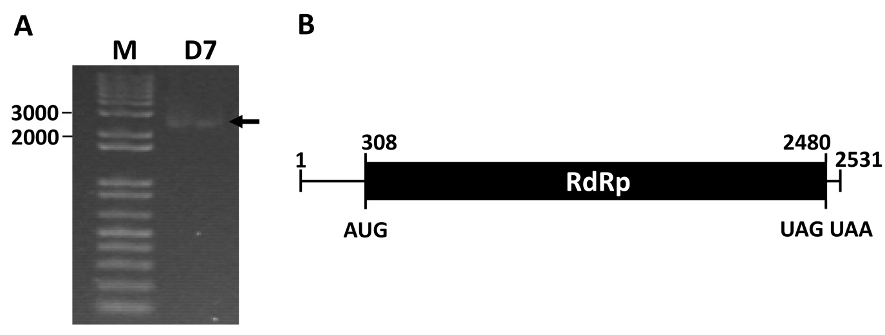
Figure 1: (A) Agarose gel electrophoresis of dsRNA associated with Sclerotinia sclerotiorum isolate D7. M: 1 kb plus marker. (B) Schematic representation shows the genome organization of the (+) strand of Sclerotinia sclerotiorum mitovirus 1 (SsMV1-D7).

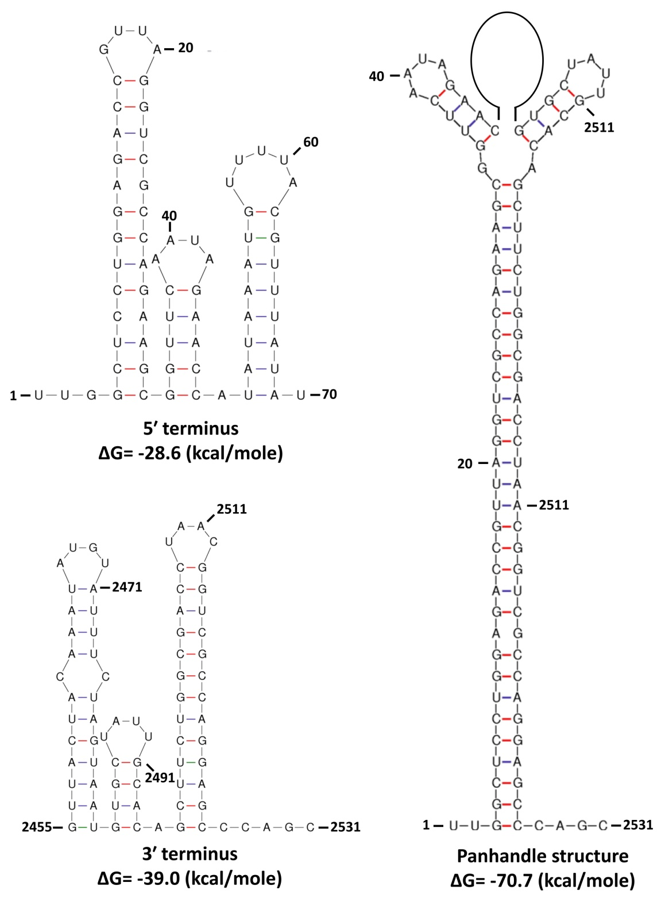
Figure 2: Potential secondary structures formed by the complementary sequences of the 5' and 3' terminal sequences of Sclerotinia sclerotiorum mitovirus 1 (SsMV1-D7) (+) strand. Secondary structures were predicted and ΔG values calculated using MFOLD software.

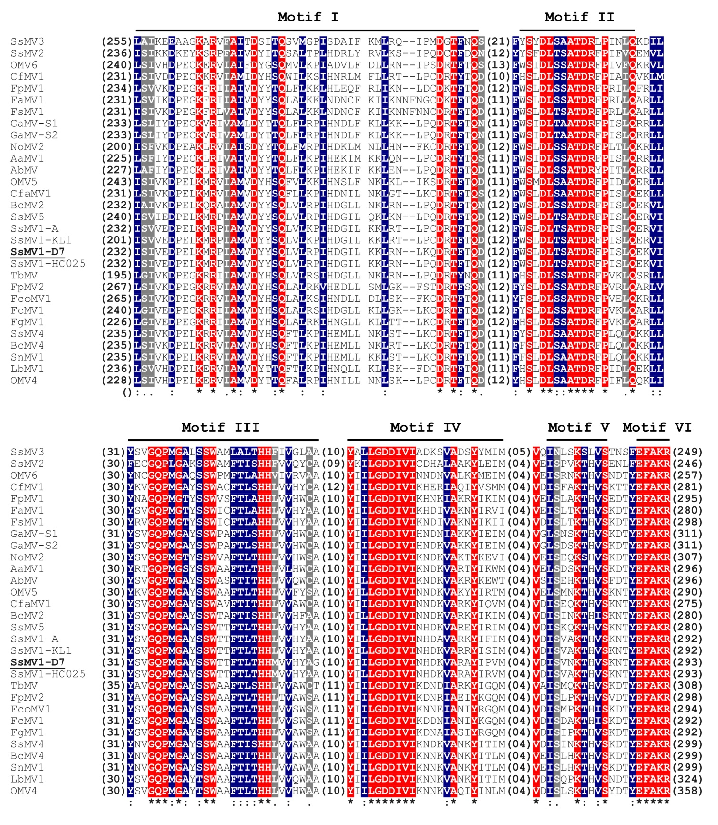
Figure 3: Amino acid (aa) sequence alignments of RNA-dependent RNA-polymerase (RdRp) sequences of Sclerotinia sclerotiorum mitovirus 1 (SsMV1-D7) and other members of Mitoviridae. Identical residues are indicated by asterisks “*”, whereas higher and lower chemically similar residues are indicated by colons “:” and dots “.”, respectively. Conserved motifs (I-VI) of RdRps of mitoviruses are indicated. Virus notations are as shown in Table 1.
Table 1: Percent amino acid (aa) sequence identity (RdRp) between Sclerotinia sclerotiorum mitovirus 1 (SsMV1-D7) and other members of the genus Mitovirus.
Mitovirus | Acronym | Identity (%) | GenBank Accession No.
Alternaria arborescens mitovirus 1 | AaMV1 | 35.22 | BAV53122
Alternaria brassicicola mitovirus | AbMV | 40.80 | AKN79252
Botrytis cinerea mitovirus 1 | BcMV1 | 29.88 | ABQ65153
Botrytis cinerea mitovirus 2 | BcMV2 | 64.73 | CEZ26301
Botrytis cinerea mitovirus 4 | BcMV4 | 39.81 | CEZ26303
Colletotrichum falcatum mitovirus 1 | CfaMV1 | 46.02 | AZT88621
Colletotrichum fructicola mitovirus 1 | CfMV1 | 38.17 | BBN51032
Cryphonectria cubensis mitovirus 1a | CcMV1a | 40.52 | AAR01970
Fusarium andiyazi mitovirus 1 | FaMV1 | 36.88 | QIQ28426
Fusarium circinatum mitovirus 1 | FcMV1 | 37.69 | AHI43533
Fusarium coeruleum mitovirus 1 | FcoMV1 | 36.85 | BAQ36630
Fusarium globosum mitovirus 1 | FgMV1 | 37.38 | BAQ36629
Fusarium poae mitovirus 1 | FpMV1 | 34.44 | BAV56289
Fusarium poae mitovirus 2 | FpMV2 | 35.23 | BAV56290
Fusarium sacchari mitovirus 1 | FsMV1 | 37.50 | QIQ28428
Gremmeniella abietina mitovirus S1 | GaMV-S1 | 37.41 | AAN05635
Gremmeniella abietina mitovirus S2 | GaMV-S2 | 37.76 | AAT48883
Helicobasidium mompa mitovirus 1-18 | HmMV1-18 | 34.68 | BAD72871
Leptosphaeria biglobosa mitovirus 1 | LbMV1 | 42.67 | AVZ65960
Nigrospora oryzae mitovirus 2 | NoMV2 | 33.53 | AZP53929
Ophiostoma mitovirus 3a | OMV3a | 28.64 | CAA06228
Ophiostoma mitovirus 3b | OMV3b | 28.84 | CAJ32468
Ophiostoma mitovirus 4 | OMV4 | 41.19 | CAB42652
Ophiostoma mitovirus 5 | OMV5 | 41.35 | CAB42653
Ophiostoma mitovirus 6 | OMV6 | 35.71 | CAB42654
Sclerotinia homoeocarpa mitovirus | ShMV | 27.70 | AAO21337
Sclerotinia nivalis mitovirus 1 | SnMV1 | 39.34 | ANJ77669
Sclerotinia sclerotiorum mitovirus 1-A | SsMV1-A | 78.56 | AWY10961
Sclerotinia sclerotiorum mitovirus 1-HC025 | SsMV1-HC025 | 91.84 | AHX72146
Sclerotinia sclerotiorum mitovirus 1-KL1 | SsMV1-KL1 | 79.19 | AEX91878
Sclerotinia sclerotiorum mitovirus 2 | SsMV2 | 33.04 | AHX84129
Sclerotinia sclerotiorum mitovirus 3 | SsMV3 | 31.41 | AGC24232
Sclerotinia sclerotiorum mitovirus 4 | SsMV4 | 41.54 | AGC24233
Sclerotinia sclerotiorum mitovirus 5 | SsMV5 | 74.31 | AHX84130
Thielaviopsis basicola mitovirus | TbMV | 40.26 | AAZ99833

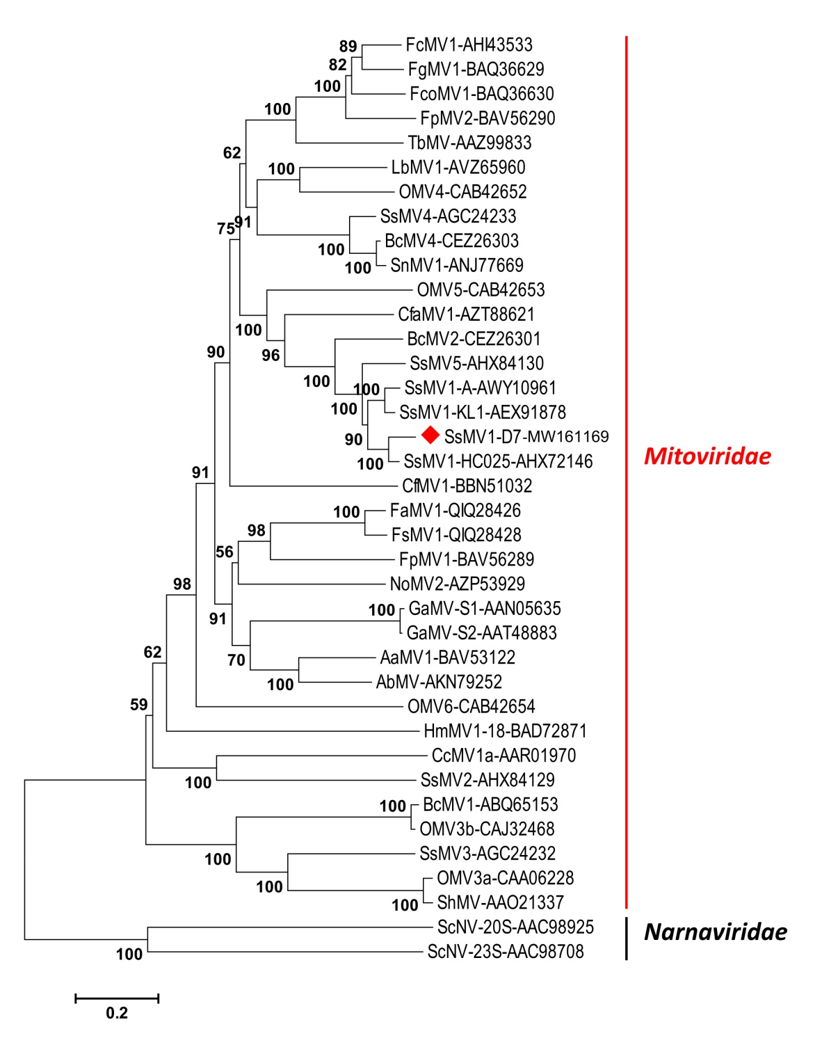
Figure 4: Neighbor-joining phylogenetic tree based on multiple alignments of RNA-dependent RNA-polymerase (RdRp) aa sequences of Sclerotinia sclerotiorum mitovirus 1 (SsMV1-D7) and other mitoviruses. Sequences of two members of Narnaviridae were used as outgroup. The tree was displayed using MEGA 5 software using Poisson model. Values on the branches represent the percentage of 1000 bootstrap replicates. Virus notations are as shown in Table 1. ScNV-20S and ScNV-23S are abbreviations for Saccharomyces cervisiae 20S narnavirus and Saccharomyces cervisiae 23S narnavirus, respectively.

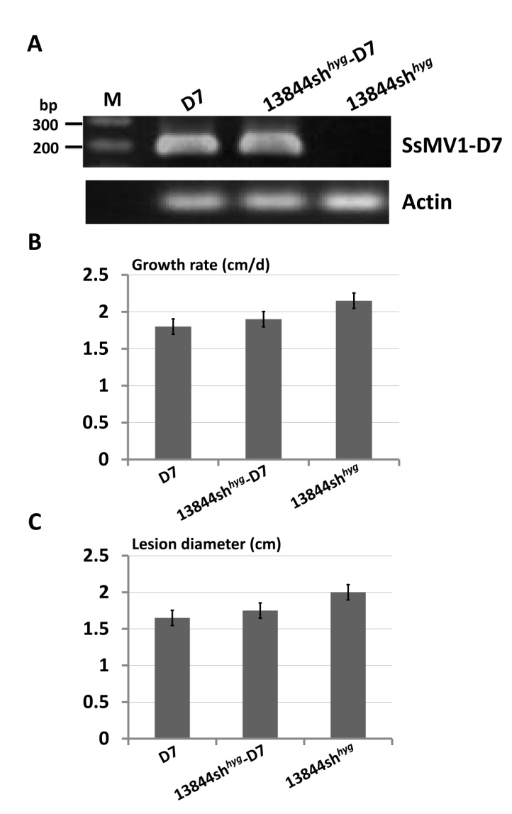
Figure 5: (A) RT-PCR detection of Sclerotinia sclerotiorum mitovirus 1 (SsMV1-D7) and actin gene of Sclerotinia sclerotiorum in different fungal isolates. (B) Growth rate and (C) lesion diameter assessments of virus-free and virus-containing isolates.

