Effect of Bio- and Nano-fertilization and growing media on the essential oil production and chemical constituents in Pelargonium graveolens L. plants
Atef Z. Sarhanª, Khaled A. Emam^{b}, Aya Magdy^{a**}, Ahmed A. El-Tantawyª
ª Ornamental Horticulture Dept., Faculty of Agriculture, Cairo University, Giza, Egypt
^{b} Horticulture Research Institute, Agricultural Research Center, Giza, Egypt
**Corresponding author: ayamagdy3394@gmail.com
Abstract
The aim of this research is the studying effect of three types of bio-fertilization (Nitrobine, Phosphorine, Potasine) and foliar application of NPK-nano-fertilization on the chemical composition of Pelargonium graveolens L.,plants grown in two types of soil mixture; sandy soil + compost (SC) and loamy soil + compost (LC) to achieve the desirable essential oil productivity and finding the best fertilization treatment safe for the environment. The results revealed that the highest values of chlorophyll a, b and carotenoids and essential oil percentage were obtained from the treatments of Nitrobine at the rate of 0.05gm for plants grown in the SC and Phosphorine at the rate of 0.05gm for plant grown in the LC, respectively followed by the nano-fertilization treatments 50ppm for plant grown in the LC. The main constituents of the oil were found to be. B-linalool (7.48%) resulted from Nitrobine at 0.05gm for plant grown in the SS treatment. Citronellol (26.76%) resulted from Nano-fertilization at 50ppm for plant grown in the LC. Geraniol (30.44%) resulted from phosphorene at 0.05gm for plant grown in the LC and I-menthone (11.51%) resulted from nano-fertilization at 50ppm for plant grown in the LC. These results referred the importance of bio and nano-fertilization, and reflects the importance of the interaction between fertilizer concentrations and soil mixture. The comparison between first and second cuts in the two seasons showed the effect of environmental conditions on essential oil constituents, as these findings can help the plant growers to detect the suitable time for harvesting geranium plants.
Keywords: Pelargonium graveolens - Bio-fertilizer- NPK Nano-fertilizer - Chlorophyll a, b – Carotenoides - Essential oil.
Introduction
Pelargonium Gravolens, L., belonging to the family Geraniaceae, is a perennial herbaceous plant cultivated for medicinal and ornamental purposes (Abd El-Kafi et al., 2014). It is widely cultivated in Egypt as a source of essential oil which is obtained by steam distillation of the herb either immediately after harvest, or after 24 hours to reduce volume and release the oil from the pesticide form of the glycoside. A maximum content of 0.4% can be obtained from weeds harvested before and during flowering (Fleisher and Fleisher, 1985). The volatile oil of geranium plants contains citronellol (40-43%), geraniol (8-9%), 10-epi-𝛾-eudesmol (6-7%), citronyl formate (7-8%), geranyl formate (1- 2 %) and isomenthone (6-7%) as the main components (Gupta et al., 2016). Global production of geranium oil is about 500-750 tons per year (Gupta et al., 2016). Previous scientific reports interested in rose-scented geranium essential oils and organic extracts have shown antioxidants, and anti-inflammatory (Ćavar and Maksimović, 2012; Ghanizadeh et al., 2015). Pelargonium gravolens oil is widely used in a high class of perfumes, soaps and cosmetics due to its pronounced and lasting rose-like scent due to its rhodinal content. Pelargonium gravolens oil is also used in aromatherapy (Mishra et al., 2010). Plant nutrition affects positively plant growth and development leading to increases in herb and essential oil production. Nitrogen, phosphorus and potassium are the most important plant nutrients. Nitrogen is incorporated in proteins molecules that build plant tissues and promotes growth and production. Phosphorus helps in transportation and to assimilation of nutrients; it is responsible for energy storage and many vital roles. Potassium is associated with retention of water, nutrients, and carbohydrates in plant. It improves plants tolerance to stresses, pests and diseases and participates in the development of flowers and seeds. Previous researches pointed out that NPK increased growth and production of many aromatic plants such as Foeniculum vulgare, and Mentha longifolia and Matricaria chamomilla (Tanious, 2008; Hendawy and Kalid, 2011).
Chemical fertilizers, play an important role in increasing the yield of agricultural crops (Chaudhary et al., 2017) and the impressive results achieved by adding these fertilizers led to their excessive use. This has caused many environmental problems such as water pollution, soil fertility deterioration, high levels of heavy metals, and low biodiversity followed by a severe reduction in yield in addition to negative effects on human health (Arora, 2018). At the same time, there is still an urgent need to increase agricultural production to feed 70% of the world's population and provide them with appropriate medicines to treat many diseases and epidemics (Mandal and Lalrinchani, 2021). Several investigations related to long-term experiments with the use of chemical fertilizers and their effects on the production of active substances from medicinal and aromatic plants have been published.
Nanotechnology science refers to manipulating and control of matter at nano scale (at range 1-100 nm), where a unique phenomenon enables novel applications (Bhushan, 2017). Nanoparticles (NPs) and nanotechnology have been used significantly in the horticulture field as bio stimulators that improve growth, plant propagation, productivity, development, and health in the form of agrochemicals, use in the genetic engineering of plants, the bioremediation of contaminated soil, and improving plant tolerance to stress (Manzoor et al., 2020). The mechanism of nanoparticle action is due to the fact that NPs can easily enter plant cells by the stomata and trichomes because they have fewer diameters smaller than the diameter of pores of the cell wall, then transferred to other plant parts by the transfer tissues (Kamiab et al., 2017). Therefore, over the past decade, great efforts have been made to replace chemical fertilizers with bio- and nano-fertilizers that are environmentally friendly and less harmful to human health (Davarpanah et al., 2016; Mikhak et al., 2017).
Bio-fertilizers are microbial inoculants consisting of living cells of microorganisms. They play a very important role in improving soil fertility by fixing atmospheric nitrogen, both in combination with and without plant roots, dissolving insoluble soil phosphate and producing plant growth materials in the soil; This is in addition to its effective role in making plants more tolerant to drought and salinity stress in arid and semi-arid regions (Kumar et al., 2022). Bio-fertilizers have become a very compelling alternative when compared to chemical fertilizers because they are easy to apply, non-toxic, environmentally friendly and cost-effective in nature. In the recent past, medicinal plant research has mainly focused on the evaluation of bioactive plant molecules. However, there is little information on the effect of microbes on essential oil quality and antioxidant status of plants. Another type of fertilizer that has been used recently is nano-fertilizer, which is the nutrient for plants in the form of nano-granules. Nanomaterials usually have a role in the slow release of fertilizers, as the nanoparticles preserve the fertilizer very strong due to higher surface tension than conventional surfaces (Solanki et al., 2015), and thus they solve the problem of nutrients loss and runoff survivors that pollute the environment (Wilson et al., 2008). The applications of using nano-fertilizers in agricultural fields are numerous and varied, provided that investigations on the behavior and safety of these fertilizers are completed (El-Ghamry et al., 2018). Due to the role of nanomaterials as a catalyst for secondary metabolism, they can be used as new effective abiotic additives in plant biotechnology to stimulate the biosynthesis of secondary metabolic products (Al-Rekaby and Atiyah, 2020), including essential oil. Nanofertilization applications have been done on the cultivation of medicinal and aromatic plants as in sweet basil (Ocimum basilicum L), treatment with F₃O₄ showed that nanoparticles improved plant growth (Mandal and Lalrinchani, 2021; Elfeky et al., 2013), while treatment with a moderate rate of integrated nano-fertilizer (NPK) showed good results in leaf traits (Alhasan, 2020). Also, nano-fertilizers were treated in Crocus sativus using nano iron, phosphorous and potassium (Amirnia, 2014), Matricaria chamomilla L. by nano-zeolite treatment (Mikhak et al. 2017), and Mentha piperita L. by iron. Zinc and potassium nanoparticles (Hassani and Tajalli ,2015).
In Pelargonium graveolens L. plants, bio- and nano-fertilizers were used in previous research. It has been shown that treating the plant with bacterial chains of tannery sludge led to an increase in the uptake of heavy metals with an increase in the essential oil content and vegetative and root growth (Gupta et al., 2016; Dharni et al., 2014). Mishra et al. (2010) found that treatment of geranium plant with rhizomes leads to an increase in the proportion of essential oil, biomass of leaves and roots, and flavonoid contents (Riahi et al., 2020). As for the nano-fertilization, the role of nano-fertilization has been recently studied and it was found that it has the ability to improve the vegetative and root growth of the plant in addition to a significant increase in the chemical content (Osman and Adil, 2022). However, studies on the use of nano-fertilizers on the geranium plant are still limited. This study aims to know the use of bio-fertilizers and some nano-fertilizers as an alternative to traditional mineral fertilizers to increase the proportion of essential oil and improve its properties in Pelargonium gravolens L. plants.
Materials and Methods
Plant materials and growth conditions
This study was carried out in the open field of Ornamental Horticulture Department Nursery, Faculty of Agriculture, Cairo University, Giza, Egypt during the two successive seasons of 2019 and 2020. Rooted cuttings of Pelargonium graveolens L. were transplanted into 20 cm diameter pots filled with eight kg of the growing media. After that, the plants were kept in the open field for 10 months per season (starting from March 1st until the end of December) with regular irrigation according to their need until 24 h before starting the treatments.
Growing media
Two mixtures of growing media were tested in this study along with the fertilization treatments which were loam + compost (LC) at the rate of 1: 1 and sand + compost (SC) at the rate of 1: 1. Average total weight for the growing medium was 8.5and 9 kg, respectively. The physical and chemical components are shown in Table 1, 2.
Bio-fertilizers used
Commercial bio-fertilizers were provided by Agricultural Research Center, Giza, Egypt. Three bio-fertilizers, Nitrobine, Potasine, and Phosphorine, were mixed with the growing media at the rate of 1 or 0.05 g per/pot before transplanting the plants. The effective microorganisms of each bio-fertilizer are shown in Table 3.
Nano-fertilizer preparing, structure of the studied nano-fertilizer, and treatments
Chitosan (MW 71.3 kDa, degree of deacetylation (89%) was purchased from Aldrich (Germany). All reagents were of analytical grade from precursor Potassium persulfate (K2S2O8) and methacrylic acid were purchased from Aldrich (Germany). Calcium phosphate (Ca (H₂PO₄)₂·H₂O), salt NH₄NO₃, urea (CO (NH₂)₂) and potassium chloride KCl were purchased from Sigma Chemical Co. (St. Louis, USA).
Nanoparticles were obtained by (Top to bottom molecular chemical approach method under pressure 2 Mpa.) polymerizing methacrylic acid in chitosan solution as carrier coated in buffer solution for 5 hours at room temperature in two-steps processes. In the first step, 0.23 g chitosan was dissolved in methacrylic acid aqueous solution (0.5%, v/v) for 18 h under magnetic stirring. In the second step, with continued stirring, 0.2 mmol of K₂S₂O₈ was added to the solution, until the solution became clear. The polymerization was subsequently carried out at 75°C under magnetic stirring for 4 h which leads to the formation of nanoparticle solution, then centrifuged at 500 rpm for 30 minutes, which was thereafter cooled in an ice bath. The sources of N, P and K used were used separately. The loading of N fertilizers in Chitosan nanoparticles was obtained by dissolving of 2M N into 100 ml of chitosan nanoparticle solution under magnetic stirring for 8 h at 25°C. Subsequently dried at 50 C for 72 h. The following concentrations: i) 1000 ppm of N; ii) 1000 ppm of P and iii) 1000 ppm of K were finally obtained in each solution. The resulting solutions had a pH of 5.5. The particles were uncontrolled in shape with a size range of 17.5 nm for nitrogen, 16.1 nm for phosphorous, and 15.2 nm for potassium with crystal structure and 98.5% purity (Figure 1).
The morphology and size of the nanoparticles were investigated using a JEOL 1010 transmission electron microscope at 80 kV (JEOL, Japan). One drop of the nanoparticle solution was spread onto a carbon-coated copper grid and was subsequently dried at room temperature for transmission electron microscopy (TEM) analysis. The sizes of the nanoparticles were determined directly from the figure using an Image-Pro Plus 4.5 software. The value is an average size of three parallels. The prepared NPK-nanofertilizer, which was in concentration1000 ppm, was applied in the growing medium every 15 days during one season at the rate of 50 and 100 ml/liter of water.

Experimental design
The experiment was conducted in two seasons (2019 – 2020) starting from March 1st 2019 until the end of December 2019 as a first season, and starting from March 1st 2020 until the end of December 2020 as a second season, with the aim of knowing the effect of two growing media types with different levels of bio-fertilizer, and nano-fertilizers to Pelrgonium graveolens L. plants. The plants were cut two times per one season, firstly at the end of may, whereas secondly was in the end of August remaining 20 cm of the plants.
randomized completely blocks design (RCBD) was adapted to a factorial experiment consisting of two factors and three replicates (2 × 8 × 3). The first factor is two types of growing media, whereas the second factor is 8 levels of fertilization treatments, bio-fertilizer treatments were performed at 6 levels of Nitrobine, Phosphorine, and Potasine at the rate of 1 and 0.05 g/pot, respectively, while, the nano-fertilizer treatments were done with two levels at concentrations of 50 and 100 ml/l water (v/v), and three replicates for each treatment distributed randomly in block and became the total units experimental were (2 × 8 × 3 = 48).
Essential oil determination
The essential oil determination was performed in Medicinal and Aromatic Plants Researches Department, Pharmaceutical and Drug Industries Research Division, in National Research Center, Giza, Egypt. For each studied treatment, plant material was placed in a 2-liter round bottomed flask with distilled deionized water (400 ml for 200g fresh herb) and the volatile oil was extracted by water distillation using a modified Clevenger trap. For smaller fresh plant sample, the distillation period was one hour and the volatile oil content was determined on an oil volume to tissue weight.
GC-MS analysis
This experiment was done in Medicinal and Aromatic Plants Researches Department, Pharmaceutical and Drug Industries Research division, in National Research Center, Giza, Egypt. The chemical constituents of the essential oil for samples of each treatment were analyzed using gas chromatographic (GC). The use of GC in the quantitative determinations was performed using the methods described by Mihajlov-Krstev et al. (2011). GC-MS technique was used to separate and detect the volatileoil constituents. Analysis was performed at the Department of Medicinal and Aromatic Plants Research, National Research Center . Qualitative identification of the different constituents was performed by comparison of their relative retention times and mass spectra with those of authentic reference compounds.
The GC-MS analysis of the samples was carried out using gas chromatography-mass spectrometry instrument stands at the Department of Medicinal and Aromatic Plants Research, National Research Center with the following specifications. Instrument: a TRACE GC Ultra Gas Chromatographs (THERMO Scientific Corp., USA), coupled with a THERMO mass spectrometer detector (ISQ Single Quadrupole Mass Spectrometer). The GC-MS system was equipped with a TG-WAX MS column (30 m x 0.25 mm i.d., 0.25 μm film thickness). Analyses were carried out using helium as carrier gas at a flow rate of 1.0 ml/min and a split ratio of 1:10 using the following temperature program: 60 oC for 1 min; rising at 3.0 oC /min to 240 oC and held for 1 min. The injector and detector were held at 240 oC. Diluted samples (1:100 hexane, v/v) of 1 μL of the mixtures were always injected. Mass spectra were obtained by electron ionization (EI) at 70 eV, using a spectral range of m/z 40-450. Most of the compounds were identified using the analytical method: mass spectra (authentic chemicals, Wiley spectral library collection and NSIT library).
Chlorophyll and carotenoid determination
Chlorophyll measurement was performed using of N,N-Dimethylformamide method as described by Moran (1982). Extraction was done by immersing the leaves in N,N-Dimethylformamide. After that, the samples were transferred to the laboratory of Horticultural Research Institute, in Agricultural Research Center, Giza, Egypt. Spectrophotometric measurements were performed by means of CENTRAL LAB model 630 UV-VIS scanning spectrophotometer, calibrated at 703 nm, using the 1.5 nm band width measuring beam. After that, conversion of the chlorophylls and carotenoids to their acidic derivative was done as described by Lichtenthaler and Buschmann (2001) using this formula:
Chl_{a} (µg/ml) = 13.36 A_{664.1} – 5.19 A_{648.6}
Chl_{b} (µg/ml) = 27.43 A_{648.6} – 8.12 A_{664.1}
C_{(x+c)} (µg/ml) = (1000 A₄₇₀ – 2.13 c_{a} – 97.64 c_{b})/ 209
Where Chl is the chlorophyll, C is the carotenoids, whereas A is the absorption recorded at the individual wavelength, expressed in OD units.
Statistical analyses
The data were subjected to statistical analysis according to Snedecor and Cochran (1969) using MSTAT-C which the variance was analyzed by ANOVA two factors followed by Duncan’s multiple range test. The significant differences between mean values were determined at the level of P ≤ 0.05.
Results
Essential oil percentage
- Differences among all treatments
Concerning all treatments, we observed that treatments with Phosphorine bio-fertilizer at concentration of 0.05 g/pot in the mixture of loamy soil + compost (LC). gave the highest percentage of volatile oil which recorded 2.73 and 1.87 % at the first and second cut, respectively during first season and recorded 2.68 and 1.98 % at the first and second cut, respectively during second season (Table 4). followed by treatment with NPK nano-fertilizer at concentration of 50 ppm in LC soil. which recorded 2.00 and 1.57 % at the first and second cut, respectively during first season and recorded 2.01 and 1.78 % at the first and second cut, respectively during second season. While, the treatment with Nitrobine at the rate of 1 g/pot in LC soil recorded the lowest value after control (0.60 and 0.45 % during first season, and 0.57 and 0.58 % during second season) as shown in Table 4.
For comparative study between sandy and loamy soil mixture, the produced essential oil percentage was recorded from Pelargonium graveolens herbs after cutting two times. Data presented in Table 4 show that the plants grown in the mixture of sandy soil + compost (SC) gave higher percentage of volatile oil in the first and second cut during the first season (1.47 % and 1.08 %) compared with the percentage of produced oil from the plants grown in LC soil (1.31 % and 0.98 %). At the second season, the mean values of the essential oil percentage were 1.37 and 1.16 % for the sandy soil and 1.34 and 1.09 % in the first and second cut, respectively.
Worthy to note that differences between the efficiency of the mixture of SC and LC soils are dependent on the fertilization treatments. Significant differences (P value ≤ 0.05) were found in all fertilization treatments between sandy and loamy soils with the treatments of Nitrobine at 1 and 0.05 g/pot, Phosphorine at 0.05 g/pot, and NPK nano-fertilizer at 100 ppm at the first cut, whereas at the second cut, significant differences were found between sandy and loamy soils except the treatments of control, and NPK nano-fertilization at 50 ppm. During second season, similar results were found at the first cut except for the treatment with Potasine at 1 and 0.05 g/pot, NPK nano-fertilizer at the rate of 100 ppm. At the second cut, we found significant differences between sandy and loamy soils with the treatments of NPK nano-fertilizer at the rate of 100 ppm.
- Comparison between first and second cuts
We observed that the second cut, which was performed at the end of July, showed higher volatile oil percentage compared with the first cut, which was performed at the end of May, indicating the role of the temperature changes in the essential oil quantity. In the mixture of SC soil, significant differences (P value ≤ 0.05) between first and second cut in both two seasons were observed. No significant differences were observed in control, Nitrobine at 1 g/pot, Potasine at 1g/pot, and Potasine 0.05 g/pot in the first and second season. In the mixture of LC soil, significant differences (P value ≤ 0.05) between first and second cut in both two seasons were also observed except control, Nitrobine 1g/pot, Phosphorine 1 g/ pot, and Potasine 1g/pot (Table 4).
Essential oil constituents
The total ion chromatogram recorded by GC–MS of the P. graveolens essential oil and the total chemical composition are shown in Table 5, which contained 32 identified compounds. Control treatment recorded the lowest percentage of the essential oil chemical constituents (Figure 2). The treatment with nitrobeine 0.05g /pot in SC soil gave the best result as shown in Figure 3, The main constituents of the essential oil were citronellol (12.44%), geraniol (26.96%), b-Linalool (7.48%), I-menthone (7.58%), citronellyl formate (6.94%), geraniol formate (6.45%), (-)-b-Brurbonene (0.92%) and geranyl tiglate (2.61%). The second-best result was recorded with the treatment of Phosphorine 0.05g/pot in mixture of LC soil as shown in Figure 4, The main constituents of the essential oil were citronellol (12.56%), geraniol (30.44%), b-Linalool (3.87%), I-menthone (4.79%), citronellyl formate (0.59%), geraniol formate (9.90%), (-)-b-Brurbonene (1.21%) and geranyl tiglate (3.64%). The treatment of Potasine 0.05g/pot in LC soil recorded as the third best result as shown in Figure 5, The main constituents of the essential oil were citronellol (11.52%), geraniol (27.23%), b-Linalool (1.98%), I-menthone (7.60%), citronellyl formate (8.21%), geraniol formate (7.85%), (-)-b-Brurbonene (1.39%) and geranyl tiglate (4.41%). The treatment with NPK nano-ferilizer 50 ppm/pot in the mixture of LC soil ranked as the fourth best treatment in respect of percentages of the chemical constituents as shown in Figure 6, The main constituents of the essential oil were citronellol (26.76%), geraniol (18.93%), b-linalool (1.7), I-menthone (3.1%), citronellyl formate (22.25%), geraniol formate (4.75%), (-)-b-brurbonene (0.38%) and geranyl tiglate (2.0%).
Chlorophyll and carotenoids content
Data presented in Table 6 showed clearly that the plants grown in SC soil. and the mixture of LC soil produced the lowest record in chlorophyll a, chlorophyll b, and carotenoids in non-fertilized plants (control), while the plants grown in sandy soil gave the highest record when it was inoculated with Nitrobine at the rate of 0.05 g/pot in both first and second seasons, whereas the best result was given by the mixture of LC soil. when treated with Phosphorine at the rate of 0.05 g/pot which also recorded the highest value in all fertilization treatments in both first and second seasons. Nano-fertilizer treatments recorded as a second level after Phosphorine bio-fertilizer treatments which Nano-NPK fertilizer treatment at the concentration of 50 ppm gave higher record compared with the fertilization ate the concentration of 100 ppm.
Discussion
Bio- and nano-fertilizers are among the most important tools in modern agriculture and agro-food as well as being an economic driving force in the near future. Also, bio- and nano-fertilizers play as promising ways to increase the efficiency of the use of various water and soil resources, as well as reduction of the environmental pollution. So, environmentally friendly methods may provide alternatives to chemical fertilizers (El-Ghamry et al., 2018). Hence, using these fertilizers lead to sustainable agriculture by reducing inputs and generating less waste, and minimizing nutrient loss by releasing at a rate appropriate to plant demand compared to conventional agriculture. There is very little difference between bio-fertilizers and nano-fertilizers depending on their mechanisms in soil and plant, methods of application, effective application rates as well as their impact on the environment. However, both nano- and bio-fertilizers, and their interaction are required for further studies. Therefore, this work is focusing on new insights and comparison between nano- and bio-fertilizers.
It is important to use nano- and bio-fertilizers for increasing the production of active substances in the medicinal plants, because cultivation in a habitat other than their origin, as the environmental and soil conditions is very different which may not be suitable for the plant growth. Therefore, this study aims to find out the effect of nano- and bio-fertilizers on the production of the active component of Pelargonium graveolens L. plants that is measured by GC.

Essential oil yield was increased with bio- and nano- fertilization treatments
Essential oil plays as a second metabolite in many aromatic plant species. Its quantity and quality is affected by many factors as we as the biotic and abiotic stresses. Like chemical fertilization, the bio- and nano- fertilizer treatments can stimulate the biosynthesis of the pharmaceutical compounds in the essential oil through the role of macro- and micro- nutrients in the plant physiological processes. In this work, we found that bio- and nano- fertilization increased the productivity of the essential oil compared with the control. Likewise, a variation among all our treatments was found which the bio-fertilizer Phosphorine, the source of phosphorus, in the mixture of loamy soil + compost showed the highest record followed by Nitrobine, the source of nitrogen, in the mixture of loamy soil + compost, the mixture of sandy soil + compost. The role of phosphorus and nitrogen in essential oil production has been studied in many researches. It has been reported that the accumulation of essential oil constituents is influenced by the nitrogen and phosphorus fertilizer treatments in Satureja montana L. (Said-Al Ahl and Hussien, 2016). Phosphorus is required for metabolic processes which can active the amino acid production (Kisko et al., 2018). Hence, phosphorus fertilization has ability to increase plant growth and essential oil yield in medicinal and aromatic plants. Moreover, it has been demonstrated that treatments with phosphorus nutrient produce high yield and good quality of essential oil in lavender (Erbaş et al., 2017), Agathosma betulina (De Villiers 2007). Also, phosphorus bio-fertilization increased the essential oil percentage in Majorana hortensis L. (El-Ghandour et al., 2009). In Pelargonium graveolens, high oil yield was obtained with increment of phosphorus concentrations (Sedibe and Allemann, 2012; Abd El-Kafee et al., 2014). In this work, the phosphorus bio-fertilization (Phosphorine) increased the essential oil percentage suggesting the crucial role of phosphorus nutrient in essential oil production and the possibility of use this type of fertilizer instead of the chemical form. Regarding the nano-fertilization, it has been indicated that nanoparticles have a key role in increase of biochemical activities and reactivity (El-Ansary and Faddah, 2010). It has been demonstrated that NPK nano-fertilizer has positive effects on essential oil yield in Ocimum basilicum (Elfeky et al., 2013; Alhasan, 2020), and Nigella sativa (Azizi and Safaei, 2016). Our results showed that NPK nano-fertilizer treatments increased the essential oil percentage in Pelargonium graveolens L. plants compared with control. In comparison between bio- and nano- fertilization, we found that fertilization with Phosphorine and Nitrobine gave higher recorded than in nano-fertilizer treatments. This result agrees with the findings of Hegab et al. (2018) who they tested the differences between bio- and nano- fertilization treatments in Salvia officcinalis L. plants. On the other hand, the treatments of NPK nano-fertilization gave higher percentage of essential oil than in Phosphorine in the mixture of sandy soil + compost, Nitrobine in the mixture of loamy soil + compost, and Potasine. Therefore, it could be observed similarities between bio- and nano- fertilizers in respect of essential oil production. Neverthless, there are some differences in the mechanisms and effectiveness of each other in the plant (El-Ghamry et al., 2018).
Influence of the bio- and nano-fertilization on essential oil production was dependent on soil type
Soil is the main source of providing the plants with essential nutrients and water as well as the vital functions of many terrestrial life forms which its microbes are very important to the different biogeochemical cycles of nutrients (Singh, 2015). Thus, soil components are essential for controlling the sustainability of this soil ecosystem by maintaining soil fertility as well as plant productivity including the essential oil components (Tuğrul, 2019). Roots are critical for bio- and nano-fertilizers which the beneficial aspects like plant nutrition and crop yield have effects on the biological state of these roots (Solanki et al., 2015). So, the effects of bio- and nano- fertilization on the percentage of essential oil in Pelargonium graveolens should be dependent on the soil type. In this work, we found that Phosphorine gave higher essential oil in the mixture of loamy soil + compost than in the soil mixture of sandy soil + compost indicating the presence of nitrogen element in the mixture of loamy soil + compost beside the phosphorus. Whereas, Nitrobine recorded higher essential oil percentage in the soil mixture of sandy soil + compost than in the mixture of loamy soil + compost suggesting that higher nitrogen element in the soil mixture of loam + compost produce lower essential oil yield. Also, Potasine treatment recorded higher essential oil in the mixture of loamy soil + compost than in the soil mixture of sandy soil + compost. indicating the importance of soil type selection before the fertilization treatment.
Concentration of the fertilizers has a key role in the essential oil productivity
It has been reported that high concentration of nitrogen fertilization reduces essential oil yield in creeping juniper (Juniperus horizontalis) (Robert and Francis, 1986). However, high N concentration increased the essential oil content in in thyme (Thymus vulgaris L.) (Baranauskiene et al., 2003) and in cumin (Cuminum cyminum) (Azizi and Kahrizi, 2008). Also, high concentration of phosphorus decreased the essential oil quantity of chamomile (Matricaria chamomilla L.) (Emongor et al., 1990) but increased in feverfew (Tanacetum parthenium L.) (Saharkhiz and Omidbaigi, 2008) and in sage (Salvia officinalis L.) (Nell et al., 2009). In this work, lower concentration of bio-fertilization (0.05 g/pot compared with 1 g/pot) and nano-fertilization (50 ppm compared with 100 ppm) gave better result compared with higher. It has been reported that nanoparticles and bio-fertilizers may be toxic to soil organisms and cultivated plants which both of them could be transported and uptake by plants causing the phytotoxicity (Vachan and Tripathi, 2017). Our results found that high concentration of bio- and nano- fertilizers gave lower percentage of volatile oil in Pelargonium graveolens indicating the toxicity of high rates of bio- and nano- fertilization.
Differences were found in the concentration of chemical constituents between bio-fertilizers and nano-fertilizers.
The essential oil of geranium is one the most important objects in the perfumery, food, cosmetic and pharmaceutical industries (Rao, 2002). The geranium oils are characterized by presence of citronellol, geraniol, isomenthone, linalool and wide range of esters such as geranyl formate, citronellyl formate, geranyl acetate and geranyl propionated (Gomes, 2007). The first two main oil compound (citronellol and geraniol) produced from same progenitor (geranyl pyrophosphate) but it is assumed that different enzymes produced these two alcohols. This could be the reason for variation in the content of citronellol and geraniol with respect to the employed treatments. Our results clearly indicated the superiority of the low concentration of bio-fertilizers that gave the highest percentages of the main constituents of essential oil composition (Citronellol, Geraniol, B-Linalool, I-menthone, Citronellyl formate, Geraniol formate, and geranyl tiglate) which is in an agreement with the findings of several scientists (Chand et al., 2011, Abdou et al., 2015, Alam et al., 2011, Shivani Negi et al., 2022). Also, the results of this research showed that the low concentration of Nano-fertilizer treatment gave high percentages of the essential oil constituents compared with the higher concentration. This result agreed with some previous investigations in other plant species (Ostadi et al., 2020 on Mentha x piperita L., Elsayed et al., 2021 on Rosmarinus officinalis L. plants, Bahmanzadegan et al., 2022 on Zataria multiflora, Mohammadghasemi et al., 2020 on Lallemantia iberica).
Photosynthetic pigments were increased with bio- and nano- fertilization treatments
As we mentioned before, bio- and nano-fertilization treatments increased chlorophyll and carotenoid contents in Pelargonium graveolens plants. The beneficial effects of fertilization treatments on our plants are achieved by increasing cellular chlorophyll biosynthesis. The first observation of photosynthetic pigments increment was found after foliar fertilizer application by converting the leaf’s color to dark green (Pflugmacher et al., 2006). Bio-fertilizer treatments enhanced the photosynthesis in leaves with a synthesis of sucrose that is rapidly transported to the root and released into their rhizosphere (Trevisan et al., 2010). Generally, the fertilization treatments increase the cellular activity and respiration involved in an increase in the absorption of water through the vascular system in response to the increased water demand of the leaves. The increased amount of water through the vascular system leads to the nutrient supply of the plant (via vascular system) (Pflugmacher et al., 2006). In this work, we observed that Bio-fertilizer treatments increased the photosynthetic pigments. Similarly, many investigations proved that chlorophyll a, b, and carotenoid increased with bio-fertilizers in many plant species, for example, but not limited, Moringa oleifera (Mazher et al., 2014), and Cupressus sempervirens (Youssef and Gharib, 2013). Regarding the high records of the treatment with Phosphorine bio-fertilizers, it was reported that large amount of phosphorus has significant increment in chlorophyll a, b and carotenoids (Figas et al., 2016 in Helichrysum arenarium; Makhlouf et al., 2020 in Beta vulgaris var. saccharifera; Emara and Abd El-All, 2017 in cotton). Phosphorus has a key role in the improvement of photosynthesis (Bisht and Chandel, 1991), therefore, it can act as a way to influence the growth of the key enzyme of photosynthesis – carboxydismutase (Rao and Terry, 1995; Pieters et al., 2001) and thereby the photosynthetic activity of the plant. Our results indicated the importance of Phosphorine application as a source of phosphorus in photosynthetic pigments in Pelargonium graveolens in the soil mixture of loamy soil + compost. Relatively, nano-fertilizers treatments gave good results compared with bio-fertilization treatments, except Phosphorine in the soil mixture of loamy soil + compost and Nitrobine in the mixture of sandy soil + compost. Recently, it has been found that high chlorophyll contents were observed in maize plants by treating with nano-fertilizers (Umar et al., 2020). Similarly, increases in chlorophyll contents were observed in Caesalpinia bonducella plants when nano-fertilizers were applied (Khalid et al., 2022).
Conclusions
In comparison between bio- and nano-fertilization, we found that bio-fertilizer treatment is the most recommended compared with NPK nano-fertilizers. Although that, this is not a final indicator to make this type of comparison as more investigations are needed to find the differences both fertilization in respect of phosphorus sources. Concerning the comparison between the first and second cut, we can consider that this study is to show the effect of the environmental conditions on the essential oil constituents. It is extremely important for the farmers and plant breeder to detect the best time for harvesting Pelargonium graveolens plants according to the target of this cultivation.
References
Abd El-Kafee, O.M., El-Mogy, E.E.A.M., Ashour, N.A.M.A. (2014). Response of Pelargonium graveolens L. plants to treatments of irrigation, chemical, organic and bio-fertilization under sandy soil conditions. J. Plant Production, Mansoura Univ., 5, 1345-1373.
Abdou, M.A.H., Ahmed, E.E.T., Ibrahim, T.I.E. (2015). Effect of nitrogen sources and ascorbic acid on growth and essential oil production of geranium (Pelargonium graveolens, L.) plants. Scientific J. Flowers & Ornamental Plants, 2, 157 – 165.
Alam, M., Abdul Khaliq, Abdul Sattar, Shukla, R.S., Anwar, M., Dharni, S. (2011). Synergistic effect of arbuscular mycorrhizal fungi and Bacillus subtilis on the biomass and essential oil yield of rose-scented geranium (Pelargonium graveolens). Archives of Agronomy and Soil Science, 57, 889-898.
Alhasan, AS. (2020). Effect of different NPK nano-fertilizer rates on agronomic traits, essential oil, and seed yield of basil (Ocimum basilicum L. CV Dolly) grown under field conditions. Plant archives, 20, 2959-2962.
Al-Rekaby, L.S., Atiyah, K.M. (2020). Effect of Nano and bio fertilizer on production of bioactive compounds of Solidago canadensis L. Journal of Physics: Conference Series, 1664, 1st International Virtual Conference on Pure Science 10th -11th June 2020, College of Science, University of Al-Qadisiyah, Iraq.
Amirnia, R., Mahdi, B., Tajbakhsh, M. (2014). Effects of nano fertilizer application and maternal corm weight on flowering of some saffron (Crocus sativus L.) ecotypes. Turkish Journal of Field Crop, 19, 158-167.
Arora, N.K. (2018). Agricultural sustainability and food security. Environmental Sustainability, 1, 217–219.
Azizi, K., Kahrizi D (2008). Effect of Nitrogen Levels, Plant Density and Climate on Yield Quantity and Quality in Cumin (Cuminum cyminum L.) Under the Conditions of Iran. Asian Journal of Plant Sciences, 7, 710-716.
Azizi, M., Safaei, Z. (2017). Effect of foliar application of humic acid and Nano fertilizer (Farmks®) on growth index, yield, yield components essential oil content and yield of Black cumin (Nigella sativa L.). Journal of Horticultural Science, 30, Pe671-Pe680.
Baranauskiene, R., Venskutonis, P.R., Viskelis, P., Dambrauskiene, E. (2003). Influence of nitrogen fertilizers on the yield and composition of thyme (Thymus vulgaris). Journal of Agriculture and Food Chemistry, 51, 7751-7758.
Bahmanzadegan, A., Tavallali, H., Tavallali, V., Karimi, M.A. (2022). Variations in biochemical characteristics of Zataria multiflora in response to foliar application of zinc nano complex formed on pomace extract of Punica granatum. Industrial Crops and Products, 187, 115369.
Bhushan, B. [Eds.] (2010). "Springer handbook of nanotechnology". Springer, Ohio, USA.
Bisht, J.K., Chandel, A.S. (1991). Effect of integrated nutrient management of leaf area index photosynthetic rate and agronomic and physiological efficiencies of soyabean (Glycine max.). Indian Journal of Agronomy, 36, 129-132.
Ćavar, S., Maksimović, M. (2012). Antioxidant activity of essential oil and aqueous extract of Pelargonium graveolens L’Her. Food Control, 23, 263-267.
Chand, S., Pandey, A., Anwar, M., Patra, D.D. (2011). Influence of integrated supply of vermicompost, biofertilizer and inorganic fertilizer on productivity and quality of rose scented geranium (Pelargonium species). Indian Journal of Natural Products and Resources, 2, 375-382.
Chaudhary, S., Dheri, G.S., Brar, B.S. (2017). Long term effects of NPK fertilizers and organic manures on carbon stabilization and management index under rice-wheat cropping system. Soil and Tillage Research, 166, 59-66.
Davarpanah, S., Tehranifar, A., Davarynejad, G., Abadía, J., Khorasani, R. (2016). Effects of foliar applications of zinc and boron nano-fertilizers on pomegranate (Punica granatum cv. Ardestani) fruit yield and quality. Scientia Horticulturae, 210, 57-64.
De Villiers, C.J. (2007). "The effect of phosphorus on the growth, plant mineral content and essential oil composition of buchu (Agathosma betulina)". Thesis (MsAgric) (Agronomy). University of Stellenbosch
Dharni, S., Srivastava, A.K., Samad, A., Patra, D.D. (2014). Impact of plant growth promoting Pseudomonas monteilii PsF84 and Pseudomonas plecoglossicida PsF610 on metal uptake and production of secondary metabolite (monoterpenes) by rose-scented geranium (Pelargonium graveolens cv. bourbon) grown on tannery sludge amended soil. Chemosphere, 117, 433-9.
El-Ansary, A., Faddah, L.M. (2010). Nanoparticles as biochemical sensors. Nanotechnology, science and applications, 3, 65–76.
Elfeky, S.A; Mohammed, M.; Khater ,M.S. Osman YA and Elsherbini E (2013). Effect of magnetite nano-fertilizer on growth and yield of Ocimum basilicum L. Intl. J. Indigenous Medicinal Plants, 46, 1286-1293.
El-Ghamry, A., Mosa, A., Alshaal, T., El-Ramady, H. (2018). Nanofertilizers vs. Biofertilizers: New Insights. Environment, Biodiversity and Soil Security, 2, 51-72.
El-Ghandour, I., Desouky, E., Galal, Y., Arafa, R., Abou Seer, A. (2009). Effect of biofertilizers and organic phosphorus amendments on growth and essential oil of marjoram (Majorana hortensis L.). Egyptian Academic Journal of Biological Sciences, G. Microbiology, 1, 29-36.
Elsayed, A.A.A., EL-Gohary, A, Taha, Z.K., Farag, H.M., Hussein, M.S., AbouAitah, K. (2021). Hydroxyapatite nanoparticles as novel nano-fertilizer for production of rosemary plants. Scientia Horticulturae, 295, 110851.
Emara, M., Abd El-All, A. (2017). Effect of Different Sources of Phosphorus and Boron on Chemical Composition and Water Relations in Leaves, Growth, Productivity and Quality of Egyptian Cotton. Journal of Plant Production, 8, 219-229.
Emongor, V.E., Chweya, J.A., Keya, S.O., Munavu, R.M. (1990). Effect of Nitrogen and Phosphorus on the Essential Oil Yield and Quality of Chamomile (Matricaria chamomilla L.) Flowers. East African Agricultural and Forestry Journal, 55, 261-264.
Erbaş, S., Kucukyumuk, Z., Baydar, H., Erdal, and Sanl A (2017). Effects of different phosphorus doses on nutrient concentrations as well as yield and quality characteristics of lavandin (Lavandula × intermedia Emeric ex Loisel. var. Super). Turkish Journal Of Field Crops, 22, 32-38.
Figas, A., Tomaszewska-Sowa, M., Sawilska, A., Bocian, K., Figas, A. (2016). Effect of phosphorus on the growth and photosynthetic pigments content of Helichrysum arenarium (L.) Moench plantlets in in vitro cultures. Nr III/1/2016, POLSKA AKADEMIA NAUK, Oddział w Krakowie, s. 697–704.
Fleisher, A., Fleisher, Z. (1985). Yield and quality of essential oil from Pelargonium graveolens cultivated in Israel. J. Sci. Food Agric., 36, 1047-1050.
Ghanizadeh, B., Shafaroodi, H., Asgarpanah, J., Sharifi, Z.N. (2015). The anti-inflammatory effect of Pelargonium graveolens methanolic extract in acetic acid-induced ulcerative colitis in Rat model. Clinical Therapeutics, 37, 0149-2918.
Gomes, P.B., Mata, V.G., Rodrigues, A.E. (2007). Production of rose geranium oil using supercritical fluid extraction. The Journal of Supercritical Fluids, 41, 50-60.
Gupta,,R., Singh, A., Pandey, R. (2016). Microbe-based technology ameliorates glandular trichomes, secondary metabolites and antioxidants in Pelargonium graveolens L'Hér. J Sci Food Agric. 96, 4151-9.
Hassani, A., Tajali, A.A. (2015). Studying the conventional chemical fertilizers and nano-fertilizer of iron, zinc, and potassium on the quantitative yield of the medicinal plant of peppermint (Mentha piperita L.) in Khuzestan. International Journal of Agriculture Innovations and Research, 3, 1078-1082.
Hegab, R., Abou Batta, W., El-Shazly, M. (2018). Effect of Mineral, Nano and Bio Nitrogen Fertilization on Nitrogen Content and Productivity of Salvia officinalis L. Plant. Journal of Soil Sciences and Agricultural Engineering, 9, 393-401.
Hendawy, S.F., Khalid, K.A. (2011). Effect of chemical and organic fertilizers on yield and essential oil of chamomile flower heads. Medicinal and Aromatic Plant Science and Biotechnology, 5, 43-48.
Kamiab, F.; Fahreji, S.S.; Bahramabadi, E.Z. (2017). Antimicrobial and Physiological Effects of Silver and Silicon Nanoparticles on Vase Life of Lisianthus (Eustoma grandiflora cv. Echo) Flowers. Int. J. Hort. Sci. Technol, 4, 135–144.
Khalid, U., Sher, F., Noreen, S., Lima, E.C., Rasheed, T., Sehar, S., Amami, R. (2022). Comparative effects of conventional and nano-enabled fertilizers on morphological and physiological attributes of Caesalpinia bonducella plants. Journal of the Saudi Society of Agricultural Sciences, 21, 61-72.
Kisko, M., Shukla, V., Kaur, M., Bouain, N., Chaiwong, N., Lacombe, B., Pandey, A.K., Rouached, H. (2018). Phosphorus Transport in Arabidopsis and Wheat: Emerging Strategies to Improve P Pool in Seeds. Agriculture, 8, 27.
Kumar, S, Diksha, Sindhu, S.S., Kumar, R. (2022). Biofertilizers: An ecofriendly technology for nutrient recycling and environmental sustainability. Current Research in Microbial Sciences, 3, 100094.
Lichtenthaler, H.K., Buschmann, C. (2001) Chlorophylls and Carotenoids: Measurement and Characterization by UV-VIS Spectroscopy. In: Wrolstad, R.E., Acree, T.E., An, H., Decker, E.A., Penner, M.H., Reid, D.S., Schwartz, S.J., Shoemaker, C.F. and Sporns, P., Eds., Current Protocols in Food Analytical Chemistry, John Wiley and Sons, New York, F4.3.1-F4.3.8.
Makhlouf, B., Gadallah, A., El-Laboudy, E. (2020). Effect of Phosphorus, Boron and Magnesium Fertilization on Yield and Quality of Sugar Beet Grown in a Sandy Soil. Journal of Plant Production, 11, 485-493.
Mandal, D., Lalrinchhani (2021). Nanofertilizer and its application in horticulture. Journal of Applied Horticulture, 23, 70-77.
Manzoor, A., Bashir, M.A., Hashmi, M.M. (2020). Nanoparticles as a preservative solution can enhance postharvest attributes of cut flowers. Italus Hortus, 27, 1–14.
Mazher, A.A.M., Abdel-Aziz, N.G., El-Dabh, R.S., El-Khateeb, M.S., Abd El-Badaie, A.A. (2014). Effect of Bio Fertilization on Growth and Constituents of Moringa oleifera Lam. Plants. Middle East Journal of Agriculture Research, 3, 793-798.
Mihajlov-Krstev, T.M., Kitic, D., Radnovic, D.V., Ristic, M.S., Mihajlovic-Ukropina, M., Zlatkovic, B.K. (2011). Chemical composition and antimicrobial activity of Satureja kitaibelii essential oil against pathogenic microbial strains. Natural Product Communications, 6, 1167-1172.
Mikhak, A., Sohrabi, A., Kassaee, M.Z., Feizian, M. (2017). Synthetic nanozeolite/nanohydroxy apatite as a phosphorus fertilizer for German chamomile (Matricaria chamomilla L.). Industrial Crops and Products, 95, 444-452.
Mishra, R.K., Prakash, O., Alam, M., Dikshit, A. (2010). Influence of Plant Growth Promoting Rhizobacteria (PGPR) on the Productivity of Pelargonium graveolens L. Herit. Microbiology, 2, 53-57.
Mohammadghasemi, V., Siavash Moghaddam, S., Rahimi, A. et al. (2021). The Effect of Winter Sowing, Chemical, and Nano-Fertilizer Sources on Oil Content and Fatty Acids of Dragon’s Head (Lallemantia iberica Fischer & C.A. Meyrefeer). J Plant Growth Regul, 40, 1714–1727.
Moran, R. (1982). Formulae for Determination of Chlorophyllous Pigments Extracted with N, N-Dimethyl formamide. Plant Physiology, 69, 1376–1381.
Nell, M., Vötsch, M., Vierheilig, H., Steinkellner, S., Zitterl-Eglseer, K., Franz, C., Novak, J. (2009). Effect of phosphorus uptake on growth and secondary metabolites of garden sage (Salvia officinalis L.). J. Sci. Food Agric., 89, 1090-1096.
Osman, A.S., Adil, A.M. (2022). The Role of Proline and Nano-Fert in Growth of Pelargonium (Pelargonium graveolens L.) Under Different Irrigation Period. East African Scholars Journal of Agriculture and Life Sciences, 4, 15-24.
Ostadi, A., Javanmard, A., Machiani, M.A., Morshedloo, M.R., Nouraein, M., Rasouli, F., Maggi, F. (2020). Effect of different fertilizer sources and harvesting time on the growth characteristics, nutrient uptakes, essential oil productivity and composition of Mentha x piperita L. Industrial Crops & Products, 148, 112290.
Pflugmacher, S., Pietsch, C., Rieger, W., Steinberg, C. (2006). Dissolved natural organic matter (NOM) impacts photosynthetic oxygen production and electron transport in coontail Ceratophyllum demersum. Science of Total Environmental, 357, 169-175.
Pieters, A., Paul, M.J., Lawlor, D.W. (2001). Low sink demand limits photosynthesis under P deficiency. Journal of Experimental Botany, 52, 1083-1091.
Rao, I.M., Terry, N. (1995). Leaf phosphate status, photosynthesis and carbon partitioning in sugar beet IV. Changes with time following increased supply of phosphate to low-phosphate plants. Plant Physiology, 107, 1313-1321.
Riahi, L., Cherif, H., Miladi, S., Neifar, M., Bejaoui, B., Chouchane, H., Masmoudi, A.S., Cherif, A. (2020). Use of plant growth promoting bacteria as an efficient biotechnological tool to enhance the biomass and secondary metabolites production of the industrial crop Pelargonium graveolens L'Hér. under semi-controlled conditions. Industrial Crops and Products, 154, 112721.
Robert, M.D., Francis, N.A. (1986). “Plant Physiology”. A division of Wadsworth Inc., Boston, USA, p. 786.
Saharkhiz, M.J., Omidbaigi, R. (2008). The effect phosphorus on the productivity of feverfew (Tanacetum parthenium (L.) Schultz Bip). Advances in Natural and Applied Sciences, 2, 63. Gale Academic.
Said-Al Ahl, H.A.H., Hussien, M.S. (2016). Effect of nitrogen and phosphorus application on herb and essential oil composition of Satureja montana L. ‘carvacrol’ chemotype. Journal of Chemical and Pharmaceutical Research, 8, 119-128.
Sedibe, M.M., Allemann, J. (2012). Yield and quality response of rose geranium (Pelargonium graveolens L.) to sulphur and phosphorus application. South African Journal of Plant and Soil, 29, 151–156.
Shivani Negi, Abdul Mazeed, Pooja Maurya, Dipender Kumar and Priyanka Suryavanshi.(2022). Effect of microbial bio-elicitors on yield and chemical composition of essential oil in Pelargonium graveolens L.. Indian Journal of Ecology, 49, 1208-1213.
Singh, J.S. (2015). Plant–microbe interactions: A viable tool for agricultural sustainability Plant Microbes Symbiosis: Applied Facets, N.K. Arora (Ed.). Springer, New Delhi/Heidelberg/New York/Dordrecht/London (2015). 384 pp., Price: 149.99 €, ISBN: 9788132220671. Applied Soil Ecology, 92, 45-46.
Snedecor, G.W., Cochran, W.G. (1969).”Statistical Methods 5ht ED.”, lowa State Univ., Press, lowa, USA.
Solanki, P., Bhargava, A., Chhipa, H., Jain, N., Panwar, J. (2015). Nano-fertilizers and Their Smart Delivery System. In: Rai, M., Ribeiro, C., Mattoso, L., Duran, N. (eds) “Nanotechnologies in Food and Agriculture”. Springer, Cham.
Tanious, C.T. (2008). Effect of Some Organic and Biofertilization Treatments on Fennel Plants. M.Sc. Thesis, Fac. Agric. Minia Univ.
Trevisan, S., Francioso, O., Quaggiotti, S., Nardi, S. (2010). Humic substances biological activity at the plant-soil interface. Plant Signal Behavoir, 5, 635-643.
Tuğrul, K.M. (2019). Soil Management in Sustainable Agriculture, in M. Hasanuzzaman et al. (eds.), Sustainable Crop Production, IntechOpen, London, UK.
Umar, W., Hameed, M.K., Aziz, T., Maqsood, M.A., Bilal, H.M., Rasheed, N. (2021). Synthesis, characterization and application of ZnO nanoparticles for improved growth and Zn biofortification in maize, Archives of Agronomy and Soil Science, 67, 1164-1176.
Vachan, R., Tripathi, S. (2017). Study on the effect of bio-fertilizer with chemical fertilizer on plant growth, Yield and economics of Rabi season onion (Allium cepa L.) cv. NHRDF Red 2. Journal of Pharmacognosy and Phytochemistry, 6, 1496-1499.
Wilson, M.A., Tran, N.H., Milev, A.S., Kannangara, K., Volk, H., Lu, M. (2008). Nanomaterials in soils. Geoderma, 146, 291-302.
Youssef H and Gharib H (2013). Effect of Biogen, Rhizobacterien and Viva Rose fertilization on growth and chemical compostion of Cupressus sempervierens, L. seedlings. Egyptian Journal of Agricultural Research, 91, 1541-1550.

تأثير التسميد الحيوي والنانوي ووسائط النمو على إنتاج الزيوت الطيارة والمكونات الكيميائية في نباتات العتر (Pelargonium gravolens L).
عاطف زكريا سرحان ^{أ}, خالد عبد المحسن إمام ^{ب}, آية مجدى ^{أ}, أحمد عبد الله الطنطاوى ^{أ}
^{أ} قسم بساتين الزينة - كلية الزراعة - جامعة القاهرة - الجيزة - مصر.
^{ب} معهد بحوث البساتين - مركز البحوث الزراعية – الجيزة – مصر
يهدف هذا البحث إلى دراسة تأثير ثلاثة أنواع من الإخصاب الحيوي (النيتروبين ، الفوسفور ، البوتاسين) والرش الورقي للتسميد النانوي على التركيب الكيميائي لنباتات العتر المزروعة في نوعين من أوساط الزراعة وهما التربة الرملية والطينية بعد خلطهما مع الكومبوست لتحقيق أعلى إنتاجية للزيت العطري وإيجاد أفضل معاملة آمنة للبيئة. أظهرت النتائج أنه تم الحصول على أعلى قيم للكلوروفيل أ، ب والكاروتينات ونسبة الزيت العطري من معاملات النيتروبين بمعدل 0.05 جرام للنباتات المزروعة في التربة الرملية والفوسفور بمعدل 0.05 جرام للنبات المزروع في التربة الطينية، تليها على التوالي معاملات التسميد النانوي بمعدل 50 جزء في المليون للنباتات المزروعة في التربة الطينية. تم العثور على المكونات الرئيسية للزيت لتكون ب-لينالول (7.48٪) والناتجة من المعاملة بالنيتروبين بمعدل 0.05 جرام للنباتات المزروعة في التربة الرملية. تم إنتاج السيترونيللول (26.76٪) من التسميد بالنانو بمعدل 50 جزء في المليون في التربة الطينية. نتج جيرانيول (30.44٪) من المعاملة بالفوسفورين بمعدل 0.05 جرام في التربة الطينية و الميثيونين (11.51٪) نتيجة التسميد النانوي بمعدل 50 جزء في المليون في التربة الطينية. أشارت هذه النتائج إلى أهمية التسميد الحيوي والنانو وتعكس أهمية التفاعل بين تركيزات الأسمدة ونوع التربة. أظهرت المقارنة بين الحشتين الأولى والثانية تأثير الظروف البيئية على مكونات الزيوت الطيارة والتى تساعد المزارعين على تحديد الوقت المناسب لحصاد العتر.

Figure legends
Figure 1. NPK nanoparticles.
Figure 2. GC-MS determination for the essential oil of Pelargonium graveolens L. herb harvested from the control plants.
Figure 3. GC-MS determination for the essential oil of Pelargonium graveolens L. herb harvested from the plants treated with Nitrobeine 0.05g /pot in sandy soil.
Figure 4. GC-MS determination for the essential oil of Pelargonium graveolens L. herb harvested from the plants treated with Phosphorine 0.05g/pot in loamy soil.
Figure 5. GC-MS determination for the essential oil of Pelargonium graveolens L. herb harvested from the plants treated with Potasine 0.05g/pot in loamy soil.
Figure 6. GC-MS determination for the essential oil of Pelargonium graveolens L. herb harvested from the plants treated with NPK nano-ferilizer 50ppm/pot in loamy soil.

Figure 1

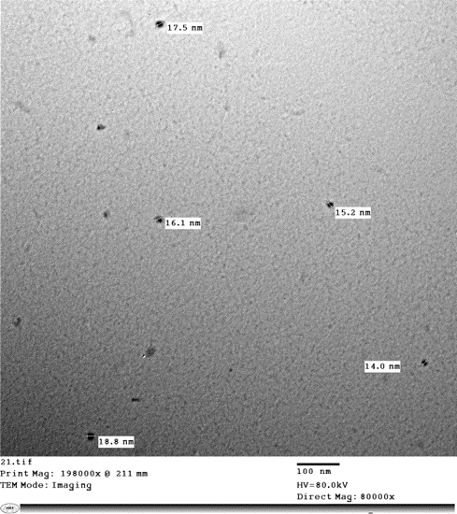

Figure 2

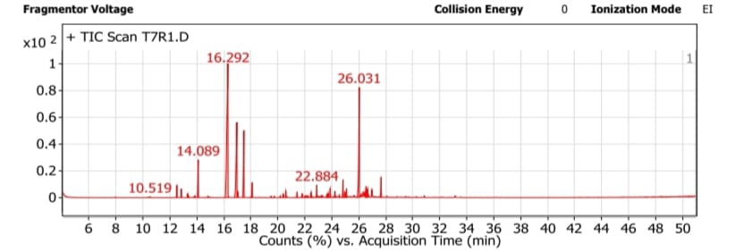
Figure 3
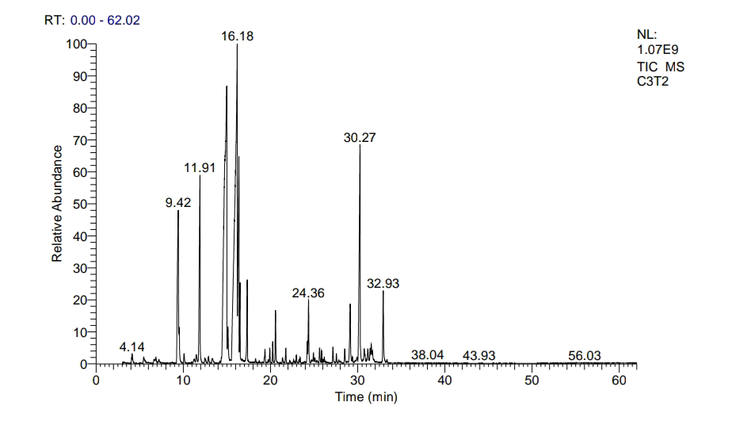
Figure 4
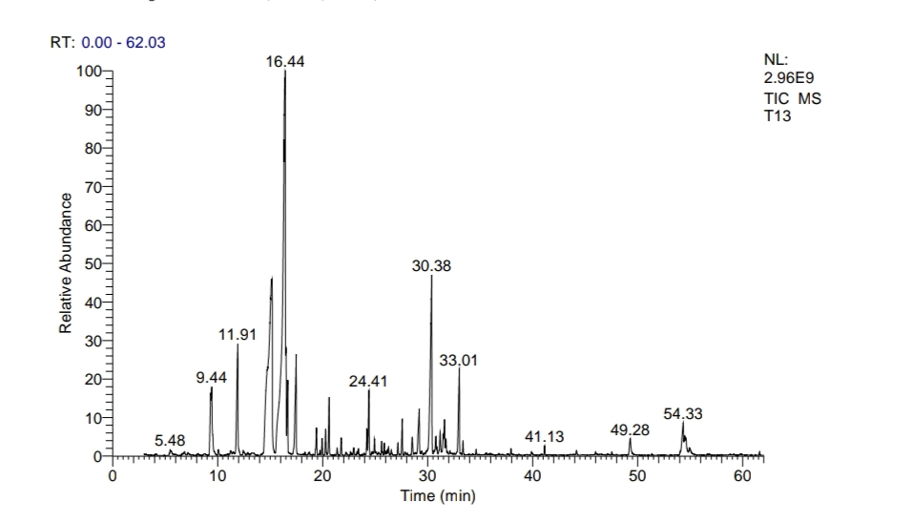
Figure 5
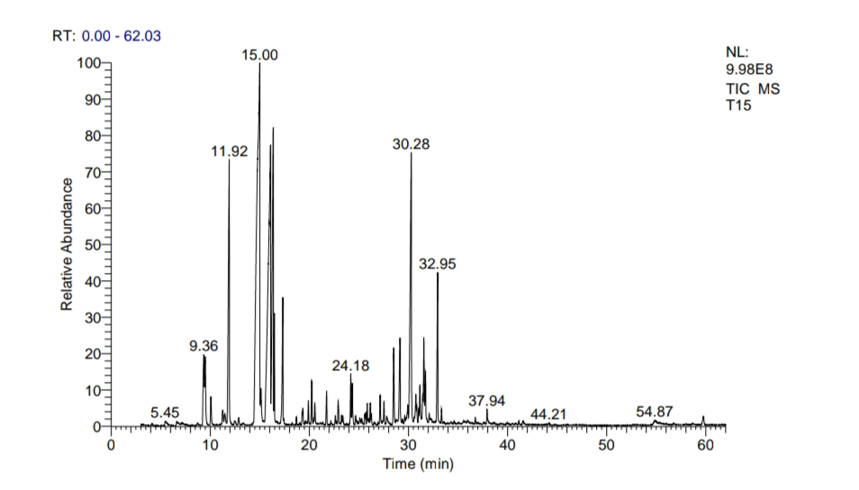
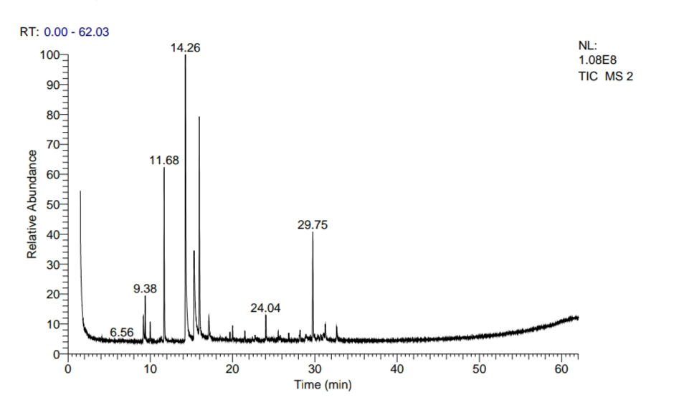
Figure 6

Tables
Table 1. Physical and chemical analysis of the used soil mixture sand + compost (1/1).
No. | Method | Elements | Symbol (unit) | Result | LOW | MEDIUM | HIGH | VERY HIGH
1 | Soluble | Total salts | E.C. (mmhos/cm) | 2.8 | 0.3-0.7 | 0.8-1.2 | 1.3-3 | >3
 |  |  | E.C. (ppm) | 1792 | 192-448 | 512-768 | 832-1920 | >1920
2 | Water 1:2.5 | pH | pH | 8.4 | 5.5-6.6 | 6.5-7.5 | 7.5-8.2 | >8.3
3 | Walkley | Organic Mater | O.M. (%) | 3.2 | 0.1-0.8 | 0.9-1.5 | 1.6-5 | >5
4 | Olsen | Phosphorus (available) | P (Meq/liter) | 26.2 | 10-22 | 23-30 | 31-36 | >36
5 | Soluble | Calcium | Ca (Meq/liter) | 12.4 | 50-100 | 101-250 | 250-450 | >450
6 | Soluble | Magnesium | Mg (Meq/liter) | 8.2 | 0-50 | ---- | 51-100 | >100
7 | Soluble | Potassium | K (Meq/liter) | 1 | 41-80 | 81-120 | 121-160 | >160
8 | Soluble | Sodium | Na (Meq/liter) | 6.4 | 41-80 | 81-120 | 121-160 | >160
9 | Soluble | Carbonate | Co3 (Meq/liter) | 0 | 0 | 0 | 0 | 0
10 | Soluble | Bicarbonate | Hco3 (Meq/liter) | 8.8 | 50-75 | 76-100 | 101-250 | >250
11 | Soluble | Chloride | Cl (Meq/liter) | 18 | 30 | 45 | 60 | >60
12 | Soluble | Sulfur | So4 (Meq/liter) | 1.2 | 4-7 | 7-11 | 11-15 | >15
13 | Calculation | Sodium Adsorption Ratio | SAR | 1.99 | 0-5 | 1-10 | 10-15 | >15
14 | Soluble | Density | Density (g/cm3) | 1.05 | ---- | ---- | ---- | ----
15 | Soluble | Nitrogen | N (%) | 0.16 | 0 | 0 | 0 | 0
16 | Calculation | Saturation present | Sp (%) | 21.4 | 10-15 | 16-20 | 21-28 | >28

Table 2. Physical and chemical analysis of the used soil mixture loamy + compost (1:1).
No. | Method | Elements | Symbol (unit) | Result | LOW | MEDIUM | HIGH | VERY HIGH
1 | Soluble | Total salts | E.C. (mmhos/cm) | 0.85 | 0.3-0.7 | 0.8-1.2 | 1.3-3 | >3
 |  |  | E.C. (ppm) | 544 | 192-448 | 512-768 | 832-1920 | >1920
2 | Water 1:2.5 | pH | pH | 8.3 | 5.5-6.6 | 6.5-7.5 | 7.5-8.2 | >8.3
3 | Walkley | Organic Mater | O.M. (%) | 1.2 | 0.1-0.8 | 0.9-1.5 | 1.6-5 | >5
4 | Olsen | Phosphorus (available) | P (Meq/liter) | 28.6 | 10-22 | 23-22 | 31-36 | >36
5 | Soluble | Calcium | Ca (Meq/liter) | 4 | 50-100 | 101-250 | 250-450 | >450
6 | Soluble | Magnesium | Mg (Meq/liter) | 2.4 | 0-50 | ---- | 51-100 | >100
7 | Soluble | Potassium | K (Meq/liter) | 0.4 | 41-80 | 81-120 | 121-160 | >160
8 | Soluble | Sodium | Na (Meq/liter) | 1.7 | 41-80 | 81-120 | 121-160 | >160
9 | Soluble | Carbonate | Co3 (Meq/liter) | 0 | 0 | 0 | 0 | 0
10 | Soluble | Bicarbonate | Hco3 (Meq/liter) | 3 | 50-75 | 76-100 | 101-250 | >250
11 | Soluble | Chloride | Cl (Meq/liter) | 4.8 | 30 | 45 | 60 | >60
12 | Soluble | Sulfur | So4 (Meq/liter) | 0.7 | 4-7 | 7-11 | 11-15 | >15
13 | Calculation | Sodium Adsorption Ratio | SAR | 0.95 | 0-5 | 1-10 | 10-15 | >15
14 | Soluble | Density | Density (g/cm3) | 1.12 | ---- | ---- | ---- | ----
15 | Soluble | Nitrogen | N (%) | 0.2 | 0 | 0 | 0 | 0
16 | Calculation | Saturation present | Sp (%) | 27.8 | 10-15 | 16-20 | 21-28 | >28

Table 3. Function and the microorganism name of the used commercial bio-fertilizers.
No. | Name of product | Function | Name of microorganism
1 | Nitrobine | Releasing nitrogen nutrient in the soil | Azotobacter sp.
2 | Phosphorine | Releasing phosphorus nutrient in the soil | Bacillus megatherium var. phosphaticum
3 | Potasine | Releasing potassium nutrient in the soil | Bacillus circulans

Table 4. Effect of bio- and nano- fertilization and their interaction with the soil types on essential oil percentage of Pelargonium graveolens L. plants
Essential oil (%)
First season

 | First cut |  | Second cut
 | Soil type
Treatment | SC | LC | SC | LC
Control | 0.20 ± 0.03^{dA} | 0.23 ± 0.06^{eA} | 0.14 ± 0.02^{gA} | 0.18 ± 0.04^{fA}
Nitrobine 1 g/pot | 1.73 ± 0.29^{bA} | 0.60 ± 0.10^{dB} | 1.20 ± 0.05^{cA} | 0.45 ± 0.04^{eB}
Nitrobine 0.05 g/pot | 2.40 ± 0.06^{aA} | 0.70 ± 0.10^{dC} | 1.69 ± 0.04^{aB} | 0.47 ± 0.04^{eD}
Phosphorine1 g/pot | 1.50 ± 0.06^{cA} | 1.53 ± 0.07^{bA} | 1.10 ± 0.03^{dC} | 1.18 ± 0.03^{cB}
Phosphorine 0.05 g/pot | 1.70 ± 0.06^{bB} | 2.73 ± 0.50^{aA} | 1.13 ± 0.03^{cC} | 1.87 ± 0.05^{aB}
Potasine 1 g/pot | 0.87 ± 0.24^{cA} | 1.13 ± 0.31^{cA} | 0.62 ± 0.05^{fB} | 0.91 ± 0.04^{dA}
Potasine 0.05 g/pot | 1.10 ± 0.21^{cA} | 1.30 ± 0.02^{cB} | 1.01 ± 0.02^{eC} | 1.07 ± 0.03^{cB}
NPK Nano 100 ppm | 1.85 ± 0.01^{bA} | 1.60 ± 0.20^{bA} | 1.39 ± 0.01^{bB} | 1.11 ± 0.06^{cC}
NPK Nano 50 ppm | 1.89 ± 0.06^{bA} | 2.00 ± 1.00^{aA} | 1.43 ± 0.03^{bA} | 1.57 ± 0.06^{bA}
Mean | 1.47 | 1.31 | 1.08 | 0.98
Second season

 | First cut |  | Second cut
 | Soil type
Treatment | SC | LC | SC | LC
Control | 0.22 ± 0.04^{fA} | 0.25 ± 0.06^{fA} | 0.18 ± 0.01^{gA} | 0.19 ± 0.04^{hA}
Nitrobine 1 g/pot | 1.71 ± 0.51^{cA} | 0.57 ± 0.02^{eC} | 1.36 ± 0.04^{cB} | 0.58 ± 0.01^{fC}
Nitrobine 0.05 g/pot | 2.38 ± 0.11^{aA} | 0.69 ± 0.01^{eC} | 1.80 ± 0.05^{aB} | 0.41 ± 0.02^{gC}
Phosphorine1 g/pot | 1.46 ± 0.10^{dA} | 1.51 ± 0.54^{bA} | 1.18 ± 0.03^{dC} | 1.36 ± 0.01^{cB}
Phosphorine 0.05 g/pot | 1.66 ± 0.11^{cC} | 2.68 ± 0.45^{aA} | 1.27 ± 0.03^{dD} | 1.98 ± 0.03^{aB}
Potasine 1 g/pot | 0.82 ± 0.32^{eB} | 1.28 ± 0.24^{dA} | 0.70 ± 0.04^{fB} | 1.05 ± 0.04^{eA}
Potasine 0.05 g/pot | 0.88 ± 0.35^{fC} | 1.66 ± 0.23^{bA} | 0.78 ± 0.02^{eC} | 1.15 ± 0.03^{dB}
NPK Nano 100 ppm | 1.87 ± 0.2^{bA} | 1.41 ± 0.01^{cB} | 1.48 ± 0.01^{bB} | 1.27 ± 0.04^{cB}
NPK Nano 50 ppm | 1.98 ± 0.08^{bA} | 2.01 ± 0.01^{aA} | 1.55 ± 0.03^{bB} | 1.78 ± 0.02^{bB}
Mean | 1.37 | 1.34 | 1.16 | 1.09
SC: sand + compost; LC: loam + compost. Mean values followed by the same uppercase letter in the row and lowercase in the column within the same factor are not significantly different according to the Duncan’s multiple test (P ≤ 0.05)

Table 5. Effect of bio- and nano-fertilization and their interaction with the soil types on essential oil constituents of Pelargonium graveolens L. plants
R.T. | Identification
 |  | Control | Nano.  50ppm Loamy soil + compost | Phos. 0.5g Loamy soil + compost | Potas. 0.5g  Loamy soil + compost | Nitro. 0.5g  Sandy soil + compost
4.10 | α-Pinene | 0.05 | -- | -- | -- | 0.69
5.47 | β-Myrcene | -- | -- | 0.48 | -- | 0.37
9.16 | β-Linalool | 1.13 | 1.78% | 3.87% | 1.98 | 7.48
9.38 | Rose oxide | 0.73 | 5.84 | -- | 3.57 | 1.27
11.25 | Citronellal | 0.17 | -- | -- | 0.48 | --
11.67 | l-Menthone | 3.94 | 11.51 | 4.79 | 7.60 | 7.58
14.24 | Citronellol | 35.64 | 26.76 | 12.56 | 11.52 | 12.44
14.86 | cis-Citral | -- | -- | -- | 0.79 | 1.28
15.25 | Geraniol | 14.1 | 18.93 | 30.44 | 27.23 | 26.96
15.94 | Citronellyl formate | 8.04 | 22.25 | 0.59 | 8.21 | 6.94
16.17 | trans-Citral | -- | -- | 4.98 | 3.71 | 3.72
17.07 | Geraniol formate | 1.41 | 4.75 | 9.90 | 7.85 | 6.45
19.41 | Geraniol, trimethylsilyl ether | -- | -- | 1.38 | -- | 0.55
19.67 | à-ylangene | 0.20 | -- | -- | --
19.74 | Propanoic acid, 2-phenylethyl ester | -- | -- | 0.51 | -- | 0.35
19.94 | β-Cubebene | 1.29 | -- | 0.49 | 0.43 | 0.35
19.99 | (-)-β-Bourbonene | 0.61 | 0.38 | 1.21 | 1.39 | 0.92
20.45 | Nerol acetate | -- | -- | 3.34 | 0.73 | 2.66
21.38 | β-Phenylethyl butyrate | -- | -- | 0.80 | -- | 0.67
22.91 | 6-Octen-1-ol, 3,7-dimethyl-, propanoate | -- | -- | -- | 0.46 | --
24.21 | 2,6-Octadien-1-ol, 3,7-dimethyl-, propanoate, (E)- | -- | -- | 1.16 | 1.72 | 1.03
24.40 | Germacrene D | 0.15 | -- | 1.92 | 0.62 | 1.67
25.61 | Geranyl isobutyrate | -- | -- | 2.41 | 0.67 | 0.68
26.15 | cis-Calamene | 0.46 | -- | -- | 1.38 | 0.50
27.56 | Geranyl butyrate | 0.26 | -- | -- | -- | 0.41
28.85 | Phenylethyl tiglate | -- | -- | 5.94 | 7.68 | 6.47
30.37 | γ-Eudesmol | 15.87 | -- | 4.13 | 3.88 | 5.20
31.48 | Guaiol | 1.14 | -- | 0.66 | 0.55 | 0.40
32.62 | Geranyl tiglate | 2.21 | 0.23 | 3.64 | 4.41 | 2.61
49.28 | Tetradecanamide | -- | -- | 1.81 | -- | --
54.33 | 9-Octadecenamide, (Z)- | -- | -- | 1.29 | -- | --
54.95 | Octadecanamide | -- | -- | 0.52 | -- | --
Table 6. Effect of bio- and nano- fertilization and their interaction with the soil types on chlorophyll a and b, and carotenoid contents of Pelargonium graveolens L. plants
Chlorophyll a content (mg/g FW)
 | First season |  | Second season
 | Soil type
Treatment | SC | LC | SC | LC
Control | 0.24 | 0.24 | 0.26 | 0.25
Nitrobine 1 g/pot | 0.38 | 0.29 | 0.40 | 0.30
Nitrobine 0.05 g/pot | 0.69 | 0.32 | 0.71 | 0.33
Phosphorine1 g/pot | 0.34 | 0.35 | 0.37 | 0.37
Phosphorine 0.05 g/pot | 0.37 | 0.88 | 0.4 | 0.89
Potasine 1 g/pot | 0.28 | 0.35 | 0.3 | 0.37
Potasine 0.05 g/pot | 0.31 | 0.36 | 0.33 | 0.37
NPK Nano 100 ppm | 0.47 | 0.41 | 0.50 | 0.43
NPK Nano 50 ppm | 0.51 | 0.55 | 0.53 | 0.57
Mean | 0.40 | 0.432 | 0.42 | 0.43
Chlorophyll b content (mg/g FW)
 | First season |  | Second season
 | Soil type
Treatment | SC | LC | SC | LC
Control | 0.05 | 0.07 | 0.06 | 0.07
Nitrobine 1 g/pot | 0.34 | 0.14 | 0.35 | 0.15
Nitrobine 0.05 g/pot | 0.58 | 0.21 | 0.59 | 0.22
Phosphorine1 g/pot | 0.31 | 0.25 | 0.32 | 0.25
Phosphorine0.05 g/pot | 0.34 | 0.72 | 0.34 | 0.72
Potasine 1 g/pot | 0.14 | 0.24 | 0.15 | 0.25
Potasine 0.05 g/pot | 0.22 | 0.27 | 0.23 | 0.28
NPK Nano 100 ppm | 0.39 | 0.35 | 0.40 | 0.34
NPK Nano 50 ppm | 0.42 | 0.38 | 0.44 | 0.38
Mean | 0.31 | 0.29 | 0.32 | 0.30
Carotenoid content (mg/g FW)
 | First season |  | Second season
 | Soil type
Treatment | Sandy soil + compost | Loamy soil + compost | Sandy soil + compost | Loamy soil + compost
Control | 0.09 | 0.06 | 0.11 | 0.07
Nitrobine 1 g/pot | 0.24 | 0.10 | 0.26 | 0.09
Nitrobine 0.05 g/pot | 0.43 | 0.13 | 0.45 | 0.15
Phosphorine1 g/pot | 0.22 | 0.15 | 0.24 | 0.17
Phosphorine0.05 g/pot | 0.25 | 0.43 | 0.26 | 0.46
Potasine 1 g/pot | 0.13 | 0.14 | 0.15 | 0.16
Potasine 0.05 g/pot | 0.19 | 0.18 | 0.22 | 0.19
NPK Nano 100 ppm | 0.27 | 0.21 | 0.29 | 0.23
NPK Nano 50 ppm | 0.28 | 0.21 | 0.31 | 0.24
Mean | 0.23 | 0.18 | 0.25 | 0.20
SC: sand + compost; LC: loam + compost.

