Running title: Anti-proliferation of MDA-MB-231by fruit extract of Antidesma bunius

**Inhibitory Activity of Fruits Extracts of *Antidesma bunius* on the Proliferation and migration of MDA-MB-231 Breast Cancer Cells**

Ma Funing1, Tariq Masood1, 2*, Huang Dongmei1, Wu Bin1, Ge Yu1, Chen Di1, Song Shun1*

1*Haikou Experimental Station, Chinese Academy of Tropical Agricultural Sciences / Hainan Key Laboratory of Banana Genetic Improvement, Hainan 571101, China*

2*Department of Agricultural Chemistry, The University of Agriculture, Peshawar, Pakistan*

*For correspondence: [sss1984006@163.com](mailto:sss1984006@163.com); tariqafridi@aup.edu.pk

**Novelty statement**

Leaves of bignay (*Antidesma bunius*) have been exploited for its anticancer use, but fruit rarely been investigated. These results show that the extract of bignay fruits inhibit the proliferation and migration of breast cancer cells MDA-MB-231. We found that extract prolong the G1 stage of cells cycle, and major compounds in ethanol extract were phenolic acids and flavonoid by UHPLC-MS/MS analysis. The antiproliferation activity of one biflavonoids (amentoflavone) was verified.

**Abstract**

In this research, we investigated the inhibitory activity of the ethanol (EA) extract of bignay (*Antidesma bunius*) fruit on the viability of MDA-MB-231 breast cancer cells by CCK-8 assay. The results showed that the half inhibitory concentration (IC50) was 219 μg/mL after the cells were treated with EA extract for 72 hours. The EA extract was sequentially extracted by petroleum ether (PET), ethyl acetate (EtOAc), and n-butanol (nBuOH). Among them, the EtOAc fraction showed higher anti-proliferative activity than the other fractions. Wound healing experiment showed the EtOAc fraction inhibited the migration of MDA-MB-231 cells and significantly delayed the transition of the G1 to S phase compared to control. UHPLC-MS/MS analysis showed that in addition to phenolic acids (citric acid, 4-hydroxycinnamic acid, aspirin, fertaric acid), EA extract of bignay fruit contains active ingredient like coumarin, genistin, amentoflavone, and luteolin 7-galactoside. The anti-proliferation activity of amentoflavone against MDA-MB-231 cells was also confirmed.

**Keywords:** breast cancer; ethno medicine; flavonoid; tropical fruits

**Introduction**

Bignay (*Antidesma bunius* (L.) Sprengel) also known as Wu-Yuer-Cha in China and Mao-Luang in Thailand, belongs to Euphorbiaceae family, Phyllanthoideae subfamily (Lim, 2012). There are about 170 plant species contained in the genus *Antidesma* and are distributed in tropical regions of the eastern hemisphere (Djouossi *et al.* 2014). The plants of genus *Antidesma* are important ethno-medicinal plants in Thailand, the Philippines, and Indonesia (Krongyut and Sutthanut 2019). The entire plant of *A. bunius* is of medicinal value due to its antioxidant, anticancer and antidiabetic activities (Shariful *et al.* 2018).

There are 16 species of *Antidesma* genus plants in China, mainly distributed in Guangdong, Guangxi, Fujian, Guizhou, Yunnan and Hainan provinces. It often grows as a wild plant or is used as a green ornamental tree. Chinese traditional medicine books "Color Atlas of Commonly Used Chinese Herbal Medicines" records that the roots, fruits, and leaves of *A.bunius* has the medicinal activities of convergence, quenching diarrhea, quenching thirst and promoting blood flow. Edible fruits of *A. bunius* are used to make juice or red wine rich in phytochemicals with enhanced health-promoting properties (Micor *et al.* 2005). Despite the presence of phenolic acids, flavonoids and anthocyanins in the fruit of *A. bunius* (Butkhup and Samappito 2011), its anticancer effect has not been elucidated.

Breast cancer is the type of cancer with the highest incidence in women in the world today, and about 2 million new cases and 500,000 deaths in 2018 (Globocan, 2018). The MDA-MB-231 cancer cell line is a well-known model of malignant breast cancer, due to its high invasiveness and motility and its ability to develop tumors in *in vivo* assays in rodents (Chacon and Costanzo 2010). Currently, chemotherapy is the most effective treatment for cancer-suffering patients, and there is a constant need to find new therapeutic drugs and treatment methods to fight this disease. Plant-derived paclitaxel is a widely used drug for the treatment of breast and ovarian cancer, but it has the disadvantages of low water solubility and large adverse reactions (Cao *et al.* 2018). Thus, research dedicated to finding novel compounds to inhibit any of the acquired features of cancer cells are of high value.

Our *in vitro* studies show that the fruit extract of *A. bunius* inhibits the proliferation and migration of breast cancer cells. This result provides an empirical basis for using fruits of*A. bunius* as food with anticancer effects.

**Materials and Methods**

**Plant Material**

Fruits of *A. bunius* were collected from Wanning, China and were certified by the botanist Rong-tao Li from Hainan Branch of institute of medicinal plants, Chinese academy of medical sciences in August 2019. The red color fruit (2 kg) were dried in oven at 40 ˚C for 72 h. Later, the dried fruit was grounded and extracted with 80% ethanol (EA) for 24 h. Then, ultrasound was applied 3 times (30 min each time). Extract was dried by rotary evaporation at 40 ˚C and a freeze dryer. A main stock solution was prepared by solving 0.2 g of the dried extract in 2 mL DMSO, filtered with a 0.22 μm-pore filter and stored at -20 ˚C until use.

In a second phase of extraction, the stock solution was dissolved in ultra-pure water, and sequentially extracted using petroleum ether (30-60°C boiling range, PET), ethyl acetate (EtOAc), and n-butanol (nBuOH). Each fraction was separately freeze-dried to obtain PET, EtOAc, nBuOH and water extracts.

**Cell line**

Human breast cancer cell line MDA-MB-231 was obtained from Kunming Cell Bank, Chinese Academy of Sciences (Kunming, China) and was cultivated with RPMI 1640 media (Gibco, USA) supplemented with 10% fetal bovine serum (BOSTER, Wuhan, China) and 1% streptomycin/penicillin (Biosharp, Hefei, China). 25 mM Hepes (Yuanye, Shanghai, China) was added to cell culture when performing experiment with the fruit extract. Cultures were maintained in humidified incubator (Thermo, USA) at 37 °C with 5% CO2 in air.

**Methods**

**Cell proliferation and viability assay**

Cells were seeded at 2000 cells per well in 96-well microplates. 24 h later, media containing different concentrations of *A. bunius* fruit extract was added. As control, media with 0.1% DMSO was used. After treatment, cell viability was assessed by using the Cell Counting Kit-8 (CCK-8) (BOSTER, Wuhan, China) following the company’s recommended protocol. Briefly, media was gently removed after 72 h of treatment, cells were washed with PBS (Biosharp, Hefei, China) and then 90 μL of medium plus 10 μL of CCK-8 were added and the cell culture plate was put back in the incubator for 2 h. Finally, the absorbance was determined at 450 nm with a microplate reader (Thermo, USA). To calculate the relative cell viability. The following formula was used:

Cell viability = (OD control-OD treatment)/OD control.

**EA extract analysis by UHPLC-MS/MS**

To 2 mg of extract, 500 μL extract solution (methanol: water = 1: 1, with internal standard) was added for LC-MS/MS analyses using an UHPLC system (Vanquish, Thermo Fisher Scientific) with a UPLC BEH Amide column (2.1 mm × 100 mm, 1.7 μm) coupled to Q Exactive HFX mass spectrometer (Orbitrap MS, Thermo). The mobile phase consisted of 25 mmol/L ammonium acetate and 25 ammonia hydroxide in water（pH = 9.75 (A) and acetonitrile (B). The analysis was carried with elution gradient as follows: 0~0.5 min, 95%B; 0.5~7.0 min, 95%~65% B; 7.0~8.0 min, 65%~40% B; 8.0~9.0 min, 40% B; 9.0~9.1 min, 40%~95% B; 9.1~12.0 min, 95% B. The column temperature was 30 °C. The auto-sampler temperature was 4 °C, and the injection volume was 2 μL.

The QE HFX mass spectrometer was used to acquire MS/MS spectra on information-dependent acquisition (IDA) mode in the control of the acquisition software (Xcalibur, Thermo). The ESI source conditions were set as following: sheath gas flow rate as 30 Arb, Aux gas flow rate as 25 Arb, capillary temperature 350 °C, full MS resolution as 60000, MS/MS resolution as 7500, collision energy as 10/30/60 in NCE mode, spray Voltage as 3.6 kV (positive) or -3.2 kV (negative), respectively.

The raw data were converted to the mzXML format using ProteoWizard and processed with an in-house program, which was developed using R and based on XCMS, for peak detection, extraction, alignment, and integration. Then an in-house MS2 database (BiotreeDB) was applied in metabolite annotation. The cutoff for annotation was set at 0.3.

**Wound-healing assay**

2.2×105 MDA-MB-231 cells were seeded per well in 24-well plates 24 h before performing a wound with a 200 μL tip. Cells were gently washed with PBS to remove floating cells, and media containing 2.5% FBS with or without fruit extract was added. Media was removed and cells were fixed and stained with 0.1% crystal violet stain (Yuanye, Shanghai, China). Pictures of the same field were taken at 0 and 24 h. Cell-free areas were determined using ImageJ software. Migration index was calculated with the formula: [(Area 0h)-(Area 24h)] / (Area 0h)×100.

**Flow cytometry**

Each well of 6-well plate was seeded with 5×105 MDA-MB-231 cells, and cultivated with 50 ug/mL EA extract. After 24 h of treatment, cells were detached with trypsin without EDTA, washed twice with pre-cooled PBS. Then, cells were fixed with 70% ethanol, and refrigerated overnight at -20 °C. Later, cells were washed twice with pre-cooled PBS, and 2 μL ribonuclease (RNaseA) at a concentration of 1 mg/mL was added, and kept at 37°C for 30 min, then 400 μL propidiun iodide staining solution (KeyGen, JiangSu, China) was added and kept in the dark for 30 minutes. Cell cycle status was detected by flow cytometry (BD FACSCalibur, USA) and the percentage of cells in each phase was calculated by Modfit LT5.0 software (Verity Software House, USA).

**EtOAc extract analysis by HPLC**

The EtOAc extract and amentoflavone (Yuanye, Shanghai, China) standard were analyzed by Agilent 1200 HPLC (Agilent, USA) with an UV detection, SB-C18 column (4.6 mm×250 mm，5 μm), using methanol (A) and 0.5% formic acid aqueous solution (B) as mobile phases, and gradient elution (0~20 min, 40%~ 60%A; 20~40 min, 80% A; 40~60 min, 40% A). The flow rate is 0.4 mL/min, and the injection volume is 10 μL.

**Statistical analysis**

All experiments were set to be repeated more than 3 times. One-way ANOVA followed by Dunnett’s multiple comparisons test was performed using GraphPad Prism version 8.0.1 for Windows (GraphPad Software, San Diego, California USA). Statistical significances were determined using Student’s t-test *P < 0.05, **P < 0.01.

**Results**

**The ethanol extract inhibits the proliferation of MDA-MB-231 cells**

Altogether 14 g of extract powder were obtained from 0.29 kg dried fruits of *A. bunius* by ethanol extraction. EA was dissolved in DMSO, diluted to a certain concentration in DMEM medium, and tested for its proliferation inhibitory activity on MDA-MB-231 cells. The results are shown in Figure 1. The anti-proliferative activity of EA showed a dose-dependent effect. The IC50 of the EA extract of *A. bunius* fruits against MDA-MB-231 cells was 219 ug/mL after treatment for 72 h.

**UHPLC-MS/MS analysis of EA extract**

The 30 top content compounds are listed in table 1. Most of these compounds were detected in the negative MS and only two compounds were detected in the positive MS (Fig.2). The compound in highest concentration was citric acid, which is the main acid in fruits like orange, passion fruit and pineapple. There are other phenolic acids like 3-hydroxybenzoic acid, 4-hydroxycinnamic acid, fertaric acid, aspirin, 2,3-dihydroxybutanedioic acid, itaconic acid, gallic acid, terephthalic acid and vanillic acid. Coumarin and flavonoids like genistin, amentoflavone and luteolin 7-galactoside are also in high content in EA extract and may play an important anticancer activity.

**Fraction extract inhibits the proliferation of MDA-MB-231 cells**

200 μg/mL of PET, EtOAc, nBuOH and water extracts of were tested to evaluate their inhibitory activity on the viability of MDA-MB-231 cells. The results showed that among those extraction fractions, EtOAc extract had the significantly highest inhibition of cell viability, and the aqueous phase had the lowest activity (Figure 3).

**EtOAc extract on cell migration**

The effect of EtOAc extract on the migration of MDA-MB-231 cells was also investigated. Increasing concentrations of EtOAc extract perturbed the migration of these cells in a dose-dependent manner (Figure 4). The results showed that treatment of MDA-MB-231 cells with 100 μg/mL EtOAc strongly inhibited the motility of these cells towards the wound (Figure 4).

**Effect of EtOAc extract on cell cycle**

The 50 μg/mL EtOAc extract significantly increased the proportion of cells in G0/G1 phase after 24 h of treatment compared to control (Figure 5). The proportion of cells in G0/G1 phase was 58% in the control group while the EtOAc reached 63% (p<0.01). On the other hand, the proportion of cells in S phase was 37% when treated with EtOAc compared to 32% in the control group (p<0.05). This result shows that the EtOAc extract phase of *A. bunius* fruit accumulates MDA-MB-231 cells in the G0/G1 phase.

**HPLC analysis of EtOAc extract and amentoflavone**

From the HPLC analysis of the EtOAc extract fraction of *A. bunius*, the component that peaked at 49.2 min was isolated and identified as amentoflavone by mass spectrometry (C30H18O10). Molecular Weight of amentoflavone was 538.4579 (Figure 6).

**Amentoflavone inhibited the viability of MDA-MB-231 cells**

Next, five different concentrations (31.25, 62.5, 125, 250, 500 μg/mL) of amentoflavone were tested for the inhibition of MDA-MB-231 cells viability. It was observed that the amentoflavone IC50 against MDA-MB-231 cell viability was 192 μg/mL after treatment for 72 h. A slight non-significant increase on cell viability was observed with concentrations of amentoflavone lower than 100 μg/mL (Figure 7).

**Discussion**

Breast cancer accounts for 7%-10% of all malignant tumors and triple-negative breast cancer (TNBC) accounts for about 15-20% of breast cancer (Beiki *et al.* 2012). Intervention of traditional Chinese medicine at different stages of breast cancer treatment can effectively improve the cancer patients, life quality and reduce the rate of recurrence and metastasis (Tian *et al.* 2017). Previous studies have shown that crude methanol extracts from leaves and fruits of *A. bunius* have cytotoxic activity against *Artemia salina* (Micor *et al.* 2005). Matured leaves of *A. bunius* have been used against snakebite and young leaves are boiled and used in syphilis and skin disorders in India (Hazarika *et al.* 2012). Ethanolic fruit extracts of *A. bunius* were used as herbal drug in diabetes therapy (Noel *et al.* 2017).

Butkhup and Samappito (2011) found that the polyphenolic compounds in fruit of *A. bunius* are mainly procyanidin B2, procyanidinB1, (+)-catechin, (–)-epicatechin, rutin and tran-resveratrol cyanidin-3-O-glucoside, and the contents of gallic acid, (-)-epicatechin, and (+)-catechin decreased during fruit ripening, and *A. bunius* fruit possess the highest antioxidants at over ripe stage. In this study, anthocyanins with wine red color mainly concentrate in water fraction, which showed no anti-proliferation activity to MDA-MB-231 cells. In our work, the high concentration of phenolic acid in our extract implies the red fruits we collected were not fully riped, since the fully riped fruit shows dark red color. The relationship between anti-cancer activity and the concentration of polyphenols needs to be further studied.

The G1 phase of the cell cycle involves mechanisms that allow gene expression for regular cell functioning and evaluation of DNA damage before the duplication of the genetic material, the S phase. The results of this study show that fruit extract of *A. bunius* delays MDA-MB-231 cells in the G1 phase that correlates with the decrease proportion of cells in the S phase. Altogether with the decrease in cell survival caused by exposure to *A. bunius* suggest that the extract inhibits cell proliferation by blocking or inhibiting cells in the transition from G1 to S phase. Probably, signaling pathways of cyclin D and cyclin E (regulators of entering the S phase) could be possible targets of *A. bunius* fruit extract.

MDA-MB-231 cells represent a great model of aggressive breast cancer since they have a high level of motility. Thus, finding compounds that preclude their cell motility are of great interest. Clinically, preventing cancer cell motility could retard cancer aggressiveness and increase the treatment time. As showed in this work, the extract of *A. bunius* fruit inhibits the migration of MDA-MB-231cells, pointing to a plausible use of this fruit extract as an anticancer agent.

Flavonoids are a large group of polyphenolic compounds present in a variety of fruits and vegetables with many biological properties. The flavonoids in the fruit extract of *A. bunius* such ascoumarin, genistin, amentoflavone and luteolin 7-galactoside have already been proved to have multiple biological activities (Choi *et al.* 2020; Russo *et al.* 2020; Hwang *et al.* 2020). Amentoflavone is a naturally occurring biflavonoid compound abundant in *Selaginella tamariscina*, with anti-inflammatory (Oh *et al.* 2013), anti-oxidative (Bajpai *et al.* 2019), anti-microbial (Jorjong *et al.* 2015), anti-apoptotic (Lee *et al.* 2009), anti-radiation (Lee *et al.* 2012), antitumor (Tian *et al.* 2013), neuroprotective (Cao *et al.* 2017; Rong *et al.* 2019), and cyanobacterial killing effects (Lee *et al.* 2020). Additionally, we demonstrated the anti-proliferative effect of the ethanolic extract of leaves of *A. montanum* on the MDA-MD-231 cells and found that amentoflavone was present in this extract (Ma *et al.* 2020).

The molecular mechanism underlying amentoflavone have been previously studied (Yu *et al.* 2017). Amentoflavone inhibits expression and secretion of VEGF, MMP-2, MMP-9, TNF-α, IL-1β, and IL-6 via suppression of NF-ĸB activation (Chen *et al.* 2015). It induced SK-BR-3 breast cancer cell apoptosis through blockade of fatty acid synthesis (Lee *et al.* 2009), and inhibits tumorsphere formation by regulating the Hedgehog/Gli1 signaling pathway in SUM159 breast cancer stem cells (Bao *et al.* 2019). Amentoflavone has also been suggested as a potential adjuvant agent to boost the anti-cancer effect of doxorubicin (Jung *et al.* 2017).

**Conclusion**

The ethanol extract of the fruit of bignay (*A. bunius*) possess anti-proliferative and anti-migratory effect on MDA-MB-231 breast cancer cells. There are abundant phenolic acids and flavonoids in the ethanol extract of bignay fruit. The main active substance concentrates in the ethyl acetate fraction, and it delays the G1 phase of MDA-MB-231 cells, probably causing apoptosis that could explain the reduced cell survival. Importantly, amentoflavone was identified as one active ingredient in fruitof *A. bunius*.

**Acknowledgements**

This research was funded by the Central Public-interest Scientific Institution Basal Research Fund for the Chinese Academy of Tropical Agricultural Sciences (grant number 1630092019002). We would like to thank Biotree Biotech Co., Ltd. (Shanghai, China) for technical assistance in carrying out the UHPLC-MS/MS analyses.

**References**

Bajpai VK, I Park, J Lee, S Shukla, SH Nile, HS Chun, I Khan, SY Oh, H Lee, YS Huh, M Na, YK Han (2019). Antioxidant and antimicrobial efficacy of a biflavonoid, amentoflavone from Nandina domestica in vitro and in minced chicken meat and apple juice food models. Food Chem 271: 239-247

Bao C, J Chen, JT Kim, S Qiu, JS Cho, HJ Lee (2019). Amentoflavone inhibits tumorsphere formation by regulating the Hedgehog/Gli1 signaling pathway in SUM159 breast cancer stem cells. J Func Foods 61:103501

Beiki O, P Hall, A Ekbom, T Moradi (2012). Breast cancer incidence and case fatality among 4.7 million women in relation to social and ethnic background: a population-based cohort study. Breast Cancer Res 14: R5

Butkhup L, S Samappito (2011). Changes in physico-chemical properties, polyphenol compounds and antiradical activity during development and ripening of maoluang (Antidesma bunius L. Spreng) fruits. J Fruit Ornam Plant Res 19: 85-99

Cao Q, L Qin, F Huang, X Wang, L Yang, H Shi, H Wu, B Zhang, Z Chen, X Wu (2017). Amentoflavone protects dopaminergic neurons in MPTP-induced Parkinson's disease model mice through PI3K/Akt and ERK signaling pathways. Toxicol Appl Pharmacol 319: 80-90

Cao Sq, K Zhang, X Yan, Y Ma (2018). Preparation and evaluation of paclitaxel and Brucea javanica oil core-matched nanoemulsions to treat cancer in vitro and in vivo. Chin Herb Med 10: 310-317

Chacon RD, MV Costanzo (2010). Triple-negative breast cancer. Breast Cancer Research 12(Suppl2): S3

Chen J, W Chen, Y Liu (2015). Amentoflavone Induces Anti-angiogenic and Anti-metastatic Effects through Suppression of NF-ĸB Activation in MCF-7 cells. Anticancer Res 35: 6685-6694

Choi YR, J Shim, MJ Kim (2020). Genistin: A Novel Potent Anti-Adipogenic and Anti-Lipogenic Agent. Molecules 25:2042

Djouossi MG, PLF Tebou, FD Mabou, D Ngnokam, LA Tapondjou, L V-Nazabadioko (2014). Chevalierinoside A: A new isoflavonoid glycoside from the stem bark of Antidesma chevalieri Beille (Euphorbiaceae). Bull Chem Soc Ethiop 28: 309-314

Globocan (2018).Cancer today：population fact sheets. International agency for research of cancer. https://gco.iarc.fr/today/home

Hazarika TK, Lalramchuana, BP Nautiyal (2012). Studies on wild edible fruits of mizoram, india used as ethno-medicine. Genet Resour Crop Ev 59:1767-1776

Hwang ST, MH Yang, SH Baek, JY Um, KS Ahn (2020). Genistin attenuates cellular growth and promotes apoptotic cell death breast cancer cells through modulation of ERalpha signaling pathway, Life Sciences 263:118594

Jei J, C Liu, Y Hsu, L Lin, S Wang, J Chung, D Bau, S Lin (2012). Amentoflavone Induces Cell-cycle Arrest and Apoptosis in MCF-7 Human Breast Cancer Cells via Mitochondria-dependent Pathway. In vivo 26: 963-970

Jorjong S, B Luchai, S Supachai (2015). Phytochemicals and antioxidant capacities of Mao-Luang (Antidesma bunius L.) cultivars from Northeastern Thailand. Food Chemistry 2:93

Jung YJ, EH Lee, CG Lee, KJ Rhee, WS Jung, Y Choi, CH Pan, K Kang (2017). AKR1B10-inhibitory Selaginella tamariscina extract and amentoflavone decrease the growth of A549 human lung cancer cells in vitro and in vivo. J Ethnopharmacol 202: 78-84

Krongyut O, K Sutthanut (2019). Phenolic Profile, Antioxidant Activity, and Anti-obesogenic Bioactivity of Mao Luang Fruits (Antidesma bunius L.). Molecules 24:4109

Lee CW, Y Na, Nh Park, HS. Kim, SM Ahn, JW Kim, HK Kim, YP Jang (2012). Amentoflavone Inhibits UVB-Induced Matrix Metalloproteinase-1 Expression Through the Modulation of AP-1 Components in Normal Human Fibroblasts. Appl Biochem Biotechnol 166: 1137-1147

Lee J, M Kim, SE Jeong, HY Park, CO Jeon, W Park (2020). Amentoflavone, a novel cyanobacterial killing agent from Selaginella tamariscina. J Hazard Mater 384: 121312

Lee JS, MS Lee, WK Oh, JY Sul (2009). Fatty acid synthase inhibition by amentoflavone induces apoptosis and antiproliferation in human breast cancer cells. Biol Pharm Bull 32: 1427-1432

Lim TK (2012). Antidesma bunius. Edible Medicinal And Non-Medicinal Plants: volume 4, Fruits 220-224

Ma F, D Huang, S Song, B Wu, G Guo, D Wang, L Tan (2020). Inhibitory Activity of Extracts of Antidesma montanum on the Proliferation of Breast Cancer Cells MDA-MB-231. Chin J Trop Crops 41: 1693-1699

Micor, JRL, CC Deocaris and ERE Mojica (2005). Biological Activity of Bignay [Antidesma bunius (L.) Spreng] Crude Extract in Artemia salina. J Med Sci 5:195-198

Noel QM, NJ Dayanan, N Marilou, V Dhennis, RA Michael (2017). Hypoglycemic Activities of Chromatographic Fractions of Antidesma bunius Fruit Ethanolic Extract on Alloxan-Induced Hyperglycemic Balb/C Mice. J Appl Pharm Sci 7: 120-123

Oh J, HS Rho, Y Yang, JY Yoon, J Lee, YD Hong, HC Kim, SS Choi, TW Kim, SS Shin, JY Cho (2013). Extracellular signal-regulated kinase is a direct target of the anti-inflammatory compound amentoflavone derived from Torreya nucifera. Mediators Inflamm 2013: 761506

Pongnaratorn P, P Kuacharan, V Kotsuno, P Nitchakan,P Sriraj, J Sattayasai (2017). In vitro antimicrobial activity of Antidesma bunius extracts on oral pathogenic bacteria. Thai J Pharm Sci 41:144-149

Rong S, D Wan, Y Fan, S Liu, K Sun, J Huo, P Zhang, X Li, X Xie, F Wang, T Sun (2019). Amentoflavone Affects Epileptogenesis and Exerts Neuroprotective Effects by Inhibiting NLRP3 Inflammasome. Front Pharmacol 10: 856

Russo M, S Moccia, C Spagnuolo, I Tedesco, GL Russo (2020). Roles of flavonoids against coronavirus infection. Chemi Biol Interact 328:109211

Shariful IM, MS Ahammed, FI Sukorno, SF Koly, MM Biswas, S Hossain (2018). A review on phytochemical and pharmacological potentials of Antidesma bunius. J Anal Pharm Res 7:602-604

Tian Q, P Du, S Li, Z Bai, Y Yang, J Zeng (2017). Effect of antitumor treatments on triple-negative breast cancer patients: A PRISMA-compliant network meta-analysis of randomized controlled trials. Medicine (Baltimore) 96:45 e8389

Tian HY, ZX Li , HY Li , HJ Wang , ZH Dou (2013). Effects of 14 single herbs on the induction of caspase-3 in tumor cells: a brief review. Chinese Journal of Integrative Medicine, 19, 636-640

Yu S, H Yan, L Zhang, M Shan, P Chen, A Ding, SF Li (2017). A Review on the Phytochemistry, Pharmacology, and Pharmacokinetics of Amentoflavone, a Naturally-Occurring Biflavonoid. Molecules 22:299

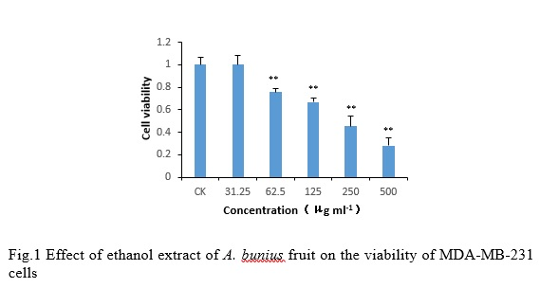

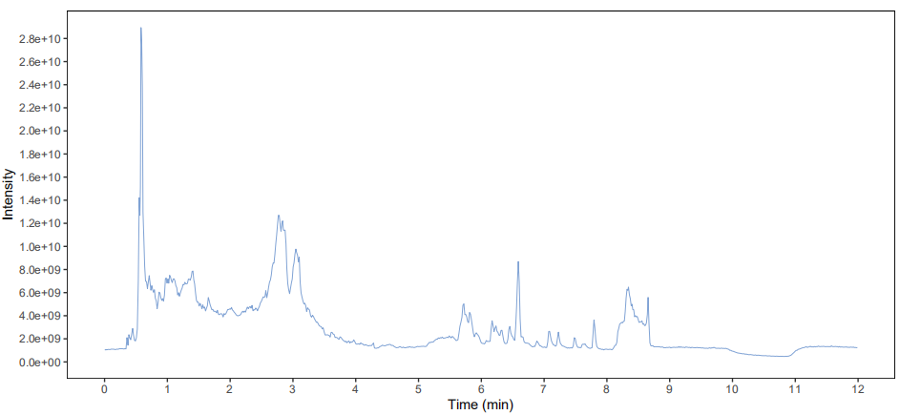

Negative

Positive

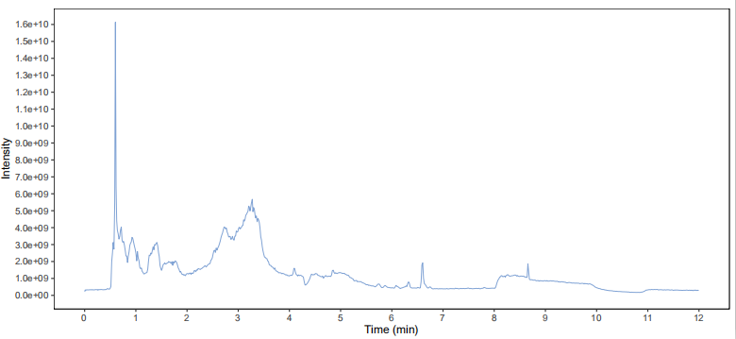

Fig.2 UPLC MS/MS analysis of Eth extracts of *A. bunius* fruit

Table 1 Identified main compounds in Eth extract of *A.burius* fruit

|  |  |  |  |  |  |  |  |
| --- | --- | --- | --- | --- | --- | --- | --- |
| No. | MS2 name | MS2 score | rt | mz | type | SuperClass | Area% |
| 1 | Citric acid | 0.9941 | 516.89 | 191.0189 | - | Organic acids and derivatives | 19.76 |
| 2 | 3-Hydroxybenzoic acid | 0.9917 | 35.48 | 137.0235 | - | Benzenoids | 9.50 |
| 3 | Coumarin | 0.5256 | 183.57 | 145.0287 | - | Phenylpropanoids and polyketides | 7.87 |
| 4 | Genistin | 0.9531 | 158.49 | 431.0987 | - | Phenylpropanoids and polyketides | 5.53 |
| 5 | 4-Hydroxycinnamic acid | 0.9243 | 180.20 | 163.0396 | - | Phenylpropanoids and polyketides | 5.05 |
| 6 | Aspirin | 0.9904 | 112.33 | 179.0344 | - | Benzenoids | 4.35 |
| 7 | Amentoflavone | 0.9420 | 33.75 | 537.0827 | - | Phenylpropanoids and polyketides | 3.77 |
| 8 | Fertaric acid | 0.4985 | 349.60 | 325.0562 | - | Phenylpropanoids and polyketides | 3.65 |
| 9 | Mesylate | 0.9357 | 119.48 | 94.9800 | - | Organic compounds | 3.57 |
| 10 | 2,3-Dihydroxybutanedioic acid | 0.9942 | 434.55 | 149.0084 | - | Organic oxygen compounds | 3.51 |
| 11 | Itaconic acid | 0.9968 | 64.63 | 129.0187 | - | Lipids and lipid-like molecules | 3.09 |
| 12 | Gallic acid | 0.9527 | 477.04 | 169.0134 | - | Benzenoids | 2.85 |
| 13 | Terephthalic acid | 0.9855 | 125.75 | 165.0189 | - | Benzenoids | 2.83 |
| 14 | 4-Hydroxybenzeneacetonitrile | 1.0000 | 163.54 | 132.0449 | - | Benzenoids | 2.77 |
| 15 | Vanillic acid | 0.9715 | 177.66 | 167.0345 | - | Benzenoids | 2.76 |
| 16 | 4-Hydroxybenzoic acid | 0.9981 | 186.89 | 137.0238 | - | Benzenoids | 2.37 |
| 17 | Abscisic acid | 0.8276 | 85.21 | 263.1290 | - | Lipids and lipid-like molecules | 2.25 |
| 18 | cis-Aconitic acid | 0.9803 | 468.52 | 173.0087 | - | Organic acids and derivatives | 1.53 |
| 19 | 3-Hydroxymethylglutaric acid | 0.9466 | 389.14 | 161.0447 | - | Lipids and lipid-like molecules | 1.44 |
| 20 | But-2-enoic acid | 1.0000 | 468.52 | 85.0287 | - | Lipids and lipid-like molecules | 1.40 |
| 21 | Luteolin 7-galactoside | 0.9060 | 216.47 | 447.0927 | - | Phenylpropanoids and polyketides | 1.36 |
| 22 | Isoferulic acid | 0.8679 | 34.82 | 193.0501 | - | Phenylpropanoids and polyketides | 1.21 |
| 23 | Maleic acid | 0.9981 | 295.00 | 115.0030 | - | Organic acids and derivatives | 1.09 |
| 24 | Methyl vanillate | 0.8092 | 35.48 | 181.0499 | - | Benzenoids | 1.06 |
| 25 | 4-Hydroxystyrene | 0.9991 | 180.20 | 119.0496 | - | Benzenoids | 1.05 |
| 26 | trans-Ferulic acid | 0.9791 | 349.60 | 193.0501 | - | Phenylpropanoids and polyketides | 1.01 |
| 27 | 1,2,3-Trihydroxybenzene | 0.9945 | 325.53 | 125.0236 | - | Benzenoids | 1.00 |
| 28 | Cosmosiin | 0.9896 | 176.01 | 433.1130 | + | Phenylpropanoids and polyketides | 0.86 |
| 29 | Peonidin-3-glucoside | 0.9257 | 139.49 | 463.1224 | + | Phenylpropanoids and polyketides | 0.74 |
| 30 | Choline | 0.9997 | 291.34 | 104.1070 |  | Organic nitrogen compounds | 0.74 |

Fig.3 Effect of different extraction of fruit of *A.bunius* on the viability of MDA-MB-231 cells

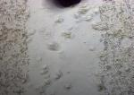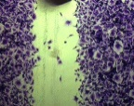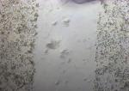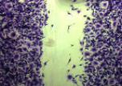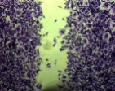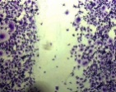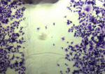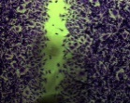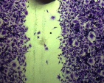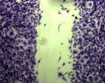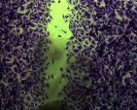

control 6.25μg/mL 12.5μg/mL 25μg/mL 50μg/mL 100μg/mL



Fig.4 Effect of EA extract of *A. bunius* fruit on the migration of MDA-MB-231 cells

50μg/mL



control

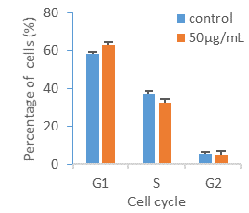

**

*

Fig.5 Effect of EA extract of *A.bunius* fruit on cell cycle of MDA-MB-231 cells

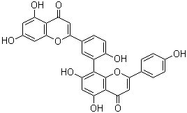

EtOAc extract of *A.bunius* fruit

Amentoflavone

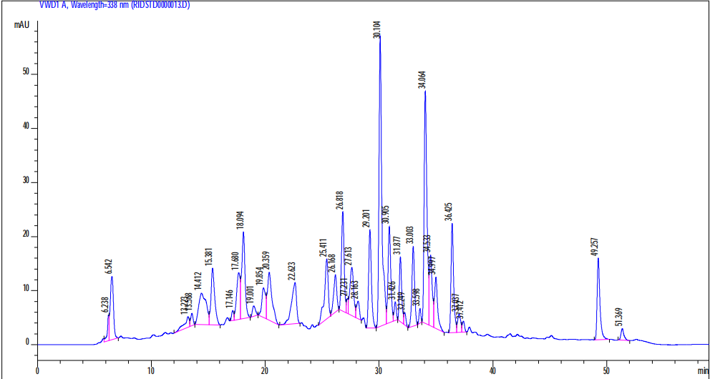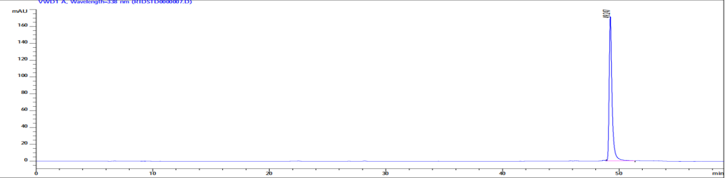

Fig.6 HPLC total ion chromatogram of ethyl acetate phase extract of *A.bunius* fruit

