Running title: Gender Recognition of Blue Swimming Crab Seeds

Color And Morphometric Markers For Gender Recognition Of Blue Swimming Crab (Portunus pelagicus) Seeds

Yushinta Fujaya^{1*}, Andi Aliah Hidayani¹, Moh. Tauhid Umar ¹, Lindah Lindah¹, Iman Sudrajat², Faidar Faidar³, Waiho Khor⁴ and Hanafiah Fazhan⁴
¹Fisheries Department, Faculty of Marine Science and Fisheries, Hasanuddin University, South Sulawesi, 90245, Indonesia
²National Research and Innovation Agency, Indonesia
³Takalar Brackish Water Aquaculture Fisheries Center, Indonesia.
⁴Institute of Tropical Aquaculture and Fisheries, Universiti Malaysia Terengganu, Malaysia

*For correspondence: yushinta.fujaya@unhas.ac.id

†Contributed equally to this work and areco-first authors

Received;Accepted;Published

Novelty statement

Identification of sex in crab seeds has not been widely done even though this is important for cultivating crabs with single sex. The results of this study show that seed color (dark and light) can be used to determine the sex of crab seeds before the secondary genitalia can be observed visually.

Abstract

This research aims to reveal whether differences in seed color can be used as a benchmark in determining the sex of blue swimmer crab (BSC) seeds. To reveal the morphological differences between the seed color and gender, firstly the crab seeds were grouped based on color, namely dark, dark-spotted, and light. The morphological characteristics were measured at the age of 10 days (C10) and sexual confirmation at 31 days (C31) of crabs. Measurements were carried out using a surgical microscope. Based on Fisher's F asymptotic approximation shows that seed color has different morphometric characters (P<0.05). The results of the Fisher distance test explained that there was no significant difference between dark spotted and light (P>0.05), but both were different from dark (P<0.05). Based on the canonical discriminant function, six discriminator characters are obtained, namely the CL/CW, MEL/CW, MAL/CW, MEW/CW, PL/CW, and TW/CW ratios. The classification of dark members can be seen with a percentage of accuracy (% correct) of 76.67%, dark-spotted (70.00% accuracy), and light pattern of 60.00%. After cross-validation, it can be seen that the percentage of classification accuracy is 62.22%. Observations for secondary sexual traits (pleopods and gonophores) showed that the dark spotted and light crab seeds were predominantly female (60% - 63% each) while the dark crab seeds were dominantly male (63%). The findings contribute greatly to the accuracy of gender identification of BSC during the early stages and provide an understanding of selecting crabs of a certain gender for cultivation.

Keywords: Aquaculture, Color, Crab, Gender, Morphometric, Portunus pelagicus

Introduction
Blue Swimming Crab (Portunus pelagicus) is one of the important fisheries commodities in the world. These crabs are traded whole with hard shells, or as soft shell crabs, and also in the form of canned meat and exported overseas. Apart from being produced by catching crabs at sea, these crabs can be cultivated in earthen ponds (Fujaya et al. 2016).
Crab cultivation can be a solution for the sustainable supply of crab products. However, with various specific characteristics of crabs, cultivation techniques also require specific strategies. Several reports state that mono-sex culture in crustaceans is better than mixed culture because males and females in decapod species generally have different growth patterns which cause variations in harvest size (Oniam et al. 2017). Differences in growth are characterized by variations in behavior, and specific growth rates followed by gonad maturity and food conversion ratio. Some control over these parameters can be done by carrying out mono-sex cultures so that the energy is not directed toward reproduction but toward somatic growth. This is part of commercial considerations such as increasing cultivation production. Li (2022) said that knowledge of sex determination and sex differentiation in crustaceans not only contributes to technical innovation in monosexual cultivation but also to improving overall economic efficiency.
Determining gender is easy when the crab is an adult. Gender can be determined based on body color and the shape of the abdominal covering. The body color of the male blue swimmer crab is bluish, especially on the walking legs. The carapace, claws, and base of the swimming legs are covered in white dots. Female crabs have different colors from males. Female crabs have a greenish to brownish or dirty green body color. Some females have olive-colored spots and some are plainer (Lai et al. 2010). In addition, gender is easy to identify based on the shape of the abdominal covering (Waiho et al. 2021; Fazhan et al. 2021; Hidayani et al. 2015). In males, the abdominal cover is more tapered in a triangular shape, while in females it is wider. Under the female's abdominal covering, there are four pairs of pleopods, and on the coxae of the third pair of walking legs, there is a pair of gonophores. Males have only two pairs of pleopods and are located anteriorly on the abdomen, on segments 1 and 2 Both function in the transfer of sperm to the female during copulation. The long, curved, tubular first pleopod is the gonopod. It is not the penis, instead an intermittent organ used to deliver spermatophores to the female gonopore. The second pleopod is much shorter and functions as a piston to push spermatophores through the hollow core of the gonopod (Efrizal et al. 2015).
The sex of crablets of mud crabs (Scylla paramamosain) could be distinguished based on the shape of the abdomen and the presence of gonophores or not using a dissecting microscope or scanning electron microscope (Cui et al. 2021). However, recognizing the gender in the crablet phase is difficult because the shape of the abdomen is still difficult to distinguish without using a microscope. The visible difference is that the color of the seeds is plain dark, plain light, and light with dark spots. Can the difference in color of blue swimmer crab seeds be used as a marker of gender? The answer will be discussed in this paper.

Materials and Methods

Blue Swimmer Crab Seed
10-day blue swimmer crab seeds (C10) were obtained from the hatchery production of the Takalar Brackish Water Cultivation Research Institute. Crab seeds are grouped based on three color groups, namely dark-spotted, dark, and light (Fig. 1). There were 390 crab seeds used in this research. Ninety seeds with three color groups were observed for their morphometric characteristics in the fish hatchery laboratory at Hasanuddin University and 300 crab seeds were reared for 21 days in fixed cages in earthen ponds.

Morphological Traits and Sex Determination
Morphological traits measured include Carapace width (CW), Carapace length (CL), Major cheliped means length (MEL), Major cheliped merus Width (MEW), Major cheliped manus length (MAL), Major cheliped dactylus length (DAL), Penultimate segment length (PL), Penultimate segment width (PW), Telson width (TW), Abdomen width (AB) (Fig. 2) and sex determination is carried out based on the presence of gonopods and gonophores located under the abdominal cover (Fig. 3) after crab one-month-old. Observations of morphometric characters and the presence of gonopods-gonophores were carried out under an SZ61 stereo microscope (Olympus) connected to a computer.

Statistic analysis
All data were analyzed with Microsoft Excel 2019. Results are expressed as mean values with standard error of the mean (StDev). Analisis korelasi antara ciri-ciri morfologi dengan jenis kelamin dilakukan dengan menggunakan koefisien Pearson (two-tailed, p-value). For the construction of discriminant function equations, the values of ten traits (except CW) were standardized by CW. Discriminant analysis was carried out on the ratio values of the three color groups of crab seeds using the Stepwise (Backward) method with the help of XLSTAT software version 2019.2.2.59614.

Results
The results of measuring ten morphological characters on 10-day-old crabs showed that there were variations in each group of seed color (Table 1). Based on Fisher's F asymptotic approximation box test, it was found that the covariance matrix for the three colors was significantly different (p<0.05) and Fisher's distance test explained that the dark color group was different from dark spotted and light, but dark spotted and light were not significantly different (Table 2 ).
The results of the canonical discriminant function analysis obtained six discriminator characters that discriminate (characterize) the three color groups of blue swimmer crab seeds, namely the CL/CW, MEL/CW, MAL/CW, MEW/CW, PL/CW, and TW/CW ratios with coefficients good canonical discriminant function F1 = -3.458 + 13.032*CL/CW – 16.420*MEL/CW + 13.907*MAL/CW + 22.479*MEW/CW 90.121*PL/CW + 77.752*TW/CW and F2 = -4.376 + 36.941 *CL/CW – 13,352*MEL/CW – 27,286*MAL/CW + 5,054*MEW/CW + 16,406*PL/CW – 26,866*TW/CW. The discriminant function shows that the distribution of each member (individual) of the three crab seed colors in the F1 plot has a variance contribution of 83.45% and F2 (16.55%). In Figure 4, it can be seen that there is a tendency for members to group together at each seed color centroid, although there is also an overlap of several members that are scattered at other color centroids.
Based on the Classification of Member Matrix and after Cross-Validation, it can be seen that the dark group has an accuracy (% correct) of 76.67%, dark-spotted (70.00% accuracy), and light % correct is 60.00%. After cross-validation, it can be seen that the percentage of classification accuracy is 62.22% (Table 3).
Gender confirmation is carried out after the crab is one month old when the gonopods and gonophores can be observed under a microscope. The results of observing the presence or absence of gonopods but rather gonophores under the abdominal cover showed that the discriminant analysis carried out correctly identified gender (Figure 5). The dark-spotted and light-colored groups are predominantly female (60-63%), while the dark group is predominantly male (63%).

Discussion
The color of crab seeds tends to be a marker of gender. Although the level of accuracy does not reach 100%, dark-colored seeds are dominantly male while light-colored seeds and spotted dark-colored seeds are dominantly female (Figure 5). These results strengthen the results of the morphometric analysis (Table 3) which explains that the size and shape of the carapace, claws, and abdominal covering can be used as markers of sex. This is similar to sexual dimorphism in mud crabs (Cui et al. 2021) and Xenograpsus testudinatus (Tseng et al. 2020). The chelipeds are used for fighting making male chelipeds tend to be larger than females. Female chelipeds are generally only used for finding food. Besides that, the abdominal cover is the part that protects the reproductive organs. The abdominal cover in males is smaller because it only functions to protect the genitals such as the penis and gonopods, whereas in females, the abdominal cover is also used to incubate eggs (Alencar et al. 2014).
The presence of gonopods and gonophores in blue swimmer crab seeds is an important marker in identifying gender. In this study, 1-month-old juvenile crabs with an average carapace width of 3.8 cm could have their sex identified based on the presence of gonopods or gonophores observed under a stereo microscope. In fact (Cui et al. 2021) reported that the secondary sexual traits and abdominal morphology (shape and pleopods) of the seed of the mud crab Scylla paramamosain can be easily observed under a dissecting microscope and scanning electron microscope starting at stage C VIII at a carapace width above 2 cm with 90.48% accuracy.
The sex ratio in each color group (Figure 5) provides interesting information that the color of the crab seeds can be used as a marker of sex. The sex ratio in each color group shows 2:1 (F:M) in the light color group and black, conversely 1:2 in the dark color group. This is different from reports by several researchers that in nature, the sex ratio of crabs is 1:1 (Shabrina et al. 2020; Rohmayani et al. 2020; Hosseini et al. 2014). Cui et al. (2021) also reported that the female:male sex ratio of all crablets S.paramamosain was 1:1. from stage C V to stage C VIII.
According to Arnheiter (2010), sexual color dimorphism is also called sexual dichromatism and is widespread among animals. One sex (usually the male) has a striking color, while the other sex, the female, is inconspicuous. This is closely related to natural selection, on the contrary, it will act antagonistically and select genes that allow carriers of their color genes to blend in with the environment. thereby protecting them from predation, or, when they become predators, reducing detection by their prey. Obviously, there is an inherent conflict in the selection of traits that are beneficial and detrimental and are otherwise more beneficial to one sex than to the other. Mutations and evolution occur in a species that cause a change in color from dull to striking making carriers of that species more attractive to potential mates and helping ward off competitors. Dunn et al. (2020) said that apart from genetic factors, environmental factors such as the abiotic and biotic environment, including temperature, length of day, pollutants, and parasites influence sex determination, sex ratio, and reproductive behavior of crustaceans.
The color of crab seeds changes as they develop. After being reared in embedded cages and provided with shelter in the form of seaweed, these crabs have a dark green base color in both males and females. No more bright colors. However, dirty white spots appeared on both of them. It can be assumed that apart from genetic influences, the color of sex markers is also influenced by the environment. Color changes in animals can be triggered by various social and environmental factors and can occur within seconds or months. The most dramatic changes in color patterns are often associated with molting and its use in visually mediated mate recognition. (Detto et al. 2008). Color is influenced by chromatophore pigments found in almost all crustaceans. Chromosomes, chromatophores, and their pigments are the primary means by which crustaceans adapt chromatically to their environment. This pigmentation system is used in a variety of ways, including species-specific signals, aposematic signals, mate attraction, reproductive strategies, protection against ultraviolet (UV) radiation, and thermal regulation (Mc Namara & Milograna 2015).
However, Sex determination involves mechanisms that determine whether an individual will develop into a male, female, or in rare cases, a hermaphrodite. In crustaceans, sex determination is very diverse, including hermaphroditism, environmental sex determination (ESD), genetic sex determination (GSD), and cytoplasmic sex determination (Ye et al. 2023). Toyota et al. (2021) said that Sexual differences arise during embryogenesis. In Malacostracans, sex is generally determined by genetic factors such as sex chromosomes. Crustacean Female Sex Hormone (CFSH) is also known as a peptide hormone involved in sexual development. Color genes are thought to be under indirect sexual control, for example through the action of sex hormones that enable seasonal and sex-specific color management. The sexual system is thought to play a role in linking genes that determine sex color.
Such sex chromosome systems can be grouped into two major forms: male heterogamety (called XX/XY system), and female heterogamety (called ZW/ZZ system). In Malacostraca, the majority of shrimps, crayfishes, and terrestrial isopods employ a ZZ/ZW sex determination system while some species of crabs and lobsters employ XX/XY determination (Toyota et al. 2021). The power of genes in influencing color depends on the sexual system which is also called sex-linked genes (Arnheiter 2010). Animal color is influenced by gene expression. If individuals with sex determination XX or ZW have IAG (insulin-like androgenic gland hormone) in the off position and CFSH on during sex differentiation then they will have a female phenotype, whereas sex determination XY or ZZ which have IAG will have a male phenotype (Toyota et al. 2021).

Conclusion
The color of crab seeds tends to be a marker of gender. Although the level of accuracy does not reach 100%, dark-colored seeds are dominantly male (1:2; F:M) while light-colored seeds and spotted dark-colored seeds are dominantly female (2:1; F:M). Apart from being influenced by genetics, color sexual dimorphism may also be influenced by environmental factors.

Acknowledgments
This study was funded by Hasanuddin University under a scheme of Collaborative Fundamental Research Grants with contract number: 00323/UN4.22/PT.01.03/2023.

Author contributions
The authors contributed to the study's conception and design. Grant acquisitions were contributed by YF. Crab seeds preparation was performed by IS and FF. Data collection and analysis were performed by LL and MTU. Visualization and data validation were performed by KW and HF. The first draft of the manuscript was written by YF and AAH. All authors commented on previous versions of the manuscript. All authors read and approved the final manuscript.
Conflict of Interest
All authors declare no conflict of interest.

Data Availability
Data presented in this study will be available on a fair request to the corresponding author.

Ethics Approval
Not applicable to this paper.

References

Alencar CERD, PA Lima-Filho, WF Molina, FAM Freire (2014). Sexual Shape Dimorphism of the Mangrove Crab Ucides cordatus (Linnaeus, 1763) (Decapoda, Ucididae) Accessed through Geometric Morphometric. The Scientific World Journal 8: 206168.
Arnheiter H (2010). Sex-specific coloration for display and camouflage. Pigment Cell Melanoma Res. 23(4): 480–481.
Cui W, S Fang, LLZ Huang, F Lin, Q Wu, H Zheng, S Li, Y Zhang, M Ikhwanuddin, H Ma (2021). Evidence of Sex Differentiation Based on Morphological Traits During the Early Development Stage of Mud Crab Scylla paramamosain. Front. Vet. Sci. 8: 712942.
Detto T, JM Hemmi, PRY Backwell (2008). Colouration and Colour Changes of the Fiddler Crab, Uca capricornis: A Descriptive Study. PLoS ONE 3(2): e1629.
Dunn AM, T Rigaud, AT Ford (2020). Environmental influences on crustacean sex determination and reproduction: environmental sex determination, parasitism and pollution. In R.D. Cothran; M. Thiel. (eds). The Natural History of the Crustacea: Reproductive Biology, 6 pp.394-428, Oxford University Press.
Efrizal, A Arshad, MS Kamarudin, CR Saad, SMN Amin (2015). Some Aspects of Reproductive Biology of Blue Swimming Crab (Portunus pelagicus (Linnaeus, 1758)) Under Laboratory Conditions. Journal of Fisheries and Aquatic Science 10(2): 77-91.
Fazhan H, K Waiho, Y Fujaya, N Rukminasari, H Ma, M Ikhwanuddin (2021). Sexual dimorphism in mud crabs: a tale of three sympatric Scylla species. PeerJ 9:e10936.
Fujaya Y, DD Trijuno, S Aslamyah, N Alam (2016). Domestication and selective breeding for producing fast growing and high meat quality of blue swimming crab (Portunus pelagicus). AACL Bioflux 9(3):670–9.
Hidayani AA, Y Fujaya, AI Asphama, DD Trijuno, A Tenriulo, A Parenrengi (2015). The Morphometric Character and Mitochondrial 16S rRNA Sequence of Portunus pelagicus. Aquacultura Indonesiana 16 (1):1-9.
Hosseini M, J Pazooki, M Safaei (2014). Size at Maturity, Sex Ratio and Variant Morphometrics of Blue Swimming Crab Portunus segnis (Forskål, 1775) from Boushehr Coast (Persian Gulf). J. Marine Sci Res Dev 4: 149.
Lai JCY, PKL Ng, PJF Davie (2010). A Revision Of The Portunus pelagicus (Linnaeus, 1758) Species Complex (Crustacea: Brachyura: Portunidae), With The Recognition Of Four Species. The Raffles Bulletin of Zoology 58(2): 199–237.
Li J (2022). A Review of Sexual Determination and Differentiation in Crustacean. Journal of Biosciences and Medicines 10: 19-37.
Mcnamara JC, SR Milograna (2015). Adaptive Color Change and The Molecular Endocrinology Of Pigment Translocation In Crustacean Chromatophores. In Ernest S. Chang, Martin Thiel (eds). The Natural History of The Crustacea, Volume 4, Physiological Regulation (Pp.68-102). Oxford University Press.
Oniam V, W Taparhudee, R Yoonpundh (2017). Comparative performance of monosex and mixed-sex blue swimming crab (Portunus pelagicus Linnaeus, 1758) culture. In: The Burapha University International Conference 2017, Bangsaen, Chonburi, Thailand. 2017. p. 308–15.
Rohmayani V, ET Sari, N Romadhon (2020). Sex Ratio and Spawning Season of Blue Swimming Crab (Portunus pelagicus, Linnaeus, 1758) in North Java Sea, Indonesia. Indian Journal of Ecology 47(4): 1185-1188.
Shabrina N, AMA Khan, I Gumilar, D Supriadi (2020). Size Distribution and Sex Ratio of the Blue Swimming Crab (Portunus (Portunus) pelagicus Linnaeus, 1758) Commodities in Gebang Mekar Village, Cirebon Regency, West Java, Indonesia. World News of Natural Sciences 30(2): 232-242.
Toyota K, H Miyakawa, C Hiruta, T Sato, H Katayama, T Ohira, T Iguchi (2021). Sex Determination and Differentiation in Decapod and Cladoceran Crustaceans: An Overview of Endocrine Regulation. Genes, 12: 305.
Tseng LC, PY Yu, JS Hwang (2020). Distribution and sexual dimorphism of the crab Xenograpsus testudinatus from the hydrothermal vent field of Kueishan Island, northeastern Taiwan. PLoS ONE 15(3): e0230742.
Waiho K, M Ikhwanuddin, MH Abualreesh, AC Shu-Chien, SD Ishak, M Jalilah, G Azmie and H Fazhan (2021). Intra- and Interspecific Variation in Sexual Dimorphism Patterns of Mud Crab Genus Scylla Along the Equatorial Region. Front. Mar. Sci. 8:690836.
Ye Z, T Bishop, Y Wang, R Shahriari, M Lynch (2023). Evolution of sex determination in crustaceans. Marine Life Science & Technology, 5:1–11.

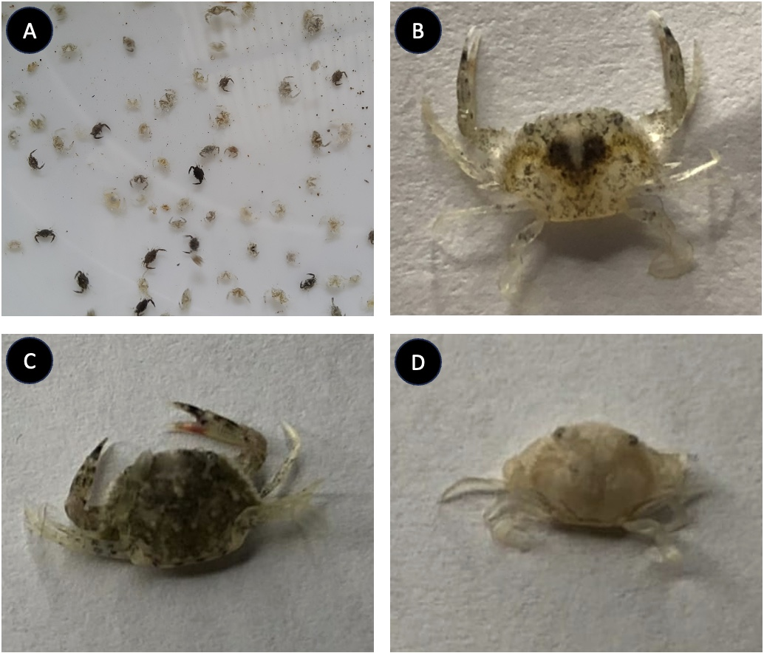
Fig. 1: Blue swimming crab seeds (C10) with various colors (A); Dark Spotted (B); Dark (C); Light (D).

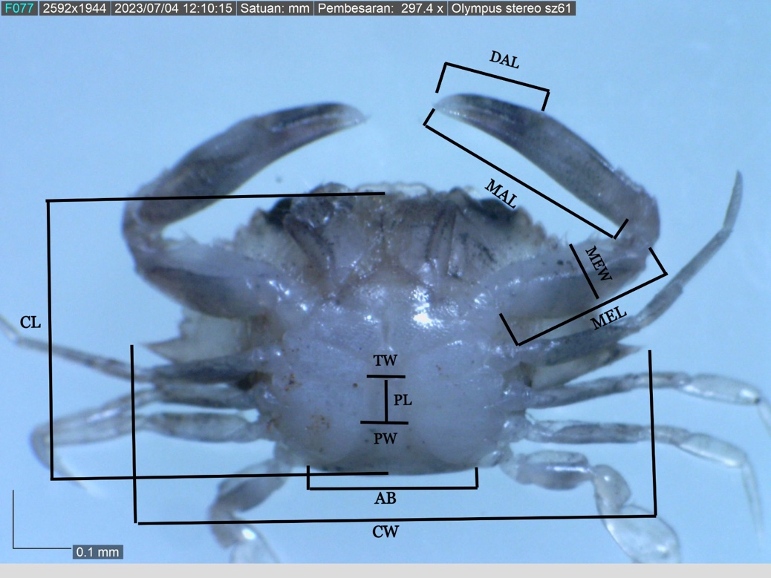

Fig. 2: Measurement index of blue swimmer crab seeds. Carapace width (CW), Carapace length (CL), Major cheliped means length (MEL), Major cheliped merus Width (MEW), Major cheliped manus length (MAL), Major cheliped dactylus length (DAL), Penultimate segment length (PL), Penultimate segment width (PW), Telson width (TW), Abdomen width (AB).

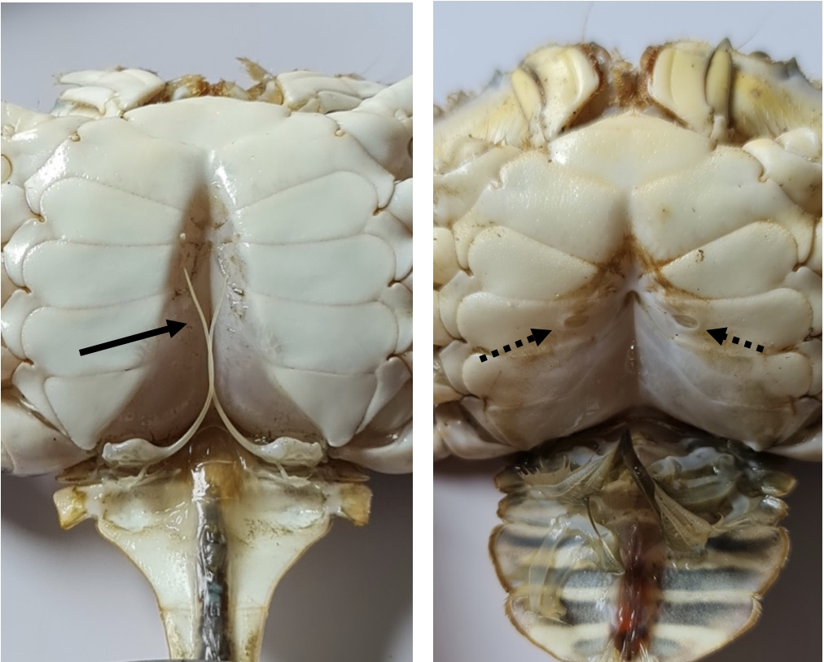

Fig. 3: Sexual characteristics of blue swimmer crabs. The solid arrow indicates the gonopod and the dashed arrow indicates the gonopore

Fig. 4: The discriminant function of the three color groups of blue swimmer crab seeds based on their morphometric characters

Fig. 5: Composition of males and females in the three color groups of blue swimmer crab seeds at one-month-old.
Table 1: Morphometric data from the three color groups of blue swimmer crab seed

Color variation | Units (mm) | CW | CL | MEL | MAL | MEW | PL | PW | TW | AB | DAL
dark spotted | average | 9,275 | 5,075 | 2,959 | 4,162 | 1,196 | 0,793 | 0,955 | 0,638 | 2,806 | 2,009
 | stdev | 1,458 | 0,776 | 0,523 | 0,704 | 0,200 | 0,146 | 0,183 | 0,124 | 0,725 | 0,340
dark | average | 8,690 | 4,891 | 2,713 | 3,928 | 1,113 | 0,620 | 0,833 | 0,600 | 2,541 | 1,873
 | stdev | 1,726 | 0,816 | 0,519 | 0,819 | 0,232 | 0,189 | 0,203 | 0,132 | 0,588 | 0,393
light | average | 9,180 | 5,114 | 2,787 | 4,036 | 1,292 | 0,791 | 0,958 | 0,639 | 2,818 | 1,910
 | stdev | 1,309 | 0,619 | 0,614 | 0,609 | 0,495 | 0,146 | 0,182 | 0,124 | 0,719 | 0,349
Note: Carapace width (CW), Carapace length (CL), Major cheliped means length (MEL), Major cheliped merus Width (MEW), Major cheliped manus length (MAL), Major cheliped dactylus length (DAL), Penultimate segment length (PL), Penultimate segment width (PW), Telson width (TW), Abdomen width (AB)

Table 2: Fisher distances analysis for the three color groups of blue swimmer crab seed

Fisher distances:
 | dark | dark spotted | light
dark | 0 | 8.293 | 8.024
dark spotted | 8.293 | 0 | 2.026
light | 8.024 | 2.026 | 0
p-values for Fisher distances:
 | dark | dark spotted | light
dark | 1 | < 0.0001 | < 0.0001
dark spotted | < 0.0001 | 1 | 0.071
light | < 0.0001 | 0.071 | 1

Table 3: Classification and Cross-Validation of Member Matrix of the three color groups of blue swimmer crab seeds

Classification of Member Matrix
from \ to | dark | dark spotted | light | Total | % correct
dark | 23 | 4 | 3 | 30 | 76.67%
dark spotted | 4 | 21 | 5 | 30 | 70.00%
light | 2 | 10 | 18 | 30 | 60.00%
Total | 29 | 35 | 26 | 90 | 68.89%

Cross-Validation of Classification Matrix
from \ to | dark | dark spotted | light | Total | % correct
dark | 22 | 5 | 3 | 30 | 73.33%
dark spotted | 4 | 18 | 8 | 30 | 60.00%
light | 3 | 11 | 16 | 30 | 53.33%
Total | 29 | 34 | 27 | 90 | 62.22%

