Manuscript type: Original Research Article
Title: Feeding Preference of Dusky Cotton Bug (Lygaeidae: Hemiptera) on Five Different Seeds and Leaves Under Laboratory Conditions
Running Title: Feeding preference of dusky cotton bug
Authors: Muhammad Afaq Ahmed^{1,2}, Waqar Jaleel^{3*}, Rabia Saeed⁴, Muhammad Umair Sial⁵, Rashid Azad⁶, Abdul Rashid⁷, Farrukh Hamid², Qasim Farooq⁸, Syed Muhammad Zaka^{2*}, Tong-Xian Liu^{1*}
¹Key Lab of Integrated Crop Pest Management of Shandong Province, College of Plant Health and Medicine, Qingdao Agricultural University, Qingdao, Shandong, China
²Department of Entomology, Faculty of Agricultural Sciences and Technology, Bahauddin Zakariya University, Multan, Pakistan
³Guangdong Provincial Key Laboratory of High Technology for Plant Protection, Plant Protection Research Institute, Guangdong Academy of Agricultural Sciences, No. 7 Jinying Rd., Tianhe District 510640, Guangzhou, Guangdong, China
⁴Entomology Section, Central Cotton Research Institute, Multan Pakistan
⁵Institute of Plant Protection, Muhammad Nawaz Shareef University of Agriculture, Multan, Pakistan
⁶Department of Entomology, The University of Haripur, Khyber Pakhtunkhwa, Pakistan
⁷Department of Entomology, College of Agriculture, South China Agricultural University, Guangzhou, Guangdong Province, China
⁸Department of Botany, University of Agriculture, Faisalabad, Punjab 38000, Pakistan

*For corresponding: txliu@qau.edu.cn; zaka_ento@bzu.edu.pk; waqar4me@yahoo.com

Novelty statement:
- Feeding preference of dusky cotton bug on different hosts (including less preferred hosts) were evaluated.
- Y-tube olfaction assays along with cage and jar experiments were performed.
- Cotton and okra are observed to be highly preferred for dusky cotton bugs.
- Less preferred hosts including moringa and eucalyptus can be grown as trap crops as a discretion of insecticides for cotton crop.

Abstract
Dusky Cotton bug (Oxycarenus laetus Kirby) is categorized as one of the serious pest of cotton and other malvaceous plants, as its damage is very prominent in cotton crop. Its status as a pest has been widely reported in tropical and subtropical countries. For integrated control of dusky cotton bugs and to reduce the use of insecticides on cotton crop, understanding the preferable and attractive host plant for dusky cotton bugs and their olfactory behavior is crucial for manipulating the effective control programs. In this probation, feeding preference of dusky cotton bugs for different host plants (seeds and leaves) was examined singly and in combination by different experiments such as cage experiment, jar experiment and Y-tube olfaction assay. Our results revealed that preference of male population of dusky cotton bugs was significantly higher on cotton seeds after 3 hours, however in further observations there was no significant difference toward other host seeds. In the case of female population, cotton seeds were highly preferred in all observations while brassica and moringa seeds were least preferred. When mixed population (male + female) were released in the cage there was no significant difference after 1 and 3 hours but after 6 hours eucalyptus seeds were highly preferred and after 12 and 24 hours, cotton seeds attracted significantly more bugs as compared to other host seeds. In cotton seeds + leaves combinations, cotton seeds + cotton leaves and cotton seeds + okra leaves were preferred more as compared to other host combinations after 3 and 24 hours. In Y-tube olfaction assay, all the combinations of host seeds and leaves had similar attraction for dusky cotton bugs. Based on these results, this analysis concluded that cotton and okra are highly preferred for dusky cotton bugs respectively. This study will be helpful for growing trap crops as a discretion of insecticides for cotton crop.
Keywords: Oxycarenus laetus Kirby, Cotton, Feeding preference, Y-tube olfaction.

Introduction
Dusky cotton bug (DCB) Oxycarenus hyalinipennis Kirby (Lygaeidae: Hemiptera) is a serious threat for cotton crop in Pakistan. Now it has gained the status of major pests of cotton crop in Pakistan (Abbas et al. 2015). Besides Pakistan, its infestation has been reported from other countries like China Florida, Bahamas, Caicos, Turks, islands of U.S. and Cayman (Baranowski and Slater 2005; Basit 2018; Khan and Naveed 2017; Smith and Brambila 2008). Although it is a well-known pest of crops of family malvaceae (El-Rahim et al. 2015), its infestation has also been observed on other crops like guava, moringa, mango, okra, chilies and lemon (Ullah Shah et al. 2016). It’s adults as well as nymphs are responsible for affecting the quality and quantity of yield and oil extraction of cotton seeds (Khan and Ahmed 2000; Srinivas and Patil 2004). Individuals of dusky cotton bug are crushed in ginning process, darken the cotton lint, resulting in low price of the cotton in market. Its adults and nymphs gregariously feed on squares of cotton plant, resulting in pale yellow color of squares and then shedding of infested squares (Atwal and Dhaliwal 2005). (Srinivas and Patil, 2004) explored that 50 pairs of dusky cotton bug per boll were responsible for 42.9% loss in cotton weight, 40.8% loss in seed weight, 35.1% loss in oil content and 29.3% loss in viability of seeds.
It has diverse host range. Even it feeds on Okra (Abelmoschus esculentus), Indian mallow (Abutilon indicum), Groundnut, Parthenium (Parthenium hysterophorus), Kenaf (Hibiscus cannabinus), Tridax daisy (Tridax procumbens), Tulip tree (Liriodendron tulipifera) and Neem (Azadirachta indica) (Srinivas and Patil 2003). Various factors are responsible for increasing infestation of dusky cotton bug e.g. adaptation of novel techniques in cotton crop like early sowing of BT-cotton and reduced insecticide application against lepidopterous insect pests. Such factors
are creating favorable conditions for dusky cotton bug and this insect pest is gaining the status of economically important pests in Pakistan (Ullah et al. 2016; Shahid et al. 2017).
Use of insecticides is considered a reliable method against this insect pest in Pakistan and other developing countries (Afzal et al. 2015; Khan et al. 2014). But excessive use of insecticides is unjust because it causes serious environmental and health problems for human being and non-target organisms. Frequent use of insecticides also causes the problems of resistance development in insects. Dusky cotton bug has also developed resistance against many insecticides including bifenthrin, chlorpyrifos, cypermethrin, deltamethrin, lambda-cyhalothrin, methomyl, profenofos, triazophos, acetamiprid, emamectin benzoate, fipronil, spinosad, spirotetramat, imidacloprid and nitenpyram (Ullah et al. 2016; Ullah et al. 2017).
So, we performed an experiment with the aim to determine the effect of physical attributes of preferred and less preferred host crops by dusky cotton bug and chemotaxis behavior of dusky cotton bugs to olfactory cues from different hosts. We used various plants and their parts in various combinations to examine their preference for dusky cotton bug under laboratory conditions. Considering the importance of cotton crop this study will be helpful to reduce the attack of dusky cotton bugs on cotton crop and may serve as alternative of insecticidal application by growing less preferred host crops near and around cotton crop as they are alternative source of habitat for dusky cotton bugs and growing highly preferred crops other than cotton e.g., okra and eucalyptus as a trap crop to guard the cotton crop from dusky cotton bugs.
Materials and Methods
Mass culturing of dusky cotton bug
Test population was collected from cotton crop in the field of Bahauddin Zakariya University, Multan, Pakistan in the beginning of March. At that time, most effective dry stalks were present within the field with unopened bolls. Dusky cotton bugs were present in these unopened bolls. Adults and nymphs were collected with the help of aspirator.
Rearing of test population before being used in experiment
Test population of dusky cotton bug was separated into three groups.
- Male population
- Female population
- Mixed population
Cotton seeds were soaked in water for 20-25 minutes and then were dried, so that these seeds can serve as food for test population. Collected individuals were kept in plastic jars with dimensions 10 x 5 x5 inches under laboratory conditions and were fed on the cotton seeds as mentioned above. Moistened cotton balls were kept in jars to meet the water requirement of test population. Cotton seeds serving as food for test population were replaced with new ones after every seven days. Eggs laid by female ones were collected and kept in another jar, so the population of test individuals may not be disturbed. Temperature was maintained at 25-29℃ and humidity was maintained at 45 to 70%.
Treatments
Feeding preference of test population of each category (males, females and mixed population) towards following seeds was tested separately.
- Cotton
- Okra
- Moringa
- Brassica
- Eucalyptus
Preference of mixed test population was determined for following combination of seeds
- Cotton + cotton
- Cotton + okra
- Cotton + moringa
- Cotton + brassica
- Cotton + eucalyptus
Feeding preferences of mixed individuals towards combinations cotton seeds with leaves of following plants was examined
- Cotton seeds + Cotton leaves
- Cotton seeds + Okra leaves
- Cotton seeds + Moringa leaves
- Cotton seeds + Eucalyptus leaves
Cotton seeds and leaves were collected from glass house in CCRI, Multan, Pakistan. Okra and brassica seeds were collected from super market, while moringa and eucalyptus seeds and leaves were collected from trees grown in the forest area of the Agricultural Department of Bahauddin Zakariya University, Multan, Pakistan. Brassica leaves were not included in the experiment because of unavailability of brassica crop in fields.
Feeding choice test for seeds of various plants
Seeds were soaked in water for 30 minutes and then were allowed to shade dry to meet the moisture requirement of test populations. 6g seeds of each treatment were placed on filter papers and then were placed in a box randomly. Starvation of 24 hours was given to test populations before being used in the experiment. 40 individuals from single group (only males/ only females / mixed: male + female) of test population were released in treatment box. Responses of all of three groups of test populations towards various treatments were measured. Treatments were replicated thrice. Number of individuals of dusky cotton bung on each treatment was recorded after 1, 3, 6, 12 and24 hours.
Feeding choice test for seed + seed combinations
Following combinations were offered to test population;
- Cotton + Cotton
- Cotton + Okra
- Cotton + Moringa
- Cotton + Brassica
- Cotton + Eucalyptus
To meet the water requirement of test population, seeds were soaked in water for 30 minutes and then were allowed to dry. 3g cotton seeds were mixed with 3g seeds of other plant. Each combination served as a treatment. All the treatments were placed on filter papers separately and randomly in a box randomly. Mixed test population was given a starvation period of 24 hours before being used in experiment. 15 individuals were released in the box to examine their preferred treatment. Experiment was replicated thrice. Number of individuals of test population on each treatment was recorded after 1, 3, 6, 12 and 24 hours.
Feeding choice test for cotton seed + leaves combinations
In this segment of experiment, mixed test population was offered following combinations;
- Cotton seeds + Cotton leaves
- Cotton seeds + Okra leaves
- Cotton seeds + Moringa leaves
- Cotton seeds + Eucalyptus leaves
To meet the water requirement of test population, cotton seeds were soaked in water for 30 minutes and then were allowed to dry. In each combination, 3g of leaves of plant were mixed with 3 g of cotton seeds. Each combination served as a treatment. All the treatments were placed in a box randomly. Mixed test population was given a starvation period of 24 hours. 15 starved individuals were released in the box to test their preference for various treatments. Experiment was replicated thrice. Number of individuals on treatments were recorded after 1, 3, 6, 12 and 24 hours.
Olfactometer response of dusky cotton bugs toward different combination of hosts
Following different combination of treatments were designed to have a look on the response of dusky cotton bug in the presence of chemical volatiles of its hosts. Arm containing cotton seeds was considered as a control.
- Combination 1= Cotton seeds Vs. Cotton seeds + Cotton leaves
- Combination 2= Cotton seeds Vs. Cotton seeds + Moringa leaves
- Combination 3= Cotton seeds Vs. Cotton seeds + Eucalyptus leaves
- Combination 4= Cotton seeds Vs. Cotton seeds + Okra leaves
To verify the choice effect of dusky cotton bug on different host plant parts (leaves, seeds), Y-tube olfactometer responses of adults were measured. The test chamber consisted of a Y-shaped glass tube, with each of its two arms connected to one of the two sources of odor. Each arm was 21.0 cm long and 2.5 cm in diameter (Fig. 1). A black cloth was additionally positioned beneath and around the Y-tube test chamber to keep away the effect of light on the movement of adult dusky cotton bugs. Air was passed at the rate of 50ml min⁻¹ through arms of the olfactometer. The second source was similarly connected to the other arm.
A line was drawn on each of the two arms of the olfactometer at 10.0 cm from junction of the two arms. Bugs crossing either line at some stage in 10 min spells were considered to have made a choice (Fig. 1). Each test was repeated 5times with at least 10 adults on each occasion. All the experiments were done under laboratory conditions at temperature of 25℃. After every treatment, the whole apparatus i.e. Y-tube test chamber, flasks, plastic tubes were washed with 95% alcohol and then dried, so that no residues of the closing treatment might remain in the apparatus. This turned into repeated after each treatment, in order that the next treatment would not be affected by the last one (Horton and Landolt 2007).

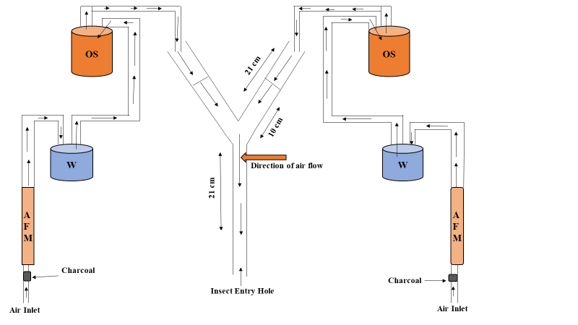
Fig. 1. Schematic diagram of the Y-tube olfactometer (OS: odor source, W: water for maintaining humidity, AFM: air flow meter).

Statistical analysis
Preference of Bugs population towards different host seeds, combination of host seeds and host seeds with leaves were analyzed by using one-way ANOVA, at P < 0.05, all pairwise comparisons test of the homogenous group in SPSS Statistics 20.0 (SPSS Inc., Chicago, IL, USA). The Contrast between different combination of treatments in Olfaction assay was analyzed by Chi-squared (χ²) test in SPSS Statistics 20.0 (SPSS Inc., Chicago, IL, USA) with due value of (α = 0.05). Insects that didn’t respond were not included in statistical analysis. Response toward treatments was summed up as the percentage of insects (Dusky cotton bugs) tempted into the treated arm of Y-tube (the number of dusky cotton bugs attracted in the treated arm divided by the total number of bugs in both host and control arm).
Results
Feeding preference of male population towards various host seeds
After 3 hours, the population of dusky cotton bug was significantly higher on cotton seeds (P = 0.010; F_{2, 4} = 6.83) with mean population of (3.67). No significant difference was recorded in population on various seeds in further observations (1, 6,12 and 24 hours) as shown in (Fig. 2).

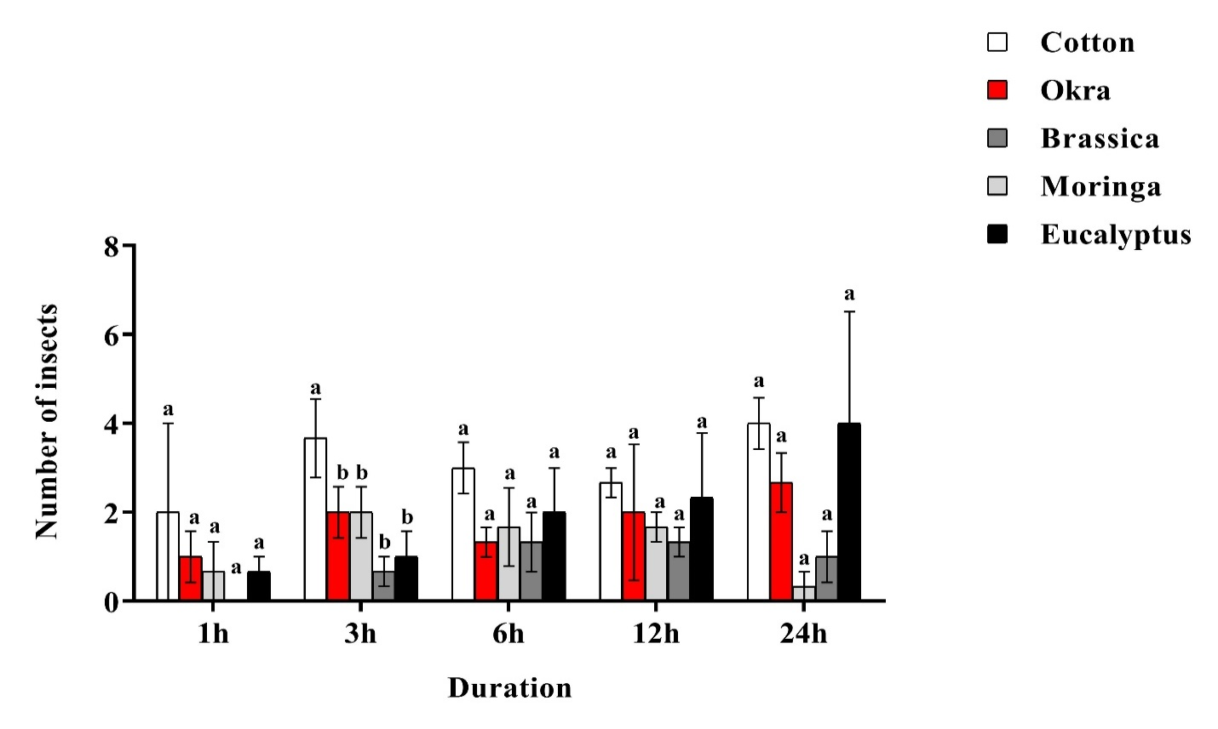
Fig. 2. Feeding population of male individuals of dusky cotton bug on various seeds. Different letters above the bars denotes significant differences (P < 0.05). Values are means ± SE (n = 40).

Feeding preference of female population towards various host seeds
No significant difference in preference by female population was observed after 1 hour. After 3 hours higher number of individuals prefer cotton seeds (P = 0.185; F_{2, 4} = 2.02) with mean population of (5.00) whereas brassica was least preferred with mean population of (0.67) respectively. After 6 hours again cotton seeds were significantly highly preferred by female test population (P = 0.020; F_{2, 4} = 5.47) with mean population of (5.67) followed by eucalyptus (3.33), okra (2.33), moringa (2.00) and brassica (1.33). Similarly, after 12 hours preference of female test population was higher on cotton seeds (P = 0.221; F_{2, 4} = 1.80) with mean number of insects (3.33) while moringa seeds were least preferred with mean population of (0.33). After 24 hours cotton seeds were highly preferred (P = 0.068; F_{2, 4} = 3.35) with mean population of (5.00) as compared to moringa (0.00), brassica (0.33) and eucalyptus seeds (0.33) respectively (Fig. 3).
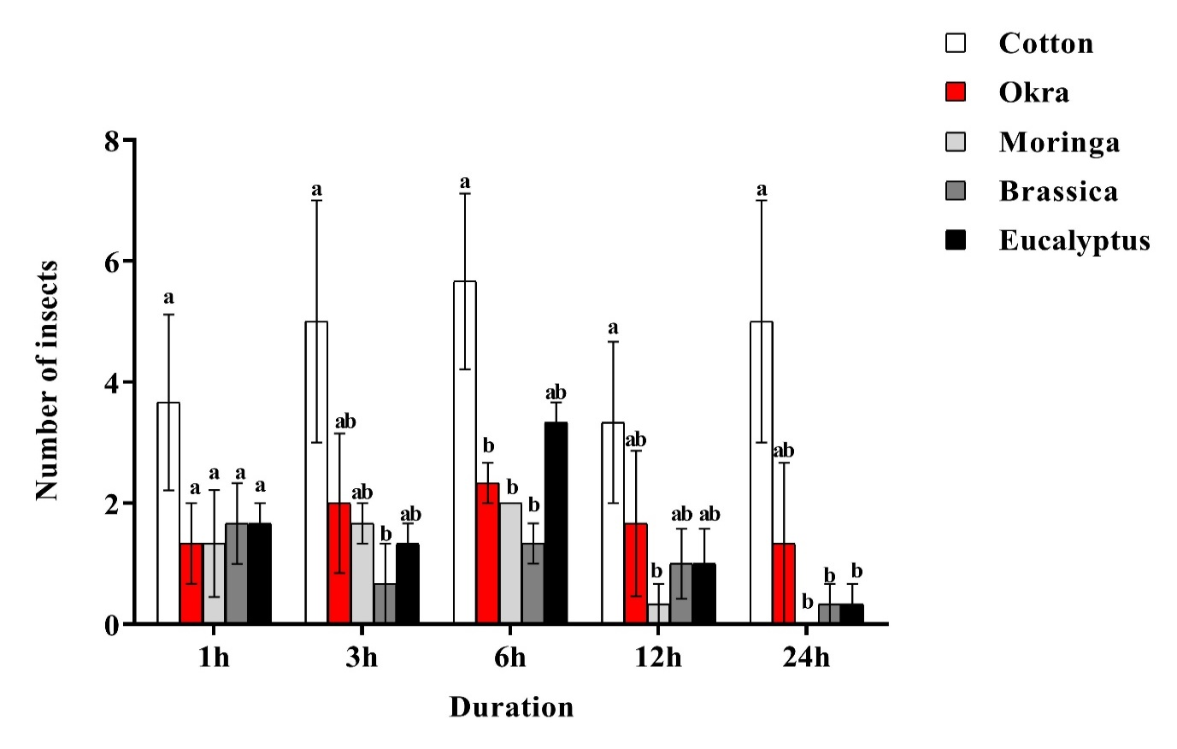
Fig. 3. Feeding population of female individuals of dusky cotton bug on various seeds. Different letters above the bars indicate significant differences (P < 0.05). Values are means ± SE (n = 40).

Feeding preference of mixed population of dusky cotton bug towards various host seeds Significantly higher population of dusky cotton bug was recorded on eucalyptus after 6 hours (P = 0.0017; F_{2, 4} = 12.23) with mean population of (6.33) followed by moringa (4.33) and cotton seeds (2.67) while brassica (1.33) and okra seeds (0.67) were least preferred. After 12 hours, significantly higher number of individuals were found on cotton seeds (P = 0.0001; F_{2, 4} = 41.35) with mean population of (7.67), followed by eucalyptus (2.33), moringa (0.67), okra (0.67) and brassica (0.67). After 24 hours, cotton seeds were again found infested with significantly higher population of dusky cotton bug (P = 0.0016; F_{2, 4} = 12.64) with mean population of (11.33), followed by okra (1.33), moringa (1.00), eucalyptus (0.67) and brassica (0.33) respectively, however there was no significant preference after 1 and 3 hours (Fig. 4).
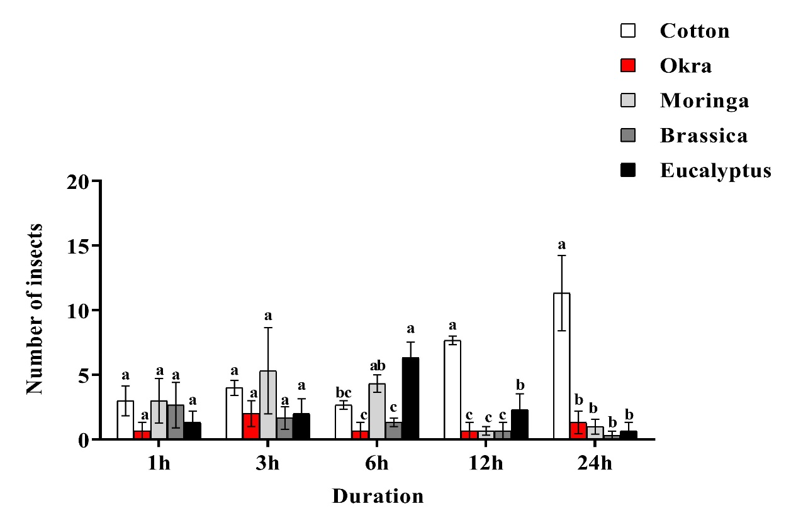
Fig. 4. Feeding preference of mixed population of dusky cotton bug on various seeds. Different letters above the bars denotes significant differences (P < 0.05). Values are means ± SE (n = 40).

Feeding preference of mixed population of dusky cotton bug towards various combinations of host seeds
After 1 hour, individuals of test population settled them on various combinations of seeds with non-significantly different populations (P = 0.1587; F_{2, 4} = 2.20). After 3 hours, population of individuals again non-significantly differed on various hosts (P = 0.131; F_{2, 4} = 2.44). After 6 hours, significantly higher population of dusky cotton bug was settled on combination of cotton + okra (P = 0.032; F_{2, 4} = 4.55) with mean number of (13.67), followed by cotton + cotton (13.00), cotton + brassica (8.67), cotton + eucalyptus (8.00) and cotton + moringa (4.00). After 12 hours, cotton + cotton combination was significantly highly infested by individuals of test population (P = 0.036; F_{2, 4} = 4.36), with mean population of (13.33), followed by cotton + okra (12.67), cotton + eucalyptus (10.33), cotton + brassica (8.67) and cotton + moringa (6.00). After 24 hours, again significantly higher number of dusky cotton bug were recorded on cotton + cotton (P = 0.002; F_{2, 4} = 10.58) with mean population of (13.67), followed by cotton + okra (13.33), cotton + eucalyptus (10.00), cotton + brassica (9.33) and cotton + moringa (6.67) (Fig. 5).
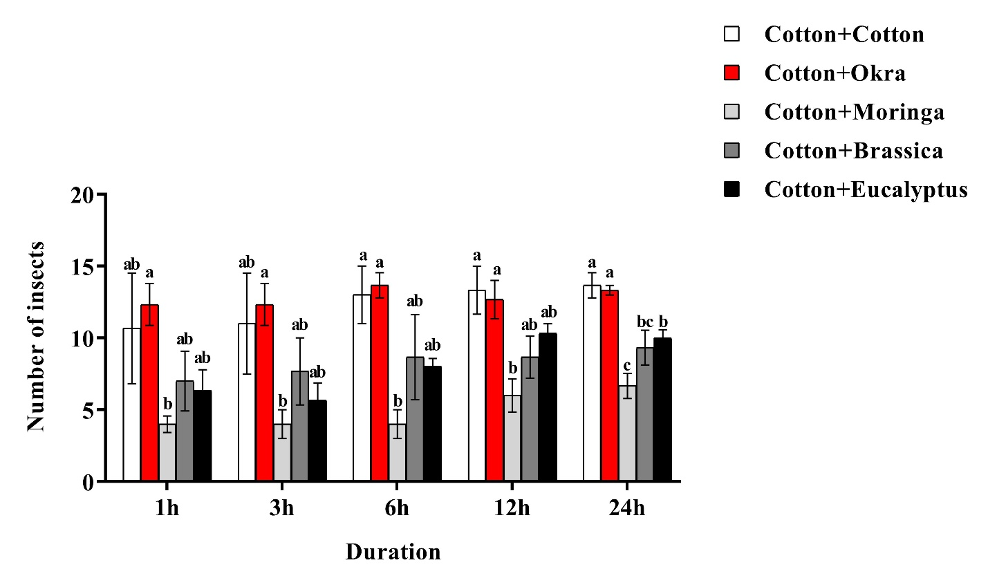
Fig. 5. Feeding preference of mixed population of dusky cotton bug on combination of various seeds. Different letters above the bars indicate significant differences (P < 0.05). Values are means ± SE (n = 15).

Feeding preference towards combinations of cotton seeds with various leaves by dusky cotton bug population
After 1 hour, non-significantly different populations of dusky cotton bug were recorded on various treatments (P = 0.491; F_{2, 4} = 0.91). After 3 hours, significantly higher population was observed on "cotton seeds + cotton leaves" combination (P = 0.025; F_{2, 4} = 6.56) with mean number of (14.33) individuals, followed by "cotton seeds + okra leaves" (12.33), "cotton seeds + eucalyptus leaves" (9.67), while "cotton seeds + moringa leaves" (8.67) respectively. After 6 hours, no significant difference among populations on various treatments was recorded (P = 0.319; F_{2, 4} = 1.45). After 12 hours, again non-significantly different population of dusky cotton bug were observed on various treatments (P = 0.122; F_{2, 4} = 2.92). After 24 hours, significantly higher population was recorded on "cotton seeds + cotton leaves" and "cotton seeds + okra leaves" (P = 0.017; F_{2, 4} = 7.71). Mean population of (13.67) individuals was recorded on both of the treatments, followed by “cotton seeds + eucalyptus leaves" (12.33) and "cotton seeds + moringa leaves" (8.00), respectively (Fig. 6).

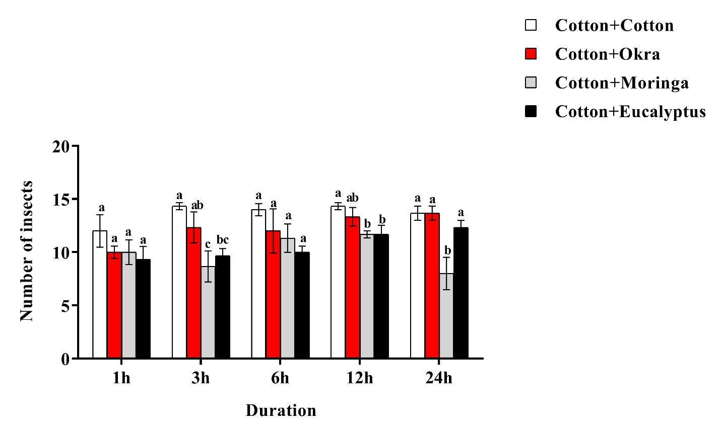
Fig. 6. Number of individuals of dusky cotton bug on combinations of cotton seeds with various leaves. Different letters above the bars indicates significant differences (P < 0.05). Values are means ± SE (n = 15).

Olfactory response of Bugs to Cotton seeds Vs. Cotton seeds + Cotton leaves
Results showed that arm of Y-shaped glass tube having cotton seeds and leaves had a non-significant effect on bugs response when compared with control arm (χ² = 0.043, P = 0.837). 48% of dusky cotton bugs selected the arm having cotton seeds while 46% bugs preferred the arm having combination of cotton seeds + cotton leaves respectively (Fig. 7).

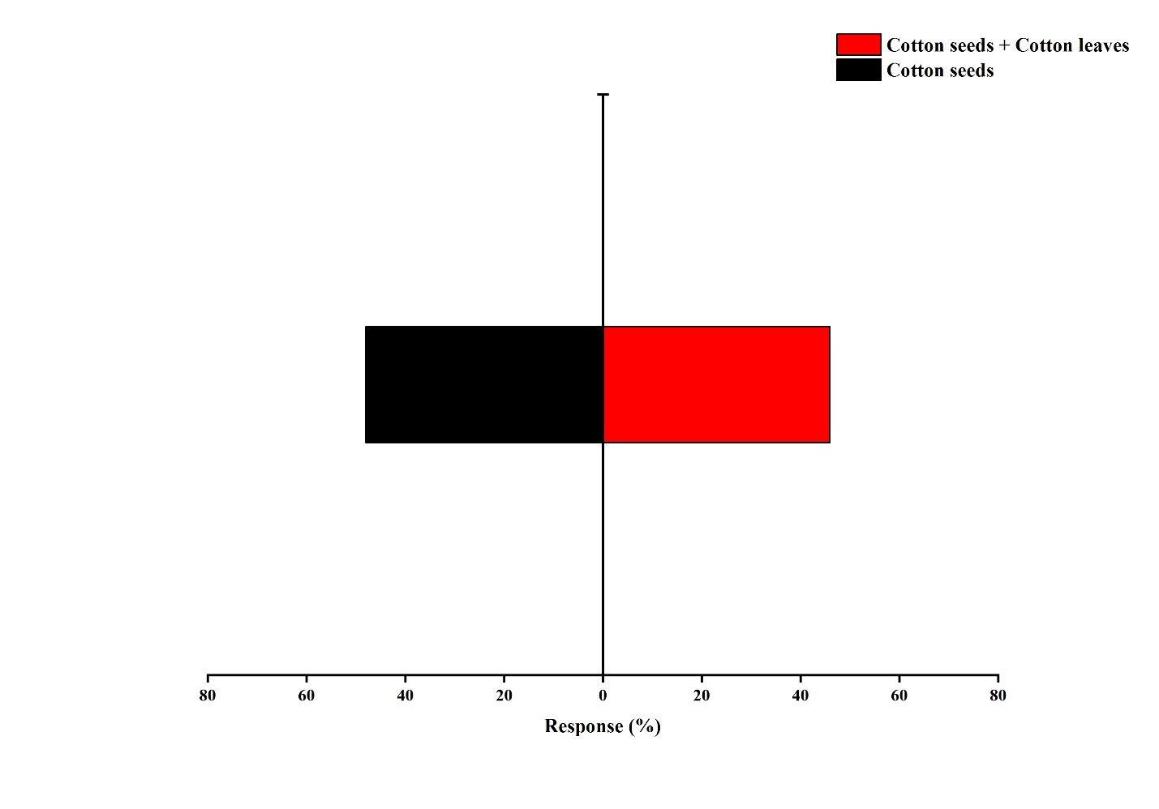
Fig. 7. Attraction of dusky cotton bugs to Cotton seeds Vs. Cotton seeds + Cotton leaves in Y-tube olfactometer. The χ² -test was used to compare the difference between treated and control arm (n = 50).

Olfactory response of Bugs to Cotton seeds Vs. Cotton seeds + Moringa leaves
The adults of dusky cotton bugs didn’t show any significant response to arm containing cotton seeds + moringa leaves and control arm containing cotton seeds of the Y-shaped glass tube (χ² = 0.182, P = 0.670) (Fig. 8). 46% dusky cotton bugs preferred the arm of Y-tube having cotton seeds + moringa leaves combination while 42% preferred the control arm having cotton seeds respectively of Y-tube olfactometer.

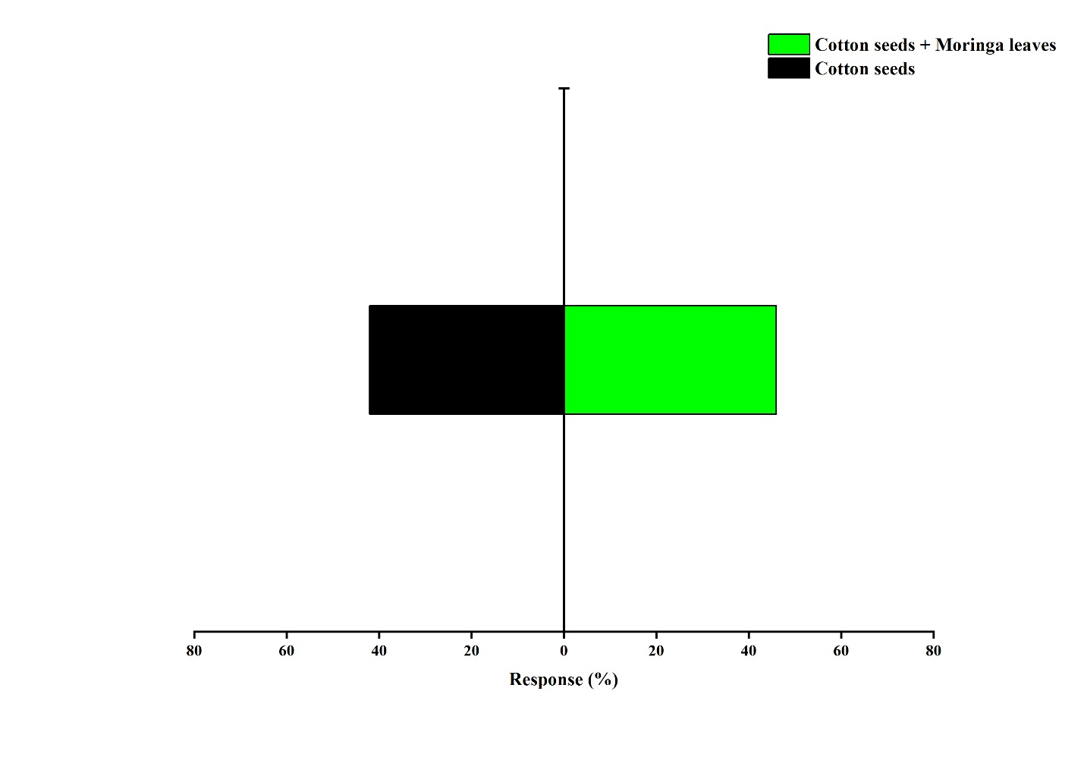
Fig. 8. Attraction of dusky cotton bugs to Cotton seeds Vs. Cotton seeds + Moringa leaves in Y-tube olfactometer. The χ² -test was used to compare the difference between treated and control arm (n = 50).

Olfactory response of Bugs to Cotton seeds Vs. Cotton seeds + Eucalyptus leaves
There were no significant effects of cotton seeds + eucalyptus leaves to the response of dusky cotton bugs when compared with control arm having cotton seeds in Y-tube olfactometer (χ² = 0.762, P = 0.383). Arm of Y-tube having cotton seeds + eucalyptus leaves combination was preferred by 46% of dusky cotton bugs however 38% of bugs responded towards control arm having cotton seeds f Y-tube olfactometer (Fig. 9).

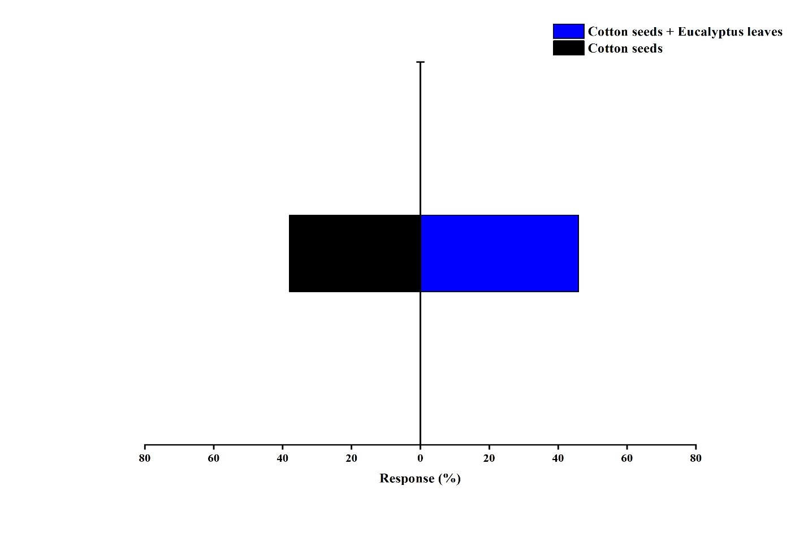
Fig. 9. Attraction of dusky cotton bugs to Cotton seeds Vs. Cotton seeds + Eucalyptus leaves in Y-tube olfactometer. The χ² -test was used to compare the difference between treated and control arm (n = 50).

Olfactory response of Bugs to Cotton seeds Vs. Cotton seeds + Okra leaves
The adults of dusky cotton bugs were not remarkably attracted to the arm that contained combination of cotton seeds + okra leaves as well as control arm of Y-tube olfactometer containing cotton seeds (χ² = 2.178, P = 0.140). Cotton seeds + okra leaves were preferred by 52% of dusky cotton bugs while 38% of bugs preferred the control arm having cotton seeds respectively (Fig. 10).

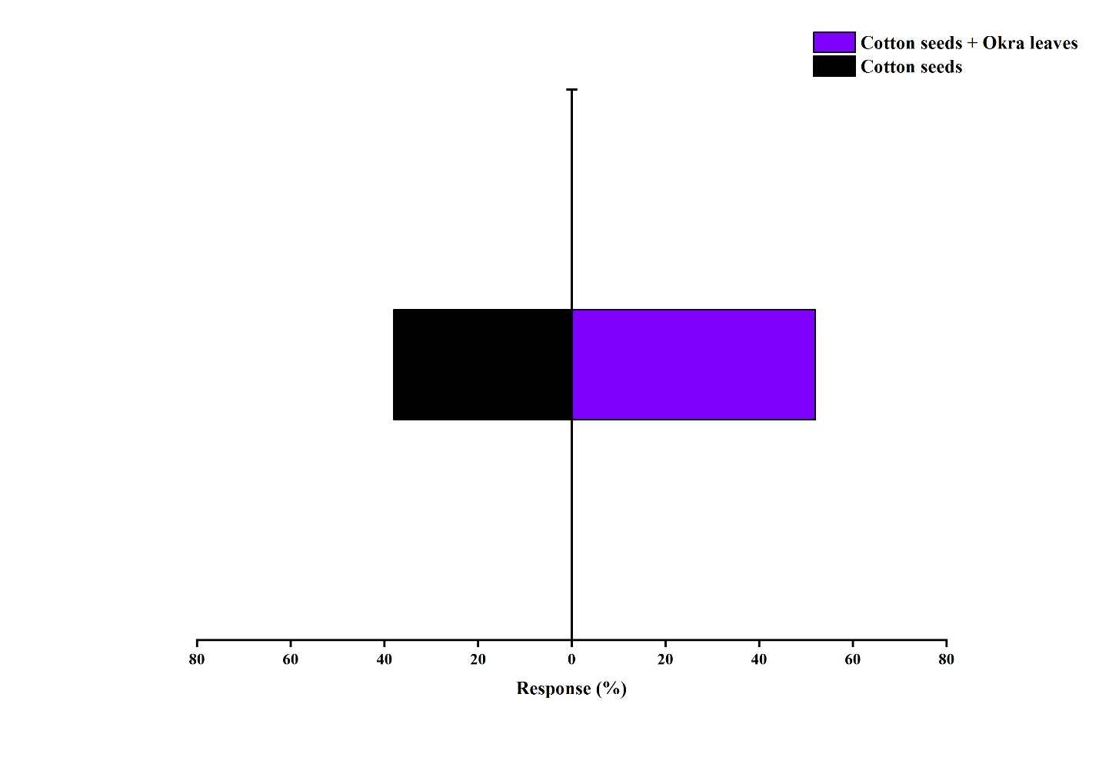
Fig. 10. Attraction of dusky cotton bugs to Cotton seeds Vs. Cotton seeds + Okra leaves in Y-tube olfactometer. The χ² -test was used to compare the difference between treated and control arm (n = 50).

Discussion
Outcomes of our research indicated that dusky cotton bug can infest all the tested plants and their parts. However, cotton seeds were the most preferred by dusky cotton bug (male, female and mixed populations) among all the other plants and their parts. After cotton, okra and eucalyptus were more preferred by test populations as compared to brassica and moringa. Seed combination of cotton with okra proved more attractive to dusky cotton bug while seed combination of cotton with moringa proved least attractive as compared to other combinations. Cotton seeds and its combination with okra leaves proved more attractive among all the treatments (seed + leave combinations). Results of research clearly revealed that smell emitted from cotton and okra seeds and leaves had extra appealing effects on dusky cotton bug as compared to other tested plants and their parts. These results are in line with the research of (Thangavelu 2007), who concluded that crops of family malvaceae are the most preferred hosts of dusky cotton bug.
Our results are in the favor of (Ullah Shah et al. 2016). They performed an experiment to find the most preferred host crop/plants of dusky cotton bug. They recorded the population of dusky cotton bug from 34 types of plants in field area of Bahawalpur City, Punjab, Pakistan. They found that cotton was significantly more infested as compared to other crops. Our results area also in agreement with (Srinivas and Patil 2003) who studied alternate hosts of dusky cotton bug in in Dharwad, Karnataka, India during 2001-2002. During that period variety of crops including okra (A. esculentus), Indian mallow (Abutilon indicum), groundnut, parthenium (Parthenium hysterophorus), Kenaf (Hibiscus cannabinus), Tridax daisy (Tridax procumbens), Tulip tree (Liriodendron tulipifera) and Neem (Azadirachta indica) were kept under observation. Their research revealed incredible outcomes that dusky cotton bug infested every crop and tree during their observation period. However maximum infestation was recorded on okra.
According to results of current study, cotton is most preferred host of dusky cotton bug among the tested host plants, but it may more preferably feed on the other crops or weeds of family malvaceae as compared to cotton, as revealed by work of (Thangavelu 2007). Although BT varieties of cotton are resistant against many insect pests as compared to traditional varieties, but they are equally susceptible to dusky cotton bug. (Iqbal et al. 2018) performed an experiment to evaluate susceptibility of various BT varieties (IUB-222, MNH-886, FH-142, CIM-599, A-555, CIM-602, NIAB-777, MNH-786 and Bt-666) to dusky cotton bug. All the varieties were susceptible to dusky cotton bug. But three varieties (CIM-599, CIM-602 & IUB-222) were less susceptible as compared to others.
According to result of our research dusky cotton bug did not preferably feed on brassica and moringa seeds. So, result of our research suggests that around or near cotton crop, other crop of malvaceae family should be strictly avoided. Also, before or after cotton crop, crops of family malvaceae should be avoided. In case of outbreak of dusky cotton bug, growing crops of family malvaceae should be discouraged otherwise frequent application of insecticides will result in resistance development in dusky cotton bug.
Declaration of Competing Interest
The authors declare that they have no any conflict of interest.
Author Contributions
MAA, WJ, RS, MUS, RZ, AR, FH, QF, SMZ, and TXL conceived and designed the experiments, analyzed the data, contributed reagents/materials/analysis tools, wrote the paper, prepared figures and/or tables, reviewed drafts of the paper, provided support for arranging field for research. WJ, SMZ, and TXL contributed reagents/materials/analysis tools, wrote the paper, prepared figures and/or tables, reviewed drafts of the paper.

References
Abbas M, F Hafeez, M Farooq, A Ali (2015). Dusky Cotton Bug Oxycarenus spp. (Hemiptera: Lygaeidae): Hibernating Sites and Management by using Plant Extracts under Laboratory Conditions. Polish J Entomol 84:127-136
Afzal MB, SA Shad, N Abbas, M Ayyaz, WB Walker (2015). Cross-resistance, the stability of acetamiprid resistance and its effect on the biological parameters of cotton mealybug, Phenacoccus solenopsis (Homoptera: Pseudococcidae), in Pakistan. Pest Manag Sci 71:151-158
Atwal AS, GS Dhaliwal (2005). Agriculture pests of South Asia and their Management. 15th Ed. Kalyani Publishers; New Delhi (India). 236-238p
Baranowski RM, JA Slater (2005). Lygaeidae of the West Indies agricultural experiment station, institute of food and agricultural sciences, University of Florida, Florida. 402.266p
Basit M (2018). Cotton pest control awareness in farmers of the Punjab, Pakistan and its impact on whitefly resistance against available insecticides. 183-195p
El-Rahim ABD, H Gamal, MA Amro (2015). Population fluctuations of Oxycarenus hyalinipennis and effect of certain compounds on its population on okra in assuit governorate. Egypt J Agric Res 93:25-35
Horton DR, PJ Landolt (2007). Attraction of male pear psylla, Cacopsylla pyricola, to female-infested pear shoots. Entomol Exp Appl 123:177-183
Iqbal J, SA Bhutta, AS Alqarni, AA Owayss, MJ Ansari (2018). Seasonal population dynamics of dusky cotton bug (Oxycarenus spp.) in transgenic cotton varieties under field conditions. Saudi J Biol Sci 25:1122-1127
Khan HAA, W Akram, SA Shad (2014). Genetics, cross-resistance and mechanism of resistance to spinosad in a field strain of Musca domestica L. (Diptera: Muscidae). Acta Tropica 130:148-154
Khan MF, SM Ahmed (2000). Toxicity of neem fruit extract and seed oil against Oxycarenus (Heteroptera) of cotton crop. Acta Biol Cracoviensia Ser Zool 42:14-21
Khan RA, M Naveed (2017). Seasonal population dynamics and management of Dusky cotton bug ( DCB ), Oxycarenus hyalinipennis costa in cotton 27. J Animal Plant Sci 27:1348-1352
Shahid, M. R., Farooq. M, Shakeel. M, Mahmood. A and Gogi. M. D (2017). Impact of Dysdercus koenigii Fabricius ( Hemiptera : Pyrrhcoridae ) density-dependent population on agronomic and qualitative characteristics of different transgenic cotton varieties. Phytoparastica 45: 125-133.
Smith, T. R and Brambila. J (2008). A major pest of cotton, Oxycarenus hyalinipennis (Heteroptera: Oxycarenidae) in the Bahamas. Florida Entomologist 91: 479-482.
Srinivas, M and Patil. B.V (2003). Alternate hosts of Dusky cotton bug, Oxycarenus laetus Kirby. Insect Environ. 9: 95-96.
Srinivas, M and Patil. B.V (2004). Quantitative and qualitative loss caused by dusky cotton bug, Oxycarenus laetus Kirby on cotton. Karnataka J. Agri. Sci. 17: 487-490.
Thangavelu, K (2007). Some aspects of host specificity in the Indian dusky cotton bug, Oxycarenus laetus Kirby (Heteroptera: Lygaeidae) J. Natural History 12: 481-486.
Ullah Shah, Z., Ali. A and Hafeez. F (2016). Seasonal history of dusky cotton bug (Oxycarenus hyalinipennis Costa). J. Entomol. Zool. Studies 4: 228-233.
Ullah, S., Shad. S. A and Abbas. N (2016). Resistance of Dusky Cotton Bug, Oxycarenus hyalinipennis Costa (Lygaidae: Hemiptera), to Conventional and Novel Chemistry Insecticides. J. Econ. Entomol. 109: 345-351.
Ullah, S., Ejaz. M and Shad. S. A (2017). Study of synergism, antagonism, and resistance mechanisms in insecticide-resistant Oxycarenus hyalinipennis (Hemiptera: Lygaeidae). J. Econ. Entomol. 110: 615-623.

