Title page
Original Research Article

Home Range Characteristics of a Released Milu (Elaphurus davidianus) Population during Different Periods and Effects of Water Submersion in Dongting Lake Wetland, China
Running Title: Home Range of Milu Population in Donting Lake Wetland
Shuangye Wang ^{1, 2}, Yunlin Zhao ^{1, 2}, Zhenggang Xu ^{2,} *, Guiyan Yang ³, Song Wang ², and Kangkang Jiang ²
¹ College of Bioscience and Biotechnology, Hunan Agricultural University, Changsha 410128, China;
² Engineering Research Center for Internet of animals, Central South University of Forestry and Technology, Changsha 410000, China;
³ College of Forestry, Northwest A & F University, Yangling, 712100, China;

* Correspondence: rssq198677@163.com; Tel: +86-18684945647

Novelty statement: To explore activity rhythm of released milu population, we estimated their home range size, and contacted with water body of Dongting Lake. Milu is the flagship species for China which died out in the last century, individuals were reintroduced from England, and milu mostly live in natural reserves, the objects in our study are the first population which are released to wild where is away from their former habitat. Focusing on the released milu population is significant for them, it is beneficial to management the rewild population, and helpful for their development.
Abstract
To understand home range (HR) characteristics and the distribution of a released milu population at Dongting Lake, we estimated HR size using the minimum convex polygon and kernel density estimator methods from location data. A maximum flooded time index (MSTI) was calculated and overlaid with seasonal HR data to explore the effects of seasonal floods on the distribution pattern. Results showed that: (1) Contemporaneous HR sizes of females were larger than the male individual during the rut; (2) Males and females individuals cohabitated in spring and their HR sizes were large, the population dispersed during summer with HR sizes decreasing, and the HR sizes in winter were largest; (3) Home range of milu population change significantly between dry period and wet period. The milu individuals were released during dry periods and their habitat was identical and large, then the population dispersed during the wet season and some individual HR sizes shrank distinctly; (4) the rut and parturition periods were sequential but somewhat short, and HR sizes during the parturition period were more preponderant than that in the rut; (5) female milu prefer to live in areas that were flooded for 40%–50% of year based on MSTI. In general, the HR distribution and size of the milu population changed with the changing periods, including different seasons, dry period and wet period etc. Available space, food resources, and shelter were influenced by water level variation in Dongting Lake, so we speculate water level were the main factor affecting the distribution and HR size of milu directly or indirectly.
Keywords: Père David’s deer; Home range; Maximum flooded time index; Dongting Lake

Introduction
Patterns of spatial utilisation and population distribution reveal significant information regarding animal biology and behaviour (Sarkar et al., 2016). Home range (HR) is defined as the area utilised during an animal’s normal daily activities, such as food gathering, mating, and caring for young (Burt, 1943). The HR provides a clear definition of the timeframe involved during a given HR analysis (Seaman, 1996; Hansteen et al., 1997). Shape, size, and structure of the HR and the relationship between HR and the environment are key components of animal ecology (Kaczensky et al., 2010). Mammals appear to have larger HR sizes when they live in less productive habitats or where food resources are distributed unevenly (Rautio et al., 2013). Furthermore, an understanding of how animals use their HR is important for managing wildlife (Kernohan, 2001; Willems and Hill, 2009).
Milu (Elaphurus davidianus, also called the Père David’s deer) is endemic to China, is Yangtze River drainage (Yang et al., 2016). Milu is a typical species that was reintroduced from Europe to China in the 1980s, nearly a century after its extirpation due to natural factors and human disturbances (Ding, 2018). There are three milu breeding and protective organizations, including Beijing Milu Park, Jiangsu Dafeng Milu National Nature Reserve (DMNNR), and Hubei Shishou Milu National Nature Reserve. Milu prefer the habitat where food is abundant, near the water, and far away from human activity (He et al., 2007). Research has investigated plants which milu eat, and proved that squishy plants are chosen by them (Liang and Li, 1991). Milu populations now mainly live in captive or free range situations, and have become more adapted to human activities than when they lived in the wild prior to their extirpation (Jiang et al., 2001). During breeding season, male individuals compete for the qualification of mating, all male milu can be classified into three ranks as King, Challenger and Bachelor (Liu, 2014). With the development of a large captive milu population, some issues have appeared, such as environmental degradation, resource scarcity, and inbreeding, thus, the recovery of the wild milu population has been slow (Zhang et al., 2011). A previous study on the mitochondrial DNA control regions in milu verified low genetic diversity (Meng et al., 2014).
Therefore, 16 milu individuals from DMNNR were selected for release in the Dongting Lake wetland. This was the first implementation of an ex-site conservation in China. A total of 11 individuals were fitted with satellite tracking equipment (Wang et al., 2019), the collars were equipped on them after they were narcotized transitorily. This project was guided by Chinese Forestry and Grassland Administration, and implemented by Hunan Provincial Government and Hunan Wild Animal Rescue and Breeding Center with approval. To the best of our knowledge, the present study is the first to explore descriptive HR characteristics of a long-distance rewild milu population using satellite transmitters. The aim of this paper is to supervise released milu population, and is beneficial for management by the Dongting Lake National Nature Reserve.

Materials and Methods

Study site
The Dongting Lake wetland (28°30′–30°20′ N, 111°40′–113°10′ E) is located in the middle reaches of the Yangtze River region, China, and is a component of larger important international wetlands (Li et al., 2013; Liang et al., 2015; Wang et al., 2017). Dongting Lake shows seasonal variation in rainfall (Zhang et al., 2016). During the wet season (from May to October), Dongting Lake reaches its highest water level and expands to a large water surface area, whereas the area becomes lake bottom–land periodically during the dry season (from November to April of the next year) (Lai et al., 2013). There are six types of landscapes in the wetland, including open water, mudflats, Carex marshes, reed marshes, polar forests, and other areas (Guan et al., 2016). The Dongting was recognized as the key region for numerous migratory water-bird for overwintering (Cao et al., 2008). There was no large sarcophagous animals, but some ungulates occasionally appear which owned by herdsmen. The study survey determined that nearly 90% of the local people depend on Dongting Lake (Cao et al., 2010), and numerous residents live beside the Lake. In general, considering the climate, resources, and environmental conditions, the Dongting Lake wetland contains an ideal habitat for milu populations, where an exclusive natural wild milu population has been established since 1998 due to heavy flooding (Yang et al., 2002; Yang et al., 2007).

Period partition and home range (HR) size estimation
In the present study, the location data of 11 milu individuals were collected from March 4, 2016, to July 29, 2017, covering more than one year. During the whole experiment process, we all concerned about animal welfare. Approving body and any reference numbers of milu individuals and other details were supplied relating to ethical approvals: The Animal Ethics Committee, Central South University of Forestry and Technology provided full approval for this study. To more clearly understand the HR characteristics of the milu population, we divided the location data into different periods based on usual seasonal change, water level characteristic in Dongting Lake, and physiological situation of the Père David’s deer.
Displaying the satellite tracking data on the map, and the single male individual habitat was divided into two apparent periods with one data collection period being from March 4, 2016, to May 23, 2016, and the other from May 23, 2016, to June 26, 2016. Based on the data collected from the male milu, the study estimated the HRs of female milu whose habitats overlapped with the male milu during the above two periods (Fig. S1). There were ten females with associated location data. Based on seasonal transformation, the periods were divided into spring (March to May), summer (June to August), autumn (September to November), and winter (December to February the following year) (Fig. S2). Considering water levels, the wet period (May to October) and dry period (November to April the following year) were separated (Fig. S3).
Because of our interest in the HR characteristics of female milu during specific physiological periods, we also examined the parturition period (April and May) and the rut period (June and July) (Fig. S4).
When the location data of individuals included the entire month in each period, then the period was usable. For example, there was location data for one individual existed in March, April, and May, therefore, the spring period was chosen, if there were data just in one or two month, it could not be used.
HR sizes were estimated using "Home range Tools (HRT)" in ArcGIS 10.2. According to previous studies, we chose both the minimum convex polygon (MCP) (Reinecke et al., 2014; Flanagan et al., 2016; Plotz et al., 2016) and kernel density estimator (KDE) (Kitts-morgan et al., 2015; Fleming et al., 2016) methods. After the location data from each individual were imported into ArcGIS 10.2, the HR size was estimated using levels of 95% and 50% for MCP and KDE, respectively.

Water surface variation monitoring
The water surface area of Dongting Lake fluctuates regularly, which greatly affects the habitat. Terra/MODIS data were selected to monitor variations in the water surface area of Dongting Lake. Based on the visible light and near-infrared band remote-sensing imagery, the water body area was extracted from other land cover types. MOD09Q1 was MODIS image which update every 8-day, and all MOD09Q1 data during 2016 and 2017 have been downloaded from LAADS DAAC (http://ladsweb.modaps.eosdis.nasa.gov/) (Huang et al., 2012). Images with obscuring cloud cover were omitted from the study, yielding 34 images from 2016 and 25 images from 2017. These 59 images were re-projected to the commonly used projection of the Universal Transverse Mercator (WGS84) using a nearest neighbour re-sampling method with the MODIS Reprojection Tool. To eliminate the influence of water plants, sediment, soil moisture content, and clouds, the water body extraction steps in the study, including the three rules listed below, relied on band1, band2, and NDVI of the MODIS data.
(1) If NDVI ≤ 0.1, the pixel could be identified as a water body. The NDVI value is influenced by climate and landscapes, but 0 could not be used as a threshold value to extract water because there are many water plants in Dongting Lake from April to September. Referring to previous study regarding threshold ranges from −0.1 to 0.3 (Tan, 2002), we selected 0.1 as the threshold based on our visual opinion by comparing with original image.
(2) If the DNband2＜1,400, the pixel could be identified as a water body. The band2 of MOD09Q1 is a near-infrared band in which the characteristics of plants and soil are opposite to those of water bodies. When the threshold is between 1,000 and 1,400 (Huang et al., 2012) water bodies can be distinguished from other landscape, such as build-up and bare soil. As in rule (1), 1,400 was selected as the threshold with the help of visual assessment.
(3) To eliminate the influence of clouds, based on rules (1) and rule (2), if DNband1＞2,000, and DNband2＞2,000, then the pixel could be identified as non-water body.
The value of water bodies and non-water bodies was defined as 1 and 0, respectively; then, the images were combined based on the period partition and estimated maximum flooded time index (MSTI) of each period using the band calculator in ArcGIS 10.2 software.

Overlay analysis of HR and water variation
Considering the seasonality of water surface variations of Dongting Lake, the MSTI was estimated based on seasons, making use of images from March 2016 to February 2017. The study did not distinguish individuals during the analysis process, but combined milu location data based on their habitats during different seasons, and estimated HR sizes using the 95%MCP method for visualized observation, respectively. These estimates were coupled with a MSTI map over the year long period. To analyse the utilisation of MSTI by the milu population of Dongting Lake, MSTI was divided into 10 levels (0−10%, 10%−20%, 20%−30%, 30%−40%, 40%−50%, 50%−60%, 60%−70%, 70%−80%, 80%−90%, and 90%−100%), then calculated the HRs utilization proportion of each above level for each different seasonal. The overlay analysis was performed using ArcGIS 10.2. Fig. 1 shows the workflow diagram of the present study.
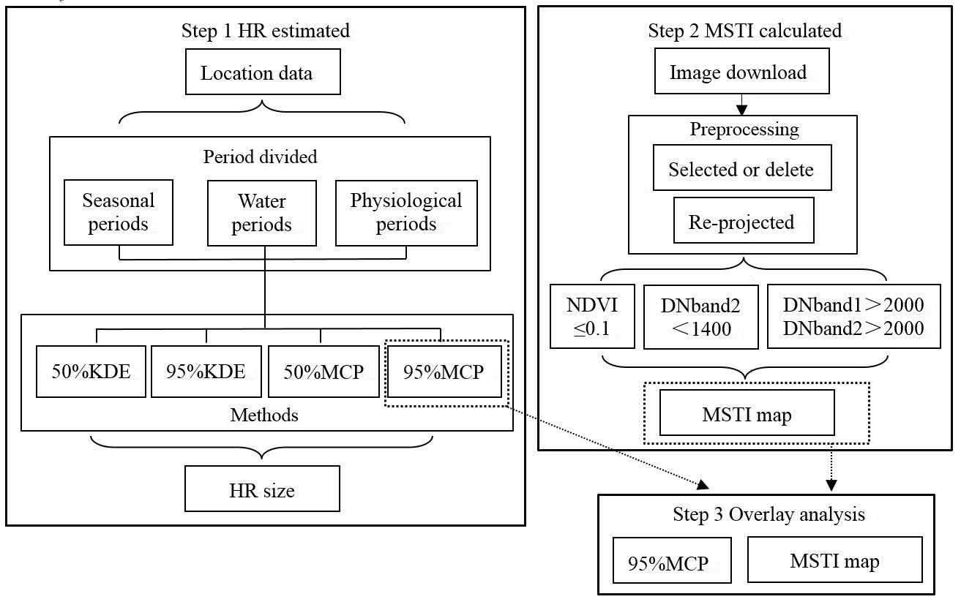
Fig. 1: Water extraction andseasonal home-range overlaying analysis procedures. Notes: HR represents home range, KDE represents kernel density estimator method, MCP represents minimum convex polygon method, MSTI represents maximum flooded time index

Results

Summary of location data
Location data were collected from individual via the milu, matching tracker IDs (Table 1). The study collected 52,815 location data points in total, and the mean quantity for each animal was approximately 4,000. The majority of the trackers did not provide the location data of milu individuals in 2017, except for Milu02 and Milu04. Milu16 was the only male individual in the studied population, whose location data were collected from March 4 to June 26, 2016, and from September 8 to 26, 2016.
Table 1: Location data of milu individuals
Milu ID | Tracker ID | Sex | Location data quantity | Time span
Milu01 | HNRC001 | Female | 4481 | 2016/3/4–2016/8/14
Milu02 | HNRC002 | Female | 5653 | 2016/3/4–2017/7/29
Milu03 | HNRC003 | Female | 4516 | 2016/3/4–2016/9/15
Milu04 | HNRC004 | Female | 6142 | 2016/3/4–2017/7/29
Milu05 | HNRC005 | Female | 5124 | 2016/3/4–2017/3/15
Milu08 | HNRC008 | Female | 4688 | 2016/3/4–2017/3/17
Milu09 | HNRC009 | Female | 2976 | 2016/3/4–2016/5/26
Milu14 | HNRC014 | Female | 3633 | 2016/3/4–2016/7/20
Milu15 | HNRC015 | Female | 4189 | 2016/3/4–2016/8/30
Milu16 | HNRC016 | Male | 4641 | 2016/3/4–2016/6/26  2016/9/8–2016/9/27
Milu17 | HNRC017 | Female | 6772 | 2016/3/4–2017/5/5

Sex differences in milu HR
There were two distinct habitats utilised by the male milu from March 4 to May 23, and from May 23 to June 26, which was driven by the increasing water level (Fig. S1). Several female individuals range overlapped with the male milu in these two habitats. Comparing the milu of different sexes, the HR sizes were dissimilar. The results showed that (1) there were ten female individuals living with the male milu in habitat 1, the male HR size was smaller than that of the females, and only the HR size of Milu05 was smaller than that of the male determined by both the 50%MCP and 50%KDE methods; and (2) four individual females lived with the male in habitat 2 over time. During the study period, the HR size of the male seemed to approximate that of the female milu, or was slightly larger than the females except for Milu09, determined by the 95%KDE method (Table 2).
Table 2: HR sizes of individual milu by sex (km²). Notes: “H1” denotes habitat 1, “H2” denotes habitat 2, and the distributions are shown in Fig. S1
Period | Habitat | HR ID | Sex | 95%MCP | 50%MCP | 95%KDE | 50%KDE
20160304—  20160523 | H1 | Milu16 | Male | 9.33 | 2.84 | 14.48 | 2.96
 |  | Milu01 | Female | 17.63 | 4.26 | 19.78 | 4.36
 |  | Milu02 | Female | 17.93 | 5.72 | 21.11 | 5.29
 |  | Milu03 | Female | 18.41 | 6.07 | 20.37 | 5.28
 |  | Milu04 | Female | 16.64 | 4.90 | 20.20 | 4.86
 |  | Milu05 | Female | 16.78 | 2.01 | 15.47 | 2.50
 |  | Milu08 | Female | 17.82 | 6.48 | 24.38 | 6.63
 |  | Milu09 | Female | 16.22 | 7.62 | 25.04 | 6.37
 |  | Milu14 | Female | 17.81 | 8.30 | 27.57 | 6.68
 |  | Milu15 | Female | 15.97 | 5.81 | 20.63 | 4.60
 |  | Milu17 | Female | 12.87 | 7.11 | 18.69 | 4.84
 |  | Mean of female |  | 16.81±1.60 | 5.83±1.81 | 21.32±3.47 | 5.14±1.26
20160523—  20160626 | H2 | Milu16 | Male | 0.59 | 0.30 | 0.81 | 0.22
 |  | Milu04 | Female | 0.60 | 0.29 | 0.71 | 0.22
 |  | Milu08 | Female | 0.60 | 0.28 | 0.75 | 0.21
 |  | Milu09 | Female | 0.63 | 0.14 | 1.19 | 0.29
 |  | Milu15 | Female | 0.64 | 0.29 | 0.75 | 0.21
 |  | Mean of female |  | 0.62±0.02 | 0.25±0.07 | 0.85±0.23 | 0.23±0.04

HR variations during different seasons
Based on the data collection periods, the spring period existed both in 2016 and 2017, and the milu population changed their habitats over time. Large differences in HR sizes for different individuals existed during each season. HRs in winter were larger than in other seasons, whereas HR sizes during summer were smallest (Table 3, Fig. S2). In different seasons, habitat utilisation by milu was unequal. Primarily, all individuals lived together during the spring of 2016, but during the spring in 2017, only three individuals provided data, and they lived alone. Space utilization showed great discrepancy, with the HR size of Milu17 during spring of 2017 being vast, reaching 146.12km² using the 95%KDE method, which was considerably larger than the HR sizes for the other milu. The milu population dispersed and became separated into two groups during the summer of 2016, and the population that lived at habitat 2 (Su-H2) during the summer utilised a smallest HR. Five individuals which offered data lived at three habitats respectively during autumn, the form of groups was unaltered also in winter.
Table 3: Milu home range size during different seasons (km²). Notes: In the list “Habitats”, the abbreviation of the preceding two letters represents respective seasons, the number “17” after the HR ID in list 3 represents the year date e.g. “Milu02-Sp17” represents the HR of Milu02 during the spring of 2017. The habitat distributions are shown in Fig. S2
 | Habitats | HR ID | 95%MCP | 50%MCP | 95%KDE | 50%KDE
Spring | Sp-H1 | Milu01-Sp | 17.81 | 5.15 | 21.08 | 4.71
 |  | Milu02-Sp | 17.81 | 6.84 | 20.80 | 5.44
 |  | Milu03-Sp | 18.35 | 6.95 | 17.49 | 4.41
 |  | Milu04-Sp | 23.49 | 6.05 | 29.42 | 6.45
 |  | Milu05-Sp | 16.37 | 3.33 | 15.33 | 2.65
 |  | Milu08-Sp | 24.68 | 8.39 | 35.58 | 8.78
 |  | Milu09-Sp | 17.44 | 8.11 | 25.48 | 5.96
 |  | Milu14-Sp | 17.92 | 8.72 | 23.17 | 5.94
 |  | Milu15-Sp | 22.63 | 7.70 | 29.50 | 6.11
 |  | Milu17-Sp | 13.10 | 6.80 | 18.51 | 4.80
 |  | Mean value | 18.96±3.56 | 6.80±1.64 | 23.64±6.34 | 5.53±1.59
 | Sp-H2 | Milu02-Sp17 | 2.76 | 0.87 | 4.62 | 1.16
 | Sp-H3 | Milu04-Sp17 | 28.41 | 9.50 | 37.70 | 8.63
 | Sp-H4 | Milu17-Sp17 | 57.49 | 29.78 | 146.12 | 44.28
Summer | Su-H1 | Milu01-Su | 2.72 | 0.41 | 4.18 | 0.85
 |  | Milu02-Su | 2.57 | 0.40 | 4.14 | 0.77
 |  | Milu03-Su | 2.82 | 0.51 | 4.14 | 0.78
 |  | Milu05-Su | 2.78 | 0.51 | 4.10 | 0.79
 |  | Milu17-Su | 2.78 | 0.57 | 4.03 | 0.82
 |  | Mean value | 2.73±0.10 | 0.48±0.07 | 4.12±0.06 | 0.80±0.03
 | Su-H2 | Milu04-Su | 0.79 | 0.37 | 0.89 | 0.23
 |  | Milu08-Su | 0.75 | 0.34 | 0.88 | 0.24
 |  | Milu15-Su | 0.83 | 0.36 | 0.89 | 0.21
 |  | Mean value | 0.79±0.04 | 0.36±0.02 | 0.89±0.01 | 0.23±0.02
Autumn | Au-H1 | Milu02-Au | 5.19 | 0.60 | 7.87 | 0.94
 | Au-H2 | Milu04-Au | 15.11 | 1.32 | 29.38 | 3.95
 |  | Milu08-Au | 15.04 | 1.24 | 45.45 | 7.93
 |  | Mean value | 15.08±0.05 | 1.28±0.06 | 37.42±11.36 | 5.94±2.81
 | Au-H3 | Milu05-Au | 64.40 | 9.56 | 64.70 | 13.18
 |  | Milu17-Au | 67.52 | 10.01 | 67.01 | 13.74
 |  | Mean value | 65.96±2.21 | 9.79±0.32 | 65.86±1.63 | 13.46±0.40
Winter | Wi-H1 | Milu02-Wi | 4.22 | 0.69 | 6.64 | 1.48
 | Wi-H2 | Milu04-Wi | 35.80 | 12.82 | 55.45 | 12.67
 |  | Milu08-Wi | 49.71 | 14.70 | 72.05 | 17.15
 |  | Mean value | 42.76±9.84 | 13.76±1.33 | 63.75±11.74 | 14.91±3.17
 | Wi-H3 | Milu05-Wi | 52.20 | 10.60 | 57.91 | 10.38
 |  | Milu17-Wi | 51.66 | 15.94 | 73.44 | 14.53
 |  | Mean value | 51.93±0.38 | 13.27±3.78 | 65.68±10.98 | 12.46±2.93

HR variation during different water periods
There were two main habitats utilised by the milu population during the wet period (Table 4 and Fig. S3). Milu02 and Milu04 provided data corresponding with the wet period in 2017. Milu04 moved to a third habitat in 2017, however Milu02 stayed at the same habitat where it had lived during 2016. The size of the HRs of individuals fluctuated, with the level in habitat 1 during the wet period (Wet-H1) being higher than that of habitat 2 (Wet-H2). Maximum acreage during the wet period was 44.92 km² using the 95%KDE method for Milu02 in 2017. During dry periods, HRs size when milu lived at habitat 3 (Dry-H3) were much larger than they lived at habitat 2 (Dry-H2) and habitat 1 (Dry-H1). During dry periods, all individuals lived together in 2016, but four milu moved to new during dry period in 2017. The size of the HRs during the dry period in habitat 1 (Dry-H1) was approximately equal, however, an increase of space utilisation occurred in habitat 2 (Dry-H2), and especially in habitat 3 (Dry-H3). The HR size of Milu17 reached 287.71 km² in habitat 3 (Dry-H3) during the dry period.
Table 4: Home range size of milu during different water periods (km²). Notes: The number “17” after the HR ID in list 3 represents the year data, e.g. “Milu02-Wet17” represents the HR of Milu02 during the wet period in 2017, and so on. The habitat distributions are shown in Fig. S3
 | Habitat | HR ID | 95%MCP | 50%MCP | 95%KDE | 50%KDE
Wet Period | Wet-H1 | Milu01-Wet | 5.23 | 1.33 | 10.50 | 2.18
 |  | Milu02-Wet | 14.14 | 0.43 | 6.50 | 1.09
 |  | Milu03-Wet | 7.72 | 0.56 | 7.55 | 1.35
 |  | Milu05-Wet | 15.74 | 0.59 | 9.95 | 1.07
 |  | Milu14-Wet | 7.63 | 2.04 | 11.10 | 2.39
 |  | Milu17-Wet | 16.28 | 1.04 | 11.95 | 1.11
 |  | Milu02-Wet17 | 16.09 | 4.16 | 44.92 | 10.22
 |  | Mean value | 11.83±4.77 | 1.45±1.32 | 14.64±13.49 | 2.77±3.33
 | Wet-H2 | Milu04-Wet | 8.00 | 1.96 | 10.92 | 1.59
 |  | Milu08-Wet | 8.59 | 0.88 | 9.96 | 1.43
 |  | Milu09-Wet | 3.39 | 0.34 | 4.58 | 0.65
 |  | Milu15-Wet | 3.32 | 0.44 | 4.46 | 0.85
 |  | Mean value | 5.83±2.86 | 0.91±0.74 | 7.48±3.44 | 1.13±0.45
 | Wet-H3 | Milu04-Wet17 | 8.31 | 2.09 | 16.28 | 3.09
Dry Period | Dry-H1 | Milu01-Dry | 15.10 | 2.33 | 15.24 | 3.02
 |  | Milu02-Dry | 12.31 | 2.73 | 17.16 | 3.65
 |  | Milu03-Dry | 11.39 | 3.46 | 13.40 | 3.13
 |  | Milu04-Dry | 11.06 | 2.17 | 15.66 | 3.13
 |  | Milu05-Dry | 12.59 | 1.16 | 13.54 | 1.60
 |  | Milu08-Dry | 13.37 | 4.02 | 19.35 | 4.57
 |  | Milu09-Dry | 15.20 | 4.40 | 17.77 | 4.21
 |  | Milu14-Dry | 14.94 | 4.26 | 18.89 | 4.11
 |  | Milu15-Dry | 15.01 | 2.39 | 15.95 | 3.13
 |  | Milu17-Dry | 11.38 | 4.16 | 16.65 | 3.67
 |  | Milu02-Dry17 | 6.50 | 1.18 | 8.13 | 1.79
 |  | Mean value | 12.62±2.60 | 2.93±1.20 | 15.61±3.13 | 3.27±0.93
 | Dry-H2 | Milu04-Dry17 | 68.59 | 28.45 | 100.09 | 23.83
 |  | Milu08-Dry17 | 71.94 | 16.96 | 85.66 | 18.05
 |  | Mean value | 70.27±2.37 | 22.71±8.12 | 92.88±10.20 | 20.94±4.09
 | Dry-H3 | Milu05-Dry17 | 108.99 | 39.12 | 280.33 | 59.47
 |  | Milu17-Dry17 | 166.95 | 52.18 | 287.71 | 78.60
 |  | Mean value | 137.97±40.98 | 45.65±9.23 | 284.02±5.22 | 69.04±13.53

HR size during the parturition and rut periods
The parturition and rut periods were two continuous periods (Table 5). In 2016, ten individuals were living together in habitat 1 (Par-H1) during the parturition period. The population was separated into two groups from the parturition period to the rut period, and their HR sizes reduced (Fig. S4). The HR of Milu08 was prominent, totalling 41.93 km² during the parturition period from the 95%KDE method. Comparing habitat 1 (Rut-H1) and habitat 2 (Rut-H2) during the rut period, the milu population use lesser space in habitat 2 (Rut-H2). Three individuals lived in habitat 2 (Rut-H2), and their respective HRs were all less than 1 km².
Table 5: Milu home range sizes during the parturition and rut periods (km²). Notes: “Par” in list 2 denotes the parturition period; the number “17” after the HR ID in list 3 represents the year data, such as in the listing "Milu02-Par17" represents the home range of Milu02 during the parturition period in 2017, and so on. The habitat distributions are shown in Fig. S4
 | Habitat | HR ID | 95%MCP | 50%MCP | 95%KDE | 50%KDE
Parturition Period | Par-H1 | Milu01-Par | 13.72 | 6.50 | 19.00 | 4.29
 |  | Milu02-Par | 16.39 | 6.09 | 23.27 | 5.66
 |  | Milu03-Par | 16.75 | 5.82 | 22.00 | 5.50
 |  | Milu04-Par | 23.98 | 10.90 | 39.81 | 10.05
 |  | Milu05-Par | 12.47 | 4.40 | 14.05 | 3.00
 |  | Milu08-Par | 24.16 | 9.80 | 41.63 | 10.84
 |  | Milu09-Par | 20.91 | 6.64 | 33.94 | 6.45
 |  | Milu14-Par | 17.27 | 10.54 | 30.87 | 7.42
 |  | Milu15-Par | 16.08 | 7.24 | 26.30 | 5.73
 |  | Milu17-Par | 16.63 | 3.90 | 19.37 | 4.11
 |  | Mean value | 17.84±3.96 | 7.18±2.46 | 27.02±9.25 | 6.31±2.52
 | Par-H2 | Milu02-Par17 | 2.71 | 0.75 | 4.96 | 1.25
 | Par-H3 | Milu04-Par17 | 10.43 | 2.98 | 20.35 | 4.27
Rut Period | Rut-H1 | Milu01-Rut | 2.03 | 0.50 | 3.23 | 0.66
 |  | Milu02-Rut | 2.32 | 0.37 | 3.26 | 0.64
 |  | Milu03-Rut | 2.26 | 0.52 | 3.32 | 0.65
 |  | Milu05-Rut | 2.29 | 0.47 | 3.20 | 0.64
 |  | Milu14-Rut | 1.89 | 0.49 | 3.20 | 0.68
 |  | Milu17-Rut | 2.19 | 0.55 | 3.21 | 0.68
 |  | Mean value | 2.16±0.17 | 0.48±0.06 | 3.24±0.05 | 0.66±0.02
 | Rut-H2 | Milu04-Rut | 0.75 | 0.31 | 0.81 | 0.21
 |  | Milu08-Rut | 0.72 | 0.29 | 0.83 | 0.21
 |  | Milu15-Rut | 0.80 | 0.31 | 0.85 | 0.20
 |  | Mean value | 0.76±0.04 | 0.30±0.01 | 0.83±0.02 | 0.21±0.01
 | Rut-H3 | Milu02-Rut17 | 12.13 | 8.12 | 50.77 | 11.54
 | Rut-H4 | Milu04-Rut17 | 5.37 | 2.05 | 17.74 | 3.95

Maximum submersion time index of Dongting Lake
Because of the seasonal change in water levels, the MSTI was higher in the inner lake and mainstream, and decreased gradually towards the lake edges. Compared with 2016 under the visual, the MSTI seem increased near the inner lake and mainstream in 2017. The MSTI changed inconspicuously at the two poles, and bottomland with low MSTI remained visually similar between 2016 and 2017 (Fig. 2).
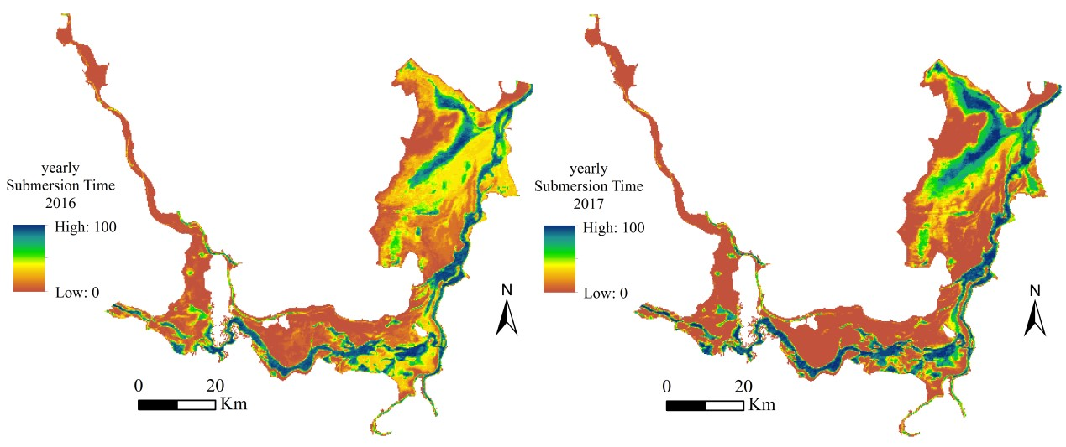
Fig. 2: Average yearly max-submersion time index of Dongting Lake in 2016 and 2017

Relationship of HR and water variation
As Fig. 3 showed, there are more than one HRs in some seasons, and size of all HRs were different from each other. In 2016, the milu population lived together in spring, and then split into two groups in summer. Groups increased to three in autumn, and the habitats they used were wider, and somewhere was more than ten kilometres farther from where they were initially released. When the water surface covered most of the Dongting Lake area in summer, the milu left the Dongting Lake wetland and lived outside until water levels receded. The HR size increased and then decreased from spring to autumn, and the HRs in summer were the smallest of any season. Most of the HRs in the summer and part of the HR in the spring and autumn were outside of Dongting Lake. Some milu individuals travelled through the inner lake and moved towards the far southern edge of the lake, whereas others stayed near the inner lake during the autumn and winter. Compared with the HRs near the inner lake, the sizes of the southern HRs were larger than northern.
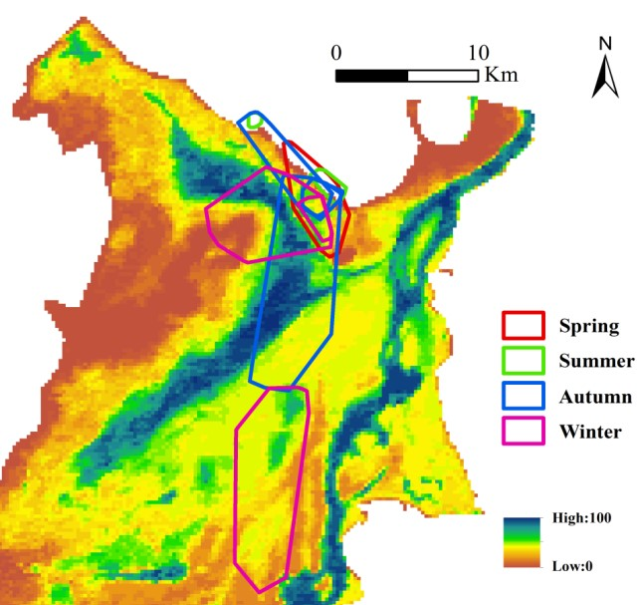
Fig. 3: Seasonal home range and max-submersion time index of Dongting Lake. The HRs were estimation using 95%MCP base on location data of all individuals in different seasons

The proportion of MSTI utilisation by HR during the seasons is shown in Table 6. Most MSTI levels were utilised as HRs except for Su-HR1 and Su-HR2. When the water surface extended during summer, milu moved outwards. Su-HR1 only made use of the marginal area when MSTI was low, and another HR used in summer, the Su-HR2, was outside of the Dongting Lake area. During other seasons, milu inhabited the area where MSTI ranged from 30% to 50%, making higher use of the area where MSTI was 40%–50% than where it was 30%–40%. When MSTI was close to 0% or 100%, milu rarely appeared in that area at any time of the year.
Table 6: Percentage of utilisation of each MSTI level of the home range during different seasons (%)
MSTI | Sp-HR1 | Su-HR1 | Su-HR2 | Au-HR1 | Au-HR2 | Au-HR3 | Wi-HR1 | Wi-HR2 | Wi-HR3
0~10% | 12.40 | 87.50 | - | 17.91 | 20.71 | 1.68 | 0 | 13.86 | 0.22
10%~20% | 6.40 | 12.50 | - | 8.96 | 8.59 | 0.84 | 0 | 5.01 | 11.42
20%~30% | 8.80 | 0 | - | 4.48 | 12.63 | 1.12 | 0 | 3.98 | 6.90
30%~40% | 23.20 | 0 | - | 28.36 | 27.27 | 13.69 | 23.19 | 13.57 | 32.11
40%~50% | 34.40 | 0 | - | 25.37 | 19.70 | 33.71 | 56.52 | 22.27 | 39.01
50%~60% | 9.20 | 0 | - | 13.43 | 9.09 | 5.59 | 8.70 | 6.93 | 4.09
60%~70% | 3.20 | 0 | - | 0 | 2.02 | 5.68 | 2.90 | 6.78 | 4.63
70%~80% | 2.00 | 0 | - | 1.49 | 0 | 4.93 | 7.25 | 3.69 | 1.62
80%~90% | 0.40 | 0 | - | 0 | 0 | 12.48 | 1.45 | 12.54 | 0
90%~100% | 0.00 | 0 | - | 0 | 0 | 20.30 | 0 | 11.36 | 0

Discussion
During the period when one individual male milu lived with the females, the HR of the male was smaller than that of the females. Regarding the behaviour of milu during rutting periods, the dominant male prefer to rest more than the other males and females (Ren et al., 2011). Because only one male milu provided GPS location data in the present study, it was highly possible that this was the dominant male; if not, it also faced competition from other male milu or challenged the dominant male voted by itself. Thus, the male milu tended to maintain its physical attributes by undertaking less daily activity.
With a change in season, the distribution and size of milu HRs changed from average to different. This phenomenon was apparent between spring and summer when milu entered their rutting period, and simultaneously water levels varied greatly. These were also differences between HRs during the rut and parturition periods. Water surface area of Dongting Lake was considered as the significant factor that influencing the distributions of milu (Yang et al., 2016). Water supplies in Dongting Lake are concentrated from June to September (Wang et al., 1998; Shi et al., 2012), thus the water level varied considerably during the summer or rut period. The milu population moved outward from the inner lake, and even moved outside the lake boundary. Without the pressure of the water body, human disturbance was probably the main external factor which influencing HR of milu. The milu population suffered greatly from human disturbance in the area and they only lived in the circumscribed area after they left the lake area. When the wet period passed, the milu population returned to the inner portion of the Dongting Lake wetland for searching favorite food and avoid human disturbance when water level reduced.
Food resources are one of the factors related to HRs (Damuth, 1981). Milu prefer to eat soft plants, however, they sometimes eat dry grass or branches when preferred food resources are unavailable (Wang and Wang, 2011). There is a great diversity of plants in the Dongting Lake wetland, with carex (Carex brevicuspis), reed (Phragmites australis), and poplars (Populus euramericana) being the main species (Yuan, 2008), therefore, Dongting Lake wetland is a suitable habitat for the milu population as it contains abundant food, water, and shelter. Other animal species are also abundant in Dongting Lake wetland, including birds and livestock, fortunately, there are no predators or contender species of milu in this region (Yang et al., 2005). Thus, when the milu population live in Dongting Lake, they are faced with low species competition and human disturbance. Food and water acquisition are the main energy demand factors for the deer. The water level may hinder milu foraging, thus, water influences the relationship of HR with food availability indirectly (Yang et al., 2016).
The present study combined the HRs with the MSTI of Dongting Lake, and showed that the hierarchy of MSTI was progressive. Areas with MSTI values of 30%–50% were well utilised by milu. Marshland is the main landscape of the area when the water surface shrinks. Some individuals converged with the natural wild milu population, hence, it is attractive to posit that communication with or the spoor of the congener population could cause the migration of an introduced enthetic population.

Conclusions
The aim of the present study was to explore the spatial utilisation of a milu population living in Dongting Lake wetland during different periods. According to the HR sizes during each period, spatial utilisation was related to water level. When water levels rose, milu changed habitat passively due to water surface extension. During such periods (summer, the wet period, and the rut period), HR sizes were smaller than those during the previous period, and most of the time the milu lived out of the lake boundary where human disturbance was common. Milu migrated back to the inner region of Dongting Lake until the water surface area receded, and they were more initiative of choice habitats. The areas where MSTI ranged from 30%–50% were primarily utilised areas that the milu preferred. Marshland is the main landscape in these areas which the milu could readily inhabit. Available food for milu was widely distributed. However, the searching process was impeded when water level increase (Yang et al., 2016). From the discussion, we think a lot of the relationship between water surface area with HR, and the distribution of the milu population, water level was likely to influenced the availability of space and food for milu population in Dongting Lake wetland.
Supplementary Materials:
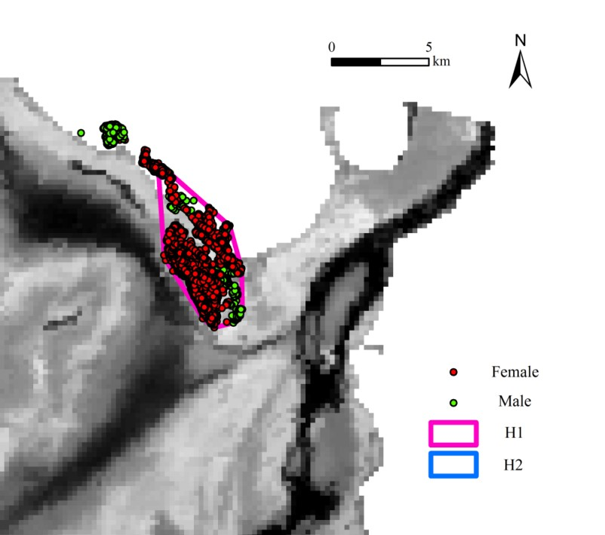
Fig. S1: Habitat distributions of the individual male milu

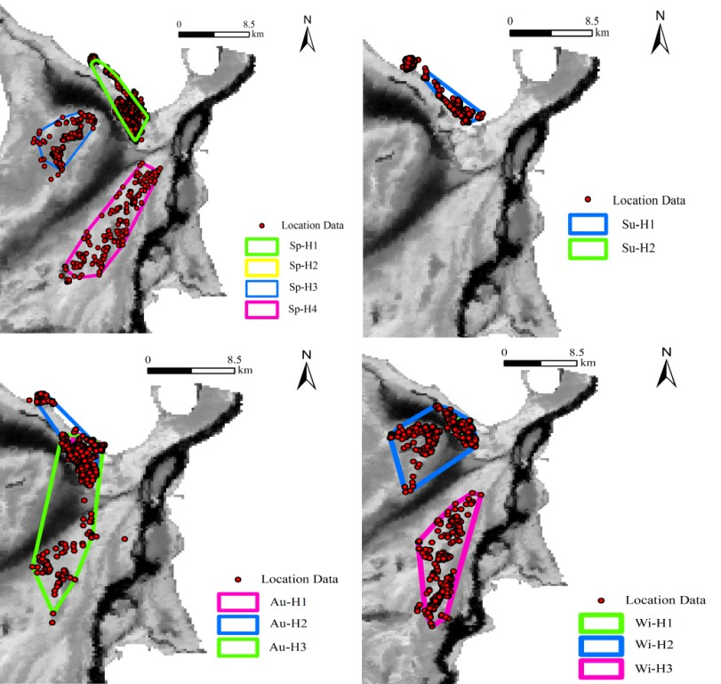
Fig. S2: Seasonal habitat distributions of the milu population
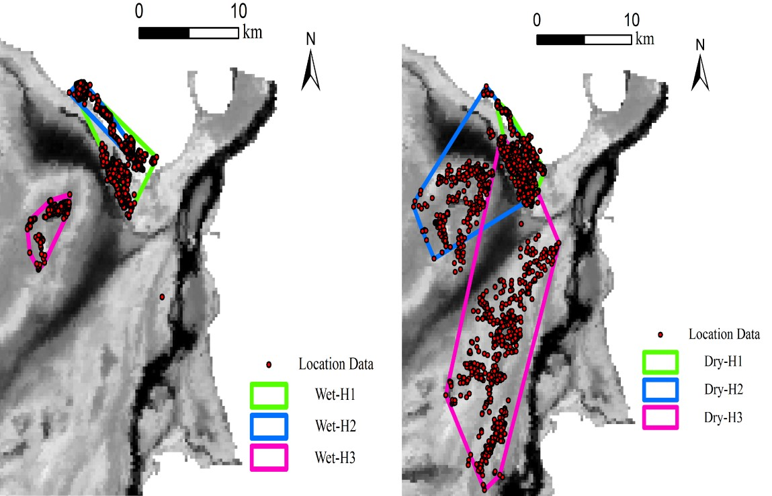
Fig. S3: Habitat distribution of the milu population during different water periods

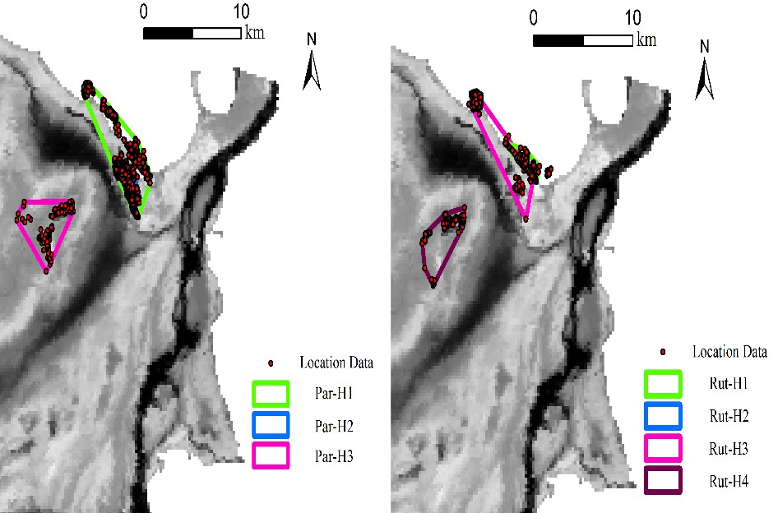
Fig. S4: Habitat distributions of the milu population during the rut and parturition periods

Acknowledgments: We are indebted to Hunan Eastern Dongting Lake National Nature Reserve Management for their help when we investigated population in the wild. The interpretation of locator data was provided by Hunan Global Messenger Co., Ltd. Animal Ethics Clearance was obtained from the Animal Ethics Committee, Central South University of Forestry and Technology (with ethics number XLK201525) and the project is under the supervision of the National Forestry Administration.

References
Burt, W.H., 1943. Territoriality and Home Range Concepts as Applied to Mammals. Journal of Mammalogy, 24(3): 346–352
Cao, L., M. Barter and C. Lei, 2008. New Anatidae population estimates for eastern China: Implications for current flyway estimates. Biological Conservation, 141(9): 2301–2309
Cao, X.Y., Y. Lv and Y.C. Liu, 2010. Investigation on Peripheral Community Resident's Dependence and Attitude to Dongting Lake. Journal of Northwest Forestry University, 25(1): 221–224
Zhang, C., Y.J. Yuan, G.M. Zeng, J. Liang, S.L. Guo, L. Huang, S.S. Hua, H.P. Wu, Y. Zhu, H.X. An and L.H. Zhang, 2016. Influence of hydrological regime and climatic factor on waterbird abundance in Dongting Lake Wetland, China: Implications for biological conservation. Ecological Engineering, 90: 473–481
Damuth, J., 1981. Home range, home range overlap, and species energy use among herbivorous mammals. Biological Journal of the Linnean Society, 153: 185–193
Ding, Y.H., J.J. Ding, P.F. Li and J.Q. Zhu, 2018. Strategy study of wild Pere David deer (Elaphurus davidianus) population development in China. Journal of Jiangsu Forestry Science &Tachnology, 45(5): 49–51
Kitts-morgan, S.E., K.C. Caires, L.A. Bohannon, E.I. Parsons and K.A. Huiburn, 2015. Free-Ranging Farm Cats: Home Range Size and Predation on a Livestock Unit In Northwest Georgia. Plos One, 10(3): e0120513
Flanagan, S.E., M.B. Brown, J. Fennessy and D.T. Bolger, 2016. Use of home range behaviour to assess establishment in translocated giraffes. African Journal of Ecology, 54(3): 365–374
Fleming, C.H., W.F. Fagan, T. Mueller, K.A. Olson, P. Leimgruber and J.M. Calabrese, 2016. Rigorous home-range estimation with movement data: A new autocorrelated kernel-density estimator. Ecology, 96(5): 1182–1188
Hansteen, T.L., H.P. Aanreassen and R.A. Ims, 1997. Effects of Spatiotemporal Scale on Autocorrelation and Home Range Estimators. Journal of Wildlife Management. 61(2): 280–290
Huang, S.F., J.G. Li and M. Xu, 2012. Water surface variations monitoring and flood hazard analysis in Dongting Lake area using long-term Terra/MODIS data time series. Natural Hazards, 62(1): 93–100
Jiang, Z.G., C.W. Li, J.J. Peng and H.J. Hu, 2001. Structure, elasticity and diversity of animal behavior. Chinese Biodiversity, 9(3): 265–274
Kaczensky, P., O. Ganbaatar, H.V. Wehrden and C. Walzer, 2010. Resource Selection by Sympatric Wild Equids in the Mongolian Gobi. Journal of Applied Ecology, 45(6): 1762–1769
Kernohan, B.J., R.A. Gitzen and J.J. Millspaugh, 2001. Chapter 5 – Analysis of Animal Space Use and Movements. Radio Tracking & Animal Populations: 125–166
Lai, X.J., J.H. Jiang and Q, Huang, 2013. Effects of the normal operation of the Three Gorges Reservoir on wetland inundation in Dongting Lake, China: a modelling study. Hydrological Sciences Journal-Journal Des Sciences Hydrologiques, 58(7): 1467–1477
Guan, L., J.L. Lei, A.J. Zuo, H. Zhang, G.C. Lei and L. Wen, 2016. Optimizing the timing of water level recession for conservation of wintering geese in Dongting Lake, China. Ecological Engineering 88: 90–98
Li, F., J.H. Huang, G.M. Zeng, X.Z. Yuan, X.D. Li, J. Liang, X.Y. Wang, X.J. Tang and B. Bai, 2013. Spatial risk assessment and sources identification of heavy metals in surface sediments from the Dongting Lake, Middle China. Journal of Geochemical Exploration, 132(3): 75–83.
Liang, C.Q. and B.S. Li, 1991. The Habitat Vegetation of Semi-free Range Milu (Elaphurus davidianus). Scientia Slivae Sinicae, 27(4): 425–434
Liang, J., J.Y. Liu, X.Z. Yuan, G.M. Zeng, X. Lai, X.D. Li, H.P. Wu, Y.J. Yuan and F. Li, 2015. Spatial and temporal variation of heavy metal risk and source in sediments of Dongting Lake wetland, mid-south China. J Environ Sci Health A Tox Hazard Subst Environ Eng, 50(1): 100–108
Liu, N, 2014. Bellowing mechanism and mating success of reproductive strategies in Père David’s deer stag. Sichuan Agriculture University
Meng, H., H.J. Wu, L.Y. Zhang, C.M. Han and Q.H. Gao, 2014. Analysis on Genetic Diversity in mtDNA Control Region of Elaphurus davidianus (EIK). Journal of Economic Animal, 18(1): 15–18, 23
Plotz, R.D., W.J. Grecian, G.I.H. Kerley and W.L. Linklater, 2016. Standardising home range studies towards improved management of the critically endangered black rhinoceros. Plos One, 11(3): e0150571
Seaman, D.E. and R.A. Powell, 1996. An Evaluation of the Accuracy of Kernel Density Estimators for Home Range Analysis. Ecology, 77(7): 2075–2085
Rautio, A., A. Valtonen and M. Kunnasranta, 2013. The effects of sex and season on home range in European hedgehogs at the northern edge of the species range. Annales Zoologici Fennici, 50(1-2): 107–123
Reinecke, H., L. Leinen, I. Thissen, M. Meissner, S. Herzog, S. Schutz and C. Kiffner, 2014. Home range size estimates of red deer in Germany: environmental, individual and methodological correlates. European Journal of Wildlife Research, 60(2): 237–247
Ren, Y.J., Y.H. Ding, S.B. Xie, L.B. Hou and B. Liu, 2011. Behavior of Wild Père David's Deer(Elaphurus davidianus) during the Period of Metestrus. Chinese Journal of Wildlife, 32(6): 309–311, 342
Sarkar, M.S., K. Ramesh, J.A. Johnson, S. Sen, P. Nigam, S.K. Gupta, R.S. Murthy and G.K. Saha, 2016. Movement and home range characteristics of reintroduced tiger (Panthera tigris) population in Panna Tiger Reserve, central India. European Journal of Wildlife Research, 62(5): 1–11
Shi, X., W.H. Xiao, Y. Wang and X. Wang, 2012. Characteristics and Factors of Water Level Variations in the Dongting Lake during the Recent 50 Years. South-to-North Water Diversion and Water Science & Technology, 10(5): 18–22
Tan, Q.L., 2002. Study on Remote Sensing Change Detection and Its Application to Poyang International Importance Wetland. Chinese Academy of Science
Wang, S.M., H.S. Dou, K.Z. Chen, X.C. Wang and J.H. Jiang, 1998. The History of Chinese Lakes, 1st ed. Science Press: Beijing, China: 185–193
Wang, S.Y., Y.L. Zhao, Z.G. Xu, L. Li, L. Wu, C.C. Duan and J. Peng, 2017. Behavioural Rhythms during the Adaptive Phase of Introduced Milu/Pere David's Deer, Elaphurus davidianus, in the Dongting Lake Wetland, China. Pakistan Journal of Zoology, 49(5): 1657–1664
Wang, X., L. Cao, A.D. Fox, R. Fuller, L. Griffin, C. Mitchell, Y.L. Zhao, O.K. Moon, D. Cabot, Z.G. Xu, N. Batbayar, A. Kölzsch, H.P. van der Jeugd, J. Madsen, L.D. Chen and R. Nathan, 2019. Stochastic simulations reveal few green wave surfing populations among spring migrating herbivorous waterfowl. Nature Communications, 10: 12
Wang, Y. and W. Wang, 2011. Diet of Père David’s deer (Elaphurus davidianus) at Milu Park in Beijing, China. Chinese Journal of Wildlife, 32(2): 65–68
Willems, E.P. and R.A. Hill, 2009. Predator-specific landscapes of fear and resource distribution: effects on spatial range use. Ecology, 90(2): 546–555
Yang, D.D., Z.G. Jiang, T.R. Cao, S.Z. Wen, K.J. Zhao, X.J. Gui, Y.X. Xu, 2002. Feasibility of reintroducing Pere David^ s deer (Elaphurus davidianus) to the Dongting Lake region, Hunan Province. Chinese Biodiversity, 10(4): 369–375
Yang, D.D., Y.C. Song, J.Z. Ma, P.F. Li, H. Zhang, M.R.S. Price, C.L. Li and Z.G. Jiang, 2016. Stepping-stones and dispersal flow: establishment of a meta-population of Milu (Elaphurus davidianus) through natural re-wilding. Scientific Reports, 6(1): 27297
Yang, D.D., J.Z. Ma, Z. He, P.F. Li, H.J. Wen and Z.G. Jiang, 2007. Population dynamics of the Père David’s deer Elaphurus davidianus in Shishou Milu National Nature Reserve, Hubei Province, China. Acta Zoologica Sinica, 53(6): 947–952
Yang, D.D., Z.G. Jiang, J.Z. Ma, H.J. Hu and P.F. Li, 2005. Causes of endangerment or extinction of some mammals and its relevance to the reintroduction of Père David's deer in the Dongting Lake drainage area. Biodiversity Science, 13(5): 451–461
Yuan, Z.K., 2008. Resources and Environment of Wetland in Dongting Lake, 1st ed. Hunan Normal University Press: Changsha, China.
Zhang, S.M, B.K. Liang, L.Y. Zhang and D.F. Hu, 2011. Challenges of Farmed Père David's deer Population Developmentand Its Protection Strategy. Forest Inventory & Planning, 36(2): 128–132
He, Z., D.D.Yang, J.Z. Ma, P.F. Li and Z.G. Jiang, 2007. Winter Habitat Selection by Milu in Shishou, Hubei. Sichuan Journal of Zoology, 26(4): 764–768

