Utilization of Fungal Consortium as Biofertilizer
Isolation of Fungal Consortium on Several Land Uses on the Western Slope of Lawu Mountain and its Potential Used as Biofertilizers.
Retno Rosariastuti*, Nanda Mutiara Pradiana Wulandari, Sumani, Siti Maro’ah
Department of Soil Science. Faculty of Agriculture, Sebelas Maret University, Surakarta, 57126, Indonesia
* For correspondence: retnobs@staff.uns.ac.id
Received_____________; Accepted_____________; Published____________
Novelty Statement
There is no information on the exploration and utilization of fungal consortia from several land uses on the western slope of Lawu Mountain as biofertilizers. From the exploration results, functional fungal species were obtained that can be used as material for biofertilizers. The test results of the fungal consortium as a biofertilizer were able to increase growth in Pakcoy plants (Brassica rapa L.). The use of fungal consortium four land use on the western slope of Lawu Mountain as a biofertilizer is expected to be used as an alternative to reduce the use of inorganic fertilizers.
Abstract
The mountainside area is one example of an area that has potential for agricultural development and it is very interesting to be studied. The research aimed to explore fungi in paddy fields (LS), forest land (LH), vegetable garden land (LY), and residential land (LP) on the western slope of Lawu Mountain. This research consisted of two types, which were descriptive-exploratory and experimental in the greenhouse with Pakcoy (Brassica rapa L.) as the test plant. Fungal isolation was carried out by culturing soil samples on PDA (Potato Dextrose Agar) medium with the spread plate method and then observed for morphology, physiology, and molecular. Biofertilizer production was done by culturing the fungal consortium on PDB (Potato Dextrose Broth) medium. Pakcoy planting was done using a Randomized Complete Block Design (CRD) with regosol soil as the planting media. Plant height and leaf number were observed. The research was conducted from May 2022 to February 2023. The results of fungal isolation obtained four fungal species, in rice fields (LS) there were fungal species Aspergillus ibericus and Aspergillus flavus, in forest land (LH) there were fungal species Aspergillus sp., Aspergillus ibericus, Aspergilus aculeatus, and Aspergillus flavus, in vegetable garden land (LY) and residential land (LP) there were fungal species Aspergilus aculeatus and Aspergillus flavus. The test results of the potential of the fungal consortium as a biofertilizer showed that the forest land (LH) fungal consortium treatment gave the best average result in Pakcoy plants yields.
Keywords: Lawu Mountain, Land Use, Fungi, Exploration, Biofertilizer
Introduction
Lawu Mountain is a mountain located on the border between East Java Province and Central Java Province. According to Noviani et al. (2020), most of the soil types on Lawu Mountain are Andisol soils. Vistoso et al. (2021) stated that volcanic soils such as Andisol have low available phosphorus (P) content. According to Poblete-Grant et al. (2020), Andisol soils are rich in minerals such as allophane, imogilite, iron (Fe), and aluminum (Al) which cause high phosphorus (P) uptake in Andisol soils. Different types of land use will affect the abundance of microorganisms in the soil. Based on the results of research conducted by Moora et al. (2014), it can be seen that different types of land use will affect the type and abundance of fungi in the soil. This allows the existence of functional fungi such as phosphate (P) solubilizing fungi, potassium (K) solubilizing fungi, and nitrogen (N) fixing fungi in the soil so that the soil is interesting to be used as a source of isolates.
One of the efforts made by farmers to increase agricultural products is to prioritize the use of inorganic fertilizers because they are considered easier to apply. Guo et al. (2021), stated that excessive use of inorganic fertilizers over a long time can cause serious problems such as soil degradation, greenhouse gas emissions, and food insecurity. To reduce the use of inorganic fertilizers, there is an alternative that can be used, specifically using biofertilizers by utilizing microorganisms such as functional fungi. According to Hammad et al. (2020), the use of organic fertilizers can improve soil quality and sustainable crop productivity because it has many functions in agroecosystems.
Biofertilizer is a fertilizer that contains active microorganisms. According to Mohsen et al. (2022), a biofertilizer is a fertilizer that contains one or more microorganisms that can convert unavailable nutrients into more available to plants. Raimi et al. (2021), stated that the advantages of biological fertilizers compared to chemical fertilizers are more cost-effective, environmentally friendly, and ensure sustainable agricultural production.
The utilization of biological technology made from active microorganisms such as functional fungi is one of the efforts that can be made to support agriculture that is environmentally friendly and sustainable. Mitter et al. (2021), stated that biofertilizers are considered an important component in supporting sustainable agriculture, which provides long-term effects on soil fertility. Therefore, exploration of fungal consortia needs to be done to obtain functional fungal isolates that can be used as biofertilizers.

Materials and Methods
Methods
This research is descriptive-explorative with a survey method to obtain fungal isolates then continued with the application of fungal consortium as bofertilizer to promote Pakcoy plant growth, planted in pots experiment. The survey was conducted on four land uses consisting of rice fields (LS), forest land (LH), vegetable garden land (LY), and residential land (LP) on the Western Slope of Lawu Mountain, located in Karanganyar Regency, Central Java Province, Indonesia. The experimental design the test of potential the fungal consortium as a biofertilizer on Pakcoy plants using a completely randomized design (CRD), consisting of five treatments, including the application of NPK fertilizer (N), LS fungal consortium biofertilizer, LH fungal consortium biofertilizer, LY fungal consortium biofertilizer, and LP fungal consortium biofertilizer. All treatments were replicated three times, so there were 15 experimental units with a spacing of 30 x 30 cm.
Time and Location
This research was completed from May 2022 to February 2023 located on the western slope of Lawu Mountain, Karanganyar Regency, Central Java Province, Indonesia for taking soil sample as the source of fungal isolate. The soil was then brought to the Soil Biology and Biotechnology Laboratory of the Faculty of Agriculture Universitas Sebelas Maret for microbiological analysis and Soil Chemistry Laboratory of the Faculty of Agriculture, Universitas Sebelas Maret for soil chemical analysis.
Sampling
Sampling was conducted in May 2023. The sampling method used in this study is purposive random sampling by land use units on the western slope of Lawu Mountain, Karanganyar Regency, Central Java Province, Indonesia. Soil sampling was carried out around the rhizosphere of plants, for each type of land use consisting of two samples taken, which are soil samples from the upper slopes and lower slopes.
Fungal Exploration
Fungal Isolation: Fungal isolation was carried out by growing fungi from four land uses (LS, LH, LY, and LP) on the western slope of Lawu Mountain on PDA (Potato Dextrose Agar) medium. PDA medium was made by weighing 19.5 grams of PDA powder (potato extract, dextrose, and agar) and dissolved in 500 ml of distilled water. The homogenized PDA solution was then sterilized using an autoclave for 15 minutes at 121˚C. The sterilized PDA media was then poured into petri dishes that had been sterilized in an autoclave about 10 ml each petri dish and then the petri dish was closed and waited until it solidified. The next process is to prepare the isolate source by dissolving 5 grams of soil samples in 45 ml of physiological salt and then shaking until homogeneous and settled. Then the solution that has settled is taken 1 ml, put into a reaction tube with 9 ml of physiological salt, and then labeled the test tube with the code 10⁻². Serial dilutions were carried out until obtaining a 10⁻⁵ dilution. The results of each dilution were cultured into a petri dish containing PDA medium that had solidified and then incubated at room temperature. After that, a mixed culture will be obtained, then purification is carried out by transferring one different fungal colony to a new sterile PDA medium until a single culture is obtained.
Identification of Fungal Morphology and Physiology: Morphological identification of fungi that have been successfully isolated is carried out using macroscopic and microscopic observations. Macroscopic observations are in the form of colony surface color, colony edge color, and bottom color of fungal colonies. Microscopic observations were made using a microscope including fungal spores and hyphae (Putra et al. 2021). Physiological identification is carried out by growing fungi at different temperature and pH conditions (Sulistiyono, 2017). The temperature used in physiological identification is 4⁰C for the minimum temperature which is the temperature of the refrigerator, 28⁰C which is room temperature, and 40⁰C which is used as the optimum temperature (Putir et al. 2021), while the pH used is pH 4 for the minimum pH, 7 for neutral pH, and 9 for alkaline pH.
Molecular Identification: Molecular identification was carried out at PT Genetika Science using the PCR (polymerase chain reaction) method using universal primers ITS1-ITS4. Molecular identification begins with the DNA extraction process, the results of DNA extraction are then amplified. The amplification results will obtain gene sequences which will later be used as sequencing material to identify the type of fungus by matching the sequencing results with Gen Bank.
Testing the Potential of Fungal Consortium as Biofertilizer
Preparation of Liquid Inoculum as Biofertilizer: Liquid inoculum was prepared by growing each fungal isolate from the four land uses on 100 ml PDB liquid medium for each land use. PDB media was made by boiling 250 grams of potatoes in 750 ml of distilled water to extract. The extract obtained was then put into an Erlenmeyer and dextrose was added as much as 1 gram / 100 ml of potato extract, then sterilized using an autoclave for 15 minutes at 121˚C. The next step is to put fungal isolates from each land use into PDB media and then shaker at 70 rpm for 2 x 24 hours. After that, the spore density was calculated using a hemocytometer to determine the dose to be given to plants.
Planting: Starting with the preparation of planting media by drying the soil taken from the Colomadu sub-district area which is Regosol soil, then sieved using a 2 mm sieve. The results of the sieve were weighed as the amount of 3 kg for each pot. Soil that has been sieved is sterilized first by steaming (steam sterilization) for 3 hours/day within three consecutive days.
Next, the process of sowing pakcoy seeds as a test plant to determine the ability of the fungal consortium as a biofertilizer. After 7 days, the seeds were transferred into pots containing sterile soil. The pots were placed according to the experimental plan with a spacing of 30 x 30 cm.
The application of fungal consortium as biofertilizer and NPK fertilizer was done 1 week after planting. The dose of fungal spores given to the pots was 10⁵ spores/g soil. The application of liquid inoculum of the fungal consortium was given as much as 30 ml with a spore density of 10⁷ spores/ml. The application of compound NPK fertilizer given as a control was at the recommended dose of 300kg/ha so the dose for each pot was 0.45 grams.
Maintenance activities carried out including watering everyday which is carried out twice a day in the morning and evening, weeding and controlling pests or diseases. Plant parameters were observed once a week were of plant height and number of leaves. Harvesting was done 35 days after planting.
Harvesting was done by pulling the plants from the pots and weigh the plants to getting the fresh weight data, then the plants were dried using an oven for 24 hours until reach the constant weight to getting dry weight data. Soil used as planting media analyzed its chemical characteristics before planting and after harvesting. The observation parameters were soil pH, soil C-Organic, soil N-Total, soil P-Available, and soil K-Available.
Data Analysis
Data were statistically analyzed using ANOVA (Analysis of Variance) followed by DMRT (Duncan's Multiple Range Test) and correlation test.
Results
Fungal Isolation
Based on fungal isolation results, there 19 fungal isolates were obtained from rice fields, 15 fungal isolates from forest land, 14 fungal isolates from vegetable gardens, and 13 fungal isolates from residential land. The results of fungal isolates from the four land uses were then selected based on the best colony growth marked by clear colony color and the number of colonies that dominate in one petri dish.
Table 1. Fungal Isolates from Rice Field, Forest, Vegetable Garden, and Settlement Land Use
Type of Land Use | Code of Dominant Fungal Isolate
Agricultural Land Use (LS) | S1, S2
Forest Land Use (LH) | H1a, H1b , H2a , H2b
Vegetable Garden Land Use (LY) | Y1, Y2
Settlement Land Use (LP) | P1 , P2
Source: Primary Data
Based on the selection results, the fungal isolates used as a fungal consortium from each land use were obtained (Table 1). Rice fields obtained 2 fungal isolates, forest land 4 fungal isolates, vegetable garden land 2 fungal isolates, and residential land obtained 2 fungal isolates.
Morphological Identification of Fungal Colonies
Table 2. Macroscopic Observation of Fungal Colony Morphology
No | Isolate Code | Colony Surface Color | Colony Edge Color | Colony Bottom Color
1. | A1 | Yellow-Green | White | Pale
2. | S2b(2) | Black | White | Pale-yellow
3. | Y1b | Brownish-Black | White | Brownish-White
4. | H2a | Orange-Red | White | Reddish
Source: Primary Data

Table 3. Microscopic Observation of Fungal Colony Morphology
No | Isolate Code | Spores | Hyphae
1. | A1 | Round green | Has septum
2. | S2b(2) | Round blackish green | Has septum
3. | Y1b | Round yellowish green | Has septum
4. | H2a | Round green | Has septum
Source: Primary Data
Physiological Identification of Fungal Colonies
Table 4. Identification Results of Fungal Isolates at Different Temperature and pH
No. | Isolate Code | Temperature |  |  | pH
 |  | 4⁰C | 28⁰C | 40⁰C | 4 | 7 | 9
1. | A1 | - | + | + | + | + | +
2. | S2b(2) | - | + | + | + | + | +
3. | Y1b | - | + | + | + | + | +
4. | H2a | - | + | + | + | + | +
Source: Primary Data
Description: (+) sign can grow
(-) sign cannot grow
According to the identification results of fungal physiology in Table 4, it can be seen that the fungal isolates found can grow in all pH conditions, but are only able to grow in temperature conditions of 28⁰C and 40⁰C.
Molecular Identification of Fungal Colonies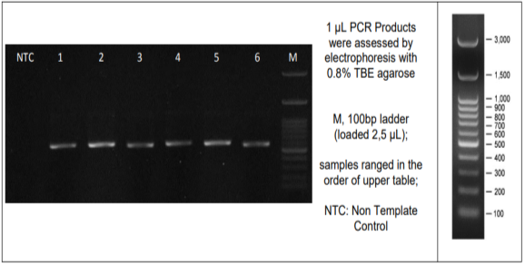
Figure 1. Amplification Results of Isolate A1
Description: Number 1 is a DNA band owned by isolate A1
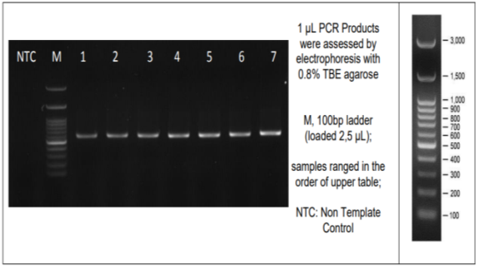
Figure 2. Amplification Results of Isolates S2b(2), Y1b, and H2a
Description: number 2 is a DNA band belonging to isolate S2b (2), number 5 belongs to isolate Y1b, and number 7 belongs to isolate H2a.

Figure 1 and Figure 2 above show the gene amplification results of isolates A1, S2b(2), H2a, and Y1b. The letter M in the amplification results above is a marker. Figure 1 is a DNA band owned by isolate A1 with a DNA molecular weight of about 600 bp. Figure 2 is a DNA band belonging to isolates S2b (2), Y1b, and H2a with a DNA molecular weight of about 700 bp.
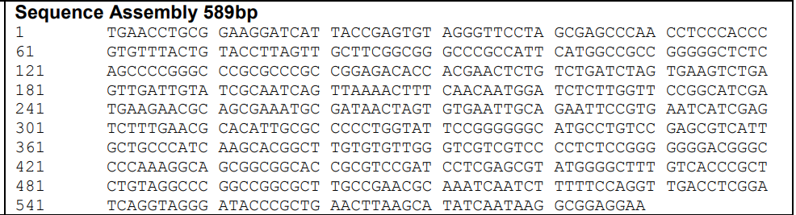
Figure 3. Nitrogen Base Sequence of Isolate A1
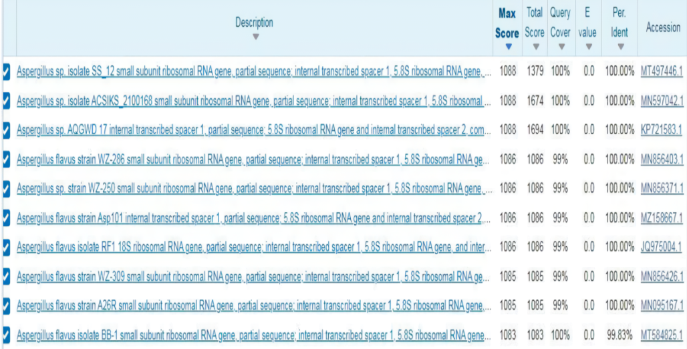
Figure 4. BLAST Analysis of Isolate A1

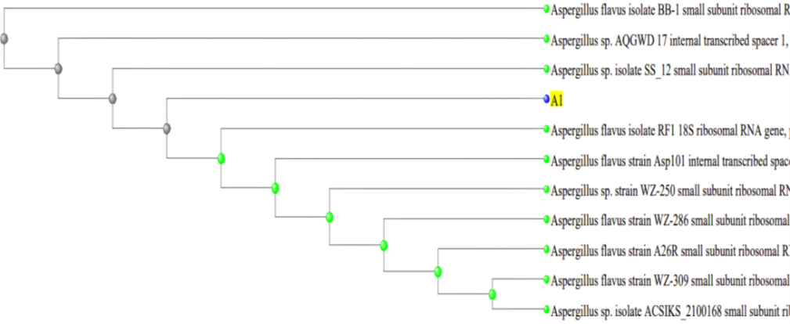
Figure 5. Phylogenetic Tree of Isolate A1
Based on the sequencing results shown in Figure 3, isolate A1 has a DNA length of 589 bp. Based on the results of BLAST analysis and phylogenetic tree construction, it can be concluded that isolate A1 has the most similarity with Aspergillus flavus isolate RF1 species with a percentage of 100%.
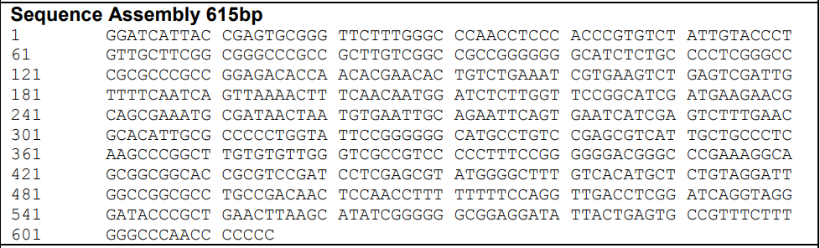
Figure 6. Nitrogen Base Sequence of Isolate S2b(2)
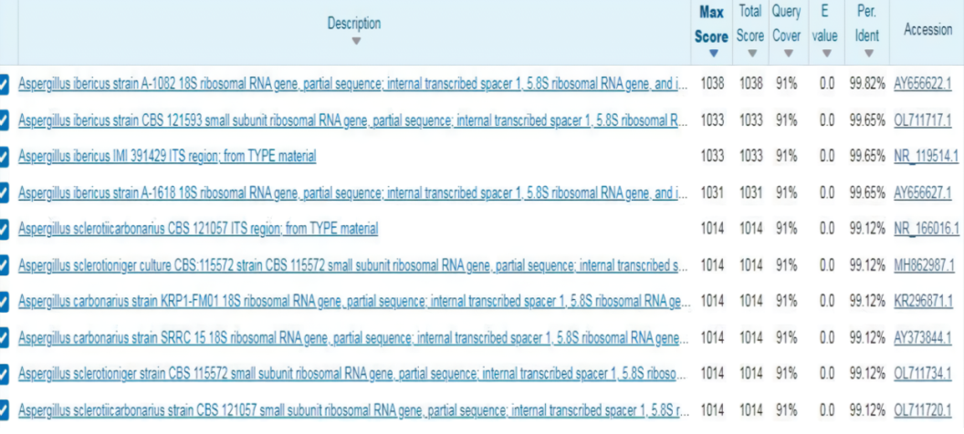
Figure 7. BLAST Analysis of Isolate S2b(2)
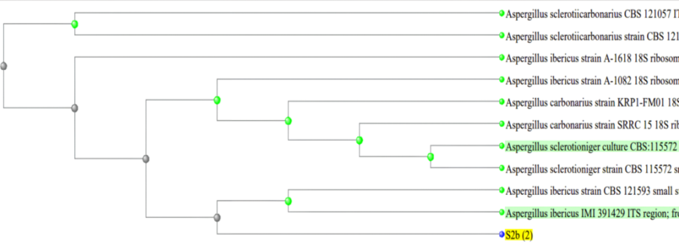
Figure 8. Phylogenetic Tree of Isolate S2b(2)
Based on the sequencing results shown in Figure 6, isolate S2b(2) has a DNA length of 615 bp. Based on the results of BLAST analysis and phylogenetic tree construction, it can be concluded that isolate S2b(2) has the most similarity with the species Aspergillus ibericus IMI 39 with a percentage of 99.65%.
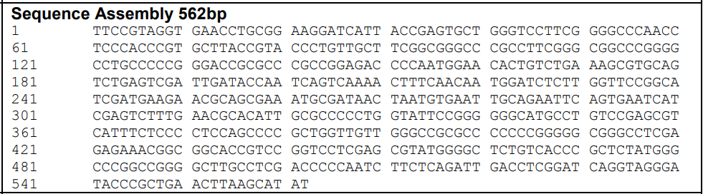
Figure 9. Nitrogen Base Sequence of Isolate Y1b
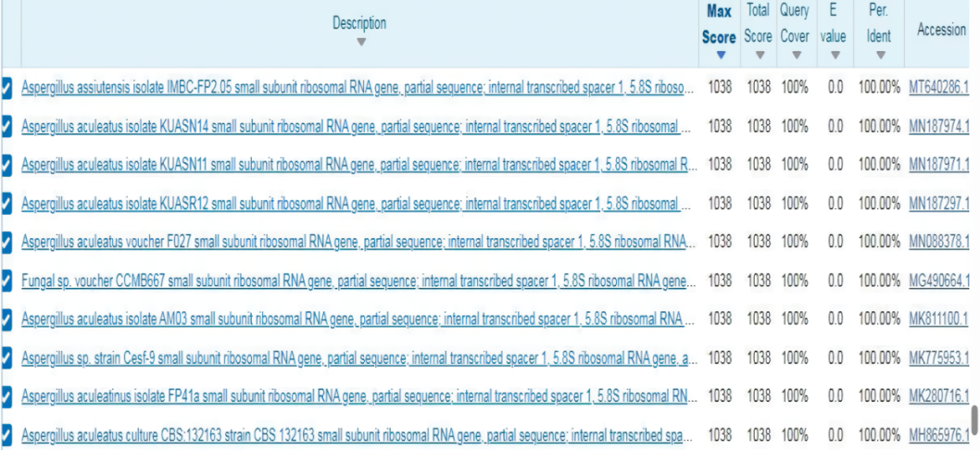
Figure 10. BLAST Analysis of Isolate Y1b

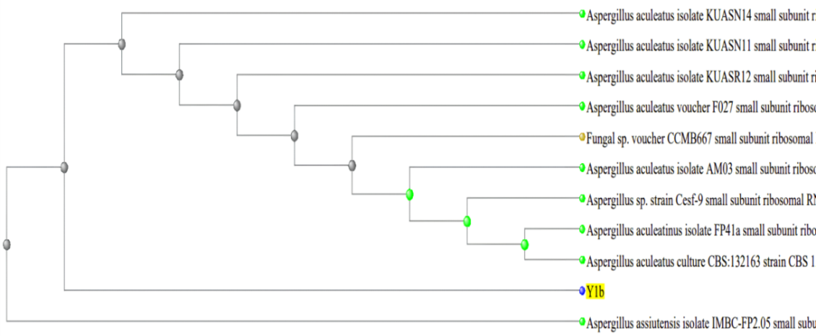
Figure 11. Phylogenetic Tree of Isolate Y1b
Based on the sequencing results shown in Figure 9, isolate Y1b has a DNA length of 562 bp. The results of phylogenetic tree construction in Figure 11 show that isolate Y1b has the closest kinship with Aspergillus aculeatus culture CBS: 132163 with a percentage similarity of 100%.
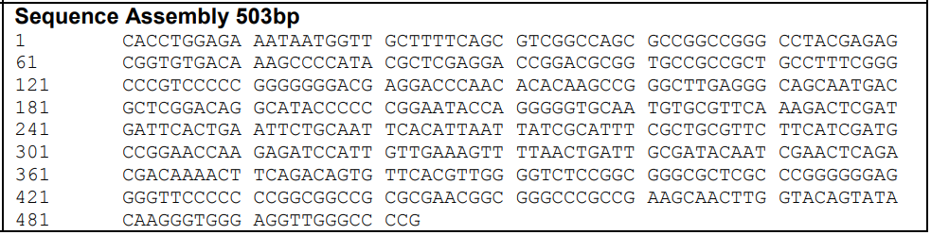
Figure 12. Nitrogen Base Sequence of Isolate H2a
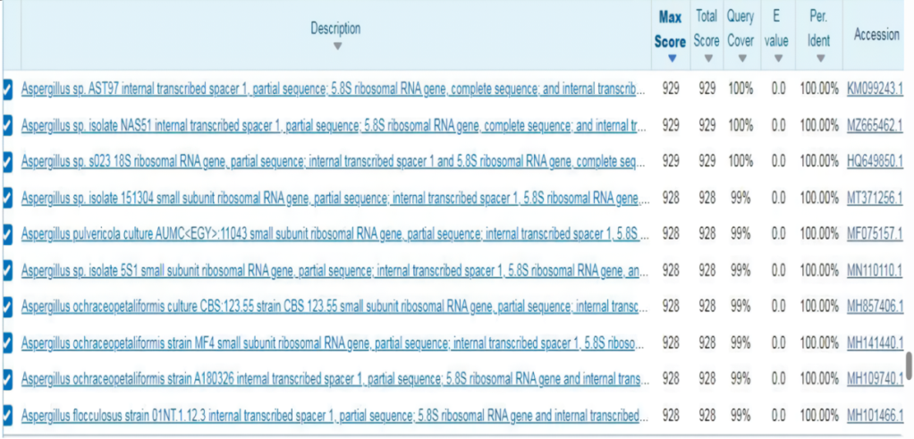
Figure 13. BLAST Analysis of Isolate H2a
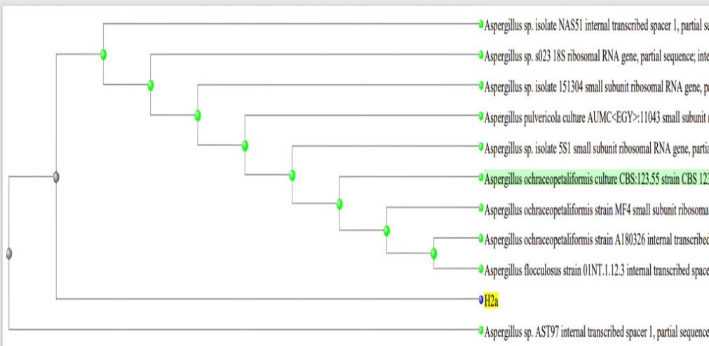
Figure 14. Phylogenetic Tree of Isolate H2a
Based on the sequencing results shown in Figure 12 isolate H2a has a DNA length of 503 bp. Based on the results of BLAST analysis and phylogenetic tree construction, it can be concluded that isolate H2a has the most similarity with the species Aspergillus sp. AST97 with a percentage of 100%.
Based on the results of BLAST analysis and phylogenetic tree construction, it can be concluded that the fungal consortium from each land use is obtained as follows:
Table 5. Fungal Consortium from Each Land Use
No | Land Use | Species
1. | Rice Field (LS) | Aspergillus ibericus dan Aspergillus flavus
2. | Forest Land (LH) | Aspergillus sp., Aspergillus ibericus, Aspergilus aculeatus, dan Aspergillus flavus
3. | Vegetable Garden Land (LY) | Aspergilus aculeatus dan Aspergillus flavus
4. | Residential Land (LP) | Aspergilus aculeatus dan Aspergillus flavus
Source: Primary Data
Initial Soil Characteristics of Planting Media
Table 6. Results of Initial Soil Characteristics (before planting )Analysis of Planting Media
No | Parameter | Result | Unit | Classified
1. | pH | 6,19 | - | Slightly acidic
2. | C-Organic | 1,92 | % | Low
3. | N-Total | 0,06 | % | Very low
4. | P-Available | 1,72 | ppm | Very low
5. | K-Available | 0,13 | cmol/kg | Low
Source: Primary Data
The initial soil analysis (Table 6) showed that the soil had a pH that was classified as slightly acidic, which is 6.19. The C-Organic content of the soil is low at 1.92%. The content of nitrogen (N) and phosphorus (P) according to the results of the analysis is in the very low category, which is 0.06% for soil N-Total and 1.72 ppm for soil P-Available. The K-available content is low at 0.13 cmol/kg. From the preliminary analysis, it can be concluded that the soil still has a low fertility level.
Effect of Treatment on Final Soil Characteristics (After Harvesting)
Soil pH

Figure 15. Effect of Treatment on Soil pH
In general, the treatment can increase soil pH compared to the initial soil with a range of 4.6% to 10.3%. ANOVA results showed that the application of fungal consortium as biofertilizer significantly affected soil pH (p<0.05). Figure 15 shows that the LH fungal consortium treatment could increase pH highest compared to the control and other treatments which was 10.3%. The soil pH value in the LH fungal consortium treatment was 6.83 (5.6% higher than the control). The results of DMRT analysis showed that the LH fungal consortium treatment was significantly different from the control and other treatments.

Soil C-Organic

Figure 16. Effect of Treatment on C-Organic
In general, the treatment of fungal consortium caused a decrease in C-Organic content compared to the initial soil with a range of 41.6% to 44.8%. ANOVA results showed that the application of fungal consortium as biofertilizer interaction significantly affected to soil C-Organic (p<0.05). The study results showed that the highest decreased C-Organic occurred in the treatment of LH fungal consortium which amounted to 44.8%, and the value of C-Organic was 1.06% which means 2,8% lower than the control. The results of DMRT analysis showed that the LH fungal consortium treatment was significantly different from the control and other treatments.
Soil N-Total

Figure 17. Effect of Treatment on Soil N-Total
In general, the fungal consortium treatment increased soil N-Total content compared to the initial soil with a range of 50% to 100%. The ANOVA results showed that the application of fungal consortium as biofertilizer significantly affected soil N-Total (p<0.05). Figure 17 reveals the highest results were found in the treatment of LY fungal consortium. The N-Total value in the LY fungal consortium treatment was 0.12% (33.3% higher than the control) and the increase was 100%. DMRT results showed that the LY fungal consortium treatment was not significantly different from the LH fungal consortium treatment, but the difference was significant with the control and the other two treatments.
Soil P-Available

Figure 18. Effect of Treatment on Soil P-Available
In general, the treatment of fungal consortium was able to increase the soil P-available content compared to the initial soil with a range of 25.6% to 48.3%. The results of ANOVA showed that the application of fungal consortium as biofertilizer had a significant interaction on soil P-availability (p<0.05). The highest was found in the LY fungal consortium treatment. The value of P-Available in the treatment of LY fungal consortium is 2.55 ppm (18.1% higher than the control) and the increase was 48.3%. The results of DMRT analysis showed that the treatment of LY fungal consortium significantly differed from the control and other treatments.
Soil K-Available

Figure 19. Effect of Treatment on Soil K-Available
In general, the fungal consortium treatment was able to increase the soil K-available content compared to the initial soil with a range of 61.5% to 130.7%. ANOVA results showed that fungal consortium as biofertilizer application had a significant effect to soil K-available (p<0.05). Based on the analysis, the increase in K-available was highest in the LH fungal consortium treatment, which amounted to 130.7%., and the value of K-Available was 0.30 cmol/kg which means 42.9% higher than the control. The DMRT analysis showed that the treatment of LH fungal consortium showed a significant difference with the control, but the difference was not significant with the treatment of LY fungal consortium and LP fungal consortium.

Effect of Treatment on Plants Growth
Plant Height

Figure 20. Effect of Treatment on Plant Height
ANOVA results showed that the treatment of fungal consortium as biofertilizer had a significant effect on plant height (p<0.05). The results showed that the treatment of LH fungal consortium had the highest average value of 27 cm (35% higher than the control). Based on the DMRT results, the plant height by the LH fungal consortium treatment was not significantly different from the LY fungal consortium treatment, but the difference was significant with the control and the other two treatments.
Number of Leaves

Figure 21. Effect of Treatment on Number of Leaves
ANOVA results showed that the provision of fungal consortium as biofertilizer significantly affected the number of leaves (p<0.05). The results of this study revealed that the LY fungal consortium treatment resulted in the highest average leaf number. The treatment of LY fungal consortium had 11 leaves (57% higher than the control). Based on the results of DMRT, the number of leaves by LY fungal consortium treatment was not significantly different from the LH fungal consortium treatment, but the difference was significant with the control and the other two treatments.
Plant Dry Weight

Figure 22. Effect of Treatment on Plant Dry Weight
ANOVA results showed a significant effect on plant dry weight by the treatment of fungal consortium as biofertilizer (p<0.05). The highest results were found in the treatment of LH fungal consortium. The treatment of LH fungal consortium obtained a dry weight of 0.42 grams (50% higher than the control). Based on the results of DMRT, the dry weight of plants by LH fungal consortium was significantly different from the control and other treatments.
Discussion
Soil pH is one of the factors that can support the growth of soil microorganisms. According to Rukmana et al. (2019), in conditions of pH 5.5 to pH 7 fungi and bacteria that are functional, namely as decomposers of organic matter in the soil, will grow well. Wan et al. (2021), stated that soil pH is considered a major factor affecting microbial diversity and activity in the soil.
The treatment of LH fungal consortium had the highest pH increase value than the other treatments., this is because the LH fungal consortium has the most combined fungal species compared to the fungal consortium from other land uses (Table 6). Increasing the pH of the soil to neutral can be caused by the decomposition process carried out by soil microorganisms such as fungi. According to Li et al. (2022), fungi contribute to the decomposition of organic matter and the carbon cycle. Kaya et al. (2017), stated that the decomposition of organic matter will produce basic cations such as Ca, Mg, K, and Na which cause the concentration of OH¯ ions to increase which results in soil pH also increasing.
Based on the results of the study, it can be seen that there is a decrease in the C-Organic content of the initial soil after being treated. The decrease in C-Organic content can occur because the carbon is used by fungi as an energy source to support the decomposition process of organic matter. Macias-Benitez et al. (2020), stated that soil microorganisms use carbon as an energy source. Nurrohman et al. (2014), stated that the decomposition process will produce minerals that are a source of nutrients for plants that would be released by the mineralization process to be used by plants to support their growth. The decrease in C-Organic content can also be caused by the respiration process in plants and soil. Yuniarti et al. (2017) stated that the factors causing the decline of carbon in the soil are the result of the process of plant respiration, soil respiration, and transported during harvest. The process of plant respiration and soil respiration will cause the release of organic carbon in the form of carbon dioxide (CO₂) so that the soil C-Organic content will decrease.
The LY fungal consortium treatment which is a combination of Aspergilus aculeatus and Aspergillus flavus species has the highest N-Total value compared to other treatments. Hastuti, (2011), stated that the fungus Aspergillus flavus is included in heterotrophic microorganisms that can produce nitrate. According to Al-Maadhidi & Henriksson (1980), their research stated that Aspergillus flavus can increase nitrogen fixation but its ability is not better than Trichoderma fungi because Aspergillus fungi produce more inhibitory substances than Trichoderma fungi. This is in line with the results of the study which showed that soil N-total after being treated increased from the initial soil but the results were still relatively low.
The treatment of LY fungal consortium also gave the highest increase in available P compared to other treatments. Omomowo et al. (2020), stated that Aspergillus flavus has the potential to increase plant growth when used as a biological fertilizer. Aspergilllus flavus can dissolve phosphate in the soil. The increase in available P is also influenced by pH. According to Balogun et al. (2022), usually acidic pH causes high phosphate dissolution due to the presence of acids that ionize bound phosphate, but this species of Aspergillus fungus can grow well in neutral soil conditions, so it tends to dissolve more phosphate in neutral conditions. It is shown from the research results that the control treatment with pH 6.47 (slightly acidic) has the lowest P-available value compared to other treatments with soil conditions that have a neutral pH.
According to Ristiari et al. (2018), soil microbes such as fungi that can dissolve P, generally also can dissolve potassium. The fungal species found in the LH fungal consortium treatment, namely Aspergillus flavus, Aspergillus aculeatus, and Aspergillus sp. can dissolve P, which means they can dissolve potassium (K). According to Li et al. (2019), Aspergillus aculeatus can dissolve insoluble forms of phosphorus (P) to become available to plants. Li et al. (2023), stated that Aspergillus aculeatus also can dissolve potassium (K) in the soil which can encourage plant growth. According to Sattar et al. (2019), fungi dissolve potassium by producing organic acids such as oxalic acid, citric acid, and gluconate which can cause damage to silicate clay, mica, and feldspar. Based on the results of the study, it can be seen that the application of fungal consortium is able to increase K-available in the soil higher than the control.
Plant height is a parameter used to determine the effect of treatment on plant growth. The treatment of LH fungal consortium was able to provide the highest plant height compared to other treatments. Benu et al. (2020), stated that the number of biota in the soil affects the physical and chemical properties of the soil and affects plant growth. According to Aulia et al. (2016), the application of biological fertilizers to plants will cause the formation of functional microbial colonies at the roots to protect the roots from pathogen attacks and break down organic matter, to encourage plant growth by increasing the supply of nutrients for plants.
The treatment of LY fungal consortium was able to provide the highest number of leaves compared to other treatments. Andriani (2017) stated that observations on the number of leaves showed that as the age of the plant increases, the number of leaves will increase. The number of leaves that increase along with the age of the plant indicates the activity of vegetative growth in plants.
Plant dry weight is the total weight of the plant after the water content of the metabolic products in the plant is removed (Anastasia et al. 2014). The highest results were found in the LH fungal consortium treatment. The LH fungal consortium treatment obtained a dry weight of 0.42 grams. Anjani et al. (2022), stated that the dry weight of plants is influenced by the number of leaves because the leaves are the storage of photosynthetic products of plants. The large number of leaves will cause an increase in the photosynthesis process which will be translocated to the plant body. Plant dry weight is also influenced by plant height According to Pane et al. (2014), an increase in plant height will directly affect plant weight.
Conclusion
The results of fungal isolation from four land uses on the western slope of Mount Lawu obtained four fungal species namely Aspergillus ibericus, Aspergillus flavus, Aspergillus sp., and Aspergilus aculeatus. In general, the LH fungal consortium which is a combination of Aspergillus sp., Aspergillus ibericus, Aspergilus aculeatus, and Aspergillus flavus has the best potential in supporting plant growth. LH fungal consortium gave the best average results in plant height, which reached 27 cm (35% higher than the control) and dry weight reached 0.42 grams (50% higher than the control) in Pakcoy (Brassica rapa L) plants. LH fungal consortium also has the best potential in increasing soil pH up to 6.83 (5.6% higher than the control) from the initial soil and K-Available up to 0.30 cmol/gr (42.9% higher than the control) from the initial soil, followed by LY fungal consortium which can increase N-Total content up to 0.12% (33.3% higher than the control) from the initial soil and P-Available up to 2.55 ppm (18.1% higher than the control) from the initial soil. Based on these results, LH fungal consortium and LY fungal consortium can be used as biofertilizers that can support plant

Reference
Al-Maadhidi, & E, H. (1980). Nordic Society Oikos Effects of the Fungi Trichoderma Harzianum and Aspergillus Flavus on the Nitrogen Fixation and Growth of the Alga Anabaena Variabilis. Nordic Society Oikos 35(1): 115–119.
Anastasia, I., Izatti, M., & Suedy, S. W. A. (2014). Pengaruh Pemberian Kombinasi Pupuk Organik Padat dan Organik Cair terhadap Porositas Tanah dan Pertumbuhan Tanaman Bayam (Amarantus tricolor L.). Jurnal Akademika Biologi 3(2): 1–10.
Andriani, V. (2017). Pertumbuhan dan Kadar Klorofil Tanaman Pakcoy (Brassica rapa L.) terhadap Cekaman NaCl. STIGMA: Jurnal Matematika Dan Ilmu Pengetahuan Alam Unipa 10(02): 58–67.
Anjani, B. P. T., Bambang Budi Santoso, & Sumarjan. (2022). Pertumbuhan dan Hasil Sawi Pakcoy (Brassica rapa L.) Sistem Tanam Wadah pada Berbagai Dosis Pupuk Kascing. Jurnal Ilmiah Mahasiswa Agrokomplek 1(1): 1–9.
Aulia, F., Susanti, H., & Fikri, E. N. (2016). Pengaruh Pemberian Pupuk Hayati dan Mikoriza terhadap Intensitas Serangan Penyakit Layu Bakteri (Ralstonia solanacearum), Pertumbuhan, dan Hasil Tanaman Tomat. Jurnal ZIiraa’ah 41(2): 250–260.
Balogun, D. A., Oke, M. A., Rocha-Meneses, L., Fawole, O. B., & Omojasola, P. F. (2022). Phosphate Solubilization Potential of Indigenous Rhizosphere Fungi and Their Biofertilizer Formulations. Agronomy Research 20(1): 40–55.
Benu, M. M. M., Tae, A. S. J. A., & Mukkun, L. (2020). Dampak Residu Insektisida terhadap Keanekaragaman Jamur Tanah pada Lahan Sayuran Sawi. Jurnah Ilmu Tanah Dan Lingkungan 22(2): 80–88.
Guo, L., Li, H., Cao, X., Cao, A., & Huang, M. (2021). Effect of Agricultural Subsidies on The Use of Chemical Fertilizer. Journal of Environmental Management, 299(August): 113621.
Hammad, H. M., Khaliq, A., Abbas, F., Farhad, W., Fahad, S., Aslam, M., Shah, G. M., Nasim, W., Mubeen, M., & Bakhat, H. F. (2020). Comparative Effects of Organic and Inorganic Fertilizers on Soil Organic Carbon and Wheat Productivity under Arid Region. Communications in Soil Science and Plant Analysis 51(10): 1406–1422.
Hastuti, Y. P. (2011). Nitrifikasi dan denitrifikasi di tambak. Jurnal Akuakultur Indonesia 10(1): 89–98.
Kaya, E., Ch, S., & Y, Risambessy (2017). Pengaruh Pemberian Pupuk Organik Cair dan Mikroorganisme terhadap Keasaman dan P-Tersedia pada Tanah Ultisol. Jurnal Mikologi Indonesia 1(2): 91–99.
Li, X., Qu, Z., Zhang, Y., Ge, Y., & Sun, H. (2022). Soil Fungal Community and Potential Function in Different Forest Ecosystems. Diversity 14(7): 1–12.
Li, X., Sun, X., Wang, G., Amombo, E., Zhou, X., Du, Z., Zhang, Y., Xie, Y., & Fu, J. (2019). Inoculation with Aspergillus Aculeatus Alters the Performance of Perennial Ryegrass under Phosphorus Deficiency. Journal of the American Society for Horticultural Science 144(3): 182–192.
Li, X., Zhang, T., Xue, Y., Xu, X., Cui, X., & Fu, J. (2023). Aspergillus Aculeatus Enhances Nutrient Uptake and Forage Quality in Bermudagrass by Increasing Phosphorus and Potassium Availability. Frontiers in Plant Science 14(April): 1–10.
Macias-Benitez, S., Garcia-Martinez, A. M., Caballero Jimenez, P., Gonzalez, J. M., Tejada Moral, M., & Parrado Rubio, J. (2020). Rhizospheric Organic Acids as Biostimulants: Monitoring Feedbacks on Soil Microorganisms and Biochemical Properties. Frontiers in Plant Science 11: 1–16.
Mitter, E. K., Tosi, M., Obregón, D., Dunfield, K. E., & Germida, J. J. (2021). Rethinking Crop Nutrition in Times of Modern Microbiology: Innovative Biofertilizer Technologies. Frontiers in Sustainable Food Systems 5(February): 1–23.
Mohsen, B., Asadzadeh, F., Masoumeh, H., Edith, C. H., Ramesh, R. V., & Vahedi, R. (2022). Optimization of Biofertilizer Formulation for Phosphorus Solubilizing by Pseudomonas fluorescens Ur21 via Response Surfance Methodology. Process 10(650): 1–12.
Moora, M., Davison, J., Öpik, M., Metsis, M., Saks, Ü., Jairus, T., Vasar, M., & Zobel, M. (2014). Anthropogenic Land Use Shapes the Composition and Phylogenetic Structure of Soil Arbuscular Mycorrhizal Fungal Communities. FEMS Microbiology Ecology 90(3): 609–621.
Noviani, N., Sugiyarto, & Sunarto. (2020). Berbagai Penggunaan Lahan di Lereng Gunung Lawu. Biological Journal of Indonesia 01: 7–10.
Omomowo, I. O., Shittu, O. E., Omomowo, O. I., & Majolagbe, O. N. (2020). Influence of Phosphate Solubilizing Non-Toxigenic Aspergillus flavus Strains on Maize (Zea mays l.) Growth Parameters and Mineral Nutrients Content. AIMS Agriculture and Food 5(3): 408–421.
Pane, M. A., Damanik, M. M. B., & Sitorus, B. (2014). Pemberian Bahan Organik Kompos Jerami Padi dan Abu Sekam Padi dalam Memperbaiki Sifat Kimia Tanah Ultisol serta Pertumbuhan Tanaman Jagung. Jurnal Online Agroekoteknologi 2(4): 1426–1432.
Poblete-Grant, P., Suazo-Hernández, J., Condron, L., Rumpel, C., Demanet, R., Malone, S. L., & Mora, M. de L. L. (2020). Soil Available P, Soil Organic Carbon and Aggregation as Affected by Long-term Poultry Manure Application to Andisols under Pastures in Southern Chile. Geoderma Regional 21: 1–10.
Putir, P. E., Penyang, & Fetriasie. (2021). Jamur Makro Basidiomycetes di Hutan Rawa Ganbut Taman Nasional Sebangau Kabupaten Katingan Kalimantan Tegah. Jurnal Hutan Tropika 16(2): 175–185.
Putra, I., Sudiarta, 1, & Suniti, N. (2021). Identifikasi Morfologi Jamur Kontaminan pada Naskah Lontar. Jurnal Agroekoteknologi Tropika Lembab 10(4): 448–455.
Raimi, A., Roopnarain, A., & Adeleke, R. (2021). Biofertilizer Production in Africa: Current Status, Factors Impeding Adoption and Strategies for Success. Scientific African, 11: e00694.
Ristiari, N. P. N., Julyasih, K. S. M., & Suryanti, I. A. P. (2018). Isolasi dan Identifikasi Jamur Mikroskopis pada Rizosfer Tanaman Jeruk Siam (Citrus nobilis Lour.) di Kecamatan Kintamani, Bali. Jurnal Pendidikan Biologi Undiksha 6(1): 10–19.
Rukmana, A., Susilawati, H., & Galang. (2019). Pencatatan pH Tanah Otomatis. Jurnal Penelitian dan Pengembangan Teknik Elektro Telekomunikasi Indonesia 10(1): 25–32.
Sattar, A., Naveed, M., Ali, M., Zahir, Z. A., Nadeem, S. M., Yaseen, M., Meena, V. S., Farooq, M., Singh, R., Rahman, M., & Meena, H. N. (2019). Perspectives of Potassium Solubilizing Microbes in Sustainable Food Production System: A review. Applied Soil Ecology 133(September): 146–159.

Sulistiyono, F. D. (2017). Karakteristik Fisiologi Empat Antagonis Isolat Trichoderma sp. sebagai Agensia Hayati. Jurnal Sains Natural 5(1): 24-29.
Vistoso, E., Iraira, S., & Sandaña, P. (2021). Phosphorus Use Efficiency in Permanent Pastures in Andisols. Journal of Soil Science and Plant Nutrition 21(4): 2587–2599.
Wan, W., Hao, X., Xing, Y., Liu, S., Zhang, X., Li, X., Chen, W., & Huang, Q. (2021). Spatial Differences in Soil Microbial Diversity Caused by pH-driven Organic Phosphorus Mineralizatio. Land Degradation and Development 32(2): 766–776.
Yuniarti, A., Suriadikusumah, A., & Gultom, J. U. (2017). Pengaruh Pupuk Anorganik dan Pupuk Organik Cair terhadap pH, N-Total, C-Organik, dan Hasil Pakcoy pada Inceptisols. Prosiding Pertanian Dan Tanaman Herbal Berkelanjutan di Indonesia, 213–219.

