Hematological and Serum Biochemical indices of Indigenous Goat Breeds of Punjab, Pakistan.
Omer Naseer^{1*}, Muhammad Shahid², Ameer Hamza Rabbani², Yasir Razzaq Khan¹, Abdullah Saghir Ahmad³, Muhammad Luqman Sohail¹, Junaid Naseer⁴, Ahmad Ali¹, Muhammad Bilal⁶, Waqas Abbas⁷, Muhammad Usman Saleem⁸
¹Department of Medicine, Cholistan University of Veterinary and Animal Sciences, Bahawalpur
omernaseer@cuvas.edu.pk: luqmanvet@gmail.com: yasirrazzaq@cuvas.edu.pk ahmadali@cuvas.edu.pk
^{:2}Department of Surgery, Cholistan University of Veterinary and Animal Sciences, Bahawalpur
mshahid@cuvas.edu.pk: Ameerhamzarabbani@cuvas.edu.pk:
³Department of Parasitology, Cholistan University of Veterinary and Animal Sciences, Bahawalpur.
abdullahsaghirahmad@cuvas.edu.pk:
⁴Department of Forestry Range & Wildlife Management, The Islamia University Bahawalpur.
Sheikhjohn1951@gmail.com:
⁶Poultry Research Institute, Livestock & Dairy Development Department, Punjab.
Mohammadbilaal24@gmail.com:
⁷Feed tech Division, Ghazi Brothers (pvt) limited, Pakistan.
Waqasabbas01@gmail.com:
⁸Department of Biosciences, Faculty of Veterinary Sciences, Bahauddin Zakriya Univerity, Multan.
usman1011333@hotmail.com
Corresponding Author: Omer Naseer
Email: dromersheikh@gmail.com
omernaseer@cuvas.edu.pk
Postal Address: Department of Medicine, Cholistan University of Veterinary and Animal Sciences Bahawalpur, Pakistan. +92 321 640 89 56

Abstract:
Goat breeds indigenous to Punjab namely, Teddy, Beetal, Dere Din Panah, Nachi and Long hairy were inducted into this study. Considering the consequential role of goats as livestock commodity in socio-economic fabric of Punjab and significance of haemato-biochemical reference values as diagnostic parameters, analyses were carried out to determine base-line reference values for aforementioned breeds at different stages of maturation. Twenty clinically healthy goats reared on open grazing lands belonging to different breeds and age groups i.e., pre-weaning, post weaning, pre-pubertal and post pubertal goats were studied. Blood samples were analyzed for RBC, WBC, hemoglobin (Hb) concentration, Packed cell volume (PCV), Platelets, mean corpuscular hemoglobin (MCH) and mean corpuscular volume (MCV). Moreover, serum Aspartate transaminase (AST), Alanine transaminase (ALT), Alkaline phosphatase (ALP), Gamma-glutamyltransferase (GGT) levels along with albumin, urea and creatinine concentrations were determined as well. Cholesterol, BUN and bilirubin levels were also detected however their values were not statistically significant at different phases of maturation. Significant variations were observed in RBCs, hemoglobin, white blood cell count and other biochemical parameters (P < 0.05) among different age groups showing an incremental trend as animals aged. The present data could facilitate further investigations into goats reared in comparable nutritional, climatic and managemental circumstances.

Keywords: Hematological and biochemical parameters, Indigenous goats, Age, Alanine transaminase (ALT)
Introduction:
Livestock has been the backbone of Pakistan’s economy playing a vital role in the livelihood of the rural population. It contributes a large share in national and agricultural GDP 11.69 and 60.56%, respectively. This sector has sustained the growth rate at 4.0 % while the set target was 3.8%. It is estimated that Pakistan has 3rd largest goat populations in the world just after China and India. The goat population in Pakistan is believed to grow incrementally by more than three percent per annum. (GOP 2020) Provincially, Punjab has 37%, Sindh has 23%, while Baluchistan 22% and KPK have 18% of indigenous goat populations (Khan et al. 2008).
Punjab is heavily invested in agricultural sector. Livestock rearing serves as source of livelihood for a large swath of its population. For centuries now, goat has been an integral unit of rural culture serving as a source of meat, milk, hair and other byproducts (skins, bones, offal, meals) (Muhammad, Abdullah, Javed, et al. 2015). Goat production is not very intensive and is predominantly based upon grazing. Such a rearing system requires less input, either relying solely on grassland grazing or availability of cut fodder during certain seasons.
Goats are mostly reared by small scale dairy farmers having 6 to 15 animals. Approximately 70 percent of goat population is distributed as small herds with an average of 50 heads of animals. On the other hand, rest of them are divided in bigger herds nearly 50–200 goats or more (Khan et al. 2008). Indigenous goats of Punjab have best adaptability to survive in harsh production situations like dry weather, low quality forage, water scarcity, high altitude and temperature extremes, as compared with those from other geographic locations (Afzal et al. 2004; Khan et al. 2008).
There are conflicting reports pertaining to the number of goat breeds in Pakistan. However, thirty-six (36) breeds of goat have been recognized (Afzal et al. 2004). Contradictions may have arisen due to inclusion or exclusion of Azad Jammu & Kashmir (AJK), however variations in nomenclature might be attributed to difference in number (Khan et al. 2008). The most significant indigenous breeds of Punjab are long Hairy, Nachi, Beetal, Teddy, and Dera Din Panah with regard to parameters of production, size of population and economic impact (Khan et al. 2008; Naqvi et al. 2017).
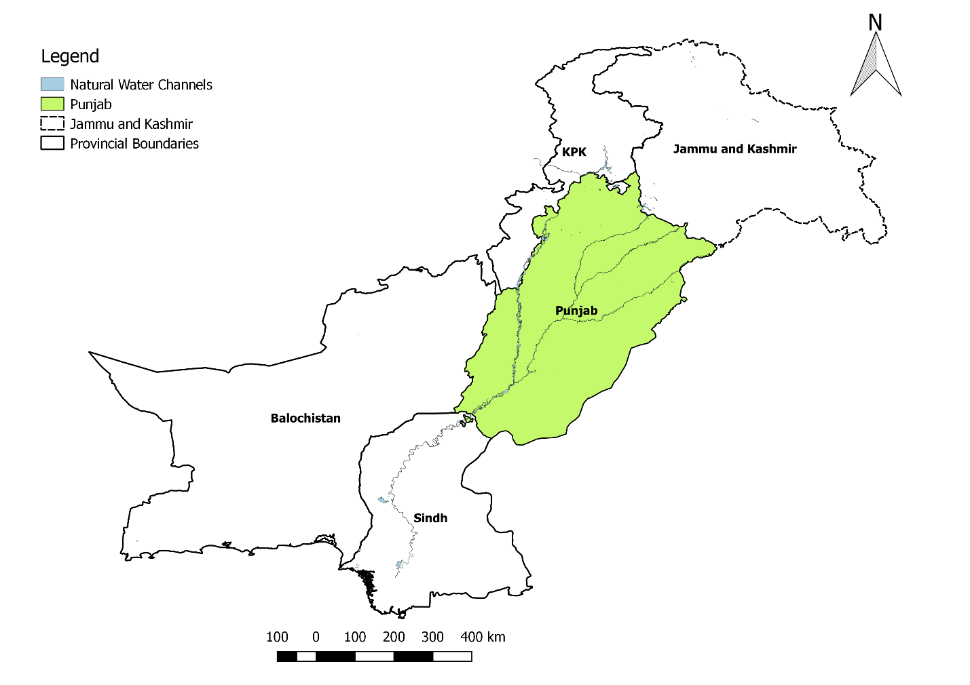Fig.1 Geographical Location of Punjab, Pakistan.
Blood is a significant and authentic medium for assessing the health status of individual animal (Ramprabhu et al. 2010). The hematological values are mainly used for indicating the stress and welfare of the animal and to evaluate the physiological status of the animal. There is enormous deviation in the haemato-biochemical indices present between different breeds of goats (Harahap et al. 2018). Hematological and biochemical parameters are essential for gaining valuable insight into the animals’ health status, breed, and sex (Madan et al. 2016). Such analysis is helpful in evaluating the status of immunity as well (Al-Seaf and Al-Harbi 2012). These hematological values will widely help in the systemic relationship and physiological adaptation of animals (Khan et al. 2009) but during pregnancy these figures could be disturbed (Waziri et al. 2010). The blood plasma components and the biochemical profile express variations according to the age, necessities of growth, breed, (Piccione et al. 2007) environmental and managemental conditions (Arfuso et al. 2016) sexual maturity (Piccione et al. 2007) along with the production of the animals (Madan et al. 2016).
Goat breeds have great deviation regarding their hemato-biochemical indices (Muhammad, Abdullah, Khan, et al. 2015). So, to determine significant standardized values for the physiological parameters of goats reared in Punjab with the intension of further evaluation of their nutrition, management and health is the dire need of hour. Therefore, the purpose of the present study was to explore the biochemical and hematological indices of indigenous goat breeds of Punjab.
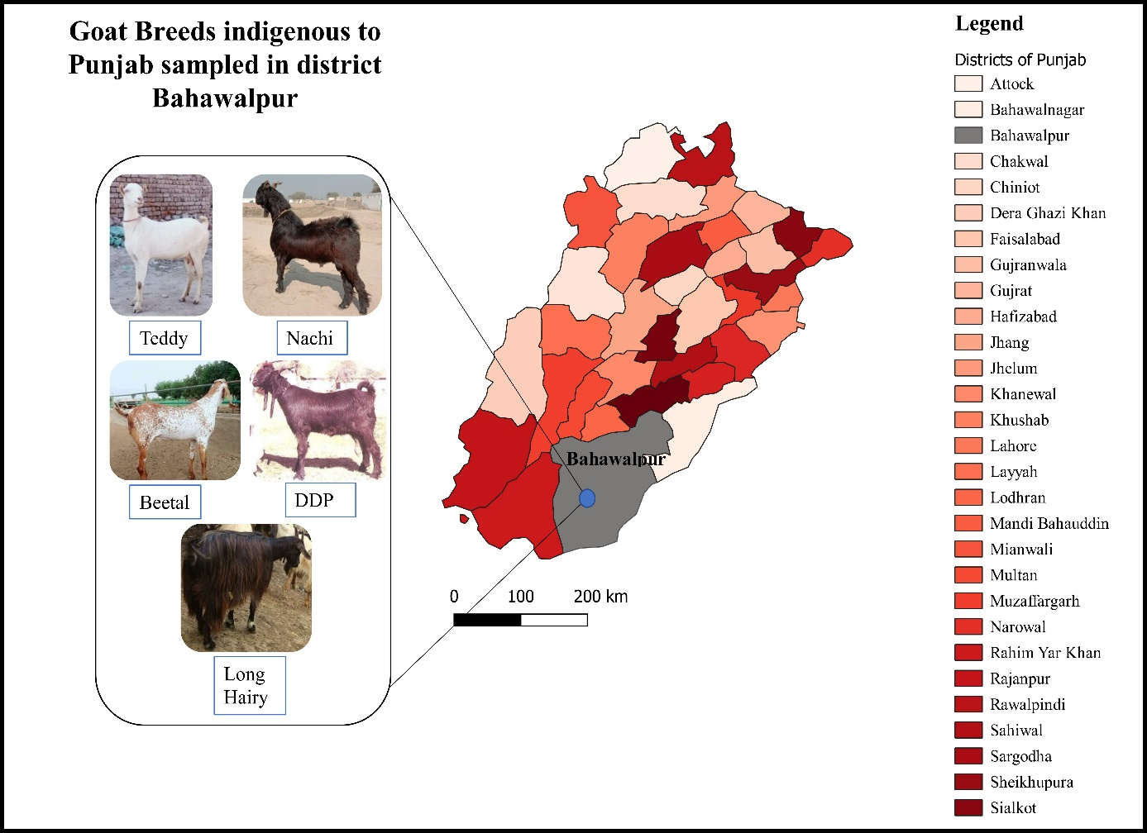
Fig.2 Goat Breeds of Punjab, Pakistan
Materials and Methods
This investigation was carried out at the Veterinary Teaching Hospital, Cholistan University of Veterinary & Animal Sciences, Bahawalpur (CUVAS).
Animal sampling
A large population of goats of varied breeds, sexes and ages were identified and grouped based upon their maturity. Animals aged under 2 months were placed in pre-weaning group, lesser than 4month-old kids were allocated into post weaning group, animals aging up to 8months were categorized as pre-pubertal while animals older than 8months were called post pubertal. Five indigenous breeds of Punjab (Beetal, Dera Din Panah, Teddy, Nachi and long hairy) were inducted into study and 20 animals were placed into each age group. Sex was not taken into account while placing the animals into groups. After clinical examination the animals were declared healthy before sampling and all animals were on grazing.
Sampling of Blood
Jugular veins were used for the collection of blood samples into 2 tubes (Atlas medo-o-vac Faransico), one tube was coated with ethylene diamine tetra acetic acid (EDTA) for hematology of blood and for biochemistry of the blood collection tube has no anticoagulants (BD Vacutainer TM). All collected samples were shifted to the laboratory as early as possible in ice packed box.
Hematological Analysis
Hematological analysis was carried out with the help of an approved lysing buffer particularly for goats (Concentrated Lysing Reagent, SEAC, Florence, Italy). All the samples of blood collected were processed within forty-five minutes just after collection with the help of Paramedical Italy (PKLPPC 610 H) for the estimation of (Hb) Hemoglobin, (RBC) Red blood cells, (MCV) Mean corpuscular volume, (WBC) White blood cells count, (MCH) Mean corpuscular hemoglobin, (PCV) Packed cell volume and mean platelet volume.
Serum biochemical Analysis
For biochemical investigation, blood samples were left on the shelves to clot in collection tubes, then for fifteen minutes centrifuged at 3000 rpm for serum separation which was stored at −20°C till used for the biochemical examination. For the determination of goat’s liver profile following parameters were observed: (ALT) Alanine aminotransferase, (AST) Aspartate transaminase, (ALB) Albumin, (GGT) Gamma glutamyl transferase, (ALP) Alkaline phosphatase, (BUN) Blood urea nitrogen. Cholesterol, Creatinine, Bilirubin and Urea by using Vet Scan VS2 analyzer (ABAXIS, USA).
Statistical analysis
For the statistical analysis, Graph Pad Prism software version 8.4.3 was used to calculate the mean, and standard deviation for all values. A non-parametric one-way ANOVA was employed for statistical evaluation of all parameters between different age groups of the same breed whereby significance was determined when P<0.05.
Results:
Hemato-biochemical indices are influenced by age, amongst different goat breeds of Punjab at varied age groups as well as standard deviation (SD) were shown in Table 1 and Table 2. Following parameters namely RBC, Hemoglobin, PCV, MCH and MCV were significantly (P<0.05) elevated in post pubertal animals (Table 1). Likewise, a similar trend was observed for ALP, ALT and albumin. Whereas, RFT values, mainly Creatinine was reportedly increased in pre-pubertal and post weaning animals (Table 2).
Table 1. Average values of hematological parameters in different Local breeds at varying phases of maturity.
Sr. No | Blood Parameter | Breed | Pre-weaning | Post weaning | Pre-Pubertal | Post pubertal
1 | Hb (g/dl) | Teddy | 7.73±  0.67^{c} | 7.82±  0.34^{c} | 8.63±  0.99^{b} | 10.40±  1.05ª
 |  | Beetal | 7.84±  0.53 | 7.97±  0.29^{c} | 8.6515±  0.82^{b} | 10.0505±  0.92ª
 |  | DDP | 7.63±  0.30^{c} | 8.40±  0.21^{b} | 10.17±  0.87ª | 10.366±  0.86ª
 |  | Nachi | 7.80±  0.38^{b} | 8.293±  0.15^{b} | 9.672±  0.94ª | 10.19±  0.88ª
 |  | Long hairy | 8.26±  0.16^{c} | 8.2855±  0.11^{c} | 9.26±  0.83^{b} | 10.47±  0.57ª
2 | RBC (× 10⁶/μl) | Teddy | 10.38±  1.54^{c} | 10.85±  1.57^{c} | 13.00±  0.69^{b} | 13.95±  0.66ª
 |  | Beetal | 9.94±  1.98^{c} | 12.78±  1.09ª | 12.61±  0.64^{b} | 13.57±  0.72ª
 |  | DDP | 7.94±  1.09^{c} | 12.32±  0.73^{b} | 12.88±  0.77ª | 13.46±  0.83ª
 |  | Nachi | 9.15±  1.61^{c} | 13.02±  0.62^{b} | 13.59±  0.96^{b} | 14.49±  0.56ª
 |  | Long hairy | 12.19±  0.48^{b} | 12.36±  0.67^{b} | 13.09±  0.76^{b} | 14.25±  0.40ª
3 | WBC (× 10³/μl) | Teddy | 14.22±  1.31 | 14.58±  1.30 | 15±  1.17 | 14.485±  1.24
 |  | Beetal | 14.37±  1.26 | 14.56±  1.12 | 14.75±  1.04 | 14.88±  1.50
 |  | DDP | 14.35±  1.17 | 14.11±  1.13 | 14.58±  1.25 | 14.96±  1.31
 |  | Nachi | 15.06±  1.18 | 14.71±  1.16 | 14.42±  1.16 | 14.4±  1.12
 |  | Long hairy | 15.26±  1.20 | 15.11±  1.14 | 14.27±  1.19 | 14.21±  1.24
4 | PCV (%) | Teddy | 40.22±  1.30ª | 38.94±  2.04^{b} | 38.56±  1.71^{b} | 36.27±  1.02^{c}
 |  | Beetal | 38.94±  1.96ª | 39.08±  1.89ª | 39.04±  1.79ª | 37.79±  1.82^{b}
 |  | DDP | 39.05±  1.87^{c} | 39.76±  1.40^{b} | 38.80±  0.86^{c} | 41.53±  0.49ª
 |  | Nachi | 39.90±  1.41^{b} | 40.44±  1.03ª | 38.74±  0.69^{b} | 40.70±  1.15ª
 |  | Long hairy | 37.17±  1.40^{b} | 39.55±  1.91ª | 38.74±  1.85ª | 38.81±  2.03ª
5 | MCH (pg) | Teddy | 27.56±  1.51 | 27.87±  1.43 | 27.72±  1.38 | 26.91±  1.65
 |  | Beetal | 27.23±  1.68 | 27.84±  1.73 | 27.21±  1.56 | 27.09±  1.67
 |  | DDP | 27.56±  1.46 | 26.72±  1.32 | 26.84±  1.85 | 26.76±  1.89
 |  | Nachi | 27.28±  1.52 | 27.37±  1.63 | 26.77±  1.37 | 27.47±  1.60
 |  | Long hairy | 26.84±  1.62 | 27.29±  1.74 | 26.60±  1.89 | 27.72±  1.46
6 | Platelets (/μl ) | Teddy | 266.00±  5.63 | 270.26±  4.463975423 | 265.42±  6.11 | 265.24±  4.96
 |  | Beetal | 265.48±  7.40 | 265.55±  6.22 | 267.11±  6.34 | 266.98±  6.05
 |  | DDP | 265.27±  6.59 | 267.72±  5.83 | 264.24±  5.77 | 262.05±  5.59
 |  | Nachi | 267.12±  6.63 | 267.76±  6.88 | 265.59±  7.28 | 266.38±  5.35
 |  | Long hairy | 266.74±  6.20 | 268.64±  6.20 | 267.34±  5.76 | 266.10±  7.05
7 | MCV (fL) | Teddy | 11.88±  1.94^{b} | 13.63±  0.60ª | 13.74±  0.65ª | 13.61±  0.49ª
 |  | Beetal | 12.81±  2.11^{b} | 13.8±  0.59ª | 13.81±  0.51ª | 13.42±  0.56ª
 |  | DDP | 13.59±  0.62 | 13.645±  0.42 | 13.72±  0.55 | 13.74±  0.50
 |  | Nachi | 13.77±  0.52 | 13.455±  0.64 | 13.71±  0.47 | 13.68±  0.60
 |  | Long hairy | 13.69±  0.42 | 13.675±  0.61 | 13.63±  0.58 | 13.44±  0.51

Table 2. Average values of Blood chemistry parameters in different Local breeds at varying phases of maturity
Sr. No | Blood Chemistry | Breed | Pre- Weaning | Post Weaning | Pre-Pubertal | Post Pubertal
1. | AST (IU/L) | Teddy | 75.9±18.1 | 77.2±18 | 78.8±17.4 | 80.3±18.2
 |  | Beetal | 79.7±17.5 | 80.7±17.9 | 84.5±18.9 | 87.0±18.1
 |  | DDP | 78.3±16.3 | 79.5±17.4 | 82.7±17.3 | 85.0±17.4
 |  | Nachi | 79.5±16.3 | 80.0±16.5 | 84.0±18.2 | 85.3±18.5
 |  | Long hairy | 78.8±15.3 | 80.8±17.3 | 84.3±16.6 | 85.9±18.8
2. | ALP (IU/L) | Teddy | 190.79± | 189.21± | 170.69± | 172.47±
 |  |  | 25.39ª | 21.11ª | 28.29^{b} | 20.01ª
 |  | Beetal | 192.80± | 165.93± | 182.54± | 183.99±
 |  |  | 25.01ª | 33.45^{b} | 31.70ª | 19.40ª
 |  | DDP | 168.83± | 203.55± | 197.01± | 173.75±
 |  |  | 19.17^{b} | 19.55ª | 19.08ª | 30.66^{b}
 |  | Nachi | 171.62± | 188.44± | 146.15± | 194.07±
 |  |  | 18.81^{b} | 20.74ª | 19.86^{c} | 18.65ª
 |  | Long hairy | 182.87± | 178.96± | 189.21± | 171.83±
 |  |  | 18.48 | 16.33 | 17.26 | 20.35
3. | ALT (IU/L) | Teddy | 39.96± | 38.96± | 38.44± | 36.23±
 |  |  | 5.40ª | 6.11ª | 6.38ª | 6.73^{b}
 |  | Beetal | 37.28± | 41.86± | 38.48± | 42.09±
 |  |  | 8.39^{b} | 5.16ª | 6.80ª | 5.08ª
 |  | DDP | 41.87± | 36.50± | 38.46± | 39.51±
 |  |  | 5.21ª | 5.24^{b} | 5.11^{b} | 4.63^{b}
 |  | Nachi | 43.53± | 43.34± | 34.60± | 36.62±
 |  |  | 5.24ª | 5.43ª | 5.45^{c} | 5.60^{b}
 |  | Long hairy | 38.29± | 39.82± | 35.49± | 41.70±
 |  |  | 5.40ª | 6.30ª | 5.65^{b} | 5.05ª
4. | GGT (IU/L) | Teddy | 60.20± | 53.94± | 56.68± | 52.61±
 |  |  | 0.91ª | 1.82^{c} | 1.16^{b} | 0.43^{d}
 |  | Beetal | 58.12± | 53.20± | 52.74± | 53.90±
 |  |  | 0.73ª | 1.65^{c} | 0.42^{c} | 1.39^{b}
 |  | DDP | 57.61± | 52.48± | 52.63± | 56.68±
 |  |  | 0.44ª | 0.39^{c} | 0.45^{c} | 0.19^{b}
 |  | Nachi | 62.09± | 58.20± | 56.22± | 52.42±
 |  |  | 0.37ª | 0.26^{b} | 0.38^{c} | 0.42^{d}
 |  | Long hairy | 57.23± | 52.84± | 52.61± | 56.68±
 |  |  | 0.37ª | 0.48^{b} | 0.73^{b} | 0.15ª
5. | ALB (IU/L) | Teddy | 3.48± | 3.85± | 4.14± | 4.22±
 |  |  | 0.32^{b} | 0.45ª | 0.38ª | 0.47ª
 |  | Beetal | 3.45± | 3.73± | 3.81± | 3.97±
 |  |  | 0.43^{b} | 0.41ª | 0.50ª | 0.52ª
 |  | DDP | 3.57± | 3.93± | 4.06± | 4.73±
 |  |  | 0.50^{c} | 0.16^{b} | 0.56^{b} | 0.35ª
 |  | Nachi | 3.72± | 4.11± | 4.47± | 5.32±
 |  |  | 0.38^{d} | 0.37^{c} | 0.36^{b} | 0.21ª
 |  | Long hairy | 4.08± | 4.35± | 4.91± | 5.69±
 |  |  | 0.33^{c} | 0.30^{c} | 0.29^{b} | 0.24ª
6. | BUN mg/dl | Teddy | 33.62± | 34.07± | 31.01± | 33.82±
 |  |  | 8.50 | 8.84 | 9.29 | 10.37
 |  | Beetal | 35.97± | 33.79± | 33.57± | 33.00±
 |  |  | 6.55 | 6.26 | 6.80 | 6.85
 |  | DDP | 37.99± | 36.30± | 33.09± | 32.01±
 |  |  | 6.52 | 6.51 | 5.63 | 5.90
 |  | Nachi | 34.08± | 34.99± | 36.29± | 37.23±
 |  |  | 5.30 | 5.92 | 5.91 | 5.51
 |  | Long hairy | 34.21± | 36.16± | 36.31± | 36.22±
 |  |  | 6.40 | 5.33 | 5.13 | 6.18
7. | Bilirubin (mg/dl) | Teddy | 1.59± | 1.18± | 1.195± | 1.459±
 |  |  | 0.54ª | 0.58^{b} | 0.53 | 0.57
 |  | Beetal | 1.64± | 1.285± | 1.175± | 1.38±
 |  |  | 0.55ª | 0.46^{b} | 0.53^{b} | 0.53^{b}
 |  | DDP | 1.45± | 1.255± | 1.32± | 1.455±
 |  |  | 0.53 | 0.48 | 0.43 | 0.49
 |  | Nachi | 1.33± | 1.655± | 1.355± | 1.47±
 |  |  | 0.49 | 0.48 | 0.47 | 0.46
 |  | Long hairy | 1.525± | 1.475± | 1.2± | 1.625±
 |  |  | 0.44^{b} | 0.51^{b} | 0.42^{b} | 0.44ª
8. | Cholesterol (mg/dl) | Teddy | 81.61± | 84.49± | 77.21± | 82.32±
 |  |  | 10.40 | 11.17 | 10.40 | 9.55
 |  | Beetal | 84.94± | 79.86± | 81.08± | 86.06±
 |  |  | 9.87 | 10.07 | 10.44 | 10.30
 |  | DDP | 79.47± | 80.09± | 83.34± | 84.49±
 |  |  | 9.10 | 9.20 | 10.37 | 8.54
 |  | Nachi | 85.88± | 85.56± | 87.39± | 86.06±
 |  |  | 9.94 | 10.13 | 8.56 | 10.36
 |  | Long hairy | 83.34± | 87.93± | 85.90± | 81.54±
 |  |  | 10.28 | 9.12 | 8.53 | 10.01
9. | Urea (mg/dl) | Teddy | 18.44± | 18.48± | 18.61± | 18.56±
 |  |  | 0.45 | 0.52 | 0.40 | 0.39
 |  | Beetal | 18.52± | 18.61± | 18.72± | 18.60±
 |  |  | 0.47 | 0.46 | 0.42 | 0.40
 |  | DDP | 18.73± | 18.40± | 18.70± | 18.56±
 |  |  | 0.46 | 0.50 | 0.43 | 0.46
 |  | Nachi | 18.25± | 18.62± | 18.39± | 18.82±
 |  |  | 0.47 | 0.41 | 0.48 | 0.36
 |  | Long hairy | 18.48± | 18.55± | 18.51± | 18.41±
 |  |  | 0.47 | 0.45 | 0.45 | 0.45
 | Creatinine (mg/dl) | Teddy | 0.54± | 0.55± | 0.39± | 0.36±
 |  |  | 0.02ª | 0.02ª | 0.13^{b} | 0.17^{b}
 |  | Beetal | 0.641± | 0.60± | 0.34± | 0.25±
 |  |  | 0.07ª | 0.09ª | 0.13^{b} | 0.16^{c}
 |  | DDP | 0.42± | 0.56± | 0.27± | 0.17±
 |  |  | 0.17^{b} | 0.00ª | 0.07^{c} | 0.10^{d}
 |  | Nachi | 0.50± | 0.55± | 0.57± | 0.19±
 |  |  | 0.16ª | 0.11ª | 0.11ª | 0.13^{b}
 |  | Long hairy | 0.20± | 0.54± | 0.56± | 0.56±
 |  |  | 0.15^{b} | 0.10ª | 0.00ª | 0.00ª

Discussion:
The hematological and biochemical profile of goat breeds of Punjab raised in our country have previously been overlooked by researchers. Determination of normal hematological values of goats, which constitute the majority of livestock population in Pakistan bears quantifiable impact on the livelihood of the poor farmers.
Age can influence hematological values (Piccione et al. 2007; Roubies et al. 2006). The outcomes of our study expressed that higher RBC values in adult goats of post pubertal age group as compared to younger ones were in contrast to the observation by Daramola et al. (2005). Outcomes acquired from this study also exhibited that WBC was progressively increased with age which contradicted findings of Elitok (2012). Furthermore, variations in MCV related to age were estimated, but the tendency was not parallel to Iriadam (2004). Lowest MCV values in kids of goats improved with age because of the decrease in the erythrocyte count similar to the findings of Elitok (2012) (Table 1). Values for hemoglobin in mature goats at post pubertal age were significantly higher in this study, this is because hemoglobin transport oxygen to the cells and organs of the body through blood (Temizel et al. 2009). Likewise, hematological profile was same in Kilis goats observed by Iriadam (2004). Packed cell volume of pre- pubertal goats was quite high as compared to the other groups included in this study, which is an indicator of the proportion of blood that is made up of cells (Tsukahara et al. 2019), expressed as a fraction or percentage of cells in blood. These findings were corroborated by observations made by Iriadam (2004) and Elitok (2012).
Determination of serum biochemical profile of goats were essential constituent of experiment, having the following recommendations: Serum Aspartate transaminase (AST), cholesterol, Alanine transaminase (ALT) and Gamma-glutamyl transferase (GGT) were lower in mature goats than in the youngest animals because our animals were quite healthy (Table 2) which contradicted prior findings of Elitok (2012), who observed the higher level of said parameters as the animals matured. The enzymatic activity of GGT, AST and ALT were indicators of hepatocellular injury, physical anxiety and sun stroke (Temizel et al. 2009; Žubčić 2001). The cyto-plasmatic enzyme, Gamma-glutamyl transferase, during slight hepatic enhanced as a very first indicator (Bolacali et al. 2017).
Elevated Alkaline phosphatase (ALP) values were found higher in younger animals because of strong remodeling of bones and enzymes leaked from the intestines and developing bones into the blood of animal (Celik 2019; Elitok 2012). In our observation, major age-related alterations were also noticed corroborating experimentation of Red Sokoto goats (Daramola et al. 2005).
We observed age related gradual decrease in creatinine levels which was not in agreement with prior study of Elitok (2012). This phenomenon may be rationalized by lower muscle mass of goat used in our study, which resulted in lower secretion of creatinine (Celik 2019), in adult animals, higher creatinine level was associated with metabolism of protein related with their larger mass of body (Bolacali et al. 2017). Peripheral blood contains urea which is an essential indirect gauge of feed protein in domestic animals (Șİmșek et al. 2015). It was reported by Bolacali et al. (2017) and Șİmșek et al. (2015) that hyperalbuminemia affects secondary to hypo-globulinemia, as decreased osmotic pressure of blood will dictate the liver to enhance production of albumin.
Cholesterol level was highest in pre-pubertal goats as compared to the rest of groups (Table 2). Feeding system of goats is not altering the level of cholesterol level which denotes a growing tendency after puberty (El-Sayed et al. 2020; Žubčić 2001). Our observation shows, difference of BUN related to age were not significant, in line with experimentation by (Piccione et al. 2007).
Present study denotes the normal haemato-biochemical profile of indigenous goat breeds of Punjab, Beetal, Dera Din Panah, Teddy, Nachi and long hairy. Results expressed the significant distinction in some of the parameters. Furthermore, variation was also be observed based on different age groups. Though, further investigations are obligatory to validate the obtained data depending on sex, seasons, climate and other managemental conditions. Reference values of haemato-biochemical profile is essential parameter for evaluation of health and physiological status of animals which will help researchers, veterinarians and students to interpret the laboratory data appropriately. Establishing and utilizing breed-specific reference intervals for all goat breeds would be challenging for the laboratory and veterinarian alike, but knowledge of differences in certain analysts for breed types is essential to clinical interpretation of blood values.
References:
Afzal M, Naqvi AN, Khurassani L (2004). Livestock resources of pakistan: Present status and future trends. Q Sci Vis 9.
Al-Seaf AM, Al-Harbi KB (2012). Variability of disease resistance, hematological parameters and lymphocyte proliferation in two goat breeds and their F1 and F2 crosses. Int J Food Agric Vet Sci 2:47–53.
Arfuso F, Fazio F, Rizzo M, Marafioti S, Zanghì E, Piccione G (2016). Factors affecting the hematological parameters in different goat breeds from Italy. Ann Anim Sci 16:743–757.
Bolacali M, Öztürk Y, Yilmaz O, Küçük M, Karsli MA (2017). Effect of genotype and non-genetic factors on growth traits and survival rates in Turkish indigenous Hair goats and their first cross with Boer bucks. Indian J Anim Res 51:975–981.
Celik S (2019). Comparing Predictive Performances of TreeBased Data Mining Algorithms and MARS Algorithm in the Prediction of Live Body Weight from Body Traits in Pakistan Goats. Pak J Zool 51:1447.
Daramola JO, Adeloye AA, Fatoba TA, Soladoye AO (2005). Haematological and biochemical parameters of West African Dwarf goats. Livest Res Rural Dev 17:95.
El-Sayed A, El-Ashker M, Ibrahim Η, Shoieb S, Ibrahim F, Youssef M, El-Khodery S (2020). Blood Metabolic Profile in Barki Ewes during Transition Period. J Hell Vet Med Soc 71:2261–2266.
Elitok B (2012). Reference values for hematological and biochemical parameters in Saanen goats breeding in Afyonkarahisar province. Kocatepe Vet Derg 5:2012517117–2012517121.
Harahap Y, Jaswir I, Anwar E (2018). Physicochemical and functional properties of gelatin extracted from goat (Capra hircus) skin using the partial acid hydrolysis method. Proc. 3rd Int. Halal Conf. (INHAC 2016). 565–576.
Iriadam M (2004). Some haematological and biochemical parameters in Kilis goat. Vet J Ankara Univ 51:83–85.
Khan A, Faridi HAM, Ali M, Khan MZ, Siddique M, Hussain I, Ahmad M (2009). Effects of cypermethrin on some clinico-hemato-biochemical and pathological parameters in male dwarf goats (Capra hircus). Exp Toxicol Pathol Off J Gesellschaft fur Toxikologische Pathol 61:151–160.
Khan MS, Khan MA, Mahmood S (2008). Genetic resources and diversity in Pakistani goats. Int J Agric Biol 10:227–231.
Madan J, Sindhu S, Gupta M, Kumar S (2016). Hematobiochemical profile and mineral status in growing beetal goat kids. J Cell Tissue Res 16:461–466.
Muhammad MS, Abdullah M, Javed K, Khan MS, Jabbar MA (2015). Goat production systems in Punjab, Pakistan. J Anim Plant Sci 3:618–624.
Muhammad MS, Abdullah M, Khan MS, Javed K, Jabbar MA (2015). Farmers’ preferences for goat breeds in Punjab, Pakistan. J Anim Plant Sci 25:380–386.
Naqvi AN, Bukhari JF, Vahidi SMF, Utsunomiya YT, Garcia JF, Babar ME, Han JL, Pichler R, Periasamy K (2017). Microsatellite based genetic diversity and mitochondrial DNA D-Loop variation in economically important goat breeds of Pakistan. Small Rumin Res 148:62–71.
Piccione G, Caola G, Refinetti R (2007). Annual rhythmicity and maturation of physiological parameters in goats. Res Vet Sci 83:239–243.
Ramprabhu R, Chellapandian M, Balachandran S, Rajeswar JJ (2010). Influence of age and sex on blood parameters of Kanni goats in Tamil Nadu. Indian J Small Ruminants 16:249–251.
Roubies N, Panousis N, Fytianou A, Katsoulos PD, Giadinis N, Karatzias H (2006). Effects of age and reproductive stage on certain serum biochemical parameters of chios sheep under greek rearing conditions. J Vet Med A Physiol Pathol Clin Med 53:277–281.
Șİmșek Ö, Karașahİn T, Güner B, Dursun Ș (2015). Some haematological and biochemical parameters in Hasak and Hasmer crossbred sheep. Atatürk Üniversitesi Vet Bilim Derg 10:27–32.
Temizel EM, Senturk S, Kasap S (2009). Clinical, haematological and biochemical findings in Saanen goat kids with naturally occurring heat stroke. Tierärztliche Prax Ausgabe G Großtiere/Nutztiere 37:236–241.
Tsukahara Y, Gipson TA, Hart SP, Dawson LJ, Wang Z, Puchala R, Sahlu T, Goetsch AL (2019). Across and within breed differences in the relationship between packed cell volume and fecal egg count in growing meat goat and hair sheep males naturally and artificially infected with gastrointestinal nematodes. Vet Parasitol Reg Stud Reports 17:100311.
Waziri MA, Ribadu AY, Sivachelvan N (2010). Changes in the serum proteins, hematological and some serum biochemical profiles in the gestation period in the Sahel goats. Vet Arh 80:215–224.
Žubčić D (2001). Some biochemical parameters in the blood of grazing German improved fawn goats from Istria, Croatia. Vet Arh 71:237–244.

