Running title: Traditional Knowledge in Conservation and Use of Rice Variety
Traditional Knowledge of the H’Mong Ethenic Community in Conservation and Use of the Te Meo Rice Variety in the Bac Dao San Area, Phong Tho District, Lai Chau Province, Vietnam

Nga Thi Hoang^{1*+}, Tu Van Le²⁺, Hoa Thi Nguyen³⁺, Thuy Hang Thi Nguyen⁴, Chi Linh Vu⁵, Ngoc Hue Thi Nguyen⁶, Lan Huong Thi Hoang⁷, Tin Quang Nguyen⁸
^{1,2,3,4,5,7} Plant Resources Center (PRC), An Khanh, Hoai Duc, Hanoi, Vietnam.
⁶Vietnam Seed Association (VSA), Trau Quy, Gia Lam Hanoi, Vietnam.
⁸Ministry of Agricultural and Rural Development (MARD), Ba Dinh, Hanoi, Vietnam.
*For correspondence: ngaht.prc@mard.gov.vn
⁺ Contributed equally to this work and are co-first authors.
Abstract:
Today, the development of science and technology has achieved many achievements in the rice production industry, but it also affects the production of traditional indigenous rice varieties. Therefore, learning traditional knowledge to preserve and develop indigenous rice genetic resources is extremely necessary in the current period. Te Meo is an indigenous rice variety of the H'Mong people in Phong Tho district, Lai Chau province. The results of the traditional knowledge investigation play an essential role in preserving and using Te Meo rice genetic resources to serve food security and local economic development. Results showed that conventional farming techniques for the Te Meo rice variety of the H'Mong people, such as cultivating one crop per year, not using pesticides, and not using inorganic fertilizers, etc., are good, sustainable, and eco-friendly farming methods, suitable for producers, and safe for users, those need conserved, maintained, and developed in agricultural production. However, other traditional farming techniques must be improved, such as selecting varieties, using reasonable fertilizers, and controlling pests and diseases to achieve high economic efficiency. The H'Mong community needs support in science and technology to choose and restore the Te Meo variety. In addition, several farming techniques (density, fertilizer level, harvest time, storage, etc.) need improvement to cultivate Te Meo rice to achieve high productivity, quality, and economic efficiency. This issue requires technical support from scientists for sustainable rice cultivation associated with the in-situ conservation of Te Meo rice genetic resources in the Bac Dao San area, Phong Tho district, Lai Chau province.
Keywords: Bac Dao San area; H'Mong ethnic community; Te Meo rice variety; Traditional knowledge.
Introduction

Rice has been closely familiar with Vietnamese people and villages for thousands of years. Rice is the primary food source for the people; it ensures food security, and rice cultivation has become a beauty in Vietnamese people's cultural and spiritual life. Today, the international community increasingly recognizes the vital role of indigenous people and their knowledge in managing and conserving plant genetic resources. Traditional knowledge is considered the knowledge system of indigenous peoples or of an ethnic community that exists and develops in each specific situation with the contributions of all members of the community in a region's geography (Carlos M. 2001). In the field of agriculture, especially the cultivation industry, traditional knowledge that is focused on exploiting and documenting is knowledge related to the conservation and use of plant resources such as the domestication of plants, selection of seed filters, propagation, seed preservation, and seed exchange; about farming techniques (land preparation, irrigation, fertilization, weed control, pest and disease prevention etc.); on harvesting and post-harvest preservation; on processing and use; on using wild forms as food (FAO 2009).

Around the world, there have been many studies on traditional knowledge in the conservation and use of indigenous plants, such as in China (Paul Q. 2006; Pablo E. 2000). Several studies on traditional knowledge related to using and developing plant genetic resources for daily life and associated with on-farm conservation have been published in Vietnam. Researchs by Ty et al. 1988, Tuyet et al. 2003, Hue et al. 2004, Hue et al. 2005, Nga et al. 2023 have documented and evaluated the experience in preserving and using rice, mango, and taro plants of ethnic people in some localities.

The conservation of rice, mainly traditional rice varieties, is significant to people's lives. This gene source is an indispensable source of materials for production, cross-breeding, and developing new varieties with necessary and outstanding characteristics such as high productivity, improved qualities, resistance to pests and diseases, and adverse natural conditions. With this material source, there can be new varieties. In addition, through conservation, researching measures to preserve, restore, and develop suitable indigenous rice varieties is an important research direction that the International Rice Research Institute (IRRI), the International Rice Research Organization (IRRI), and the International Rice Diversity Organization have conducted. Bioversy International has set out in its current and future rice development orientation (FAO 2009).

Lai Chau has a rich flora in the tropical monsoon region. In that rich flora, rice varieties are considered local specialties, such as Khau Ky, Seng Cu, Nep Tan Pom, Ta Cu, Te Rau, Nep Khau Hoc, Te Meo, etc. All varieties have the exact origin and good quality rice. The process of economic development and introduction of new rice varieties means that local specialty rice varieties cannot retain their original genetic characteristics and are at high risk of degeneration. If there are no timely measures to restore the initial varieties, Lai Chau province will lose the specialty mentioned above in rice varieties in the future. Therefore, the Department of Science and Technology advises the People's Committee of Lai Chau province to select research organizations and individuals to restore the original characteristics and create super original seeds to serve production for the people (Oanh 2021).
The project "Restore and develop genetic resources of Te Meo Bac Dao San rice variety to serve commodity production in Phong Tho, Lai Chau province" was carried out to restore and develop rice varieties in Lai Chau. To have a basis for reviving and developing technical measures for rice varieties, investigating and understanding the role of traditional knowledge of the H'Mong community in preserving and using Te Meo rice genetic resources is essential. Traditional knowledge serves people's lives and current rice market needs; Identify existing problems to provide scientific and technological solutions to support people in sustainable development associated with on-site conservation of Te Meo rice genetic resources in the Bac Dao San area, Phong Tho district, Lai Chau province. This article presents some of the results of the mentioned investigation.

Materials and methods
The research object is the traditional knowledge of the H'Mong people in preserving and using Te Meo rice genetic resources in Bac Dao San, Phong Tho district.
Location: Bac Dao San area, Phong Tho district, the province includes eight highland communes as Dao San, Tung Qua Lin, Mo Si San, Si Lo Lau, Ma Li Chai, Vang Ma Chai, Mu Sang, Pa Vay Su. However, the implementation budget is still limited. Through advice from Phong Tho district, we have selected three typical communes for the North Dao San area, including Mu Sang, Tung Qua Lin, and Dao San communes, Phong Tho district, Lai Chau province, to conduct an investigation.

Researchers collected secondary data on natural conditions, socio-economic conditions, people's livelihood, and labor distribution from the departments of Agriculture and Rural Development of Phong Tho district as documents on the current status of the area and yield of the Te Meo rice variety in Bac Dao San in Phong Tho district. These data are used for systematization and summary on a theoretical and practical basis.
Primary data was collected from the survey from November 2022 to October 2023 in 03 communes of Phong Tho district: Mu Sang, Tung Qua Lin, and Dao San communes; each commune from 2 - 4 villages. These villages had houseshold growing Te Meo rice variety for many years. The main content of the surveys is to assess the actual situation, get information from people through questions, and directly interview subjects such as village elders, village/village heads, rice growers, and local leadership. A questionnaire had 47 criteria for storing and using the local Te Meo rice variety surveyed. The composition of the 150 farming households included:
- Both male and female.
- Poor households (90 households).
- Near-poor households (10 households).
- Households with an average living standard (50 households).
The findings of this study objectively reflect the influence of gender and household economic sectors in using the traditional knowledge of the H'Mong people to preserve and use the Te Meo rice variety in the North Dao San area, Phong Tho district, Lai Chau province. The analysis, evaluation, and selection of the expression status of each criterion were based on the results of agreeing to select multiple-choice tests of the total number of interviewed people, ensuring a rigorous and unbiased approach to data interpretation.
The people's participatory rapid assessment (PRA) method is also used to collect opinions on people's local difficulties and desires regarding the conservation and sustainable development of rice genetic resources. All data were sellected through interviews, investigations, which were synthesized, and processed using Excel software and system analysis.

Results

Characteristics of the research location and subjects

Phong Tho is a border highland district located in the northern part of Lai Chau province, located in geographical coordinates from 22⁰25' to 22⁰51' North latitude, 103⁰08' to 103⁰36' East longitude, 30 km from Lai Chau city. It is bordered to the north by Kim Binh district, Yunnan Province (China), with a length of 97,229 km and the Ma Lu Thang national border gate; to the east and southeast by Lao Cai Province; to the south by Tam Duong district and Lai Chau city, and to the west and southwest by Sin Ho district. Phong Tho district consists of 17 communes and towns: Ban Lang, Dao San, Hoang Then, Huoi Luong, Khong Lao, Lan Nhi Thang, Ma Ly Pho, Mo Si San, Mu Sang, Muong So, Nam Xe, Pa Vay Su, Si Lo Lau, Sin Suoi Ho, Tung Qua Lin, Vang Ma Chai and Phong Tho town, including 12 border communes adjacent to China (Phong Tho District People's Committee 2021).

The terrain is high, mainly mountains descending from northeast to southwest. The average elevation above sea level is 1,000-1,500m, aranging from 270-1,800 m, alternating with narrow valleys divided into alpine and low-mountain zones. The tropical climate is hot and humid, influenced by the monsoon regime. Summer lasts from May to October, with hot and humid weather, and abundant rain. Winter follows from November to April next year, the weather is cold, dry, and rainy (Phong Tho District People's Committee 2021).

The district's population is nearly 8.3 lakh, and the average population density is 77.36 people/km2. The ethnic composition consists of 9 ethnic groups, of which the Dao ethnic group accounts for 36.25%, the Mong ethnic group accounts for 25.46%, the Thai ethnic group accounts for 17.92%, the Ha Nhi ethnic group accounts for 7.85%, etc., Kinh ethnic group accounts for 3.98%; Giay ethnic group accounts for 3.1% (Phong Tho District People's Committee 2021).
In 2022, Phong Tho district's summer rice planting area will reach 3,739 hectares, reaching 100% of the plan. Rice yield reached 4.66 tons/ha; production reached 17,475 tons. The soybean crop covers an area of 239.2 hectares, reaching 93.4% of the plan. The yield is 1.05 tons/ha; the output is 251.6 tons (Phong Tho District People's Committee 2020).
Mu Sang is a highland commune on the border of Phong Tho district, 25 km from the district center, including ten villages and 590 households, with 3,496 people living. Mu Sang is one of the poorest communes of Phong Tho district. In 2022, the commune has just completed 10/19 new rural criteria, the per capita income will only reach 17.02 million VND/person/year, the number of poor households by 2022 were 361 households, accounting for 61.18%; near-poor households were 65 households, accounting for 9.49%. About the geographical location of Mu Sang commune: It borders Dao San commune to the east, China to the west, Ma Ly Pho commune to the south, and Vang Ma Chai commune to the north. Regarding agricultural production, the complicated terrain, mainly high hills and mountains, steep slopes, frequent rains and floods, frequent natural disasters, frequent shortages of production water, and traffic that makes agricultural products challenging to consume are factors that significantly hinder the production activities of people here (Mu Sang Commune People's Committee 2022).

Tung Qua Lin is a highland border commune, challenging, located in the north of Phong Tho district, 46 km from the district center. The commune has a total area of 32.08 km² divided into five villages; the total number of households in the commune is 524, with 2,565 people. The number of low-income families in the commune is 418, and the commune's poverty rate is 79.77%. Near-poor homes were 44, a rate of 8.48%; the reduction rate of near-poor households increased by 2.48%. The commune has two ethnic groups, mainly H'Mong and Ha Nhi. Tung Qua Lin commune has 132 Provincial Road runs, which is the internal transport route of Phong Tho district, connecting eight northern highland communes (including Dao San, Tung Qua Lìn, Mo Si San, Si Lo Lau, Ma Li Chai, Vang Ma Chai, Mu Sang, and Pa Vay Su). Tung Qua Lin is located at an altitude of more than 1,400m above sea level; the terrain is complicated, mainly hilly, with steep slopes, low intellectuality, many customs are still maintained, little agricultural land, lack of productive water, natural disasters, frequent rains, and floods, leading to high poverty rates (Tung Qua Lin Commune People's Committee (2022).

Dao San is a northern border highland commune of Phong Tho district, 40 km from the center of Phong Tho district, with 13 villages with a total natural area of 7,144.39 ha, a population of 1,681 households with 8,517 people living, including five ethnic groups living (H'Mong; Dao; Ha Nhi; Hoa and Giay groups), in which the total number of poor households according to multidimensional access criteria in the period 2016-2020 were 167 poor households, accounting for 10.25%, 274 near-poor homes, accounting for 16.82%. People live mainly on agriculture, low per capita income, the poverty rate is still high, and natural disasters often cause economic losses and affect people's lives. In addition, the agricultural production land mostly has a high slope, inferior infrastructure, low awareness of most people, and limited exploitation of economic development potential (Dao San Commune People's Committee (2022).

There are 150 households interviewed in 3 Mu San, Tung Qua Lin, and Dao San communes, 46, 48, and 56, respectively. The households investigated in the Mu Sang commune, including Sin Chai (24) and Khao San (22) villages); the Tung Qua Lin commune in four villages as Tung Qua Lin (13), Co Ky (12), Cang Ky (12) and Ho Meo (11) and in Dao San commune surveyed in 2 villages content Den Thang B (31) and Hop 1 (25). There were 90 poor households, accounted for 60%; the remaining 10 are near-poor households, and 50 were average living standards households. There were 137 households with direct income from agriculture - 100% from farming; only 13 families had income from non-agricultural, business, and miniature trading.

One hundred twenty-six men and 24 women were gender workers in 150 households surveyed; the men were responsible for household work; they could spoken Kinh's language better than women. The average age of the interviewees was 48 years, ranged from 33 to 72, being working age. The number of members per household ranged from 4 to 10, averaged 5.8 persons. Rice is the main food crop of Vietnamese people in general and has significant food security for ethnic people in mountainous areas, so the size of rice cultivation households was relatively large. Each household's rice cultivation area ranged from 2,200 m² to 11,500 m², an average of 6,713 m² per household. It shown that the selection sample of the investigation's subject ensured reliable information was obtained.

Traditional knowledge in conserving Te Meo rice variety

To conserve plant genetic resources from one generation to the next locally, the stages of selecting, multiplying, and keeping good bulbs and applying appropriate farming techniques are essential. Therefore, the surveys focused on documenting traditional knowledge of seed preservation and cultivation methods on the Te Meo rice variety of the H'Mong ethnic community in the Bac Dao San area, Phong Tho district, Lai Chau province. The results of the investigation on cultivation methods on the Te Meo rice variety are shown in Table 1.

Terrain, soil type, and irrigation for the Te Meo rice variety: 100% of households grew the Te Meo rice variety on terraced field terrain, which is light loam soil, with 150 households surveyed (Figure 1d, f). All households grew the Te Meo rice on rainfed cultivation, depending entirely on natural conditions.

Traditional farming techniques on Te Meo rice variety

Seed: Seed preparation is a crucial step in Te Meo rice cultivation. The seeds typically stored from the previous crop in sacks are carefully taken out, soaked, incubated, and sown. The average amount of seeds used is 4 kg, ranging from 3-5 kg/1,000 m² field, equivalent to 30-50 kg/ha. This amount was too much for a 1,000-planting area. The reason for sowing excess seeds was to ensure the survival of seedlings under natural cultivation conditions. While this method was adapted to weather conditions, avoiding excessive seed use was essential to prevent waste and unnecessary expenses.

Growing season: The Te Meo variety was produced by the H'Mong people only once yearly; sowing time begins in March - April, transplanting time in May - June, and harvesting time in September - October. The cultivation method for Te Meo rice involves both sowing and transplanting. The seedling age was relatively long, spanning 50-60 days. Due to rainfed cultivation, the planting density is high, with many seedlings per hill. Most households opt for a planting density of 2-3 seedlings per hill, accounted for 62.7% of households. The remaining 37.3% of households choose to plant 3-4 seedlings per hill to mitigate the risk of seedling death after transplanting during dry weather conditions. This detailed information allows farmers to make informed decisions about their planting methods and densities.

Plant density: Investigation results show that the planting density fluctuates widely from 20-40 hills per m². Planting density depends on whether the seedlings are good or bad, the family's field, care conditions, etc. No standard technical measures for cultivating the Te Meo rice variety exist. This is a weakness that needs to be improved to support people in farming and achieve maximum productivity true to the variety's nature.

Productivity: The average yield of the Te Meo rice variety is 4.88 tons/ha, fluctuating between growing households from 4.14 to 5.67 tons/ha because the yield depends heavily on the land's terrain and the cultivation method. Heavenly water vigil depends on natural conditions, care, and fertilizer. The Te Meo rice yield is generally quite good under rainfed cultivation conditions in the Bac Dao San, Phong Tho district.

Weeding and care: Manual weeding is applied by 44/150 households in Te Meo rice cultivation because the family does not have money to buy pesticides and at the same time wants to protect their health in agricultural cultivation. The remaining 104/150 households use manual weeding and herbicides simultaneously. Before preparing land for sowing, farmers use herbicides to spray on the field surface, then prepare the soil thoroughly and transplant it. During the development of rice, people weeded the rice fields by hand and then intercropped soybeans on the rice field edges after using herbicide (Figure 1 j, k).

Control pests and diseases: Most households do not use pesticides during Te Meo rice cultivation. Because of economic conditions, there is no money to buy pesticides, and the Te Meo variety is often less susceptible to pests and diseases in cultivation or causes negligible damage. If harmful pests are present, people also let the plants fend for themselves without spraying any pesticides.
Cultivation method of Te Meo rice variety: Te Meo rice variety is grown by H'Mong people in the Bac Dao San area, Phong Tho district, Lai Chau province, once a year because cultivation depends entirely on rainwater. The Te Meo rice-growing land cultivates rice once a year and only sometimes cultivates it with any other crop. It helps the soil "rest" and replenish nutrients to prepare for a new rice crop the following year. This may be why people do not need fertilizer when cultivating Te Meo rice in the Bac Dao San area; the rice is naturally grown. It is also a suitable, sustainable, friendly agricultural method worth maintaining.

Harvest: Te Meo rice harvest time starts from September to October every year. When the rice was ripe, the H'Mong people harvested and dried it in the fields. After 2-3 days, people threshed the grains, dried them again, and stored them in sacks to take home for consumption or sale. The straw had dried in the field, then rolled/bundled and returned home as food for buffaloes/cows in the winter months (November to April of the following year) (Figure 1 g).

Selecting, harvesting, and preserving seeds: All households surveyed kept their rice seeds for planting in the next crop. Households did not exchange good seeds, and local seed and material companies provided no good Te Meo seeds. Households choose their good fields. If they are not mixed with other varieties or pests, they harvest a small area of their fields, then set them aside, dry them, and store them in the refrigerator sack in a dry place. This method was applied by the H'Mong people as a method of mass and population selection to have a better amount of seeds for the next crop. This method will have more seeds for the next crop, shortening the production process, but the seeds could be more optimal quality. The advantage of this method is that it is simple, easy to conduct, and costs little money. However, it cannot test the genotype or consolidate accumulated variation. This measure needs improving by selecting individuals to have the best quality seeds: super original seeds, original seeds, and certified Te Meo rice variety; this requires scientific and technical support techniques of research staff.

Preserving commercial rice: The H'Mong community permanently stores food in their homes, especially rice, because it is their primary food. If the rice from the previous crop is unused completely, people will continue to use it until the old rice is used up and then switch to new rice, which leads to low-quality rice. Therefore, it needs to be improved, which requires changes in the preservation and use of rice by the H'Mong people.
Thus, through investigation, it has been shown that the Te Meo rice variety has been grown by people for many years, cultivated based on rainwater on terraced fields; families choose suitable varieties on the fields, with no mistakes, no diseases. of my family then harvest, dry and put in sacks, stored in a dry place. Sowing time is March-April, transplanting May-June and harvesting September-October. In households that grew the Te Meo rice, almost all did not use fertilizers and pesticides, the proportion of households using a combination of manual weeding and herbicides to limit weeds (106/150 households accounts for a rate of 70.7%) and almost 100% of households were damaged by rats but at a low level. Transplanting techniques vary between communes; there is no standard process, the transplanting density ranges from 20-40 hills/m2, and the number of transplanted seedlings ranges from 2-4 seedlings per hill.

Using the Te Meo Bac Dao San rice variety

All 100% of households use rice varieties as food for household needs. There are 100 households, accounting for 66.7% of the families interviewed, showing that rice produced was used for families's needs and sold to the market or local traders. The primary used of Te Meo rice in Bac Dao San was to cook rice for people's daily meals, not to prepare other dishes. Survey results in 2022 reveal that the selling price of each kilogram of Teo Meo rice averaged 9,000 VND/kg, with fluctuations from 8,000-10,000 VND/kg. Despite the cost of rice being 18,000-20,000 VND/kg, the market value of Te Meo rice remains promising. Beside that, all harvested straw was dried, collected, and used by local people to raise livestock during the cold winter.

Findings on development intentions and the need for scientific and technological support for sustainable development of the Te Meo rice variety in the Bac Dao San area, Phong Tho district, Lai Chau province.

The survey results in Table 2 show that most surveyed households want to continue growing the Te Meo rice variety with the following options: 90/150 households, accounting for 60.0%, want to continue maintaining the same area. Sixty of one hundred fifty households (40.0%) wanted to increase the area planted with the Te Meo variety to serve household needs and sell well due to the excellent price and good adaptation to local conditions (good yield, resistance to pests and diseases).

All households interviewed (150/150 families), accounting for 100% of households, wish to grow the restored local Te Meo rice variety because having a good seed source with high purity will help rice plants grow. Therefore, the Te Meo selected rice variety growth and development, good yield, more uniform and stable quality. In addition, 50/150 households wanted to produce other new rice varieties with high yield and quality and unique varieties adapted to local conditions.

The technical factors that need support in the coming time, ranked in order of priority, are support for seed restoration (100% of households), received training in new farming techniques (100% of households), and fertilizer support (6.7% of households) (Table 2).

The survey data collected on the cultivation of the Te Meo variety showed that local people need support to select, restore, and complete the farming process for the Te Meo variety for stable and sustainable cultivation, economic efficiency, and increased income for people. It was very urgent to help ethnic minorities in highland areas, specifically the H'Mong people, were accessed to technical advances and training in farming so that they will be more proactive in their farming activities and agricultural production. To develop and expand the area of the Te Meo variety in the Bac Dao San area, Phong Tho district, Lai Chau province, and restore the cultivar, accessing information channels to promote and introduce it was necessary. Product consumption was also essential and needs to be carried out simultaneously with scientific-technical support. Besides that, the farming methods applied to the Te Meo variety are cultivating one crop per year, letting the soil rest for one crop before planting a new crop to accumulate nutrients for the soil, cultivating rice without using pesticides, and applying organic fertilizers, which were stable, sustainable, and environmentally friendly farming techniques that agricultural production needs to maintain, promote, and expand.

Discussion

Results of investigating traditional knowledge of H'Mong people in cultivating the Te Meo rice variety in the Bac Dao San area, Phong Tho district, show that:
The Te Meo rice variety holds a significant place in the hearts and lives of the local community. Most households surveyed have a deep-rooted traditional knowledge and experience in preserving, propagating, cultivating, and using this variety. This invaluable traditional knowledge has not only preserved but also developed the local Te Meo rice genetic resources for many generations, a testament to its enduring importance.
Currently, the policy of the Phong Tho District People's Committee is to expand the area of ​​growing local Rice of good quality, adapted to farming conditions and product consumption, which is a favorable condition for developing a stable Te Meo rice variety locally and sustainably. The investigation results also show that the advantages of the Te Meo variety in farming conditions in the Bac Dao San area are:
+ Te Meo is a local pure rice variety that is easy to grow and adaped to local farming condition;
+ People have experience in cultivating the Te Meo rice variety;
+ Less care during farming;
+ Seed productivity is stable;
+ Grows well, less affected by pests, diseases, and unfavorable weather conditions.
+ Rice is quite delicious.
+ Local people like to grow it commonly in the Bac Dao San area, Phong Tho district, and it has the potential to become a commercial rice variety.
Besides the above advantages, cultivating the Te Meo Bac Dao San variety also encounters difficulties, including:
+ Seed productivity is still low, fluctuating from 4.14-5.67 tons/ha, and tends to gradually decrease in productivity because the variety has been cultivated for a long time and has yet to receive technical support for cultivation and restoration.
+ Varieties show signs of degeneration and confusion.
+ There have not been any specific studies to provide suitable cultivation procedures for the Te Meo rice variety in the Bac Dao San area, Phong Tho district.
+ Consumption price ranged from 8,000-10,000 VND/kg.
However, the production of the Te Meo rice variety still has the following problems:
Seed selection: Although aware of the importance and desire to have good seeds in growing the Te Meo rice variety, most households need to care about choosing quality seeds and how to choose filter seeds to have good seeds for the next crop. Therefore, the plants do not grow well, the fields are not uniform, there are still mixed varieties, the productivity is not high, and the ability to resist pests and diseases is reduced.The farming method applied to the Te Meo rice variety is still simple, so the yield is still low, and the variety has yet to show its full potential.
To ensure the stable and sustainable development of the Te Meo rice variety in the Bac Dao San area, Phong Tho district, Lai Chau province, and to strengthen local policy mechanisms to support and encourage people in agricultural cultivation, there is an urgent need for scientific and technical support activities. These include seed restoration to ensure good seeds, high quality, and uniformity; research on appropriate cultivation methods for the Te Meo rice variety to achieve the highest efficiency; and propaganda and training activities to raise awareness and guide people on sustainable farming practices.
Our investigation shown that the H'Mong ethnic community cultivated Te Meo rice in Bac Dao San area, Phong Tho Lai Chau district, one crop per year. Our research also coincides with author Oanh's 2021 information about cultivating the indigenous rice variety Khau Hoc in Nam So commune, Tan Uyen district, Lai Chau province. Research shown that Khau Hoc was an indigenous upland sticky rice variety with a characteristic, delicious, strong, and flexible flavor of the H’Mong ethnic community in Nam So commune, Tan Uyen district, Lai Chau province. The variety has large seeds and was only grew once per year. Although it was a specialty sticky rice variety, only some people grew it, and there is a risk of losing it.

Conclusion

Good traditional knowledge in cultivating the Te Meo rice variety, such as producing one crop per year, letting the soil rest before planting a new rice crop with a target to accumulate nutrients for the soil, without using pesticides, no inorganic fertilizers, etc., are stable, sustainable, environmentally friendly farming methods that are good for producers and safe for users and need to be maintained, promoted and expanded in production agriculture.
The H'Mong community needs to receive support from science and technology to select and restore the Te Meo rice variety, creating pure and consistent varieties. In addition, research to improve several farming techniques (concentrated planting season, fertilizer density and dosage, harvest time, preservation etc.) to cultivate the Te Meo rice variety success. High productivity, good quality, and high economic efficiency. It is an issue that needs support and help from scientists for the sustainable development of the Te Meo rice variety associated with the on-site conservation of Te Meo rice genetic resources in the Bac Dao San area of Phong Tho district, Lai Chau province.

Acknowledgments

This research is funded by the project "Restoration and development of the Te Meo rice variety at the Bac Dao San area for commodity production in Phong Tho district, Lai Chau Province" code: DTNNLC.03/22, was implemented from 11/2022 to 11/2025 with capital provided by the Department of Science and Technology of Lai Chau province.

Author contributions

Nga TH, Tu VL, Hang TTN, Chi LV, Tin QN, Hue NTN planned and investigation; Nga TH, Tu VL, Hoa TN interpreted the results; Nga TH and Tu VL made the write-up; Nga TH, Hoa TN, Huong LTH statistically analyzed the data and made illustrations.

Conflict of interest
All authors declare no conflict of interest.

Data availability
Data presented in this study will be available on a fair request to the corresponding author.

Ethics approval
Not applicable to this paper.

References
Carlos M.C. (2001). Traditional Knowledge and Intellectual Property. Issues and options surrounding the protection of Traditional Knowledge. A discussion paper. The Quaker United Nations Office, Geneva. November 2001.
FAO (2009). Draft second report on the world's plant resources for food and agriculture. FAO, Rome. www.fao.org
Hue NTN, Chi LV (2004). Documenting traditional knowledge and experience in preserving fruit tree biodiversity: Results from research on building a model for community conservation of mango genetic resources in Yen Chau district, Son La province. Training workshop materials on collecting and documenting indigenous knowledge in Lao Cai sponsored by GEF-UNDP.
Hue NTN, Ha PN (2005). The scientific basis for building a model for in situ conservation of cranial genetic resources in the Nho Quan district, Ninh Binh field. Journal of Agriculture and Rural Development No. 14, 2005, pages 26-29.
Mu Sang Commune People's Committee (2022). Report on socio-economic development in 2022, directions, and tasks in 2023.
Nga HT, Tu VL, Hue NTN, Tin QN, Tan QN, Phuong MN, Hang TTN, Huong LTH (2023). Traditional knowledge of the H'Mong people in preserving and using upland taro genetic resources in Tram Tau district, Yen Bai province. Journal of Agriculture and Rural Development, issue 2, April 2023, pages: 79-88.
Oanh N (2021). Lai Chau focuses on preserving and restoring indigenous rice varieties. https://dantocmiennui.vn/lai-chau-chu-trong-bao-ton-phuc-trang-cac-giong-lua-ban-dia- post305244.html, update 26/7/2021.
Pablo E (2000). Ethnobotanical study in Asia, in Ethnobotany and genetic diversity of Asian Taro: Focus on China. Proceedings of the Symposium on Ethnobotanical and genetic diversity of taro, November 10-12, 1998-Laiyang Shangdong, China. IPGRI, Rome Italy, pp. 5-8.
Paul Q (2006). Collaborate with traditional communities to preserve knowledge of plant genetic resources. Workshop and training materials on collecting and documenting indigenous knowledge in Nghe An in October 2006, sponsored by GEF-UNDP.
People's Committee of Dao San Commune (2021). Report on the results of implementing the socio- economic development plan, ensuring National Defense and Security in 2021, and the 2022 Plan, No. 460/BC-UBND Dao San commune dated December 21, 2021, 11 pages.
Phong Tho District People's Committee (2021): Phong Pho District People's Committee electronic information page: https://phongtho.laichau.gov.vn/gioi-thieu/dieu-kien-tu-nhien-xa- hoi/phong- th-la-huyen-vung-cao-bien-gioi-nam-o-phia-bac-cua-tin.html, updated May 21, 2021.
Phong Tho District People's Committee (2020). Report on implementing the Socio-Economic development plan, ensuring National Defense and Security in 2020, and the Socio-Economic Development Plan in 2021.
Tung Qua Lin Commune People's Committee (2022). Report on socio-economic development in 2022, directions, and tasks in 2023.
Tuyet TTN, Hue NTN, Nien VD (2003). Indigenous knowledge and diversity of rice genetic resources in Da Bac district, Hoa Binh province. Proceedings of the Conference on biodiversity and poverty reduction in mountainous areas of Vietnam, Sa Pa, May 26-28, 2003. Hanoi National University Publishing House, pages 253-265.
Ty XH (1998). Some farming solutions on the sloping land of the Black Thai people in Son La, in Indigenous knowledge of highland people in agriculture and natural resource management. Agriculture Publishing House, Hanoi, pages 53-74.

Table 1. Traditional cultivation methods of the Te Meo rice variety at Mu Sang, Tung Qua Lin, and Dao San communes, Phong Tho district, Lai Chau province, Vietnam.

N0 | Criteria | Degree of manifestation | Amount | Percentage (%)
1 | Topography for growing rice | Terraced fields | 150 | 100
2 | Type of land for rice cultivation | Light loamy soil | 150 | 100
3 | Soil preparation and, soil treatment before planting | Thorough tillage | 150 | 100
4 | Cultivated method | Sowing and transplanting | 150 | 100
5 | Seed sources for next season | Family self-selection and to keep seed | 150 | 100
6 | Number of seasoon crops per year | 1 season | 150 | 100
7 | Seasonal cultivation | Sowing: March -April | 150 | 100
 |  | Transplanting:  May to June | 150 | 100
 |  | Harvest: Septermber - Octorber | 150 | 100
8 | Number of seedlings per hill | 2-3 seedlings/hill | 94 | 62,7
 |  | 3-4 seedlings/hill | 56 | 37,3
9 | Fertilizer/1.000m² | Do not use fertilizers | 140 | 93,3
 |  | Use fertilizers | 10 | 6,7
10 | Weeding, care | Manual weeding | 44 | 29,3
 |  | Manual weeding and use of herbicides | 106 | 70,7
11 | Irrigation | Rainfed agriculture | 150 | 100
12 | Crop rotation after rice | No | 150 | 100
13 | What worms appear during rice planting? | Brown hoppers | 150 | 100
 |  | Stem borer | 150 | 100
14 | The main stage of pests and diseases of the main pests | Flowering to harvest | 150 | 100
15 | Control | No processing | 150 | 100
16 | What disease appears during rice planting? | Blast | 26 | 17,3
 |  | Rhizoctonia solani | 29 | 19,3
17 | Predominantly damaging stage of the disease? | Flowering to harvest | 50 | 33,3
18 | Disease control | No processing to natural | 150 | 100
19 | Rat damages | Yes | 150 | 100
20 | Snail damages | Yes | 78 | 52
 |  | No | 62 | 48

Table 2. Development orientation and support needs for Te Meo rice variety in Bac Dao San area, Phong Tho district, Lai Chau province, Vietnam.
N0 | Criteria | Household farmers' options | Amount | Percentage (%)
1 | The development direction of the Teo Meo rice variety in the coming time | a. Continue planting, stable area | 90 | 60,0
 |  | b. Continue planting, increasing area | 60 | 40,0
 |  | c. Continue planting, reducing area | 0 | 0
2 | Directions for choosing rice varieties in the coming time | a. Old varieties now planted | 100 | 66,7
 |  | b. Old varieties are restored | 150 | 100
 |  | c. New productive, high-quality varieties | 50 | 33,0
 |  | d. New varieties adapted, well resistant | 50 | 33,3
3 | The need for supporting shortly | a. Restored varieties | 150 | 100
 |  | b. Technical training | 150 | 100
 |  | c. Stable consumption source | 100 | 66,7
 |  | d. Preservation and processing | 0 | 0
 |  | e. Policy mechanisms | 0 | 0
 |  | f. Fertilizer support | 10 | 6,7

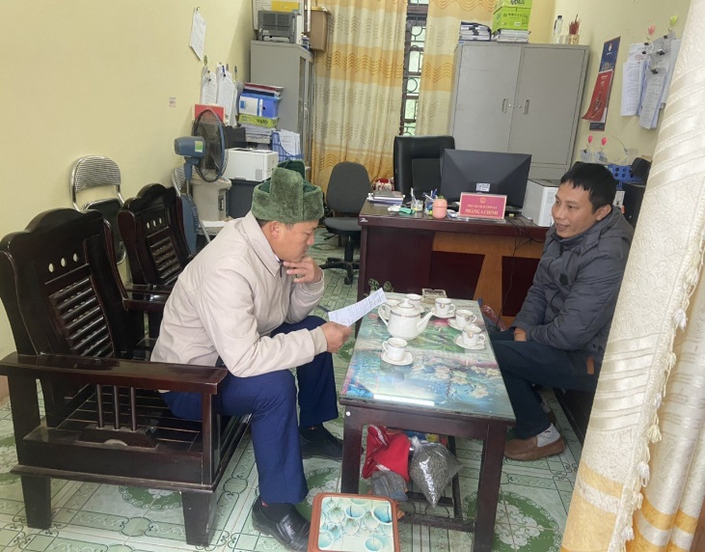  a. Survey at Mu Sang commune, Noverber 2022 | b. Survey at Tung Qua Lin commune, December 2022 | 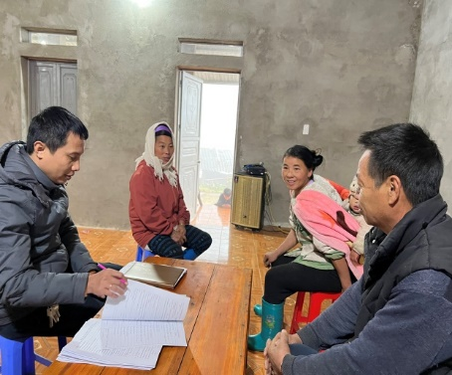  c. Survey at Dao San commune, December 2022
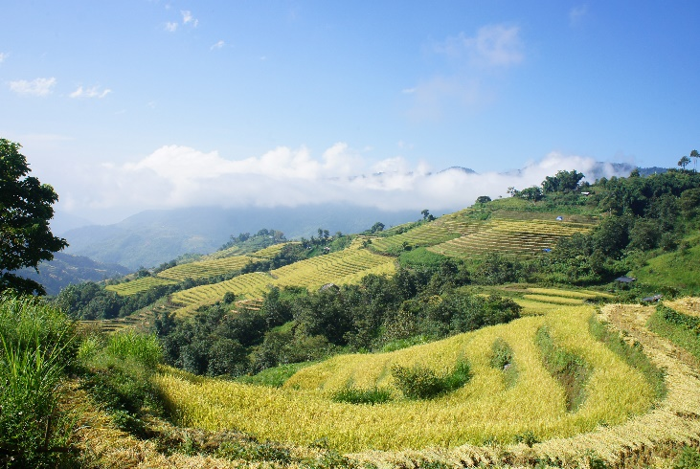  d. Terraced fields planted Te Meo rice variety, at Dao San commune, September 2023 | 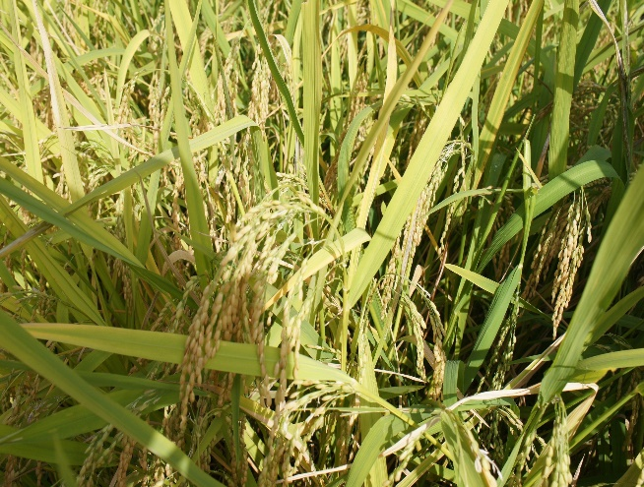  e. Te Meo rice variety at Den Thang A village, Dao San commune, September 2023 | 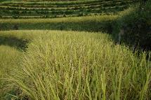  f. Te Meo rice variety before harvesting at  Dao San commune,  September 2023
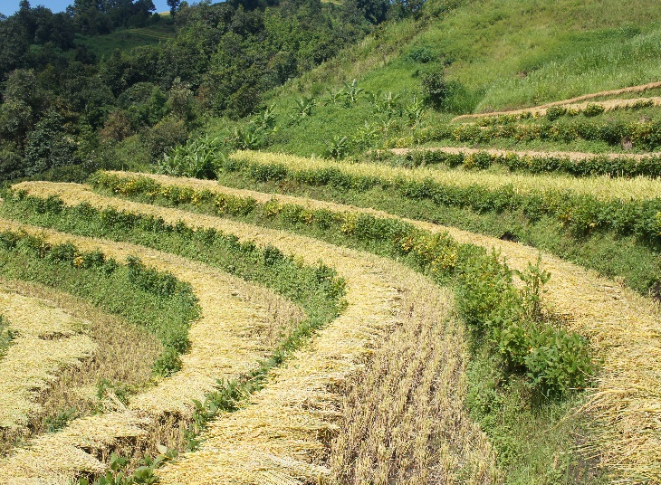  g. Harvested rice is dried in the field for 2-3 days,  September 2023 | 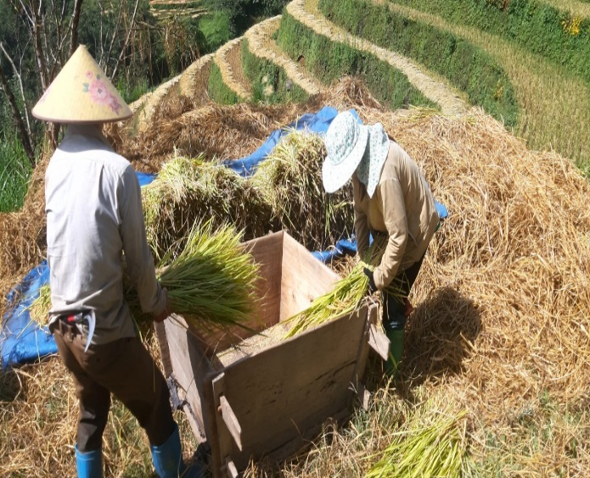  h. Threshing rice by hand after harvest, October 2023 | 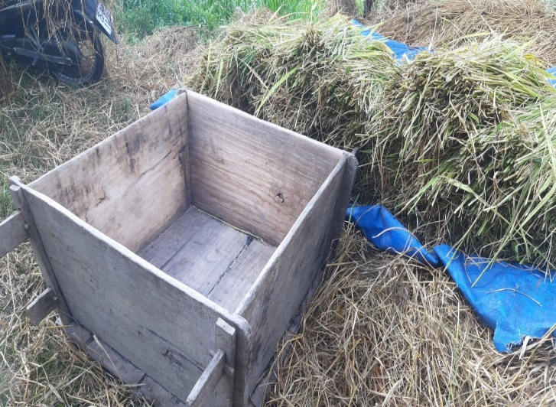  i. Wooden box used for threshing rice after harvest, October 2023
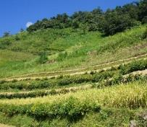  j. Growing Indigenous soybeans on the banks of Te Meo rice fields,  September 2023 | 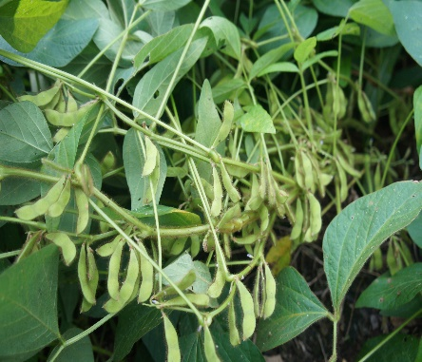  k. Indigenous soybeans variety grown on the banks of Te Meo rice fields, September 2023 | 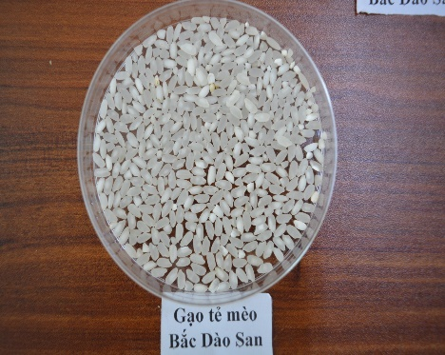  l. Te Meo rice at Bac Dao San area, December 2022
Fig. 1. Images from an investigation of indigenous knowledge in preserving the Te Meo rice variety in the Bac Dao San area
(Photo by Hoang Thi Nga, et al. 2022-2023)

