Study of using some natural substances in rooting of two fig varieties

Wisam K. Khalid* | Ahmed A. A. M. Ahmed
Dept. of Horticulture and Landscape Design\ College of Agriculture and Forestry\
University of Mosul\ Iraq
Wisam.khalid@uomosul.edu.iq | Ahmed79@uomosul.edu.iq

Abstract
The goal of this expermint was to investigate the role of some natural substances (Aloe Vera, cinnamon, and honey) in comparison with rooting hormone naphthalene acetic acid (NAA) and control on rooting characteristics of two hardwood cuttings fig (Ficus carica) varieties chechik and Black Genoa , The results showed that chechik was significantly superior in most of rooting characteristics like rooting percentage (97.33), rooting number (39.42), number of leaves (12.21) and new shoot/ cutting (1.97). For the use of natural substances, there was similarity in performance in most of the rooting characteristics compared to the use of naphthalene acetic acid (NAA) except the number of rooting which reached (59.85) compare with other natural substances and control.
Introduction
Fig (Ficus carica L.) is considered one of the conventional Mediterranean tree species. they are an essential part of the diet regim due to their dietary and medicinal value (Flaishman et al., 2008). Figs have recently gained a lot of popularity and are now grown all over the world. Over a million lots of figs are produced worldwide each year, with 82 percent coming from Mediterranean countries. (FAO, 2009). The Fruit has been consumed by humans for centuries, and its nutritional and medicinal properties have recently been studied (Lazreg-Aref et al., 2011; Trad et al., 2014).
Vegetative reproduction Is broadly preferred, instead of propagation by seed. And cutting is one of the most vital methods for Plant reproduction. Cutting propagation is rapid and easy , No unique techniques and procedures are required to use such those which used for grafting, budding, or micropropagation. Cut Is a famous ordinary and comparatively reasonably-priced technique In the reproduction of multiple plant species. It consider best method to get the better of the difficulty of plant seed reproduction. In addition, A determine plant can offer a number of quality cutting. additionally, every cut Can grow to be a plant have the same ideal genetic characteristics as the parent plant (Hartmann et al., 2002). Among the methods of vegetative reproduction, cuttings are the main method of commercial reproduction of figs (Almeida & Silveira, 1997), Because of its high efficiency and low cost, it uses annual hardwood cuttings from winter pruning and does not require intermittent spray irrigation. (Chalfun et al., 2002). Over the years, researchers have proposed Plant growth regulators and metabolites interact to promote root formation. Understand the physiology of rootless cuttings and the effects of endogenous and exogenous hormones on Successful plant reproduction (Alem, 2010 and Pijut et al., 2011). The Cuttings taken for rooting without the use of root hormones are difficult and time-consuming. Hormones are engaged in cell division or react with the effects of another hormones on plants. Plants produce the essential auxin in their shoots and leaves, however artificial auxin is used instead. To prohibit cuttings from dying, auxin should be utilized for effective roots (Kasim and Rayya, 2009).
Because synthetic rooting hormones such as indole-3-acetic acid (IAA) and indole-3-butyric acid (IBA) are now becoming increasingly difficult to get and costly, there is a demand to propagate cuttings with substitute rooting hormones that stimulate rooting (Dunsin et al.,2016). Synthetic growth regulators used in high doses regularly can affect the environment and humans. These materials can contaminate the soil through agricultural treatments, come into contact with groundwater through infiltration, and create harmful effects that accumulate in living beings through the food chain. (Sezgina and Kahya 2018).
Alternative hormones are natural materials that can encourage the rooting of cuttings, and they are a good substitute for artificial hormones like auxins, cytokinins, and gibberellins, which are important and widely used rooting hormones.
coconut water , Honey, willow tea, and saliva are examples of alternative hormones. (Shield P., 2012). Plant hormones are abundant in essential plant extracts like Aloe Vera, which can be utilized to promote and encourage the growth of different plant species (Hamouda et al., 2012). Honey can be used As an natural alternative for rooting hormone powder, that is anti-fungal, anti-bacterial, and anti-infectious, and promotes the rooting of plants. (Gangwar, 2016). It is a natural supply of many vitamins, like Vitamin B1 and Vitamin C which observed in lots of plants as a promoter for Rooting cuttings (Turetskaya and Polikarpova, 1968). For a long time, it has been found that vitamins can promote root formation in in lots of plant species (Chee, 1995). Cinnamon is one of the most important medicinal plants, with a high concentration of active chemicals. It contains 4% volatile oil, which contains cinnamon aldehyde, cinnamic acid, cinnamyl alcohol, cinnamyl acetate, eugenol, tannin (Gunjan and Anart, 2009). Cinnamon powder is thought to have a lot of capability as a organic control agent and a rooting agent, which can help plants establish roots. (Xing et al., 2010).
In an expermint carried out (Jamal Uddin et al., 2020). to test the impact of using normal substances and artifical hormones on rooting and vegetative increment of grapevine cutting By using six treatments: (control) no hormone, Indole-3- Butyric acid (IBA), Indole Acetic acid (IAA), Aloe vera gel, Undiluted honey, and Cinnamon powder. They found that using (IBA) was close to the natural substance (Aloe vera gel) in the highest survival percentages and roots number. Instead of that , the treatment of Aloe vera gel achieved a significant increase value compare to other treatments in terms of length and diameter of the vine, root length, and SPAD value. (Dunsin et al.,2016) cleared in an expermint was conducted to investigate the most suitable substance hormone on the cutting of Parkia biglobosa. The utilized substances hormones were Control, honey (Pure) , Coconut milk , and Moringa leaves Extract. The results cleared that Moringa leaves Extract was significantly superior compare with other treatments especially to the roots number , roots length , and length of the tallest root. in terms of number of cuttings with callus and percentage of rooted cuttings, Coconut milk was higher compared to other treatments.
This study aims to estmite the role of some natural substances like Aloe Vera, cinnamon, and honey as natural alternative chemical growth regulators like Naphthalene Acetic Acid (NAA) on growth rooting response of cutting of Fig (Ficus carica L.).

Materials and Methods
Location of study and Preparation of the cuttings:
The expermint was carried out in the plastic house of the Department of Horticulture and Landscape Design /College of Agriculture and Forestry/University of Mosul during the growing season of 2021. The semi-woody cuttings were prepared from 8-years old fig trees off, The cuttings were taken from Branches (11-14 mm) in diameter and then cut into (25) cm long.
Factors studied:
First: Two cultivars of Fig (Ficus carica L.): chechik and Black Genoa
Second: The bases of cuttings were treated with different natural substances in addition to rooting hormone:
1. control (distil water) only.
2. Aloe Vera gel, which has been extracted freshly from Aloe vera leaves.
3. Cinnamon powder.
4. Pure honey Bee.
5. Naphthalene Acetic Acid (NAA) 0.5gm as a rooting hormone. The solution was prepared on time of treatment.
Planting of cuttings:
The cuttings were then planted in beds with dimensions of (3 x 1 x 5.0) m containing sand, the beds were covered after planting with transparent nylon to preserve humidity. 12 weeks later the cuttings were uprooted for measurements.
Design of Expermint and statistical analysis:
The Experiment design was conducted in a Completely Randomized Design (CRD) with three replications and 10 cuttings for each treatment. the following measurements were recorded:
rooting percentage %, an average of Number of roots, an average of roots length (cm), an average of the number of leaves, an average of the number of new shoots, shoots length (cm). The data collected from various parameters were statistically evaluated using (SAS) software to determine the significance of variance among treatments, and treatment means were compared using Duncan's Multiple Range Test at a 5% probability.

Results and discussion
Rooting percentage: Table (1) shows the result of using natural substances on the rooting percentage of cuttings of the Chechik and Black genoa, The rooting percentage was the highest for the chechik (97.33) % and significantly different than Black genoa which achieved the lowest rooting percentage (57.14) %, Regarding the effect of natural substances it noticed from the data that using of Aloe vera and Cinnamon led to insignificant increasing in rooting percentage which reached to (86.67)% compare with other treatments. These results may belong to the effect of Aloe vera gel which contains necessary amino acids, vitamins, macronutrients, micronutrients (Hamouda et al., 2012), and to the role of these substances in stimulating plant growth and development (Mady, 2008).
Table (1): Effect of Natural substances on rooting percentage (%) of fig (Ficus carica L.) Chechik and Black genoa.
Natural sub.  Cultivar | Control | NAA | Aloe Vera | Cinnamon | Honey | Effect of CVs.
Chechik | 100 A | 93.33 AB | 100 A | 100 A | 93.33 AB | 97.33 A
Black genoa | 53.33 A-C | 40.00 C | 73.33 A-C | 73.33 A-C | 46.67 BC | 57.14 B
Effect of Natural sub. | 76.67 A | 66.67 A | 86.67 A | 86.67 A | 72.00 A
Values with the same letter (s) for each factor did not differ significantly according to the Duncan test at 5% P.
Rooting Number: Table (2) shows that Chechik cuttings achieve the highest rooting number which reached (39.42) and was significantly different than Black genoa which achieved the lowest rooting number (25.55). It is also clear from the table that synthetic hormone NAA led to a significant increasing in rooting number which reached (59.85) comparing with using of other Natural substances. The interaction treatment between NAA and Chechik led to give the highest rooting number which reached (78.70) that differ significantly from all other interaction treatments, these results agree with Uddin et al. (2020) since they found the superiority of synthetic Hormone in the propagation of Grapevine compare to other natural substances.

Table (2): Effect of Natural substances on roots Number of fig (Ficus carica L.) Chechik and Black genoa.
Natural sub.  Cultivar | Control | NAA | Aloe Vera | Cinnamon | Honey | Effect of CVs.
Chechik | 27.20 B | 78.70 A | 33.93 B | 29.20 B | 28.07 B | 39.42 A
Black genoa | 20.43 B | 41.00 B | 20.53 B | 22.50 B | 20.30 B | 25.55 B
Effect of Natural Sub. | 23.82 B | 59.85 A | 27.23 B | 25.85 B | 25.70 B

Values with the same letter (s) for each factor did not differ significantly according to the Duncan test at 5%
Roots length: Table (3) cleared that the main effect of Chechik and Black genoa roots length were (9.21 and 9.13 cm) respectively and there was no significant difference between the two values, Also For the main effect of Natural substances, no significant differences between them. Regarding the interaction treatments, the highest roots length which reached (11.60 cm) were recorded to the treatment of using NAA and Black genoa and there was no significant difference for both Aloe vera and Honey with the same cultivar and the values reached (9.07 and 9.05 cm) respectively.

Table (3): Effect of Natural substances on roots length of fig (Ficus carica L.) Chechik and Black genoa.
Natural sub.  Cultivar | Control | NAA | Aloe Vera | Cinnamon | Honey | Effect of CVs.
Chechik | 9.23 AB | 9.27 AB | 8.87 B | 9.83 AB | 8.87 B | 9.21 A
Black genoa | 8.30 B | 11.60 A | 9.07 AB | 7.60 B | 9.05 AB | 9.13 A
Effect of Natural sub. | 8.77 A | 10.43 A | 8.97 A | 8.72 A | 8.93 A
Values with the same letter (s) for each factor did not differ significantly according to the Duncan test at 5% P.
The number of leaves/cutting: From the data in the table (4), It's clear that Chechik achieved a significant increase and the highest number of leaves which reached (12.21) leave/cutting, compared with Black genoa which reached (9.69) leave/cutting. While using different Natural substances in addition to growth regulator hormone NAA led to a decrease in the number of leaves/cutting. Although these differences were insignificant. For interaction treatments, using Aloe vera for Chechik led to the highest number of leaves which reached (14.27) leave/cutting.

Table (4): Effect of Natural substances number of leaves/cutting of fig (Ficus carica L.) Chechik and Black genoa.
Natural sub.  Cultivar | Control | NAA | Aloe Vera | Cinnamon | Honey | Effect of CVs.
Chechik | 13.07 AB | 9.55 A-C | 14.27 A | 11.27 A-C | 12.88 AB | 12.21 A
Black genoa | 11.70 A-C | 11.90 A-C | 7.67 C | 8.33 BC | 8.90 BC | 9.69 B
Effect of Natural Sub. | 12.38 A | 10.73 A | 10.97 A | 9.80 A | 11.11 A
Values with the same letter (s) for each factor did not differ significantly according to the Duncan test at 5% P.
The number of New shoots/cutting: For the main factors table (5) showed that Chechik give a significant increase and the highest number of new shoots which reached (1.97) shoot/cutting compared with Black genoa which reached (1.66) shoot/cutting. the differences were insignificant When using different Natural substances in addition to NAA. For interaction treatments, using honey for Chechik led to the highest number of shoots which reached (2.33) shoot/cutting. The similarity in enhancing the growth of cutting maybe belong to the rich content of natural plant substances with plant hormones and natural antioxidants that can be applied to induce, enhance , and improve the growth of another plant species. (Mirihagalla and Fernando, 2020) . Generally, the results of all study parameters of hardwood stem cuttings have improved and increased the adventitious root initiation, The accumulation of carbohydrate contain may be attributed to root formation (Ahmed and Khalid,2020).

Table (5): Effect of Natural substances number of New shoot/cutting of fig (Ficus carica L.) Chechik and Black genoa.
Natural sub.  Cultivar | Control | NAA | Aloe Vera | Cinnamon | Honey | Effect of CVs.
Chechik | 1.87 A-C | 1.63 BC | 2.13 AB | 1.87 A-C | 2.33 A | 1.97 A
Black genoa | 2.07 AB | 1.70 BC | 1.40 C | 1.53 BC | 1.65 BC | 1.66 B
Effect of Natural Sub. | 1.97 A | 1.67 A | 1.77 A | 1.70 A | 2.03 A
Values with the same letter (s) for each factor did not differ significantly according to the Duncan test at 5% P.

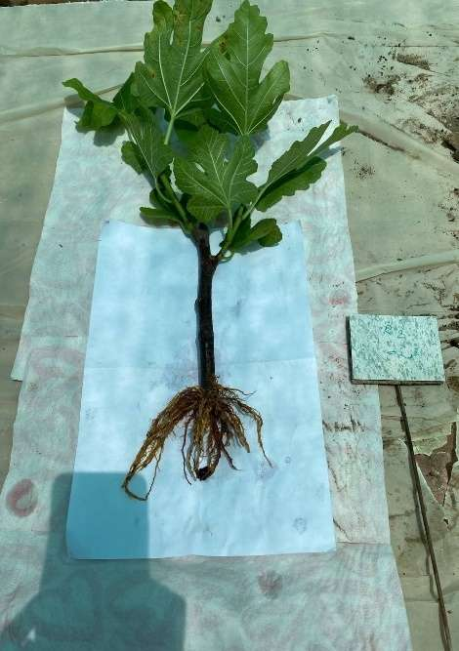
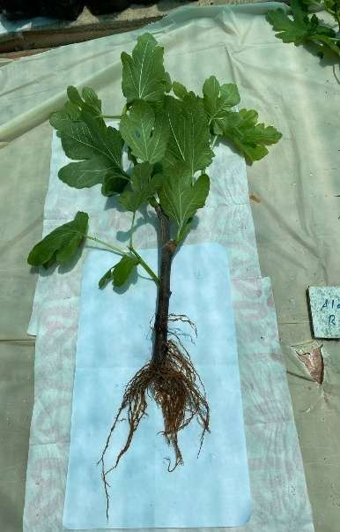
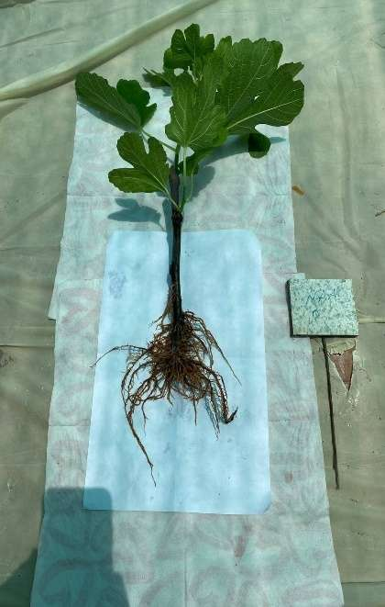
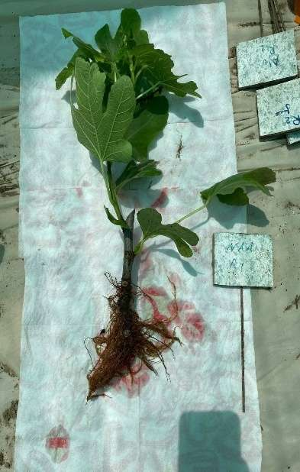
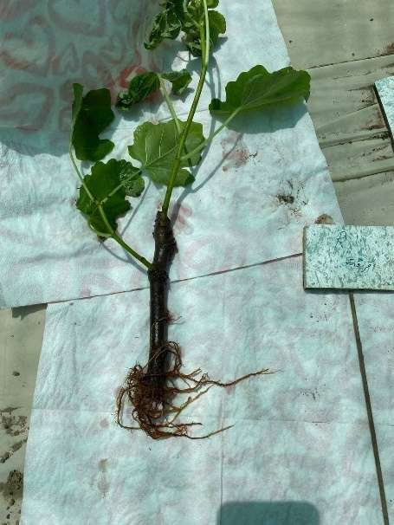
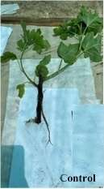
Cinnamon
Aloe Vera
NAA
Control
NAA
Cinnamon
Honey
A
Aloe Vera
Honey
B
Control

Fig(1): Effect Natural substances on rooting and vegetative characters:
A: Cv. Chechik and B: Cv. Black genoa

References
Ahmed, A. A. A. M., and W. K. Khalid,(2020), Effect of cutting type, IBA and wounding on the rooting of assyrian plum cordia myxa l., Plant Cell Biotechnology and Molecular Biology 21(39&40):135-141.
Alem, O.P., (2010). Unrooted stem cutting physiology; water use and leaf gas exchange of severed stem cuttings. A Master of Science thesis, Clemson University.
Almeida MM. and E.T. Silveira (1997). Cultural treatments in the fig tree culture in the Southwest of Minas Gerais. Agricultural Report, 18:27-33.
Chalfun N.N.J., E. Abrahão, A.A. Alvarenga, M.A. Regina and R. Pio (2002). Pruning and driving the fig tree. Lavras, UFLA. 12p. (Extension bulletin, 104).
Chee, P.P. (1995). Stimulation of adventitious rooting of Taxus species by thiamine. Plant Cell Reports, 14: 753-757.
Dunsin O, G. Ajiboye, T. Adeyemo (2016). Effect of alternative hormones on the root ability of Parkia biglobosa. Scientia Agriculturea. 13(2):113-118.
FAO (Food & Agriculture Organization) (2009), The FAO Statistical Database-Agriculture, FAO (Food & Agriculture Organization), Rome, Italy.
Flaishman, M., V. Rodov, and E. Stover, (2008). “The fig: botany, horticulture, and breeding,” in Horticultural Reviews, vol. 34, pp. 113–197.
Gandhiyappan, K. and P. Perumal, (2001). Growth promoting effect of seaweed liquid fertilizer (Enteromorpha intestinalis) on the sesame crop plant. Seaweed Res. Utiln., 23(1&2): 23-25.
Gangwar, S. K. (2016). Honey physio-chemical parameters and its application with reference to Ethiopia. International Journal of Science and Nature, 7(1), 16-24.
Gunjan, S. and R. N. Anart, (2009). Influence of explants type and plant growth regulators on in vitro multiple shoots regeneration of laurel from Himalaya. Nature and Science, 7(9):1-7.
Hamouda, A. M. A., D. M. G.Hendi, and O. F. A. Abu-El-Leel, (2012). Improving basil growth, yield and oil production by Aloe vera extract and active dry yeast. Egypt Journal Horticulture, 39. 45-71.
Hartmann HT, D. E. Kester, F.T. Davies Junior and R. L. Geneve (2002). Plant propagation: principles and practices. 7Şed. New Jersey, Prentice Hall. 880p.
Kasim, N. E. and A. Rayya, (2009). Effect of different collection times and some treatments on rooting and chemical interminal constituents of bitter almond hardwood cutting. Journal of Agriculture and Biological Science, 5(2), 116-122.
Lazreg-Aref, H., B. Gaaliche, A. Fekih, M. Mars, M. Aouni, J. P.Chaumon and K. Said (2011). In vitro cytotoxic and antiviral activities of Ficus carica latex extracts. Natural Product Research. 25: 310-319.
Mady, A. (2008). Effect of certain medicinal plant extracts on growth, yield and metabolism of some medicinal and aromatic plants. (M.Sc. Thesis) Faculty of Science Al-Azher University.
Mirihagalla, M.K.P.N.; Fernando, K.M.C.(2020). Effect of Aloe vera gel for inducing rooting of stem cuttings and air layering of plants. J. Dry Zone Agric. 6, 13–26.
Pijut, P.M., K.E. Woeste, and C.H. Michler, (2011). Promotion of adventitious root formation of difficult-to-root hardwood tree species. Horticultural Reviews, 38: 213-251.
Sezgina M. and M. Kahya (2018). Phytohormones. Journal of Sciences and Technology 8(1): 35-39.
Shield P. (2012). Three organic alternatives to hormone rooting powder. Retrieved from HTTP:// montrouch-organic.over-blog.com/article-three -organic-alternatives-to-hormone-rooting-powder-101172112.html.
Sivasankari, S., V. Venkatesalu, M. Ananhtaraj and M. Chandrasekaran, (2006). Effect of seaweed extracts on the growth and biochemical constituents of Vigna sinensis. Bioresource Technology, 97: 1745- 1751.
Trad M., C. Le Bourvellec, B. Gaaliche, C. M. G. C. Renard, C. M. G. C. Mars (2014). Nutritional compounds in figs from the Southern Mediterranean region. International Journal of Food Properties. 17: 491-499.
Turetskaya, R. and F. Polikarpova (1968). Plant propagation using plant growth regulators. Publ. Science, Moscow
Uddin, A.J.; Rakibuzzaman, M.; Raisa, I.; Maliha, M. and Husna, M.A. (2020). Impact of natural substances and synthetic hormones on grapevine cutting. Journal of Bioscience and Agriculture Research, 25(01): 2069- 2074.
Xing, Y., X. Li, Q. Xu, J. Yun and Y. Lu, (2010). Antifungal activities of cinnamon oil against Rhizopus nigricans, Aspergillus flavus and Penicillium expansum in vitro and in vivo fruit test. International Journal of Food Science and Technology, 45(9), 1837-1842.

