Editorial Board December. 25, 2023

International Journal of Agriculture and Biology
Dear Editor,
Please find enclosed our manuscript titled “Comparative Neuroprotective Activities of the Ethanol extracts of Washingtonia filifera”, by Aalaa Salem, El-Sayed M. Marwan, Saleh H. El-Sharkawy and Amira Mira as a research article to be considered for the publication in International Journal of Agriculture and Biology.
In this article, we investigated the in vitro neuroprotective activity of the ethanol extracts of different parts of Washingtonia filifera; root, bark, leaves, the fruitless bunch, fruits and seeds. The biological evaluation included the determination of the phenolic contents, antioxidant, anti-inflammatory, acetylcholinesterase inhibitory activities. Besides, the protection of the extracts against H₂O₂ and Aβ₁-₄₂ -induced neurotoxicity were evaluated in human neuroblastoma (SH-SY5Y) cells. Among the tested extracts, the ethanol extract of the fruitless bunch showed the strongest neuroprotective activity. These findingis shed the light on the biological value of one of the huge wastes of this palm tree.
We declare that this manuscript is original, hasn’t been published before and is not currently being considered for publication elsewhere. There is no conflict of interest associated with this publication, and there has been no significant financial support for this work that could have influenced its outcome.
As corresponding authors, we confirm that the manuscript has been read and approved for submission by all the named authors. We hope you find our manuscript suitable for publication and look forward to hearing from you in due to course.
Sincerely,
Amira Mira, Ph.D.
Associate Professor, Department of Pharmacognosy & Pharmaceutical Chemistry, College of Dentistry & Pharmacy Buraydah Private Colleges, Buraydah 51418, Saudi Arabia. Email: Amira.Mera@bpc.edu.sa, Tel.: (+966)535-800-915

Comparative Neuroprotective Activities of the Ethanol Extracts of Washingtonia filifera

Aalaa Salem ⁽¹⁾, El-Sayed M. Marwan⁽¹⁾, Saleh H. El-Sharkawy⁽¹⁾, Amira Mira^{(2)*}
⁽¹⁾ Department of Pharmacognosy, Faculty of Pharmacy, Mansoura University Mansoura 35516, Egypt.
⁽²⁾ Department of Pharmacognosy & Pharmaceutical Chemistry, College of Dentistry & Pharmacy Buraydah Private Colleges, Buraydah 51418, Saudi Arabia; Amira.Mera@bpc.edu.sa
* For correspondence: Amira.Mera@bpc.edu.sa, Tel: +966535800915.

Abstract

Washingtonia filifera (w. filifera) is an ornamental palm tree that has a yearly huge amount of waste in the form of dried fruit bunches and barks, leaves, fruits and seeds. Most of its waste hasn’t been investigated for their biological activities. So, the present study aimed at the in vitro investigation of the neuroprotective activities of the ethanol extracts of Washingtonia filifera roots (W.R), barks (W.B), leaves (W.L), fruitless bunches (W.F) and seeds (W.S). The phenolic content and antioxidant activity using Folin-Ciocalteu and DPPH assays, respectively were determined. The anti-inflammatory activity was evaluated using the in vitro inhibition of cyclooxygenase-2 (COX-2) assay. Also, the potentiality of the extracts to inhibit acetylcholinesterase (AChE) enzyme and to protect human neuroblastoma (SH-SY5Y) cells against H₂O₂ and Aβ₁-₄₂ -induced neurotoxicity were measured. Among the extracts, W.L and W.F had the highest phenolic content; 226.7 and 172.3 GAE, respectively. Consequently, W.L and W.F showed pronounced DPPH radical scavenging activity with IC₅₀ values of 19.95 and 30.46 µg/mL, respectively. The highest inhibitory potential of COX-2 and AChE was achieved by W.F then W.L with IC₅₀ values of 111.62 and 191.77 µg/mL for COX-2 inhibition and 35.99 and 282.65 µg/mL for AChE inhibition, respectively. The most efficient extract for the neuroprotection against H₂O₂ and Aβ₁-₄₂ -induced neurotoxicity was W.F which had more potent activity than epigallocatechin-3-gallate as a positive control in Aβ₁-₄₂ assay. This the first report to indicate the neuroprotective activities of W. filifera leaf and the fruitless bunch extracts.

Keywords
W. filifera; neuroprotection; acetylcholinesterase; H₂O₂; Aβ₁-₄₂; anti-inflammatory

Introduction
Washingtonia is a palm genus of two species W. filifera and W. robusta (Villanueva-Almanza et al., 2021) belongs to family Arecaceae that includes approximately 2500 species (Simpson, 2010). W. filifera (L. Linden) H. Wendl "commonly called California palm or desert fan palm" is an endemic species and the only native ornamental palm to the Western of the United States (Klimova et al., 2017) however, it had been introduced to Egypt and elsewhere. For decades, the fan palm fruits were eaten for their sweet taste and healthy values (Sturtevant et al., 1972). The basal tissues of the leaves were reported to have larvicidal activity against red palm weevil (Cangelosi et al., 2015). Leaves and fruits were proved to have antiviral activity against coxsackievirus B3 (Abid et al., 2012). Proanthocyanidins with antioxidant, anti butyrylcholinesterase and anti-xanthine oxidase were reported from the seeds (Floris et al., 2019). Furthermore, the seeds extracts exhibited inhibition of amyloid polypeptides aggregation, α-amylase; α-glucosidase (Floris et al., 2021).
The complications of neurodegenerative diseases (ND) as Alzheimer’s disease (AD) and parkinsonism are the riskiest factors in elderly populations. They are primarily characterized by increased oxidative stress and neuroinflammation which consequently lead to neuronal death, loss of cognitive and motor functions. The recent treatments of ND are mostly symptomatic, so there is an urgent demand for searching for new protectives and therapies especially from natural resources (Mortada et al., 2021)-(Müller et al., 2021).
To the best of our knowledge, there was no previous report about the neuroprotective activities of W. filifera parts other than the seeds. So, this study includes the ethanol extracts of the fruitless bunches (WF), roots (WR), barks (WB), leaves (WL), and seeds (WS) of W. filifera were comparatively screened for their in vitro antioxidant, anti-inflammatory and neuroprotective activities to pave the way for their phytochemical screening in the direction of valuing potential neuroprotective leads from medicinal plants.

Materials and Methods
Plant materials
Roots, barks, leaves, seeds and fruitless bunches of W. flifera were collected from the garden of faculty of pharmacy, Mansoura university on 11th November, 2022 and were identified by Associate Prof. Dr Mahmoud Makram Qassem, Department of Vegetables & Floriculture, Faculty of Agriculture, Mansoura university, Egypt where a voucher specimen (Voucher No.WF-07) was deposited at the department of pharmacognosy, Mansoura university, Egypt. Plant materials were then washed with water to get rid of dirt and were shade-dried for several days. The dried material were ground into a coarse powder and were stored at refrigerated temperature until use.
General
Hydrogen peroxide (H₂O₂), Aβ₁₋₄₂ stock solution: Aβ₁₋₄₂, cyclooxygenase-2 (COX-2) Cayman human enzyme inhibitory assay kit (No. 701070), COX-2 Cayman human enzyme inhibitory assay kit (No.701080, USA), 2,2-diphenyl-1-picrylhydrazyl (DPPH), ascorbic acid celecoxib®, galantamine, catechin, epigallocatechin-3-gallate were purchased from Sigma Chemical Co (Sigma Aldrich St Louis, MO, USA).
Cell lines
Human neuroblastoma (SH-SY5Y) cells obtained from American Type Culture Collection (Manassas, VA, USA) were cultured in Dulbecco's Modified Eagle's medium (DMEM) supplemented with 10% heat-inactivated fetal bovine serum, 20 mm glutamine, 10 U/mL penicillin an 100 μg/mL streptomycin (Gibco BRL, Gaithersburg, MD, USA) and maintained at 37 °C in a humidified atmosphere with 5% CO₂. Cell viabiliyy was determined using WST-1 reagent (Sigma Aldrich St Louis, MO, USA).
Preparation of plant material
Two hundred grams of each of the fruitless bunches, roots, barks, leaves, and seeds of W. filifera palms were separately soaked in ethanol (400 mL x 3) at room temperature (25ºC) in amber-colored extraction bottles. The sealed bottles were kept for several days with occasional shaking and stirring. The extracts were separately filtered and concentrated using the rotary evaporator under reduced pressure at 50ºC to afford 10 (5%), 17.5 (8.75%), 15 (7.5%), 63 (31.5%) and 17 (8.5%) g extract of each of W.F, W.R, W.B, W.L, and W.S, respectively.
Determination of total phenolic content:
The total phenolic contents was measured in the extracts as previously described (Ainsworth & Gillespie, 2007). Briefly, 0.5 mL of each sample at a concentration of 2 mg/mL or ethanol (as a negative control) was mixed with 1 mL of 10% of Folin-Ciocalteu reagent and 4 ml of 700 mM sodium carbonate. After 2 h, the reaction color was measured spectrophotometrically at 765 nm. Gallic acid was used to prepare the standard curve and phenolic contents were calculated from this curve.
DPPH-assay:
The antioxidant activity of the extracts was measured by evaluating their ability to scavenge The DPPH radical and spectrophotometrically measuring the decrease in the intensity of the purple color of DPPH solution at 517 nm (Blois, 1958). The assay was done as previously described (Baliyan et al., 2022) with little modifications. Stock solutions (1 mg/mL) of the tested samples or ascorbic acid (as a positive control) were diluted to final concentrations of 10, 20, 40, 60, 80, 100 µg/mL in ethanol. Three milliliters of each concertation were mixed with 0.5 mM of filtered DPPH solution in ethanol and left in complete darkness at room temperature for 30 minutes. The absorbance (A) of the colored reaction mixture was measured spectrophotometrically at 517 nm. To avoid the interference of the sample colors, 1 mL of ethanol mixed with 3 mL of each of the tested concentrations and used as a sample control where 0.5 mM DPPH in 3 mL ethanol were served as blank. The antioxidant activity (AA) was measured as follows:
AA%= [(A_{blank} - {A_{sample} -A _{sample control}) /A_{blank}] x 100
The half-maximal inhibitory concentration (IC₅₀) was calculated from the regression equations of the curves prepared in Microsoft Excel 2010 by plotting the % inhibition against sample concentrations.
In vitro COX-2 inhibitory assay:
The anti-inflammatory activity of the extracts was determined by measuring their efficiency to inhibit COX-2 enzyme that is responsible for the conversion of arachidonic acid to prostaglandins which are the main controller of pain sensation and the inflammatory process (Hoozemans & O’Banion, 2005). The Procedures were carried out according to manufacturer’s protocol using COX-2 Cayman human enzyme inhibitory assay kit (No.701080, USA), ROBONIK P2000 EIA reader and Celecoxib® as a positive control (Kundu et al., 2001). Four Parameter Logistic Curve online data analysis tool of My Assays Ltd was used to evaluate the data.
In vitro AChE inhibitory assay:
The inhibition potential of the tested samples towards AChE was evaluated using modified Ellman’s method as previously described (Mira et al., 2015).
Protection against H₂O₂ induced-neurotoxicity in SH-SY5Y cells
In the presence of the metal componenets of the cell medium, H₂O₂ is converted into hydroxyl radicals which increase the oxidative stress and stimulate the cascade of events that may result in neuronal cell death (Anbar & Neta, 1967; Tabner et al., 2002). So, the antioxidant extracts will be able to scavange the free radicals resulting in increasing cell viability.
In this experiment, the concentration of H₂O₂ that could decrease cell viability to about 50% was determined as previously described (Mira et al., 2015). The results showed that H₂O₂ at a concentration of 150 μM had the desired decrease in cell viability (Fig. 1A). Cells (2 x 10⁴ cells/ well) were incubated with different non-cytotoxic concentrations (6.25, 12.5, 25, 50, 100 μg/mL) of the tested extracts or catechin as a positive control (Ismail et al., 2014). After two hours the media were replaced with fresh ones and the cells were treated with H₂O₂ (150 μM) for 24 h. Finally, cell viability was determined using WST-1 reagent. Ten microliters of WST-1 reagent were added to each well, followed by 4 h incubation at 37 ºC, after which the absorbance was measured at 450 nm using a microplate reader (Biotek, Winooski, VT, USA).
Protection against Aβ₁₋₄₂ induced-neurotoxicity in SH-SY5Y cells
Extracellular aggregation of Aβ₁₋₄₂ mediates the loss of synaptic connections, high oxidative stress and neuroinflammation which consequently leads to neurotoxicity (Fernandez-Perez et al., 2016). So, the prepared extracts were tested for the protection against neurotoxic complications of Aβ₁₋₄₂ aggregation.
Preparation of Aβ₁₋₄₂ stock solution: Aβ₁₋₄₂ peptide was dissolved in deionized distilled water to prepare a 1 mM stock solution and incubated at 37˚C for 3 days. The solution was kept at ‑20˚C and thawed for subsequent use.
Firstly, the concentration of Aβ₁₋₄₂ that resulted in about 50% reduction in cell viability was determined as follows: SH-SY5Y cells were seeded in 96 well plate at a cell density of 1x10⁴ cells/ well, after 48 h cells were treated with different concentrations of Aβ₁₋₄₂ (12.5, 25, 50 μM) for 24 h and cell viability was determined by WST-1 reagent. Aβ₁₋₄₂ at 25 μM resulted in the desired reduction of cell viability (Fig. 2A) and used for the determination of the neuroprotective activities of the tested compounds. The cells were treated with different concentrations of the tested samples or epicatechin-3-gallate as a positive control (Fang et al., 2022) (6.25, 12.5, 25, 50, 100 μg/ mL) or DMSO as a negative control. After 24 h the media were replaced with fresh one and the cells were incubate for 48 h with 25 μM of Aβ₁₋₄₂ . Finally, cell viability was determined using WST-1 reagent.
Statistical analysis
All experiments were carried out in independent triplicates. The half-maximal inhibitory concentrations (IC₅₀) for DPPH, COX-2 and AChEI assays were calculated from the regression equations of the curves prepared in Microsoft Excel 2010 by plotting the % inhibition against sample concentrations. Cell viability was expressed as a percentage of WST-1 reduction, considering that the viability of cells treated with 1% DMSO as a negative control was 100%. Figures were built in Microsoft Excel 2010. All values were the mean ± SD. Statistical significance was determined using one-way ANOVA followed by Dunnett’s post hoc test in GraphPad Prism® 10 (Version 10.0.3, GraphPad Software, Inc., USA).
Results and discussions
Determination of the total phenolic content:
The total phenolic content was expressed as GAE (mg of gallic acid/ g dry extract) in Table 1. The ethanol extract of the leaves (W. L) showed the highest amount of the phenolic content (226.7 GAE) while that of the bark (W.B) had the lowest amount (99.97 GAE). The ethanol extract of the fruitless bunches (W.F) had higher phenolic content than that of roots (W.R) and seeds (W.S) by 2.52 and 63.53 GAE, respectively but lower than that of W.L by 54.4 GAE.

The high phenolic content of (W. L) is due to its flavonoid compounds; luteolin, tricin (Williams et al., 1973) and 5,7,4ˈ-triacetate tricin (Hammami et al., 2011). In addition, a polyhydroxy chalconoid analogue; filiferol was previously isolated from the basal tissues of the leaves (Cangelosi et al., 2015).
Determination of the antioxidant activity using DPPH assay.
The results of DPPH assay manifested good matching with the phenolic contents of the ethanol extracts of different parts of W. filifera. All the extracts showed IC₅₀ values for the scavenging of the DPPH free radicals less than 100 µg/mL (Table 1). The antioxidant activity was achieved in the following order: W.L> W.F > W.R > W.B> W.S.
The antioxidant potential of only leaves, aerial parts and seeds were previously studied. The antioxidant activity of different extracts of the leaves and aerial parts was formerly evaluated using DPPH (Hammami et al., 2011) and β-carotene bleaching method (El-Sayed et al., 2006) and it was found that the ethanol extract of the leaves and the ether extract of the aerial parts had the highest antioxidant activities. The antioxidant activity was justified by the isolation of flavonoid compounds; vitexin, isovitexin7-O-methyl ether, luteolin 7-O-glucoside, luteolin7-O-β-D-glucoside -2″-sulfate, luteolin7-O-β-D-glucoside-4"-sulfate, orientin, iso-orientin, 8-hydroxyisoscoparin, tricin 7-O-β-D-glucoside, tricin7-rhamnopyranoside (1" 6") glucopyranoside. On the contrary, hexane extract of mature and immature seed was found to be inactive in ABTS radical scavenging assay (Uluçınar & Hatice, 2017).
Determination of the in vitro anti-inflammatory activity using COX-2 inhibitory assay.
The ethanol extract of the fruitless bunches (W.F) showed the strongest in vitro anti-inflammatory activity (lowest IC₅₀ value) through the inhibition of COX-2 enzyme. W.L and W.B had less potent activities while W.R and W.S couldn’t inhibit COX-2 enzyme at concentrations up to 1 mg/ mL.
The anti-inflammatory activity of the leaves (W.L) may be due the presence of several anti-inflammatory compounds such as vitexin which showed significant in vivo reduction of COX-2 levels (Zhang et al., 2022), orientin which was proved to decrease the expression of COX-2 mRNA (Khalil et al., 2022) and iso-orientin which had selective COX-2 inhibitory activity (Sumalatha et al., 2015).
In vitro Inhibition of AChE
Alzheimer’s disease is characterized by the decrease of the cholinergic neurotransmission. So, AChE inhibitors that help in the increase of the neurotransmitter; acetylcholine are always viewed as the first plan of choice for alleviating the symptoms of AD (Perl, 2010). In our study, W.F showed the strongest inhibition of AChE while other parts had either very week activity (W.L) or no activity (W.B, W.S and W.R.).
The W.S was previously reported to have moderate butyrylcholine esterase inhibitory activity and in the same study showed inactivity against AChE (Floris et al., 2019) which matches with our results. However, there is no previous mention about the AChEI activity of the other parts of W. filifera.
Protection against H₂O₂ induced-neurotoxicity in SH-SY5Y cells
Treatment of SH-SY5Y cells with H₂O₂ induced dose dependent cell cytotoxicity. Doses of 100, 150 and 200 µM of H₂O₂ caused loss of 19.66, 53.77 and 79.78 % of viable SH-SY5Y cells, respectively. To investigate the neuroprotection of ethanol extracts of different parts of W. filifera, H₂O₂ at a dose of 150 µM was used to induce neurotoxicity as it caused about 50 % reduction of cell viability (Fig. 1 A). The other 2 doses 100 and 200 µM lead to either very low or severe cytotoxicity to the cells, respectively. Catechin as a positive control could significantly (P < 0.01) increase the cell viability of H₂O₂-treated cells only at high doses of 50 and 100 µg/mL by 19.3 and 35.2%, respectively (Fig. 1B). Lower concentrations of catechin couldn’t show any significant increase in cell viability. W.F and W.L showed the most potent neuroprotective activities in this assay. W.F manifested significant (P < 0.01) dose- dependent neuroprotection at 12.5, 25, 50 and 100 µg/mL and increased cell viability by 16.22, 20.80, 26.64 and 28.83%, respectively. Similarly, W.L showed significant increase in cell viability by 9.57, 13.22, 20.58 and 28.81% at 12.5, 25, 50 and 100 µg/mL, respectively. The other two extracts; W.B and W.R showed less potent activity at high concentrations; 50 and 100 µg/mL of W.B which increased cell viability by 9.47 and 12.84%, respectively and at 100 µg/mL of W.R that increased cell viability by 9.99%.
Protection against Aβ₁₋₄₂ induced-neurotoxicity in SH-SY5Y cells
Twenty-four hours incubation of SH-SY5Y cells with different concentrations of Aβ₁₋₄₂ resulted in neurotoxicity and reduction of cell viability in a dose dependent manner (Fig. 2A). The 25 µM concentration of Aβ₁₋₄₂ resulted in 51.1 % decline in cell viability. Epigallocatechin-3-gallate as a positive control could effectively counteract the Aβ₁₋₄₂-induced neurotoxicity by increasing the cell viability of Aβ₁₋₄₂ -treated cells (TC) by 10.35, 16.17, 21.89 and 34.99 %, at 12.5, 25, 50 and 100 µg/mL, respectively. The most efficient extracts exhibiting neuroprotection against Aβ₁₋₄₂-induced neurotoxicity were W.F followed by W.L that showed more neuroprotection than epicatechin-3-gallate at 12.5, 25, 50 and 100 µg/mL concentrations. The significant neuroprotection (P< 0.01) of W.S and W.B was displayed at higher concentrations; 50 and 100 µg/m.
Previous investigation of the activity of the methanol extract of W. filifera seeds (MES) on islet amyloid poly peptide (IAPP) revealed that MES had dose-dependent inhibition of the in vitro IAPP toxic aggregates using Thioflavin T fluorescence assay. Molecular docking study of the isolated compounds illustrated the high binding affinity of the phenolic compounds; procyanidin dimer, P-hydroxy benzoic acid, protocatechuic acid and catechin to IAPP (Floris et al., 2021). To date, other parts of W. filifera were firstly studied for the neuroprotection against Aβ₁₋₄₂ in the present study.
Conclusion
This study showed that the ornamental palm wastes could be exploited for biological investigations as well as solving a part of the problems of agro-wastes. Neuroprotective activities of the ethanolic extracts of W. filifera botanical parts were evaluated. The study indicated that fruitless bunch extract (W.F) exhibited the highest neuroprotective activity as it could potentially inhibit AChE and COX-2 and protect against H₂O₂ and Aβ-induced neurotoxicity in a dose dependent manner. These findings could contribute to the future bio-guided isolation and identification of the neuroprotective compounds of the active extracts in this study (W.F and W.L) as well as studying their neuroprotective mechanisms.
Acknowledgments
Department of Pharmacognosy & Pharmaceutical Chemistry, College of Dentistry & Pharmacy Buraydah Private Colleges is acknowledged for supporting this research.
Funding
This research did not receive any specific grant from funding agencies in the public, commercial, or not-for-profit sectors.
Declaration of Competing Interest:
The authors declare that there is no competing interest associated with this work.
Supplementary materials
Supplementary material associated with this article can be found in the online version, at https://xxxxxxxx

Author contribution
Conceptualization, S.E and A.A; methodology, A.S and A.A; investigations, A.A, A.S, S.E resources, A.A and A.S; writing—original draft preparation, A.A and A. S.; writing—review and editing S.E, A.A, A.S and E.M. All authors have read and agreed to the published this version of the manuscript.
Data Availability
Data presented in this study will be available on a fair request to the corresponding author.
Ethics Approval
Not applicable to this paper

REFERENCES:
Abid NB, Z Rouis, MA Lassoued, S Sfar, M Aouni (2012). Assessment of the cytotoxic effect and in vitro evaluation of the anti-enteroviral activities of plants rich in flavonoids. J Appl Pharm Sci 2(5):74–78. https://doi.org/10.7324/JAPS.2012.2532
Ainsworth EA, KM Gillespie (2007). Estimation of total phenolic content and other oxidation substrates in plant tissues using Folin–Ciocalteu reagent. Nat 2(4): 875–877. https://doi.org/10.1038/nprot.2007.102
Anbar M, P Neta (1967). A compilation of specific bimolecular rate constants for the reactions of hydrated electrons, hydrogen atoms and hydroxyl radicals with inorganic and organic compounds in aqueous solution. Int J Appl Radiat Isot 18(7):493–523. https://doi.org/10.1016/0020-708X(67)90115-9
Baliyan S, R Mukherjee, A Priyadarshini, A Vibhuti, A Gupta, RP Pandey, CM Chang (2022). Determination of Antioxidants by DPPH Radical Scavenging Activity and Quantitative Phytochemical Analysis of Ficus religiosa. MOL 27(4):1326. https://doi.org/10.3390/MOLECULES27041326
Blois MS (1958). Antioxidant Determinations by the Use of a Stable Free Radical. Nat 181(4617): 1199–1200. https://doi.org/10.1038/1811199a0
Cangelosi B, F Clematis, F Monroy, PF Roversi, R Troiano, P Curir, V Lanzotti (2015). Filiferol, a chalconoid analogue from Washingtonia filifera possibly involved in the defence against the Red Palm Weevil Rhynchophorus ferrugineus Olivier. Phytochem 115(1):216–221. https://doi.org/10.1016/J.PHYTOCHEM.2015.02.008
El-Sayed NH, NM Ammar, SY Al-Okbi, ALT El-Kassem, TJ Mabry (2006). Antioxidant activity and two new flavonoids from Washingtonia filifera. Nat Prod Res 20(1):57–61. https://doi.org/10.1080/1478641500059276
Fang M, Q Zhang, X Wang, K Su, P Guan, X Hu (2022). Inhibition Mechanisms of (-)-Epigallocatechin-3-gallate and Genistein on Amyloid-beta 42 Peptide of Alzheimer’s Disease via Molecular Simulations. ACS Omega 7(23): 19665–19675. https://doi.org/10.1021/ACSOMEGA.2C01412/ASSET/IMAGES/LARGE/AO2C01412_0010.JPEG
Fernandez-Perez E, C Peters, L G. Aguayo (2016). Membrane Damage Induced by Amyloid Beta and a Potential Link with Neuroinflammation. Curr Pharm Des 22(10): 1295–1304. https://doi.org/10.2174/138161282210160304111702
Floris S, A Fais, R Medda, F Pintus, A Piras, A Kumar, PM Kuś, GT Westermark, B Era (2021). Washingtonia filifera seed extracts inhibit the islet amyloid polypeptide fibrils formations and α-amylase and α-glucosidase activity. J Enzyme Inhib Med Chem 36(1): 517. https://doi.org/10.1080/14756366.2021.1874945
Floris S, A Fais, A Rosa, A Piras, H Marzouki, R Medda, AM González-Paramás, A Kumar, C Santos-Buelga, B Era (2019). Phytochemical composition and the cholinesterase and xanthine oxidase inhibitory properties of seed extracts from the Washingtonia filifera palm fruit. RSC Adv 9(37): 21278. https://doi.org/10.1039/C9RA02928A
Hammami S, B Salem, H Jarraya, P Devi, A Nefzi, Z Mighri (2011). Chemical Composition And Antioxydant Properties Of Washingtonia Filifera Leaves And Flowers. Journal de la Société Chimique de Tunisie 13:133-137
Hoozemans JJM, MK O’Banion (2005). The Role of COX-1 and COX-2 in Alzheimer’s Disease Pathology and the Therapeutic Potentials of Non-Steroidal Anti-Inflammatory Drugs. Curr Drug Targets CNS Neurol Disord 4(3):307–315. https://doi.org/10.2174/1568007054038201
Ismail N, MN Akhtar, M Ismail, S Zareen, SAA Shah, NH Lajis, SN Tajuddin (2014). Neuroprotective effect from stem bark extracts of Knema laurina against H2O2- and Aβ1–42-induced cell death in human SH-SY5Y cells. Nat Prod Res 29(16): 1571–1574 Http://Dx.Doi.Org/10.1080/14786419.2014.985676,. https://doi.org/10.1080/14786419.2014.985676
Khalil HE, HIM Ibrahim, EA Ahmed, PM Emeka, IA Alhaider (2022). Orientin, a Bio-Flavonoid from Trigonella hamosa L., Regulates COX-2/PGE-2 in A549 Cell Lines via miR-26b and miR-146a. J Pharm 15(2):154. https://doi.org/10.3390/PH15020154/S1
Klimova A, JI Hoffman, JN Gutierrez-Rivera, J Leon de la Luz, A Ortega-Rubio (2017). Molecular genetic analysis of two native desert palm genera, Washingtonia and Brahea, from the Baja California Peninsula and Guadalupe Island. Ecol Evol 7(13): 4919. https://doi.org/10.1002/ECE3.3036
Kundu N, Q Yang, R Dorsey, AM Fulton (2001). Increased cyclooxygenase-2 (cox-2) expression and activity in a murine model of metastatic breast cancer. Int J Cancer 93(5):681–686. https://doi.org/10.1002/IJC.1397
Mira A, S Yamashita, Y Katakura, K Shimizu (2015). In Vitro Neuroprotective Activities of Compounds from Angelica shikokiana Makino. MOL 20(3): 4813. https://doi.org/10.3390/MOLECULES20034813
Mortada I, R Farah, S Nabha, DM Ojcius, Y Fares, WY Almawi, NS Sadier (2021). Immunotherapies for Neurodegenerative Diseases. Front Neurol 12:654739. https://doi.org/10.3389/FNEUR.2021.654739/BIBTEX
Müller T, BK Mueller, P Riederer (2021). Perspective: Treatment for Disease Modification in Chronic Neurodegeneration. Cell J 10(4):873 https://doi.org/10.3390/CELLS10040873
Perl DP (2010). Neuropathology of Alzheimer’s Disease. Mt Sinai J Med 77(1):32–42. https://doi.org/10.1002/MSJ.20157
Simpson MG (2010). Diversity and Classification of Flowering Plants. Pl Syst Evol https://doi.org/10.1016/B978-0-12-374380-0.50007-5
Sturtevant EL (L Edward, UP Hedrick) (1972). Sturtevant’s edible plants of the world. 686.
Sumalatha M, R Munikishore, A Rammohan, D Gunasekar, KA Kumar, KK Reddy, R Azad, P Reddanna, B Bodo (2015). Isoorientin, a selective inhibitor of cyclooxygenase-2 (COX-2) from the tubers of pueraria tuberosa. Nat Prod Commun 10(10): 1703–1704. https://doi.org/10.1177/1934578X1501001017
Tabner BJ, S Turnbull, OMA El-Agnaf, D Allsop (2002). Formation of hydrogen peroxide and hydroxyl radicals from Aβ and α-synuclein as a possible mechanism of cell death in Alzheimer’s disease and Parkinson’s disease. Free Radic Biol Med 32(11):1076–1083. https://doi.org/10.1016/S0891-5849(02)00801-8
Uluçınar, Hatice (2017). Phytochemical Analysis and Biochemical Analysis of Washingtonia filifera Fruits and Seeds. http://i-rep.emu.edu.tr:8080/xmlui/handle/11129/4811
Villanueva-Almanza L, JB Landis, D Koenig, E Ezcurra (2021). Genetic and morphological differentiation in Washingtonia (Arecaceae): solving a century-old palm mystery. Bot J Linn Soc 196(4): 506–523. https://doi.org/10.1093/BOTLINNEAN/BOAB009
Williams CA, JB Harborne, HT Clifford (1973). Negatively Charged Flavones And Tricin As Chemosystematic Markers In The Palmae. Phytochem (Vol. 12)
Zhang D, T Ning, H Wang (2022). Vitexin alleviates inflammation and enhances apoptosis through the regulation of the JAK/STAT/SOCS signaling pathway in the arthritis rat model. J Biochem Mol Toxicol 36(12): e23201. https://doi.org/10.1002/JBT.23201

Table 1: Phenolic content and IC₅₀ values of different ethanol extracts of W.filifera in DPPH, COX-2 and AChE assays.
Sample | IC₅₀ values (µg/mL) |  |  | Phenolic content
 | DPPHª | COX-2^{b} | AChEI^{c}
W.R | 55.12 ± 0.21 | > 400 | > 400 | 169.78
W.B | 67.63 ± 0.32 | 320.28 ± 9.87 | > 400 | 99.97
W.L | 19.95 ± 0.12 | 191.77 ± 8.21 | 282.65 ± 4.92 | 226.70
W.F | 30.46 ± 0.14 | 111.62 ± 5.43 | 35.99 ± 4.27 | 172.30
W.S | 80.83 ± 0.43 | > 400 | > 400 | 108.77
ª Ascorbic acid was used as a positive control and had IC₅₀= 17 ± 0.1 µg/mL.
^{b} Celecoxib® was used as a positive control and had IC₅₀= 13.13 ± 0.49 µg/mL.
^{C} Galanthamine was used as a positive control and showed IC₅₀= 1.44 ± 0.25 µM.
^{d} expressed in terms of GAE

Figure Captions:
Fig. 1: (A) Dose-dependent cytotoxic effects of H₂O₂ on SH-SY5Y cells. (B) Neuroprotection against H₂O₂-induced neurotoxicity in SH-SY5Y cells. Catechin was used as a positive control. Values are represented as means ± standard deviations (SD), n = 5. UT: is the cells treated with DMSO, TC: is the cells treated with H₂O₂ (150 µM). Significant difference from UT in (A) and from cell viability of TC in (B) where * at p < 0.05 and ** p < 0.01.
Fig. 2: (A) Dose-dependent cytotoxic effects of Aβ₁₋₄₂ on SH-SY5Y cells. (B)Neuroprotection against Aβ₁₋₄₂ -induced neurotoxicity in SH-SY5Y cells. Epigallocatechin-3-gallate was used as a positive control. Values are represented as means ± standard deviations (SD), n =5. UT: is the cells treated with DMSO, TC: is the cells treated with Aβ₁₋₄₂ (25 µM). ** Significant difference from UT in (A) and from cell viability of TC (25 μM) treatment in (B) at * at p < 0.05 and ** p < 0.01.

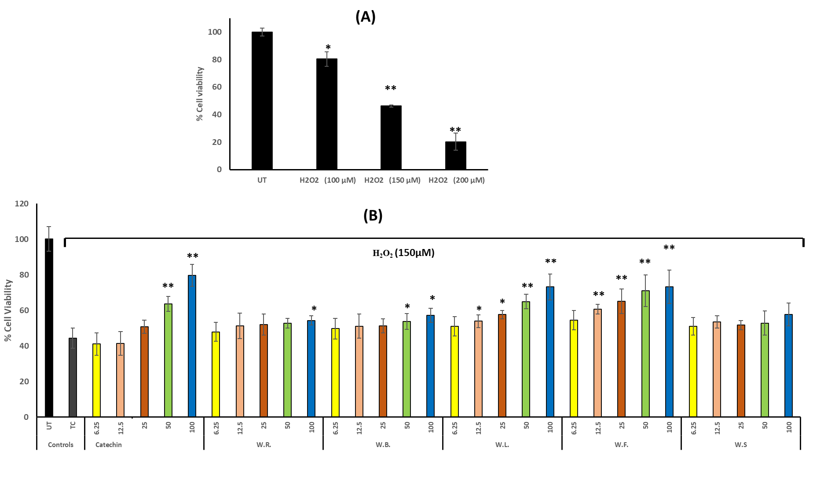

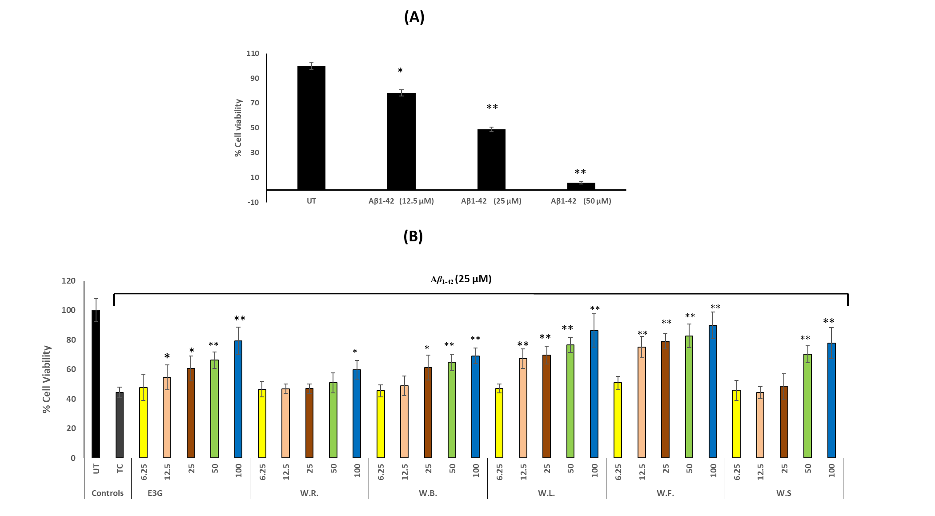

Supplementary file

Table of content

Fig. S1: Standard curve of gallic acid for Phenolic content determination. | 2
Fig. S2: DPPH assay of different tested samples | 3-4
Fig. S3: Anti-COX2 inhibitory activity by different concentrations of tested samples | 5-6
Fig. S4: Acetylcholine esterase inhibitory activity by different concentrations of tested samples | 7

Fig. S1

Fig. S2

In vitro COX-2 inhibitory assay:
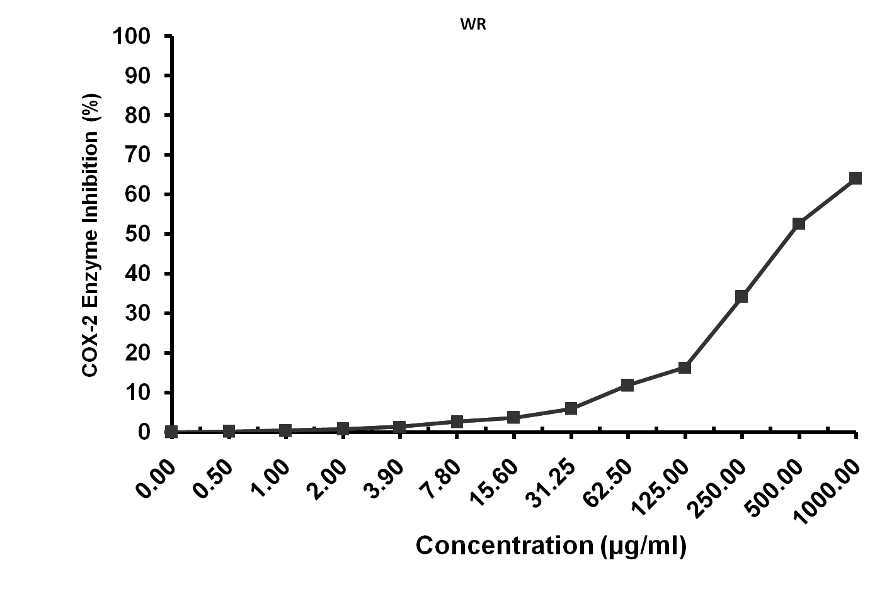
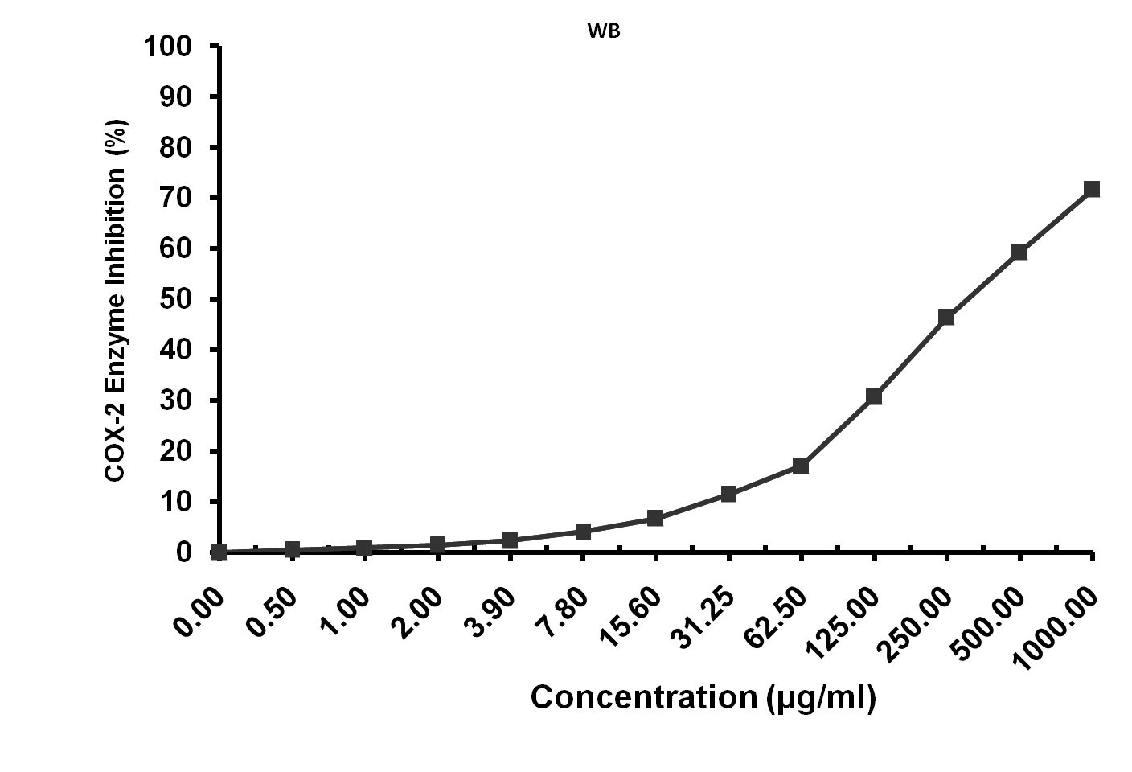
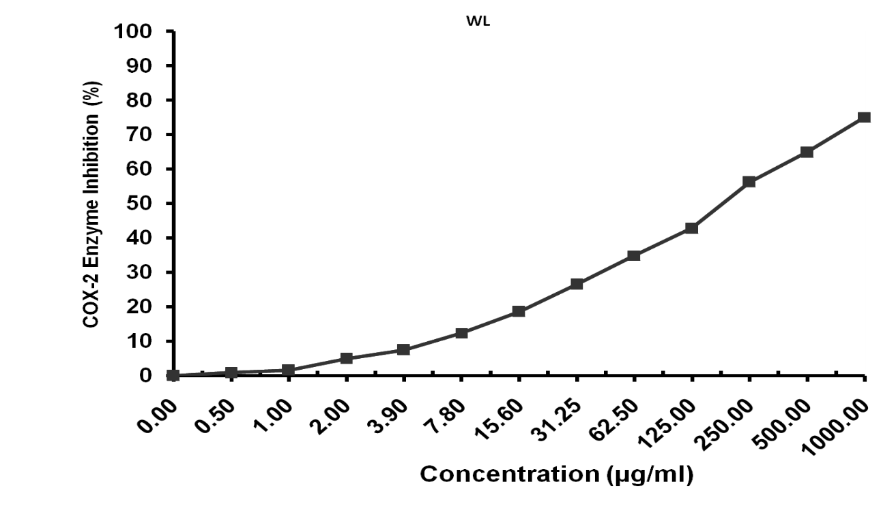
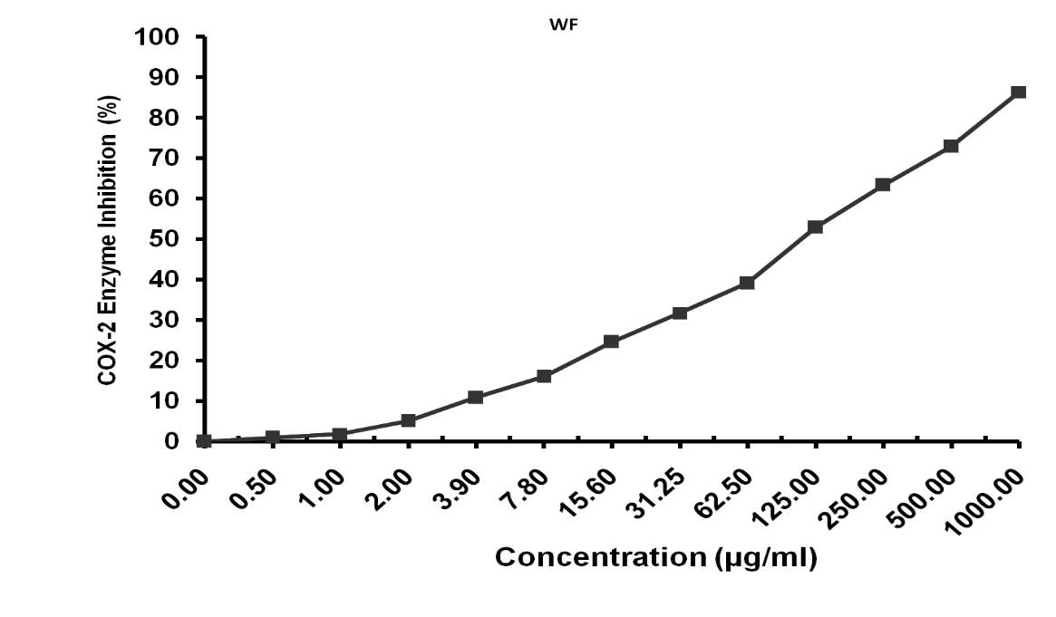
Fig. S3

Fig. S4

