Cellulase production by a newly isolated soil fungus Penicillium griseofulvum A2
Fachun Guan ¹, Jie Liu ², Jinling Cai ², Chunyan Qi ¹, Chao Wang ¹, Yanru Cui ^{1,} , Ligang Hou ^{1, *}, Xie Jiao ¹, Zhonghe Li ¹

- Jilin Academy of Agricultural Sciences, Changchun 130033, China.
- College of Chemical Engineering and Materials Science, Tianjin University of Science & Technology, Tianjin Key Laboratory of Brine Chemical Engineering and Resource Eco-utilization, Tianjin 300457, China.

Abstract: Rice straw is one of the most abundant resources in the world. Returning straw to field is an effective method facilitating sustainable agricultural production in many countries. However, the crop residues cannot be degraded easily due to recalcitrant structure and composition of lignocellulosic material. A straw-degrading fungus Penicillium griseofulvum A2 was isolated from rice straw culture medium and identified by morphology and ITS rRNA gene sequencing. Enzyme-producing condition of A2 was optimized, including nitrogen source ((NH₄)₂SO₄, NH₄Cl, urea, and peptone), pH value (5.0 to 7.5), and incubation time (1 to 20 d). Results showed that P. griseofulvum A2 produced the highest CMCase (33.97 ± 0.33 U/mL) utilizing urea as nitrogen source and growing at pH 7.0-7.5 after 15 d cultivation. While, NH₄Cl was more suitable for β-glucosidase (15.40 ± 1.77 U/mL) production under pH 7.0 condition after 10 d cultivation. The isolated fungus P. griseofulvum A2 is a good potential strains to decomposed rice straw.
Keywords: Rice straw, Straw returning, Cellulose, Penicillium griseofulvum, Condition optimization

1 Introduction
Rice straw (RS) is the byproducts of paddy crop as well as an abundant resource of lignocellulosic biomass. Its worldwide production is 800 to 1000 million tonnes. More than 75% of RS is produced by Asia countries like China and India (1). Crop straw returning to field is a widely used method for facilitating sustainable agricultural production in many countries (2). However, straw is hard to degrade due to its recalcitrant structure and composition of lignocellulosic material including lignin, hemicellulose and cellulose (1). Furthermore, the presence of silica (7.5-13.9%) in RS make it more recalcitrant than other straw residues including wheat straw and corn straw (1).
Straw-degrading microorganisms playing an important role in straw decomposition process, which could greatly speed up the straw ripening process, increase farmland fertility, and play important role in keeping sustainable development of agriculture (3). Microbial degradation of lignocellulose depends on the secretion of cellulase including exoglucanase (EC3.2.1.91), endoglucanase is also called CMCase (EC3.2.1.4), and β-glucosidase (EC3.2.1.21)(4). Cellulase activity is an important indicator of lignocellulose-degradation ability of the microbial strains. Digestion of straw lignocellulose to saccharides requires the synergy of these three enzymes (5). The high cost of cellulase is one of the main bottlenecks for the lignocellulose decomposition (6). Thus, it is quite important to screening microorganisms with effective cellulase activity and applying on-site plants for enzyme production.
Many straw-degrading microorganisms are well explored for straw degradation, including Trichoderma, Chaetomium, Penicillium, Aspergillus, Acremonium, Rhizopus, etc [7, 8](7-11). The most widely used cellulase producing strain is Trichoderma reesei. However, T. reesei often has insufficient β-glucosidase activity, resulting in cellobiose accumulation and reduced enzymatic hydrolysis efficiency (12). By increasing β-glucosidase activity, the competitive product inhibition of cellobiose can be overcome to a certain extent (5). P. purpureus and P. ropeum have been shown to exert higher activity on lignocellulose compared with T. reesei, because they produce more β-glucosidase and hemicellulas (13, 14). P. griseofulvum can produce more β-glucosidase to supplement traditional cellulase products. However, their straw decomposition efficiencies still need increasing. It is necessary to screen different cellulolytic strains. And, natural habitat is a key factor influencing cellulase characteristics. Hence it is important to explore new habitats to search for novel strains with high cellulase producing potential.
As culture condition is important for converting lignocellulosic biomass to saccharides. For filamentous fungi, cellulase gene expression was mainly regulated by transcription activation factors, carbon source metabolism inhibitors, pH and nitrogen source (15). Carbon sources are key to enzyme production because they induce the expression of cellulase and allow microorganisms to secrete various types of enzymes (15). Studies have shown that pH of media strongly influence many enzymatic reactions by affecting the transport of various chemical products and enzymes on cell membranes (16). Naturally, nitrogen stimulates fungal cell growth, which in turn enhances biomass formation and cellulase enzyme expression(17). Thus, culture condition optimization is quite important for RS decomposition.
In this study, RS-degrading strains was isolated from alpine regions to screen microorganisms with better characters. Culture conditions were optimized for cellulase production by the newly isolated fungus P. griseofulvum A2, including nitrogen, pH and incubation time. The main aim is screen new strain with increased cellulase, in order to overcome the limitations that prevent a RS decomposition.

2 Materials and method
2.1 Fungal isolation and identification
The sample was collected from residues of herbage from the high-altitude area of Setira Mountain in Linzhi County, Tibet, China. The strains were activated and enriched on Carboxymethyl cellulose (CMC) medium (18) at 30℃. The fungal colonies were screened on CMC agar medium.
The isolated strain is characterized on the its colony morphology, microscopic features (light microscope H550S Nikon, Japan), and ITS sequence. Colonies were grown on the plate, and the colony characteristics were studied by observing their size, and color that they produce. Microscopic evaluation by Lactophenol cotton blue staining was done to understand spore size, shape, and arrangement (19). The genome of the fungus was extracted by the method of CTAB (20) and then used ITS common primer (ITS1 5'- TCCGTAGGTGAACCTGCGG-3′, ITS4 5'-TCCTCCGCTTATTGATATGC-3′) PCR amplification. The PCR mixture was carried out in a volume of 50 μL, contained 25 μL of Permix Taq (TaKaRa), 1 μL of each forward and reverse primer, 2 μL of template and 21μL distilled water. The PCR amplification conditions were 4 min of preheating at 95℃, 30 s denaturation at 95℃, 30 s of primer annealing at 55℃, 45 s extension step at 72℃ for 35 cycles, and postcycling extension of 10 min at 72 ℃. The reactions were carried out in a thermal cycler (K960 Thermal Cycler, Hangzhou, China). The PCR amplification products were sent to Beijing Augct Company (China) for sequencing. The resulting sequences are compared with the ITS sequences in NCBI. Then MEGA7.0 software is used to construct phylogenetic tree by Neighbor-Joining method (19).
2.2 Cellulases production through liquid state fermentation
For cellulase production, the isolated strain was cultured in medium containing (g/L), RS 10; (NH₄)₂SO₄ 1.4; KH₂PO₄ 0.2; CaCl_{2˙}2H₂O 0.4; MgSO₄ 0.3; Peptone 1.0; NaCl 0.3; FeSO₄ 0.005; MnSO₄ 0.0016; ZnSO_{4˙}7H₂O 0.0014; CoCl₂ 0.002 (21). Sterilized medium in the flask was homogeneously mixed with active inoculum 0.1% (v/v) and incubated at 30 ℃. Nitrogen source, pH, and culture time were optimized in liquid enzyme production medium by control variable method. Each experiment was carried out in triplicate.
2.3 Enzyme assay
5 mL of fermentation liquid was centrifuged at 4 ℃ for 15 minutes at 5000 r/min. After centrifugation, the supernatant was taken as the crude enzyme solution. CMCase activity was measured using 0.5 mL of 1% (w/v) carboxymethyl cellulose (CMC) as substrate with 0.5 mL of enzyme solution at 50 °C, for 30 min, followed by the addition of 3.0 mL of dinitrosalicylic acid (DNS) reagent (22) according to Ghose’ method (23). One unit (U) of CMCase was defined as the amount of enzyme that released 1 µg of glucose per minute under experimental conditions.
β-Glucosidase activity was determined by incubating 0.5 mL of enzyme solution with 0.5 mL of 1% cellobiose in 0.05 M sodium citrate buffer (pH 4.8) at 50 ℃ for 30 min and the liberated glucose was estimated by the glucose oxidase–peroxidase (GOD-POD) method (23). One unit (U) of β-glucosidase was defined as the amount of enzyme that released 1 µg of glucose per minute under experimental conditions.
2.4 Statistic analysis
Significance of difference was assessed by one-way ANOVA, using IBM SPSS Statistics 24. Data represented as mean ± SE.
3 Results and discussion
3.1 Identification of P. griseofulvum A2
Colonies of P. griseofulvum A2 was cultured for 48 h at 30 ℃ on the CMC agar medium. The individual colonies of A2 are regularly round, milky gray-green, with neat edges, raised mosses, and flocculated surface hyphae in the air (Fig.1(a)). The conidia were oval in shape, smooth in surface, blue-green in color and 3-5 μm in length. The conidial stalk also has a septum, and the surface is rough (Fig.1(d)). The conidial stalk has been branched many times to produce small stalks, which are shaped like a broom and stained with blue by lactophenol cotton blue staining, as shown in Fig. 1(b-c).
The ITS sequence was deposited in NCBI Genbank with the accession number MW874977. The homology comparison found that A2 has a sequence similarity of 100% compared with P. griseofulvum (KR296884). The phylogenetic tree constructed by the ITS rDNA sequence of the strain and its close strain is shown in the Fig. 2. Based on the results of the strain, it was identified as Penicillium Genus and named Penicillium griseofulvum A2.
3.2 Effect of nitrogen source on cellulase production
Nitrogen source is major regulatory factor on cellulase production and precursor of the enzyme protein. Therefore, the type of nitrogen source also affects the activity and yield of cellulase. In this study, peptone, urea, (NH₄)₂SO₄ and NH₄Cl were used as nitrogen sources and cultured in pH 6.5 medium for 5 days (Fig.3). The optimum nitrogen source of CMCase is urea. But for β-glucosidase, the optimum nitrogen source is NH₄Cl. However, peptone is optimum nitrogen source for Aspergillus fumigatus (24), which is an organic nitrogen. Inorganic nitrogen sources such as ammonium sulfate promoted growth, and organic nitrogen sources such as yet extract had a greater impact on enzyme production (24-26). The nitrogen sources used by different strains were also very different. The maximal activities were 12.57±0.51 U/mL for CMCase, and 4.06±0.41 U/mL for β-glucosidase (Fig.3(a-b)). In this study, the optimal nitrogen sources are inorganic nitrogen, which is low cost than most organic nitrogen, which could greatly decrease the production cost.
3.3 Effect of initial pH on cellulase produced
The pH of the medium affects the dissociation of charged groups on the cell membrane surface and its microstructure, which in turn affects the absorption of nutrients and the secretion of metabolites, resulting in changes in the growth and metabolism of microorganisms (16). Additionally, the reason for the effect of pH on cellulase is the hydrogen ion effect. Hydrogen ion concentration strongly affects many enzymatic processes and the transport of compounds on cell membranes (27). Studies have shown that growth media pH strongly influence many enzymatic reactions by affecting the transport of various chemical products and enzymes on cell membranes.
In this study, the optimal pH values of these cellulolytic enzymes were also determined on the 5th day with ammonium sulfate as the nitrogen source (Fig.4). The maximal activity of CMCase was at pH values of 7.0 - 7.5. However, β-glucosidase showed the highest activity at pH 7.0. The maximal activities were 18.13±1.1 U/mL for CMCase, and 4.56±0.21 U/mL for β-glucosidase (Fig.4(a-b)). A2 produced more cellulase under neutral condition, which was consistent with the result of Ines BH’ study (15). However, β-glucosidase also has high enzyme activity when the acid condition is pH 5.5. Cellulase production from the different bacteria and fungi is mainly based on pH, and acidic pH (4.0-6.0) supports the production of fungal cellulases(28). In addition, acid cellulase has potential applications in the animal feed industry, clarifying fruit juices, and newspaper acid inks.
3.4 Effect of culture time on cellulase production
With the growth of microorganisms, the nutrient is consuming in the fermentation broth. As the cell tends to senescence and autolysis, the production capacity of the product slows down or stops correspondingly. It is necessary to determine the fermentation time. The production of cellulase by Penicillium was studied with 1% rice straw as substrate and (NH₄)₂SO₄ as nitrogen source at pH 6.5. The activities of CMCase and β-glucosidase were maximal within15 days, then decreased dramatically. Penicillium sp. FSDE15 (29) reached their maximum enzyme production after 10 days. A2 reached its maximum enzyme production in 10-15 days too. The maximal activities were 33.97±0.33 U/mL for CMCase, and 15.40±1.77 U/mL for β-glucosidase, as shown in Fig.5(a-b).
4 Conclusion
In this study, a soil fungal, P. griseofulvum A2, was isolated from alpine regions, which could utilize RS as substrate to produce cellulase including CMCase, and β-glucosidase. Culture condition was optimized for cellulase production. These results indicate that P. griseofulvum A2 can effectively produce cellulase, which has potential to speed up straw degradation.

Acknowledgements
This work has been supported by Basic Research Foundation of JAAS of China (KYJF2021JQ003); Jilin Province Science and technology development plan project (20200403014SF, 20200602054ZP).

Authors Contributions
In this paper, Fachun Guan and Ligang Hou conceived and designed research. Fachun Guan and Chao Wang prepared the fungal isolation and identification, under the supervision of Yanru Cui, Xie Jiao and Zhonghe Li. Jie Liu and Jinling Cai prepared the cellulase production, Chunyan Qi and Ligang Hou prepared the enzyme assay. Fachun Guan and Yanru Cui wrote the manuscript. All authors contributed to the writing of the paper.

Ethical Approval
Not applicable.
Consent to Participate
The authors declare that they consent to participate.
Consent for Publication
The authors declare that they consent for publication.

Conflict of interest
Fachun Guan, Jie Liu, Jinling Cai, Chunyan Qi, Chao Wang, Yanru Cui, Ligang Hou, Xie Jiao and Zhonghe Li declare that they have no conflict of interest.

Availability of data and materials
Available upon request.

References
1. Singh G, Arya SK. 2021. A review on management of rice straw by use of cleaner technologies: Abundant opportunities and expectations for Indian farming. Journal of Cleaner Production 291:125278.
2. Zhou G, Gao S, Lu Y, Liao Y, Nie J, Cao W. 2020. Co-incorporation of green manure and rice straw improves rice production, soil chemical, biochemical and microbiological properties in a typical paddy field in southern China. Soil and Tillage Research 197:104499.
3. Jin Z, Shah T, Zhang L, Liu H, Peng S, Nie L. 2020. Effect of straw returning on soil organic carbon in rice–wheat rotation system: A review. Food and Energy Security 9:e200.
4. Subsamran K, Mahakhan P, Vichitphan K, Vichitphan S, Sawaengkaew J. 2019. Potential use of vetiver grass for cellulolytic enzyme production and bioethanol production. Biocatalysis and Agricultural Biotechnology 17:261-268.
5. Jørgensen H, Mørkeberg A, Krogh KBR, Olsson L. 2004. Production of cellulases and hemicellulases by three Penicillium species: effect of substrate and evaluation of cellulase adsorption by capillary electrophoresis Enzyme and Microbial Technology 36:42-48.
6. Kumar M, Pandey AK, Kumari S, Wani SA, Jakeer S, Tiwari R, Prasad R, Gaur NA. 2020. Secretome produced by a newly isolated Aspergillus flavus strain in engineered medium shows synergy for biomass saccharification with a commercial cellulase. Biomass Conversion and Biorefinery doi:10.1007/s13399-020-00935-3.
7. Silva LDB, Gomes TC, Ullah SF, Ticona ARP, Hamann PRV, Noronha EF. 2020. Biochemical Properties of Carbohydrate-Active Enzymes Synthesized by Penicillium chrysogenum Using Corn Straw as Carbon Source. Waste and Biomass Valorization 11:2455-2466.
8. Wang XQ, Kong ZJ, Wang YH, Wang MM, Liu DY, Shen QR. 2020. Insights into the functionality of fungal community during the large scale aerobic co-composting process of swine manure and rice straw. Journal of Environmental Management 270:110958.
9. Wang ZC, Cui JW, Gao WS, Yang Q, Chen LZ, Yang LB, Sun Q, Zhang HR. 2020. Effects of rice straw structure on chaetoglobosin A production by Chaetomium globosum CGMCC 6882. International Journal of Biological Macromolecules 150:1223-1228.
10. Zheng QX, Wei XY, Xu X, Xin L, Guo L, Zong ZM, Hu JQ. 2020. Pretreatment with Trichoderma sp. AH enhances conversion and specificity of wheat straw in supercritical methanolysis. Biomass & Bioenergy 135:105149.
11. Feng J, Wang B, Zhang D, Chu SH, Zhi Y, Hayat K, Wang JC, Chen XF, Hui N, Zhou P. 2021. Streptomyces griseorubens JSD-1 promotes rice straw composting efficiency in industrial-scale fermenter: Evaluation of change in physicochemical properties and microbial community. Bioresource Technology 321:124465.
12. Yiduo Wang CL, Sixin Liu 2013. Fermentation Condition of Penicillium purpurogenum HBZ003 from Mangrove for 1,4-β-D-cellobiohydrolase Activity. Advanced Materials Research 781-784:1284-1288.
13. Faria ML, Daniel K, Marli C, Pinheiro DAJ, Pereira RL. 2008. Comparison of Penicillium echinulatum and Trichoderma reesei cellulases in relation to their activity against various cellulosic substrates. . Bioresource technology 99:1417-1424.
14. Kyong KJ, Youngsoon U, Yong-Cheol P, Jin-Ho S, Heon KK. 2015. Compounds inhibiting the bioconversion of hydrothermally pretreated lignocellulose. . Applied Microbiology and Biotechnology 99:4201-4212.
15. Ines BH, Salma A, Walid S, Bahia A, Ali G. 2014. Medium initial pH and carbon source stimulate differential alkaline cellulase time course production in Stachybotrys microspora. . Applied Biochemistry and Biotechnology 172:2640-2649.
16. Liang Y, Feng Z, Yesuf J, Blackburn JW. 2010. Optimization of growth medium and enzyme assay conditions for crude cellulases produced by a novel thermophilic and cellulolytic bacterium, Anoxybacillus sp. 527. Appl Biochem Biotechnol 160:1841-52.
17. Elisashvili V, Kachlishvili E, Penninckx M. 2008. Effect of growth substrate, method of fermentation, and nitrogen source on lignocellulose-degrading enzymes production by white-rot basidiomycetes. Journal of Industrial Microbiology & Biotechnology 35:1531-1538.
18. Wirth S, Ulrich A. 2002. Cellulose-Degrading Potentials and Phylogenetic Classification of Carboxymethyl-cellulose Decomposing Bacteria Isolated from Soil. Systematic and Applied Microbiology 25:584-591.
19. Hailei W, Zhifang R, Ping L, Yanchang G, Guosheng L, Jianming Y. 2011. Improvement of the production of a red pigment in Penicillium sp. HSD07B synthesized during co-culture with Candida tropicalis. Bioresour Technol 102:6082-7.
20. Vivekanandhan P, Bedini S, Shivakumar MS. 2020. Isolation and identification of entomopathogenic fungus from Eastern Ghats of South Indian forest soil and their efficacy as biopesticide for mosquito control. Parasitology International 76:102099.
21. M M, W PF, T RE. 1962. Sophorose as an inducer of cellulase in Trichoderma viride. . Journal of Bacteriology 83.
22. Miller. 1959. Use of Dinitrosalicylic Acid Reagent for Determination of Reducing Sugar. Analytical Chemistry:426-428.
23. Ghose TK. 1987. Measurement of celluse activities. International Union of Pure and Applied Chemistry 59,:257—268.
24. Mehboob N, Asad MJ, Asgher M, Gulfraz M, Mukhtar T, Mahmood RT. 2014. Exploring thermophilic cellulolytic enzyme production potential of Aspergillus fumigatus by the solid-state fermentation of wheat straw. Appl Biochem Biotechnol 172:3646-55.
25. Shen L, Su Y, Sun Y, Wang G, Chen H, Yu X, Zhang S, Chen G. 2021. Establishment of a highly efficient and low cost mixed cellulase system for bioconversion of corn stover by Trichoderma reesei and Aspergillus niger. Biocatalysis and Agricultural Biotechnology 32:101849.
26. Rodriguez-Gomez D, Hobley TJ. 2013. Is an organic nitrogen source needed for cellulase production by Trichoderma reesei Rut-C30? World Journal of Microbiology & Biotechnology 29:2157-2165.
27. El-Sayed A, Abo-Sereih N, Mahmoud A, El-Kawokgy T, El-Ghamery A. 2019. Genetic identification and optimization of novel β-glucosidase-producing Lysinibacillus sphaericus QS6 strain isolated from the Egyptian environment. Egyptian Pharmaceutical Journal 18:341-355.
28. Srivastava N, Elgorban AM, Mishra PK, Marraiki N, Alharbi AM, Ahmad I, Gupta VK. 2020. Enhance production of fungal cellulase cocktail using cellulosic waste. Environmental Technology & Innovation 19:100949.
29. Santos FA, Carvalho-Gonçalves LCTd, Cardoso-Simões ALdC, Santos SFdM. 2021. Evaluation of the production of cellulases by Penicillium sp. FSDE15 using corncob and wheat bran as substrates. Bioresource Technology Reports 14:100648.

Figure legend
Figure 1. Morphological characteristics of P. griseofulvum A2. (a) Colony morphology; (b) Unstained hyphae morphology; (c) Stained hyphae morphology (d) Spore morphology.
Figure 2. Phylogenetic tree of the ITS sequence of P. griseofulvum A2. Numbers in parentheses represent accession numbers in GenBank. Numbers at each branch point represent the bootstrap values on Neighbor-joining analysis of 1000 replication data sets. Bar 0.050 is the sequence divergence.
Figure 3. Effect of nitrogen source on cellulase production of P.griseofulvum A2. (a) CMCase; (b) β-glucosidase.
Figure 4. Effect of pH on cellulase production of strain P. griseofulvum A2. (a) CMCase; (b) β-glucosidase.
Figure 5. Effect of pH on cellulase production of P. griseofulvum A2. (a) CMCase; (b) β-glucosidase.

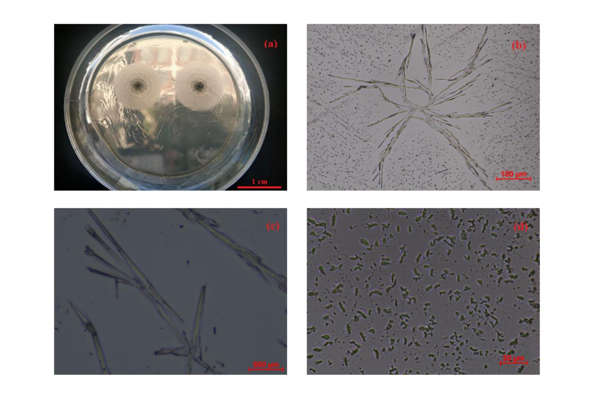
Figure 1.

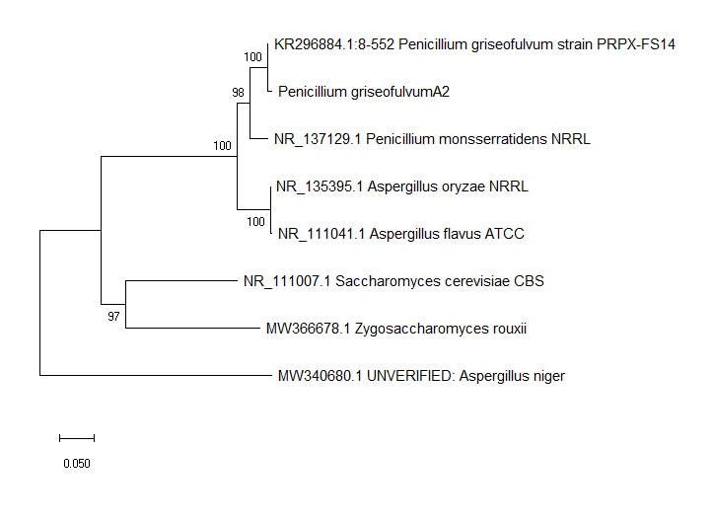
Figure 2.
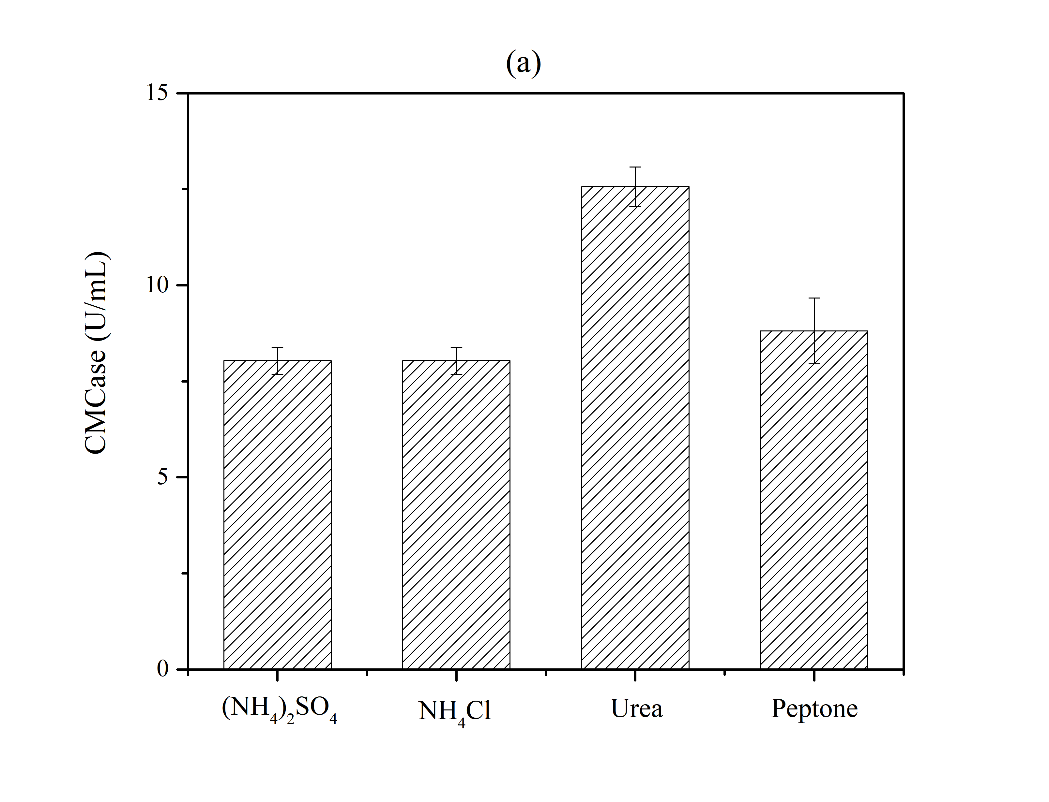Figure 3. (a)CMCase.
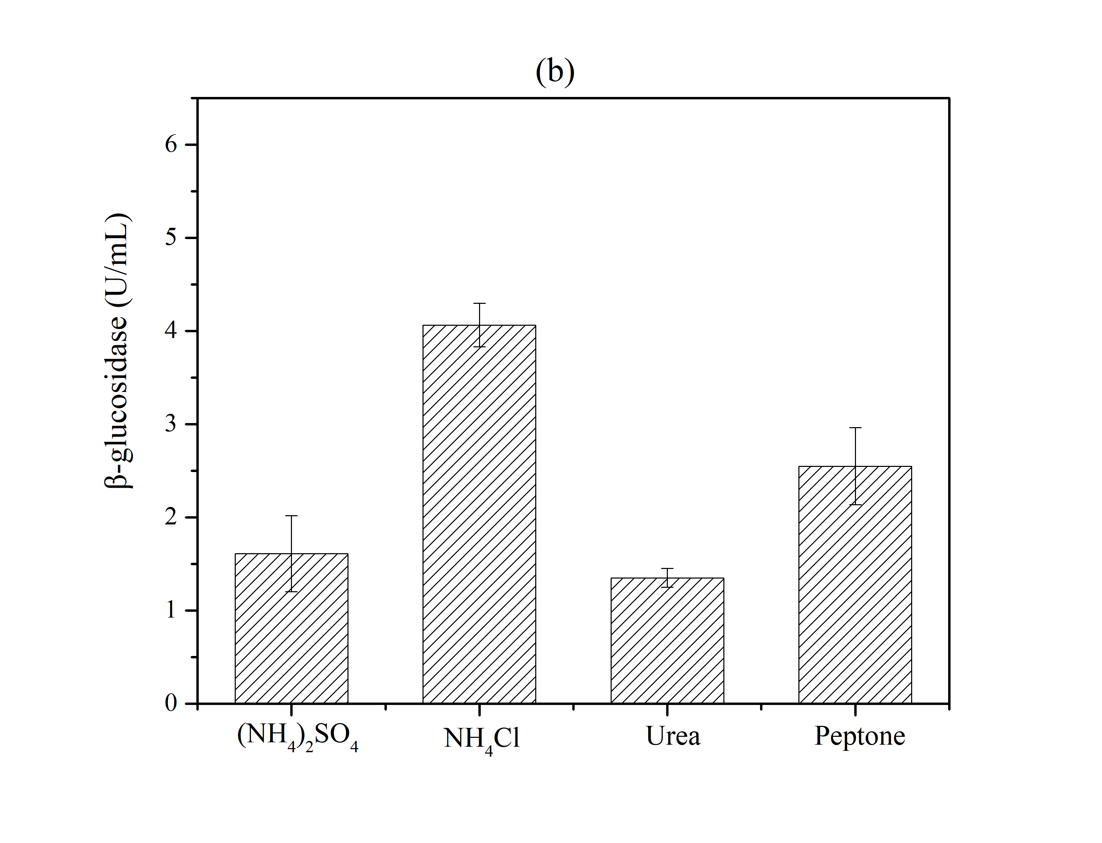Figure 3. (b) β-glucosidase.
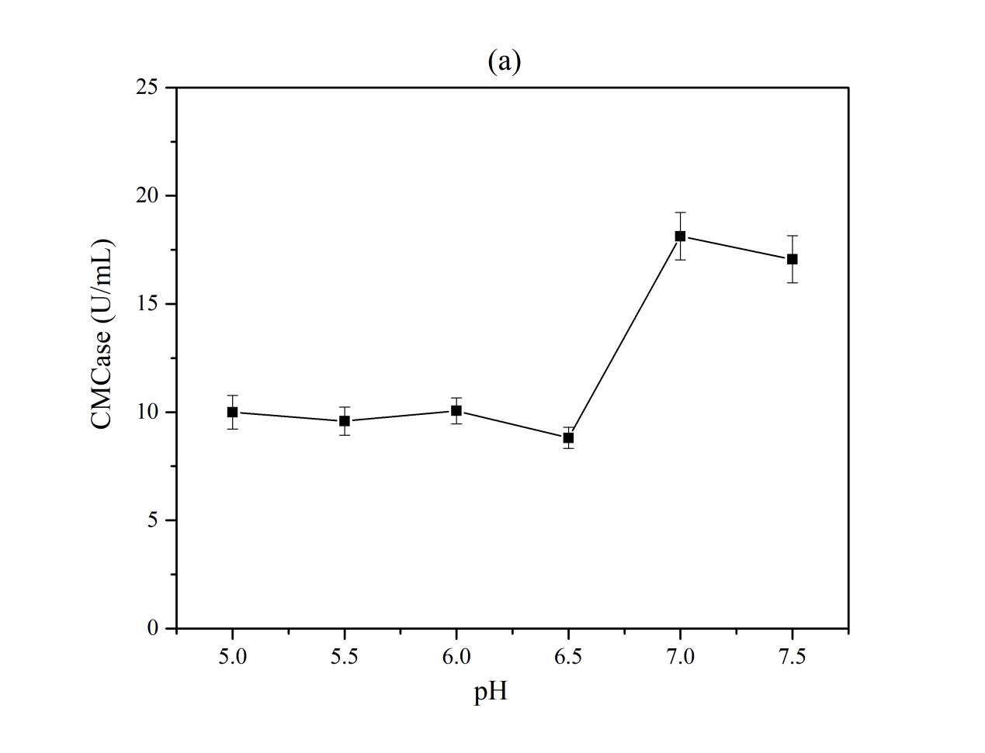Figure 4. (a) CMCase.
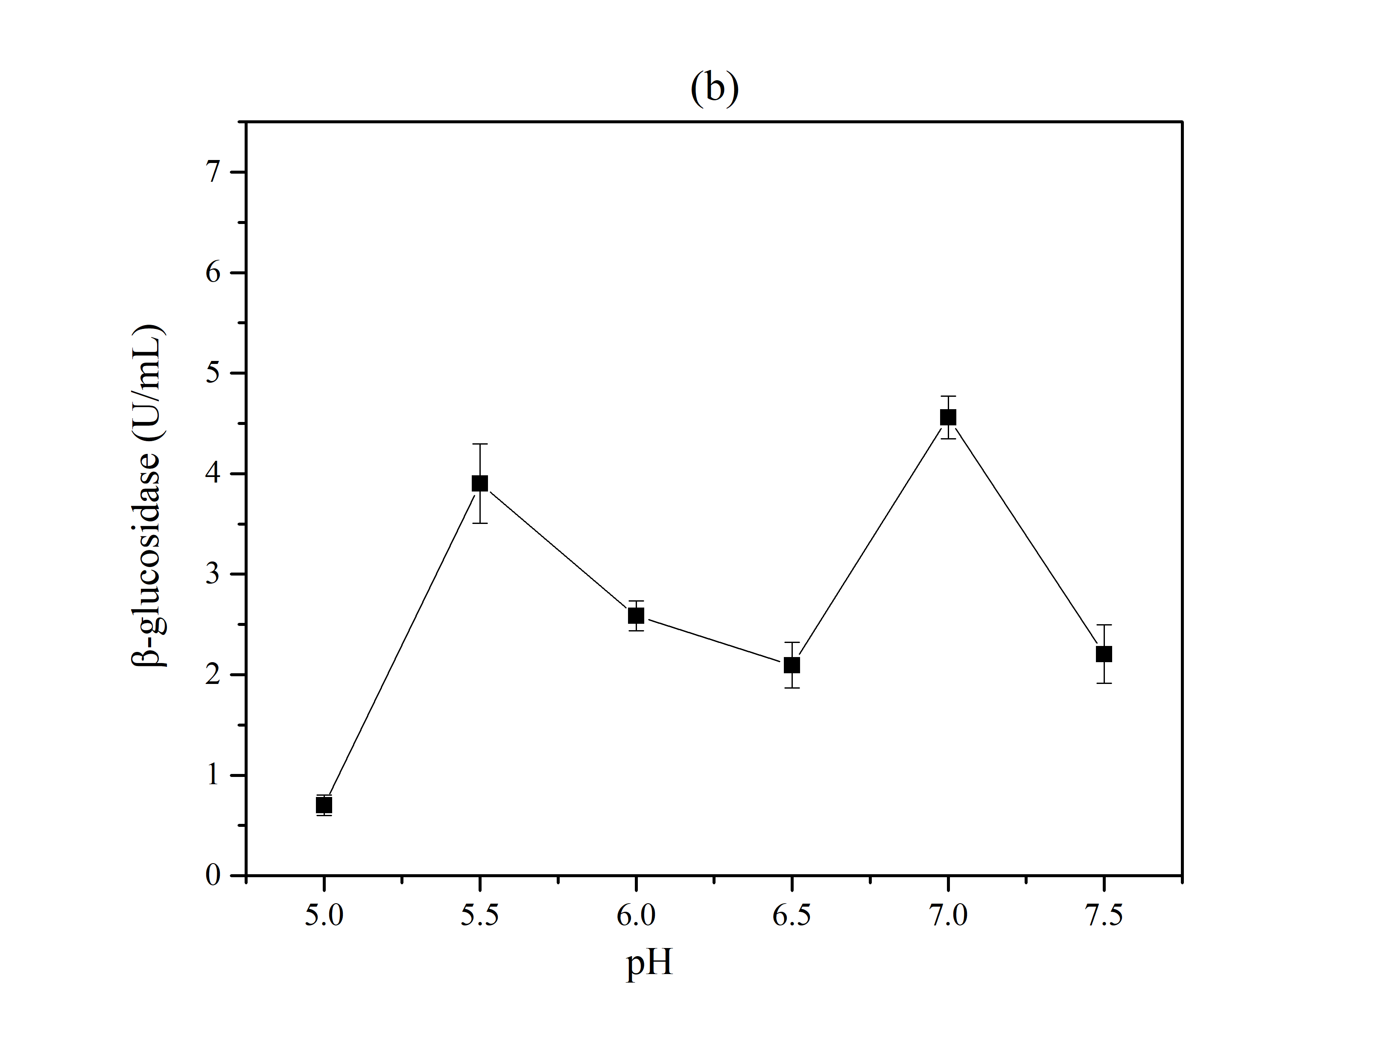
Figure 4. (b) β-glucosidase
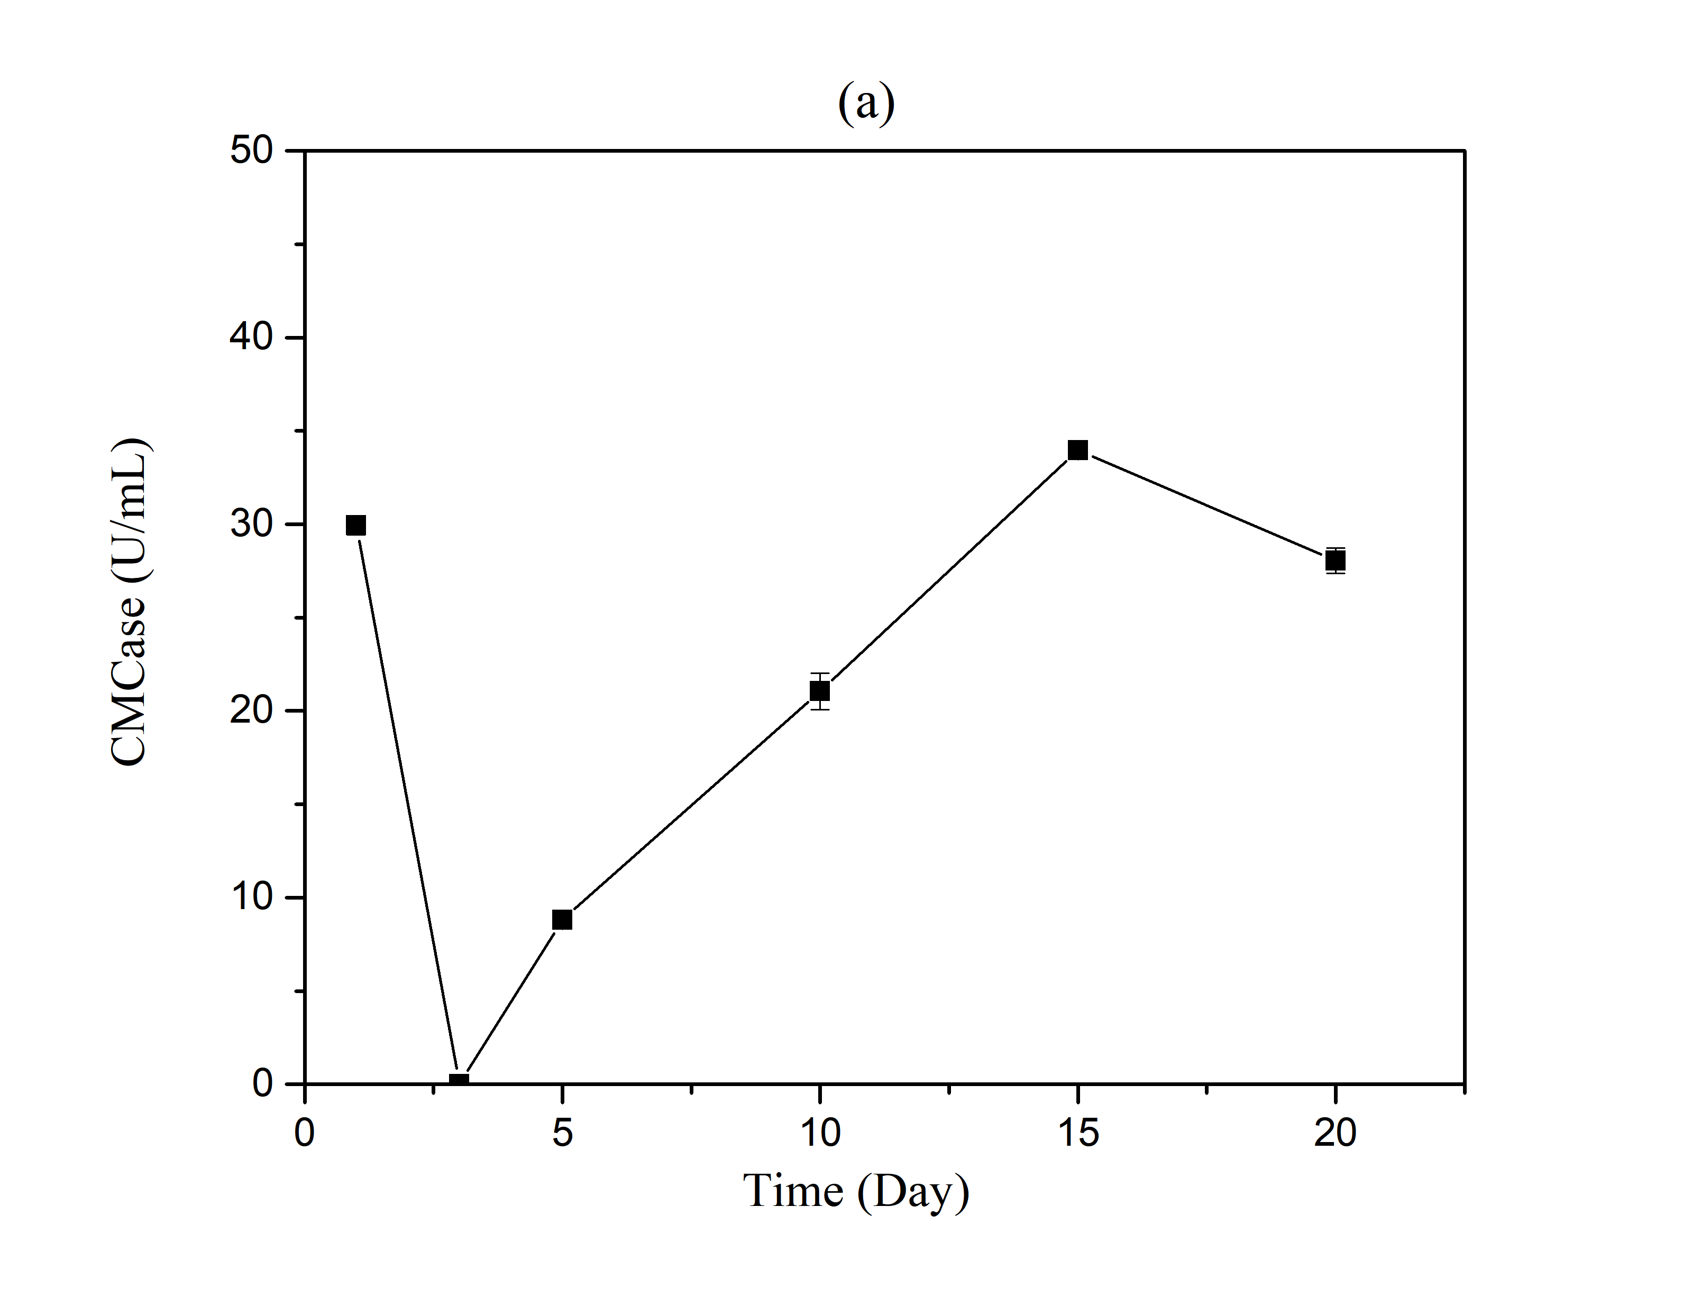Figure 5. (a) CMCase
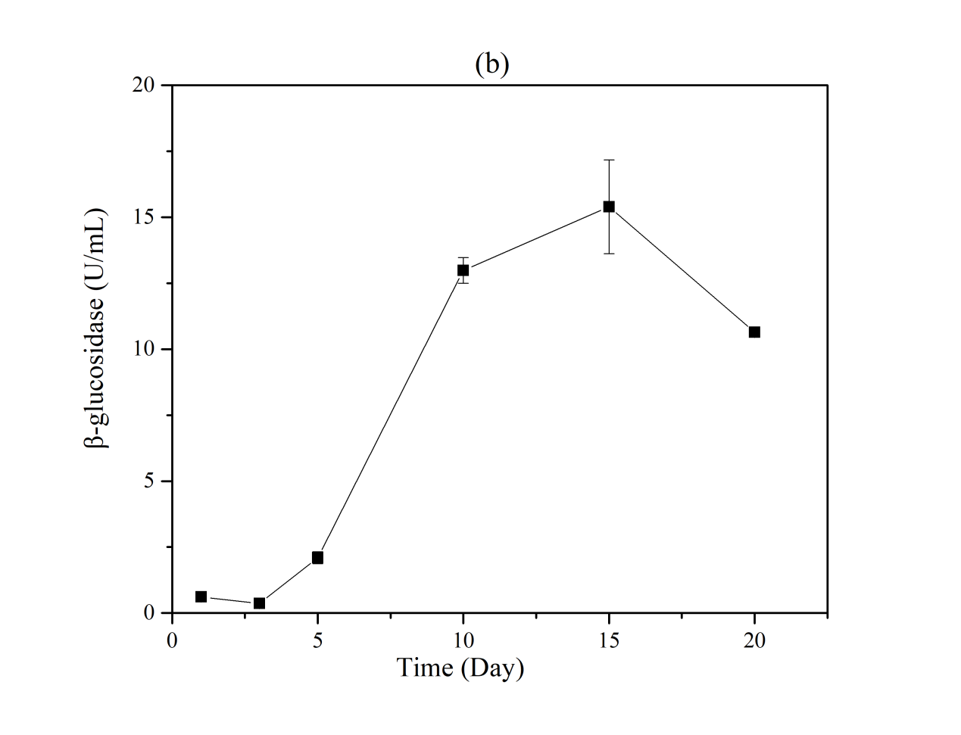
Figure 5. (b)β-glucosidase

Corresponding author: Jilin Academy of Agricultural Sciences, E-mail: 434965430@163.com (Yanru Cui) and houligang888@163.com (Ligang Hou).

