Optimization of an In Vitro Embryo Rescue for Mandarins Triploids (Citrus Reticulata) Obtained from Diploids Crosses

Ennaciri Hanae^{1/2}, Handaji Najat¹, Brhadda Najiba², Benyahia Hamid¹, Ziri Rabea², Hmimidi Adnane^{1/2}, Daghouj Oumaima^{1/2}, Aderdour Tarik¹, Benaouda Hassan¹.
^{1:} Laboratory for the Improvement and Conservation of Plant Genetic Resources, National Institute of

Agricultural Research of Morocco (INRA), Kenitra, Morocco
^{2:} Laboratory of Plant, Animal and Agro-Industry Productions, Faculty of Sciences, University Ibn Tofail, Kenitra, Morocco

[* For Correspondence: E-mail: najat.handaji@inra.ma]

Abstract
Triploidy is a promising way for the creation of new citrus varieties with seedless fruits. Thus, the objective of this study was to investigate the influence of seed shape size and female parents genotypes factors on the efficiency of embryo rescue technique for the regeneration of triploids seedless hybrids from mandarin’s diploids crosses. The culture of immature embryos was initiated from the excised embryos of the four varieties of mandarin (Murcott honney, Nadorcott, variant of Murcott M104 and Ortanique). Seeds are extracted from ripe fruits and immature embryos derived from abnormal seeds (small and flat) were cultured in vitro on Murachige and Tucker (MT) culture medium, supplemented with 1mg/L of acid gibberellic (GA3). The triploid seedlings were identified by the flow cytometry technique. The variance analysis showed that there are significant differences between the varieties studied for all the criteria except for the germination interval having an average value of 3 days. The germination percentage of immature embryos varied from 77% (Ortanique) to 92% (Nadorcott). Similarly, the aerial growth rate of vitroplants oscillated from 1 mm/day (Murcott Honney) to 3.70 mm/day (Ortanique) while the root growth rate evolved from 1.90 mm/day (variant of Murcott M104) to 3.80 mm /day (Ortanique). In addition, the triploidy rate evolved from 2.70% (Murcott Honney) to 13.51% (Ortanique). Flow cytometry Analysis revealed that the majority of triploids come from abnormally developed seeds (flat and small), specifically small seeds. Which give a high number of triploid seedlings, and from this the variety Ortanique showed the highest rate of regeneration of the triploid seedlings (15.38%) in comparison with the others varieties. The variation in germination rate, seedling growth and triploidy of the citrus varieties studied depends on the genotype and seed shape factors. The development and mastery of this method of preferential selection of triploids opens the way to the creation of populations of varieties of mandarin trees with seedless and easy-to-peel fruits.
Keywords: Citrus; Mandarin; Triploidy; Embryo rescue; Flow cytometry.
Introduction
Citrus is one of the major fruit crops in the world and is widely grown in tropical and subtropical areas. They account for an annual production of over 124.3 million tones worldwide and around 18% of total global fruit production (Mahato et al. 2020). Morocco is among the major exporting countries of small-fruited citrus in the Mediterranean region. In a very competitive fresh fruit market, mandarins and clementines are today one of the most dynamic sectors of citrus production and world trade. However, mandarins and their diploid hybrids generally produce fruits with many seeds and their cultivation at the edge of clementine orchards can induce the production of a lot seeded clementines. One of the best strategies to meet the constraints set out above would be to create new triploid varieties of mandarin (2n=3x=27) characterized by sterility (Aleza et al. 2010b; Handaji et al. 2020; Lourkisti et al. 2021a). The triploidy has proved to be a powerful approach breeding programs, particularly in Citrus, since seedlessness is one of the greatest consumer expectations (Lourkisti et al. 2021b). Moreover, triploidy could play an important role in the coming decades by improving biomass and abiotic stress tolerance resulting in commercial benefits (Costa et al. 2019; Lourkisti et al. 2020). On the other hand, triploid embryos are mostly found in small seeds, between one-third and one-sixth larger than normal seeds, which generally do not germinate under conventional greenhouse conditions. Thus, embryo rescue from these small seeds is necessary to achieve high germination rates (Navarro et al. 2002; Aleza et al. 2010b). Thus, the rescue of immature embryos in vitro with an evaluation of ploidy by flow cytometry have been revealed as two decisive methods in the development of effective programs for the selection of triploid plants (Ollitrault et al. 1996b; Navarro et al. 2003; Aleza et al. 2010b; Dalel et al. 2020). In addition to seedlessness in citrus, embryo rescue has been applied in breeding programs for early ripening (Ramming et al. 1990), triploidy or interspecific crosses in many other fruit crops such as apple (Druart et al. 2000), grape (Angelica et al. 2022), banana (Uma et al. 2011), mango (Krishna and Singh. 2007), persimmon (Hu et al. 2013), and peach (Yamada and Tao. 2007). However, despite continuous efforts to optimize the in vitro rescue technology, the number of obtained spontaneous triploids is insufficient for improvement programs of seedlessness as protocol efficiency is deeply affected by several endogenous and exogenous factors: Parental crossing genotypes (Handaji et al. 2005; Essalhi et al. 2020 and 2021), culture medium composition (Ennaciri et al. 2020; Hmimidi et al. 2020), addition of growth regulators, and plantlet acclimation conditions are among the most influential factors affecting rescue efficiency (Mahmoudi et al. 2019 and 2020). The formation of new constant triploid hybrids can be recovered through diploid species hybridization from the fusion of divalent gametes at low frequency or intra-and inter-ploidy crosses. However, extensive breeding work based on small F1 hybrid seeds developed is impossible without a very effective aseptic methodology and ploidy event. In this study, in vitro embryo culture was employed to recover natural hybrids from monoembryonic diploid, open-pollinated mandarin. The aim of the present work was to investigate the influence of seed shape size and female parents genotypes factors on the efficiency of embryo rescue technique for the regeneration of triploids seedless hybrids from mandarin’s diploids crosses.
Materials and Methods
Plant materials
Four varieties of mandarin were open pollinated in non-block area during the anthesis on Marsh and April: 1. Nadorcott, 2. Murcott honney, 3. Ortanique and variant of Murcott Honney (M104). These varieties were planted in National Institute of Agronomic Research domain (INRA Kenitra/ El Menzeh).
Methods
In vitro culture of immature embryos
At maturity stage, the fruits of the four mandarin’s varieties were harvested. Then, after extraction of the seeds, two categories were identified: normal (fully developed) and abnormal seeds (partially developed). These last are classified into two types (flat and small) (Fig.1; Table 1). Seeds were classified by size and developmental stage. Size in (mm²) was measured and developmental stage was evaluated by morphological parameters. Perfect seeds (PS) were normal in appearance, totally filled out, and without any malformation. Undeveloped seeds (US) had incomplete development, not totally filled out, wrinkled, and with split outer integument (Fig. 2). Under a laminar flow hood, seeds were surface sterilized for 5 min in a solution of 70% ethanol, followed by immersion for 10 min in 10% sodium hypochlorite. Then they were washed three times in sterile distilled water.
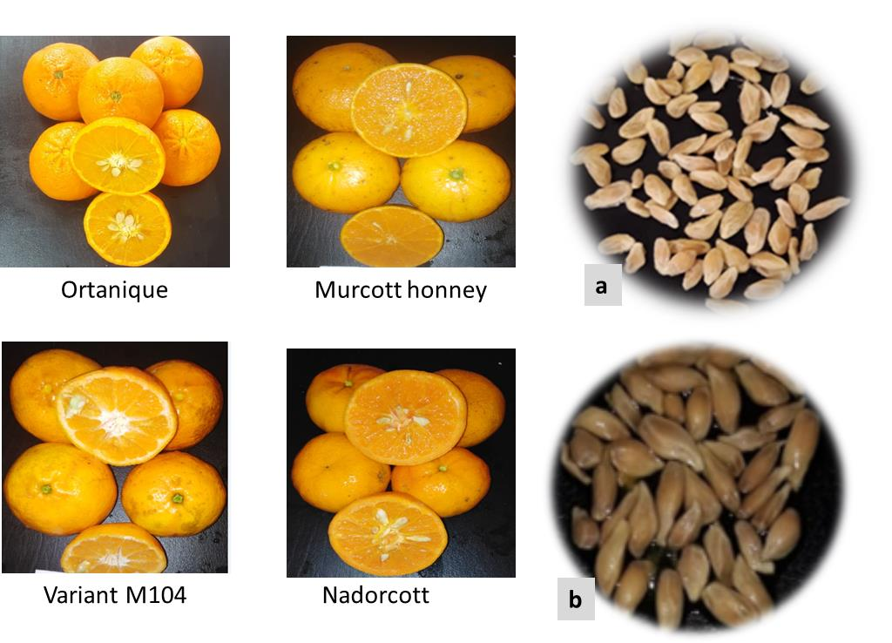
Fig.1: Mandarin’s varieties with their seeds extracted from ripe fruits and classified according to theirs shapes and sizes (a: abnormal, b: normal)

Table 1: Average length, normal, flat and small seeds of each studied variety
Mandarins | Length means of seeds en mm²
 | Normal | Abnormally developed
 |  | Small | Flat
Ortanique | 122.15 | 23.9 | 70.4
Murcott honney | 116.25 | 26.2 | 67.1
Nadorcott | 122.2 | 25.2 | 55.8
Variant of Murcott (M104) | 105 | 22.15 | 61.2
Mean (mm²) | 116.40 | 24.36 | 63.63
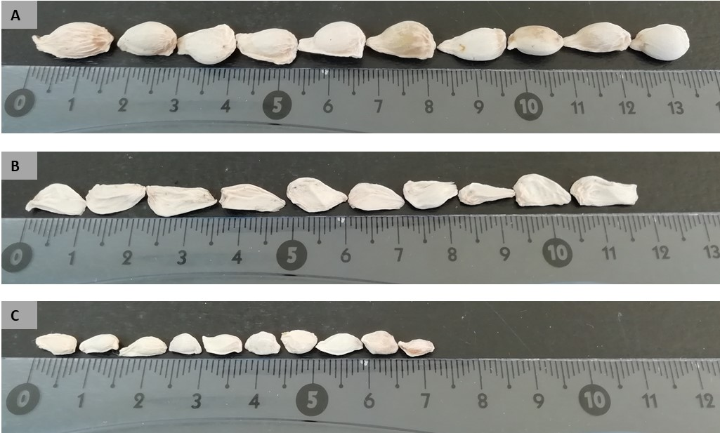

Fig.2: Comparison of seeds Size, with A: Normal; B: Flat and C: Small seeds
The decortications of seeds should be done very carefully to avoid damaging embryos that were cultured under aseptic condition in petri dishes containing the Murashige and Tucker [(1969) culture media with 50 g/l sucrose, 500 mg/l malt extract and supplemented with vitamins (100 mg/l myo-inositol, 1 mg/l pyridoxine hydrochloride, 1 mg/l nicotinic acid, 0.2 mg/l thiamine hydrochloride, 4 mg/l glycine), and 8 g/l Bacto agar (MT culture media sterilized at 120 ° C for 20 minutes). Baskets cultures are placed in an incubator under 16/18 hours (light/dark) photoperiod with light intensity of 1000 lux provided through neon and a temperature of 27 ° C during the day and 19 ° C at night. Embryo germination was conducted for 12 weeks in a growth chamber under a 16-h photoperiod with a light intensity of 1000 lux provided by a cool-white fluorescent lamp, at a temperature of 23 ± 2 °C. Embryos showing newly formed cotyledonal leaves were observed and recorded regularly. The percentage of embryo germination was calculated as the number of germinated embryos in the total number of formed embryos. Plant growth allows determining the rate of regeneration. The triploidy rate is calculated in percentage. Also, the formulas of all parameters were detailed by (Ennaciri et al. 2020).
Ploidy determination by the Flow cytometry
Ploidy levels of seedlings were evaluated by flow cytometry using a Partec II cytometer. Nuclei suspensions were made from mature leaf samples and whole seeds. About 0.5 g of leaf tissue was collected from fully or near fully expanded leaves of seedlings two or three months after germination. In the presence of a leaf portion of a triploid control, the tissue was placed in a 60×15 mm polystyrene dish with 0.5 ml of phosphate-buffered saline (PBS) buffer, dithiothreitol 1 mg/L and 0.1% Triton X 100, chopped to a fine mash with a single-edge razor blade. The nuclei were then filtered through a 50-μm nylon filter and stained with 2 ml of 4,6-diamine-2-phenylindole (DAPI) solution (High Resolution DNA Kit Type P, solution B; Partec). This fluorochrome binds specifically to DNA. The amount of DNA is evaluated by the intensity of the fluorescence re-emitted by the nuclei under UV excitation (365 nm). After a 2-min incubation period, stained samples were run in a Ploidy Analyzer (Partec, PA) flow cytometer. Histograms were analyzed using the dpac v 2.18 software (Partec), which determines peak position, coefficient of variation (CV), and the relative ploidy index of the samples. The triploid control used in this study is Moroccan cultivar “HANA”.
Statistical Data analysis
Quantitative data were analyzed using SAS (Statistical Analysis System version 9.1 and version 5.5) and were subjected to analysis of variance (ANOVA). Means were compared to Duncan's test at a 5% level of significance. Several analyzes variances are carried out in order to establish a comparison between the means of the variables.
Results

Seed Germination and Seedling Formation
Variance analysis showed a significant effect between the four mandarin’s varieties for the majority of the traits (germination rate and interval, stem and root growth rate) (Fig.3; Tables 2 and 3).
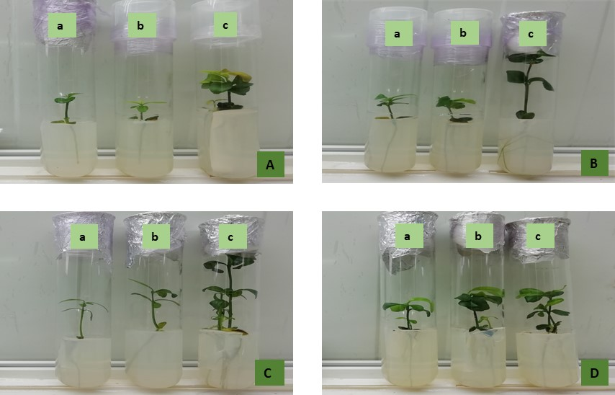
Fig.3: Seedlings from immature embryo rescue of three types of seeds; a: normal; b: small; c: flat; for four varieties of mandarin’s (A: Nadocott; B: Variant of Murcott M104; C: Ortanique; D: Murcott Honney)
Germination Rate and Interval
The germination rate varied from 77% to 92% with an average of 83.58%. Three statistically differentiated groups were identified. The first group included the varieties Nadorcott and the variant of Murcott M104, the second group ab contained the variety Murcott Honney and the group b with the variety Ortanique. For the germination interval, there is no significant difference between all the varieties studied. The germination was taken approximate 3 days.
Table 2: Percentage and interval germination of seeds from mandarin’s varieties
Mandarins varieties | Germination rate (%) | Germination Interval (days)
Ortanique | 76.66b | 3.00a
Nadorcott | 91.85a | 2.77a
Variant of Murcott M104 | 89.28a | 2.78a
Murcott Honney | 83.73ab | 3.00a
Mean | 83.58 | 2.88
Duncan's test according to a level of significance (5%).
Stem growth rate
The aerial growth rate varied statistically according to the genotypes studied (Table 3). It oscillated from 1.00 mm/day to 3.70 mm/day with an average of 2.03 mm/day and from 0.60 mm/day to 1.80 mm/day with an average of 1.10 mm/day during the second and third weeks respectively. Indeed, the growth rate of the stem decreased from the third week for all the varieties studied. This could be explained by the exhaustion of the culture medium used. Similarly, the variety Ortanique is relatively characterized by a better stem growth rate with an average of 3.70 mm/day followed by the variant M104. A good development of the foliar system is thus observed for all the regenerated green seedlings.
Root growth rate
Statistical analyzes revealed a significant difference between the four varieties of mandarins for root growth. Thus, three different groups have been highlighted, group b includes the two varieties Ortanique and Nadorcott, group c represents the variant of Murcott M104 and group bc contains the variety Murcott honney. In addition, the average value of root growth speed varied from 3.03 mm/day (2nd week) to 2.33 mm/day (3rd week). In addition, a decrease in the evolution of growth took place during the following weeks for all varieties with the exception of the variant Murcott M104.

Table 3: Growth rate of stem and root of four mandarin’s varieties
 | Growth rate (mm/day)
Stem |  |  | Root
Varieties | SGR1 | SGR2 | RGR1 | RGR2
Ortanique | 3.70a | 1.80b | 3.80ab | 2.30ab
Nadorcott | 1.20b | 0.60c | 3.40b | 1.60b
Variant of Murcott M104 | 2.20ab | 1.40bc | 1.90c | 3.30a
Murcott honney | 1.00b | 0.60c | 3.00bc | 2.10b
Mean (mm/j) | 2.03 | 1.10 | 3.03 | 2.33
Duncan's test with significance (5%).
SGR1: stem growth rate of seedlings in the second week, SGR2: stem growth rate of seedlings in the third week, RGR1: root growth rate of seedlings in 2nd week, RGR2: root growth rate of seedling root growth for 3rd week.

The Influence of Seed Size on the parameters studied
Germination Rate and Interval
There was a significant difference between the four varieties of mandarin in germination rate and seed shape (Fig.4). The germination rate was 100% for the normal seeds, but it varied from 55% to 98% for the small seeds and from 66% to 100% for the one with the flat shape. For the variety Ortanique, there are two statistically different groups, the first group a includes the normal and flat seeds which are characterized by a very high germination rate followed by the second group b which includes only the small form. For Nadorcott, the normal seeds forming group a gave a higher germination rate than the small and flat seeds ab. In the majority of citrus varieties, the germination rate of normal seeds is higher than that of abnormal seeds (flat and small). For germination rate of Murcott Honney varieties and its variant M104, normal and small pips showed the highest germination rate compared to the flat form.
For the interval of germination, there is not a significant difference between the three forms of seeds of the two varieties Ortanique and Murcott Honney, their seeds gave all an average interval of three days. Unlike the other two genotypes, there is a statistically significant difference. The variety Nadorcott presented two groups a which includes the normal seeds and ab the small and flat seeds, while for the variant of Murcott M104 three statistical groups were distinguished a which includes the normal seeds, group ab for the small seeds and b for the flat seeds (Fig.5).
Stem and root growth rate
For the growth speed of the stem during the first two weeks, the small seeds of the variety Ortanique are characterized by a better aerial growth, followed by the normal and flat seeds. For the Nadorcott variety, there is no significant difference between the three seed forms, they all gave the same growth rate. For the variant of Murcott M104, the small seeds were characterized by a better stem growth. Also, the small seeds gave a fast growth rate compared to the flat and normal seeds. At the fourth week, the stem growth rate decreased for all four tangerine varieties, this can be explained by the depletion of growing medium for the tangerine varieties during the first two weeks.
The seed forms that are characterized by better root growth rate in the first two weeks are small seeds for Ortanique variety, normal seeds for varieties Nadorcott and Murcott honney. The flat seeds of the variant of Murcott M104 showed a better growth rate, at the third week, the root growth rate decreased for the three seed forms of the four varieties studied and this can be explained by the depletion of the culture medium (Fig.6 and Fig.7).
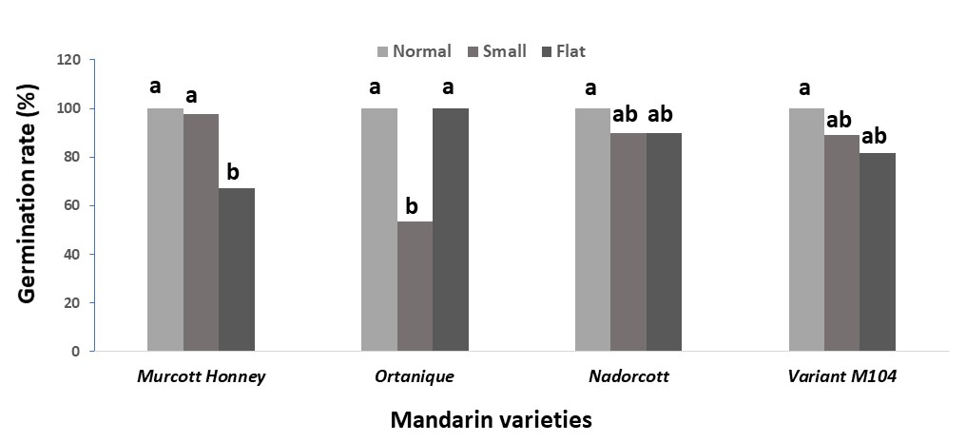
Fig.4: Comparison of immature embryos germination rate according to the seeds size (normal, small and flat) of the mandarin’s varieties.
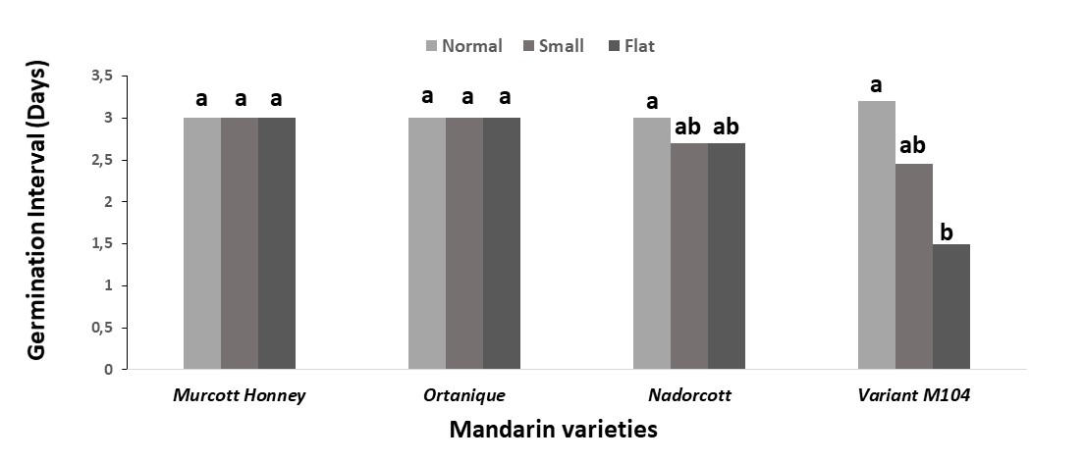
Fig.5: Comparison of immature embryos germination interval according to the seeds size (normal, small and flat) of the mandarin’s varieties.

Fig. 6: Comparison of the Stem growth rate for the four mandarin varieties. SGR1: Stem growth rate during two weeks; SGR2: Stem growth rate during three weeks

Fig.7: Comparison of the root growth rate for the four mandarin varieties. RGR1: Root growth rate during the first two weeks; RGR1: Root growth rate during three weeks
Study of the effect of size seeds on different parameters studied
According to a statistical comparison of the values of the studied parameters (Table 4), for the germination rate of the embryos there is a significant difference for the three forms of seeds, which detects two large groups, a group a including the flat form giving a maximum germination rate (87.69%) and group b including the two small and normal forms with an average germination rate of 84.68%. While there is no significant difference for the other variables studied (germination interval, stem growth rate (SGR1 and SGR2), root growth rate (RGR1 and RGR2) in relation to the tested seed form (small, flat and normal). The average values vary respectively as follows: 2.88; 1.9 mm/d; 1.7 mm/d; 3.5 mm/d and 2.3 mm/d.
Table 4: Multiple comparisons of the average values of the different parameters studied according to the shape of the seeds (small, flat and Normal)
 | seeds shape
Variables | Small | Flat | Normal | Mean
Germination rate (%) | 78.67b | 87.69a | 87.68a | 84.68
Germination interval (days) | 3.00a | 2.79a | 2.87a | 2.88
Stem Growth Rate (mm/days)
SGR1 | 2.51a | 1.72a | 1.60a | 1.93
SGR2 | 1.85a | 1.65a | 1.94a | 1.76
Root Growth Rate (mm/days)
RGR1 | 3.62a | 3.14a | 3.89a | 3.50
RGR2 | 2.64a | 2.37a | 2.23a | 2.36
SGR1: stem growth rate of seedlings in the second week, SGR2: stem growth rate of seedlings in the third week, RGR1: root growth rate of seedlings in 2nd week, RGR2: root growth rate of seedling root growth for 3rd week.

The results obtained showed a statistical variation of the variables according to the genotype and all depending on the seed shape (Table 5), the interaction between the seed shape and the variety studied varied for each character, the interaction is highly significant for the germination percentage (P < 0. 001), it is significant for germination interval and root growth rate between the fourth and third week (RGR2), however the interaction is statistically insignificant for aerial growth rate during the four weeks (SGR1 and SGR2) as well as root growth rate between the second and first week (RGR1) with (P > 0.05).
Table 5: Multiple comparisons of genotype*seeds size interaction
Variables | CV (%) |  | F Value | Pr > F
Germination rate (%) | 20.48 |  | 74.22 | <.0001 ***
Germination interval (days) | 21.08 |  | 2.33 | 0.0226 *
Stem Growth Rate (mm/days)
SGR1 | 178.37 |  | 0.40 | 0.9190
SGR2 | 89.17 |  | 1.07 | 0.3870
Root Growth Rate (mm/days)
RGR1 | 60.61 |  | 1.45 | 0.1817
RGR2 | 76.81 |  | 2.25 | 0.0281 *
SGR1: stem growth rate of seedlings in the second week, SGR2: stem growth rate of seedlings in the third week, RGR1: root growth rate of seedlings in 2nd week, RGR2: root growth rate of seedling root growth for 3rd week.

Leaf analysis by flow cytometry
A significant number of triploid plants recovered from immature embryos of citrus varieties in M1 medium containing GA3, through leaf analysis by flow cytometry technique. The triploidy rate varied according to the size of the seed and the variety studied.

Study of the genotype effect on triploidy
Four varieties of seedlings from immature embryo rescue were analyzed by flow cytometry, two levels of ploidy were identified for these tested varieties: triploid hybrids and diploids. The variety Ortanique showed a higher triploidy rate than the other varieties with a percentage of 13.51%, followed by the variant of Murcott M104 and Nadorcott with an average percentage of 8.11% and 5.40% respectively. Then the variety Murcott honney which is in last place producing a low percentage of triploid vitroplants at about 2.70%. According to these results, mandarin varieties are able to give a very high triploidy rate but depending on the genotype studied (Table 6; Fig.8).
Table 6: Percentage of diploid and triploid seedlings from in vitro germination of abnormal seeds (flat and small) analyzed by flow cytometry
 | Percentage of plantlets (%)
Varieties | Diploids | Triploids
Ortanique | 86.49 | 13.51
Variant of Murcott M104 | 91.89 | 8.11
Nadorcott | 94.59 | 5.40
Murcott Honney | 97.30 | 2.70
Total Mean | 92.57 | 7.43

Study of the effect of seed size on triploidy
In the case for the variety Ortanique, 8.11% of the triploid plants were derived from small seeds compared to diploid hybrids, in contrast to the flat seeds which gave a percentage of 5.41% of triploid plants. The variant M104 also showed similar results due to the fact that only small seeds gave a high percentage of triploid plants in order of 8,11% and no triploid hybrids were regenerated from flat seeds. For the variety Nadorcott, there is an equality of percentage between the small and flat seeds, both had the same chance to give triploids. Lastly and the case of the variety Murcott Honney that was found in this study only one triploid hybrid, this last one was regenerated from the germination of a flat seed while the small seeds of this variety studied gave a percentage in the order of 2.70% and 0 % for the small seeds.
The results obtained showed the significant effect of genotype and seed shape on the percentage of triploidy of all the mandarins varieties studied, the variety Ortanique showed a very good ability to regenerate triploid hybrids in comparison with the other varieties and for the small seeds are the best to produce these hybrids sought in the case of the three varieties Ortanique, variant of Murcott M104 and the Nadorcott compared to the flat seeds giving low percentages of triploidy. Only the variety Murcott honney from which a single triploid hybrid was obtained from a flat seed (Table 7). The variety Ortanique appeared to be the best genotype to produce triploid in vitro plants, which are mainly derived from small seed germination.
Table 7: Percentage of polyploid plants analyzed by flow cytometry of the four varieties studied according to seed shape
Percentage of polyploids (%)
Varieties | Seeds shape | Diploids | Triploids
Ortanique | Small | 40,54 | 8,11
 | Flat | 45,95 | 5,41
Variant of Murcott M104 | Small | 48,65 | 8,11
 | Flat | 45,95 | 0,00
Nadorcott | Small | 56,76 | 2,70
 | Flat | 35,14 | 2,70
Murcott Honney | Small | 54,05 | 0,00
 | Flat | 43,24 | 2,70
Total Mean |  | 46,28 | 3,72
The ploidy level profiles of the varieties: Nadorcott, Murcott honney, Ortanique and variant of Murcott M104, resulting from the immature embryo rescue are presented in the form of histograms (Fig.9). The comparison of the plants tested, which are derived from in vitro immature embryo rescue, with a triploid control profile (Moroccan Mandarin Hana) and a diploid control profile (Fig.10), allows us to conclude the amount of DNA in the plant tested and thus its ploidy level.
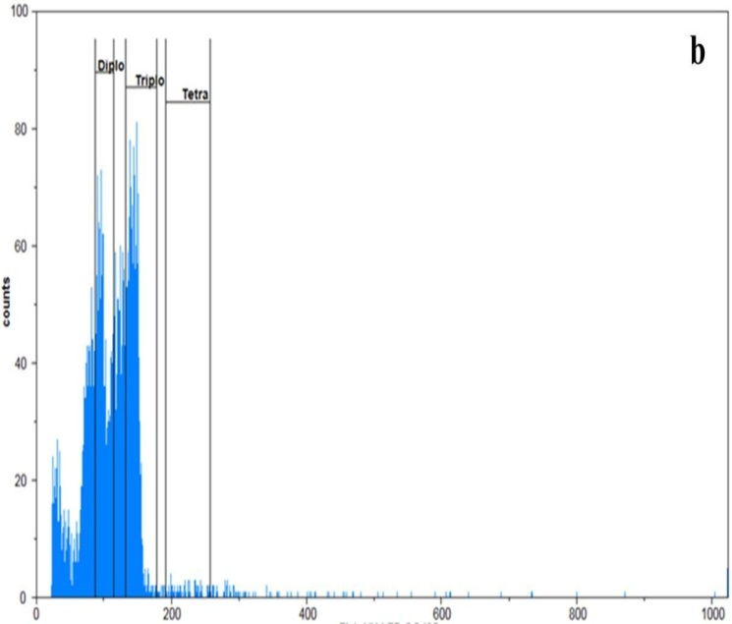
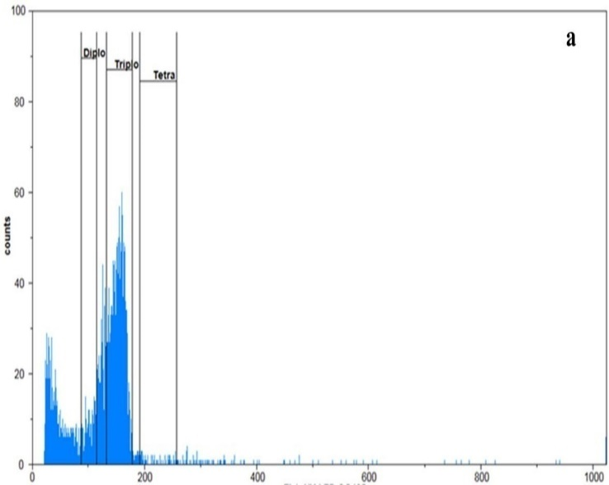

Fig.9: Histograms detected by the flow cytometry technique for counting the amount of DNA; a: profile of a triploid vitroplantlet; b: profile of a diploid vitroplantlet

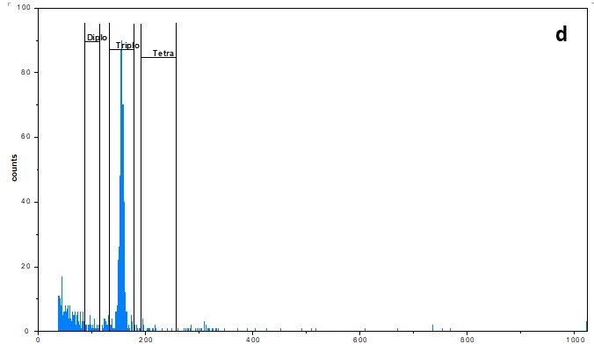
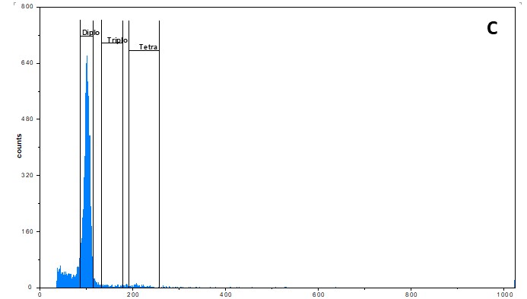
Fig.10: Histograms generated by flow cytometry for counting DNA amounts; c: triploid control profile; d: triploid control profile
The Seedlings confirmed as triploid by flow cytometry are transplanted into pots in a greenhouse. After two to three weeks, they are transplanted into black plastic bags. Thus, the triploid seedlings will be grafted and transplanted into large pots (Fig.11). They were placed in a greenhouse under conditions of temperature 25±2°C and humidity 80% (Ennaciri et al. 2020).
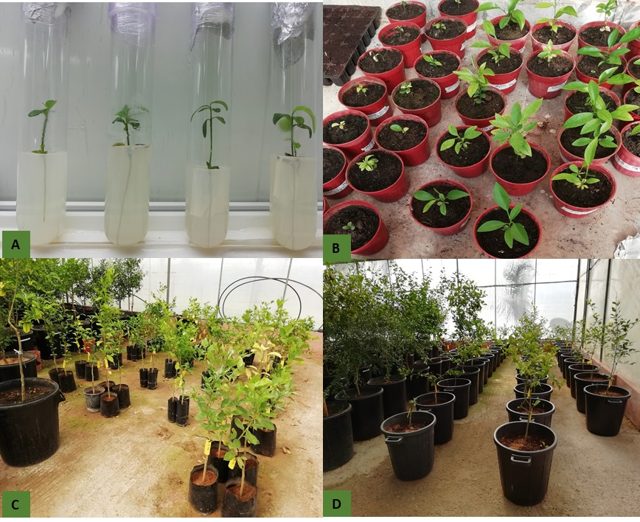
Fig.11: Regeneration of triploid green seedlings. A: triploid seedlings from small seeds; B: seedlings transplanted in pots in the greenhouse; C: triploid seedlings from grafting of triploid mother plants; D: acclimatization of grafted plants in the greenhouse in large pots.

Discussion
The average germination percentage was statistically different among the four mandarin varieties. suggesting an important distinction in the mechanisms controlling germination in these citrus cultivars. This result is similar to those found by (Fucik et al. 1974 and 1978); Orbović et al. (2013) Who worked on citrus species and thus found statistical differences for the germination rate of the cultivated seeds. Similarly, the statistical distinction of germination rates among the studied genotypes as well as stem growth; they may be related to the existence of seed coat during the cultivation of the seeds. This was proved by (Cimen et al. 2020) with his study on citrus in correlation with (Azim et al. 2013) who reported that the shoot formation of Citrus Sinensis is highly related to the presence of seed coat during in vitro culture, which leads to a reduction of the germination percentage. According to mandarin’s varieties, the germination rate was varied from 55% to 98% for the small seeds and from 66% to 100% for the one with the flat shape. These results are similar to those found by Ennaciri et al. 2020; Mahmoudi et al. 2020; Hmimidi et al. 2020; Aleza et al. 2010. It’s higher than found by Ollitrault et al. (1996b) for small clementine seeds. In citrus, many studies have reported the great importance of choosing the best culture medium in vitro to ensure successful embryo rescue (Hmimidi et al. 2020; Ennaciri et al. 2020; Mahmoudi et al. 2020). The study of germination of immature and mature seeds revealed a significant variation between seed types (small, flat and normal), so that their development was different with time. In fact, embryo rescue depends on the stages of embryonic development and the composition of the nutritional environment (Esen et al. 1973). Similarly, the choice of the best male (Handaji et al. 2005) and female (Essalhi et al. 2020) parents has been the subject of several studies to optimize the triploidy rate. Triploid embryos are found in small seeds that do not germinate under conventional greenhouse conditions (Cuensa et al. 2010). In this study, triploid embryos were contained in seeds between 1/4 and 1/5 (Table 1) smaller than normal seeds. The Embryo rescue from these small seeds is required to reach the high germination rates (Navarro et al., 2002). This result is in agreement with studies that were carried out by (Esen et al.1973; Thorpe et al. 1994; Aleza et al. 2010; Cuensa et al. 2010) indicating that triploids were obtained from underdeveloped seeds and possessing a size between 1/3 and 1/6 smaller than normal seeds. Similarly, spontaneous triploids were detected among the progeny of Eureka lime and lemon, ruby sweet orange and imperial grapefruit (Husband et al. 2004). The results of the latter studies confirm that seed size is highly correlated with ploidy level. Indeed, the size of the seeds, carrying triploid embryos, of the order of l/3 to l/6 is smaller than those carrying diploids. The probability of obtaining triploid citrus hybrids spontaneously is higher than 5% (Handaji et al. 2005). The frequency of unreduced megagametophyte production depends on the maternal genotype, and should be known before starting extensive breeding programs (Aleza et al. 2010). Furthermore, seed size is highly related to ploidy (Dalel et al. 2020). The study revealed that triploid hybrids were all obtained from partially developed seeds, mainly small seeds and this last character allows early selection of triploid plants.
Conclusion
The statistical variation of triploidy rate depends on two factors: genotypes and seeds shape. The embryo rescue linked to flow cytometry allowed to obtain and better detect triploid hybrids. The study of the genotype effect showed that only the variety Ortanique represented a good ability to produce triploids with a very high triploidy rate compared to the other genotypes and contrary to the Murcott honney which presented the lowest triploidy percentage. The seed shape effect revealed that triploid vitroplants were mainly derived from abnormal seeds (flat and small) especially the small seeds which have a high ability to produce and regenerate the desired triploid hybrids.
Ackowledgements
This work is supported by the National Center of Scientific and Technical Research (CNRST) through the scholarship program of excellence (2017 edition). A special gratitude and warm thanks go to Dr. Handaji Najat and Pr. Brhadda Najiba for their support and their particular help in the development of this work.
Author Contributions
All authors have read and agreed to the published version of this manuscript.
Conflicts of interest
The Authors declare that there is no conflict of interests that could possibly arise.
References
Aleza P, J Juarez, J Cuenca, P Ollitrault, L Navarro (2010b). Recovery of citrus triploid hybrids by embryo rescue and flow cytometry from 2x × 2x sexual hybridisation and its application to extensive breeding programs. Plant Cell Rep 29(9) :1023 –1034
Aleza P, J Juárez, P Ollitrault, L Navarro (2010). Polyembryony in non-apomictic Citrus genotypes Ann. Bot 106: 533–545
Angelica G, M Andrea, C Antonio, G Agata, S Stefano, F Giuseppe (2022). Optimization of an In Vitro Embryo Rescue Protocol for Breeding Seedless Table Grapes (Vitis vinifera L.) in Italy. Horticulturae 8(2) :121
Azim F, M Rahman, SH Prodhan, SU Sikdar, N Zobayer, M Ashrafuzzaman (2013). Development of efficient callus initiation of malta (citrus sinensis) through tissue culture. Int. J. Agric. Res. Innovation Technol 1(1–2): 64–68
Cimen B (2020). Induction of Polyploidy in C35 Citrange through in Vitro Colchicine Treatments of Seed-Derived Explants. International Journal of Fruit Science 20(sup3):1929-1941
Costa SN, PA Cortez, LA da Hora Almeida, FM Martins, W Soares Filho, MAC Filho (2019). Triploid frequency of sexual hybridization and pollen and ovary development in mandarins. Braz. J. Bot 42: 73–82
Cuenca J, P Aleza, J Juárez, JA Pina, L Navarro (2010). ‘Safor’ mandarin: a new citrus mid-late triploid hybrid. HortScience 45(6): 977-980
Dalel A (2020). Analyse de l’hérédité des fragments chromosomiques et de l’association phénotype/génotype au sein de populations d’agrumes triploïdes d’origine interspécifique
Druart P (2000). Aneuploids and variants of apple (Malus domestica Borkh.) through in vitro culture techniques. Acta Horticulturae 520: 301–307
Ennaciri H, N Handaji, N Brhadda, H Benyahya, N Gmira, R Ziri, A Hmimidi, T Aderdour, R Yacoubi, K Label, K Mahmoudi, H Benaouda (2020). Evaluation of embryo rescue media on germination and plantlet development in mandarins (Citrus reticulata). Plant Cell Biotechnology and Molecular Biology 21(9-10): 12-25
Esen A, RK Soost (1973). Precocious Development and Germination of Spontaneous Triploid Seed in Citrus, Journal of Heredity 64 (3):147-54
Essalhi M, N Handaji, N Brhadda, H Benyahya, R Ziri, A Hmimidi, H Ennaciri, H Benaouda (2021). Ploidy analysis of citrus seedlings from in vivo germination of immature embryos. Plant Cell Biotechnology and Molecular Biology 22(41-42): 261-276
Essalhi M, N Handaji, N Brhadda, R Ziri, H Benyahya (2020). Evaluation of ability to produce natural triploid from diploid crosses in different Clementine’s cultivars. Plant Cell Biotechnology and Molecular Biology 21(5-6): 48-58
Fucik JE (1974). Grapefruit seed viability and germination J. Rio Grande Valley Hort. Soc 28: 140-142
Fucik JE (1978). Sources of variability in sour orange seed germination and seedling growth Proc. Intl. Soc. Citriculture 1:141-143
Handaji N, H Benyahia, H Ennaciri, A Hmimidi, T Aderdour, H Benaouda (2020). Analyse de la diversité phénotypique des variétés de mandariniers issues de la collection marocaine INRA Kenitra. African and Mediterranean Agricultural Research Journal-Al-Awamia (129)
Handaji N, N Arsalane, A Lamarti, D Dambier, H Benyahia, H Miaghizo, P Ollitrault (2005). Induction de l’embryogenèse somatique et régénération des plantules chez les mandariniers (Citrus reticulata L). El Awamia 114(2): 2
Hmimidi A, N Handaji, N Brhadda, H Benyahya, R Ziri, H Ennaciri, T Aderdour, K Label, R Yacoubi, K Mahmoudi, H Benaouda (2020). Ploidy level analysis of seedlings from embryos extracted from seeds rarely produced by triploid mandarin hybrids. Plant Cell Biotechnology and Molecular Biology 21: 83-90
Hu D, X Tang, Q Zhang, Z Luo (2013). Cross compatibilities of oriental persimmon ‘Mopanshi’ and ‘Luotian-tianshi’ with ‘Zenjimaru’. Acta Horticulturae 996: 165–170
Husband BC (2004). The role of triploid hybrids in the evolutionary dynamics of mixed- ploidy populations, Biological Journal of the Linnean Society 82(4): 537-546
Krishna H, SK Singh (2007). Biotechnological advances in mango (Mangifera indica L.) and their future implication in crop improvement: A review. Biotechnol. Adv 25: 223–243
Lourkisti R, J Oustric, Y Quilichini, Y Froelicher, S Herbette, R Morillon, L Berti, J Santini (2021a). Improved Response of Triploid Citrus Varieties to Water Deficit Is Related to Anatomical and Cytological Properties. Plant Physiology and Biochemistry 162:762–775
Lourkisti R, Y Froelicher, S Herbette, R Morillon, F Tomi, M Gibernau, J Giannettini, L Berti, J Santini (2020). Triploid citrus genotypes have a better tolerance to natural chilling conditions of photosynthetic capacities and specific leaf volatile organic compounds. Frontiers in plant science 11: 330
Lourkisti R, Y Froelicher, S Herbette, R Morillon, J Giannettini, L Berti, J Santini (2021b). Triploidy in citrus genotypes improves leaf gas exchange and antioxidant recovery from water deficit. Frontiers in Plant Science 11 :2311
Mahato N, K Sharma, M Sinha, ER Baral, R Koteswararao, A Dhyani, MH Cho, S Cho (2020). Bio-sorbents, industrially important chemicals and novel materials from citrus processing waste as a sustainable and renewable bioresource: A review. Journal of Advanced Research 23: 61-82
Mahmoudi K, N Handaji, M Ibriz, Benyahya H (2020). Research of Citrus Triploid Hybrids by embryo rescue and Flow Cytometry from two oranges varieties Pineapple and Parson Brown. Plant Cell Biotechnology and Molecular Biology 21(1-2): 19-27
Mahmoudi K, N Handaji, M Ibriz, N Arsalane, T Aderdour, K Label, M Essalhi, H Ennaciri, C Cherrah, H Benyahya (2019). Analysis of ploidy level seedlings derived from in vivo germination of immature embryos of oranges. Plant Cell Biotechnology and Molecular Biology 20(15-16): 643-653
Navarro L, J Juárez, P Aleza, JA Pina (2003). Recovery of triploid seedless mandarin hybrids from 2n × 2n and 2n × 4n crosses by embryo rescue and flow cytometry. In: Vasil IK (ed) Plant biotechnology 2002 and beyond. Springer, Dordrecht, pp: 541-544
Navarro L, JA Pina, J Juárez, JF Ballester-Olmos, JM Arregui, C Ortega, A Navarro, N Duran-Vila, J Guerri, P Moreno, M Cambra, S Zaragoza (2002). The Citrus variety improvement program in Spain in the period 1975–2001. Proceedings of the 15th Conference of the International Organization for Citrus Virol, In : N. Duran-Vila, R.G. Milne and J.V. da Grača (Eds.), International Organization for Citrus Virology, Riverside, CA pp : 306–316
Ollitrault P, V Allent, F Luro (1996b). Production of haploid plants and embryogenic calli of clementine (Citrus reticulum Blanco) after in situ parthenogenesis induced by irradiated pollen. In:Proceedings International Society Citriculture Volume 2, pp: 913-917
Orbović V, M Dutt, JW Grosser (2013). Evaluation of the germination potential of citrus seeds during the harvesting season. Hort Science 48(9): 1197-1199
Ramming DW (1990). The use of embryo culture in fruit breeding. Hort Science 25(4):393-398
Thorpe TA (1994). Morphogenesis and regeneration. In Plant cell and tissue culture, Dordrecht, pp: 17-36
Uma S, MS Saraswathi, A Akbar, MM Mustaffa (2011). Embryo rescue and plant regeneration in banana (Musa spp.). Plant Cell Tissue Organ Cult 105: 105–111
Yamada A, R Tao (2007). Controlled pollination with sorted reduced and unreduced pollen grains reveals unreduced embryo sac formation in Diospyros kaki Thunb. ‘Fujiwaragosho’ J. Jpn. Soc. Hortic. Sci 76: 133–138

