Running title: Land Use Changes in Edaphic Beetles Comunity

Edaphic beetles (Insecta: Coleoptera) in three different land use systems in the Eastern Amazon

Helender Ueno¹*, Zilza T.M. Guimarães², Nara M.S. de Almeida³, Afrânio F.N. Junior⁴, Herberto U. S. de Souza⁵ and Adenomar N. de Carvalho⁶

¹Postgraduate Program of Forest and Environmental Science, Federal University of Amazonas, Amazonas 69080900, Brazil
²Coordination of Environmental Dynamics, National Institute of Amazon Research, Amazonas 69060062, Brazil
³Maria Amália Municipal School, Pará, 68005090, Brazil
⁴Distance Education Center, Federal University of Amazonas, Amazonas 69080900, Brazil
⁵Chico Mendes Institute of Biodiversity Conservation, Amazonas 69500000, Brazil ⁶Federal University of Western Pará, Pará 68040255, Brazil

*For correspondence: helenderueno@gmail.com

Received _______________; Accepted _______________; Published _______________

Novelty statement

Edaphic beetles have rarely been studied under different land use systems with tropical conditions, particularly in the Eastern Amazon. Beetle community composition in natural ecosystem, such as primary forest fragment, differs from that in conventional agricultural cultivation and agroforestry system. However, these results show that homogeneous vegetation established by no-tillage with decayed plant material from the last culture cycle can improve and preserve beetles’ detritivore trophic guild. We found that the accumulated richness of edaphic beetles was the greatest parameter related to vegetation diversity.

Abstract

Beetles are important insects in terrestrial ecosystems and can be used to assess and monitor environmental changes. The objective of this study was to evaluate the abundance and relationship of trophic groups in different land use systems (LUS) and the beetles’ composition dependence on plant diversity under tropical climate conditions. Edaphic beetles were collected using pitfall traps in conventional primary forest fragment (FFP), agroforestry (SAF) and agricultural cultivation (CAC) systems in the Irurama community, Eastern Amazon. The sample design, in each LUS, was established by a square grid with 25 sampling points equidistant at five meters, the traps remaining on the field for five days. Six collections campaigns were made during August, the beginning of the less rainy period. The Scarabaeidae and Staphylinidae families showed strong dominance in all LUS. The edaphic beetles community is influenced by the LUS, since the highest rates of abundance, average richness, diversity and evenness were found in the CAC, a fact that can be associated with the provision of plant residues between crop rotation and the dominance of the detritivore trophic group. The families composition of edaphic beetles is dependent on plant diversity, mainly due to factors such as improving the quality of the litter and providing suitable microclimatic conditions for the growth and development of the soil community.

Keywords: Soil biology, Diversity, Trophic guilds, Pitfall trap, Bioindicator.

Introduction
Global environmental changes are resulting in severe biodiversity loss (Cardinale et al. 2012; Newbold et al. 2015). Habitat loss and degradation are the main causes of biodiversity loss and species extinction around the world (Krauss et al. 2010; Mantyka-pringle, 2012). This phenomenon occurs particularly in the tropics since it harbors most of the planet's biodiversity and has one of the highest land use change rates (Lambin et al. 2003; Romdal et al., 2013).
The conditions imposed by land use and management can alter edaphic organisms populations, thus impacting the environmental services supply through direct and indirect effects related to soil and plants (Barreta et al., 2014; Bernardes et al., 2020). In general, observed changes in the environment occur due to changes in plant composition, climate change, and land use intensification, which can cause positive and negative impacts on the soil community (Fagundes et al., 2011; Pompeo et al., 2020).
Among soil organisms, beetles are the most impacted since they represent one of the most abundant and diverse taxa of the Arthropoda group, with more than 380,000 described species (Slipinski et al. 2011), and they occupy almost all terrestrial niches and microhabitats (Erwin, 2004). Therefore, these organisms are essential for ecosystem functionality (Audino et al., 2014), mainly for excavating and incorporating organic matter at various soil depths, decomposing animals and plants, transporting organic matter, controlling pests, and pollinating plants (Marinoni 2001; Pompeo et al. 2020). Consequently, this group can respond immediately to continuous changes in habitat and thus indicate environmental conditions on and in the soil, as well as balance or levels of soil disturbance, mainly related to agricultural and forestry practices (Fagundes et al., 2011; Pompeo et al., 2016; Salomão et al., 2018; Bernardes et al., 2020; Rebeschini et al., 2021) since any type of forest conversion or severe tree cover loss involves local extinctions and rapid replacement toward open area species (Quinto et al., 2021).
A higher richness of edaphic beetles families is broadly associated with more conserved ecosystems such as forests, forest fragments, or forests in successional processes (Marinoni & Ganho 2003; Fagundes et al. 2011; Marques et al., 2016; Pompeo et al., 2016; Salomão et al., 2018). Among these families, Scarabaeidae and Staphylinidae are the most dominant in these ecosystems (Didham et al. 1998; Marinoni & Ganho 2003; Favero et al., 2011; Solomão et al., 2018; Bernardes et al., 2020). In a recent study, it was found that the proximity of forest fragments to grassland systems influenced the soil Coleoptera fauna increasing family richness and reducing abundance (Rebeschini et al., 2021).
In forest plantations and agricultural crops, systems mostly based on monoculture, in general, edaphic beetles do not have a distribution pattern that is clearly preestablished (Marinoni & Ganho 2003; Fagundes et al. 2011; Garlet et al., 2015; Pompeo et al., 2016; Bernardes et al., 2020), despite beetle assemblages exhibiting high species turnover in habitats with increasing tree cover (Quinto et al.,2021). High single-plant species dominance drives a large production of fruits and similar plant material, which attracts adapted beetles taxa with selective habits to consume this resource (Favero et al., 2011; Bernardes et al., 2020). For example, the Cicindelidae family had higher abundance in sugarcane plantations than in forest fragments (Salomão et al., 2018). High resource redundancy can also attract beetles predator's trophic guild (since other invertebrates, potential prey, could increase with available resources), as found by Quinto et al. (2021) in monocultures compared to polycultures in both plantations containing big-leaf mahogany (Swietenia macrophylla King).
Therefore, edaphic beetles can be used to assess and monitor changes in several land use systems (Cajaiba & Silva, 2015; Marques et al., 2016; Gonçalves 2017; Pompeo et al., 2020; Bernardes et al., 2020), a fact that can be justified due to the ease in sampling (Fagundes et al., 2011; Audino et al., 2014; Quinto et al.,2021), identification (Fagundes et al., 2011; Salomão et al., 2018; Rebeschini et al., 2021), year-round distribution (Teixeira et al., 2009; Gonçalves 2017), occurrence in small, fragmented areas (Teixeira et al., 2009; Favero et al., 2011; Cajaiba & Silva, 2015), and early months after plantation (Garlet et al., 2015; Quinto et al.,2021).
The hypothesis underlying this study is that land-use system change influences the beetles community and that vegetation diversity favors the abundance and diversity of edaphic beetles under tropical climate conditions. We aimed to evaluate the abundance and relationship of trophic groups in different land-use systems and the beetles composition dependence on plant diversity.

Material and Methods

Study area

The study was conducted in the Irurama community (Eixo Forte Agroextrativist Settlement Project) at São José farm (02° 29' 22.80" S, 54° 50' 04.77" W) in Santarém, Pará, Eastern Amazon (Figure 1A). The collections were carried out in three land use systems (LUS; Figure 1B): primary forest fragment (FFP) characterized as submontane dense ombrophilous rainforest; agroforestry system (SAF) composed of pineapple crops (Ananas comosus L.), curaua (Ananas erectifolius Smith), banana (Musa sp), cupuassu (Theobroma grandiflorum Schum), avocado (Persea americana Mill.), cacao (Theobroma cacao L.), toka bean (Dipteryx odorata Willd.) and “paricá” (Schizolobium amazonicum Huber ex Ducke), five years after implementation; and conventional agricultural cultivation (CAC), established by a no-tillage homogeneous plantation with crop rotation, formed by corn (Zea mays L.) and cassava (Manihot esculenta Crantz). In this system, sampling was performed during the cassava cycle, seven months after implementation. The soil is an Ultisol (Soil Survey Staff, 2014), which corresponds to “Argissolo Amarelo Distrófico típico” according to the Brazilian Soil Classification System (Santos et al., 2018). The altitude varies between 47 and 55 m.
The region's climate is classified as Am (Alvares et al., 2013), with accumulated annual precipitation ranging from 1,800 to 2,200 mm, average annual temperature between 25º to 28º C, and 86% relative humidity (EMATER, 2008). In 2014, the year that the experiment was conducted, the highest temperatures occurred between July and December, and the highest rainfall occurred from January to June (Figure 2).

Beetles sampling

Insects were collected with pitfall traps set in a square grid with 25 sampling points equidistant at five meters, established in each LUS, represented by five transects (north‒south) with five sampling points. Six collections were made during August, the beginning of the less rainy period (Figure 2), and when it is estimated a higher population abundance of edaphic beetles that can be favored in the period when higher temperatures and lower rainfall prevail (Teixeira et al., 2009; Moraes & Köhler, 2011).
Each pitfall trap consisted of a plastic container with capacity of 600 ml (10 cm high and 9 cm diameter), buried at ground level, filled halfway with a solution of water saturated with salt and neutral detergent (Audino et al., 2014), plus a cover suspended at 10 cm and without atractives (Figure 1C). The salt (NaCl) in the solution minimizes sampled insects rotting but does not completely prevent it, and the detergent breaks the water surface tension, while the suspended cover protects from rain contact and organic material deposited under the soil.
Specimens were removed from the traps after five days on field exposure, taken to the Entomology Laboratory from Western Pará Federal University, sieved, cleaned in running water, sorted, preserved in 70% alcohol, and identified to the family level according to the classification proposed by Triplehorn & Johnson (2015). The families classification into trophic guilds (carnivore, detritivore, fungivore, and/or herbivore) followed Marinoni et al. (2001).

Data analysis

Analyses were processed using families abundance data. Using abundance, we calculated: relative abundance (%), accumulated richness, average richness, Shannon's diversity index (H'), and Pielou's equitability (e). All these variables, except cumulative richness, were submitted to parametric assumption tests of homoscedasticity (p > 0.05; Bartlett's test) and data normality (p > 0.05; Shapiro-Wilk test), and if positive, variance analysis (ANOVA) was applied followed by Tukey's test (post hoc) to compare significant differences (p < 0.05). When negative, Kruskal-Wallis nonparametric statistics with Bonferroni correction were adopted.
The accumulation curve and its confidence interval were applied to compare the addition of edaphic beetles families in each LUS. The graph was plotted by the collection campaigns in relation to families accumulation.
To assess the sorting patterns and distribution of beetles families composition among the LUS, we used principal coordinates analysis (PCoA) with a Bry-Curtis dissimilarity matrix and standardization (division by sum) in each LUS per campaign. Posteriorly, variance analysis by multivariate permutation (PERMANOVA) with 9,999 random permutations was applied to highlight whether the composition differed among the LUS. If significant (p < 0.05), a paired multilevel comparison test (equivalent to PERMANOVA pot hoc) was conducted, with Bonferroni correction, to verify the differences.
Families with a relative abundance of less than 1%, considering all LUS, were included in a category called "Other beetles". This approach was used only to analyze community composition to minimize sampling effects from rare families (singletons).

Results

We collected 2,425 beetles distributed in 22 families (Table 1), of which the most abundant families in all LUS were Scarabaeidae (62.06%), Staphylinidae (15.26%), and Nitidulidae (7.47%). Among the 22 families sampled, 14 (63.64%) were found in CAC, 18 (81.82%) in SAF, and 15 (68.18%) in FFP (Table 1); 15 families had a relative abundance of less than 1% and were therefore placed in the “Other beetles" category (Table 1). For abundance, 1,679 individuals (69.24%) were collected in the CAC, 255 (10.51%) in the SAF, and 491 (20.25%) in the FFP (Table 1).
The most frequent trophic guild was herbivore, with 15 families, followed by detritivore, carnivore, and fungivore, with 10, 6, and 4 families, respectively (Table 1). For dominance, the most prominent trophic guild was detritivore, represented mainly by the Scarabaeidae and Staphylinidae families, which together contributed 77.32% of the relative abundance (Table 1).
The accumulation curve of beetles families (Figure 3) indicates stabilization in CAC from the third collection campaign, with accumulated richness equal to 14 families. Regarding the SAF and FFP, six collection campaigns associated with the sampling scheme were not enough to represent all beetles families (Figure 3). Finally, it is possible to estimate a greater number of families in SAF, followed by FFP and CAC (Figure 3).
The parameters of abundance (Figure 4A), mean richness (Figure 4B), Shannon diversity (Figure 4C), and Pielou's equitability (Figure 4D) were higher (p < 0.05) in CAC than in the other LUS. Between the SAF and FFP, no difference was found when evaluating these same indices (Figure 4).
PCoA contemplating abundance data of beetles families in all LUS (Figure 5) captured 80.76% for all variation in data on the first two explanatory axes. The first axis is strongly correlated with Scarabaeidae (0.99), Curculionidae (-0.79), and Staphylinidae (-0.68), while the second axis is more associated with Nitidulidae (-0.75), Chrysomelidae (-0.68), Staphylinidae (0.67) and Elateridae (-0.61).
A difference was found between the LUS in bettles families composition by PERMANOVA (df = 2; Pseudo-F = 5.87; p = 0.002). A multilevel paired comparison test detected that CAC and SAF are similar (adjusted p = 0.117) and that FFP differs from both CAC (adjusted p = 0.009) and SAF (adjusted p = 0.003).

Discussion

Dominant families

The three LUS showed strong dominance by the Scarabaeidae and Staphylinidae families (CAC = 73.73%; SAF = 80.00%; FFP = 88.20%; Table 1). The dominance of these families was also found in forest systems (semidecid seasonal forest) and pasture (Medri & Lopes, 2001); native forest (decid seasonal forest), eucalyptus plantation and pasture (Moraes & Köhler, 2011); forest (wide variety of vegetation types) in the initial and advanced restoration process (Favero et al, 2011); seven different LUS in the Pantanal of Poconé, including flooding areas (Marques et al., 2016); native forest (ombrophylous mixed forest), eucalyptus reforestation, crop-livestock integration, no-till farming (soybean and corn) and perennial pasture (Pompeo et al., 2016). In general, surveys involving edaphic beetles indicate that most Coleoptera families are represented by few individuals (Medri & Lopes, 2001; Teixeira et al. 2009; Moraes & Köhler, 2011; Fagundes et al., 2011; Marques et al., 2016; Bernardes et al., 2020; Rebeschini et al., 2021).
In tropical forests, the Scarabaeidae family is a representative group within Coleoptera, found with greater abundance in more conserved habitats (Halffter, 1991; Audino et al., 2014). The high dispersal ability (Silva & Hernández, 2015) and rapid establishment in altered areas near natural vegetation (Peck & Forysth, 1982), as well as the wide food variability that this group can consume (Didham et al. 1998), are factors to consider about the high abundance of these organisms in all LUS of this study, since the marked presence of this group is related to resource availability (Halffter 1991). For example, in corn cultivation under no-tillage, the Scarabaeidae family benefited from the availability of decayed plant material in the soil (Silva & Carvalho, 2000), corroborating the results in CAC (989 ind.; Table 1), in which corn plant residues were used for its implementation.
The Staphylinidae family was highlighted as the second most dominant group in this study. This group is constantly associated with more natural environments, such as native forests, in which greater plant diversity is observed (Fagundes et al., 2011; Moraes & Köhler, 2011; Pompeo et al., 2016) due to its dependence on microclimatic conditions, such as temperature and soil moisture (Martins et al., 2009; Moraes & Köhler, 2011). Nevertheless, the data found in this study showed another trend for this family, indicating higher abundance in less conserved LUS (CAC = 249 ind.; SAF = 68; FFP = 53; Table 1). Similar results were found by Callahan et al. (2006), in which seasonal differences could explain this pattern (Pompeo et al., 2020).
Even though the Nitidulidae family represents the third most dominant group in this study, it is important to highlight that this group was expressive only in the CAC (171 ind.; 10.18 %; Table 1), a fact that could be related to the greater adaptation of this organism to the anthropic environment (Medri & Lopes, 2001; Teixeira et al, 2009) and to the LUS changes (Salomão et al., 2018), as well as the association of this family with increased luminosity (Rebeschini et al., 2021) and with cultivation systems with high input of organic material (Bernardes et al., 2020). The great variety of trophic guilds to which these organisms can belong (Table 1) is one of the success strategies for environmental occupation in different configurations and conservation statuses (Marinoni et al., 2001) since generalist individuals are less affected by vegetation structure conditions (Moraes & Köhler, 2011).

Trophic guild

In this study, the more prominent trophic guilds were herbivores and detritivores, which presented high occurrence (15 families; Table 1) and dominance (77.32%; Table 1), respectively. Herbivorous and detritivorous arthropods receive considerable attention as organisms with a high impact on the ecosystem; detritivores are responsible for increasing nutrient flow in the soil, while herbivores are responsible for energy supply (Fagundes et al., 2011). In a study conducted in the Amazon with beetles populations, it was found that the herbivores proportion increased toward the forest edge, while detritivores decreased toward the forest edge and increased with the effect of reducing fragmentation area (Didham et al., 1998). In the Pantanal of Poconé, detritivore (decomposer and saprophages) beetles predominated over others trophic guilds, mostly due to the high Scarabaeidae dominance (Marques et al., 2016), as we found in the current study (Table 1).
The differential loss of the most abundant species or the uniformity under all trophic levels causes a disproportionate effect on ecosystem processes (Didham et al., 1998), since assemblages with high uniformity among trophic guilds could present greater functional redundancy (Fonseca & Ganade, 2001). High functional redundancy and high diversity response, i.e., different species contributing to the same ecosystem service, can increase community resilience to environmental changes against natural and anthropogenic disturbances and represent relevant results from a conservation perspective (Audino et al., 2014).

Families accumulation

Among the LUS, only CAC obtained an asymptote in the rarefaction curve (Figure 4), indicating that, for this case, sampling was satisfactory; however, a lower accumulated richness is associated with this system (Table 1; Figure 4). This result can be explained by the observation that the beetles richness in edaphic environments is negatively related to vegetation homogeneity (Marinoni & Ganho, 2003; Fagundes et al., 2011; Salomão et al., 2018). For FFP and SAF, both did not reanach an asymptote in the rarefaction curve (Figure 4), with a lower tendency to stabilize the curve associated to SAF for the greater number of singletons (9 families; Table 1). The rare individual presence could be related to these differences between the LUS (Favero et al., 2011). Alternatives such as including another collection method in the survey (Fagundes et al., 2011; Marques et al., 2016) or increasing trap exposure in the field (Cheli & Corley, 2010) could minimize these sampling effects.

Community composition

The results obtained for the variables of abundance, mean richness, diversity, and equitability were more expressive in CAC (Figure 4), since in this LUS, 1679 individuals were sampled, which corresponds to 69.24% of the total abundance of this study (Table 1). In addition to factors such as proximity to natural vegetation that can provide shelter to edaphic beetles (Silva et al. 2010; Salomão et al., 2018; Rebeschini et al., 2021), aspects such as crop rotation in conventional agricultural systems associated with plant residues deposition between cycles can contribute to the optimal development of edaphic beetles (Silva & Carvalho, 2000). However, limitations related to plant species dominance can favor a certain soil beetles group (Favero et al., 2011; Salomão et al., 2018) since the greater availability of a particular resource can determine characteristic distribution patterns that are associated with the adaptation of the organisms to consume this material (Bardgett & Putten, 2014) and favor opportunistic and tolerant species (Silva et al. 2010).
For composition, it is valid to consider that this shows a sudden change to modifications in habitat, while richness and abundance are parameters that in some specific cases do not show clear responses to the LUS transformation (Barlow et al. 2007; Nichols et al. 2007); therefore, they could not be environmental quality indicators (Silva et al., 2010; Cajaiba & Silva, 2015). These factors possibly justify the composition results of this study (Figure 5) since the pattern found in the composition diverged from the pattern represented by the variables of abundance, mean richness, diversity, and equitability (Figure 4) for isolating FFP from the others LUS (PERMANOVA: df = 2; Pseudo-F = 5.87; p = 0.002) and for grouping CAC and SAF.
Factors such as greater vegetation diversity could not only influence better litter quality but also provide food, shelter, protection and adequate microclimatic conditions for the edaphic beetles community (Halffter 1991; Didham et al.,1998; Rebeschini et al., 2021) and are aspects that possibly have influenced the FFP’s composition results. However, when comparing SAF and CAC in isolation, even with SAF´s greater vegetation diversity, we found similarity with CAC´s composition, which could be related both to SAF´s short period of implementation (five years) due to the vegetation establishment stage influencing edaphic beetles population (Marinoni & Ganho, 2003; Audino et al., 2014) and to CAC´s practices (availability of decaying plant residuals from last culture cycle) favoring edaphic beetles development (Silva & Carvalho, 2000) and thus resembling these systems’ composition despite the differences in vegetation diversity.

Conclusions

The edaphic beettles community is influenced by the LUS, in which the accumulated richness of beetle families showed a greater relation to vegetation diversity under tropical climate conditions. Due to the CAC´s higher abundance, average richness, diversity, and equitability indices mostly associated with both detritivorous trophic guild dominance and plant residues provision between crop rotations, we highlight the importance of maintaining decaying plant material to preserve edaphic beetles assemblages in agriculture systems. The edaphic beetle composition is dependent on plant diversity due to the improvement of the litter layer quality, providing food, shelter, protection, and adequate microclimatic conditions for the growth and development of the soil community.

Acknowledgments

We want to thank the owners of "Bar do Caio" in the Irurama community for kindly allowing access to São José farm since this study began. To the Western Pará Federal University for the infrastructure necessary to conduct this research.

Author contributions

Conceptualization: HU; Data curation: HU, ZTMG, NMSA; Formal analysis: HU, HUSS; Investigation: HU, ZTMG, NMSA; Methodology: HU, ANC; Project administration: HU, ANC; Resources: HU, HUSS, ANC; Supervision: HU; Validation: HU, ANC; Visualization: HU, ZTMG; Writing – original draft: HU, HUSS; Writing – review & editing: HU, ZTMG, AFNJ, ANC.

Conflict of Interest

All authors declare no potential conflicts of interest with respect to the research, authorship, and/or publication of this article.

Data Availability

Data presented in this study will be available on a fair request to the corresponding author.

Ethics Approval

This work does not require ethics approval.

References

Alvares CA., JL Stape, PC Sentelhas, JLM Gonçalves, G Sparovek (2013). Köppen’s climate classification map for Brazil. Meteorol Zeitschrift 22(6):711-728.
Audino LD, J Louzada, L Comita (2014). Dung beetles as indicators of tropical forest restoration success: is it possible to recover species and functional diversity? Biol Conser 169:248-257.
Barlow J, TA Gardner, IS Araujo, TA Gardner, IS Araujo, TC Ávila-Pires, AB Bonaldo, JE Costa, MC Esposito, LV Ferreira, J Hawes, MIM Hernandez, MS Hoogmoed, RN Leite, NF Lo-Man-Hung, JR Malcolm, MB Martins, LAM Mestre, R Miranda-Santos, AL Nunes-Gutjahr, WL Overal, L Parry, SL Peters, MA Ribeiro-Junior, MNF Silva, C Silva Motta, CA Peres (2007). Quantifying the biodiversity value of tropical primary, secondary, and plantation forests. PNAS 104(47):18555-18560.
Bardgett RD and WH van der Putten (2014). Belowground biodiversity and ecosystem functioning. Nature 515:505-511.
Baretta D, MLC Bartz, I Fachini, R. Anselmi, T. Zortéa, CRD Maluche-Baretta (2014). Soil fauna and its relation with environmental variables in soil management systems. Cienc Agron 45(4):871-879.
Bernardes ACC, OCC Oliveira, RA Silva, PMC Albuquerque, JMM Rebêlo, JH Viana, GM Siqueira (2020). Abundance and diversity of beetles (Insecta: Coleoptera) in land use and management systems. Rev Bras Cienc Solo 44:e0190183.
Cajaíba RL and Silva, WB (2015). Abundance and Diversity of Ground Dwelling Beetles (Arthropoda: Insecta) in Fragments of Shrubbery Vegetation (Capoeira) in the Surroundings of the Urban Zone of Uruará City-PA, Brazil. EntomoBrasilis 8:30-37.
Callaham MA, DD Richter, Coleman DC, M Hofmockel (2006). Long-term land-use effects on soil invertebrate communities in southern piedmont soils, USA. Eur J Soil Biol 42:S150-S156.
Cardinale BJ, JE Duffy, A Gonzalez, DU Hooper, C Perrings, P Venail, A Narwani, GM Mace, D Tilman, DA Wardle, AP Kinzig, GC Daily, M Loreau, JB Grace, A Larigauderie, D Srivastava, S Naeem (2012). Biodiversity loss and its impact on humanity. Nature 489(7401):59-67.
Cheli GH, JC Corley (2010). Efficient sampling of ground-dwelling arthropods using pitfall traps in arid steppes. Neotrop Entom 39(6):912-917.
Didham RK, PM Hammond, JH Lawton, P Eggleton, NE Stork (1998). Beetle species responses to tropical forest fragmentation. Ecol Monogr 68:295-323.
Technical Assistance and Extension Company of Pará State [EMATER] (2008). Development Plan for the Agroextractive Settlement Project of Eixo Forte - PDA. EMATER. Santarém, PA: Brazil.
Erwin TL (2004). The Biodiversity Question: How Many Species of Terrestrial Arthropods Are There? Forest Canopies, 2th ed. Physiological Ecology, Academic Press, Amsterdam.
Fagundes CK, RA Di Mare, C Wink, D Manfio (2011). Diversity of the families of Coleoptera captured with pitfall traps in five different environments in Santa Maria, RS, Brazil. Braz J of Biol 71(2):381-390.
Favero S, HA Souza, AKM Oliveira (2011). Coleoptera (Insecta) as forest fragmentation indicators in the Rio Negro sub-region of the Pantanal, Mato Grosso do Sul, Brazil. Braz J of Biol 71(1):291-295
Fonseca CR and Ganade G (2001). Species functional redundancy, random extinctions and the stability of ecosystems. J Ecol 89:18-125.
Garlet J, EC Costa, J Boscardin, DN Machado, L Pedron (2015). Edaphic Beetle Fauna in Eucalyptus Under Different Systems of Chemical Control of Weed Competition. FLORAM 22(2):239-248.
Gonçalves MPG (2017). Relationship Between Meteorological Conditions and Beetles in Mata de Cocal. Rev Bras Meteorol 32(4):543-554.
Halffter GN (1991). Historical and ecological factors determining the geographical distribution of beetles (Coleoptera: Scarabaeidae: Scarabaeinae). Biogeographia 15(1):11-40.
Krauss J, R Bommarco, M Guardiola, RK Heikkinen, A Helm, M Kuussaari, R Lindborg, E Ockinger, M Pärtel, J Pino, J Pöyry, KM Raatikainen, A Sang, C Stefanescu, T Teder, M Zobel, I Steffan-Dewenter (2010). Habitat fragmentation causes immediate and time-delayed biodiversity loss at different trophic levels. Eco Lett 13(5):597-605.
Lambin EF, HJ Geist, E Lepers (2003). Dynamics of land-use and land-cover change in tropical regions. Annu Rev Environ Resour 28:205-241.
Mantyka-pringle CS, TG Martin, JR Rhodes (2012). Interactions between climate and habitat loss effects on biodiversity: a systematic review and meta-analysis. Glob Chang Biol 18(4):1239-1252.
Marinoni RC and Ganho NG (2003). Coleoptera fauna in the Parque Estadual de Vila Velha, Ponta Grossa, Paraná, Brazil. Abundance and family richness captured with pitfall traps. Rev Bras Zoo 20(4):737-744
Marinoni RC, Ganho NG, ML Monne, JRM Mermudes (2001). Feeding habits in Coleoptera Insecta. Holos, Ribeirão Preto, Brazil.

Martins ICF, FJ Cividanes, JC Barbosa, ES Araújo, GQ Haddad (2009). Faunal analysis and population fluctuation of Carabidae and Staphylinidae (Coleoptera) in no-illage and conventional tillage systems. Rev Bras de Entomol 53(3):432-443.
Medri IM and J Lopes (2001). Forest and pasture coleopterofauna in North of Paraná, Brazil, collccted using pitfull traps. Rev Bras Zoo 18 (1):125-133.
Marques MI, AM Figueiredo, GB Santos, WO Sousa, S Ide, LD Battirola (2016). Diversity of Soil Beetles (Hexapoda, Coleoptera) in an Area at the Pantanal of Poconé, Mato Grosso, Brazil. EntomoBrasilis 9(2):89-96.
Moraes J and A Köhler (2011). Faunistic Analysis of Beetles (Coleoptera) in Three Different Vegetation Types in Santa Cruz Do Sul, RS, Brazil. Cad Pesqui 23(1):34-50.
Nichols E, T Larsen T, D Spector, AL Davis, F Escobar, M Favila, K Vulinec (2007). Global dung beetle response to tropical forest modification and fragmentation: a quantitative literature review and meta-analysis. Biol Conserv 137(1):1-19.
Newbold T, LN Hudson, SLL Hill, S Contu, I Lysenko, RA Senior, L Börger, DJ Bennett, A Choimes, B Collen, J Day, A Palma, S Díaz, S Echeverria-Londoño, MJ Edgar, A Feldman, M Garon, MLK Harrison, T Alhusseini, DJ Ingram, Y Itescu, J Kattge, V Kemp, L Kirkpatrick, M Kleyer, DLP Correia, CD Martin, S Meiri, M Novosolov, Y Pan, HRP Phillips, DW Purves, A Robinson, J Simpson, SL Tuck, E Weiher, HJ White, RM Ewers, GM Mace, JPW Scharlemann, A Purvis (2015). Global effects of land use on local terrestrial biodiversity. Nature 520:45-50.
Peck SB and A Forsyth (1982). Composition, structure, and competitive behaviour guild of Ecuadorian rain forest dung beetles (Coleoptera; Scarabaeidae). Can J Zool 60:1624-1633.
Pompeo PN, LCI Oliveira Filho, OK Klauberg Filho, AL Mafra, D Baretta (2020). Coleoptera diversity and soil properties in land use systems. FLORAM 27(3):e20180068.
Pompeo PN, LCI Oliveira Filho, O Klauberg Filho, AL Mafra, CRD Maluche-Baretta, D Baretta (2016). Coleoptera diversity (Arthropoda: Insecta) and soil properties under soil management systems in the highlands of Santa Catarina state, Brazil. Sci Agrar 17(1):16-28.
Quinto J, AP Martínez-Falcón, JI Murillo-Pacheco, L Abdala-Roberts, V Parra-Tabla (2021). Diversity Patterns of Tropical Epigeal Beetle Assemblages Associated with Monoculture and Polyculture Plantations with Big-Leaf Mahogany. Neotrop Entomol 50:551-561.
Romdal TS, MB Araujo, C Rahbek (2013). Life on a tropical planet: niche conservatism and the global diversity gradient. Glob Ecol Biogeog 22:344-350.
Rebeschini C, G Galeti, P Farias, R Baldissera (2021). Edaphic beetle (Coleoptera) community response to the presence of gallery forest in a Brazilian subtropical grassland landscape. Biologia 76:2503-2510.
Salomão RP, LM Pordeus, AFL Araujo, L Iannuzzi (2018). Edaphic beetle (Insecta: Coleoptera) diversity over a forest-matrix gradient in a tropical rainforest. J Insect Conserv 22:511-519.
Santos HG, PKT Jacomine, LHC Anjos, VA Oliveira, JF Lumbreras, MR Coelho, JÁ Almeida, JC Araújo Filho, JB Oliveira, TJF Cunha (2018). Brazilian System of Soil Classification, 5th ed. Embrapa Solos, Brasília, Brazil.
Slipinski AS, RAB Leschen, JF Lawrence (2011). Order Coleoptera Linnaeus, 1758. In: Zhang ZQ (ed) Animal biodiversity: an outline of higher-level classification and survey of taxonomic richness. Zootaxa 3148:203-208.
Silva FAB, CMQ Costa, RC Moura, AI Farias (2010). Study of the dung beetle (Coleoptera: Scarabaeidae) community at two sites: Atlantic Forest and Clear-Cut, Pernambuco, Brazil. Environ Entomol 39(2):359-367.
Silva PG and MIM Hernández (2015). Spatial Patterns of Movement of Dung Beetle Species in a Tropical Forest Suggest a New Trap Spacing for Dung Beetle Biodiversity Studies. PloS One 10(5):e0126112.
Silva RA and GS Carvalho (2000). Insect Ocurrence in Corn Crops Grown Under No-Tillage Collected With Pitfall Traps. Cienc Rural 30(2):199-203.
Soil Survey Staff (2014). Keys to soil taxonomy, 12th ed. Washington, DC: United States. Department of Agriculture, Natural Resources Conservation Service.
Teixeira CCL, M Hoffmann, G Silva-Filho (2009). Comunity of soil fauna Coleoptera in the remnants of lowland Atlantic Forest in state of Rio de Janeiro, Brazil. Biota Neotrop 9(2):91-95.
Triplehorn CA and NF Johnson. Study of Insects (2th Brazilian Edition, São Paulo). Translation of 7th ed from Borror and Delong’s introduction to the study of insects, Cengage Learning.
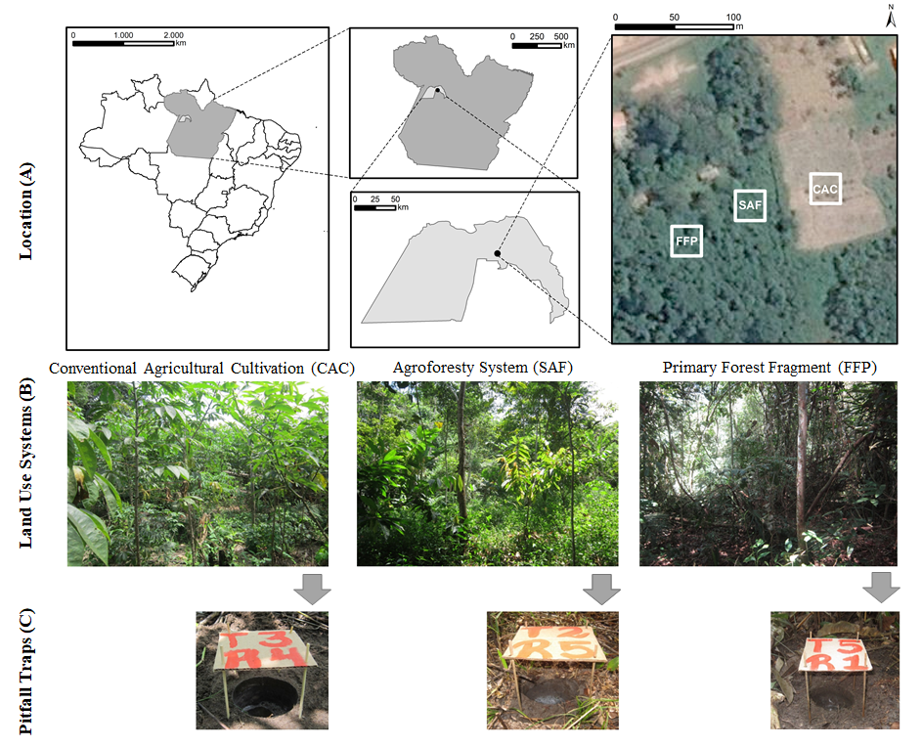
Figure 1: Beetles sampling sites (A) land use systems (B), pitfall traps (C)

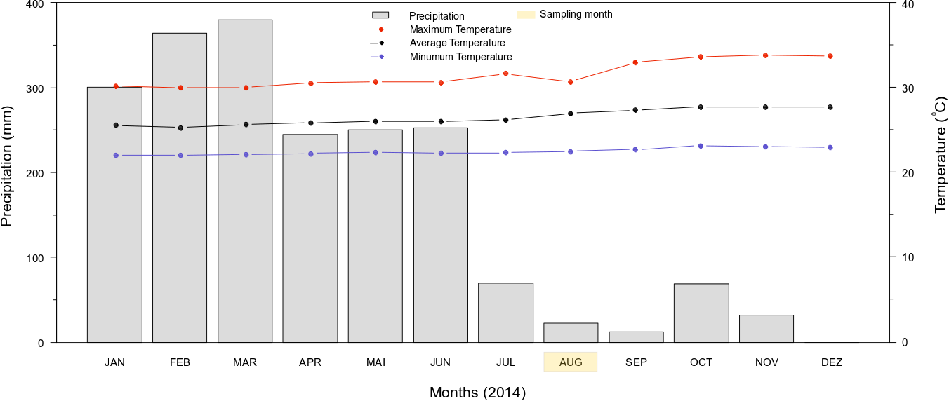
Figure 2: Accumulated precipitation and air temperature (maximum, average, and minimum) for 2014 obtained from a climatological station near the community of Irurama, Eastern Amazon. Source: INMET

Table 1: Trophic guild, abundance, relative abundance (%), and cumulative richness of beetles families sampled by pitfall traps in land use systems (CAC: Conventional Agricultural Cultivation; SAF: Agroforestry System; FFP: Primary Forest Fragment) in the Irurama community, Eastern Amazonia

 | Families |  |  | Trophic guild * |  | Land Use Systems |  |  |  |  | Total
 |  |  |  |  |  | CAC | SAF |  | FFP
 |  | Chrysomelidae |  | D ou H |  | 59 (3,51) | 6 (2,36) |  | 3 (0,61) |  | 68 (2,8)
 |  | Curculionidae |  | H |  | 77 (4,59) | 14 (5,49) |  | 16 (3,26) |  | 107 (4,42)
 |  | Elateridae |  | H |  | 23 (1,37) | 1# (0,39) |  | 1# (0,20) |  | 25 (1,03)
 |  | Leiodidae |  | D ou F |  | 62 (3,69) | 7 (2,75) |  | 19 (3,88) |  | 88 (3,63)
 |  |  | Nitidulidae | C, D, F ou H |  | 171 (10,18) |  | 6 (2,36) |  | 4 (0,81) |  | 181 (7,47)
 |  |  | Scarabaeidae | D ou H |  | 989 (58,90) |  | 136 (53,33) |  | 380 (77,40) |  | 1505 (62,06)
 |  |  | Staphylinidae | C, D ou F |  | 249 (14,83) |  | 68 (26,67) |  | 53 (10,80) |  | 370 (15,26)
 | Other beetles ** |  | Anobiidae | H |  | 3 (0,18) |  | 1# (0,39) |  | 0 |  | 4 (0,17)
 |  |  | Anthicidae | C ou H |  | 6 (0,36) |  | 1# (0,39) |  | 1# (0,20) |  | 8 (0,33)
 |  |  | Buprestidae | H |  | 3 (0,18) |  | 0 |  | 0 |  | 3 (0,12)
 |  |  | Cantharidae | C ou H |  | 0 |  | 3 (1,18) |  | 0 |  | 3 (0,12)
 |  |  | Carabidae | C |  | 12 (0,71) |  | 1# (0,39) |  | 2 (0,41) |  | 15 (0,62)
 |  |  | Cerambycidae | H |  | 0 |  | 0 |  | 2 (0,41) |  | 2 (0,08)
 |  |  | Ceratocanthidae | D ou H |  | 0 |  | 2 (0,78) |  | 1# (0,20) |  | 3 (0,12)
 |  |  | Histeridae | C |  | 14 (0,83) |  | 1# (0,39) |  | 6 (1,22) |  | 21 (0,87)
 |  |  | Meloidae | H |  | 0 |  | 1# (0,39) |  | 1# (0,20) |  | 2 (0,08)
 |  |  | Mordellidae | H |  | 0 |  | 1# (0,39) |  | 0 |  | 1 (0,04)
 |  |  | Ochodaeidae | D ou H |  | 0 |  | 1# (0,39) |  | 0 |  | 1 (0,04)
 |  |  | Pitiilidae | H |  | 0 |  | 1# (0,39) |  | 1# (0,20) |  | 2 (0,08)
 |  |  | Tenebrionidae | D ou F |  | 6 (0,36) |  | 4 (1,57) |  | 0 |  | 10 (0,41)
 |  |  | Trogossitidae | C ou F |  | 5 (0,30) |  | 0 |  | 0 |  | 5 (0,21)
 |  |  | Trogridae | D |  | 0 |  | 0 |  | 1# (0,20) |  | 1 (0,04)
 | Total of individuals |  |  |  | - | 1679 | 255 |  | 491 |  | 2425
 | Accumulative richness |  |  |  | - | 14 | 18 |  | 15 |  | 22
*Trophic guild according to Marinoni et al. (2001) classification; C = carnivore; D = detritivore; F = fungivore; H = herbivore
**Families with a relative abundance of less than 1% in all LUS
# Singletons

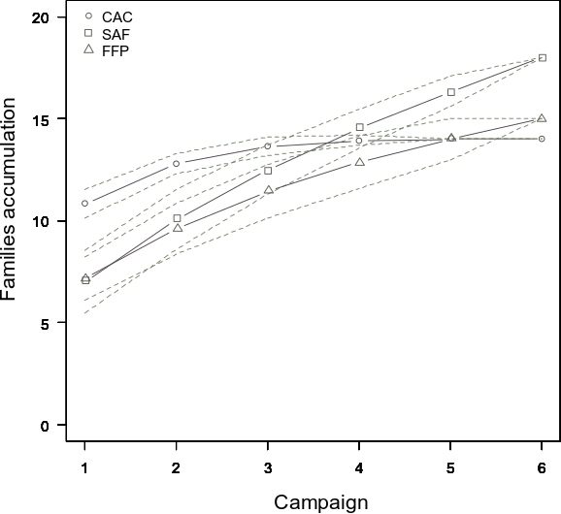
Figure 3: Accumulation curve of beetles families sampled with pitfall traps in land use systems (CAC: Conventional Agricultural Cultivation; SAF: Agroforestry System; FFP: Primary Forest Fragment) in the Irurama community, Eastern Amazonia

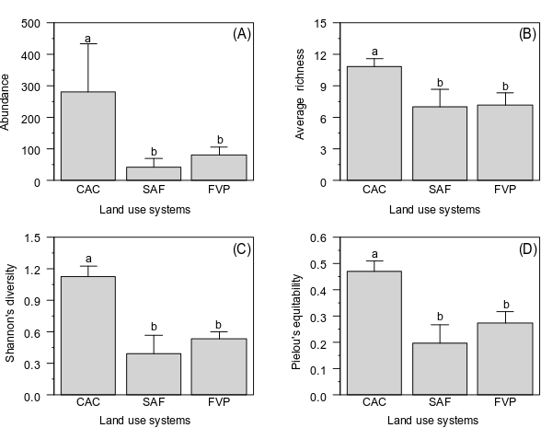
Figure 4: Abundance (A), average richness (B), Shannon’s diversity (C), and Pielou's equitability (D) for beetles families sampled with pitfall traps in land use systems (CAC: Conventional Agricultural Cultivation; SAF: Agroforestry System; FFP: Primary Forest Fragment) in the Irurama community, Eastern Amazon

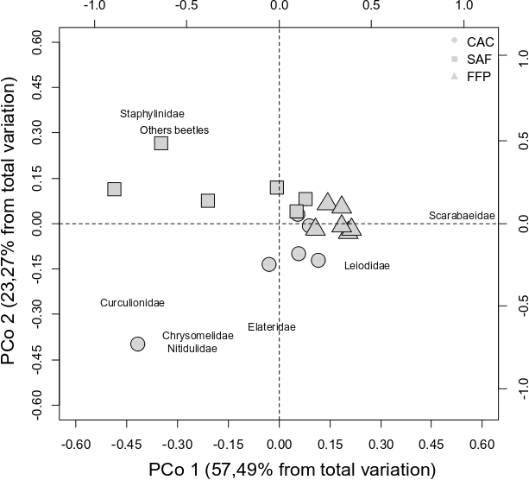
Figure 5: Principal coordinates analysis (PCoA) composed of beetle family assemblages sampled with pitfall traps in land use systems (CAC: Conventional Agricultural Cultivation; SAF: Agroforestry System; FFP: Primary Forest Fragment) in the Irurama community, Eastern Amazon. Other beetles correspond to rare families with a relative abundance of less than 1% in all LUS (see Table 1)

