A Review of Challenges and Solution in the Detection of Disease in the Brinjal Leaves

S. Abisha¹, Frank Stephen²
¹Department of Electronics and communication Engineering, Rohini college of Engineering and Technology, India; s.abishastephen@gmail.com
²Department of Civil Engineering, St.Xavier’s Catholic College of Engineering, Nagercoil, India sfrankstephenen@gmail.com

Abstract: Plant diseases cause crop damage and financial losses. Farmers keep a close eye on their crops in the field at prescribed intervals to spot infections. Computers have been utilized to give computerized recognition and tracking of various diseases in place of manual diagnosis. The disease affected in lesion regions are segmented is the main contribution of this paper. Furthermore, an image fusion technique based on Discrete Shearlet transforms is applied to improve imaging quality while reducing redundancy. The color, texture, and structural elements of the fused images are retrieved and fed into the ANN for classification, resulting in improved performance. While formulating newer editions of testing standards, this study will assist farmers in selecting the best criteria among these four.
Keyword: Recognition, Texture, Structural, Image fusion, Discrete Shearlet Transform.

INTRODUCTION
India is an agricultural country where 70% of population directly or indirectly depends on agriculture. Shrinking of agricultural lands and increase in human population decreasing the yielding varieties and improve modern scientific technologies in a broad manner. In order to improve the crop yield, modern technologies are used broadly and assess the severity of diseases. Plant diseases are caused by pathogens. Theophrastus have mentioned about plant diseases in 350BC. In one of the book of shake sphere, he mentions about wheat mildew disease in the middle ages (5th to 15th century). In early 20th century American Chestnut tree was affected by Asian blight disease.
Identification of diseases is the first step which includes two categories. The first category is the seeing through naked eye and second category is visualizing through image processing. Visualizing and identifying the plant disease in the common method followed in agriculture. By using our naked eye, identification of diseases is insufficient and inefficient for large areas. The use of image processing is better than naked eye observation and it has many efficient techniques to help farmers in monitoring the diseases and improving the crop yield.
This chapter is scheduled as follows: section 3 discusses about the methodology of the disease detection system, section 3.1 explains about the image preprocessing and segmentation method. section 4, image fusion is discussed. In section 5 color, texture and structural based feature descriptors for the generation and complexity of the brinjal plant diseases are discussed. In section 6 image classification such SVM, MSVM, FFNN, and RFNN are used to classify the diseases in brinjal leaves are explained.

1.1 Contribution
This section focuses on the design and improvement of plant identification by recognition and classification.
- The denoising algorithm enhancing the picture details, edge details, and contrast. Segmentation was performed by applying a technique that isolated the affected region of the leaf. The segmented image produced from different segmentation findings is used to perform image fusion.
- The study suggests that numerous factors such as texture, colour, and form be used to extract features.
- Different forms of classification are suggested in the plant recognition using leaf recognition stage. Three well-known classifiers, notably SVM, MSVM, FFNN, and RFNN, are employed.

LITERATURE REVIEW
The diseases in sunflower and oats leaves based on detection method were proposed by [1] Tuker and Chakraborty (1977). This method has good correlation between infected disease area. The K Means clustering and Ostu’s segmentation method is adopted [2], however the images have an extremely low MSE. To extract the contaminated area of the brinjal leaf pictures, Anand et al (2016) used K Means clustering based segmentation. Skaloudova et al (2016) determined the value of threshold based on two stage [3]. In the first step, identifies leaf from the background and the second step is to differentiate from the healthy part. Youwen et al (2008) developed image processing and support vector machine to recognize and differentiate the leaf disease in cucumber leaf [4]. In the first step, vector Median filter was used to remove the noise. In the second step segmentation of the diseased leaf images were obtained based on the statistic pattern recognition and mathematical morphology. Finally, the shape, texture and color were extracted and the diseases were classified based on SVM classified where it produced better results.
Muthukannan et al (2015) applied an algorithm based on clustering segmentation and fuzzy edge for various investigations in plants. Preprocessing procedures like commotion, picture change, diminishment by middle channel, morphological operations were performed before segmentation. Energy, Variation of information, Entropy and evaluation time were evaluated [8]. Aji et al (2013) proposed a linear polynomial method to minimize the processing time in Palm oil leaf foliar diseases, in this method classification of diseases was done based on features extracted using neural network and obtained 87.75% accuracy based on classification process [7]. Threshold method and color analysis was developed by Barbedo et al (2014) to detect the disease symptoms on leaves. The proposed algorithm shows pixel miscalculation error and system robustness with variation in size shape and color [6].
Back Propagation Artificial Neural Network (BPNN) proposed by Orillo et al (2014) to find the rice leaf related to diseases [17]. In this method, the image enhancement, image segmentation and feature extraction are performed. The method consists of image enhancement, segmentation and feature extraction. Bhange et al (2015) identified pomegranate leaf disease by developing a web based tool [9]. First, feature extraction was done and latter, segment the diseased part from the healthy part SVM and K means algorithm. 82 percent accuracy was achieved in this method. Classification of plant diseases based on Genetic algorithm was used to differentiate healthy and infected part of the leaf and this method was proposed by Singh and Misra [10].
Recent studies indicate that machine vision has a greater role in agriculture to explore more and no serious attempts have been made in the past in detecting the severity of the disease in various stages which affects the economy of the farmers as well as the country.

METHODOLOGY
The proposed methodology for the diseases detection and recognition of the collected brinjal plant using image processing technique is shown in the Figure 1.

Segmentation I
HFBi

Median based Fusion rule
Image $A_{2}$

Decomposition (DWT, DTCWT&DST)
Decomposition (DWT, DTCWT&DST)
HFBi

LFBi
LFBi
Median based Fusion rule
Fused wavelet coefficients.
Inverse Transformation 1
Fused image 7
Color
Texture
Structural
Image Classification.

Image Fusion
Preprocessing
Feature Extraction
Image Denoising
Input image
Image $A_{1}$
Segmentation II
Pseudomonas solanacearum 1
Cercosporasolani 1
Alternariamelongenea 1
Tobacco Mosaic Virus 1
Figure 1: Block diagram for diseases detection in brinjal leaves.

3.1 Image processing
Image preprocessing involves different steps. In order to correct the geometric distortions and to eliminate the noise in the input leaf images and to extract any specific information and to

achieve a more reliable representation of the actual key. The collected image for the diseases detection is shown in Figure 2.
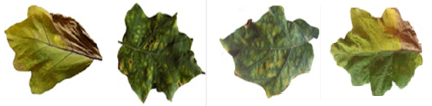
(a) (b) (c) (d)
Figure 2: (a) Pseudomonas solanacearum (b) Cercospora solani (c) Alternaria melongenea (d) Tobacco Mosaic Virus.
Image preprocessing is essential, and it consists of two primary steps: image denoising as well as image segmentation. The initial stage of denoising is to remove unnecessary information and suppress noise in order to obtain the accurate image. Image denoising smoothen the leaf surface by removing high frequency components and blurring the image to obtain low frequency, resulting in a smoothed leaf image. In the first step of segmentation, the leaf is removed from its background (ie, the region of interest), and then the contaminated area of the brinjal leaf is removed for classifying the different ailments in the leaf.

3.1.1 Fuzzy C means segmentation
Fuzzy clustering algorithm introduced by James et al 1974 is one of the most important techniques. While diminishing a membership function, a range of data points is partitioned using the FCM algorithm. Assume that, $X=\{x_{1},x_{2}…x_{m}\}$represents the set of diseased leaves, and $n$ is the total number of sample points. Let $μ_{mn}$be the degree of membership in the n class that satisfy the condition mentioned below
$$\sum_{a=1}^{m}{μ_{ab}}=1 (1)$$
The fuzzy C Means is focused on iterative minimization of the below-mentioned objective function.
$$O\left(M,C\right)=\sum_{a=1}^{c}{\sum_{b=1}^{m}{μ_{ab}^{l}{\left|x_{b}-C_{a}\right|}^{2}}} (2)$$
$x_{1},x_{2}…x_{m}$ is a vector for infected samples. Let C={ $C_{1},C_{2}…C_{a}\}$ be the cluster center and $U=\left\{μ_{ab}\right\}$be M*N matrix where$μ_{mn}$ is the m^{th} membership value of the n^{th} leaf collected is taken as a sample$x_{b}$. The following constraints apply to function membership.
$0≤μ_{ab}≤1 a=1,2,…c; n=1,2,….m (3)$
For the estimate of the cluster center, all leaf samples are taken into account, as well as the samples was weighted using membership functions. Each leaf sample's membership value for each class is determined by its distance from the relevant cluster center. The steps of the FCM algorithm are as follows.
- The number of clusters to choose from the fuzzifier$0≤l≤∝$, Set up the membership matrix $∪^{0}$ such that $μ_{ab}^{0}=1, a=1,2,…c; b=1,2,….k$ are not equal.
- Cluster center to be calculated.
$${ C}_{m}=\frac{\sum_{b=1}^{m}{n{{(μ}_{ab})}^{l}}}{\sum_{b=1}^{m}{{{(μ}_{ab})}^{l}}} (4)$$
- New membership based on a formula that will be calculated
$$μ_{ab}=\frac{1}{\sum_{p=1}^{c}{{\left(\frac{\left\|x_{b}-c_{a}\right\|}{\left\|x_{b}-c_{p}\right\|}\right)}^{2/{l-1}}}}; a=1,2,…c;$$
$b=1,2,….m \left(5\right)$
- Compare $∪^{n+1}$and $∪^{n}$, if $\left|∪^{n+1}-∪^{n}\right|<∈$go to step 2, otherwise to step 2; where $∈$ is the predetermined number reflecting the lowest permissible change in $∪$.
In the membership function of the FCM method, each leaf sample $x_{n}$ appears only once, and the membership function is clearly decreased if each sample is linked with its closest cluster centre. As a result, $x_{b}$ is assigned to the class ‘a’. Ensuring that $\left\|x_{b}-c_{a}\right\|$ is the smallest when $a=p.$ The cluster center is determined based on the minimize $n$ after the leaf samples is regrouped. The operation can be repeated until the predetermined value can no longer be registered

3.1.2 K Means clustering algorithm
This is an unsupervised clustering strategy that uses large of datasets to relocate items by transferring them from one cluster to the next, starting with the original partitioning (Singh et al 2017). The cluster centers are picked at random, and a distance between the image datasets and the cluster center is calculated from the data points. The centroid value was recalculated by transforming each data point to a cluster with the shortest distance between them.
The steps of a K Means clustering algorithm are as follows.
Step 1: Initialize the $K$ centroid vectors arbitrarily.
Step 2: The dataset is given to the closest centroid vector in every point based on the Euclidean distance and every cluster center formula, which is calculated using equation (6).
$$K\left(d_{o},c_{r}\right)\sqrt{\sum_{k=1}^{n}{{{(d}_{oe}-c_{re})}^{2}}} (6)$$
Where $d_{o}$signifies o^{th} data vector and $c_{r}$ indicates the centroid vector of cluster $r$ and $E$ subscripts for every centroid vector.
Step 3: Using the equation below, the cluster centroid vectors are re-estimated.
$$kD_{r}=\frac{1}{n_{r}}\sum{C_{vr}∈}d_{o} (7)$$
Where $n_{r}$is the number of data vectors in a cluster and $C_{vr}$ represents the centroid vector and $d_{o}$is the subset of data vectors that make up cluster 'v' until a stopping criteria is satisfied. Mean Squared Error could be calculated as follows:
$$MSE=\sum_{I=1}^{A}{{\left\|S_{j}-C_{r}\right\|}^{2} } \left(8\right)$$
where $M$is the number of additional samples gathered from the leaf. A Set of $a$data samples $S=\{s_{1},s_{2},……s_{a}\}$; Cluster centroids is $C=\{c_{1},c_{2},……c_{a}\}$
In randomized partitions, K Means clustering converges to a local optimal solution with some constraints, such as the K Means clustering method operates on the initial centroid vectors generated randomly for every dimension in order to boost accuracy and efficiency.

3.1.3. Expectation Maximization Segmentation
In EM segmentation, parametric distribution is used to represent each region in a Gaussian model. A Gaussian mixture model is a density model with a large number of component distributions. The parameters like mean and covariance matrix are used to determine the Gaussian density for all data points for a 1D vector measurement$X=\left\{x_{1},x_{2},….,x_{j},….,x_{b}\right\}$. In a Gaussian mixture model, equation (9) gives the distribution-based density for the leaf picture.
$$p\left({x_{j}}/θ\right)=\sum_{k=1}^{e}{a_{e}(x_{j}|}φ_{e}) (9)$$
Component should satisfy$a_{e}>0$, where $k$ is the weight of the mixture based on the prior probability.
The value of MAP in E step with respect to the infected part of the image are based on joint density function for initialization using the Bayes rule algorithm, which computes the conditional expectation of the data point within the region to determine a posterior probability.
$p_{ej}^{(d)}=\frac{a_{e}^{\left(d\right)}G(x_{j}|φ_{e}^{\left(d\right)})}{\sum_{e=1}^{k}{a_{e}^{\left(d\right)}G\left(x_{j} | φ_{e}^{\left(d\right)}\right)}} (10)$
The M step are used to maximize the expected value, and the means are determined as:
$$μ_{e}^{(d+1)}=\frac{1}{\sum_{j=1}^{n}{p_{ej}^{(d)}}}\sum_{j}^{n}{p_{ej}^{(d)}x_{j}} (11)$$
Eventhough it performs better segmentation; it has significant disadvantages. It’s shades as well as images won't be distinguishable. To address these flaws, Automatic Spectral-based Lesion Segmentation includes a new restriction called "orientation."

3.1.4. Automatic Spectral based lesion segmentation
Gridding, selecting a pixel mask, and applying ROI are the steps in automatic spectral based lesion segmentation. By tracing an imaginary grid above a single leaf image, gridding divides it into little images. Each grid is splitted and subjected for masking technique. The pixel mask was compared to the neighboring pixels with orientation and intensity threshold. Assume that the pixel mask has an intensity value of $I_{qm}$and the neighboring pixel has an intensity value of $I_{np}$and that the intensity threshold is set to T. The difference in intensity between the pixel mask and the neighboring pixel would be within the range of the threshold. Gradients along the x and y axes are computed to establish the orientation constraint.
Let $G_{a}$the gradient value when applying the gradient in the x axis, and $G_{b}$ be the gradient value in the y axis. Gradient matrix G is given by,
$$G=\frac{1}{1+({G_{a}}^{2}+{G_{b}}^{2})} (12)$$
If a mask and surrounding pixel satisfy both the orientation and intensity restrictions, the lesion area is expanded by incorporating the neighboring pixel into the region. ROI performs the accurate detection of the lesion area the equation,
$$D_{ab}=\frac{\left|A|A∈I\left(a,b\right),A∈B_{s}\right|}{\sqrt{\left|A|A∈I\left(a,b\right)\right|}} (13)$$
A is the location in the leaf image, and $B_{s}$is the collection of boundaries within the leaf image.
1. R, G and B component values are determined using color difference between two colors a and b is
$$∆E=\sqrt{\left({R^{'}}_{1}-{R^{'}}_{r}\right)+\left(G-{G^{'}}_{r}\right)+\left({b^{'}}_{1}-{b^{'}}_{r}\right)} (14)$$
Where $∆R^{'}={R^{'}}_{1}-{R^{'}}_{r} ,$
$$∆G^{'}={G_{1}}^{'}-{G^{'}}_{r}, { ∆b}^{'}={b^{'}}_{1}-{b^{'}}_{r}$$
The RGB color space is defined by three channels of the input image $∆R'$,$∆G'$ and $∆B'$and ${R^{'}}_{r}$, ${G^{'}}_{r}$ and ${B^{'}}_{r}$ are denoted as the RGB color space and $∆R'$represents the difference among green and red. The difference among green and blue is represented by $∆G^{'}.$ and the difference among red and blue is represented by $∆B'$.
2. The binary image ${ I}_{bi}$ is produced by apply the threshold T to the input image ${ I}_{im}$ in the equation (15).
$${ I}_{bi}=\left\{\begin{aligned}1, if I_{im}≤T \\ 0, otherwise \end{aligned}\right. (15)$$
3.The subsequent elements of the segmented image are multiplied with the original image with the binary images as indicated in equation (16)
$${ I}_{{rgb}_{seg}}=I_{bi}⊛I_{im} (16)$$
Where ⊛ is the multiplicative operator, The input picture is $I_{im}$ and the output image is $I_{{rgb}_{seg}}$is the output image. This technique solves the problems for large dataset images with small lesion regions and boundaries.

4. IMAGE FUSION

4.1. Discrete Wavelet transform based fusion
DWT based fusion technique is presented to merge all critical information from segmented images into a single image. This strategy is used to reduce the data as well as to recognize the images that are most suited to machine intelligence perception. The following are the significant steps of DWT-based fusion:
Step 1: $B_{1}$ and $B_{2}$ are the two segmented pictures acquired using Automatic Spectral Lesion. DWT is used to construct these images, yielding complex coefficient sets$D_{1}$ and $D_{2}.$
Step 2: The median values for each decomposition level by 3*3 window for the coefficient sets are determined.
Step 3: The absolute difference between all the coefficients based on the matching median.
$E_{1}=\left|{median}_{1}\right|-\left|D_{1}\right|$ (17)
$E_{2}=\left|{median}_{2}\right|-\left|D_{2}\right|$ (18) Step 4: The absolute differences of coefficients for both segmented images are compared, and the coefficient with the greatest absolute difference is given by.
D$\left(i,j\right)=\left\{\begin{matrix}D_{1 }if \left|E_{1}\right|≥\left|E_{2}\right| \\ D_{2} if otherwise \end{matrix} \right.$ (19)
Step 5: Finally, the fused infected images are created by applying an inverse transform on fused coefficients set.

4.2. Dual Tree Complex Wavelet Transform (DTCWT)
The Dual tree complex wavelet transform is used to boost translation invariance and directionality. The DTCWT is a directional wavelet transform with shift variation. The phase information corresponds to the structural specifics of the imaginary coefficients of DTCWT. Analysis & synthesis filter banks are used to implement the DTCWT as well as its inverse DTCWT. After applying DTCWT, the input leaf pictures are transformed into a set of low frequency coefficient (L) or high frequency coefficient (H) described in the equation.
$\left(L,H\right)=DTCWT\left(B\right) (20)$
The approximation coefficients$M,M_{2}$are fused using the median fusion rule, and detailed coefficients $I_{1},I_{2}$are joined using the median fusion rule to form a single set of coefficients equivalent to fused pictures and determined by the following equation.
$M_{f}=α_{l}\left(L_{1},L_{2}\right) (21)$
$e_{f}=α_{d}\left(I_{1},I_{2}\right) (22)$
Where $α_{l}$ and $α_{e}$ are the fusion rules for low and high frequency coefficients, respectively. $M_{f}$ and $E_{f}$are the merged high and low frequency coefficients displayed in figure 3. The fused coefficient are then converted into a fusion image (A) using inverse DTCWT on $M_{f}$ and $E_{f}$, as defined by the equation 23.
$A=IDTCWT\left(M_{f},E_{f}\right) (23)$
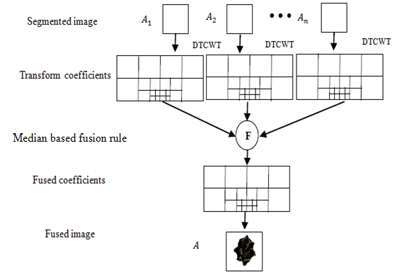
Figure 3: Dual tree complex wavelet transform

4.3 Discrete Shearlet Transform
The shearlets appear to be the most advanced approach for displaying multidimensional data. The shearlet is highly efficient and adheres to the parabolic scaling law. For each penalties scale, the range of directions is doubled. Scaling parameter '$a'$, shearlet parameters,' and translation parameter '$tr$' are all based on shearlet parameters. The element is used to find the best spare approximation.$φ_{a}:a>0, S∈γ, tr∈γ^{2}$. The matrix $M_{a}$can be expressed as
$M_{a}=S_{a}P_{a}$ (24)
Where Shear matrix represent as $S_{a}$ and parabolic scaling matrix is represent as$P_{a}$
${ S}_{x}=\left(\begin{matrix}1 & s \\ 0 & 1\end{matrix}\right)$ (25)
$P_{a}=\left(\begin{matrix}a & 0 \\ 0 & \sqrt{a}\end{matrix}\right)$ (26) Then Shearlet Transform of a function is defined as,
$ST=〈f,φ_{a}〉$ (27)
The multi scale subdivision of the shearlet transform is achieved by using the pyramid transform. Shearlet transform introduces Shift Variance by substituting the convolution process, resulting in the use of Gibbs phenomenon, which provides smoothness along of the edges. Shift invariant filters are employed in the next phase to obtain directional localization. The frequency plane is decomposed into low frequency sub bands and numerous trapezoidal high frequency sub bands. The low frequency sub band would be further subdivided using the pyramid transform. The operation is repeated until the required decomposition level is reached. Figure 4. depicts the Discrete Shearlet Transform's basic structure.
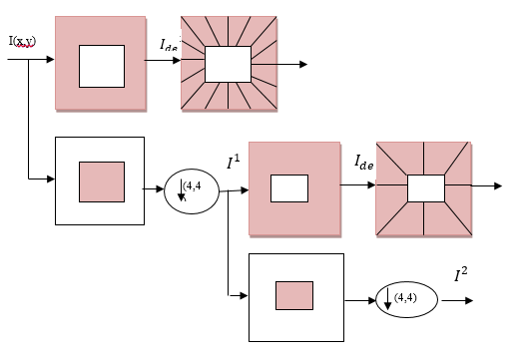
Figure 4: Structure of Discrete Shearlet Transform.
The image decomposition based on Discrete Shearlet based Transform takes place in 2 steps:
- The image is decomposed in several directions using the shear matrix $X_{0}$ or $X_{1}$.
- The multi scale decomposition of each direction of the image is performed via shearlet packets decomposition.
If the image is decomposed either by $X_{0}$ or $X_{1}$the number of directions is expressed as $2(l + 1) 1$. If the image is decomposed both as $X_{0}$ and $X_{1}$, then the number of direction given in $2(l +2) 2$.

FEATURE EXTRACTION
It is done to obtain high level information in order to characterize the picture feature extraction process. Color, shape, and texture are all key aspects of the image. In the identification of illnesses, texture is a crucial trait for detecting the contaminated region of the leaf. It consists of two steps: obtaining the co-occurrence matrix and determining the texture feature using the co-occurrence matrix. It is a two-dimensional matrix ${NX}_{d}$that contains information about the pixel's position as well as a brightness value that is relatively the same.
The matrix ${NX}_{d}$ specifies the relationship among segmented and neighbour pixels at a given moment ${NX}_{d}$. The co-concurrence matrix is built in the following steps.
- The $E(i,j)$ matrix of I (the initial pixel) and j (the matching pixel) located at a distance D is used to count the pair of pixels.
- At the i^{th} row and j^{th} column of the matrix, the estimated count is entered.
The ABCD structural rule is one of the most efficient and reliable approaches used by photo pathologists for identifying and classifying lesion spots. Asymmetry, Border colour, and Diameter are the four primary parameters. Different types of illnesses in brinjal can be recognized using asymmetry of lesion. To determine the asymmetry value, the lesion area is divided along the major and minor axes.
$$Asymmetry index=\frac{N_{1}+N_{2}}{N} (28)$$
Where $N_{1}$and $N_{2}$ are the overlapped regions along the minor and major axis of the lesion respectively and N is the total area of the lesion spot.
The lesion spots are characterized by the presence of various hues such as red, white, light brown, dark brown, green, and yellow. Each hue is given a score of '1' for execution. When all of the colors are represented in the lesion area, the highest score range is '1', and the minimum score is obviously '0.' To confirm the presence of one or more colors in the lesion area of the leaf, the image is transformed from RGB model to CIE Lab color space. This is because, unlike the CIE lab models, the distance between these two colors in the RGB color models does not reflect the true difference as experienced by the naked eye.
The difference in between estimated worth in the equation below is then measured using the Euclidean distance.
$$D=\sqrt{{{(R}_{2}-R_{1})}^{2}+{{(G}_{2}-G_{1})}^{2}+{{(B}_{2}-B_{1})}^{2}} (29)$$
where, $R_{1}$, $G_{1}$ and $B_{1}$indicate the desired color's components in the CIE Lab colour space, and$R_{2}$, $G_{2}$and $B_{2}$represent each pixel in the lesion image.

6. IMAGE CLASSIFICATION

6.1. SVM and MSVM
To train a classifier using radial basis function, polynomial function, probabilistic neural networks, and other functions. SVM is a powerful supervised learning method. It generates input output mapping function from tagged training data. SVM is a pattern recognition algorithm that is commonly used. The key ideas of SVM are to generate a feature vector, then transfer kernel functions into a feature model with the help of a feature vector. Finally, the feature space is used to classify training vectors. In higher-dimensional feature space, the key characteristic of SVM is that it does not require a transformation to locate the separating hyperplane; instead, a kernel function can identify the hyperplane separation. Furthermore, the weighted sum of differs depending on the kernel functions is the answer discovered in support vectors. The kernel functions and essential parameters can be chosen by raising the accuracy rate. SVM classifiers are built in two steps using kernel functions:
Step :1 Divide the input features space into higher dimensional features space using kernel suitable functions. In that feature space the SVM construct the maximal hyperplane margin by radial basis function because of the finite and localized responses across the entire range of real x axis. In terms of precision, kernel functions are defined as,
$k\left(a,b\right)=exp⁡\{\frac{-{\left\|a-b\right\|}^{2}}{2ρ^{2}}\}$ (30)
Step :2 Because of the finite and localized responses throughout the whole range of real x axis, the SVM constructs the maximal hyperplane margin using radial basis function in that feature space
where P is the function's kernel width. When compared to other kernels, the RBF kernel has a low error rate. MSVM is a more advanced form of SVM. It comes in two varieties: one that prevents overall decomposition and another which prevents only one type of decomposition. One against all approach is developed with 'N' SVM models for an N-class diagnosis, which differentiates the samples leaf of all others classes. The kth SVM classifier is trained in this technique using all of the learning methods, with the kth class enhancing good labels in some cases & negative labels in others. To categories the leaf pictures, the Gaussian RBF kernel generates a 'N' hyperplane at the conclusion. As indicated in Figure 6, a single class of approach is separated from other categories of approach hierarchically.
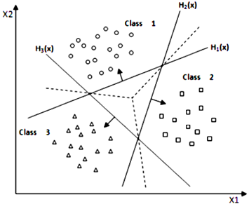
Figure 6: Multiclass Support Vector Machine
The MSVM is trained along with all the training set having positive labels and all those with negative labels based on decision value for each data object. It is constructed a nonlinear decision hyperplane surfaces in an input space by optimizing the kernel function parameters and defining mapping function from the input space.
Fast cross validation is allocated to one class in the OAA method, while the rest classes are assigned to all. In addition, the second class is chosen and assigned to one student, while the remaining classes are assigned to all students, and so on. Finally, the MSVM is employed to distinguish the leaf images. The specified feature values are fed into MSVM to train the classifier. The OAA decomposition approach is used to create the kernel parameter selection using an MSVM classifier. The hyper parameters are modified using 10-fold cross validation estimates for generalisation. There includes a dataset of 500leaf pictures.
The training set receives two-thirds of all leaves extract from all classes, while the testing set receives one-third of all leaf samples across all classes. Take a look at a named training pattern.$\left\{\left(x_{i},y_{i}:i∈I(x,y)\right)\right\}$ where a pattern $x_{i}$ is denoted in N dimensional space and its label attains a value from a set according to
$$Z_{i}=arg\max_{j}{h\left(A_{i}\right)α_{i}+α_{0i}} (31)$$

6.2. Feed Forward Neural Network
A dataset is a collection of illness photos gathered in the field. There are five output classes, including healthy leaf with unknown diseases, as well as low and high severity tasks. The features were captured from the fused images for the detection of various diseases, including 13 texture features, 3 color features, and 4 structure features. The FFNN classifier uses epoch 4500, 20 input neurons, an intermediate hidden layer, and 5 neurons in the output layer to represent five diseases. In the network, the back propagation algorithm was learned. Figure 7, depicts these findings.
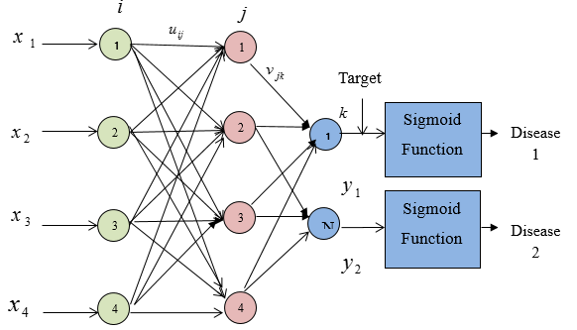
Figure 7: Structure of Feed Forward Neural Network.
When comparing to all other machine learning techniques, the performance of the classifier is raised for the FFNN network. When compared to SVM, FFNN has superior sensitivity, specificity, and precision.

6.3. Radial Basis Function Neural Network
The radial basis function (RBF) has two layers in a neural network: an output linear $n^{2}$ layer of and a hidden layer of $n^{1}$ layer as shown in Figure 8.
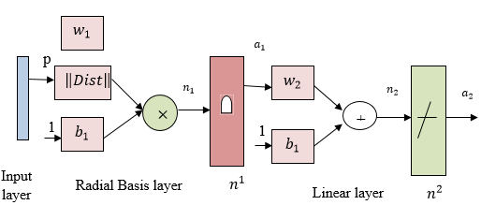
Figure 8: Structure of Radial Basis Function Neural Network.
Whenever the distance measure takes the input set of weights $w_{1}$ and an input vectors $p,$ the result is a vector with $n^{1}$ entries.These elements are all distances between vector ${1×w}_{1}$which is created from the input weight matrix's rows. The bias of$b_{1}$ is used to perform element-by-element multiplication, and the output is combined using the multiplication operation. Through the output$a_{2}$. Each neuron in the radial basis neural layers have an output value that is near to the input vector. The output of the radial basis neural using weight vector differs from the input vector in that it is close to 0. The linear output neural using linear transform function produces a minor effect in the tiny output, however the radial basis neuron having weight vector is close to the input value p provides a value close to 1. It's being used to adjust the weight as well as biases during the startup procedure.
Step 1: Random weights are set up for the first time.
Step 2: Initialize the momentum factor as well as learning rate parameter with random values.
Step 3: If the requirement is not satisfied, repeat steps 32-46.
Step 4: Repeat steps 5–10 for the samples training dataset vector pair.
Step 5: These input features $i_{a}$which is provided as the hidden layer, are received by each input layer.
Step 6:The hidden layer units $z_{b},b=1,2,…p$ are used to sum up the weighted input features.
$${ z}_{-inb}=v_{ob}+\sum_{a=1}^{n}{i_{a}v_{ab} (32)}$$
The Gaussian activation method is designed to the net input features derived using the equation
$z_{b}=f(z_{inb})$ (33)
$$f\left(z_{inb}\right)=e^{{z_{-inb}}^{2}}$$
and these features are sent to every units in the layer beneath, i.e. output units.S
Step 7: Calculate the net input for each output unit $\left(j_{v}, v=1,2…m\right),$using:
$$j_{-inc}=w_{ov}+\sum_{y=1}^{p}{z_{a}w_{bv}} (34)$$
and calculate the output value using Gaussian activation function on the net input layer:
$j_{c}=f(j_{inc})$ i.e, $f\left(j_{inc}\right)=e^{{j_{-inc}}^{2}} (35)$
Step 8: Each output unit $(j_{c}, c=1,2…m)$then receives the target sample equivalent to an input sample inaccuracy (between output and concealed) that is determined using the equation,
${δ_{c}=(t_{c}-j_{c})f}_{-inc}^{'} (36)$
Step 9: Every hidden unit $(z_{y}, y=1,2…n)$ adds the delta input feature values from units inside the layer above to get delta input feature value:
$δ_{-inb}=\sum_{c=1}^{m}{δ_{b}w_{bc}} (37)$
The error between the hidden and input layers is calculated as follows:
${δ_{b}=δ_{-inb}f}_{-inb}^{'} (38)$
Step 10: Determine the adjusted weight in between output unit and the concealed unit, as follows:
${∆w}_{bc}=αδ_{c}z_{b}+μ{∆w}_{bc}\left(old\right) (39)$
This bias term is then updated and provided by,
${∆w}_{oc}=αδ_{c}+μ{∆w}_{oc}\left(old\right) (40)$
Step 11: Calculate the revised weight between both the hidden and input units as follows:
$${∆v}_{ab}=αδ_{b}i_{a}+μ{∆v}_{ab}\left(old\right) (41)$$
In addition, the bias term has been revised and is provided by,
${∆v}_{ob}=αδ_{j}+μ{∆v}_{ob}\left(old\right) (42)$
Step 12: Every output unit $(j_{v}, v=1,2…m)$ adjusts its bias & weights $y=1,2…p)$ and are given by,
$$w_{bc}\left(new\right)=w_{bc}\left(old\right)+{∆w}_{bc}(43)$$
$$w_{oc}\left(new\right)=w_{oc}\left(old\right)+{∆w}_{oc}(44)$$
Step 13: Each hidden unit $(z_{b}, b=1,2…n)$updates its bias as well as weights $a=1,2…n$ which are determined by,
$$v_{ab}\left(new\right)=v_{ab}+∆v_{ab} (45)$$
$v_{ob}\left(new\right)=v_{ob}\left(old\right)+∆v_{ob}(46)$
Step 14: When the algorithmic process reaches an iteration with the lowest MSE value, it should be stopped.

RESULTS
Images of brinjal leaflets from various locations were collected and utilized as datasets in this investigation. The diseased and healthy leaves were gathered from Nagercoil, Valliyoor, and Panakudi in southern TamilNadu, and Hosur in northern TamilNadu, and from Kerala State (Neyathinkara) in India. Pseudomonas solanacearum (250), Cercospora solani (220), Alterneria melongenea (230), Tobacco Mosaic Virus (200), and healthy Brinjal leaves were collected (500). Figure 9 depicts the sample leaves.
(a) (b) (c) (d)
Figure 9: (a) Pseudomonas solanacearum (b) Cercospora solani (c) Alternaria melongenea (d) Tobacco Mosaic Virus
The image is resized to 256*256 resolution to reduce computing time as well as processing speed as in images. The scaled image is further denoised by using a variety of filters. The Mean Square Error as well as Peak Signal to Noise Ratio were used to assess the quality of the noise-free photos as shown in Figure 10 and 11.
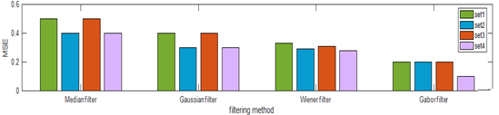Figure 10: Mean Square Error
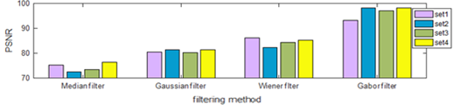
Figure 11: Peak Signal to Noise Ratio
The MSE appears to be more responsive to the Gabor filter than the Wiener filter. Furthermore, when compared to the Gaussian filter, Median filter, and Weiner filter, the Gabor filter has enhanced by smoothing as well as removing the blurring effect. By evaluating MSE as well as PSNR for four different filter method for all five types of illnesses. The Gabor filter's PSNR value is larger than that of the PSNR of the Gaussian, Median, and Weiner filters. When the MSE is modest, the Gabor filter produces a high PSNR value. It provides a higher-quality image. As demonstrated in Figure 12, FCM segmentation is carried out for all types of disorders.
Figure 12: FCM based segmentation
This model (FCM) is only suitable for bimodal intensity distributions, however it is simple and quick to implement. The brinjal leaves are clustered using the K means method, and the segmentation results are shown in figure 13.
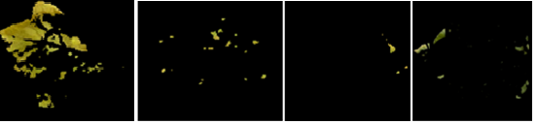
Figure 13: K means Clustering based segmentation.
By overcoming FCM segmentation, the above method eliminates the noisy spot and also ignores some noise sensitivity deficiencies, but the drawback is that the initial value for the cluster type must be chosen. The infected brinjal leaf is segmented using Expectation and Maximization, as shown in figure 14.
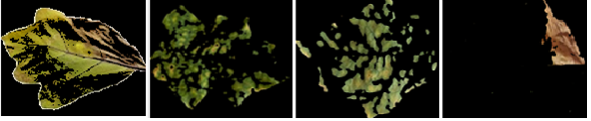
Figure 14: Expectation Maximization based segmentation
Inside the lesion area, along with the noisy pixels, this approach delivers good segmentation results. However, the main disadvantage of this procedure is that the contour area of the infected part of the region deteriorates. As demonstrated in Figure 15, Automated Spectral Lesion based segmentation was done to an infected brinjal leaf.
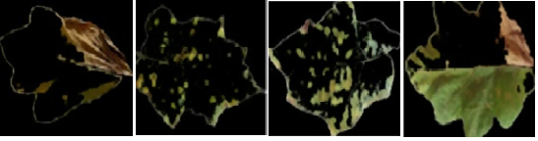
Figure 15: Automatic Spectral lesion based segmentation
Even by segmenting in noisy areas, this model outperforms all known approaches. Furthermore, it allows for greater freedom in identifying the diseased portions of the leaf by generating clear cut boundary detection, resulting in precise segmentation results while reducing computation time. The accuracy of the various segmentation results is provided in Table 1 below.
Table 1. Accuracy measures for the segmented results

Segmentation methods | Accuracy
 | Pseudomonas solanacearum | Cercospora solani | Alterneria melongenea | Tobacco Mosaic virus
FCM | 79.13 | 84.26 | 86.36 | 87.43
K-means | 89.78 | 87.45 | 85.18 | 87.74
EM | 97.54 | 94.89 | 95.67 | 95.86
ASL | 99.79 | 98.46 | 98.78 | 99.89

When compared to the other segmentation results, Automatic Spectral Lesion Based Segmentation produced 99.89 percent. By integrating Expectation Maximization segmentation with Automatic Spectral Lesion Based segmentation, an image fusion technique is used to obtain more information. Figure 16. depicts picture fusion using the discrete wavelet transform.
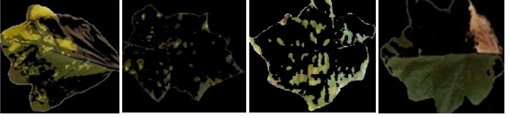
Figure 16: Discrete Wavelet Transform based image fusion
The method based on the discrete wavelet transform achieved increased accuracy by using spectral and spatial information, even in images with higher contrast. Figure 17, depicts image fusion using the Dual Tree Complex Wavelet Transform.
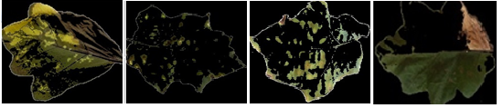
Figure 17: Dual Tree Complex Wavelet Transform based image fusion
When compared to the previous fusion findings, the Dual tree complex wavelet technique produced better results in noisy distortion while preserving all of the information in the brinjal leaf. Figure 18. depicts picture fusion using the Discrete Shearlet Transform.
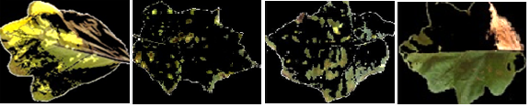
Figure 18: Discrete Shearlet Transform based image fusion
Even in the presence of artifacts and fuzzy regions, Discrete Shearlet transform-based image fusion reveals detail information, as well as a higher grey level and sharper image. The texture characteristic from the fused image is shown in Table 2.

Tables 2. Texture Feature

Features | Pseudomonas solanacearum | Cercospora solani | Alterneria melongenea | Tobacco Mosaic virus
Mean | 121.35 | 143.43 | 153.75 | 145.16
SD | 118.41 | 134.14 | 147.32 | 135.74
Entropy | 4.67 | 13.13 | 3.65 | 4.33
RMS | 12.36 | 3.75 | 13.66 | 13.75
Variance | 9265 | 9686 | 11674 | 9433
Smoothness | 1.01 | 1 | 1 | 1
Kurtosis | 2.16 | 2.57 | 3.02 | 2.57
Skewness | 0.25 | 0.032 | 0.007 | -0.053
IDM | 255 | 255 | 255 | 255
Contrast | 0. 723 | 0.482 | 0.468 | 0.465
Correlation | 0.9837 | 0.9784 | 0.9799 | 0.9962
Energy | 0.449 | 0.4567 | 0.4723 | 0.4355
Homogeneity | 0.9534 | 0.9724 | 0.9725 | 0.9892

Contrast features produce a low value for the leaf in Pseudomonas solanacearum disease and a value larger than '1' for the remaining diseases, as shown in Table 1. The correlation shows that leaf photos with Cercospora solani have a low energy value, whereas leaf images with Alterneria melongenea illness have a greater energy value. In terms of entropy, homogeneity yields a low value for leaf images in Alterneria melongenea and a larger value for leaf images with Tobacco Mosaic Virus. The colour features are then used to extract colour features such as colour moment and colour histogram descriptors. Table 3. shows how color-based features are extracted with and without the use of fusion techniques.
Table 3. Color features for DST

Diseases | Histogram | Mean | Standard Deviation | Skewness
Pseudomonas solanacearum | 0.065 | 126.34 | 68.23 | -1.34
Cercospora solani | 0.287 | 136.34 | 66.34 | -1.18
Alterneria melongenea | 0.465 | 143.23 | 65.24 | -0.92
Tobacco Mosaic virus | 0.363 | 136.23 | 68.34 | -0.64

Table 4. Structural features for DST

Diseases | Asymmetry | Border Irregularity | Color | Diameter
Pseudomonas solanacearum | 4.25 | 0.19 | 1.76 | 5.78
Cercospora solani | 2.78 | 0.32 | 1.67 | 3.56
Alterneria melongenea | 2.45 | 0.16 | 1.89 | 7.67
Pythium aphanidermatum | 7.23 | 0.26 | 2.67 | 4.35
Tobacco Mosaic virus | 3.67 | 0.65 | 2.89 | 3.45

When compared to DWT, it is obvious that DST-based fusion algorithms produce better outcomes in improving both spectral and spatial information in all circumstances. For recognizing the sorts of diseases, the difference between the severity levels for the brinjal leaf may be readily recognized. When compared to the individual feature dataset, the feature vector contains composite features such as structural, color, and textural elements to improve classification accuracy. The classifier receives these combined features in order to detect diseases automatically is shown Figure 19.
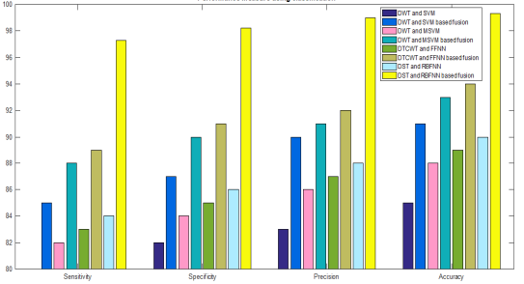
Figure 19: Performance analysis of classifier with image fusion
When compared to other classification methods, the accuracy required for the DST based fusion approach and the Radial Basis Function Neural Network is relatively high. The classification accuracy was 99.35 percent, with 89.24 percent sensitivity, 94.67 percent specificity, and 90.12 percent precision. The agricultural department evaluates the results as well. Except for Tobacco Mosaic Virus, all of the diseases' results are valid, however the textural feature, particularly skewness, shows a lot of diversity across the board. The characteristics for the same collection of diseases are nearly matched for all other parameters such as mean, standard deviation, kurtosis, IDM, energy, contrast, entropy, RMS, variance, smoothness, correlation, energy, and homogeneity.

CONCLUSION
The DST-based feature extraction methods given in this paper overcome the shortcomings of the Discrete Wavelet Transform and the Discrete Dual Tree Wavelet Transform, making them more effective, practicable, and efficient. Color, texture, and structure-based characteristics characterize leaf images from three different perspectives, based on an effective combination of the three cues in terms of discriminative image descriptors. The disease in the leaf, on the other hand, is homogeneous in color and texture but heterogeneous in structure, which is accentuated by the lesion site. A successful combination of all distinct traits, in particular, produces and improves the classification rate. The experimental result also shows that the DST and the Radial Basis Function Neural Network perform well together.

REFERENCE
Journals
- C. C. Tucker, and S. Chakraborty, “Quantitative assessment of lesion characteristics and disease severity using digital image processing, Journal of Phytopathology, vol. 145, no. 7, pp. 273-278, 1997.
- W. Zhang, and G. Teng, C. Wang, “Identification of jujube trees diseases using neural Network,” International Journal for Light and Electron Optics, vol. 124, no. 11, pp. 1034-1037, June 2013.
- Skaloudova, B, Krvan, V & Zemek, R 2006, „Computer-assisted estimation of leaf damage caused by spider mites‟, Computer and Electron Agriculture, vo. 53, no. 2, pp. 81-91.
- T. Youwen, L. Tianlai, and N. Yan, “The recognition of cucumber disease based on image processing and support vector machine,” In Congress on Image and Signal Processing, vol. 2, pp. 262–267, 2008.
- A. Camargo, and J. S. Smith, “Image pattern classification for the identification of disease causing agents in plants,” Computers and Electronics in Agriculture, vol. 66, issue 2, pp. 121–125, 2009.
- J. C. A. Barbedo, “Digital image processing techniques for detecting, quantifying and classifying plant diseases,” Springer Plus, vol. 2 no. 660, pp. 1-12, 2013.
- A. F. Aji, Q. Munajat, A. P. Pratama, H. Kalamullah, Aprinaldi, J. Setiyawan, and A. M. Arymurthy, “Detection of palm oil leaf disease with image processing and neural network classification on mobile device,” International Journal of Computer Theory and Engineering, vol. 5, no. 3, pp. 529-532, 2013.
- K. Muthukannan, P. Latha, R. Pon Selvi and P. Nisha, “Classification of diseased plant leaves using neural network algorithms,” ARPN Journal of Engineering and Applied Sciences, vol. 10, no. 4, pp. 1913-1919, 2015.
- Zhaoyi Chen, Ruhui Wu, Yiyan Lin, Chuyu Li, Siyu Chen, Zhineng Yuan, Shiwei Chen, and Xiangjun Zou. “Plant Disease Recognition Model Based on Improved YOLOv5”, agronomy. 365: 1-14, 2022.
- V. Singh, and A. K. Misra, “Detection of plant leaf diseases using image segmentation and soft computing techniques,” Information Processing in Agriculture, vol. 4, no. 1, pp. 41-49, 2017.
- W. C. James, “Assessment of plant disease and losses,” Annual Review of Phytopathology, vol. 12, no. 1, pp. 27–48, 1974.
- R. V. R. Chary, D. R. Lakshmi, and K. V. N. Sunitha, “Feature extraction methods for color image similarity,” Advanced Computing: An International Journal, vol. 3, no. 2, pp. 147-157, 2012.

