Original Research Article
Meat Productivity of Black-and-White Heifers’ Over-Replacement when They are Fed Haylage with the Biological Preservative “Biotrof”
Running title: Meat productivity of heifers’ when they are fed haylage with “Biotrof”

Dim Fakhreev^{1*}, Ilnur Vagapov², Natalia Gizatova², Khamit Tagirov², Irina Mironova³, Liliya Zubairova²
¹Department of Life Safety and Technological Equipment, Federal State Budgetary Educational Establishment of Higher Education “Bashkir State Agrarian University”, 50-letia Octyabrya str., 34, Ufa, 450001, Russian Federation
²Department of Technologies of Meat, Dairy Products and Chemistry, Federal State Budgetary Educational Establishment of Higher Education “Bashkir State Agrarian University”, 50-letia Octyabrya str., 34, Ufa, 450001, Russian Federation
³Department of Special Chemical Engineering, Federal State Budgetary Educational Establishment of Higher Education “Ufa State Petroleum Technological University”, Pervomaiskaya str., 14, Ufa, 450000, Russian Federation
*Corresponding author: Federal State Budgetary Educational Establishment of Higher Education “Bashkir State Agrarian University”, 50-letia Octyabrya str., 34, Ufa, 450001, Russian Federation; e-mail: dim_fakhreev@rambler.ru, +7 9177850329

Novelty statement
- Over-replacement heifers are animals used for rearing and fattening;
- The black-and-white breed of cattle is a Soviet breed of dairy productivity;
- The meat of heifers of the control group was distinguished by a darker colour.
Abstract
The purpose of the work is to establish the optimal dose of preservative application when harvesting alfalfa hay and to assess the effect of its feeding on the beef production of over-replacement black-and-white heifers. The animals of the experimental groups (II - IV) consumed, in addition to the main diet, alfalfa haylage with the preservative “Biotrof” 2 l/t, 4 l/t and 6 l/t, respectively. To study the growth of experimental animals in the morning hours before feeding, a monthly weighing was carried out, followed by the calculation of the average daily and absolute weight gain. The relative growth rate and the coefficient of increase in body weight with age were determined by the calculation method. To determine the qualitative characteristics of the meat, the chemical composition of the selected medium samples of the longest back muscle was studied. Based on the data obtained, the best results were obtained in animals of the II experimental group, which were warming the haylage canned by “Biotrof” at a dose of 4 l/t. According to the research, the use of “Biotrof” in the preparation of feed has a positive effect on the beef production of experimental animals.
Keywords: live weight; weight gain; chemical composition; heifers’ over-replacement; black-and-white breed

Introduction
At the present stage, one of the most important and difficult tasks facing the agro-industrial complex of Russia is the production of high-quality beef - a valuable food product. In our opinion, this problem can be solved through the introduction of advanced technologies in alfalfa haylage-making, the organization of a nutritious diet and the creation of optimal conditions for keeping animals. In this regard, the search for progressive feeding technologies based on the latest scientific achievements, providing for the preservation of the quality and quantity of feed, is relevant and has a great national economic significance (Andreeva et al., 2018; Blagov et al., 2020; Gabitov et al., 2018a).
In the system of acts aimed at improving the efficiency of beef production, the due place is given to improving the technology of foraging of own production and their rational use. The creation of an optimal ratio of nutrients in the diet of heifers’ over-replacement in the beef production due to a harvested feed using various dosages of the “Biotrof” biological product contributes to increasing the productivity of animals (Gadiev et al., 2019; Aipov et al., 2018). The preservative of biological origin “Biotrof” is presented in the form of a suspension from Bacillus subtilis, with a content in 1 ml of this suspension of at least 1 * 108 colonies of forming units or CFU. The effect of the studied agent is aimed at the effective suppression of undesirable microflora in the preserved mass due to the high antagonistic activity of bacteria. At the same time, the canning process proceeds much faster. The enzymes of propionic acid bacteria (B. subtilis) of the agent affect the sugars and vegetable protein of the feed, peptonizing it, making it more accessible to animals. Due to its composition, the studied biological preservative is able to ferment any herbage, including hard - ensilaging. There are no restrictions on the use of the studied agent.
Beef production is the quantity and quality of meat obtained from an animal. The age of animals, the intensity of their breeding and the condition of their flesh have a great influence on beef production. The organization of a livestock nutritious diet by creating a solid feed base and improving the quality of feed harvested for the future are the main conditions for increasing the production of livestock products and reducing its cost (Safonov et al., 2021; Ventsova and Safonov, 2021). In nutritional value and quality, the harvested feed does not meet the requirements of a livestock nutritious diet. In most regions of Russia, animal husbandry is experiencing a shortage in protein, especially in the winter-stall feeding period, which is the reason for the overspending of feed resources (Khasanov et al., 2020). It is possible to solve the problem of increasing the production of vegetable feed protein by cultivating legumes. They have high energy and nutritional value and contain 16% of protein or even more. Except for protein, legumes and feed from them contain carbohydrates, fats, minerals, and many vitamins. Along with the question of the cultivation of high-protein crops, the item of feed preserving methods with the use of new, more effective preservatives, characterized by cheapness, harmlessness in handling and technological application, is of great importance (Gabdrakhimov et al., 2018; Okuskhanova et al., 2019; Sydykova et al., 2019). Special attention in solving this issue is paid to preservatives of green feeds that can simultaneously enrich the feed with certain substances and increase their nutritional value. In recent years, to preserve the feed advantages of the feedstock during silage, such preservatives are widely used, which can reduce the loss of nutrients by 3 to 5 times (Smolnikova et al., 2019).
The process of preserving plants is aimed at the destruction or partial suppression of bacteria on the silage mass (Mukhametov et al., 2021, 2022). In this regard, we propose to use the additive “Biotrof” as a preservative when harvesting alfalfa haylage. The choice of alfalfa as the main raw material for haylage harvesting is explained by the fact that this leguminous herbaceous plant is represented by wide species composition, a significant growth area, is characterized by a high ability to regrow after mowing and the ability to produce up to four mowings during the summer season (Chernenkova et al., 2019; Konashova et al., 2018; Sultanova et al., 2018).
Thus, taking into account the importance and technological effectiveness of the use of biological preservatives in the preparation of bulky feed, studies in using a new conservative in the alfalfa haymaking, feeding it to black-and-white heifers’ over-replacement and analyzing its impact on growth and development, slaughter indicators and beef quality are relevant and of certain scientific and practical interest (Chernoivanov et al., 2019; Gizatov et al., 2020).
The black-and-white breed of cattle is a Soviet breed of dairy productivity. Animals of this breed are very popular both among private small farms and large ones.
Over-replacement heifers are animals from among the replacements, used for rearing and fattening, that is, for obtaining meat products.
The purpose of our research was to establish the optimal dose of applying starter culture to “Biotrof” when harvesting alfalfa haylage and to evaluate the effect of its feeding on the beef production of over-replacement black-and-white heifers. According to the set goal, the following tasks were solved: to determine the growth dynamics of heifers against the background of the introduction of canned hay into the diet and assess the beef production and quality.

Materials and methods
The practical part of the research work on the study of the effect of feed additives was made based on the collective farm “Geroy”. This enterprise is located in the Chekmagushevsky district of the Republic of Bashkortostan.
The preparatory stage of the work consisted of alfalfa haylage making, which was laid in four trenches. The first one contained food without preservatives, the others with the use of “Biotrof” in different doses (Khasanov et al., 2020; Yarullin et al., 2018).
Before the start of the research, different age black-and-white heifers’ over-replacement were selected, identical taking into account the live weight. From the total number of selected animals, 4 groups of 10 heads each were formed. The age of the heifers was six months. Of the formed groups, one was the control group (I). The diet was traditional for this farm. The animals included in the experimental groups (II-IV) consumed the main diet, including alfalfa haylage with the preservative “Biotrof” 2 l/ t, 4 l/t and 6 l/t, respectively.
An additive of biological genesis called “Biotrof” is a suspension of propionic acid bacteria (Bacillus subtilis) (more than 1*108 CFU in 1 ml). The introduction of this agent helps to reduce the amount of putrefactive microflora, mould fungi, yeast. The effect of this preservative is based on a significant antagonistic activity of bacteria (Danyliv et al., 2018). The enzymes contained in the “Biotrof” have a direct effect on the sugars and vegetable protein of the feed, splitting it, lead to accessibility for animals. Its use in haylage making contributes to the preservation of vitamins A and C, vegetable proteins, the process of synthesis of natural organic compounds by microorganisms proceeds and, as a result, the preservation of dry matter and increased digestibility. Taking into account these processes, we can talk about improving the quality of the silage composition and reducing feed waste in the upper layers (Gabitov et al., 2018b; Polyanskikh et al., 2016).
The conditions of keeping the animals involved in the experiment were the same. The diets for experimental animals were developed according to detailed feeding standards. The degree of feed consumption was determined monthly during two adjacent days (Gabitov et al., 2019).
To study the growth of experimental animals in the morning hours before feeding, a monthly weighing was performed, followed by the calculation of the average daily and absolute increase in live weight. The relative growth rate and the coefficient of increase in live weight with advancing age were determined by the calculation method (Masalimov et al., 2018).
To study beef production, a controlled slaughter of three animals from each group at the age of 18 months was carried out according to the method of Lenin All-Union Academy of Agricultural Sciences, Voenizdat, Federal Scientific Centre of Food Systems after V.M. Gorbatov (1977). The slaughtering and deboning were carried out according to State Standard 31797-2012 “Meat. Beef cutting. Technical conditions” (Martynov et al., 2018).
The chemical composition of meat was studied based on the selection of average samples of the longest back muscle according to the methodological instructions of the Russian Research Institute for Metrological Service (VNIIMS) (1984). In the average samples of the shoulder meat, the chemical composition was determined following State Standard 33319-2015 “Meat and meat products. Method for determining moisture content”, State Standard 23042-2015 “Meat and meat products. Methods for determining fat “State Standard 31727-2012 (ISO 936:1998)” Meat and meat products. Method for determining the mass fraction of total ash”. When studying the functional and technological properties of the shoulder meat, generally accepted methods were used: pH by the potentiometric method using the Piccolo – 2 pH meter manufactured by HANNA(Germany); moisture-retaining ability-according to Grau – Hamm. The energy value of the longest muscle was determined according to the provisions of the Lenin All-Union Academy of Agricultural Sciences method (1983). The amino acid composition of the protein of the back muscle tissue was determined using a capillary electrophoresis system (“Drops 105/105 M” analyzer) (Kanareikina et al., 2019).
Biometric processing of the obtained data was carried out according to the methodological guidelines for the design of measurement results using the Microsoft Excel operating system. The reliability of the difference was assumed at the threshold of reliance B1 = 0.95 (significance level P < 0.05) (Ivanov et al., 2018; Sultanova et al., 2019).
The research was conducted ethically in accordance with the the National Centre for the Replacement, Refinement and Reduction of Animals in Research (NC3Rs) humane endpoints in animal experimentationand conformed to the provisions of the Declaration of Helsinki. The authors declare that the work is written with due consideration of ethical standards. The study was conducted in accordance with the ethical principles approved by the Ethics Committee of Bashkir State Agrarian University.

Results and discussion
Analyzing the obtained weighing data, the normal growth and development of animals in all the studied periods is noted. When setting up heifers’ over-replacement for the experiment, the live weight of animals of all groups was almost at the same level, and it was in the range of 160.7-161.8 kg (Fig. 1).
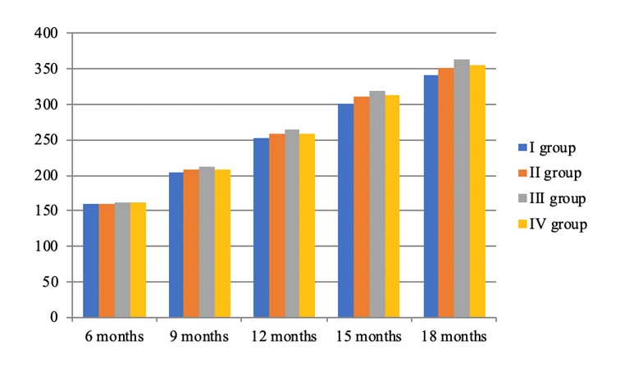
Fig. 1: Change in the livZe weight of heifers, kg

Based on the obtained data of the dynamics of live weight, it is possible to talk about certain group differences in live weight, starting from the age of 9 months. Thus, the heifers of the control group were inferior to the heifers of group II in the value of the studied indicator by 3.8 kg (1.83%; P<0.05), group III – by 6.4 kg (3.12%; P<0.05) and group IV – by 4.2 kg (2.05%). When analyzing the intergroup differences in the studied indicator, the animals of the III group begin to acquire leadership. Thus, their advantage over their herd mates of groups II and IV was 2.6 kg (1.23%) and (1.04%), respectively. It is explained by the fact that with a short period of alfalfa haylage with different dosages of “Biotrof” preservative, there was not enough influence on the course of metabolic processes in the heifer's body of different experienced groups.
By the age of one year, according to the studied indicator, the advantage remained with the animals of group III. Their superiority over the herd mates of groups II and IV was 5.8 kg (2.20%) and 4.4 kg (1.67%).
In the following age periods, the rank of the distribution of heifers by live weight was preserved.
So, at 15 months, the advantage of heifers of groups II-IV over herd mates of group I was 9.3-18.4 kg (3.09-6.11%; P<0.01), at 18 months - 10.4 kg (3.05%; P<0.01), 21.2 kg (6.21%; P<0.001), 13.8 kg (4.04%; P<0.01). The leading position was occupied by heifers of the III group.
Similar data were obtained in the work of Pozdnyakova E.V. (2019) when organizing intensive rearing of black-and-white bulls on diets with hayloft, canned “Biotrof” contributed to the manifestation of their bioresource potential and ensured that the animals reached a live weight of 515.2 kg; 523.0 kg and 520.4 kg by the age of 18 months. The value of the studied indicator among animals of the control group was 499.7 kg (Gubaidullin et al., 2019).
Using the obtained data on the dynamics of the live weight of heifers, the use of alfalfa haylage harvested with the use of the “Biotrof” preservative had a positive effect on its value. It is characteristic that the effect of the minimum dose of the working solution (2 l/t) and the maximum (6 l/t) on the live weight indicators is almost identical. At the same time, it was found that the optimal dose of the working solution of the “Biotrof” preservative is 4 l/t of the preserved weight.
The established intergroup differences in live weight are due to the unequal value of the absolute growth rate. The analysis of the obtained data indicates particular inter-group differences in the value of the studied indicator in certain growing periods (Fig. 2).
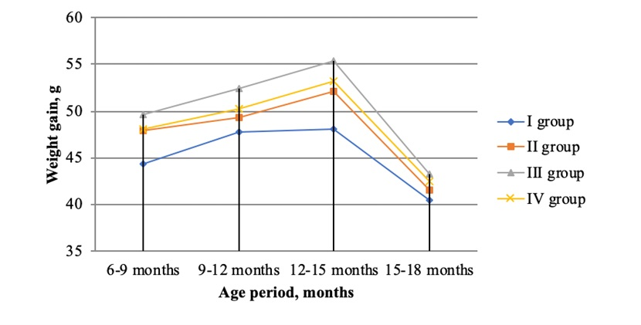
Fig. 2: Absolute weight gain of heifers, g

It was found that in the first stage of rearing from 6 to 9 months of age, the intergroup differences in absolute (gross) growth were insignificant and amounted to 3.6-5.3 kg (8.13-11.96%; P<0.05) in favour of heifers of the experimental groups.
The existing trend of changes in the studied indicator of all groups continued its positive pattern in the following age periods. There is a stable increase in it throughout the second growing period (from 9 to 12 months of age), which was in the range of 1.5-4.7 kg (3.1-9.8%; P<0.01), from 12 to 15 months – 4.0-7.3 kg (8.3-15.2%; P<0.05), from 15 to 18 months – 1.1-2.8 kg (2.7 – 6.9%). At the same time, the leading position was occupied by heifers of the III group.
The rank of the distribution of heifers by the value of the studied indicator for the entire period of the experiment from 6 to 18 months was preserved (Fig. 3). The heifers of the control group were inferior to the herd mates of group II in terms of gross weight gain throughout the experiment by 10.2 kg (5.6%; P<0,01), group III – by 20.1 kg (11.1%; P<0.001), group IV-by 13.4 kg (7.4%; P<0.01).
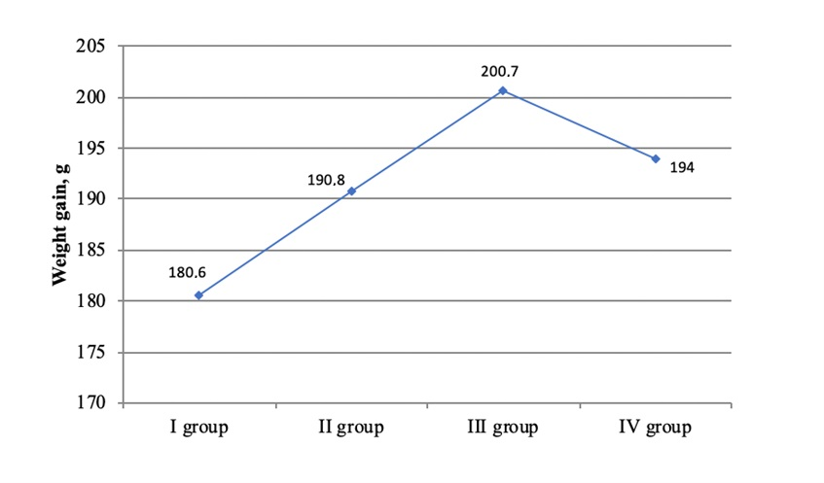Fig. 3: Absolute weight gain of heifers for the entire period of rearing, g

Based on the obtained data, we can say that the use of “Biotrof” in the feed making has a positive effect on the growth and development of heifers. The most effective dosage was 4 litres per 1 ton of canned green mass.
One of the main indicators determining the intensity of animal growth is defined as the average daily increase in live weight (Fig. 4).
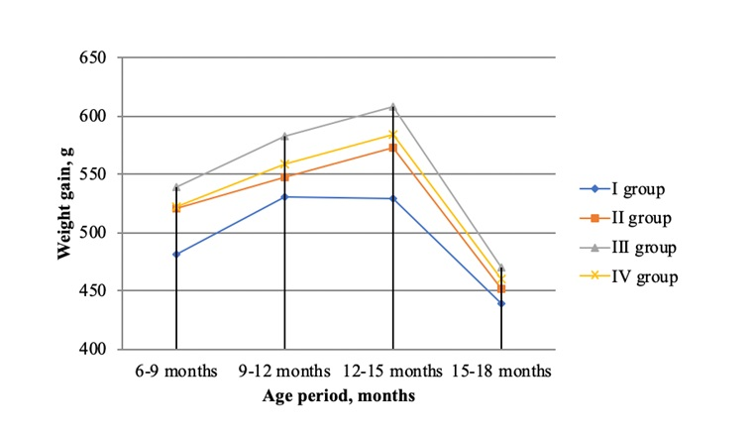
Fig. 4: Average daily gain in live weight of heifers, g

The influence of alfalfa haylage harvested with the introduction of various dosages of the biological preservative “Biotrof” on the growth of heifers over replacement was noted already at the initial stages of rearing, that is why the heifers of the control group were inferior to the herd mates of the experimental groups in growth rate. At the same time, in the age period from 6 to 9 months, this advantage was 39.2-57.6 g (8.14-11.9%), from 9 to 12 months – 16.7-52.2 g (3.14-9.83%), from 12 to 15 months – 43.9-80.2 g (8.3-15.17%;), from 15 to 18 months – 12.0-30.5 g (2.73-6.95%).
A more significant increase in the studied indicator in all periods of growing the black-and-white over-replacement was noted in animals of the experimental groups, which is explained by the influence of haylage using a preservative.
A significant decrease in the intensity of growth in the extreme period of cultivation, regardless of the high level and usefulness of feeding is due to the activation of the process of fat deposition in the animal body. Based on the obtained data, the advantage of the studied indicator in this period of heifers of group III over herd mates of groups II and IV is obvious, which was 9.8-18.5 g (2.09-3.94%).
In a comparative analysis of researches made by other scientists, a similar pattern was noted, while the average daily increase in live weight of bulls of the experimental groups of black-and-white breed was 934.71 g; 965.29 g and 956.49 g, and the control group was 867.31 g (Gubaidullin et al., 2019).
A close study of the indicators of the average daily increase in live weight for the entire period of the experiment shows that the herd mates of the control group were significantly inferior to the animals of group II by 28.0 g (5.64%; P<0,05), group III – by 55.2 g (11.12%; P<0.001), group IV-by 36.5 g (7.36%) (Fig. 5).
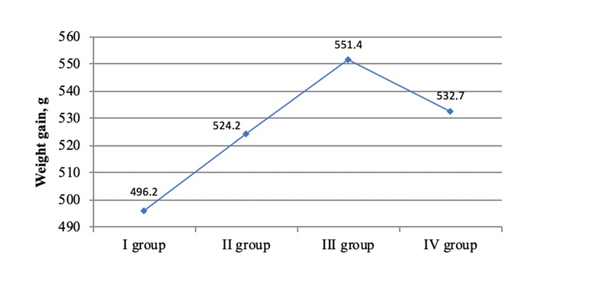
Fig. 5: The average daily gain in live weight for the entire period of the experiment, g

It is necessary to note the leadership of animals of the III group in the value of the studied indicator. Alfalfa haylage harvested with the use of a preservative of biological genesis “Biotrof” in a dosage of 4 l/t of green mass has the most beneficial effect on the growth rate of experimental heifers.
For more complete studies, it was necessary to study the quality of the meat. To do this, a controlled slaughter of 3 animals from each group was carried out. To study the quality of meat, we carried out average tests of the longest back muscle. The content of moisture, protein, fat and ash was studied in the selected samples.
The chemical composition of the selected medium sample of meat does not fully reflect the quality of the muscle tissue itself, since the shoulder meat includes not only muscle but also fatty connective tissue. Because of this, for a comprehensive assessment of muscle tissue among zootechnician scientists examine individual muscles of the carcass. Usually, the longest back muscle is used for research.
The studied muscle is one of the largest muscles in the carcass, its chemical composition gives an objective picture of the quality of muscle tissue as a whole.
The results of the chemical analysis of the longest back muscle of the carcasses of heifers’ over-replacement of the studied groups are presented in Fig. 6.
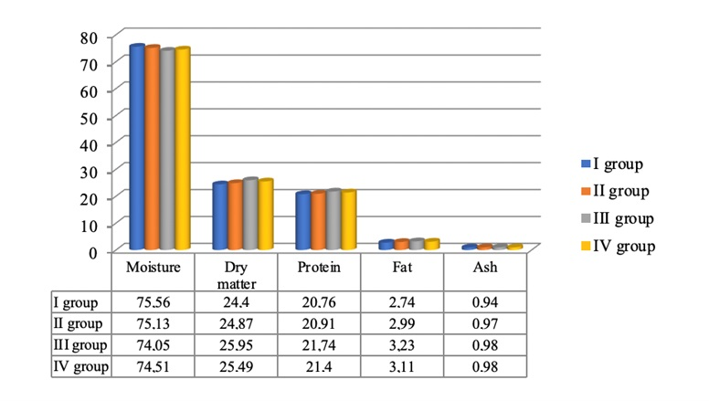
Fig. 6: Chemical analysis of the longest back muscle of heifers over -replacement, %

According to the researches made to study the effect of the conservative “Biotrof” as part of haylage on beef production, the level of moisture in the muscle thickness of heifers of all experimental groups varied from 75.13% to 74.51%. Based on the literature data, we can say that these levels of the studied indicator generally corresponded to the physiological maturity of the carcasses. However, the chemical composition of the longest back muscle taken from animals of different groups changed taking into account the dosage of the studied conservative introduced into alfalfa haylage during harvesting, as well as their value of the live weight index and the level of fatness.
The animals of the control group, having a minimum live weight in the final fattening period, were at a disadvantage compared with the herd mates of the experienced ones in dry matter content. This difference was 0.43; 1.51 and 1.05%. In the value of the fat index, the distribution rank was similar. At the same time, the difference was 0.25; 0.49 and 0.37%. As for the protein content, the distribution of values was similar.
With a more thorough comparison of fat deposits in the longest back muscle among the bulls of the experimental groups, the superiority of the indicators of the animals of group III should be noted. This difference was 0.24 and 0.12% compared to the indicators of herd mates of groups II and IV, respectively.
The high caloric content in terms of 1 kg of muscle is due to the significant protein and fat content in the herd mates of the experimental groups.
Due to the greater deposition of protein and fat in the longest back muscles of the experimental animals, the meat had a significant energy value of the longest muscle of the heifers of the control group.
A higher concentration of protein and fat in young animals of groups I, II and IV showed a positive effect on the caloric content of 1 kg of muscle. In the second group, the energy value of the last studied indicator was higher by 2.8, in the third one - by 7.8 and in the fourth group - by 5.6% compared with the herd mates of the first group.
The quality of meat in various aspects is determined by its biological value, functional and technological properties. It is well known that the main component of all meat nutrients is proteins (Azhmuldinov et al., 2019). A distinctive feature of meat proteins is their usefulness, unlike most other products. The ratio of full-fledged proteins to inferior ones is the main advantage of meat. The reason lies in its composition: together with the essential amino acids, there are also interchangeable ones (Chernyshenko et al., 2018). Taking into account the biological value of the studied meat, the content of the amino acids, tryptophan and oxyproline were obtained. A protein-quality indicator was determined, which shows the ratio between the amino acid that is part of full-fledged proteins, tryptophan, and the amino acid that is part of connective-woven proteins, oxyproline.
Using the obtained data, it can be noted that with positive dynamics of live weight, the content of tryptophan in the longest muscle increased. Concerning oxyproline, there is a slight downward trend, more full-bodied heifers of the third group at the age of one and a half years surpassed the analogues of the control group in the amount of the amino acid tryptophan by 5.27%, the second group – by 3.17% and the fourth group-by 0.16%. At the same time, the level of oxyproline was less by 1.86; 1.07 and 0.18%, respectively. Based on the data obtained during the experiment, the maximum biological value of the longest muscle belonged to the animals of the third group. Their protein-quality index exceeded the analogues of the control and the second and fourth experimental groups by 0.45 units; 0.27 units and 0.02 units accordingly. But despite these differences, the indicators of the protein value of meat were at a significant level and were closely related to the fatness of heifers.
It was in studies revealing that some intergroup differences in physical and chemical parameters and technological properties of the longest back muscle of heifers’ over-replacement were established.
From literary sources and based on practical knowledge, the relationship between the concentration of free hydrogen ions (pH) and the storage period of meat products is established. The optimal values of this indicator are considered to be 5.54-5.89. On the first day, the pH value shifts to an acidic environment. At this time, glycolysis occurs.
Taking into account the obtained data, it is possible to note the optimal level of the hydrogen index of the longest back muscle of over-replacement heifers, regardless of the feeding diet. These indicators show the ability of the meat obtained after slaughter to be stored for a long time, which positively affects the technological properties and, as a result, is a valuable raw material in the production of high-quality meat products.
Also, we should not forget about another important characteristic, such as colour. With age, the meat becomes darker, the value of the studied indicator increases.
Based on the obtained data during the research, we can note that the meat obtained from the heifers of the control group was distinguished by a darker colour. Their advantage over their herd mates from the experimental groups was 6.2 units (2.28%), 12.4 units (4.56%) and 11.1 units (4.09%).

Conclusions
Interpreting the obtained data, we can say that when used in the feeding diet of over-replacement heifers of the black-and-white breed of alfalfa haylage canned with the use of the preservative “Biotrof” at a dose of 4 liters per 1 ton of green mass contributes to more intensive growth of animals. In the study of the qualitative indicators of the obtained meat, the superiority of the samples obtained from heifers consumed haylage canned with sourdough in an optimally selected dose is obvious. Based on the above, the practical significance of the research lies in the fact that additional reserves were identified to increase the level of beef production by including alfalfa haylage harvested using different concentrations of the preservative “Biotrof” in the diet of over-replacement heifers. In the future, it is necessary to make research on the effect of canned alfalfa haylage by changing the objects of research.

Conflict of interest. This research has no conflict of interests.

Funding. This research did not receive any specific grant from funding agencies in the public, commercial, or not-for-profit sectors.
Data availability. Data will be available on request.

References
Aipov, R.S., R.B. Yarullin, I.I. Gabitov, S.G. Mudarisov, A.V. Linenko, M.N. Farhshatov, E.R. Khasanov, F.Z. Gabdrafikov, G.P. Yukhin and R.R. Galiullin, 2018. Mechatronic system linear swing vibrating screen of a grain cleaner. J. Engin. Appl. Sci., 13:6473–6477
Andreeva A.V., O.N. Nikolaeva, E.R. Ismagilova, V.R. Tuktarov, R.G. Fazlayev, A.I. Ivanov, O.M. Altynbekov, G.M. Sultangazin, I.M. Urmanov and A.Z. Khakimova, 2018. Effect of probiotic preparations on the intestinal microbiome. J. Eng. Appl. Sci., 13:6467–6472
Blagov, D.A., A.Ya. Gizatov, D.R. Smakuyev, V.I. Kosilov, V.A. Pogodaev and S.A. Tamaev, 2020. Overview of feed granulation technology and technical means for its implementation. In: IOP Conf. Series: Earth Envir. Sci. “Inter. Sci. Prac. Conf. Biotech. Agro-Indust. Comp. Sust. Envir. Manag.”.
Chernenkova, A.A., S.A. Leonova, T. Nikiforova, A. Zagranichnaya, E.N. Chernenkov, O.Yu. Kaluzhina, E.V. Badamshina and I.R. Gazeev, 2019. The usage of biologically active raw materials in confectionery products technology. OnLine J. Biol. Sci., 19:77–91
Chernoivanov V., A. Katkov, I. Gabitov, G. Yukhin, V. Martynov, E. Khasanov, S. Mudarisov, D. Baltikov, R. Khammatov and P. Kovalev, 2019. Technical equipment of farms for comfortable cow keeping in winter conditions. Bulg. J. Agric. Sci., 25:45–53
Danyliv M.M., M.M. Vasilenko, O.N. Ozhereleva and N.M. Derkanosova, 2018. Production engineering of the low fat meat products. Adv. Eng. Res., 151:129–135
Gabdrakhimov, K.M., A.F. Khayretdinov, R.R. Sultanova, S.I. Konashova, V.F. Konovalov, I.G. Sabirzyanov, A.K. Gabdelkhakov, R.R. Isyanyulova, M.V. Martynova and L.N. Blonskaya, 2018. Reproduction of stable pine forests in the Southern Urals. J. Engin. Appl. Sci., 13:6494–6499
Gabitov, I.I., R.N. Saifullin, M.N. Farhshatov, A.V. Negovora, S.G. Mudarisov, E.R. Khasanov, R.R. Galiullin, F.Z. Gabdrafikov, N.M. Yunusbaev and A.R. Valiev, 2018a. Hardening of electrohydraulic injectors valve units of diesels at repair. J. Engin. Appl. Sci., 13:6478–6486
Gabitov, I.I., G.P. Yukhin, V.M. Martynov, R.R. Galiullin, K.V. Kostarev, A.V. Negovora, S.G. Mudarisov, N.M. Yunusbaev, A.A. Kozeev and D.F. Baltikov, 2018. Modeling the power plant operation to optimize the technological and design parameters of the gas generator unit. J. Eng. Appl. Sci., 13:8857–8864
Gabitov I., A. Negovora, E. Khasanov, R. Galiullin, M. Farhshatov, R. Khamaletdinov, V. Martynov, D. Gusev, N. Yunusbaev and M. Razyapov, 2019. Risk reduction of thermal damages of units in machinery heat preparation for load acceptance. J. Eng. Appl. Sci., 14:709–716
Gadiev, R.R., D.D. Khaziev, Ch.R. Galina, A.R. Farrakhov, K.D. Farhutdinov, I.Y. Dolmatova, M.A. Kazanina and G.F. Latypova, 2019. The use of chlorella in goose breeding. AIMS Agric. Food, 4:349–361
Gizatov, A., N. Gizatova, I. Mironova, I. Gazeev and A. Nigmatyanov, 2020. Creation and use of microorganism consortium in meat production. Period. Tche Quim., 17:713–727
Gubaidullin, N., H. Tagirov, I. Mironova, Y. Lysov, F. Gafarov, L. Zubairova, R. Iskhakov, A. Nigmatyanov, A. Bagautdinov and E. Pozdnyakova, 2019. The efficiency of haylage use conserved by the pure culture of propionibacteria in black-and-white cattle feeding. Bulg. J. Agri. Sci., 25:74–79
Ivanov A., A. Andreeva, E. Skovorodin, M. Shaimukhametov, O. Altynbekov, G. Sultangazin, Ch. Galieva, I. Urmanov, A. Khakimova and O. Nikolaeva, 2018. Anaerobic microflora impact on pathomorphogenesis of swine dysentery. J. Eng. Appl. Sci., 13:8796–8802
Kanareikina, S.G., Yu.N. Chernyshenko and V.I. Kanareykin, 2019. Researching of fatty acids and amino acid structure of yogurts with use of mare's milk. In: IOP Conf Ser: Earth Envir Sci. Krasnoyarsk Science and Technology City Hall of the Russian Union of Scientific and Engineering Associations. p. 72036. Krasnoyarsk.
Khasanov, E., R. Khamaletdinov, S. Mudarisov, D. Shirokov and R. Akhunov, 2020. Optimization parameters of the spiral mixing chamber of the device for pre-sowing seed treatment with biological preparations. Comp. Electr. Agri., 173:105437
Konashova, S.I., R.R. Sultanova, A.F. Khairetdinov, K.M. Gabdrakhimov, V.F. Konovalov, Z.Z. Rakhmatullin, R.R. Isyanyulova, E.R. Nasyrova, A.F. Gubaidullin and S.I. Muftakhova, 2018. Forestry and ecological aspects of the broad-leaved forest formation. J. Engin. Appl. Sci., 13:8789–8795
Martynov V., I. Gabitov, Kh. Karimov, I. Masalimov, V. Permyakov, I. Ganeev, I. Saitov and B. Saitov, 2018. Reasoning barley grain drying modes for vacuum-infrared drying machines. J. Eng. Appl. Sci., 13:8803–8811
Masalimov, I.K., Sh.F. Faizrakhmanov, I.I. Gabitov, V.M. Martynov, V.N. Permyakov, R.S. Aipov, R.B. Yarullin, A.A. Davydova, I.R. Rakipov and A.S. Ramazanov, 2018. Optimal operating modes reasoning of sunflower seeds microwave drying in a conveyor type unit. J. Eng. Appl. Sci., 13:6570–6575
Mudarisov, S., I. Gainullin, I. Gabitov, E. Hasanov and I. Farhutdinov, 2020. Soil compaction management: Reduce soil compaction using a chain-track tractor. J. Terramech., 89:1–12
Mukhametov, A., N. Bekhorashvili, A. Avdeenko and Mikhaylov, 2021. The impact of growing legume plants under conditions of biologization and soil cultivation on chernozem fertility and productivity of rotation crops. Leg. Res., 44:1219–1225
Mukhametov, A., S. Kondrashev, G. Zvyagin and D. Spitsov, 2022. Treated livestock wastewater influence on soil quality and possibilities of crop irrigation. Saudi J. Biol. Sci., 29:2766–2771
Okuskhanova, E., Ya. Rebezov, M. Khayrullin, A. Nesterenko, I. Mironova, I. Gazeev, A. Nigmatyanov, and A. Goncharov. 2019. Low-calorie meat food for obesity prevention. Intern. J. Pharmac. Res., 11:1589–1592
Polyanskikh S.V., N.M. Ilyina, A.V. Grebenshchikov, M.M. Danyliv, D.V. Klyuchnikova, O.I. Dolmatova and E.V. Bogdanova, 2016. Products of animal origin with vegetable components. Indian. J. Sci. Technol., 9:1–8
Safonov, V., V. Ermakov, V. Danilova and V. Yakimenko, 2021. Relationship between blood superoxide dismutase activity and zinc, copper, glutathione and metallothioneines concentrations in calves. Biomath., 10:2111247
Smolnikova, F., S. Toleubekova, G. Kazhybayeva, O. Gorelik, I. Dolmatova, I. Mironova, I. Gazeev, V. Kanareikin and S. Loseva, 2019. Production technology and nutritional value of combined yogurt for dietary nutrition. Intern. J. Innov. Techn. Expl. Engin., 8:1098–1100
Sultanova, R.R., K.M. Gabdrahimov, A.F. Khayretdinov, S.I. Konashova, V.F. Konovalov, L.N. Blonskaya, I.G. Sabirzyanov, M.V. Martynova, R.R. Isyanyulova and A.K. Gabdelkhakov, 2018. Evaluation of ecological potential of forests. J. Engin. Appl. Sci., 13:6590–6596
Sultanova, R.R., I.I. Gabitov, Y.A. Yanbaev, F.G. Yumaguzhin, M.V. Martynova, I.V. Chudov and V.R. Tuktarov, 2019. Forest melliferous resources as a sustainable development factor of beekeeping. Isr. J. Ecol. Evol., 65:77–84
Sydykova, M., G. Nurymkhan, S. Gaptar, Ya.M. Rebezov, M. Khayrullin, A. Nesterenko and I. Gazeev, 2019. Using of lactic-acid bacteria in the production of sausage products: modern conditions and perspectives. Int. J. Pharm. Sci. Res., 11:1073–1083
Ventsova, I. and V. Safonov, 2021. Biochemical criteria for the development mechanisms of various reproduction disorders in dairy cows. Biodiv. J. Biol. Divers, 22:4997–5002
Yarullin, R., R. Aipov, I.I. Gabitov, A. Linenko, S. Akchurin, R. Safin, S. Mudarisov, E. Khasanov, Z. Rakhimov and I. Masalimov, 2018. Adjustable driver of grain cleaning vibro-machine with vertical axis of eccentric masses rotation. J. Engin. Appl. Sci., 13:6398–6406

