Overexpression of AcCMF1, onion CCT family gene, promotes flowering in transgenic Arabidopsis

Yong Wang¹²· Shouyi Ren¹²·Huihui Zhang¹²·Yuqi Zhang¹²·Yang Xu¹²·Jiru Wang¹²·XiaoChen Cong ¹²·Lei Qin^{12*}
¹ Key Laboratory of Biology and Genetic Improvement of Horticultural Crops (Northeast Region), Ministry of Agriculture and Rural Affairse/Northeast Agricultural University, Harbin 150030, People’s Republic of China
² College of Horticulture and Landscape Architecture, Northeast Agricultural University, Harbin 150030, People’s Republic of China
* For Correspondence: qinleil@neau.edu.cn
Abstract: The control of flowering time is crucial for reproductive growth of horticultural crops. Photoperiodic plays an important role in flowering regulation among environmental signals. Onion is a typical biennial plant. The life cycle of onion was strictly regulation by light. Study on genes linked to flowering regulation in onion was meaningful for onion production. The CCT family involves in photoperiod-induced flowering modulation and light-induced signaling. In this study, a novel CCT family gene, AcCMF1, was isolated from onion. AcCMF1 belonged to the CCT motif subfamily (CMF), in which the encoded proteins contained a single CCT domain. The full-length cDNA of AcCMF1 was 891bp, encoding a 296-amino acid protein. Subcellular localization analysis revealed AcCMF1 locating on cell nucleus. AcCMF1 expressed highest in young leaves before bolting and showed a diurnal expression pattern involved in the photoperiod response. The overexpression of AcCMF1 promoted the flowering time of Arabidopsis co mutant. In conclusion, these results suggested that AcCMF1 played a positive role in onion flowering regulation under LD.This study provided insight into the molecular mechanisms regulating flowering time in onion, specifically related to photoperiod. This results has practical implications for controlled onion production in its production systems.
Keywords: Onion; AcCMF1; Flowering regulation; Advanced flowering time

Introduction
Flowering time regulation is crucial for reproductive growth of horticultural crops, and has a significant impact on adaptation to diverse environmental conditions. Plants integrate both environmental factors and endogenous regulatory signals to modulate flowering time. Photoperiod is a vital environmental factor in plant flowering regulation. Numerous genes participating in flowering regulation have been identified in plant (Robson et al. 2001). The CCT family genes involved in photoperiod-induced flowering modulation and light-induced signaling (Putterill et al. 1995; Wenkel et al. 2006). The CCT domain originally conformed to a 43-amino acid sequence at the C-terminus of three Arabidopsis proteins, namely CONSTANS (CO), CO-LIKE, and TIMING OF CAB1 (TOC1). Previous studies had classified CCT genes into three families: the CONSTANS-like (COL) gene family, whose members encoded one or two zinc-finger B-box domains, such as CO and Hd1; the Pseudo-response regulator (PRR) family that was characterized by two conserved regions-pseudo receiver domain and a CCT domain; and the CCT motif family (CMF), in which the encoded proteins contain a single CCT domain (Cockram et al. 2012). Surveys of photoperiod pathway had shown the transcription factor CO promotes flowering under LD (long day, LD) (Putterill et al. 1995) . Genetic analyses had revealed that the CONSTANS / FLOWERING LOCUS T (CO/FT) module played central role in photoperiodic regulation of flowering (Nakamichi, 2015). CO gene integrated the circadian clock and light signals to control plant flowering (Putterill et al. 1995; Samach et al. 2000; Suarez-Lopez et al. 2001). CO-like (COL) genes were downstream component of circadian clock measuring day length. They cooperated with GIGANTEA (GI), FLAVIN KELCH F BOX 1 (FKF1), and FT, as central functional components in photoperiod pathway (Sawa et al. 2007; Turck et al. 2008; Song et al. 2012). The function of CO gene was conserved between dicots and monocots in photoperiodic ﬂoral induction pathway in Arabidopsis and rice(Wenkel et al. 2006). In Arabidopsis, 17 COL genes were identified (Robson et al. 2001; Khanna et al. 2009). AtCO was the first cloned CCT family gene regulating flowering time in Arabidopsis composed of a B-box-type zinc finger domain and a CCT domain ( Robson et al. 2001). It had reported that AtCO, AtCOL3, AtCOL5, and AtCOL9 taken part in flowering time regulation in Arabidopsis (Putterill et al. 1995; Datta et al. 2006; Cheng and Wang 2005; Hassidim et al. 2009). AtCO gene accelerated flowering in response to long photoperiods in Arabidopsis which repressed photomorphogenesis in darkness(Putterill et al. 1995) . The overexpression of AtCOL5 could induce early flowering by promoting FT expression, whereas col5 mutant plants flowering normally under both LD and SD (short day, SD) conditions (Hassidim et al. 2009). However, AtCOL9 overexpression in transgenic Arabidopsis delayed flowering under LD conditions (Cheng and Wang 2005), suggesting that AtCOL9 repressed flowering probably by reducing the expression of CO and FT (Cheng and Wang 2005). AtCOL3 interacted with CONSTITUTIVE PHOTOMORPHOGENIC1 (COP1) to promote the formation of branches specifically under SD conditions, and promotes lateral root development but independently of day length (Datta et al. 2006). Furthermore, AtCOL7 promoted shoot branching when the ratio of red to far-red light is high (Wang et al. 2013). Heading date 1 (Hd1) was identified by a map based cloning strategy, it was the suggest that Hd1 was the homolog of CO from Arabidopsis functions in the promotion of heading under SD conditions and in inhibition under LD conditions (Yano et al. 2000). Ghd7, encoding a CCT domain protein, had major effects on number of grains per panicle, plant height and heading date in rice (Xue et al. 2008). Ghd7 delayed heading under LD conditions but not SD conditions and repressed the expression of Early heading date1 (Ehd1) in the photoperiod-mediated flowering pathway (Xue et al. 2008; Nakamichi 2015). Studies in rice showed that such genes were relatively common, they demarcation this group of genes to the CMF genes(Cockram et al. 2012). CMF genes had similarity function with COL in plant flowering regulation. Ghd7 also contributes to the regulation of multiple processes including hormone metabolism and response to biotic/abiotic stresses.OsCCT1 was a new CMF gene suppressd the expression of Ehd1, Hd3a, and RFT1 to delay the flowering time (Zhang et al. 2015).
Onion (Allium cepa L.) is one of the main vegetables with economic production of bulb biennial. In 2018, onion production was 103.3 million tons harvested in 5.3 million hectares all over the world (http://www.fao.org). The life cycle of onion is strictly regulated by light. There are multiple ecotypes of onion dependent on the planting environment, as LD type, SD type and day-neutral plant. In previous study, an AcCOL was obtained, but it did not exhibit discernible diurnal expression pattern (Taylor et al. 2010). AcCOL2 showed a diurnal pattern of expression similar to AtCO and consistent with photoperiod sensing and regulation of AcFT1 (Rashid and Thomas 2020). In our previous study, AcCOL7 was cloned which involved in photoperiod pathway, as well as, it likely played a significant role in promoting flowering (Sheng et al. 2018). CMF genes have not been identified in onion. In this study, a CMF gene was isolated from onion named AcCMF1. In order to investigate the function of AcCMF1 in flowering regulation, AcCMF1 was transformed to Arabidopsis. AcCMF1 played similar roles in flowering regulation. Overexpression AcCMF1 could partly complement the function of co mutant in Arabidopsis. These results suggested that CMF gene was involvement in onion flowering regulation.

Materials and Methods
Plant materials
A LD type higher-generation inbred onion SA2 was used in this experiment. It was provided by the Onion and Garlic Research Group of Northeast Agricultural University. Arabidopsis thaliana wild-type (WT) accessions used were Col-0 and Ler. The Arabidopsis mutant col-5 (SALK_096361C, Col-0), gi (CS181, Ler-0) and ga3 (SALK-103671C, Col-0) were obtained from TAIR（http: //www.arabidopsis.org/. Plants were grown on soil in a plant growth chamber under a 16/8 h light/dark period at 22/18℃. The plant tissue samples were immediately frozen in liquid nitrogen after collection and stored at -80℃.
Cloning, sequence alignment and phylogenetic analysis of AcCMF1
Sequence of AcCMF1 was obtained from transcriptome database in our previously study (Yuan et al. 2018) . Total RNA was extracted from onion leaves using Trizol (Invitrogen, USA), and cDNA was synthesized using M-MuLV reverse transcriptase (Thermo Scientific, USA). The cDNA samples were amplified by PCR: 94℃ for 1 min, 35 cycles of 94℃for 1 min, 52℃ for 45 s, and 72℃ for 1 min, and then 72℃ for 10 min. The primers were listed in Table S1.
The conserved domains of the gene sequences were searched using the Simple Modular Architecture Research Tool (SMART, http://smart.embl-heidelberg.de/). The CCT family proteins amino acid sequence of Arabidopsis and rice were obtained from NCBI. The multiple sequence alignments of AcCMF1 and related CCT family proteins were performed using ClustalW in the MEGA5 software package, and the boxes were drawn using the BoxShade web site (http://www.ch.embnet.org/software/BOX_ form.html). The phylogenetic tree was constructed using the Neighbor-Joining (NJ) method with Poisson model and 1000 bootstrap replicates test through MEGA5 software(Saitou and Nei 1987; Tamura et al. 2011).
Quantitative Real-Time PCR (qRT-PCR)
Total RNA was extracted from onion using Trizol (Invitrogen, USA). cDNA was synthesized using ReverTra Ace® qPCR RT Master Mix with gDNA Remover (TOYOBO, Shanghai, China). Quantitative real-time RT-PCR (qRT-PCR) was performed using KOD SYBR® qPCR Mix (TOYOBO, Shanghai, China) on iQ5 Real-Time PCR Detection System (BIO-RAD Corp., Hercules, California, USA). Acaction was used as the reference gene. Three biological replicates were performed for qRT-PCR assay. Error bars indicate the standard errors. Relative expression levels of genes were determined using the comparative threshold method (2^{-△△Ct}) (Livak and Schmittgen 2001). The primers for qRT-PCR were listed in Table S1.
Subcellular localization in Arabidopsis mesophyll protoplast
The full length coding sequence (CDS) of AcCMF1 was transient expressed in Arabidopsis for subcellular localization (Yoo et al. 2007). The primers showed in Table S1. The pG-EGFP vector (with GFP protein driven by CaMV35S promoter) to generate CaMV35S: GFP- AcCMF1. The empty vector was used as a control. Then the Arabidopsis mesophyll protoplast cells were observed with a confocal laser scanning microscope.
Ectopic expression of AcCMF1 in Arabidopsis
The CDS regions of AcCMF1 was inserted to the pCXSN1250-3301 vector, in which the target genes were controlled by CaMV35S promoter. The recombinant vector was transformed to Agrobacterium strain GV3101. The transformed Agrobacterium strain was used to infect Arabidopsis (Col-0, Ler, col-5, ga3 and gi) via Agrobacterium-mediated the floral dip method (Clough and Bent 2010). The transgenic plants were screened on MS medium with Glufosinate ammonium (PPT). Homozygous Arabidopsis transgenic seeds (T₃) were used for further research.
Statistical Analysis
The values are represented as the mean ± standard errors of three independent experiments. Significant differences of the data were by univariate ANOVA analysis with the least significant difference (LSD) at P < 0.05.

Results

Cloning and phylogenetic analysis of onion AcCMF1
In this study, a novel CCT family gene was obtained based on the transcriptome database of our previously study (Yuan et al. 2018). The gene was identified as containing a CCT domain (lacking additional domains). It was annotated as CMF gene and named AcCMF1. The full length of AcCMF1 cDNA was 891bp, encoding 296 amino acids. According to phylogenetic analysis, CCT family protein could be classified into four groups (Fig. 1). The members in group I contained two B-box motifs and a CCT domain. The group II members contained one B-box motif and a CCT domain. The group III members exhibited a normal B-box domain and a second divergent B-box domain, with a CCT domain. AcCMF1 belonged to group Ⅳwithout B-box domain, but just a CCT domain. The alignment of AcCMF1 with other CMF homologs indicated that AcCMF1 only had the CCT domain (Fig. 2). The AcCMF1 protein showed 15.16% identity with OsGhd7.

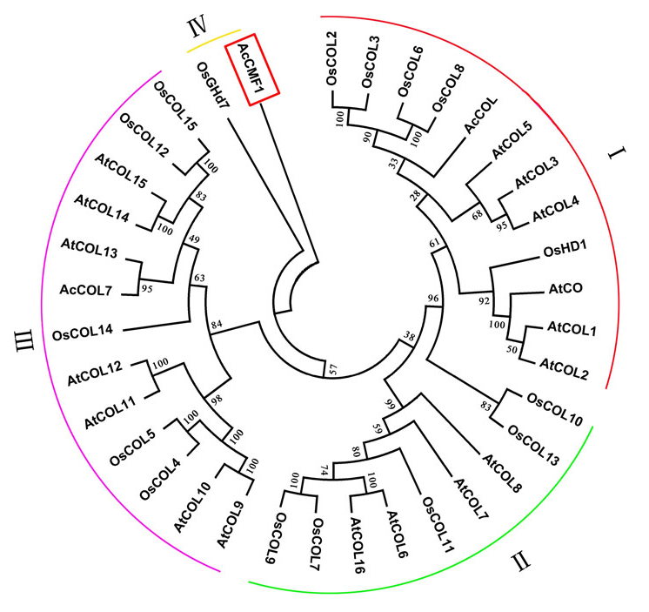

Figure 1. The phylogenetic relationship and conserved domain analysis of CCT homologs. Neighbor-joining tree of CCT family genes, AcCMF1, AcCOL, AcCOL7, AtCOLs and OsCOLs. Bootstrap values from 1000 replicates were used to assess the robustness of the tree. AcCMF1 from onion was indicated in red boxes.

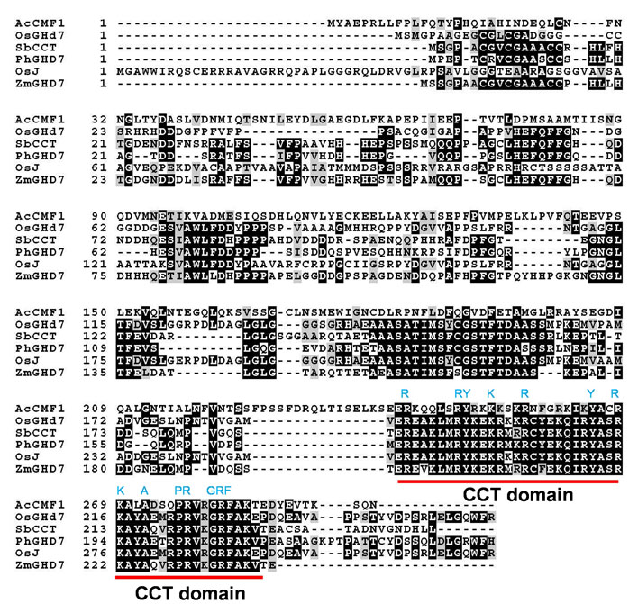

Figure 2. Conserved protein domains alignment of AcCMF1 with other CMF proteins. The identical and similar residues were shown in black and gray, respectively. The CCT domain was highlighted in red line.
Subcellular localization of AcCMF1
The fusion expression vector was constructed as pGⅡ-EGFP-AcCMF1. It were used to analyze the intracellular localization of AcCMF1. Arabidopsis protoplasts were extracted and used for observation. AcCMF1-GFP fusion protein was only present in cell nucleus (Fig. 3). These results confirmed that AcCMF1 was nuclear-localized protein. CO worked as the transcription factor to promote flowering under LD (Putterill et al. 1995). AcCMF1 suggested to be characteristic as transcription factor.
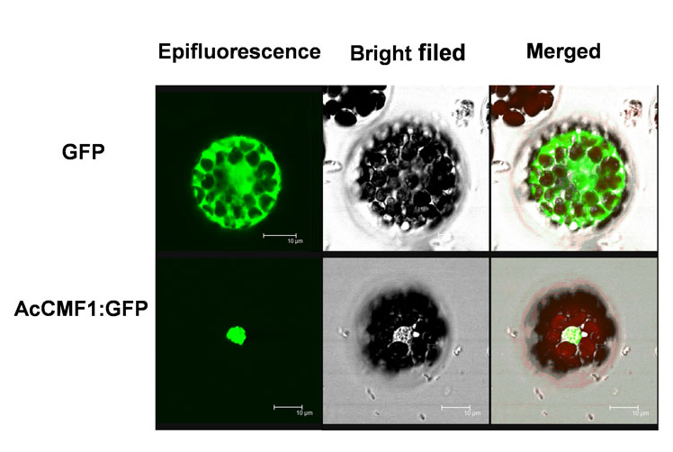

Figure 3. Subcellular localization of AcCMF1. The left verticals are green fluorescence images, middle verticals are bright-filed images, and right verticals are merged images of bright field and green fluorescence. Scale bars in this figure are 10 μm.
AcCMF1 expression characterized
To characterize the organ specific expression of AcCMF1, qRT-PCR was performed in various onion organs in reproductive phase under LD condition (Fig. 4). Although AcCMF1 expressed throughout the growth cycle of the plant, the transcript level was the highest in the young leaves before bolting, followed by a high expression level in the young flower stems (Fig. 4). The high expression of the gene in young leaves before bolting also indicated that AcCMF1 was an important gene receiving optical signal in photoperiod pathway and played an important role in plant flowering regulation.

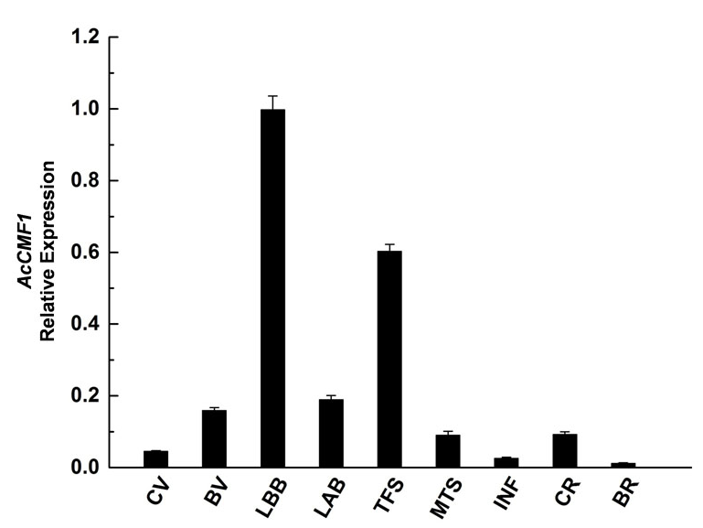

Figure 4. The expression patterns of AcCMF1. The tissue expression patterns of AcCMF1. Relative expression levels were determined by qRT-PCR. CV, cauloin in vegetative phase; BV, bulb in vegetative phase; LBB, leaf before bolting; LAB, leaf after bolting; TFS, tender floral stem; MS, mature floral stem; INF, inflorescence; CR, cauloid in reproductive phase; BR, bulb in reproductive phase.

The expression of AcCMF1 over a 24 h period under LD and short day (SD) conditions were determined using qRT-PCR (Fig. 5). AcCMF1 has double peaks of transcription under both LD and SD conditions. Under LD condition, the expression of AcCMF1 was peak at 6:00 am and 20:00 pm. The transcripts of AcCMF1 reached peak at 10:00 am and 20:00 pm under SD condition (Fig. 5).
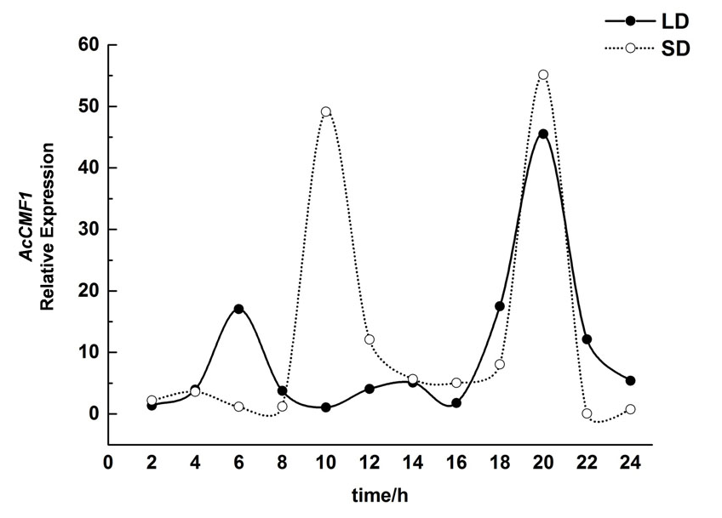

Figure 5. The diurnal rhythm expression pattern of AcCMF1 in onion leaves under different photoperiod.

AcCMF1 played a positive role in plant flowering regulation
AcCMF1 was transformed to Arabidopsis to investigate its function on flowering regulation. There were no significantly different between the wild type and AcCMF1 transgenic Arabidopsis (Supplementary Figs. S1).
Next, we tested the ability of the onion AcCMF1 gene to complement the late flowering phenotype of Arabidopsis co mutant. Compared with the wild-type Arabidopsis thaliana, the flowering time of the co mutant was delayed. AcCMF1 was overexpressed in Arabidopsis co mutant under the control of CaMV35S promoter. AcCMF1-OE transgenic plants showed similar phenotype on bolting time (Fig. 6A). The transgenic plants displayed advanced bolting time compared to co mutant (Fig. 6B). The number of the rosette leaves pieces increases slightly in transgenic plants (Fig. 6C). Plant height of AcCMF1Ls-OE was rescued (Fig. 6D). AcCMF1 not only could promote the plant flowering, but also participated in plants development regulation.
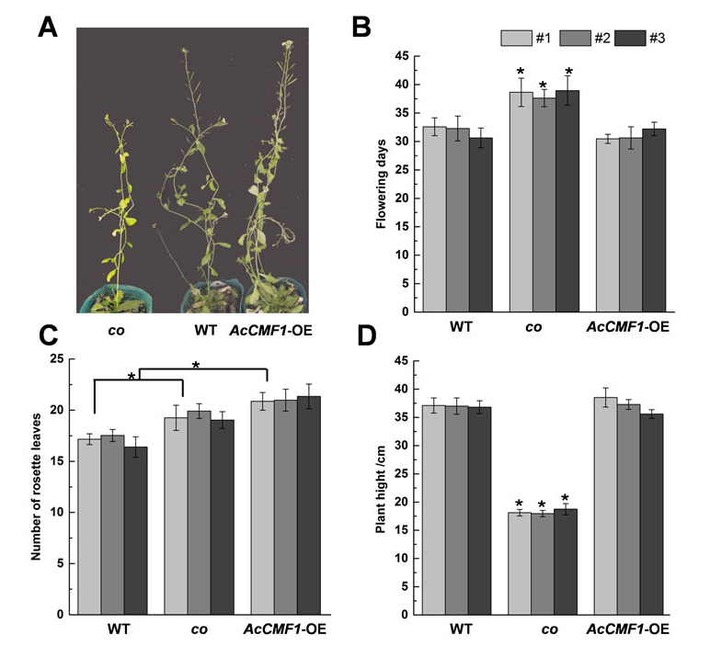
Figure 6. Overexpression of AcCMF1 in Arabidopsis co mutant. (A) Phenotype (B) Flowering time (C) Number of rosette leaves (D) Plant height of co mutant, wild type, AcCMF1-OE lines under LD condition. Error bars indicate the standard errors. Asterisks indicate the significant differences (P < 0.05).
Gi is the upstream gene of CO in the photoperiod pathway of plant flowering regulation. The gi mutants showed longer vegetative growth time, thicker stem, longer flowering time and less lateral branches than the wild-type plants. In order to explore the relationship between CO genes and other flowering regulation pathways, AcCMF1 was overexpressed in gi. There was no significant difference in flowering time and plant morphology between AcCMF1-OE plants and gi mutant (Supplementary Figs. S2). Arabidopsis thaliana ga3 mutant is a GA synthesis blocked mutant. The plant growth of ga3 was weaker than the wild type. But the flowering time is similar to the wild one. AcCMF1 overexpressed in ga3 mutant did not affect the flowering time of ga3 mutant (Supplementary Figs. S3).

Discussion
Plant flowering is an important developmental process in plant life cycle precisely controlled by various environmental signals especially in commercial crops (Nemoto et al. 2003; Miller et al. 2008; Jung and Muller 2009; Michaels 2009). CCT genes exist widely in gymnosperms and angiosperms, most members of CCT genes played important role in flowering control. The CCT family genes function having great differentiation between species. CCT family genes can be divided into four categories based on the latest sequencing information: COL (CONSTANS-like) family, PRR family, CMF family (Cockram et al. 2012). Based on the number and structure of B-box domains, COL homologs were classified into three types. Type I contains two B-box motifs, type II only one B-box motif and type III has one B-box motif and a second divergent B-box motif (Gangappa and Botto 2014). The COLs genes in Arabidopsis were classified into three major groups; group I included AtCO and AtCOL1 to AtCOL5 with two B-boxes; group II contained AtCOL6 to AtCOL8 and AtCOL16 with one B-box; and group III consisted of AtCOL9-AtCOL15 with one B-box and another diverged zinc finger domain(Robson et al. 2001; Griffiths et al. 2003; Khanna et al. 2009; Cockram et al. 2012; Wu et al. 2017). It had been reported that almost all functional COL homologs playing a positive role on flowering belonged to type I (Chaurasia et al. 2016; Gangappa and Botto 2014; Zhang et al. 2015). COL homologs of types II and type III did not seem to promote photoperiod-mediated flowering, while AtCOL9 from type III was shown to repress CO expression and delay flowering in Arabidopsis (Cheng and Wang 2005). OsGhd7 was a CCT family gene in rice with only CCT domain belonged to CMF (Xue et al., 2008). In this study, a novel CCT family gene, AcCMF1, was isolated from onion. AcCMF1 belonged to CMF, in which the encoded proteins contain a single CCT domain without other structures. AcCMF1 might be taken part in onion flowering regulation (Fig. 1 and Fig. 2).
AcCMF1 was located on cell nucleus (Fig. 3). It was accordance with other species (Xiao et al. 2018; Steinbach 2019). In our result, AcCMF1 showed high expression in leaf before bolting (Fig. 4). Leaf is the most import ant tissue for plant to feel light. In bamboo, PvCO1 had greater abundance in immature and mature leaves, as well as, PvCO2 transcript was detected only in leaves (Xiao et al. 2018). As a phloem-specific transcription activator of FT, CO promotes flowering by up-regulating the transcription of the FT and TWIN SISTER OF FT (TSF) genes (Nemoto et al.2016). AcCMF1 might perceive light in onion flowering control.
The expression of COL was regulated both by the external day night cycles and the internal circadian clock (Suarez-Lopez et al. 2001; Meng et al. 2011). CO is degraded by the ubiquitin ligase CONSTITUTIVE PHOTOMORPHOGENIC 1 (COP1) in the dark at the posttranscriptional level. Plant COL family genes were localized in nucleus and bind the promoter region of downstream target gene FT to activate the expression of FT (Wenkel et al. 2006;Tiwari et al. 2010).In Arabidopsis, circadian clock regulated the expression of CO to control flowering (Suarez-Lopez et al. 2001; Shim et al. 2017). In onion, the transcript level of AcCMF1 showed double peaks (Fig. 5). Previous study suggested that the transcription CO was peaking at dawn and dusk under LD condition (Imaizumi et al. 2005). The dusk peak is critical for the stabilization and accumulation of the CO protein, which promotes FT expression(Turck et al. 2008). In the SD plant rice, Hd1 has a similar circadian expression pattern as its homolog CO. Since Hd1 acts as a flowering repressor, SD conditions trigger flowering (Takeshi et al. 2002) AtCOL5 exhibits a circadian rhythm expression pattern and complements the late flowering effect of the co mutant (Hassidim et al. 2009). A putative onion CO homolog was cloned and assigned the name Allium cepa CO-like (AcCOL), but this gene did not exhibit a discernible diurnal expression pattern (Taylor A et al. 2010). AcCOL2 showed good diurnal expression patterns consistent with photoperiod sensing(Rashid and Thomas 2020). AcCMF1 showed the similar expression pattern with LfCOL6 in Lilium× formolongi, which played positive role in triggering flowering induction under LD(Li et al. 2018). This expression pattern was not completely consistent speculating that CCT family genes in onion had different function in flowering regulation and the circadian clock was modulated by different CCT genes.
In order to verify the effect of AcCMF1 family genes on flowering, AcCMF1 overexpression vector was constructed and transformed to Arabidopsis. The Arabidopsis co mutant performed late flowering phenotype. Nevertheless, overexpressed AcCMF1 in Arabidopsis co mutant could complement late flowering phenotype of co mutant under LD condition (Fig. 6). Previous study indicated that CO might directly bind to the specific cis-elements in the FT promoter through its CCT domain (Tiwari et al. 2010). OsGhd7 was an LD-specific repressor played a crucial role in increasing rice yields and controlling heading dates(Xue et al. 2008b). Ghd7 functions upstream of Ehd1 and Hd3a in the photoperiod-mediated flowering pathway and represses Ehd1 and Hd3a expression. Ghd7 and Hd1 form a complex in vivo and probably bind to a cis-regulatory region in Ehd1 and repress its expression (Nemoto et al. 2016). These findings implied that Hd1 along with Ghd7 could potently repress transcription of genes involved in the monocot-specific flowering time pathway. Expression of floral repressors SbGhd7, the orthologs of rice Ghd7, inhibited SbCO activity and flowering under LD conditions in sorghum (Yang et al., 2014). These genes constitute a pathway that is distinct from the analogous pathway in Arabidopsis (Nakamichi 2015). AcCMF1 restored the late phenotype of co mutant and promote the flowering of onion under LD condition. AcCMF1 played positive role in onion flowering regulation and involved in different pathways compared to cereal crops. GIGANTEA (GI) had been shown to regulate CO expression (Park et al. 1999; Mizoguchi et al. 2005; Fowler et al. 2014). We transformed AcCMF1 into gi mutant of Arabidopsis. Overexpressed AcCMF1 in gi mutants had little effect on flowering (Fig. 5). There were no significant difference between gi mutant and AcCMF1-OE lines on flowering time. It had been reported overexpression of CO could restore the late floral phenotype of gi mutants under long and short sunshine conditions in Arabidopsis (Ben-Naim et al. 2006; Sawa et al. 2007). To verify the interaction between AcCMF1 and other flowering regulatory genes, AcCMF1 was overexpressed in ga3 mutant in Arabidopsis. There were no significant changes between the transgenic plants and ga3 mutants. It indicated that AcCMF1 did not take part in the gibberellin pathway of flowering regulation. The mechanism of AcCMF1 reaction with other CCT genes control the onion flowering was unclear and should be explored in further study.

Conclusions
AcCMF1 was belonged to onion CCT family. The function of AcCMF1 in plant flowering regulation was revealed by using AcCMF1 Arabidopsis transgenic lines. AcCMF1 expressed highest in young leaves before bolting. AcCMF1 advanced the flowering time of co mutant in Arabidopsis. AcCMF1 played a positive role in plant flowering.
Acknowledgments: The authors gratefully acknowledge the financial support for
this study provided by the grants from the Open Project of Key Laboratory of Biology and Genetic Improvement of Horticultural Crops (Northeast Region), Ministry of Agriculture and Rural Affairse, China (neauhc201805); Northeast Agricultural University SIPT Project. The authors thank Key Laboratory of Vegetable Biology in Cold Region of Heilongjiang Key Laboratory of Genetic Improvement and Facility Cultivation of Horticultural Crops in Northern Cold Region of Heilongjiang Province for their help of the manuscript.
Author Contributions: Yong Wang designed the experiments, participated in generation of transgenics; Shouyi Ren participated in the cloning experiments and gene expression analysis; Cuicui Zhang participated in qRT-PCR; Yuqi Zhang and Yang Xu participated in sequence alignment and phylogenetic analysis; Jiru Wang participated in subcellular localization; Xiaochen Cong participated in collecting phenotypic data; Lei Qin helped conceiving the study, participated in its coordination and contributed to manuscript writing and editing. All authors read and approved the final manuscript.
Conflicts of Interest: The authors declare no conflict of interest

Abbreviations
CO | CONSTANS
COL | CONSTANS-like
COP1 | CONSTITUTIVE PHOTOMORPHOGENIC 1
GI | GIGANTEA
FT | FLOWERING LOCUS T
LD | long day
LSD | least significant difference
PPT | Glufosinate ammonium
qRT-PCR | Quantitative real-time Polymerase Chain Reaction
SD | short day
TSF | SISTER OF FT
WT | wild-type

References
Ben-Naim O, R Eshed, A Parnis, P Teper-Bamnolker, A Shalit, G Coupland, A Samach, E Lifschitz (2006). The CCAAT binding factor can mediate interactions between CONSTANS-like proteins and DNA. Plant Journal, 46 (3):462-476
Chaurasia AK, HB Patil, A Azeez, VR Subramaniam, B Krishna, AP Sane, PV Sane (2016). Molecular characterization of CONSTANS-Like (COL) genes in banana (Musa acuminata L. AAA Group, cv. Grand Nain). Physiology and Molecular Biology of Plants, 22 (1):1-15
Cheng XF, ZY Wang (2005). Overexpression of COL9, a CONSTANS-LIKE gene, delays flowering by reducing expression of CO and FT in Arabidopsis thaliana. Plant Journal, 43 (5):758-768
Clough SJ, AF Bent (2010). Floral dip: a simplified method for Agrobacterium-mediated transformation of Arabidopsis thaliana. Plant Journal, 16 (6):735-743
Cockram J, T Thiel, B Steuernagel, N Stein, S Taudien, PC Bailey, DM O'Sullivan (2012). Genome Dynamics Explain the Evolution of Flowering Time CCT Domain Gene Families in the Poaceae. Plos One, 7 (9)
Datta S, G Hettiarachchi, XW Deng, M Holm (2006). Arabidopsis CONSTANS-LIKE3 is a positive regulator of red light signaling and root growth, Plant Cell 18: 70–84
Fowler S, K Lee, H Onouchi, A Samach, K Richardson, B Morris, G Coupland, J Putterill (2014). GIGANTEA: a circadian clock-controlled gene that regulates photoperiodic flowering in Arabidopsis and encodes a protein with several possible membrane-spanning domains. Embo Journal, 18 (17):4679-4688
Gangappa SN, JF Botto (2014). The BBX family of plant transcription factors. Trends in Plant Science, 19 (7):460-470
Griffiths S, RP Dunford, G Coupland, DA Laurie (2003). The evolution of CONSTANS-like gene families in barley, rice, and Arabidopsis. Plant Physiology, 131 (4): 1855-1867
Hassidim M, Y Harir, E Yakir, I Kron, RM Green (2009). Over-expression of CONSTANS-LIKE 5 can induce flowering in short-day grown Arabidopsis. Planta, 230 (3): 481-491
Imaizumi T, TF Schultz, FG Harmon, LA Ho, SA Kay (2005). FKF1F-BOX protein mediates cyclic degradation of a repressor of CONSTANS in Arabidopsis. Science, 309 (5732): 293-297
Jung C, AE Muller (2009). Flowering time control and applications in plant breeding. Trends in Plant Science, 14 (10):563-573
Khanna R, B Kronmiller, DR Maszle, G Coupland, M Holm, T Mizuno, SH Wu (2009). The Arabidopsis B-Box Zinc Finger Family. Plant Cell, 21 (11):3416-3420
Li YF, YQ Zhao, M Zhang, GX Jia, M Zaccai (2018). Functional and Evolutionary Characterization of the CONSTANS-like Family in Lilium x formolongi. Plant and Cell Physiology, 59 (9):1874-1888
Livak KJ , TD Schmittgen (2001). Analysis of relative gene expression data using real-time quantitative PCR and the 2(-Delta Delta C(T)) Method. Methods, 25 (4):402-408
Meng X, MG Muszynski, ON Danilevskaya (2011). The FT-Like ZCN8 Gene Functions as a Floral Activator and Is Involved in Photoperiod Sensitivity in Maize. Plant Cell, 23 (3):942-960
Michaels SD (2009). Flowering time regulation produces much fruit. Current Opinion in Plant Biology, 12 (1):75-80
Miller TA, EH Muslin, JE Dorweiler (2008). A maize CONSTANS-like gene, conz1, exhibits distinct diurnal expression patterns in varied photoperiods. Planta, 227 (6):1377-1388
Mizoguchi T, L Wright, S Fujiwara, F Cremer, K Lee, H Onouchi, A Mouradov, S Fowler, H Kamada, J Putterill, G. Coupland (2005). Distinct roles of GIGANTEA in promoting flowering and regulating circadian rhythms in Arabidopsis. Plant Cell, 17 (8):2255-2270
Nakamichi N (2015). Adaptation to the Local Environment by Modifications of the Photoperiod Response in Crops. Plant and Cell Physiology, 56 (4):594-604
Nemoto Y, M Kisaka, T Fuse, M Yano, Y Ogihara (2003). Characterization and functional analysis of three wheat genes with homology to the CONSTANS flowering time gene in transgenic rice. Plant Journal, 36 (1):82-93
Park DH, DE Somers, YS Kim, YH Choy, HK Lim, MS Soh, HJ Kim, SA Kay, HG Nam (1999). Control of circadian rhythms and photoperiodic flowering by the Arabidopsis GIGANTEA gene. Science, 285 (5433):1579-1582
Putterill J, F Robson, K Lee, R Simon, G Coupland (1995). The Constans gene of Arabidopsis promotes flowering and encodes a protein showing similarities to zinc-finger transcription factors. Cell, 80 (6):847-857
Rashid MHA, B Thomas (2020). Diurnal expression of Arabidopsis Gene homologs during daylength-regulated bulb formation in onion (Allium cepa L.). Scientia Horticulturae, 261
Robson F, MMR Costa, SR Hepworth, I Vizir, M Pineiro, PH Reeves, J Putterill, G Coupland (2001). Functional importance of conserved domains in the flowering-time gene CONSTANS demonstrated by analysis of mutant alleles and transgenic plants. Plant Journal, 28 (6):619-631
Saitou N, M Nei (1987). The neighbor-joining method: a new method for reconstructing phylogenetic trees. Molecular Biology & Evolution, 4 (4):406
Samach A, H Onouchi, SE Gold, GS Ditta, Z Schwarz-Sommer, MF Yanofsky, G Coupland (2000). Distinct roles of CONSTANS target genes in reproductive development of Arabidopsis. Science, 288 (5471):1613-1616
Sawa M, DA Nusinow, SA Kay, T Imaizumi (2007). FKF1 and GIGANTEA complex formation is required for day-length measurement in Arabidopsis. Science, 318 (5848):261-265
Sheng J, C Yang, X Wu, Q Yuan, D Chen, D Zhang, Y Wang (2018). Molecular Cloning and Functional Identification of Photoperiod Pathway Transcription Factor Gene AcCOL7 in Allium cepa. Acta Horticulturae Sinica, 45 (3):493-502
Shim JS, A Kubota, T Imaizumi (2017). Circadian Clock and Photoperiodic Flowering in Arabidopsis: CONSTANS Is a Hub for Signal Integration. Plant Physiology, 173 (1):5-15
Song YH, RW Smith, BJ To, AJ Millar, T Imaizumi (2012). FKF1 conveys timing information for CONSTANS stabilization in photoperiodic flowering. Science, 336(6084): 1045-1049
Steinbach Y (2019). The Arabidopsis thaliana CONSTANS-LIKE 4 (COL4) - A Modulator of Flowering Time. Frontiers in Plant Science, 10
Suarez-Lopez P, K Wheatley, F Robson, H Onouchi, F Valverde, G Coupland (2001). CONSTANS mediates between the circadian clock and the control of flowering in Arabidopsis. Nature, 410 (6832):1116-1120
Takeshi I, O Tetsuo, S Nobuko, T Takatoshi, Y Masahiro, S Ko (2002). Phytochrome mediates the external light signal to repress FT orthologs in photoperiodic flowering of rice. Genes & Development, 16 (15):2006
Tamura K, D Peterson, N Peterson, G Stecher, M Nei, S Kumar (2011). MEGA5: Molecular Evolutionary Genetics Analysis Using Maximum Likelihood, Evolutionary Distance, and Maximum Parsimony Methods. Molecular Biology and Evolution, 28 (10):2731-2739
Taylor A, AJ Massiah, B Thomas (2010). Conservation of Arabidopsis thaliana Photoperiodic Flowering Time Genes in Onion (Allium cepa L.). Plant and Cell Physiology, 51 (10):1638-1647
Tiwari SB, Y Shen, HC Chang, YL Hou, A Harris, SF Ma, M McPartland, GJ Hymus, L Adam, C Marion, A Belachew, PP Repetti, TL Reuber, OJ Ratcliffe (2010). The flowering time regulator CONSTANS is recruited to the FLOWERING LOCUS T promoter via a unique cis-element. New Phytologist, 187 (1):57-66
Turck F, F Fornara, G Coupland (2008). Regulation and identity of florigen: FLOWERING LOCUS T moves center stage. Annual Review of Plant Biology, 59:573-594
Wang HG, ZL Zhang, HY Li, XY Zhao, XM Liu, M Ortiz, CT Lin, B Liu (2013). CONSTANS-LIKE 7 regulates branching and shade avoidance response in Arabidopsis. Journal of Experimental Botany, 64 :1017–1024
Wenkel S, F Turck, K Singer, L Gissot, JL Gourrierec, A Samach, G Coupland (2006). CONSTANS and the CCAAT box binding complex share a functionally important domain and interact to regulate flowering of Arabidopsis. Plant Cell, 18 (11):2971-2984
Wu W, XM Zheng, D Chen, Y Zhang, W Ma, H Zhang, L Sun, Z Yang, C Zhao, X Zhan, X Shen, P Yu, Y Fu, S Zhu, L Cao, S Cheng (2017). OsCOL16, encoding a CONSTANS-like protein, represses flowering by up regulating Ghd7 expression in rice. Plant Science, 260:60-69
Xiao GH, BJ Li, HJ Chen, W Chen, ZY Wang, BZ Mao, RY Gui, XQ Guo (2018). Overexpression of PvCO1, a bamboo CONSTANS-LIKE gene, delays flowering by reducing expression of the FT gene in transgenic Arabidopsis. BMC Plant Biology 18
Xue WY, YZ Xing, XY Weng, Y Zhao, WJ Tang, L Wang, HJ Zhou, SB Yu, CG Xu, XH Li, QF Zhang (2008). Natural variation in Ghd7 is an important regulator of heading date and yield potential in rice. Nature Genetics 40 (6):761-767
Yang S, RL Murphy, DT Morishige, PE Klein, WL Rooney, J.E. Mullet (2014). Sorghum Phytochrome B Inhibits Flowering in Long Days by Activating Expression of SbPRR37 and SbGHD7, Repressors of SbEHD1, SbCN8 and SbCN12. Plos One, 9 (8)
Yano M, Y Katayose, M Ashikari, U Yamanouchi, L Monna, T Fuse, T Baba, K Yamamoto, Y Umehara, Y Nagamura (2000). Hd1, a major photoperiod sensitivity quantitative trait locus in rice, is closely related to the Arabidopsis flowering time gene CONSTANS, Plant Cell, 12: 2473–2483
Yoo SD, YH Cho, J Sheen (2007). Arabidopsis mesophyll protoplasts: a versatile cell system for transient gene expression analysis. Nature Protocols, 2 (7):1565-1572
Yuan QL, C Song, LY Gao, HH Zhang, CC Yang, J Sheng, J Ren, D Chen, Y. Wang (2018). Transcriptome de novo assembly and analysis of differentially expressed genes related to cytoplasmic male sterility in onion. Plant Physiology and Biochemistry, 125:35-44
Zhang R, J Ding, CX Liu, CP Cai, BL Zhou, TZ Zhang, WZ Guo (2015). Molecular Evolution and Phylogenetic Analysis of Eight COL Superfamily Genes in Group I Related to Photoperiodic Regulation of Flowering Time in Wild and Domesticated Cotton (Gossypium) Species. Plos One, 10 (2)

