Assessment of transplanted tussock species related to altitude, climate, and fertilization with natural inputs

Raul Marino Yaranga Cano¹*, Karol Maraví Vilchez², Mariela Yesenia Román Callixtro², Drussi Heidy Cáceres Herrera², Aart Van Vuure³, Rodolfo Anibal Fuentes Llanos⁴, Abner Anibal Fuentes Rojas⁴, Carlos Anibal Fuentes Rojas⁵

¹ Centro de Investigación en Alta Montaña de la Universidad Nacional del Centro del Perú, Av. Mariscal Castilla 3909, CEP 12006 El Tambo, Huancayo

² Facultad de Zootecnia de la Universidad Nacional del Centro del Perú

³ University of Leuven (KUL), Materials Engineering Department, Heverlee, Belgium, Celestijnenlaan 200 E – box 2411

⁴ Asociación Civil Ecosistema & Desarrollo Sostenible, Calle Imancipación 131 Urb. Sta Patricia

⁵ Luxembourg Institute of Science and Technology, Materials Research and Technology Department, L-4940 Hautcharage, Luxembourg; University of Leuven (KUL), Materials Engineering Department, Heverlee, Belgium, Celestijnenlaan 200 E – box 2411
* Autor correspondiente: e-mail yarangacano@gmail.com, ryaranga@uncp.edu.pe

Abstract
Andean tussock grasslands are providers of multiple ecosystem services; however, they are very vulnerable to fires caused by cattle ranchers. In response to this negative fact was our interest in generating a knowledge base regarding the response of Andean grassland species to transplanting and its relationship with environmental and anthropogenic factors, by evaluating the development of cuttings, foliage cover, foliage height and height of inflorescence, in altitudinal gradients and application of cattle manure and phosphate rock to the soil; For which we have determined 5 plots with 20 subplots and the evaluation of 5 species; in such a way that, it allows us to design appropriate management strategies of the grasslands to optimize the production of phytomass for its articulation to the construction industry that uses vegetable fiber. The results obtained show the acceptable viability of the five transplanted species, with significant differences between species, the altitude of the plots, and the response to the application of cattle manure and phosphate rock to the soil. The obtained result is an advance for the optimization of plant density per m2 in grasslands, for the increase of phytomass production.
Keywords: Andean grassland species, cuttings transplanting, cuttings development, biological factors, climatic factors.
- Introduction
The Andean tussock grasslands in the central Andes of Peru are located in the headwaters of river basins from 3800 meters above sea level, covering the topographically more rugged areas with steep slopes and unstable soils, very prone to erosion; however, it is the most important natural plant formation, for fulfilling ecological functions such as the regulation of carbon sequestration, regulation of rainwater infiltration at that altitudinal level (Sarmiento et al., 2014). These grasslands are not considered important in the economy of local populations because they are not very popular with domestic livestock such as sheep, cattle, and Andean camelids (alpacas, and llamas), which reduces the opportunity to be conserved or regenerated, but on the contrary, they are burned with the sole intention of causing a green shoot that is temporarily consumed by livestock (Yaranga et al., 2019).
The burning of grasslands has an adverse effect not only on the sustainability of plant formation with degradation of surface organic matter stored in the soil for millions of years but also on the loss of Andean biodiversity (Grigulis & Lavorel, 2020), decreased ability to protect the soil against erosion and the protection of the most vulnerable grassland species (Sarmiento et al., 2014) that manage to produce seed and spread in the environment by not being consumed by animals. In this situation, there is the alternative of using the plant fiber of these grasslands in the elaboration of construction materials (Velásquez et al., 2016) that, the current ecological industry is undertaking in the world. This study is part of another project that studies this possibility, to give the tussock grasslands the use with a local economic interest, which could change the attitude of local ranchers in taking care of the tussock as a source of additional income to Andean livestock. The interest in recovering degraded Andean grasslands by transplanting seedlings in areas with low density requires the need to study of the viability of transplanting and its behavior in the face of fertilization treatments with natural inputs and microclimatic factors.
There are many studies on the use of natural fertilizers for crop growth and production; however, there are few studies on the application of these inputs on natural grasslands, especially cattle feces and phosphate rock. Andean soils are characterized by being acidic and potassium deficient (Zapata and Roy, 2007). However, phosphate rock has become an effective alternative to highly soluble industrial phosphates (Jouany et al., 2021); meanwhile, the low solubility of phosphate rock makes P remain available in the soil for a longer time (Ojeda et al., 2019), in addition to the fact that this input provides important secondary minerals such as calcium and magnesium, from other microelements such as calcite and dolomite, which increase the pH by reducing the saturation of aluminum in the soil (Zapata and Roy, 2007).
On the side of the use of cattle manure in agriculture, studies have been conducted on the effect of the application of cattle manure as a source of organic matter, to achieve long-term stable yields, maintaining optimal soil properties (Menšík et al., 2018), in addition, they carry a large amount of germinal seed (Wang et al., 2021), which is also beneficial in the case of application on natural pastures because it helps the restocking of useful species in the animal diet. Livestock manure application favors carbon sequestration in plants, also increases soil organic carbon content and total nitrogen (Ozlu & Kumar, 2018), which induce higher phytomass production even in soils contaminated by mining (Elouear et al., 2016). It has been reported that the C:N ratio in manure depends on the animal species, the diet consumed by the livestock (Wang et al., 2018), and the geographical location (Aricha et al., 2021); however, N mineralization is higher in cattle manure than sheep manure despite the higher N concentration in the latter (Wang et al., 2018). The availability of labile C and N is relatively higher in cattle feces because of the cellulose/hemicellulose content, which promotes microbial growth that accelerates the decomposition of feces, directly influencing the higher mineralization rate, with approximately twice as much N as sheep feces (Wang et al., 2018).
On the side of climatic effect on plant development, the link of plant behavior with climate is important, to obtain a deeper understanding of the function: stability and sustainability of grassland ecosystems (Gao et al., 2017), with precipitation and temperature being the most important climatic factors in the ecosystemic process of grasslands (Jiang et al., 2017). It is well known that rainfall favors plant growth, but excess rainfall mainly in autumn can impair growth, thus an increase of 10 mm can cause a delay of 0.2 to 4 days in the mean senescence date of grasslands (An et al., 2020). On the other hand, temperature elevation affects soil N and C reserve, thus also growth, flowering duration of plants in combination with altitude (Arroyo et al, 2021) and other phenological characteristics, through disturbance in respiration, assimilation, photosynthesis, and plant metabolism (Getabalew & Alemneh, 2019); However, the irregular topography in the Andes also maintains a diversity of local microclimates that differ in soil temperatures, to which various plant species have adapted, which would buffer the abrupt effect of general climate change (Ohler et al., 2020).
A similar experience was carried out in the Cordillera Blanca of Huaraz - Peru, revegetating a degraded area by transplanting Festuca dolichophylla and Calamagrostis macrophylla, obtaining good results with 28% of revegetation, through the application of sheep manure (Tacuna et al., 2015). Taking into account these considerations, the general objective was to evaluate the viability and level of growth of Andean grassland species related to altitudinal gradient, the application of natural fertilizers (cattle manure and phosphate rock) to the soil, and the behavior of temperature and local precipitation (Tacuna et al., 2015).
- Material and methods
  - Study area
The study was conducted in the territory of the Acopalca community in the province of Huancayo and Junín region, in the central Andes of Peru, located between UTM coordinates L18 S: 481880, E 8672695 at 3498 m altitude and 4941157, E 8683594 at 5510 m altitude. The local population is mainly dedicated to livestock raising, consisting of cattle, sheep, and alpacas, on grazing areas ceded to each registered family as active community members. The specific study areas are located between 4012 and 4333 meters above sea level, so the average seasonal temperature varies from -8°C at dawn to 16.2°C during the day during the dry season (May to September) and from 4°C to 12°C during the rainy season (October to April), with an average daily seasonal rainfall of 0.56 mm and 2.88 mm respectively, accumulating an annual average of 1170 mm.
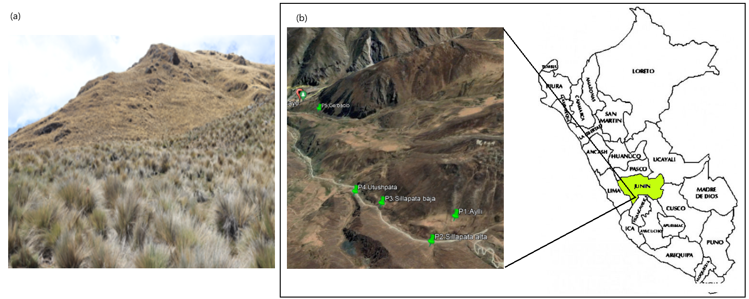
Figure 1. a) Andean tussock grasslands (plant formation that presents the dominance of the genus: Calamagrostis, Festuca, and Stipa), b) location of the study area in the central Andes of Peru.

  - Data collection
The study areas were selected for the convenience of the research, considering the dominance of grassland species (Figure 1a), in them were fenced five plots of 900 m² according to the method suggested by Otzen & Manterola, (2017), with wooden posts and barbed wire, each plot was separated between 0.8 and 3 km away. Within each plot, 5 subplots of 64 m² were located and each of them was divided into two halves, to apply two natural fertilizers: cattle manure and phosphoric rock; in each fertilized plot 25 seedlings were transplanted, of different species taking into account the species present in them, such as Calamagrostis intermedia, Festuca rigidifolia, Calamagrostis antoniana, F. sp, and Calamagrostis tarmensis.
After having marked the subplots, the natural fertilizer was applied in each area of fertilization, on the left side was applied the cattle manure, previously dried and crumbled, spreading over the area, broadcast and uniformly at the rate of 4000 kg/ha (Zapata, F., and Roy, R., 2007), in the same way, but on the right side was spread ground phosphate rock (P2O5: 18 - 22%, CaO: 28 to 30%, SO4: 3 - 5%) at a rate of 1500 kg/ha (Elouear, 2016). The transplanting procedure was carried out in stages as follows: (a) plot fencing followed by subplot marking and division of composting areas, (b) estimation of the average density of the grassland species present, using the "nearest neighbor" method (Pieper, 1973), measuring the distance to the nearest plant of the same species in cm, in the form of a cross starting from the epicenter of a plant, (c) identification and marking of transplanting points in those empty spaces between 3 or 4 plants, with space greater than the average distance between neighboring plants, d) from the contour of the plot were selected the plants of good development, enough to be divided into more than 5 cuttings, e) the leaves and stems were cut leaving between 3 to 5 cm in height, then they were extracted taking care that the root biomass is covered soil, f) division of the extracted plant in rectangular sections with approximately 10 to 15 cm of side, as far as possible maintaining the soil covering the root system, using a metal machete, g) digging of holes in the transplanting points and transplanting of the cuttings.
Data collection began 30 days after the transplants were installed (October 2020), in the case of non-viable cuttings, these were exchanged for new ones; 10 transplants were also marked in each specific area of fertilization. The height of the shoot was measured in cm, using a pleximeter graduated in mm (two measurements per plant to record the resulting average), recording 100 data for each plot. The foliage cover of the shoot was evaluated by double measurement of the projection to the ground in a cross from the flag leaves. The total data collected amounted to 200 monthly records per plot, accumulating 18000 data in 9 months of monitoring. From the last 5 months (February 2021) the beginning of inflorescence formation of some plants was observed, whose height was also measured, as additional data.
  - Data analysis
The collected data were arranged in double-entry matrices, the factors and variables (canopy cover, canopy height, and inflorescence height) and physical and (climatic, etc.) factors in rows and monthly data in columns, in an Excel sheet. Foliage cover was calculated by the ellipsoidal area formula, using the equation A= r1*r2*л, where: A is the area covered by foliage, r1 is the radius of axis 1 in cm, r2 is the radius of axis 2, and л is the ratio between the length of a circumference and its diameter as a constant element with a value of 3. 1416 (Martínez-Encino et al., 2013, Yaranga et al., 2021). To contrast the study hypotheses on foliage cover, foliage height considering the average leaf flag and, inflorescence height. The data generated were analyzed using the "Generalized linear mixed model" method recommended for biological studies by Dicovskiy & Pedroza (2018), using the Rstudio vs 4.1.2, using the following equation:

Yijkl = μ + Ω i + βj + λk + εijkl
where:
Yijkl: Plant characteristic evaluated.
Ωi: The effect of the plot on the evaluated plant characteristic.
βj: The effect of the species.
λk: The random effect of the evaluated plant characteristic.
εijkl: The random effect of variation.
A canonical correlation analysis was also performed between the biological variables under study and the environmental variables: low temperature and maximum temperature in °C, rainfall in liters per m2 in each plot, using PAS vs 3.14 software, under the multiple linear correlation model: $X=(X_1, X_2, X_p) and Y=(Y1, Y2,..., Yq)Y=(Y1, Y2,..., Yq) recommended by Trendafilov & Gallo (2021).
- Results
  - Foliage cover, leaf height, and inflorescence height
Foliage cover expressed in cm2 and growth height in cm were considered as important morphological characteristics for monitoring transplanted plants, according to plant species, plot location, and fertilizer applied.
Regarding foliage cover, it was observed that the species Calamagrostis intermedia showed the fastest response in the second month of control from 226.91 to 271.8 cm2 to experience a gradual reduction in the following months up to 195. 57 cm² in the last month of control (Figure 2a); Festuca rigidifolia showed a continuous increase until the fourth month from 232.71 to 281.71 cm² and ended with 231.62 cm² (Figure 2b), the third species Calamagrostis tarmensis showed maximum development in the second month from182. 64 to 276.3 cm² and was reduced to 120.16 cm² in the ninth month of control (Figure 2c); while, in F. sp the increase was observed in the third month 320.63 to 390.4 cm² being reduced at the end with 195. 5 cm² (Figure 2d); finally, the species C. antoniana showed the greatest increase in the third month from 250.3 to 326.05 cm² then decreased in the eighth month to 122 cm² and recovered in the ninth month with 269.67 cm² (Figure 2e).
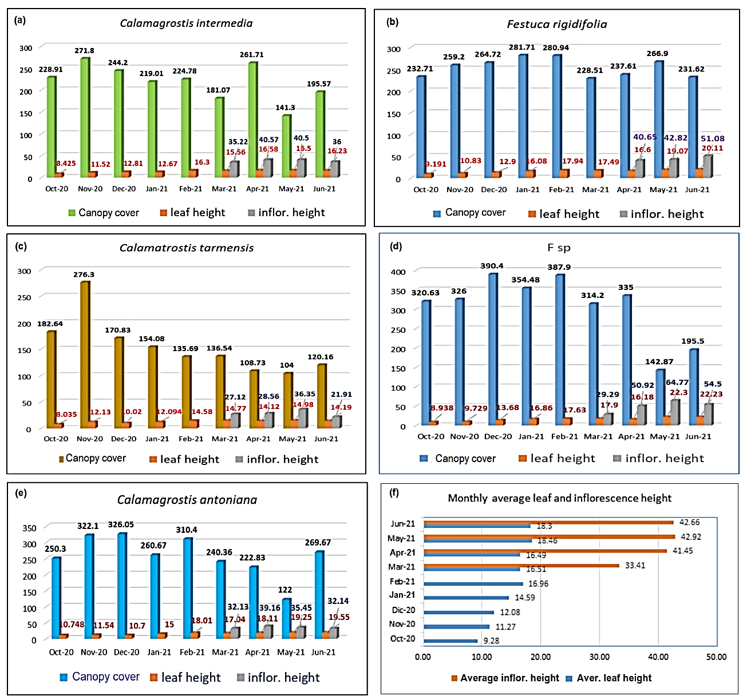
Figure 2. The behavior of aerial coverage, leaf flag height, of five Andean grassland species: a) Calamagrostis intermedia, b) Festuca rigidifolia, c) Calamagrostis tarmensis, d) F. sp, e) Calamagrostis antoniana and f) inflorescence growth, finally f) Monthly average leaf and inflorescence height.

In the statistical analysis of foliage cover, significant differences were observed for p≤0.001, resulting in the species Calamagrostis antoniana with the highest cover of 873±165.7 cm2, followed by Festuca sp with 620±143.3 cm², then F. rigidifolia with 301±63.3 cm², and C. intermedia with 278±83.2 cm² and finally C. tarmensis with 227±42.6 cm² (Figure 3a). At the plot level, differences were also observed for p≤0.001, resulting in the plot located in Gerbacio (P5) with 747±231.2 cm², followed by the plot in Sillapata Baja (P3) with 714±113. 9 cm², then in Sillapata Alta (P2) with 388±69.1 cm², then in Aylli (P1) with 205±67.9 cm², and finally in Otushpalla (P4) with 197±82.3 cm² (Figure 3b).
Leaf height in the 5 species showed a certain homogeneity even with small seasonal variations, thus in C. intermedia increased from 8.425 cm in the first month of control to 16.23 in the final control; in F. rigidifolia from 9.121 to 20.11 cm, in C. tarmensis from 8.035 to 14.19 cm, in F. sp from 8.938 to 22.23 cm, and finally in C. antoniana from 10.748 to 19.55 cm. A statistical analysis, no significant difference was observed for p ≤ 0.05, with averages of F. sp with 22.2±1.15 cm; F. rigidifolia with 20.1±0.77 cm, C. antoniana with 19.50±1.07 cm; C. intermedia with 16.2±0.815 and C. tarmensis with 14.2±0.865 cm (Figure 3c). In the comparison by plot location effect, a significant difference was observed for p ≤ 0.05, being the highest in P3 with 21.9±0.843 cm, followed by P5, P2, and P1 with 18.9±084 cm, 18.5±0.84 cm, and 17.8±.83 cm, finally the lowest for P4 with 14.4±084 cm.
In addition, the height to the apex of the inflorescence of the plants was evaluated (Figure 2f), which on average started at 33.41 cm and reached 42.92 cm in May and was reduced to 42.66 cm in June, due to the effect of the night frosts on the first inflorescences. The same figure shows the evolution of the monthly average height including the 5 species, which at the first control started with 9.28 cm and reached 18.46 cm in May and by June was reduced to 18.3 cm due to the effect of the low temperature during the period. In the statistical analysis between species, no difference was observed for p ≤ 0.05, whose averages were, for C. antoniana 50.0±14.29 cm, F. rigidifolia 54.4±5.91 cm; for F. sp 54.3±12.31 cm; for C. intermedia 46.3±7.48 cm (Figure 3c). In the statistical analysis by the effect of plot location, no difference was observed for p ≤ 0.05, whose averages were for P3 57.7±9.99 cm, for P2 55.8±6.55 cm, for P1 45.9±6.42 cm, for P5 34.5±19.49 cm and finally P4 52.3±7.34 cm (Figure 3d).
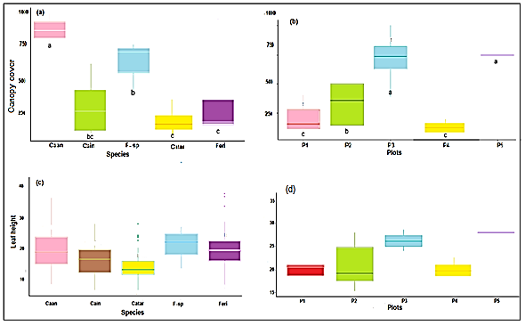
Figure 3. LSD (Least Significant Difference) of canopy cover: a) between species and b) at plot level; LSD of leaf height: c) between species and d) at plot level.

  - Effect of natural fertilization on canopy cover, leaf height, and inflorescence height
Foliage cover due to the effect of the application of cattle manure was better than in those applied with phosphate rock, In the first case, after 30 days it reached 227.06 cm², and at the end of the evaluation period, it reached 290.42 cm² (Figure 4a), while in the second case, it started with 191.71 cm² and at the end, it reached 263.60 cm² (Figure 4b). Statistical analysis showed differences for p ≤ 0.05 in favor of cattle manure with 413±38.2 cm² and phosphate rock with 258±100.8 cm² (Figure 5b).
The evolution of the average height of the leaf tray was different between natural fertilizers applied in the study site (Figure 4: a) it was observed that the transplants fertilized with cattle manure developed from 10.27 cm to 20. 43 cm, while those fertilized with phosphate rock developed from 7.95 cm to 16.17 cm, in both cases it was observed that the greatest development occurred between the third and fifth months coincided with the beginning of the rainy season, and then slowed its growth until the last month of control. In the statistical analysis, no difference was found for p ≤ 0.05, whose averages were 54.5±4.59 cm for the transplants fertilized with cattle manure and 45.4±6.76 cm for those fertilized with phosphate rock (Figure 5a).
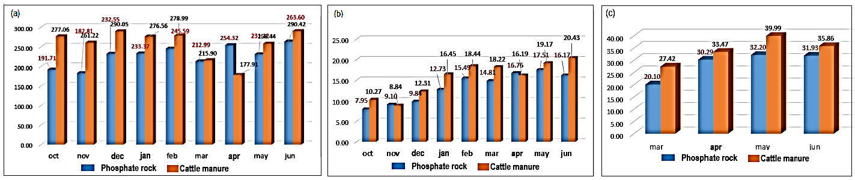
Figure 4. Monthly growth trend of species: a) Canopy cover, b) leaf height and inflorescence height, by the effect of fertilization with cattle manure and phosphate rock, at 9 months of growth control of transplanted Andean grassland species.

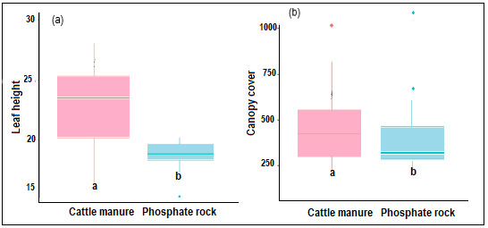
Figure 5. LSD of: a) aerial cover of Andean grassland species and b) height of flag leaves, both due to the effect of fertilization with cattle manure and phosphate rock.

  - Canonical correlation between the biological and environmental variables
Among the environmental variables, the monthly accumulated rainfall (recorded in each plot), showed that in November 2020 there was no rainfall, which marked an irregular event during the rainy season; likewise, February 2021 did not correspond to the peak of rainfall. On the other hand, precipitation was also not uniform for the five plots during the observation period (Figure 6a). Otherwise, the monthly precipitation averages varied from 1.59 to 154.67 liters/m2 (l/m2), and during the evaluation period from 457.57 to 533.96 l/m2 in 9 months of record.
The CCA with the environmental variables (monthly average of minimum temperature, the maximum temperature in °C and rainfall (l/m²) analyzed at 95% probability, showed that the biological variables (foliage cover, foliage height, and inflorescence height) maintained the highest correlation in the second quadrant, with the months from October to March (rainy period) and the maximum temperature; on the contrary, the months of April, May, and June (dry period) were not correlated with the biological variables (Figure 6b). The description of occurrences was in 90.65% of the data.
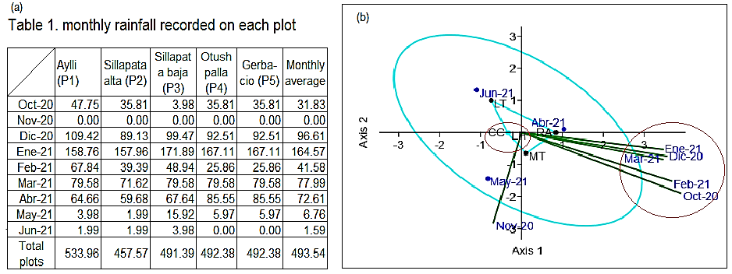
Figure 6. a) Table 1, b) Canonical correlation of leaf cover, leaf height, and inflorescence height, with climatic variables: minimum temperature, maximum temperature, and rainfall.
- Discussion
  - Canopy cover, canopy height, and inflorescence height
The rapid response observed in the initial growth of the shoot of the transplanted cuttings was due to the solidity of the root architecture that was protected by the soil loaf that accompanied and provided nutrients necessary for the growth of the grassland plants, avoiding water stress (Fry et al., 2018); even though the transplanting was done at the end of the dry seasonal period (September 2021), allowing to continue the good development in some until the third month and in others as in Festuca rigidifolia until the sixth month of transplanting, to then move to a period of slowing growth despite the rainy period that should influence the greater development. This aspect indicated that the nutritional reserve of the soil loaf was depleted, therefore, the plants had to consolidate the fixation of their roots to the surrounding soil to assimilate the nutrients of the new edaphic layer (Lepik et al., 2021), which was achieved in the ninth month of transplanting to show new growth acceleration in June, except for F. rigidifolia. This biological behavior indicates that the transplanting of grassland species including the soil bread surrounding the roots was necessary and reduced the effects that should be negative by the extraction of the plant from the soil and segmentation into cuttings; on the other hand, it was revealed the indication that root fixation under the form as the cuttings have been obtained is consolidated from the ninth month of transplanting, which coincides with results obtained in the asexual propagation of native grasses evaluated in Brazil by Figueiredo et al. (2018).
The variation of response based on the location of the plots is due to differences in soil physical-chemical characteristics such as structure, compaction, erosion susceptibility, mineral contents, moisture content, and other properties (Zeberio and Perez, 2021); according to these criteria the study plots varied in altitude (4012 and 4333 masl), precipitation received by plots (491 and 533 l/m²), and soils that varied in pH (4. 6 to 5.9), in OM (7.3 to (15.2%), in P (3.8 to 24.2 ppm); this was also found by Andueza et al. (2021) when evaluating growth and maturity stage and chemical composition in 6 perennial types of grass, about altitudinal gradient and climatic variables during 2 years in 3 different locations; also topography influences plant development, through a regulatory phenomenon of respiration, being higher in flat areas than in sloping ones (Zhang et al., 2021).
  - Effect of natural fertilizer on canopy cover, canopy height, and inflorescence height
The incorporation of organic matter and minerals to the soil, enrich the availability of nutritional elements for plants (Elouear et al., 2016); however, the effect on natural fertilizers could not be perceived immediately because the mineralization process is slow due to several factors: the decomposition time of cattle manure, the climatic characteristics and the altitude of the location of the plots; on the other hand, the poor solubility of phosphate rock in water and the acid condition of Andean soils (Rolando et al., 2017); in this context, transplants fertilized with cattle manure had greater response in the expansion of canopy cover versus those fertilized with phosphate rock, because cattle manure carries with it parts of the urine that is a source of nitrogen plus the labile carbon that is released in the decomposition period of cellulose and hemicellulose, plus those released by the microorganisms in the rumen of cattle (Wang et al., 2018; Avilio et al., 2020) and these when washed by rain is integrated into the soil in less time, therefore assimilated by the plant and by soil microorganisms; meanwhile, the phosphate rock did not contribute N or C which, are the main promoters of growth and leaf elongation in plants in the first instance.
  - Canonical correlation between biological and environmental variables
The regret is shared that inter-annual changes in precipitation are not visualized in their real dimension, because the data available in the long term are statistically managed for large areas, which hides the real changes that occur and vary over small areas where there is no recording equipment (Djebou et al., 2021; Yixing et al., 2021).
These irregularities of precipitation create space of scarcity or lack of rainfall that affect the maintenance of soil moisture; however, the lack of water in the soil can be mitigated if the vegetation protects the soil against rapid evaporation through the shade formed by the abundance of its leaves (De Jesus, 2021). These criteria are very important, to note that the Andean grasslands, being populated by tall grass species with many tillers, maintain soil moisture, which allows maintaining a continuous growth of the transplanted cuttings, at least until completing their vegetative development (Muñoz, 2017; Padilla et al., 2019).
The correlation of canopy cover, canopy height, and high inflorescence height in October 2020 to March 2021 was due to the higher rainfall that occurred in these months by which the soils were maintained with higher humidity, in addition to the less abrupt temperature, mainly in the maximum temperature. These variables, being the main climatic factors influenced the production of leaves, stems, and the development of the different phenological phases of production and reproduction of the plants (Muñoz, 2017). Meanwhile, the dry months: April, May, and June did not maintain the level of correlation observed for that period, which contrarily reduced the expansion of canopy cover and the growth of leaves, stems, and inflorescence, because of the scarcity of water in the soil, the reduction of soil microorganisms and their association with minimum temperatures (Li et al., 2021); however, the continued growth even at the lower level was due to the change of the structure with increased vertical development of roots to fulfill the function of searching for water in the subsoil (Padilla et al., 2019; Jun et al., 2020). Since, longer-lasting rainfall has allowed the greater accumulation of water deep in the subsoil and was not strongly affected by the phenomenon of evapotranspiration (Muñoz, 2017; Chen et al., 2021).
- Conclusion
The development of the Andean tussock grassland cuttings has shown attractive viability, by maintaining a continuous growth both at the level of canopy cover and at the level of canopy and inflorescence height, despite the dry season (April to August), favored by the soil loaf that accompanied the root system at the time of transplanting, which reveals the possibility of optimizing the density of plants to increase phytomass production. However, the differentiated influence of the location of the plots has been observed due to differences in altitude, soil characteristics, and the level of precipitation received by each plot, as well as due to the type of natural fertilizer applied. On the other hand, there were indications that the roots began to attach to the new soil environment from the ninth month after transplanting, under the modality adopted for the segmentation of the plants extracted in cuttings, evidencing that the initial development of the cuttings depended on the amount of soil conserved in the roots. Finally, the evaluation period (9 months) was insufficient, since at the field level the continuation of growth was observed, which suggests that similar work should guarantee an evaluation over a period longer than 12 months, taking into account the stabilization of plant growth and the time necessary for the mineralization of the fertilizers applied.
- Acknowledgments
In this article, we would like to express our gratitude to the community of Acopalca in the person of its president Dario Palomino Cunyas, and to the families who donated and fenced the study plots, as well as guarded the control plots during the evaluation period; also to the Belgian association VLIR-UOS that supported the inter-university relationship and provided funding for this and other studies, to Universiteit of Leuven (KUL) and to the Asociación Civil de Desarrollo Sostenible that played the role of bridge between the financier and the project in coordination with KUL.
References
An, S., Chen, X., Zhang, X., Lang, W., Ren, S., & Xu, L. (2020). Precipitation and minimum temperature are primary climatic controls of alpine grassland autumn phenology on the Qinghai-Tibet plateau. Remote Sensing, 12(3). https://doi.org/10.3390/rs12030431
Andueza, D., Picard, F., Note, P. & Carrère, P. (2021). Relationship between the chemical composition, nutritive value, and the maturity stage of six temperate perennial types of grass during their first growth cycle along an altitude gradient, European Journal of Agronomy. 130:126364, https://doi.org/10.1016/j.eja.2021.126364.
Arroyo, M., Tamburrino, I., Pliscoff, P., Robles, V., Colldecarrera, M., & Guerrero, P. (2021). Flowering Phenology Adjustment and Flower Longevity in a South American Alpine Species. Plants, 10(3), 461. https://doi.org/10.3390/plants10030461.
Aricha, H., Simujide, H., Wang, C., Zhang, J., Lv, W., Jimisi, X., Liu, B., Chen, H., Zhang, C., Él, L., Cui, Y., Gao, R., & Aorigele, C. (2021). Comparative Analysis of Fecal Microbiota of Grazing Mongolian Cattle from Different Regions in Inner Mongolia, China. Animals. 11(7):1938. https://doi.org/10.3390/ani11071938.
Avilio, D., Olmedo, O., & Paniagua, P. L. (2020). Aproximación teórico práctica a la evaluación del ciclo de carbono de una ganadería de cría de ciclo completo mantenida en pastizales nativos de la zona de Pantanal Chaco Paraguayo, (September). https://doi.org/10.13140/RG.2.2.17812.12167.
Chen, J., Yao, Y., Wang, G., Zhong, X., Yang, T., and Sun, W. (2021). Decreased precipitation frequency altered abundance, but not community structure, of soil nematodes in degraded grasslands. Ecological Indicators, 131:108184. https://doi.org/10.1016/j.ecolind.2021.108184.
De Jesus, J., Kuplich, T., De Carvalho, B., Niederauer, C., and Hillebrand, J. (2021). Perfiles temporales y fenológicos de Caatinga abierta y densa usando sensores remotos: respuesta a la precipitación y sus irregularidades. J. Para. Res. 32: 1067–1076. https://doi.org/10.1007/s11676-020-01145-3.
Djebou, C., Conger, S., Szogi, A., Stone, K., and Martin, J. (2021). Análisis de patrones de precipitación estacional para el apoyo a la toma de decisiones en la gestión del riego agrícola en Luisiana, EE. UU. Gestión del agua agrícola, 254:106970.
Elouear, Z., Bouhamed, F., Boujelben, N., & Bouzid, J. (2016). Application of sheep manure and potassium fertilizer to contaminated soil and its effect on Zinc, Cadmium, and lead accumulation by alfalfa plants, Sustainable Environment Research, 26: 161-135. http://dx.doi.org/10.1016/j.serj.2016.04.004.
Figueiredo, M.A., Diniz, A.P., Messias, M.C.T.B. et al. (2018). Propagation and establishment of rupestrian grassland grasses for restoration of degraded areas by mining. Braz. J. Bot 41, 287–295. https://doi.org/10.1007/s40415-018-0456-x
Fry, E., Savage, J., Hall, A., Oakley, S., Pritchard, W., Ostle, N., ... & Bardgett, R. (2018). Soil multifunctionality and drought resistance are determined by plant structural traits in restoring grassland. Ecology, 99(10), 2260-2271. https://doi.org/10.1002/ecy.2437.
Getabalew, M., & Alemneh, T. (2019). Factors Affecting the Productivity of Rangelands, Journal of Plant Sciences and Agricultural Research, 3(1):19.
Gao, T., Xu, Z., Yang, X., Deng, S., Liu, Y., Jin, Y., Ma, H., Li, J., Yu, H., Zheng, X., & Yu, Q. (2017). Aboveground net primary productivity of vegetation along a climate-related gradient in a Eurasian temperate grassland: spatiotemporal patterns and their relationships with climate factors. Environ Earth Sci, 76:56, https://doi.org/10.1007/s12665-016-6158-4.
Grigulis, K. & Lavorel, S. (2020). Simple field-based surveys reveal climate-related anomalies in mountain grassland production. Ecological Indicators 116, p 9. https://doi.org/10.1016/j.ecolind.2020.10659.
Jouany, C., Morel,C., Ziadi,N., Bélanger, G., Sinaj, S., Stroia, C., Cruz, P., Theau, JP., & Duru, M. (2021). Plant and soil tests to optimize phosphorus fertilization management of grasslands. European Journal of Agronomy, 125. https://doi.org/10.1016/j.eja.2021.126249
Jiang, C., Zhang, H., Tang, T., & Labzovskii, L. (2017). Evaluating the coupling effects of climate variability and vegetation restoration on ecosystems of the Loess Plateau, China, Land Use Policy. 69: 134-148, https://doi.org/10.1016/j.landusepol.2017.08.019.
Lepik, A., Abakumova, M., Davison, J., Zobel, K. y Semchenko, M. (2021). El mapeo espacial de los sistemas de raíces revela diversas estrategias de exploración del suelo y concurso de recursos en las plantas de pastizales. Diario de Ecología, 109 (2), 652-663. https://doi.org/10.1111/1365-2745.13535.
Li, H., Wang, C., Zhang, F., He, Y., Shi, P., Guo, X., Wang, J., Zhang, L., Li, Y., Cao, G., and Zhou, H. (2021). Atmospheric water vapor and soil moisture jointly determine the spatiotemporal variations of CO2 fluxes and evapotranspiration across the Qinghai-Tibetan Plateau grasslands. Science of The Total Environment, 791:148379. https://doi.org/10.1016/j.scitotenv.2021.148379.
Menšík, L., Hlisnikovský, L., Pospíšilová, L., & Kunzová, E. (2018). The effect of application of organic manures and mineral fertilizers on the state of soil organic matter and nutrients in the long-term field experiment. J Soils Sediments 18, 2813–2822. https://doi.org/10.1007/s11368-018-1933-3.
Muñoz, J. (2017). Regeneración Natural: Una revisión de los aspectos ecológicos en el bosque tropical de montaña del sur del Ecuador. Bosques Latitud Cero, 7(2), 130–143.
Ozlu, E., & Kumar, S. (2018). Respuesta del carbono orgánico del suelo, pH, conductividad eléctrica y agregados estables en agua al abono anual a largo plazo y fertilizantes orgánicos, Soil Science Society of America Journal. 82(5): 1243-1251, https://doi.org/10.2136/sssaj2018.02.0082
Ohler, L., Lechleitner, M., & Junker, R. (2020). Microclimatic effects on alpine plant communities and flower-visitor interactions, Scientific reports. 10. https://doi.org/10.1038/s41598-020-58388-7.
Ojeda, A., Domínguez, O. y Suárez, D. (2019). Pastoreo Racional Voisin con dosis de emulsión asfáltica y roca fosfórica en suelos ácidos de baja fertilidad natural. Asociación Brasileira de agroecología. 14(2): 13-15.
Padilla, F. M., Mommer, L., de Caluwe, H., Smit-Tiekstra, A. E., Visser, E. J. W., & de Kroon, H. (2019). Effects of extreme rainfall events are independent of plant species richness in an experimental grassland community. Oecologia, 191(1), 177–190. https://doi.org/10.1007/s00442-019-04476-z
Pieper, R.D. 1973. Measurement techniques for herbaceous shrubby vegetation. New Mexico State University. The USA. 184 p
Tacuna, R., Aguirre, L., y Flores, E (2015). Influencia de la revegetación con especies nativas y la incorporación de materia orgánica en la recuperación de pastizales degradados, Ecología Aplicada, 14(2):192-200.
Trendafilov N., Gallo M. (2021). Canonical correlation analysis (CCA). In: Multivariate Data Analysis on Matrix Manifolds. Springer Series in the Data Sciences. Springer, Cham, p 450. https://doi.org/10.1007/978-3-030-76974-1_8.

Rathinasabapathi, Bala (2018). Crop Improvement through Microbial Biotechnology. “Chapter 18. Phosphate-Solubilizing Pseudomonads for Improving Crop Plant Nutrition and Agricultural Productivity”. P: 363–372. https://doi.org/doi:10.1016/B978-0-444-63987-5.00018-9.

Rawat, P., Das, S., Shankhdhar, D., & Shankhdhar, S. C. (2020). Phosphate-solubilizing microorganisms: Mechanism and their role in phosphate solubilization and uptake. Journal of Soil Science and Plant Nutrition, (2019). https://doi.org/10.1007/s42729-020-00342-7
Sarmiento,L.; Smith, J,; Márquez,N.; Scalona, A.; and Eraza, M. (2014). Constraints for the restoration of tropical alpine vegetation on degraded slopes of the Venezuelan Andes. Plant Ecology & Diversity. (1)16-23. https://doi.org/10.1080/17550874.2014.898163.

Veláquez, S., Pelaés, G. y Gerañdo, D.(2016). Uso de materiales vegetales en materiales compuestos de matriz polimérica: una revisión con miras a su aplicación en el diseño de nuevos productos. Informador técnico (Colombia) 80(1), 77-86.
Yaranga, R., Custodio, M., & Orellana, E. (2019). Composition and floral diversity in Andean grasslands in natural post-harvest restoration with Lepidium meyenni Wapers. Ambiente & agua. 14(5): 13. https://doi.org/10.4136/ambi-agua.2351.
Yaranga, R., Van Vuure, A., Fuentes, R.A., Fuentes, A.A., Maraví, K., Román, M., Cáceres, D., & Fuentes, C.A (2021). Andean Grassland Species: Net Aerial Primary Productivity, Density, Ecomorphological Indices, and Soil Characteristics, Journal of Ecological Engineering, 22(10), 163–175, https://doi.org/10.12911/22998993/138816.
Vistoso, E., Iraira, S., & Sandaña, P. (2020). Effects of Phosphorus Fertilizer Solubility on Pastures Yield and Quality in Andisols. Journal of Soil Science and Plant Nutrition, 20(2), 637–647. https://doi.org/10.1007/s42729-019-00152-6.
Wang, J., Wang, D., Li, C., Seastedt, T.R., Liang, C., Wang, L., Sun, W., Liang, M., and Li, Y. (2018), Feces nitrogen release induced by different large herbivores in dry grassland. Ecol Appl, 28: 201-211. https://doi.org/10.1002/eap.1640
Wang, S., Hou, F. (2021). Seed Bank of Livestock Dung in the Qilian Mountain Grassland: A Potential Resource for Vegetation Recovery, Rangeland Ecology & Management, 78: 90-99, https://doi.org/10.1016/j.rama.2021.06.001.
Yin, Y., Chen, H., Wang, G., Xu, W., Wang, S., and Yu, W. (2021). Characteristics of the precipitation concentration and their relationship with the precipitation structure: A case study in the Huai River basin, China, Atmospheric Research. 253:105484. https://doi.org/10.1016/j.atmosres.2021.105484.
Zapata, F., and Roy, R. (2007). Utilización de las rocas fosfóricas para una agricultura sostenible. Organización de las Naciones Unidas para la agricultura y la alimentación. FAO, Roma, p: 94. ISBN: 978-92-5-305030-7
Zhang, Y., Zou, J., Dang, S., Osborne, B., Ren, J., and Ju, X. (2021). Topography modifies the effect of land-use change on soil respiration: A meta-analysis, EOSPHERE, 12(12):03845, https://doi.org/10.1002/ecs2.3845.

