Evaluation of antimicrobial and antioxidant activity of Rhamnolipids biosurfactant Produced by Pseudomonas aeruginosa
Nassir Abdullah Alyousif^{1,♥}, Wijdan H. Al-tamimi², Yasin Y. Y. Al-luaibi²
¹Department of Ecology, College of Science, University of Basrah. Basrah, Iraq. ²Department of Biology, College of Science, University of Basrah. Basrah, Iraq ♥ Corresponding author: nassir.hillo@uobasrah.edu.iq

ABSTRACT Rhamnolipids are the glycolipid biosurfactant that are produced by different Pseudomonas species, it shows antioxidant and antimicrobial activity. Rhamnolipid biosurfactant was tested as antioxidant agent, the results showed 22.7 %, 47.4 %, 79.8 %, 85 % and 91.4 % of antioxidant activity at the concentrations 5, 10. 15, 20 and 25 mg/ml respectively. Cytotoxicity of the rhamnolipid biosurfactant was examined also at different concentrations against human erythrocytes. Hemolysis of the erythrocytes was observed at concentrations 100, 75, 50, 40 and 35 mg/ml, whereas the results exhibited no hemolysis at concentrations 25 and 15 mg/ ml. The findings of antimicrobial activity showed the rhamnolipid biosurfactant had antimicrobial effect against the microorganisms at different concentrations such as toward Bacillus cereus and Klebsiella pneumoniae, while lower inhibitory effect toward Staphylococcus aureus and Pseudomonas aeruginosa. The rhamnolipid biosurfactant was shown lower inhibitory effect against fungal strains Candida albicans and Aspergillus niger. The lower minimum inhibitory concentration (MIC) values of rhamnolipid biosurfactant toward the investigated microorganisms was 2 mg/ml toward E. coli, Klebsiella pneumoniae and Pseudomonas aeruginosa and 3 mg/ml for Staphylococcus aureus, Enterobacter cloacae, Bacillus cereus, Proteus mirabilis, Candida albicans and Aspergillus niger. The study concluded that rhamnolipid biosurfactant exhibited effective antioxidant activity, no hemolysis at lower concentrations and has high antimicrobial effect.

KEYWORDS Rhamnolipid; Antimicrobial; Antioxidant; Cytotoxicity; Pseudomonas aeruginosa
1. Introduction
The antibiotics abuse has been led to the development of multi-drug resistant pathogens to commercially marketed antibiotics. The combatting of resistant infections emergence is required to search for development of novel antimicrobial drugs having broad spectrum antimicrobial activity (Terreni et al. 2021). The problem of the increasing resistance by pathogens to some antimicrobial compounds has paid attention to invest the natural compounds with various mechanisms of action as suitable alternatives to existing antibiotics (Álvarez-Martínez et al. 2020). A number of biosurfactants compounds have been exhibited antimicrobial activity against various human pathogenic bacteria, making them a suitable substitute for existing antimicrobial agents as potent therapeutic agents (De Giani et al. 2021).
Rhamnolipids are the glycolipid biosurfactant that are produced by different bacterial species such as Pseudomonas aeruginosa, Pseudomonas plantarii, Pseudomonas chlororaphis, Pseudomonas putida, Pseudomonas fluorescens, Burkholderia pseudomallei, Burkholderia thailandensis, Burkholderia plantarii, Burkholderia glumae and Serratia rubidaea SNAU02 (Costa et al. 2011; Nalini and Parthasarathi 2013; Irorere et al. 2017; Tan and Li 2018).
Pseudomonas aeruginosa is major producer of the rhamnolipid biosurfactant, which is widely distributed in the environment that can be available in variety of habitats, where it survives in these habitats due to its extraordinary physiological abilities (Moradali et al. 2017). Rhamnolipids are sustainable and show excellent physicochemical properties, which make them interesting for utilizing the rhamnolipids in cosmetic, food, pharmaceutical, and detergent manufacturing (Sekhon Randhawa and Rahman 2014). Rhamnolipids are good food additive as food preservatives and texturizing agents such as antimicrobials, antioxidants, emulsifiers and stabilizers that can be used in food processing (Nitsche and Silva 2018).
Lotfabad et al. (2013) reported remarkable inhibitory activity of rhamnolipids biosurfactants against Gram-positive bacteria and two fungi species Chaetonium globosum and Penicillium funiculosum, while no showed inhibition effects against Gram-negative bacteria and two fungi species Aureobasidium pullulans and Penicillium chrysogeum. While, Ndlovu et al. (2017) revealed the antimicrobial activity of rhamnolipid biosurfactants produced by P. aeruginosa ST5 against variety of opportunistic and pathogenic microorganisms, including antibiotic resistant Staphylococcus aureus and Escherichia coli and the fungal pathogens including Candida albicans and Cryptococcus neoformans.
The exact mechanism action of rhamnolipid biosurfactant against microbes is not completely understood and unknown but, it is supposed that the plasma membrane of the cell is the target, as the rhamnolipid has an amphipathic nature that allows it to interact with the phospholipids of the plasma membrane (Magalhães, and Nitschke 2013). The current study aimed to assess antimicrobial and antioxidant activity of rhamnolipids biosurfactant formed by Pseudomonas aeruginosa.

2. Materials and Methods
2.1. The rhamnolipid biosurfactant Sample
The rhamnolipid biosurfactant sample utilized in current study was extracted from Pseudomonas aeruginosa isolated in previous study from hydrocarbon contaminated soil (Alyousif et al. 2020a). The extracted rhamnolipid biosurfactant was purified and characterized in previous study (Alyousif et al. 2020b).
2.2. Antioxidant Activity of rhamnolipid biosurfactant
The method carried out according to Barros et al. (2007) with the modification in the present study. One ml of each sample at the concentrations 5, 10. 15, 20 and 25 mg/ml of DMSO was added to 1 ml of 0.2 mM methanolic DPPH of freshly prepared DPPH solution. The reduction of DPPH radicals was measured at 517 nm after incubation in the dark for 30 min. Ascorbic acid was used as the positive control with same concentration of the samples. The percentage of scavenged DPPH radical was calculated using the following formula:
DPPH radical scavenging % = [(A₀ – A₁)/A₀] x 100
Where, A₀ is the absorbance of the DPPH solution and A₁ is the absorbance of the sample.
2.3. Cytotoxicity Assay of rhamnolipid biosurfactant
The toxicity of rhamnolipid was tested against human erythrocytes according to method of He et al. (1994). The blood suspension was prepared by adding 1 ml blood into 20 ml of physiological saline. The concentrations of rhamnolipid (15, 25, 35, 50, 75 and 100 mg/ml) were dissolved in DMSO. The test was performed by adding 100 µl of varying concentrations to 2 ml of blood suspension, and then the tubes were incubated at 37 °C and the turbidity of solution monitored after (3-24 h). The positive result was turned the blood solution into turbid, while the negative result was turned the blood solution into clear. Blood suspension with tap water was used as positive control and blood suspension with normal saline was used as the negative control in addition to the DMSO as a control. The concentrations which gave a turbid solution, due to lysing of erythrocytes as an indication of toxicity degree of rhamnolipid to the erythrocytes.
2.4. Determination of antimicrobial activity of the rhamnolipid biosurfactant
The antimicrobial effect of the rhamnolipid biosurfactant was carried out according to Nanda and Saravanan (2009). The antimicrobial effect was measured using agar well diffusion method. The bacterial isolates (Bacillus cereus, E. coli, Enterobacter cloacae, Klebsiella pneumonia, Proteus mirabilis, P. aeruginosa and S. aureus) and fungal strains includes Candida albicans and Aspergillus niger were cultured and activated individually. The rhamnolipid biosurfactant was dissolved in DMSO at concentrations (5, 10,15, 20 and 25 mg/ ml) using serial rhamnolipid dilution technique. The antimicrobial effect of the rhamnolipid biosurfactant was determined by measuring the inhibition zones diameter against each strain.
2.5. Determination of Minimal Inhibition Concentration (MIC)
The minimal inhibition concentration (MIC) value of the rhamnolipid biosurfactant was carried out according to T.C et al. (2019). MIC was determined by a serial dilution technique using agar well diffusion method. A 10 mg/ml stock solution of the rhamnolipid biosurfactant in DMSO was diluted to concentrations 1, 2, 3 and 4 mg/ml. The minimal inhibition concentration (MIC) value was determined against a panel of pathogenic isolates.

3. Results
3.1. Antioxidant activities of rhamnolipid biosurfactant
The antioxidant activity results of rhamnolipid biosurfactant showed 22.7 %, 47.4 %, 79.8 %, 85 % and 91.4 % at the concentrations (5, 10. 15, 20 and 25 mg/ml) respectively as in figure (1). The rhamnolipid biosurfactant revealed effective antioxidant activity toward DPPH in a concentration dependent manner. In fact, at 25 mg/ ml, the rhamnolipid biosurfactant showed a potential scavenging effect of 91.4 %, which is four-times higher than that obtained at 5 mg/ ml (22.7 %).

Fig. 1: Antioxidant activity of different concentrations of rhamnolipid biosurfactant companying to the standard antioxidant ascorbic acid.
The colour solution was changed from violet to yellow, it turns into a non-radical form after saturation of the electronic layer led to a loss of violet color, which is due to lack of absorption in terms of time at a wavelength of 517 nm as shown in figure (2).
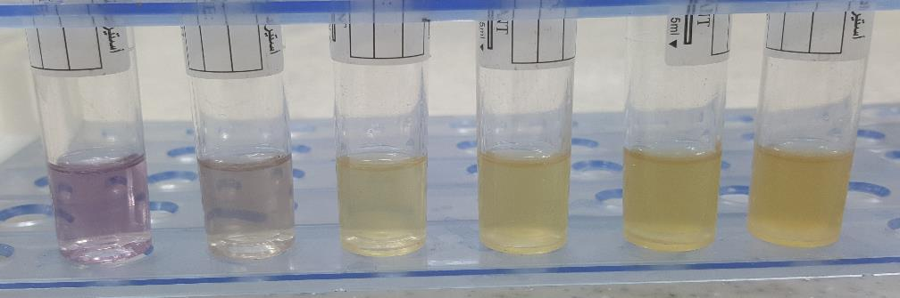
Fig. 2: The antioxidant activity of different concentrations (mg/ml) of rhamnolipid biosurfactant using the DPPH method.
DPPH 5 mg 10 mg 15 mg 20 mg 25 mg
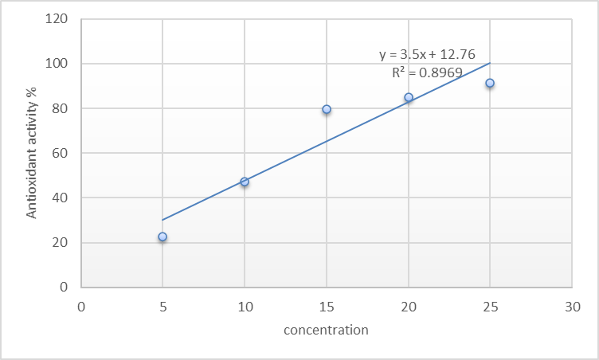
The antioxidant activity of rhamnolipid biosurfactant was assessed by calculating the IC₅₀ value to determine the concentration of rhamnolipid biosurfactant required to inhibit 50% of free radical DPPH present in the mixture. High-IC50 values refer to low antioxidant activity. The IC₅₀ value of rhamnolipid biosurfactant showed 10.6 mg/ml as in figure (3) Thus, the low IC₅₀ value refer to the high antioxidant activity.
Fig. 3: the curve of IC₅₀ value for rhamnolipid biosurfactant.
3.2. Cytotoxicity assay of rhamnolipid biosurfactant
Cytotoxicity of the rhamnolipid biosurfactant was examined at different concentrations (15, 25, 35, 50, 75 and 100 mg/ml) against human erythrocytes. Hemolysis of the erythrocytes was observed at concentrations (100, 75, 50, 40 and 35 mg/ml) to a similar degree as in a positive control of tap water, whereas the results exhibited no hemolysis at concentrations (25 and 15 mg/ ml) to a similar degree as in a negative control of DMSO exhibited no hemolysis as in figure (4).
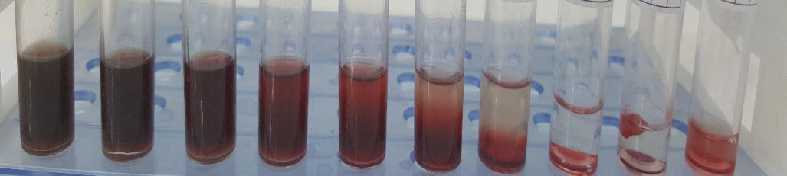
water 100 75 50 35 25 15 normal saline DMSO

Fig. 4: Cytotoxicity activity of rhamnolipid biosurfactant at different concentrations (15, 25, 35, 50, 75 and 100 mg/ml) against human erythrocytes.

3.3. The antimicrobial activity of rhamnolipid
The results of antimicrobial activity showed that the rhamnolipid biosurfactant had antimicrobial effect against all the tested pathogenic isolates at all concentrations (5, 10, 15, 20 and 25 mg/ml) in values were proportional to the rhamnolipid biosurfactant concentrations as shown in figure (5) and table (1). The rhamnolipid biosurfactant was shown higher inhibitory effect against Bacillus cereus (21/5, 23/10, 24/15, 25/20 and 25/25 mm/mg) and Klebsiella pneumoniae (19/5, 20/10, 22/15, 23/20 and 24/25 mm/mg), while lower inhibitory effect against Staphylococcus aureus (15/5, 19/10, 20/15, 20/20 and 20/25 mm/mg) and Pseudomonas aeruginosa (16/5, 19/10, 20/15, 20/20 and 20/25 mm/mg). The rhamnolipid biosurfactant was shown lower inhibitory effect against fungal strains Candida albicans (15/5,18/10, 19/15, 19/20 and 19/25 mm/mg) and Aspergillus niger (14/5, 15/10, 15/15, 15/20 and 16/25 mm/mg).
Enterobacter sp

25

15 20

kkkkk
Bacillus cereus
5
10

25

15
20

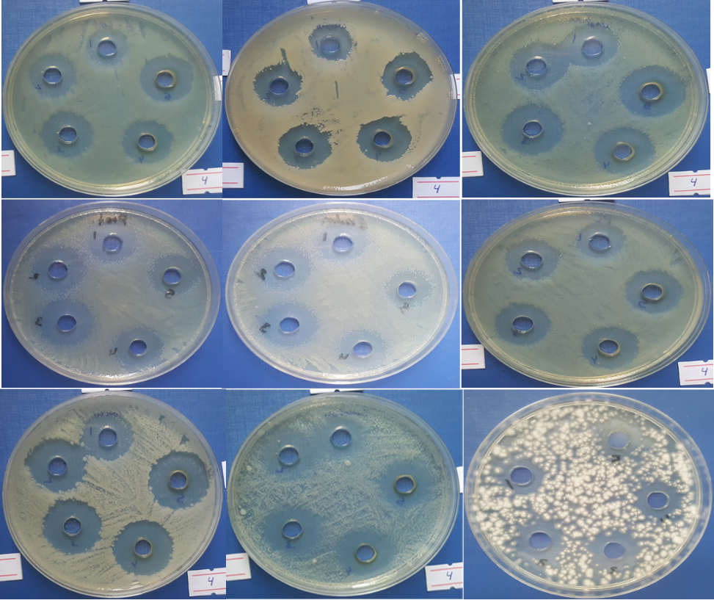
Fig. 5: The antimicrobial activity of rhamnolipid biosurfactant at different concentrations (5, 10,15, 20 and 25 mg/ ml) against nine pathogenic isolates including seven bacteria and two fungi
Table 1: The antimicrobial activity of rhamnolipid biosurfactant against nine pathogenic isolates including seven bacteria and two fungi
Microorganisms | Zone Inhibition Diameters (mm).  Rhamnolipid concentration mg/ml.
 | 5mg | 10mg | 15mg | 20mg | 25mg
E. coli | 16 | 19 | 21 | 21 | 22
Staphylococcus aureus | 15 | 19 | 20 | 20 | 20
Klebsiella pneumoniae | 19 | 20 | 22 | 23 | 24
Proteus mirabilis | 19 | 19 | 22 | 22 | 15
Enterobacter cloacae | 16 | 17 | 20 | 20 | 24
Pseudomonas aeruginosa | 16 | 19 | 20 | 20 | 20
Bacillus cereus | 21 | 23 | 24 | 25 | 25
Candida albicans | 15 | 18 | 19 | 19 | 19
Aspergillus niger | 14 | 15 | 15 | 15 | 16

3.4. Determination of Minimal Inhibition Concentration (MIC)
The MIC values of rhamnolipid biosurfactant against the cultures of pathogenic isolates are shown in figure (6). The rhamnolipid biosurfactant showed lowest minimum inhibitory concentration (MIC) values against the pathogenic isolates, it was 2 mg/ml for E. coli, Klebsiella pneumoniae and Pseudomonas aeruginosa and 3 mg/ml for Staphylococcus aureus, Enterobacter cloacae, Bacillus cereus, Proteus mirabilis, Candida albicans and Aspergillus niger as shown in in table (2).

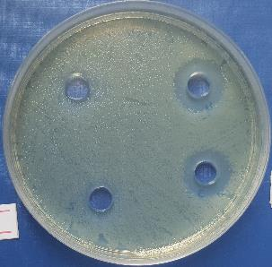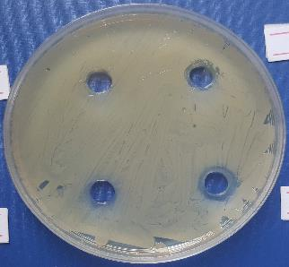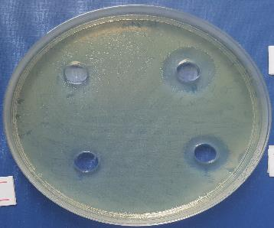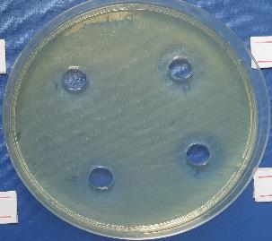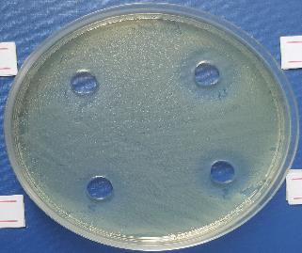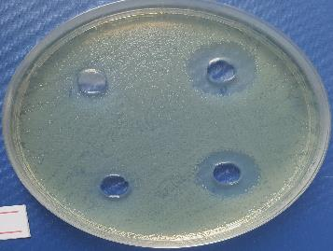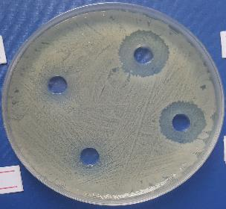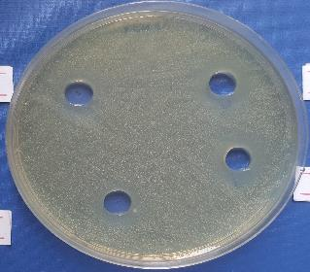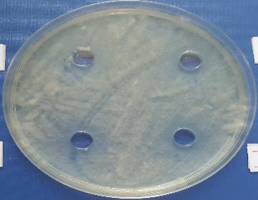Fig. 6: Minimal inhibitory concentration of rhamnolipid biosurfactant using concentrations 1, 2, 3 and 4 mg/ml against nine pathogenic isolates including seven bacteria and two fungi

Table 2: Minimal inhibitory concentration of rhamnolipid biosurfactant against nine pathogenic isolates including seven bacteria and two fungi
Microorganisms | MIC values for rhamnolipids mg/ml
E. coli | 2
Staphylococcus aureus | 3
Klebsiella pneumoniae | 2
Proteus mirabilis | 3
Enterobacter cloacae | 3
Pseudomonas aeruginosa | 2
Bacillus cereus | 3
Candida albicans | 3
Aspergillus niger | 3

4. Discussion
4.1. Antioxidant activities of rhamnolipid biosurfactant
The antioxidant activity of the rhamnolipid biosurfactant was examined with DPPH scavenging test. This test has based on the ability of rhamnolipid to act as DPPH free radical scavengers which is a stable free radical having an unpaired valence electron at one nitrogen atom bridge (Abdollahia et al. 2020). As showed in figure (2) the rhamnolipid biosurfactant revealed effective activity of antioxidant against DPPH free radical in a concentration dependent manner. where, at 25 mg/ ml, the rhamnolipid biosurfactant showed a potential scavenging effect of 91.4 %, which is four-times higher than that obtained at 5 mg/ ml (22.7 %). When the DPPH free radical encounters a substance of hydrogen-donor, the free radical would be scavenged and the absorbance is reduced due to changing its color from purple to yellow, the rhamnolipid antioxidant activity was due to the free radical neutralization by transferring electrons (Jemil et al. 2017). The powerful DPPH scavenging activity of rhamnolipid biosurfactant could be attributed to the content of unsaturated fatty acids and reducing power of rhamnolipid biosurfactant could be increased with increasing of unsaturated fatty acids content (Abdollahia et al. 2020). Haque et al. (2020) reported the maximum antioxidant activity of rhamnolipid produced by Marinobacter litoralis was 72.6% at 5 mg/ml. Abdollahi et al. (2020) showed the results which indicated that both surfactin and rhamnolipids biosurfactant had antioxidant activity but surfactin revealed higher antioxidant activity than rhamnolipids. Whereas, the low antioxidant activity of rhamnolipid biosurfactant produced from P. aeruginosa MN1 may be attributed to lower content of unsaturated fatty acids. The antioxidants compounds are considered as essential additives that are used for preservation of different products in pharmaceutical, cosmetic and food industries by hindering oxidative rancidity of lipids and retarding their spoilage (Ohadi et al. 2017).
4.2. Cytotoxicity assay of rhamnolipid biosurfactant
Cytotoxicity of the rhamnolipid biosurfactant was examined against human erythrocytes. The results exhibited that rhamnolipid biosurfactant had no hemolysis at concentrations mg/ ml (25 and 15), where the erythrocytes were not precipitated as shown in figure (4). the lower sediment layer appeared in red color, which represents the human blood, while the upper layer represents the rhamnolipid as well as the physiological solution, if the compound was toxic, would result in the degradation of the red blood cells. However, in the present study, the rhamnolipid obtained from P. aeruginosa showed no toxic effect at concentrations 25 and 15 mg/ ml on the erythrocytes which considered it as non-cytotoxic biosurfactant that could be used as a possible biological material in various clinical aspects. Al-waely, (2013) revealed that all the concentrations he used of rhamnolipid did not show any hemolysis and then did not cause any cytotoxicity towards the erythrocytes. The rhamnolipid biosurfactant appears to be suitable and great alternatives to be employed as effective and safe therapeutic agent.
4.3. The antimicrobial activity of rhamnolipid
The findings of the current study show that the rhamnolipid biosurfactant had an antimicrobial effect against all the tested microorganisms (bacteria and fungi) at all concentrations that were used. The inhibition zones against the tested microorganisms were increased with increasing the concentrations of rhamnolipid biosurfactant as shown in table (1). The mechanism action of antimicrobial activity of rhamnolipid biosurfactant against microorganisms is not completely understood but, it is suggested that the cellular plasma membrane is the target, as the rhamnolipid have an amphipathic nature that allows it’s to interact with phospholipids of plasma membrane. Another suggestion about the mechanism action of the rhamnolipid was increasing the membrane permeability of microbial cells with consequent alteration of this membrane causing cell damage (Magalhães and Nitschke 2013). Lotfabad et al. (2013) reported results which exhibit remarkable inhibitory effect of two rhamnolipids biosurfactants against Gram-positive bacteria. While none of two rhamnolipids biosurfactants exhibited inhibition effects on Gram negative bacteria. The two rhamnolipids biosurfactants showed high inhibitory effect against Chaetonium globosum and Penicillium funiculosum, while none of them showed inhibition effects on Aureobasidium pullulans and Penicillium chrysogeum and two biosurfactants revealed different inhibitory behaviors against Aspergillus niger. De Freitas Ferreira et al. (2018) examined the antimicrobial activity of rhamnolipid with different pH values (from 5.0 to 9.0) against food pathogens. The antimicrobial rhamnolipid activity against the Gram-positive bacterial pathogens such as Staphylococcus aureus, Listeria monocytogenes and Bacillus cereus was pH dependent manner and favored at more acidic conditions while the Gram-negative bacterial pathogens such as Salmonella enterica and Escherichia coli (EHEC) revealed resistance at all pH levels which studied. The rhamnolipids are anionic biosurfactants when at pH condition of neutral or alkaline while, at acidic conditions, they behave as nonionic. The antimicrobial rhamnolipid activity can be increased in acid food, favoring the control of the Gram-positive bacteria present in acidic products.
4.4. Determination of Minimal Inhibition Concentration (MIC)
The MIC values of rhamnolipid biosurfactant against the cultures of tested microorganisms are shown in table (2). The minimal inhibition concentrations (MICs) are the lowest an antimicrobial compound concentration which inhibits the microorganisms growth after incubation period. MIC depends on the types of microorganisms and an antimicrobial compound itself. The effectiveness of an antimicrobial compounds by inhibiting the microbial growth will increase with the increasing the concentrations of antimicrobial compounds used in the experiment (Andrews 2001). The antimicrobial activity of rhamnolipid biosurfactant is attributed to their effect on plasma membrane permeability. Mendoza et al. (2020) examined the antimicrobial activity of the crude rhamnolipids biosurfactants produced by Pseudomonas fluorescens, Pseudomonas poae and Pseudomonas libanensis toward two species of Gram-negative bacteria including (E. coli, Serratia marcescens) and two species of Gram-positive bacteria including (B. cereus, S. aureus) by the conventional MIC. The rhamnolipid biosurfactant had a positive relation between increasing concentrations and the inhibition zone toward test microorganisms. The rhamnolipids from Pseudomonas libanensis had the lowest value of MIC among the other types of rhamnolipids, which indicate its ability against the tested bacteria.
5. Conclusions
The rhamnolipid biosurfactant exhibited antioxidant effect toward DPPH in a concentration dependent manner, no hemolysis at lower concentrations and has significant antimicrobial effect toward gram-negative bacteria, gram-positive bacteria and fungi. Based on these results, the isolated rhamnolipid biosurfactant from Pseudomonas aeruginosa, which could be utilized in various medical and pharmaceutical purposes.
Acknowledgements
The authors are grateful to the head of Biology department, University of Basrah, Iraq for providing facilities.
Authors’ contributions
WHA, YYYA designed the study, NAA performed the laboratory work, WHA, YYYA analyzed the data, NAA wrote the manuscript. All authors read and approved the final version of the manuscript.

Conflicts of Interest
All authors declare that there is no conflict to interest.
References
Abdollahia S, Tofighib Z, Babaeea T, Shamsia M, Rahimzadehc G, Rezvanifara H, Saeidia E, Amiria MM, Ashtianid YS, Nasrin Samadi N. 2020. Evaluation of Anti-oxidant and Anti-biofilm Activities of Biogenic Surfactants Derived from Bacillus amyloliquefaciens and Pseudomonas aeruginosa. IJPR. 19 (2): 115-126. doi: 10.22037/IJPR.2020.1101033.
Álvarez-Martínez FJ, Barrajón-Catalán E, Micol V. 2020. Tackling Antibiotic Resistance with Compounds of Natural Origin: A Comprehensive Review. Biomed 8: 405. doi:10.3390/biomedicines8100405.
Al-waely WAS. 2013. Production, purification and characterization of rhamnolipid from a local isolate of Pseudomonas aeroginosa. Ph.D. Thesis, College of Agriculture, University of Basrah (in Arabic).
Alyousif NA, Al-Luaibi YYY, Hussein W. 2020. Distribution and molecular characterization of biosurfactant-producing bacteria. Biodiversitas 21: 4034-4040. DOI: 10.13057/biodiv/d210914.
Alyousif NA, Al-Tamimi WH. Al-Luaibi YYY. 2020. Screening, enhance production and characterization of biosurfactant produced by Pseudomonas aeruginosa isolated from hydrocarbon contaminated soil. Eurasia J Biosci. 14: 4377-4391.
Andrews JM. 2001. Determination of minimum inhibitory concentrations. J antimicrobe Chemother. 48(suppl_1), 5–16. doi: 10.1093/jac/48.suppl_1.5.
Barros L, Baptista P, Ferreira ICFR. 2007. Effect of Lactarius piperatus fruiting body maturity stage on antioxidant activity measured by several biochemical assays. Food Chem Toxicol. 45: 1731-1737.
Costa SGVAO, Déziel E, Lépine F. 2011. Characterization of rhamnolipid production by Burkholderia glumae. Lett Appl Microbiol. 53:620– 627. doi:10.1111/j.1472 765X.2011.03154.x.
De Freitas Ferreira J, Vieira EA, Nitschke M. 2018. The antibacterial activity of rhamnolipid biosurfactant is pH dependent. Food Res Int. doi:10.1016 /jfoodres.2018.09.005.
De Giani A, Zampolli J, Di Gennaro P. 2021. Recent trends on biosurfactants with antimicrobial activity produced by bacteria associated with human health: different perspectives on their properties, challenges, and potential applications. Front Microbiol. 12:655150. doi: 10.3389/fmicb.2021.655150.
Haque E, Kayalvizhi K, Saqib Hassan S. 2020. Biocompatibility, Antioxidant and Anti-Infective Effect of Biosurfactant Produced by Marinobacter litoralis MB15. Int J Pharm Investigation, 10(2):173-178.
He X-G, Moceka U, Floss HG, Caceres A, Giron L, Buckley H, Cooney G, Manns J, Wilsond BW. 1994. An antifungal compound from Solanum nigrescens. J Ethnopharm. 43(3): 173–177. doi:10.1016/0378- 8741(94)90039-6.
Irorere VU, Tripathi L, Marchant R, McClean S, Banat IM. 2017. Microbial rhamnolipid production: a critical re-evaluation of published data and suggested future publication criteria. Appl Microbiol Biotechnol. doi: 10.1007/s00253-017-8262-0.
Jemil N, Ayed HB, Manresa A, Nasri M, Hmidet N. 2017. Antioxidant properties, antimicrobial and anti-adhesive activities of DCS1 lipopeptides from Bacillus methylotrophicus DCS1. BMC Microbiol. 17:144 doi: 10.1186/s12866-017-1050-2.
Lotfabad TB, Shahcheraghi F, Shooraj F. 2013. Assessment of antibacterial capability of rhamnolipids produced by two indigenous Pseudomonas aeruginosa strains. Jundishapur J Microbiol. 6(1): 29-35. DOI: 10.5812/jjm.2662.
Magalhaes L, Nitschke M. 2013. Antimicrobial activity of rhamnolipids against Listeria monocytogenes and their synergistic interaction with nisin. Food Control. 29:138–142.
Mendoza ARR, Patalinghug JMR, Canonigo GO, Yee JC. 2020. Screening of rhamnolipids from Pseudomonas spp. and evaluation of its antimicrobial and antioxidant potential. Bact Emp. 3:(3) 46-51. doi: 10.36547/be.2020.3.3.46-51.
Moradali MF, Ghods S, Rehm BHA. 2017. Pseudomonas aeruginosa Lifestyle: A Paradigm for Adaptation, Survival, and Persistence. Front Cell Infect Microbiol. 7:39. doi: 10.3389/fcimb.2017.00039.
Nalini S, Parthasarathi R. 2013. Biosurfactant production by Serratia rubidaea SNAU02 isolated from hydrocarbon contaminated soil and its physicochemical characterization. Bioresour Technol. 147: 619-622.
Nanda A, Saravanan M. 2009. Biosynthesis of silver nanoparticles from Staphylococcus aureus and its antimicrobial activity against MRSA and MRSE. Nanomed. 5:452–6. doi: 10.1016/j.nano.2009.01.012
Ndlovu T, Rautenbach M, Vosloo JA, Khan S, Khan W. 2017. Characterization and antimicrobial activity of biosurfactant extracts produced by Bacillus amyloliquefaciens and Pseudomonas aeruginosa isolated from a wastewater treatment plant. AMB Expr. 7:108. doi: 10.1186/s13568-017-0363-8.
Nitsche M, Silva SS. 2018. Recent Food Applications of Microbial Surfactants. Crit Rev Food Sci Nutr. doi: 10.1080/10408398.2016.1208635.
Ohadi M, Forootanfar H, Rahimi HR, Jafari E, Shakibaie M, Eslaminejad T, Dehghannoudeh G. 2017. Antioxidant potential and wound healing activity of biosurfactant produced by acinetobacter junii B6. Curr Pharm Biotechnol. 18: 900-8.
Sekhon Randhawa KK, Rahman PKSM .2014. Rhamnolipid biosurfactants—past, present, and future scenario of global market. Front Microbiol. 5:454. doi: 10.3389/fmicb.2014.00454.
Tan YN, Li Q. 2018. Microbial production of rhamnolipids using sugars as carbon sources. Microb Cell Factories, 17(1). doi:10.1186/s12934-018-0938-3.
Terreni M, Taccani M, Pregnolato M. 2021. New Antibiotics for Multidrug-Resistant Bacterial Strains: Latest Research Developments and Future Perspectives. Molecules 26: 2671. https://doi.org/ 10.3390/molecules26092671
T CV, Srirama K, Mikkili I, Md NB, Dulla JB, Alugunulla VN, Sweety D, Karlapudi AP. 2019. Estimation of Minimum Inhibitory Concentration (MIC) and Minimum Bactericidal Concentration (MBC) of Antimicrobial peptides of Saccharomyces boulardii against Selected Pathogenic Strains. Karbala Int J Mod Sci. 5: (4). doi.org/10.33640/2405-609X.1219.

