The Role of Thaxtomin A and Necrosis Protein in Virulence of Streptomyces scabies Affecting Potato.
Mahmoud H. Ghozlan^{1*}, Eman El-Argawy¹, Ibrahim A.A. Adss² and Asia R. Eid ¹

¹Department of Plant pathology, Faculty of Agriculture, Damanhur University, Al-Beheira, Egypt
²Department of Genetics, Faculty of Agriculture, Damanhur University, Al-Beheira, Egypt
*Corresponding author: Mahmoud.ghozlan@agr.dmu.edu.eg

ABSTRACT
Three isolates of Streptomyces scabies namely St.1, St.2 and St.3 were tested for their virulence on Spunta potato cultivar, Necrosis production, Inhibition of radish seedling length and Production of Thaxtomin A. The St.1 showed the highest values for scab index of potato mini tubers 70%, the lowest for St.3 was 15%. The necrosis was observed in St.1and St.2 isolates was 2.1 and 1.7 cm necrotic lesion diameter, respectively. The isolate St.3 had different reaction no necrosis was observed. The highest toxin production was observed for the St.1 (2.8 mg/ml), the lowest from St.3(1.5 mg/ml). Regarding the Nec-1 gene only the highly virulent isolate St.1 and the moderately virulent isolate St.2 were able to produce a specific band related to this gene at 700bp, while the weakly virulent isolate St.3 failed to produce the same band and considering the amplification of Thaxtomin A bands it was clear that all the tested isolates were able to show specific gene band around 500bp. Also data cleared that at the protein molecular weight of 80 -10 kDa, eight bands were detected for the St.1 isolate. The weakly virulent St. 3 isolate exhibited five bands, while St.2 isolate showed the highest number of bands of 9 bands. Meantime, the weakly virulent St.2 isolate showed unique absence of three protein bands at 19 kDa, 28 kDa and 29 kDa, while the other isolates showed the same bands at the same molecular weight but not for St1 isolate which also showed no band at 20kDa.
Key words: Streptomyces scabies – Thaxtomin A – Nec-1 gene – Potato common scab

INTRODUCTION
Potato is the third important crop in Egypt and according to (FAO STAT., 2018). Egypt is Africa's number one potato producer. Potato common scab affected by Streptomyces scabies is an critical important potato disease widely spread in potato growing regions in Egypt. (EL-sayed et al., 2001, EL-Sheikh, 2010 and EL-Sheikh et al., 2012). There are limited number of Streptomyces species are able to cause economically important diseases to the underground parts of the plants such as common scab potato (Bignell et al., 2013, Wanner and Kirk., 2015). The types of scab symptoms induced by these species mainly depend on the virulence factors and phytotoxins produced by the species. (Bignell et al., 2014; Loria et al., 1997; Natsume., et al., 2017). Production of phytotoxic secondary metabolites that are known or suspected of contributing to diseases in different plants is known to be the mechanism of Streptomyces plant pathogenicity. The best characterized phytotoxic secondary metabolites are the thaxtomin phytotoxins, have an effective role in the development of potato common scab. (EL-sayed., 2000; Bignell et al., 2013; Wanner and Kirk 2015). A positive strong correlation between potato scab resistance and sensitivity to Thaxtomin A was found in resistant cultivar “Russet-Burbank” was tolerant to Thaxtomin A while, Bismark a susceptible cultivar found to be sensitive to the toxin (Tegg et al., 2008) on the same trend crude extracts from nonpathogenic Streptomyces scabies strains which produce no toxin induced no symptoms on potato slices Additionally, crude extracts of pathogenic S. scabies isolates induced necrotic lesions on potato slices (El –Sheikh, 2010). Thaxtomin A is crucial to the pathogenic phenotype among the genus Streptomyces. Full virulence of plant pathogenic Streptomycetes is not dependent on thaxtomin production alone (Loria et al., 2008). For all pathogenic Streptomyces species, pathogenicity requires harmonization production of a diverse virulence products, consisting of various secondary metabolites and secreted proteins. Among of these secreted virulence compounds play a role in suppressing plant defense responses. Nec1 gene was the first virulence gene cloned from plant pathogenic streptomycetes, which confers the production of necrosis protein (Bukhalid and Loria 1997). The S. turgidiscabies Car8 with deletion mutantion of Nec1 of failed to colonize the root meristem of radish roots, where under the same conditions the wild-type strain extremely damaged the tissue (Joshi et al., 2007). It was obvious that the Nec1 deletion mutant can produce the same wild-type levels of thaxtomin, which proposed that the mutant may be deficient in the ability to compete the host defense plant system but yet can produce specific amount of Thaxtomin A (Healy et al., 2000). The necrogenic phenotype of the pathogenic Streptomyces spp coding the Nec1 gene protein, suggests a role in host–pathogen interactions. However, due to the lack of Nec1 gene homologs, it has been hard to propose a hypothesis to justify the role of Nec1 gene and probable protein coded by this gene in virulence. Surprisingly, S. scabies, S. acidiscabies, and S. turgidiscabies do not hydrolyze cellulose (Johnson et al., 2007a), that possibly promote the infection thus, knowing the possible role of Nec-1 gene in S. scabies potato patho-system will add to our knowledge and will encourage further determination of known virulence factors and the characterization of additional novel pathogenicity determinants in potato common scab pathogen. However, it is already obvious that phytotoxic metabolites, especially thaxtomins, are critical to the pathogenic phenotypes in the genus Streptomyces. Our main objective of this study is to reveal the possible role Nec1 gene in Streptomyces scabies – potato patho system and how much the presence of Nec-1 gene can add to the virulence ability to the pathogenic isolates of Streptomyces scabies.

MATERIALS AND METHODS
1. Plant and Streptomyces materials:
Certified potato tubers of cv. Spunta, was obtained from the International Potato Center (CIP) Kafr El-Zayat, Egypt.
Three different Streptomyces scabies isolates i.e, St.1 (Highly virulent isolate), St.2 (Moderatly virulent isolate) and St.3 (weakly virulent isolate) were obtained from Streptomyces scabies cultures collection bank, Plant Pathology Dept., Faculty of Agriculture, Damauhour University.

2- Virulence assays of selected Streptomyces scabies isolates:
A- Scab index of Streptomyces isolates on potato mini tubers:
Potato mini tubers of certified tubers of potato cultivar Spunta was harvested 45 days after planting and surface-disinfested for 10 minutes in 10 % sodium hypochlorite and rinsed twice for 30 minutes in sterile distilled water (SDW) and left to dry. Streptomyces inoculua were prepared as described by Leiner et al., (1996). Streptomyces isolates inocula were added to autoclaved vermiculite (100 ml of inoculm to 1.5 L of vermiculite). The vermiculite inocula were added to the potato mini tubers in a small plastic bags and incubated for fourteen days and shaken vigorously several times during that period. Un- inoculated potato mini tubers were served as control. Mini tubers were rated for disease severity 14 days after inoculation. Mini tubers were removed from vermiculite, rinsed in water, and left to dry. Percent surface area covered with necrotic lesions was estimated and a scab index of was used to evaluate symptoms according to the percentage of scab area. The scab index was used as follows: 0 = no scab, 1= 1 %, 2 = 10%, 3 = 25%, 4 = 50%, 5 = 75% and 6> 95 tuber surface covered. The average of scab index of damage was calculated for each isolate tested according to the number of tubers per index
As follows:
Σ (scab index X tubers per index)
Total number of tubers
Average scab index =

B. Virulence of Streptomyce scabies isolates on potato tuber slice:
According to (Loria et al., 1995) with modification. Potato tuber slice assay was used to confirm the necrotizing ability of the tested Streptomyces isolates. Healthy potato tuber slices of cultivar spunta were cut out using sterile scalpel and surface-disinfested for 10 minutes in 10 % sodium hypochlorite and rinsed twice for 30 minutes in sterile distilled water (SDW) and left to dry. Then the potato tuber slices were placed onto moist sterile filter paper in plastic containers. The tuber slices (5 per treatment) were each inoculated with 25 μl of a Streptomyces mycelial suspension while control slices were treated with 25 μl of sterile water. The plastic jars were then wrapped with parafilm and were incubated at 22±2°C in the dark for14 days. The necrotic lesion was measured on the inoculated potato tuber slices after 14 day. The assay was repeated twice.

C. Inhibition of radish seedlings growth by Streptomyces isolates culture filtrate:
Based on Leiner et al., (1996), the effect of Streptomyces isolates on radish seedlings was evaluated. Radish seeds were surface disinfested in 0.26% NaOCl for 5 min., then rinsed twice in sterile water and germinated on moistured filter paper for 24 h. Uniform germinated seeds were then selected and placed in Petri dish containing 10ml 1% agar. Each dish was inoculated with 200μL of Streptomyces culture filtrate, and same amount of oat meal bran broth medium without Streptomyces culture filtrate was used as control. Seedlings were grown at 24ºC with light for 7 days. Thirty seedlings were inoculated with each isolate. Measurements of relative seedling growth compared to the control treatment were recorded 7 days after inoculation.
Index of radical damage evaluation:
An index of radical damage was calculated as following. Each seed was evaluated after 7 days according to the following index:
1= Radical healthy
2= Radical with necrotic flecks
3= Radical with large necrosis areas
4= Radical deformed
5= radical dead
And an average index of damage was calculated for each treatment according to the following equation:

Average index of damage = | ∑ (index of damage x number of seedling per index of damage)
Average index of damage = | Total of seedling evaluated

D. Thaxtomin A toxin production by Streptomyces isolates:
One hundred and fifty micro liters of spore suspension of isolates St.1, St.2 and St.3 each were mixed with 50 ml oat meal bran broth, and incubated at 28ºC with shaking (200 rpm) for 8 days. After centrifugation (300 rpm, 20 min), toxin was extracted from supernatants using an equal volume of ethyl acetate. The extract was concentrated by evaporation at 50ºC by rotary evaporator, and the remaining was re dissolved in ethyl acetate. The toxins were then analyzed according to Goyer et al., (1998). Thaxtomin was quantified by UV/VIS spectroscopic analysis, with a UV/VIS spectrophotometer using the absorption coefficient determined by King et al., (I992). Thaxtomin was eluted with methanol and monitored as absorbance A₃₈₀.

3. Molecular detection of virulence genes Nec.1 and Thaxtomin A in Streptomyces scabies isolates.
Streptomyces scabies DNA extraction:
DNA was isolated from 50 mg of each isolate using a Qiagen; Kit for DNA extraction. The extracted DNA was dissolved in 100 uL of elution buffer. The concentration and purity of the obtained DNA was determined. DNA concentrations were adjusted at 6 ng/ uL for all samples using TE buffer pH. 8.0. 50 ng of extracted DNA and 100 µM of the two specific primers were used for amplification reaction.

Target genes | Primer Sequence | Expected product (bp) | References
Thaxtomin A | (F) TGCGGTTCCGGTCTGCTGCTCTC  (R) GTTGTCGTACCCGCCCCGTTTGA | 500-522 | (Wang, A.X.2004)
Nec.1 | (F) ACCTCGCCTGCAGAGAGGAC  (R) GTTTCGTACTCTCCGAGCGG | 700-725 | (Duck. H.P.2003)
Table 1: Sequence of specific primers used in the Detection of target genes using (Specific primer PCR):

The PCR reaction for detection of Nec1 and Thaxtomin A virulence genes:
The reaction mixture (manufactured by Invitrogen), contained all necessary reagents except the primers and the DNA which add to the Eppendorf tubes. The sequences of the specific primers Nec-1 and Thaxtomin A respectively are shown in (Table1). The total reaction volume was completed to 25 µL using nuclease free sterile distilled water.
2. Molecular characterization of the virulence factors Thaxtomin A and Nec-1 gene using specific primer PCR:

Data in figure 3 illustrated that using the specific primer PCR technique was successful in detecting the presence of the virulence factor genes in the selected Streptomyces scabies tested isolates. Regarding the Nec-1 gene only the highly virulent isolate St.1 and the moderately virulent isolate St.2 were able to produce a specific band related to this gene at 700bp while, the weakly virulent isolate St.3 failed to produce the same band which may indicate that this isolate may lake this gene and considering the amplification of Thaxtomin A bands it was clear that all the three tested isolates were able to show specific gene band around 500bp.
Ration protocol:
The tested virulence genes were amplified as follows using MJ Research PTC200 Gradient PCR.
Denaturation at 95 ˚C for 5 min.45 cycles each consists of the following steps:
1)-Denaturation at 95 ˚C for 1 min.
2)-Annealing at 61 ˚C for 1 min for Thaxtomin A and 55 ˚C for 1 min for Nec 1.
3)-Extension at 72 ˚C for 2 min.
Final extension at 72 ˚C for 5 min. Hold at 4˚C.
DNA Gel electrophoresis:
The amplified DNA of all samples were electrophoresed (25µL, on 1% agarose containing 0.5 μg/mL ethedium bromide, at 75 constant volt, and visualized with microDOC – Compact Gel Documentation System.
DNA Gel analysis:
The DNA gel scanned using gel documentation system [ChemiDoc MP system-BIO RAD] and the different molecular weights of bands were determined against 1000 (bp) DNA marker from (Invitrogen- life technologies).
4- Protein analysis for Streptomyces scabies isolates:
All the tested Streptomyces scabies isolates were grown on 100 ml of Yeast Malt extract at 28± 2ºC for 14 days on shaker 150 rpm. Bacterial cells were harvested by filtering through Whatman No.1 filter paper, washed with 0.1 M phosphate buffer (pH 7), air dried, frozen at-20ºC and extracted for soluble protein as described by Howard and Brown (2001). Protein extracts were then electrophoretic run with standard protein marker on polyacrylamide gel (12.5%) using Laemmli method (Laemmli, 1970). Quantitative determination of the resolved protein polypeptide content of bands was carried out according to El-Agamy (2000).

5- Statistical analysis:
The obtained data were statistically analyzed using the SAS/STAT Software (SAS Institute. 2000), version 6 and means were compared by the least significant difference test (LSD).

EXPEREMINTAL RESULTS

1. Virulence bioassays of selected Streptomyces scabies isolates:

- Scab index on potato mini tubers:
Data in (Table 2 and Fig.1) showed that there were considerable variations between the tested isolates for their virulence on the potato cultivar tested. Three isolates of Streptomyces scabies i.e. St.1, St.2 and St.3 were characterized as highly virulent, moderately virulent and weakly virulent respectively. The St.1 (Highly virulent isolate) showed the highest values for scab index of potato mini tubers 70%, this isolate produce sever scab symptoms on the susceptible cultivar Spunta. The necrotic lesions were brown to black in color, superfial, extended more than 5 mm round the tuber periderm and the scabbed areas were collapsed. On the contrary, the lowest values for scab index of potato mini tubers 15% this was recorded for the St.3 (the weakly virulent isolate). Lesions produced by this isolate were just limited to the lenticels and the necrotic tissue was around 1mm and it was obvious that scabbed areas were scattered with now changing of the tissue color. Meanwhile, St.2 (Moderately virulent isolate) recorded intermediate values scab index of potato mini tubers and it was 35% (Table 1 & Fig.1).
B. Necrosis production on potato tuber slice:
Application of Streptomyces mycelial suspension on potato mini tubers produced different degrees of necrosis on the potato cultivar Spunta. Regarding the highly virulent isolate St.1 necrosis was observed after 5 days of inoculation and increased in severity over several days. Severely necrotic tissue collapsed during the course of the assay leaving a dark black area on the tuber slice surface with approximately 2.1 cm necrotic lesion diameter. On the same trend the moderately virulent isolate St.2 produced necrosis reaction after 7 days of inoculation and the necrotic tissue was bale brown and slightly sunken area on the tuber slice surface was observed and the necrosis lesion diameter was around 1.7 cm. On the contrary the weakly virulent isolate St.3 had different reaction no necrosis was observed also, the tissue around the inoculation area was pale yellow with no collapse in the inoculated tissue and the damaged area was 0.9cm in diameter (Table 1 & Fig.1).
C. Inhibition of radish seedling length:
After 7 days of inoculation inhibition of radish seedling and radical damage was evaluated. The highly virulent isolate St.1 scored the lowest radish seedling length
14.5mm and the radical index of damage were 3.0 with several dead or deformed radical. While a moderately inhibition for seedling length was observed for the moderately virulent isolate St.2 where the seedling length was 16.5mm and 2.6 for the radical index of damage. The most common signs for radical damage were large necrosis areas with some deformations. A different trend was noticed for the weakly virulent isolate St.3 where the seedling length was 30 mm and 1.3 for radical index of damage with minor necrotic flecks on inoculated plants with no dead or deformed ones (Table 1 & Fig.1).
D. Production of Thaxtomin A on Oat meal broth medium:
Toxin production by the selected isolates was evaluated after 7 days of medium inoculation. It was clearly observed that there were significant differences between the three tested isolates while, the lowest toxin production 1.5 mg/ml was observed for the weakly virulent isolate St.3 the highest toxin production 2.8 mg/ml was detected for the highly virulent isolate St.1. Meanwhile, a moderately toxin production was for the moderately virulent isolate St.2 with 2.1 mg/ml on oat meal broth medium (Table 1).
2. Molecular characterization of the virulence factors Thaxtomin A and Nec-1 gene using specific primer PCR:
Data in figure 3 illustrated that using the specific primer PCR technique was successful in detecting the presence of the virulence factor genes in the selected Streptomyces scabies tested isolates. Regarding the Nec1 gene only the highly virulent isolate St.1 and the moderately virulent isolate St.2 were able to produce a specific band related to this gene at 700bp while, the weakly virulent isolate St.3 failed to produce the same band which may indicate that this isolate may lake this gene and considering the amplification of Thaxtomin A bands it was clear that all the three tested isolates were able to show specific gene band around 500bp.
3- Total Protein analysis of Streptomyces scabies isolates:
The sodium dodecyl sulfate – Page analysis of the protein banding pattern of the analyzed Streptomyces scabies isolates (Fig. 3), and the data tabulated in Table (3) revealed that the highly virulent St.1 isolate were recognized with eight protein bands at the protein molecular weight of 80 -10 kDa,. Meanwhile, five bands were exhibited for the weakly virulent St. 3 at the same range of protein molecular weight. Regarding the moderately weakly St.2 isolate showed the highest number of bands of 9 bands at (80 – 10 kDa protein range). Meantime, the weakly virulent St.3 isolate showed unique absence of three protein bands at 19 kDa , 28 kDa and 29 kDa.
Table 1: Different Virulence Parameters Tested for the Selected Streptomyces scabies isolates.
Treatments | Virulence assays of Streptomyces scabies isolates
Treatments | Scab index for potato mini tuber♣ | Necrosis lesion diameter on potato tuber disks (cm) | Radish seedling length (mm)♦ | Radish seedling index of damage● | Toxin  production  mg/ml of oat meal broth medium■
Control | 0% | 0.0 | 120 | 0.0 | 0.0
St.1 | 70% | 2.1 | 14.5 | 3.0 | 2.8
St.2 | 35% | 1.7 | 16.5 | 2.6 | 2.1
St.3 | 15% | 0.9 | 30 | 1.3 | 1.5

♣ Index of potato mini tubers were evaluated after 7 days of potato mini tubers inoculation.
- Data with the same litter are not significant.
- Data are means of five replicates.

♦ The effect of the Streptomtces culture filtrates on the Inhibition of radish seedlings
five replicates. Data are means of -
- Control treatment was only oat meal bran broth medium without inoculation.

● Index of radical damage by bacterial cultural filtrate treatments were evaluated after 7 days of seedlings inoculation.
- Data with the same litter are not significant.
-Data are means of five replicates.

■ Thaxtomin A was measured after 7 days of inoculation of oat meal bran broth medium.
And represented as mg/ml of oat meal bran broth medium five replicates.
Lsd 0.05 = 0.25

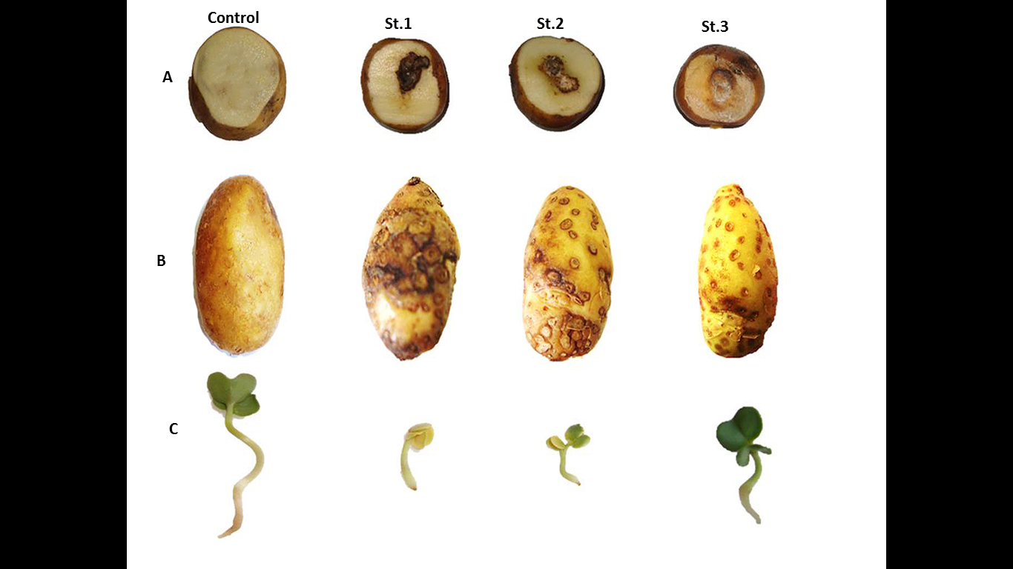

Fig. 1. Virulence assays of the tested Streptomyces isolates on potato cultivar Spunta, A: different necrotic reaction on potato tuber slices. B: Potato mini tubers scab index and C: Radish seedling length inhibition.

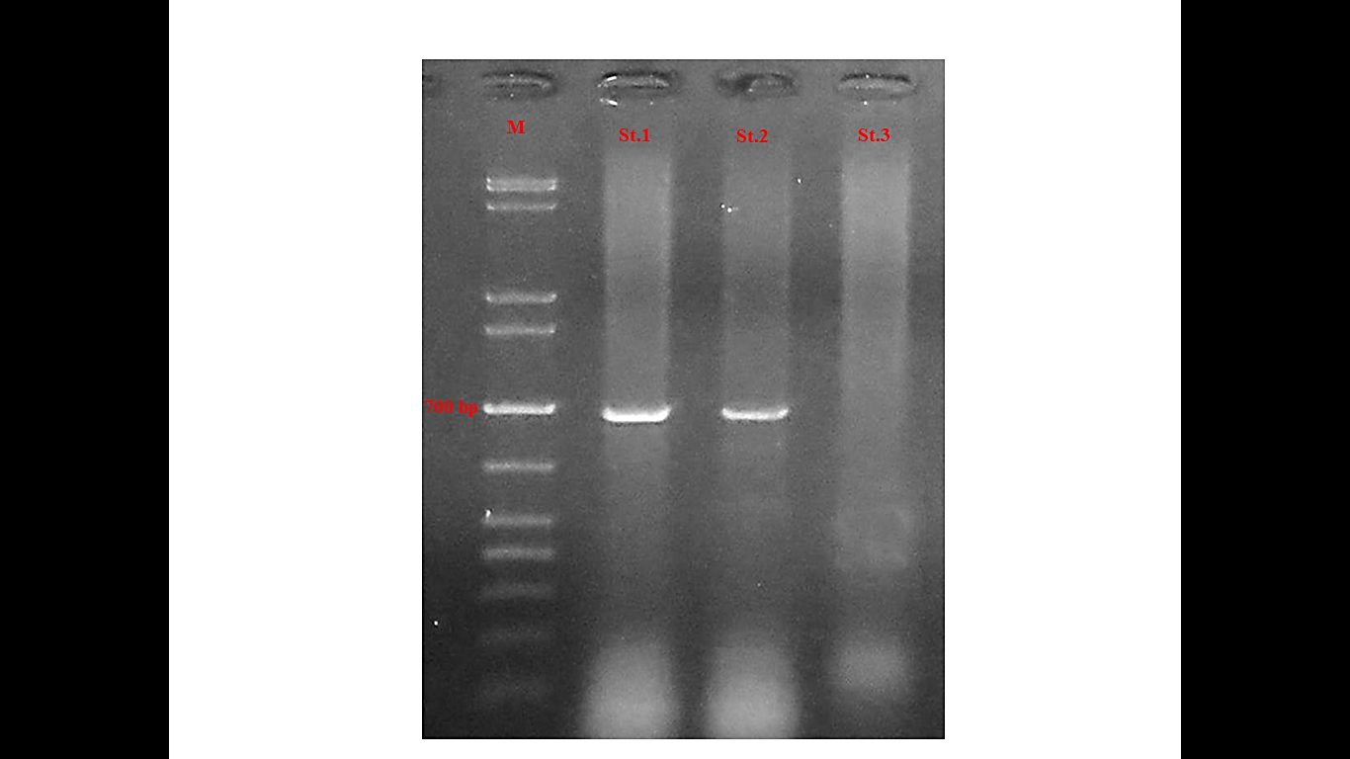
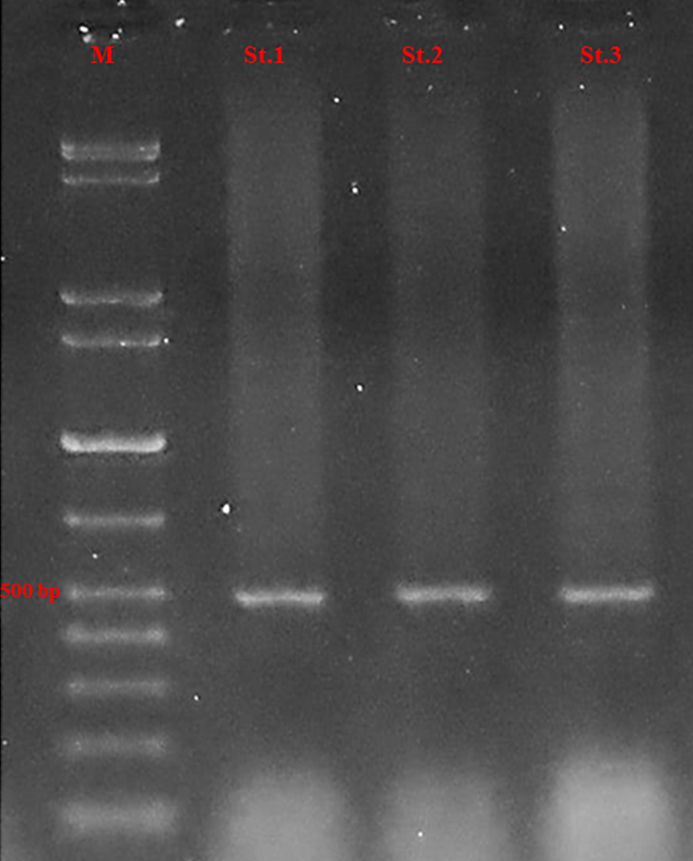
Fig. 3. Gel electrophoresis of polymerase chain reaction products generated by specific amplification of genomic DNA for the Nec-1 gene (left gel) and Thaxtomin A gene (right gel). For the Nec-1 gene Streptomyces scabies isolates St.1 and St.2 showed specific Nec1 gene bands at approximately 700bp and the St.3 isolates failed to produce this band and all the three isolates produced the specific band for Thaxtomin A at 500bp.

The phylogenetic analysis based on SDS- Page:
It is quite obvious from dendrogram (Figure 4) created based on the SDS- Page showing the phylogenetic correlation of the analyzed Streptomyces scabies isolates that the highly virulent isolate St.1 and the moderately virulent isolate St.2 were located in the same cluster. The weakly virulent isolate St.3 was located in different cluster of the other two isolates. Based on the dendrogram and clustering analysis both the highly virulent and moderately virulent isolates shared 0.94 similarity and they located in one cluster which had 0.73 similarity with the weakly virulent isolates St.2.
Table 2: Characterization of protein bands of the SDS-Page analysis in three Streptomyces scabies isolates of different degrees of virulence showing unique positive and/or negative markers.

Molecular weight of protein bands (kDa) | Number of protein bands of Streptomyces scabies isolates
Molecular weight of protein bands (kDa) | St.1  (H.v.) | St.3  (W.v.) | St.2  (M.v.)
80 | 0 | 0 | 0
70 | 0 | 0 | 0
60 | 0 | 0 | 0
59 | 1 | 1 | 1
58 | 1 | 1 | 1
50 | 1 | 1 | 1
40 | 0 | 0 | 0
31 | 1 | 1 | 1
30 | 0 | 0 | 0
29 | 1 | 0 | 1
28 | 1 | 0 | 1
20 | 0 | 0 | 1
19 | 1 | 0 | 1
15 | 1 | 1 | 1
10 | 0 | 0 | 0
Number of bands | 8 | 5 | 9

H.v. =highly virulent isolate, M.v. =moderately virulent isolate,
W.v. =weakly virulent isolate.

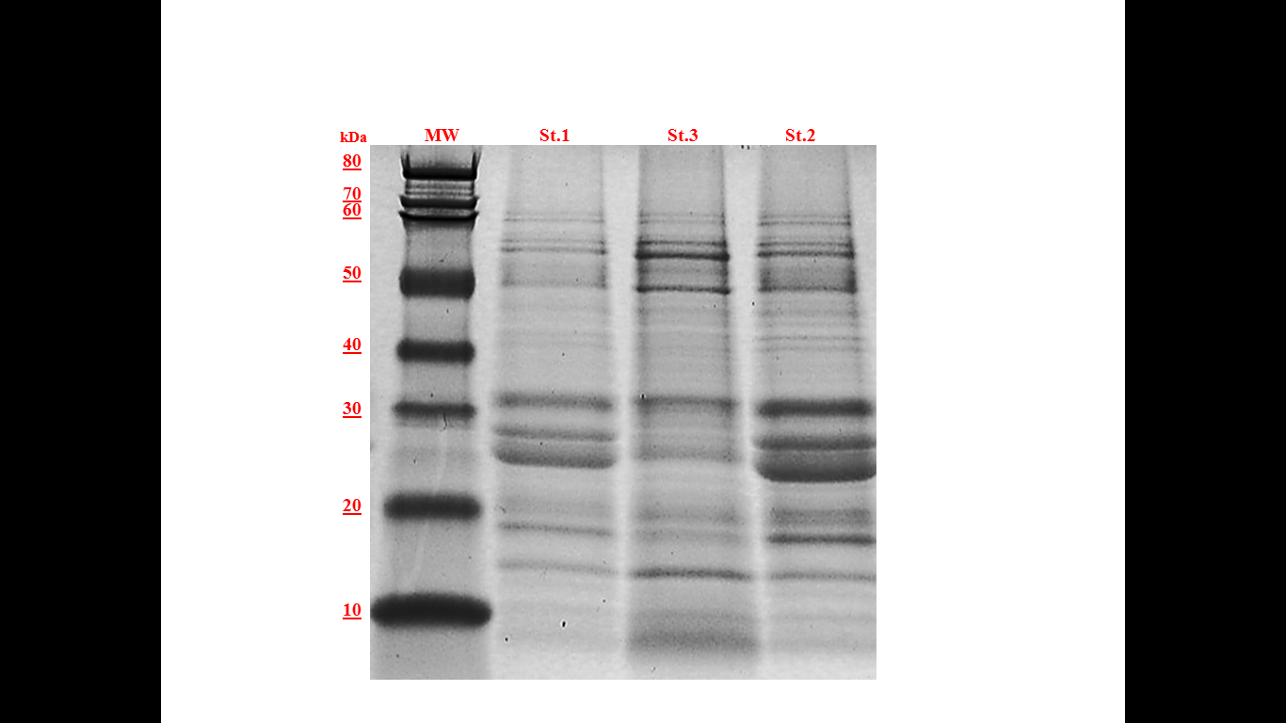

Fig. 3: SDS-Page of protein banding pattern of three Streptomyces scabies with different degree of virulence.

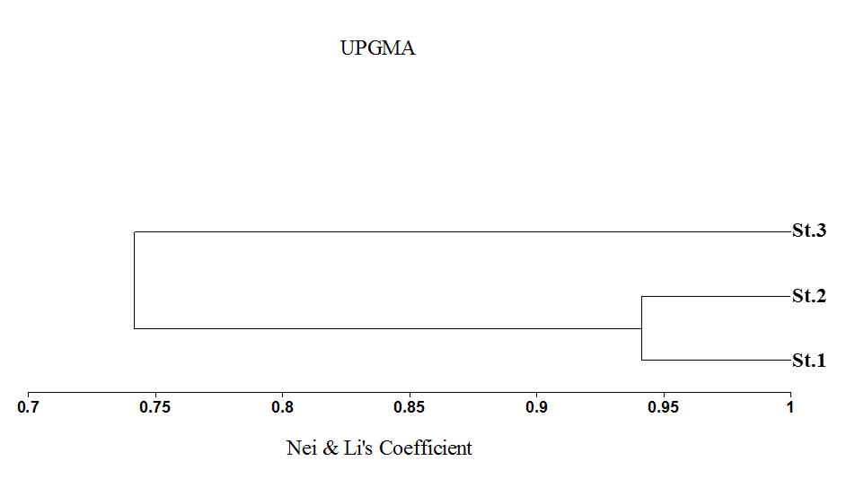

Fig. 4: Dendrogram based on the protein analysis showing the phylogenetic relationship of the analyzed S.scabies isolates.

DISCUSSION

On the basis of the results obtained from the inoculation test performed on the potato cultivar, the results concluded that, according to the scab index of the potato mini tuber, variation between isolates was reported for their virulence on potato tubers. Three Streptomyces Scabies Isolates, i.e. St.1, St.2 and St.3 were respectively identified as extremely virulent, moderately virulent and weakly virulent. Such results were in hormony with reports puplished by (Dees et al., 2013 and Shi et al., 2019)
Different degrees of necrosis on potato tuber slices were seen in the tested isolates. Necrosis was observed after (5 days with a necrotic lesion diameter of approximately 2.1 cm, 7 days with a diameter of 1.7 cm and no necrosis was observed) and (St.1, St.2 and St.3), respectively. The findings obtained are in line with those obtained by
The lowest radish seedling length was 14.5 mm with the extremely virulent isolate St.1 and the radical damage index was 3.0 with some radicals dead or deformed. For the moderately virulent isolate St.2, where the seedling length was 16.5 mm and 2.6 for the radical damage index, a mild inhibition for seedling length was observed. For the weakly virulent St.3 isolate, where the seedling length was 30 mm and 1.3 for the radical damage index, a different pattern was noticed. (Loria et al., 1995 . EL-SAYED. 2000 and Dess et al., 2013). Thaxtomin A have an inhibitory effect on radish seedling ( Loria et al., 2006)
It was clearly observed that there were major variations in the development of Thaxtomin A on Oat Meal Broth Medium between the three isolates studied. For the weakly virulent St.3 isolate, the lowest toxin production of 1.5 mg / ml was observed. For the highly virulent St.1 isolate, the highest toxin production of 2.8

mg / ml was observed. Meanwhile, with 2.1 mg / ml for the moderately virulent isolate St.2, the development of toxins was moderate (Dess et al., 2013 and Bignell et al., 1014) The production of the phytotoxic thaxtomin A is very important to the ability of S. scabies to cause scab diseas .(Johnson et al., 2007). Thaxtomin A is the main pathogenicity factor produced by S. scabies, other phytotoxins, as well as phytohormones and secreted proteins, may have a role in disease development and severity. (Li et al., 2019)
the specific primer PCR technique was successful in detecting the presence of the virulence factor genes in the selected Streptomyces scabies tested isolates . (Cao et al., 2012 and Li et al., 2019). The obtained results indicated that the Nec1 gene was found only the highly virulent isolate St.1 and the moderately virulent isolate St.2 were able to produce a specific band related to this gene at 700bp while, the weakly virulent isolate St.3 failed to produce the same band which may indicate that this isolate may lake this gene , Nec1 gene is not an essential pathogenicity factor, as several pathogenic Streptomyces strains lack this gene. This is supported by the findings of (Bukhalid et al., 2002. Wanner.2006. Seipke and Loria.2008and Wanner. 2009). Our results also showed that all the three isolates that produced thaxtomin A were all positive for the txtA genotype, even if St.3 do not have the Nec1 gene. These results are in agreement with (Wang et al., 2004). the production of thaxtomin phytotoxins is the primary pathogenicity determinant in Streptomyces species (Healy et al., 2000), thaxtomins inhibit cellulose biosynthesis in the plant and induce scab symptoms through necrosis and plant cell hypertrophy (Lawrence et al., 1990; Healy et al., 2000 and Scheible et al., 2003).
Our results also showed that at the protein molecular weight of 80 -10 kDa, eight bands were recognized for the highly virulent St.1 isolate. On the other hand, the weakly virulent St. 3 isolate exhibited five bands at this range of protein molecular weight. The moderately virulent isolates, however, showed the highest number of bands of 9 bands at this protein range. Meantime, the weakly virulent St.3 isolate showed unique absence of three protein bands at 19 kDa , 28 kDa and 29 kDa, while the other isolates exhibited bands at these molecular weight but not for St1 isolate which also showed no band at 20kDa .results also showed that both of the highly virulent and moderately virulent isolates shared 0.94 similarity and they located in one cluster which had 0.73 similarity with the weakly virulent isolates St.2 based on the dendrogram and clustering analysis. The findings of present study are in conformity with the findings of Özdemir et al. (2013) the SDS-PAGE method was found to be an efficient method regarding the determination of the phylogenetic relations between the various species of genus Streptomyces. Also prepared total cellular protein profile for bacterial strain Aeromonas by SDS-PAGE method and identify the similarities between various types and subtypes of bacteria (Manchester et al., 1990; Boynukara et al., 2004).

REFERENCES

- Alejoa, A., Eleuterio Burgueno˜ b, Luis A. Maldonadoc, Gabriel Herrera d, Ruben Felix e, Erika T. Quintana. 2019 In vitro effect of the crude extract of a potato common scab streptomycete in Sinaloa, Mexico.Rev Argent Microbial.51(4):363- 370
- Bignell DRD, Francis IM, Fyans JK, Loria R. .2014 .Thaxtomin A production and virulence are controlled by several bld gene global regulators in Streptomyces scabies. Mol Plant-Microbe Interact .27:875–885.
- Boynukara B, Korkoca H, Senler NG, Gulhan T, Atalan E (2004) The characterisation of protein profiles of the isolated Aeromonas sobria strains from animal feces by SDS-PAGE. Indian Veterenary Journal 81: 245-249.
- Bukhalid RA, Loria R. 1997. Cloning and expression of a gene from Streptomyces scabies encoding a putative pathogenicity factor. J Bacteriol .179:7776–7783.
- Cao, Z., Khodakaramian, G., Arakawa, K. and Kinashi, H. 2012 Isolation of borrelidin as a phytotoxic compound from a potato pathogenic Streptomyces strain. Biosci Biotechnol Biochem 76, 353–357
- Dees MW, Wanner LA. 2012. In search of better management of potato common scab. Potato Res.55:249–26
- Dees, M.; Sletten, A.; Hermansen, A. 2013 .Isolation and characterization of Streptomyces species from potato common scab lesions in Norway. Plant Pathol.. 62, 217–225. [CrossRef]
- EL-Agamy, S. 2000. Physiochemical, molecular and immunological characterization of camel rennet: a comparison with buffalo rennet. J. Dair. Res., 67: 73-81.
- EL-SAYED A. EL-S. Production of thaxtomin A by two species of Streptomyces causing potato scab. Folia Microbiol. 45, 415-422 (2000).
- El-Sayed A. EL-S., el-Didamony G, Mansour K. 2001. Isolation and characterization of two types of actinophage infecting Streptomyces scabies.Folia Microbiol (Praha). 46(6):519-26. D
- El-Sheikh, M.A. 2010. Common scab of potato as affected by soil mineral elements and tuber chemical constituents. J. Agric and Envi. Sci. Alex. Uni, Egypt.9 (2):1-24.
- El-Sheikh, M.A.; El-Kazzaz, S.A.; El-Argawy, E. and Ghozlan, M.H. 2012. Factors affecting thaxtomin A production by Streptomyces scabies in Egypt. Egypt. J. Phytopathol., 40(2): 131-147.
- FAO STAT, (2007). Agriculture data source. (Online) Available from: http://faostat.fao.org/default.aspx.
- Goyer, C., Vachon, J., and Beaulieu, C. 1998. Pathogenicity of Streptomyces scabies mutants altered in thaxtomin A production. Phytopathology 88:442-445.
- Hames, B.D.; Rickwood, D. 1990.Gel electrophoresis of proteins. A practical approach, Oxford University Press, New York. 323p.
- Healy FG, Wach M, Krasnoff SB, Gibson DM, Loria R. 2000.The txtAB genes of the plant pathogen Streptomyces acidiscabies encode a peptide synthetase required for phytotoxin thaxtomin A production and pathogenicity. Mol Microbiol .38:794–804.
- Howard, G.C. and W.E. Brown, 2001. Modern Protein Chemistry: Practical Aspects. ISBN, CRC Press, USA
- Johnson EG, Joshi MV, GibsonDM, LoriaR. 2007.Cello-oligosaccharides released from host plants induce pathogenicity in scab-causing Streptomyces species. Physiol Mol Plant Pathol .71:18–25.
- Joshi M, Rong X, Moll S, Kers J, Franco C et al. 2007.Streptomyces turgidiscabies secretes a novel virulence protein, Nec1 , which facilitates infection. Mol Plant Microbe Interact .20:599–608
- King Russell R., C. Harold. Lawrence, and Larry A. 1992 .Calhoun Chemistry of phytotoxins associated with Streptomyces scabies the causal organism of potato common scab , J. Agric. Food Chem., 40, 5, 834
- Lawrence, M. B., C. W. Smith, S. G. Eskin, and L. V. McIntire. 1990. Effect of venous shear stress on CD18-mediated neutrophil adhesion to cultured endothelium. Blood. 75:227–237
- Leiner RH, Fry BA, Carling DE, Loria R. 1996.Probable Involvement of Thaxtomin A in Pathogenicity of Streptomyces scabies on Seedlings. Phytopathology .86:709–713.
- Li Y, Jingyu L G D-C, Zhenlong C and Dawn R. D. B.2019. Virulence mechanisms of plant-pathogenic Streptomyces species: an updated review Microbiology 2019;165: 1025–1040
- Loria R, Bignell DRD, Moll S, Huguet-Tapia JC, Joshi MV et al. 2008.Thaxtomin biosynthesis: the path to plant pathogenicity in the genus Streptomyces. Antonie van Leeuwenhoek.94:3–10.
- Loria R, Bukhalid RA, Fry BA, King RR. 1997. Plant pathogenicity in the genus Streptomyces. Plant Dis.81: 836–846.
- Loria R, Kers J, Joshi M. 2006. Evolution of plant pathogenicity in Streptomyces. Annu Rev Phytopathol. 4 4:469–487.
- Loria, R., Bukhalid, R.A., Creath, R.A., Leiner, R.H., Olivier, M. and Steffens, J.C.1995. Differential production of thaxtomins by pathogenic Streptomyces speciesin vitro. Phytopathology, 85, 537–541
- Loria, R., Bukhalid, R.A., Creath, R.A., Leiner, R.H., Olivier, M. and Steffens, J.C.1995. Differential production of thaxtomins by pathogenic Streptomyces speciesin vitro. Phytopathology, 85, 537–541
- Manchester L, Pot B, Kersters K, Goodfellow M (1990) Classification of Streptomyces and Streptoverticillium species by numerical analysis of electrophoretic protein patterns. Systematic and Applied Microbiology 13: 333–337.
- Natsume M, Tashiro N, Doi A, Nishi Y, Kawaide H. 2017. Effects of concanamycins produced by Streptomyces scabies on lesion type of common scab of potato. J Gen Plant Pathol. 83:78–82.
- Özdemir K, Berber, Öğün E and Atalan M. 2013. DETERMINATION OF TOTAL CELL PROTEIN PROFILES OF Streptomyces SPECIES. Journal of Experimental Biology and Agricultural Sciences, Volume – 1 (3):186-190
- SAS Institute. 2000. SAS users Guide, version 8.1. SAS Inst., Cary, N.C. Res. 286-288.
- Seipke RF, Loria R .2008. Streptomyces scabies 87-22 possesses a functional tomatinase. J Bacteriol 190 (23):7684–7692
- Shi W, Mingcong L, Guangshan W, Renmao T, Cuiping L, Bing W, Rongshan L, Chunyu S,t Xiuli C, Bo Z and Zheng G. 2019. The occurrence of potato common scab correlates with the community composition and function of the geocaulosphere soil microbiome. Microbiome 7:14
- Wang, G., S. P. Kennedy, S. Fasiludeen, C. Rensing, and S. DasSarma. 2004. Arsenic resistance in Halobacterium sp. strain NRC-1 examined by using an improved gene knockout system. J. Bacteriol. 186:3187–3194.
- Wanner LA, Kirk WW. 2015. Streptomyces – from basic microbiology to role as a plant pathogen. Am J Potato Res.92:236–242.

